**EXCEL FORMULAS**

**VLOOKUP vs HLOOKUP vs XLOOKUP**

| **Feature** | **XLOOKUP** | **VLOOKUP** | **HLOOKUP** |
| --- | --- | --- | --- |
| **Purpose** | Looks up values in a range or array, returning a corresponding value. | Looks up values vertically in a table by matching the first column. | Looks up values horizontally in a table by matching the first row. |
| **Syntax** | =XLOOKUP(lookup_value, lookup_array, return_array, [if_not_found], [match_mode], [search_mode]) | =VLOOKUP(lookup_value, table_array, col_index_num, [range_lookup]) | =HLOOKUP(lookup_value, table_array, row_index_num, [range_lookup]) |
| **Orientation** | Flexible (vertical or horizontal lookup). | Vertical only. | Horizontal only. |
| **Lookup Direction** | Can search left, right, up, or down. | Right only (returns value from columns to the right). | Down only (returns value from rows below). |
| **Return Array** | Can return multiple values (array) or a single value. | Returns a single value. | Returns a single value. |
| **Column/Row Index** | No index required; directly references return_array. | Requires column index number, error-prone if table changes. | Requires row index number, error-prone if table changes. |
| **Match Mode** | Exact (0), exact or next smaller (-1), exact or next larger (1), wildcard (2). | Exact (FALSE) or approximate (TRUE). | Exact (FALSE) or approximate (TRUE). |
| **Search Mode** | First-to-last, last-to-first, binary search (ascending/descending). | First-to-last only. | First-to-last only. |
| **Error Handling** | Customizable [if_not_found] argument (e.g., "Not Found"). | Returns #N/A if not found; no custom error message. | Returns #N/A if not found; no custom error message. |
| **Performance** | Optimized for large datasets, supports dynamic arrays. | Slower on large datasets, no dynamic array support. | Slower on large datasets, no dynamic array support. |
| **Dynamic Arrays** | Native support for spill ranges (Excel 365/2021). | No support for spill ranges. | No support for spill ranges. |
| **Availability** | Excel 365, Excel 2021, and later. | All Excel versions. | All Excel versions. |
| **Example** | =XLOOKUP(A2, B2:B10, C2:C10, "Not Found", 0) | =VLOOKUP(A2, B2:D10, 2, FALSE) | =HLOOKUP(A2, B2:D10, 2, FALSE) |

**VLOOKUP**

VLOOKUP in Excel is a function that searches for a specific value in the first column of a table and returns a value in the same row from a column you specify. It's used to retrieve data from a table based on a matching value. The "V" in VLOOKUP stands for vertical, as it searches vertically down a column.

**=VLOOKUP(lookup_value, table_array, col_index_num, [range_lookup])**

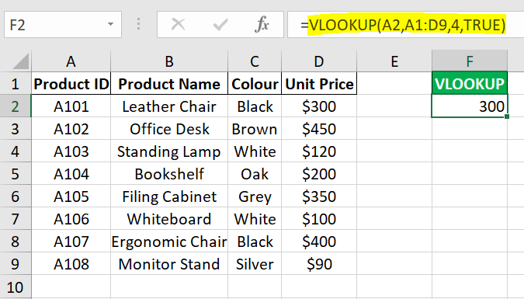

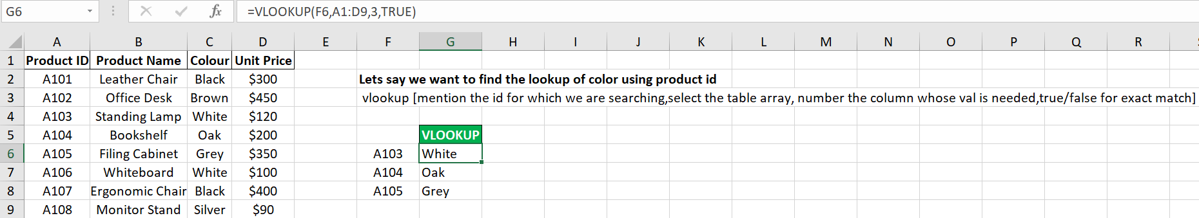

Here, we have to get multiple values:

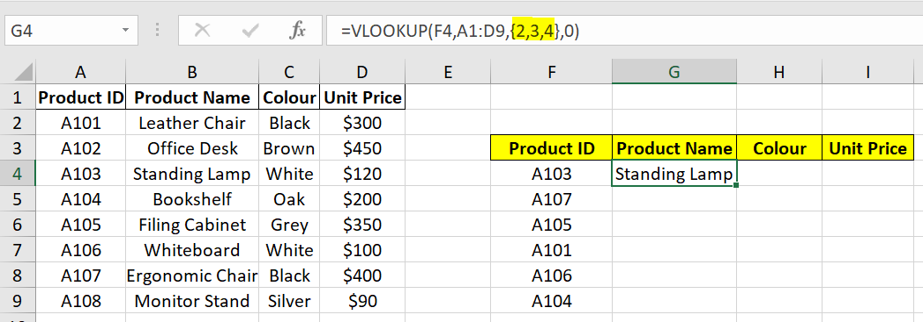

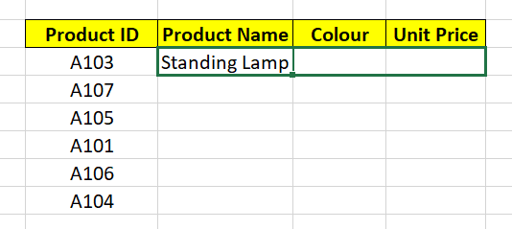

Problem is that lookup_value & table_array shifts too.

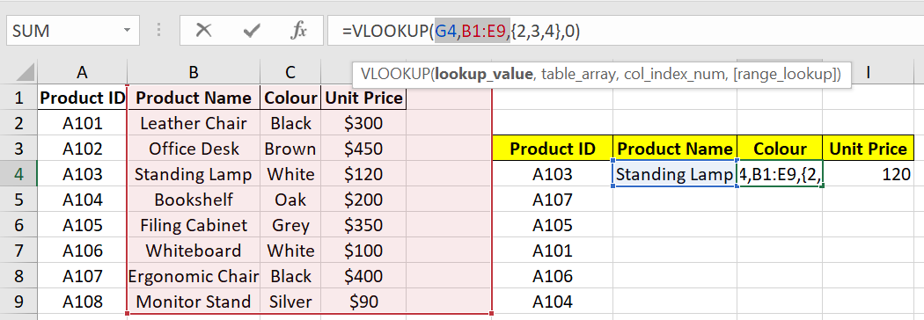

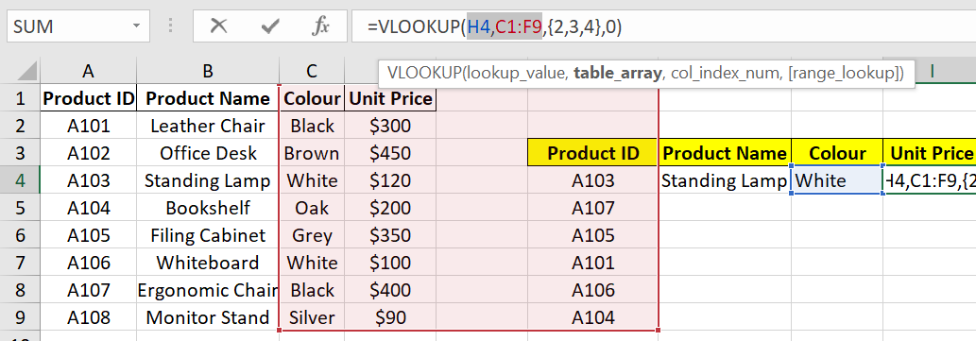

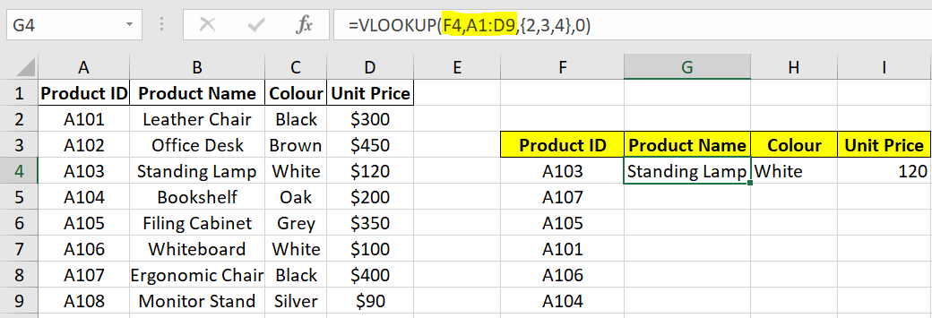

To fix F4,A1:D9  
Select it and enter ‘**Fn + F4**’

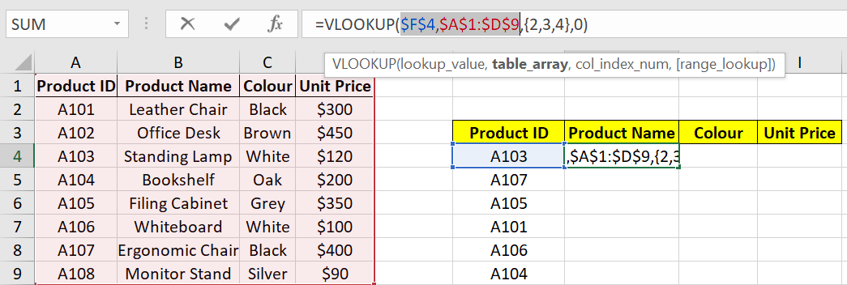

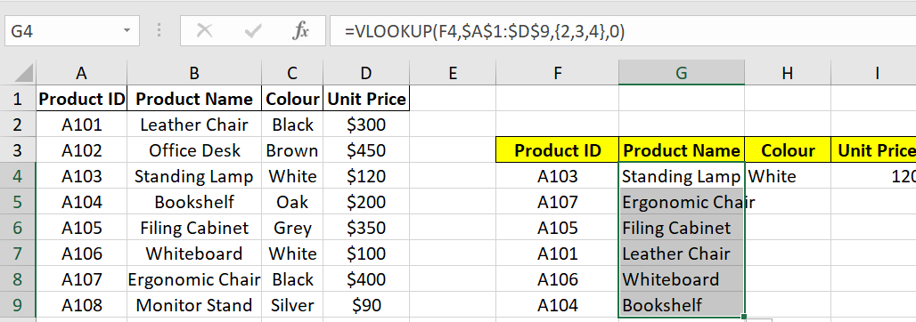

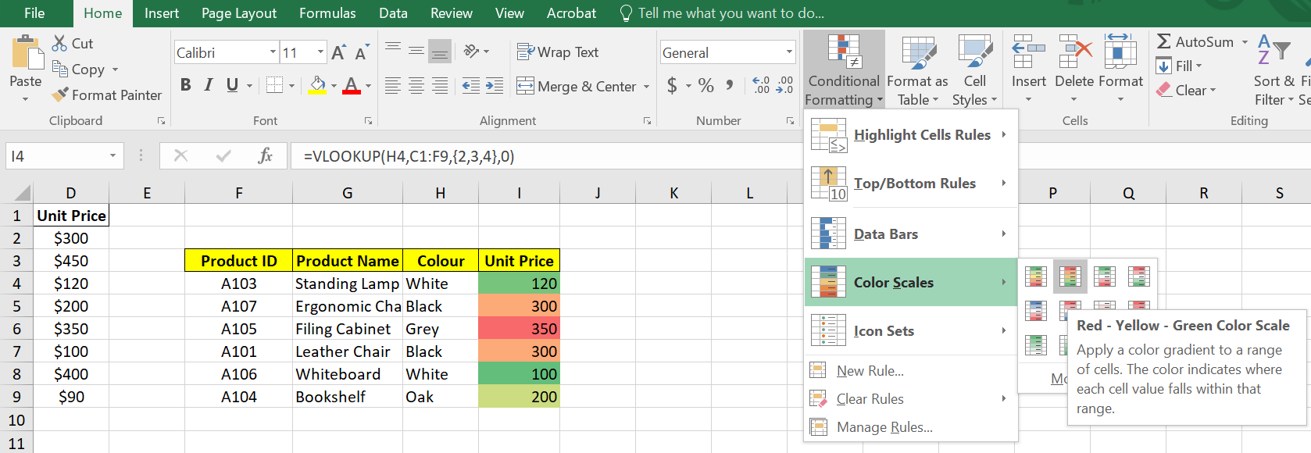

**________________________________________________________________**

**HLOOKUP**

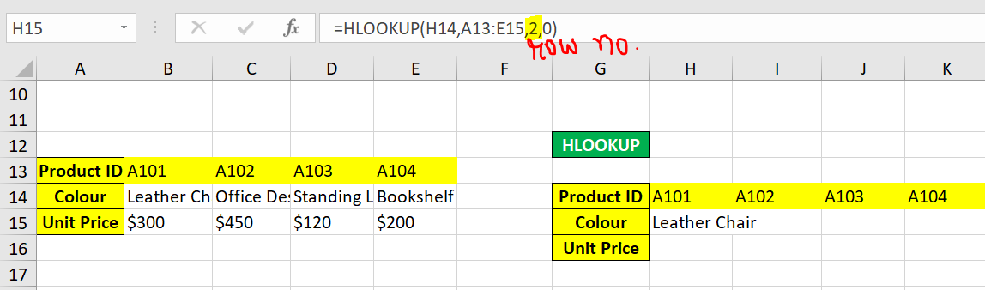

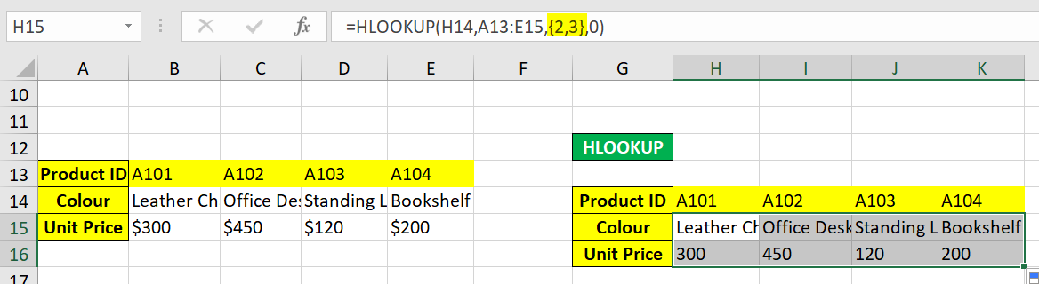

**________________________________________________________________**

**XLOOKUP**

First we will format it into table [Ctrl + T]

