**EXCEL FORMULAS**

**VLOOKUP**

VLOOKUP in Excel is a function that searches for a specific value in the first column of a table and returns a value in the same row from a column you specify. It's used to retrieve data from a table based on a matching value. The "V" in VLOOKUP stands for vertical, as it searches vertically down a column.

**=VLOOKUP(lookup_value, table_array, col_index_num, [range_lookup])**

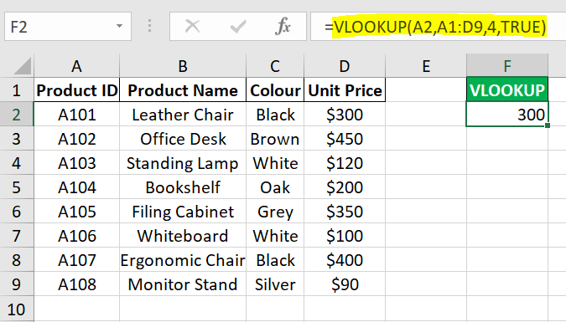

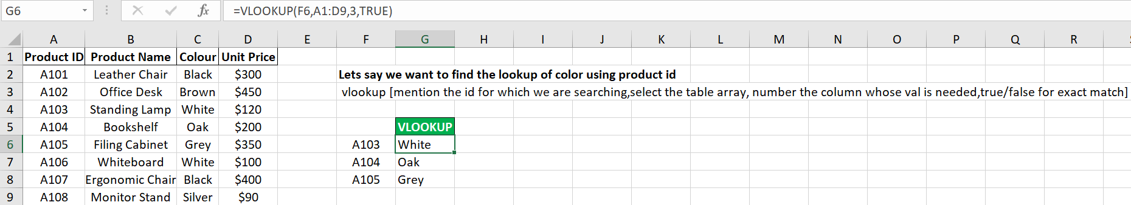

Here, we have to get multiple values:

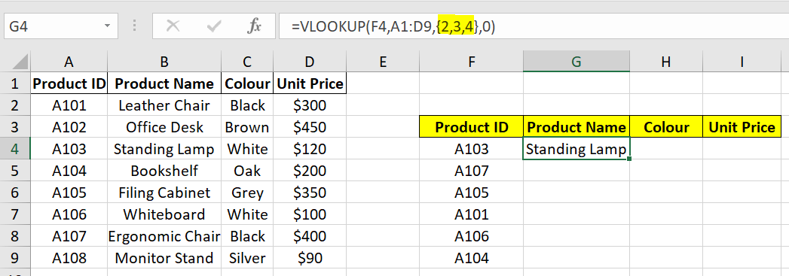

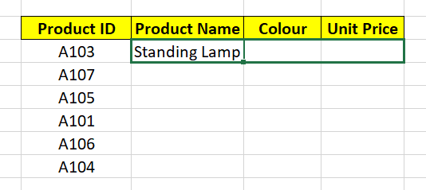

Problem is that lookup_value & table_array shifts too.

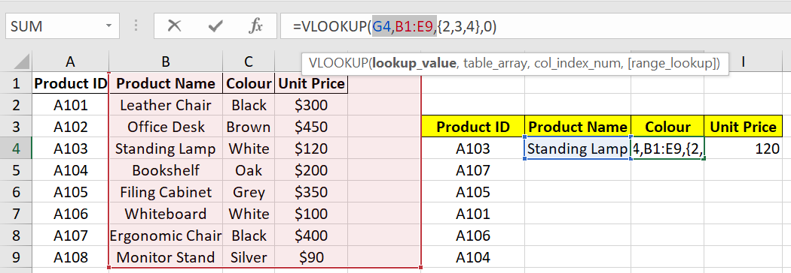

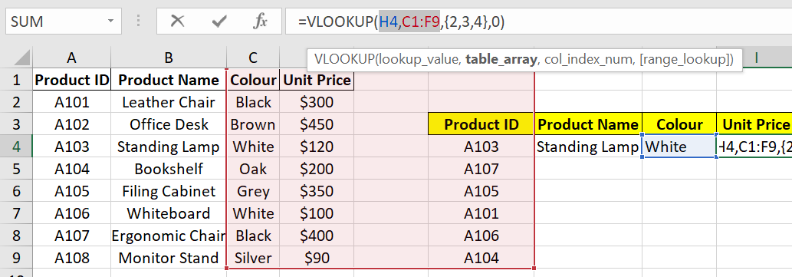

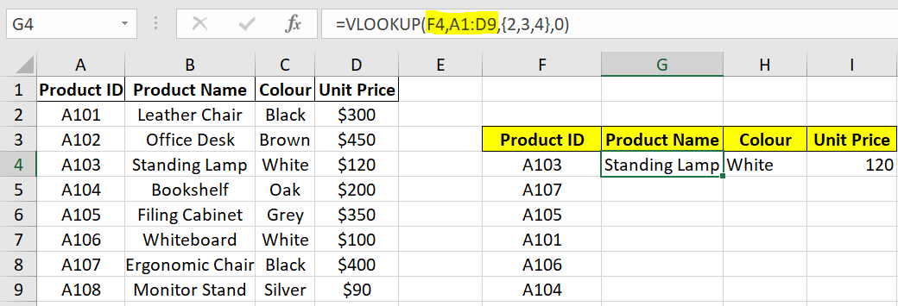

To fix F4,A1:D9  
Select it and enter ‘**Fn + F4**’

