[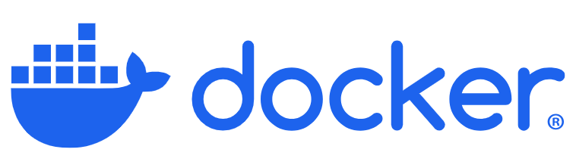](https://www.docker.com/get-started/)

Docker is a platform that has become indispensable in modern software development due to its ability to address challenges related to consistency, scalability, and efficiency. Its relevance spans job requirements and technical interviews, making it a highly sought-after skill.

Docker is a platform designed to help developers build, share, and run containerized applications. In simple terms, Docker enables you to package an application along with its dependencies (libraries, configurations, and environment settings) into a single, portable unit called a container. This container can run consistently across different environments, whether on a developer’s laptop, a testing server, or a production machine.

* ***Docker***is a tool that simplifies the process of developing, packaging, and deploying applications.
* By using ***containers***, Docker allows you to create lightweight, self-contained environments that run consistently on any system, minimising the time between writing code and deploying it into production.

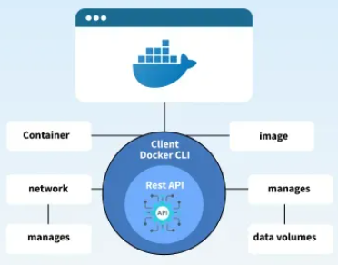

In software development, applications often behave differently across environments (development, testing, production) due to variations in operating systems, library versions, or configurations. Docker solves this by “containerizing” the application and its dependencies into a standardized package, ensuring consistent behaviour regardless of where it’s deployed.

**Why do we need Dockers?**

1. Consistency Across Environments:

In software development, applications often behave differently across environments (development, testing, production) due to variations in operating systems, library versions, or configurations. Docker solves this by “containerizing” the application and its dependencies into a standardized package, ensuring consistent behavior regardless of where it’s deployed.

*To illustrate Docker’s value, consider a scenario where you develop an amazon product price predictor application using Streamlit. The application works perfectly on your machine. You share the code via a GitHub repository with a tester, who clones it and attempts to run it.*

*However, the tester encounters an error (e.g., “ColumnTransformer object has no attribute named_to_fitted_passthrough”) because their machine has a different version of scikit-learn.*

*Resolving this requires identifying and installing the exact library version you used, which is time-consuming and error-prone. In larger teams or complex projects, these issues multiply, leading to significant inefficiencies.*

*Docker eliminates these problems by packaging the application, its dependencies, and the environment into a container. The tester can run the container directly, ensuring the application behaves exactly as it did on your machine. This standardization also simplifies deployment, as the same container can be used in production.*

*It basically encapsulates everything required to run the application.*

1. Time Efficiency:

Without Docker, developers and testers spend significant time troubleshooting environment - specific issues, such as installing the correct library versions or setting environment variables. Docker streamlines this process by providing a standardized container that works out of the box.

1. Simplified Deployment:

During deployment, the same environmental inconsistencies can arise on production servers. Docker ensures that the application runs as expected, reducing the need for manual configuration and debugging.

1. Isolation:

**Concept**: Isolation ensures multiple applications (e.g., websites) on a single server operate independently, preventing interference.

**Challenges Without Isolation**:

* **Security Risks**: A hacked website could compromise others on the same server.
* **Resource Contention**: High traffic to one website may consume excessive resources, starving others.

**Docker’s Solution**: Docker containers provide lightweight isolation, running each application in a separate environment while sharing the host OS. This:

* Enhances security by containing breaches within a single container.
* Allocates specific resources to each container, ensuring fair distribution.

**Comparison with Virtual Machines (VMs)**: VMs offer isolation but are resource-heavy, requiring a full OS per instance. This causes:

* High resource usage.
* Slow startup/shutdown times. Docker containers are lightweight, offering efficient isolation without VM overhead.

1. Scalability:

**Concept**: Scalability enables applications to handle varying traffic by dynamically adjusting resources.

**Challenges Without Scalability**:

* Low traffic periods waste resources if multiple servers run unnecessarily.
* High traffic overwhelms a single server, causing performance issues.

**Docker’s Solution**: Docker’s lightweight containers simplify scalability:

* **Rapid Deployment**: Quickly deploy new container instances to additional machines to handle traffic spikes.
* **Dynamic Management**: Shut down containers during low traffic to save resources or spin up new ones during peaks.
* **Load Balancing**: Integrates with tools like Kubernetes for efficient traffic distribution.

**Example**: A website may run on three servers during low traffic (daytime) but scale to five at night. Docker enables instant container deployment and removal, optimizing resource use.

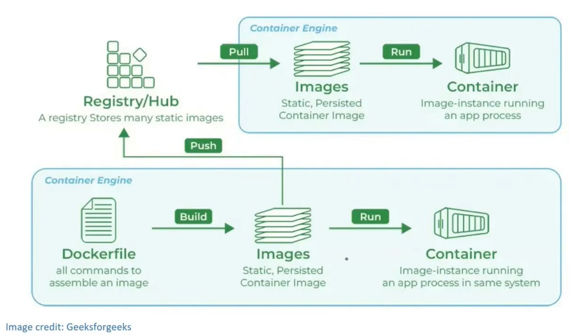

Docker Engine is the core component of the Docker platform, responsible for creating, running, and managing Docker containers. It serves as the runtime that powers

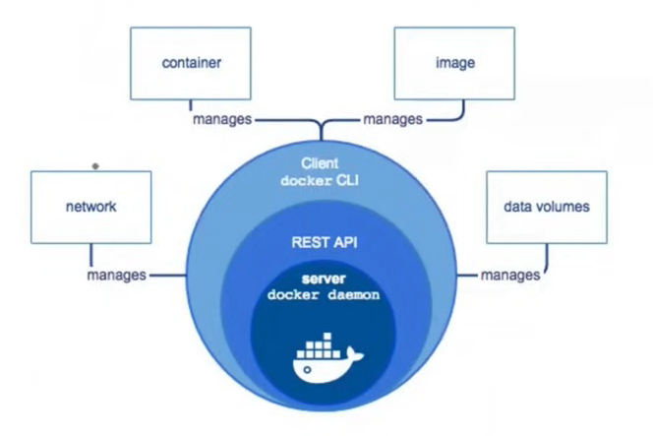

**Components of Docker Engine**

1. Docker Daemon (dockerd):

○ Function: The Docker daemon is the background service running on the host machine. It manages Docker objects such as images, containers, networks, and volumes.

○ Interaction: It listens for Docker API requests and processes them, handling container lifecycle operations (start, stop, restart, etc.).

2. Docker CLI (docker):

○ Function: The Docker Command Line Interface (CLI) is the tool that users interact with to communicate with the Docker daemon.

○ Usage: Users run Docker commands through the CLI to perform tasks like building images, running containers, and managing Docker resources.

3. REST API:

○ Function: The Docker REST API allows communication between the Docker CLI and the Docker daemon. It also enables programmatic interaction with Docker.

○Usage: Developers can use the API to automate Docker operations or integrate Docker functionality into their applications.

**Docker Image**

A Docker image is a lightweight, stand-alone, and executable software package that includes everything needed to run a piece of software, such as the code, runtime, libraries, environment variables, and configuration files. Images are used to create Docker containers, which are instances of these images.

**Dockerfile**

A Dockerfile is a text file that contains a series of instructions used to build a Docker image. Each instruction in a Dockerfile creates a layer in the image, allowing for efficient image creation and reuse of layers. Dockerfiles are used to automate the image creation process, ensuring consistency and reproducibility.

**Docker Container**

A Docker container is a lightweight, portable, and isolated environment that encapsulates an application and its dependencies, allowing it to run consistently across different computing environments. Containers are created from Docker images, which are immutable and contain all the necessary components for the application to run.

**Registry**

A Docker registry is a service that stores and distributes Docker images. It acts as a repository where users can push, pull, and manage Docker images. Docker Hub is the most well-known public registry, but private registries can also be set up to securely store and manage images within an organization.

*A Docker container is a self-contained, runnable software application or service. On the other hand, a Docker image is the template loaded onto the container to run it, like a set of instructions.*

**Implementation:**

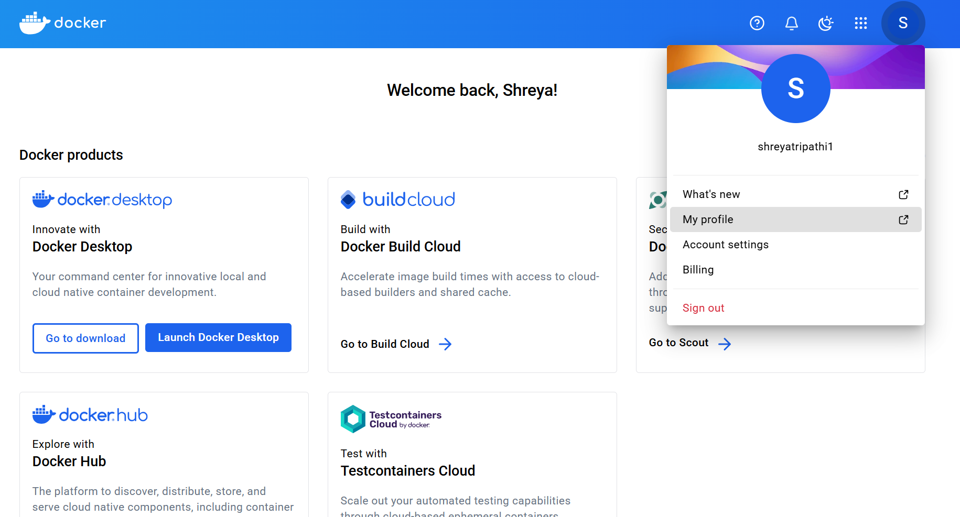

## **1. Opening Docker**

Ensure Docker is running:

* **Windows/Mac**: Launch Docker Desktop (check whale icon in system tray).
* **Linux**: Run sudo systemctl start docker and verify with sudo systemctl status docker.

## **2. Logging into a Docker Registry**

Authenticate with Docker Hub:

* Run docker login in a terminal.
* Enter your Docker username and password.
* Credentials are stored locally (e.g., ~/.docker/config.json on Linux/Mac).

## **3. Pulling Images from a Repository**

Download images from a registry:

* Use docker pull <image-name>:<tag> (e.g., docker pull python:3.9).
* For private images, ensure you’re logged in.
* Verify with docker images.

## **4. Pushing Images to a Repository**

Share your image:

* Build and tag the image: docker build -t <your-username>/<image-name>:<tag> . (e.g., myuser/ml-app:1.0).
* Log in: docker login.
* Push: docker push <your-username>/<image-name>:<tag> (e.g., docker push myuser/ml-app:1.0).
* Verify on Docker Hub.

## **Practical Example**

docker pull hello-world

docker run hello-world

For a machine learning project:

* Build image: docker build -t yourusername/price-predictor:1.0 ..
* Push: docker push yourusername/price-predictor:1.0.
* Pull and run elsewhere: docker pull yourusername/price-predictor:1.0 and docker run -p 8501:8501 yourusername/price-predictor:1.0.