

ASSIGNMENT REPORT
on
Priority Based Scheduling
Submitted by,
 | Submitted to,
Shreya Singh | Pradeep Kumar
Regno- 11612233
Roll No-B53
Computer Science Engineering
Dated: 19th April 19, 2018

School of Computer Science & Engineering
Lovely Professional University, Phagwara
Table of Contents

1. Introduction

1.1. Introduction of Topic

1.2. Purpose

- Problem Analysis 2.1. Requirements

2.1.1. Process id

2.1.2. Arrival time

2.1.3. Burst time

2.1.4. Priority

2.1.5. Average waiting time

3. Algorithm Involved

3.1 Preemptive Priority Schedule Algorithm

3.2 Advantage and Disadvantage

- Boundary Criteria 4.1 Process Id

4.2 Arrival Time

4.3 Burst Time

4.4 Service Time

5. Testing

- Conclusion
- Complexity
1. Introduction:

1.1 Introduction to my topic:

Preemptive Priority Scheduling Algorithm

The preemptive priority scheduling algorithm is a known os process management and job scheduling algorithm.

Every job that enters the job queue is assigned a priority based on which its execution takes place. As simple it sounds, the processes with a higher priority will be executed first and then the processes with the lower priorities will be executed.

If there are multiple processes in the queue with the same priority, then such jobs are executed in the order of their arrival often called as first come first served.

In this preemptive implementation of priority scheduling program in C, we consider the arrival time of the processes.

Since this is a preemptive job scheduling algorithm, the CPU can leave the process midway.
The current state of the process will be saved by the context switch.

The system can then search for another process with a higher priority in the ready queue or waiting queue and start its execution.

Once the CPU comes back to the previous incomplete process, the job is resumed from where it was earlier paused.

1.2 What is the Purpose of the Problems?

The main purpose of the problem is to find the average waiting time for each process using preemptive priority scheduling algorithm.


2. Problem analysis:

3.1 Priority (How to solve priority if same for different Process id)

3.2 Arrival Time (What is the arrival time given to system)

3.3 Burst Time (What is burst time required)

3.4 Service Time (What is the amount of CPU time)

3.5 Average Waiting Time( To calculate ?)

3. Algorithm Involved:

3.1 Preemptive Priority Schedule Algorithm:

Priority Scheduling selects the process(es) with the highest priority ( Highest priority means more preferences is given to that process) currently ready to run. If there is more than one process having the currently highest priority, you need a second scheduling algorithm to choose among these processes.

Preemptive Priority Scheduling is the same algorithm but if a new process having a higher priority than the currently running process arrives, it gets selected immediately. The new process has not to wait until the currently running process finishes or yields.

3.2 Advantages & Disadvantages:

Advantages

 Preemptive priority scheduling is more efficient and better as compared to
- the non-preemptive version one.

- This algorithm is easy to implement.

- To reduce starvation of lower priority processes, aging technique is implemented

The avg turnaround time (tat) and waiting time (wt) is efficient.

Disadvantages
- There is indefinite blockage of the lower priority jobs.

For a system occurrence of failure, the unfinished lower priority jobs are removed from the system and cannot be recovered.
4. Boundary Criteria:

1. Process Id (like P1,P2,P3 and so on)- In computing, the process identifier testing (normally referred to as the process ID or PID) is a number used by operating system kernels—such as UNIX, linux and Microsoft Windows to find an active process.

- Arrival time – This is the time at which the process arrives in the ready queue

- Burst Time- This is the time required by a process for CPU execution.

- Service Time-The amount of CPU time that a process will require before it either finishes or exits the CPU, like to wait for ip / out.

So we have to calculate the average waiting time for each process using preemptive priority scheduling algorithm.

- Test Cases:
It is the collections of I/p given by us to get desired output(o/p).

Here we have taken user defined processes for preemtive priorities scheduling algorithm where we have given arrival time and burst time along with priorities. So our task is to get or find average waiting time for above.

Higher Priority will lead to process first and if priority is same then first process will be executed .
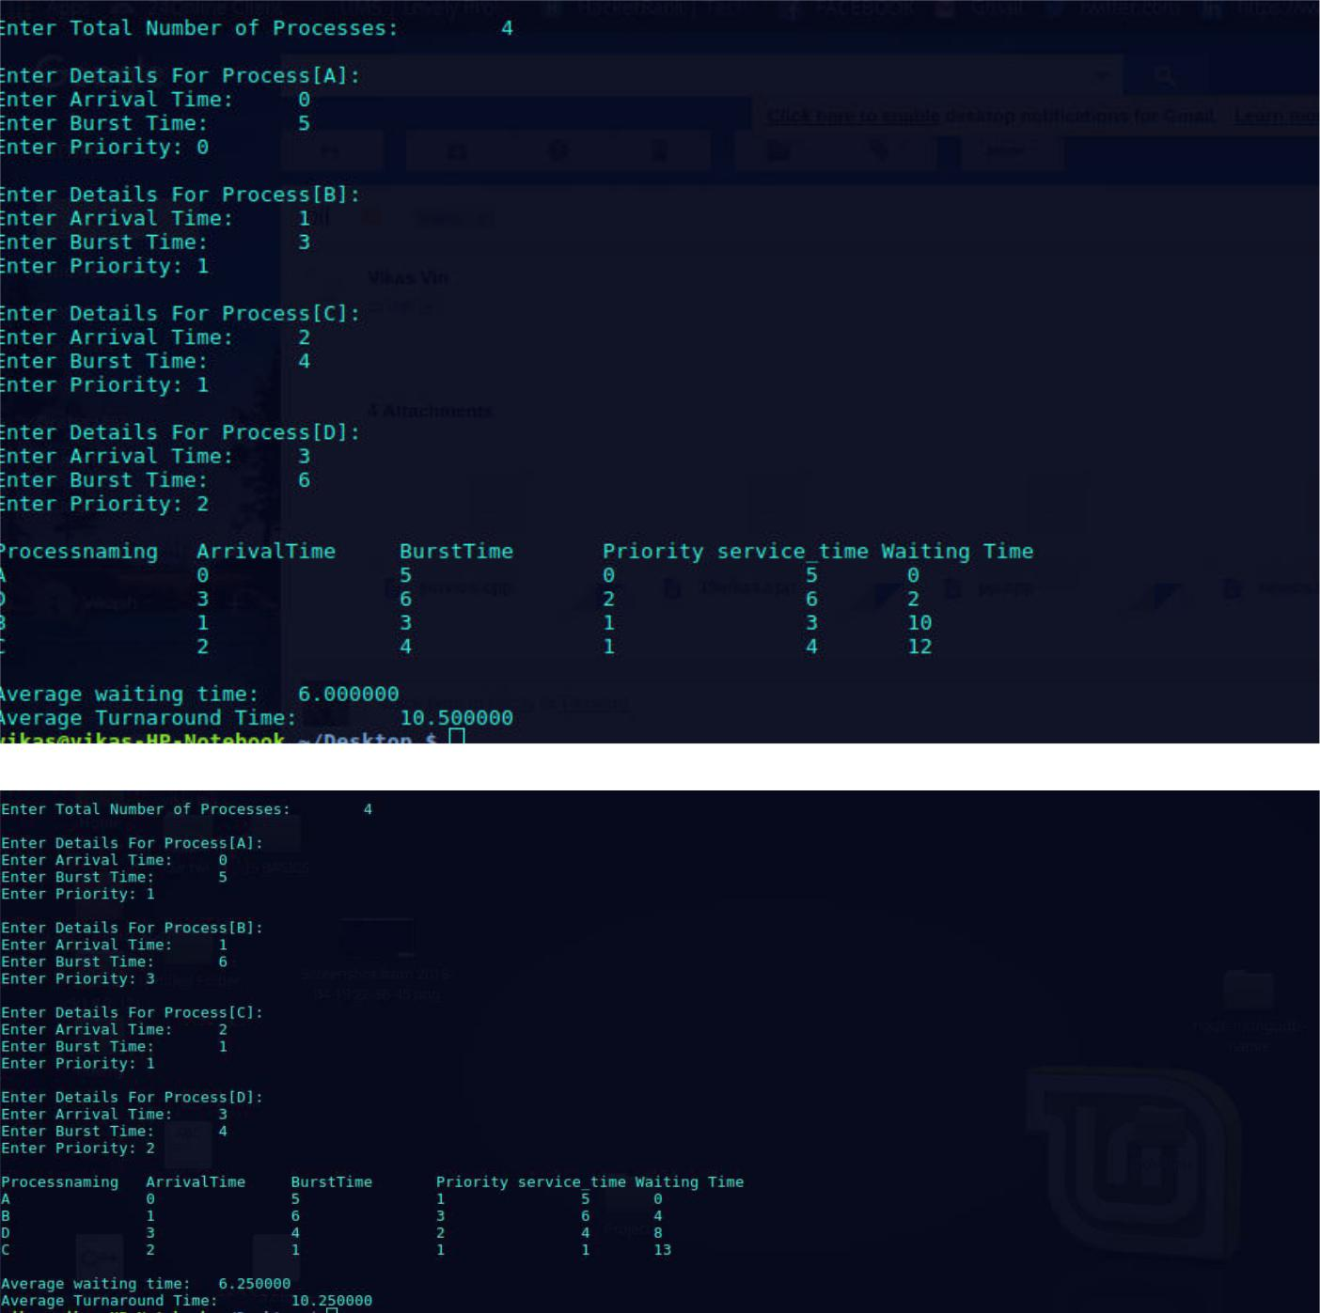

6. Solution Code:

#include<stdio.h>

struct process_schedule

{

char process_naming;

int arrival_timing, burst_timing, ctiming, waiting_timing, turnaround_timing, priority,service_timing;

int status;

}process_queue[10];

int size_limit;

void arrival_timing_Sort()

{

struct process_schedule temp;

int i, j;

for(i = 0; i < size_limit - 1; i++)

{

for(j = i + 1; j < size_limit; j++)

{

if(process_queue[i].arrival_timing > process_queue[j].arrival_timing)

{

temp = process_queue[i];

process_queue[i] = process_queue[j];

process_queue[j] = temp;

}

}

}

}

int main()

{

int i, time = 0, burst_timing = 0, largest, service_timing=0; char c;

float wait_timing = 0, turnaround_timing = 0, average_waiting_timing, average_turnaround_timing;

printf("\nEnter Total Number of Processes:\t");

scanf("%d", &size_limit);

for(i = 0, c = 'A'; i < size_limit; i++, c++)
{

process_queue[i].process_naming = c;

printf("\nEnter Details For Process[%C]:\n", process_queue[i].process_naming); printf("Enter Arrival Time:\t");

scanf("%d", &process_queue[i].arrival_timing ); printf("Enter Burst Time:\t");

scanf("%d", &process_queue[i].burst_timing);

printf("Enter Priority:\t");

scanf("%d", &process_queue[i].priority);

process_queue[i].status = 0;

burst_timing = burst_timing + process_queue[i].burst_timing;

}

arrival_timing_Sort();

process_queue[9].priority = -9999;

printf("\nProcessnaming\tArrivalTime\tBurstTime\tPriority service_timing Waiting Time");

for(time = process_queue[0].arrival_timing; time < burst_timing;)

{

largest = 9;

for(i = 0; i < size_limit; i++)

{

if(process_queue[i].arrival_timing <= time && process_queue[i].status != 1 && process_queue[i].priority > process_queue[largest].priority)

{

largest = i;

}

}

time = time + process_queue[largest].burst_timing;

process_queue[largest].ctiming = time;

process_queue[largest].waiting_timing = process_queue[largest].ctiming -

process_queue[largest].arrival_timing - process_queue[largest].burst_timing; process_queue[largest].turnaround_timing = process_queue[largest].ctiming -

process_queue[largest].arrival_timing;

process_queue[largest].status = 1;

wait_timing = wait_timing + process_queue[largest].waiting_timing;

turnaround_timing = turnaround_timing + process_queue[largest].turnaround_timing;

service_timing=service_timing+burst_timing;

process_queue[largest].service_timing+=process_queue[largest].burst_timing;

printf("\n%c\t\t%d\t\t%d\t\t%d\t\t%d\t%d", process_queue[largest].process_naming,
process_queue[largest].arrival_timing, process_queue[largest].burst_timing,

process_queue[largest].priority,process_queue[largest].service_timing,process_queue[largest].w aiting_timing);

}
average_waiting_timing = wait_timing / size_limit;

average_turnaround_timing = turnaround_timing / size_limit; printf("\n\nAverage waiting time:\t%f\n", average_waiting_timing); printf("Average Turnaround Time:\t%f\n", average_turnaround_timing);

}

7. Complexity:

The above program has a complexity of Order O (n^2).

