**Weather Data Analysis Report**

**Project Name:** Weather Data Analysis  
**Student Name:** Shreya Gupta  
**Roll Number:** 202401100400180  
**Date:** 10/03/2025

**Introduction**

Weather plays a crucial role in our daily lives, influencing agriculture, transportation, and health. This project aims to analyze weather trends using a dataset containing temperature, rainfall, and seasonal data. By visualizing these trends, we can identify patterns and make better decisions regarding climate conditions.

## ****Methodology****

1. **Data Collection**: The dataset used in this project consists of recorded weather conditions, including date, temperature, rainfall, and month.
2. **Data Processing**:
   * Loaded the dataset using **Pandas**.
   * Cleaned the dataset (handled missing values and formatted date columns).
   * Extracted useful insights such as average monthly temperature and rainfall.
3. **Data Visualization**:
   * Used **Matplotlib** and **Seaborn** to create various charts.
   * A **line graph** to observe temperature trends over time.
   * A **bar chart** to examine rainfall trends.
   * A **box plot** to compare seasonal temperature variations.

## ****Code****

import pandas as pd

import matplotlib.pyplot as plt

import seaborn as sns

from google.colab import files

# Upload CSV file

dataset = files.upload()

# Load dataset (assuming single file uploaded)

file_name = list(dataset.keys())[0]

df = pd.read_csv(file_name)

# Convert Date column to datetime format

df['Date'] = pd.to_datetime(df['Date'])

# Display first few rows

print("Dataset Preview:")

print(df.head())

# Plot Temperature Trend

plt.figure(figsize=(12, 5))

sns.lineplot(x='Date', y='Temperature', data=df, marker='o', color='b')

plt.title('Temperature Trend Over Time')

plt.xlabel('Date')

plt.ylabel('Temperature (°C)')

plt.xticks(rotation=45)

plt.grid()

plt.show()

# Plot Rainfall Trend

plt.figure(figsize=(12, 5))

sns.barplot(x='Month', y='Rainfall', data=df, ci=None, palette='Blues')

plt.title('Average Rainfall by Month')

plt.xlabel('Month')

plt.ylabel('Rainfall (mm)')

plt.show()

# Box Plot for Seasonal Temperature Variation

plt.figure(figsize=(10, 5))

sns.boxplot(x='Month', y='Temperature', data=df, palette='coolwarm')

plt.title('Temperature Variations Across Months')

plt.xlabel('Month')

plt.ylabel('Temperature (°C)')

plt.show()

## ****Output/Result****

1. A **line graph** showing temperature trends over time.
2. A **bar chart** displaying monthly rainfall trends.
3. A **box plot** revealing seasonal temperature variations.

## SCREENSHOTS:

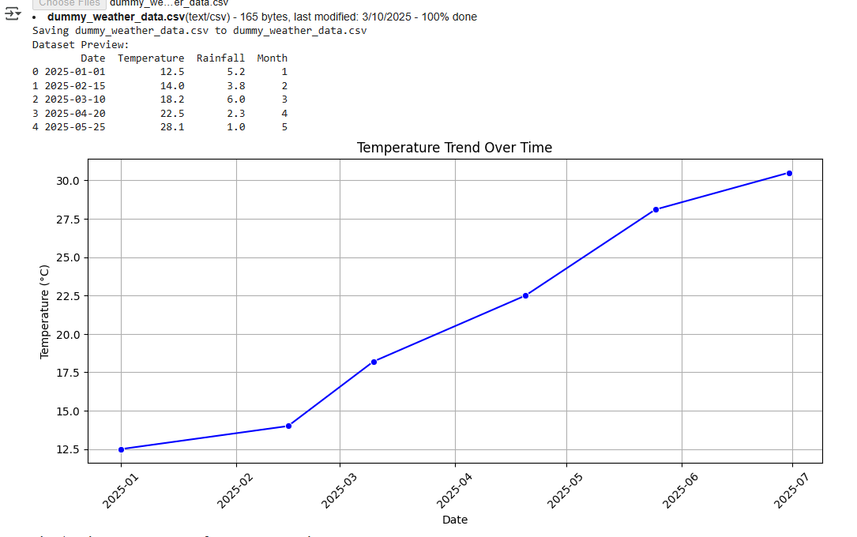

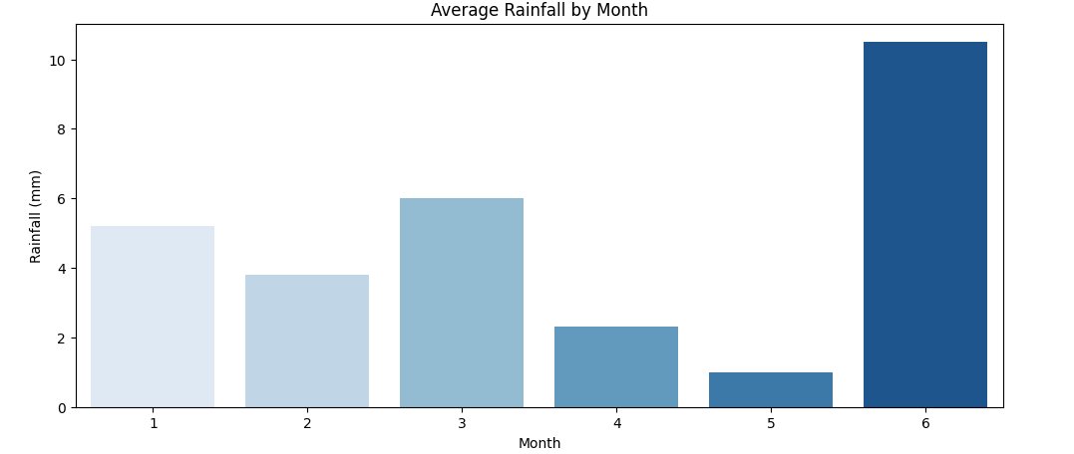

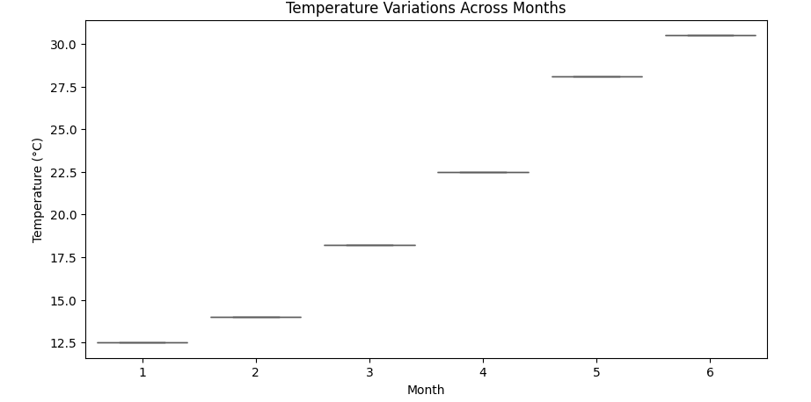**Conclusion**

Through this analysis, we observed significant variations in temperature and rainfall over different months. The project provided insights into seasonal patterns, which can be beneficial for weather forecasting and climate studies.