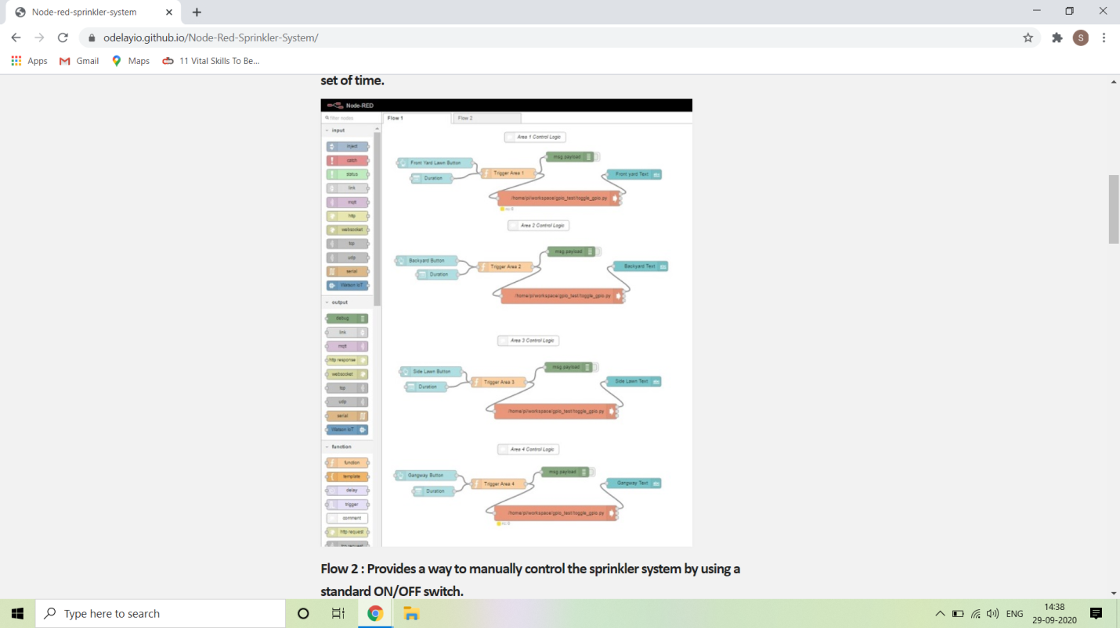 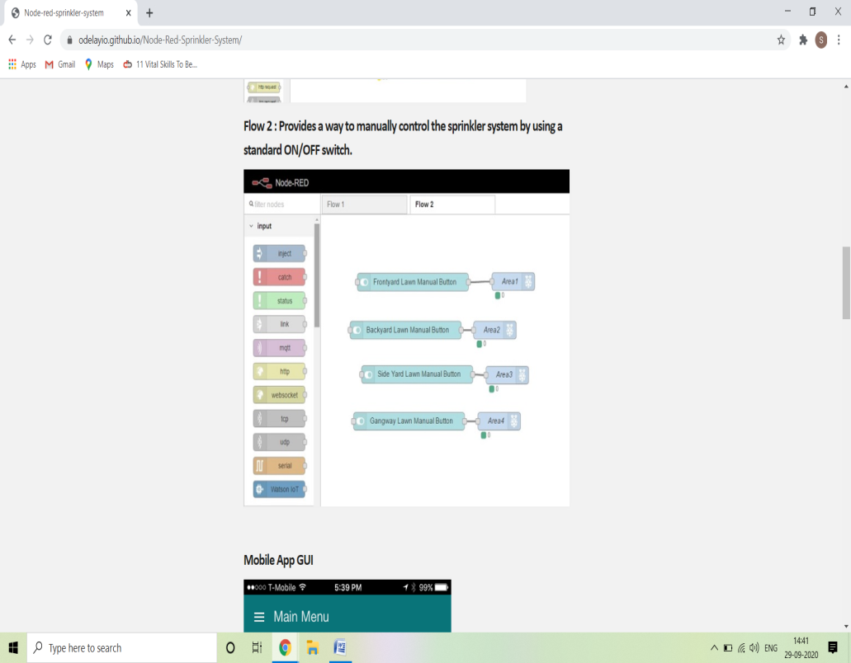

#### First flow provides a way trigger the sprinkler system to turn on for a configurable set of time.

#### Second flow provides a way to control the sprinkler system by using a standard ON/OFF switch .