Architectural Design and Implementation of Ingrion: Innovating Financial Transactions through Blockchain Technology

CAPSTONE PROJECT REPORT

Submitted by
KIRTHICK BALAJI SS - 99200041744 SHREYAAS S - 99200042047 TIRUMALA NAIDU G - 99220041739 KIRANSURYAKUMAR K - 99220041731

in partial fulfillment for the award of the degree of
BACHELOR OF TECHNOLOGY
IN

COMPUTER SCIENCE AND ENGINEERING



SCHOOL OF COMPUTING COMPUTER SCIENCE AND ENGINEERING KALASALINGAM ACADEMY OF RESEARCH
AND EDUCATION KRISHNANKOIL 626 126
April 2026

DECLARATION

We affirm that the project work titled “Architectural Design and Implementation of Ingrion: Innovating Financial Transactions through Blockchain Technology” being submitted in partial fulfillment for the award of the degree of Bachelor of Technology in Computer Science and Engineering is the original work carried out by us. It has not formed part of any other project work submitted for the award of any degree or diploma, either in this or any other University.
Kirthick Balaji SS
9920041744

Kiransuryakumar K
99220041731

Shreyaas S 9920042047

Tirumala Naidu G 99220041739

This is to certify that the above statement made by the candidate is correct to the best of my knowledge.
Date:

Signature of supervisor Dr. P. Chinnasamy Associate Professor
Department of Computer Science and Engineering



BONAFIDE CERTIFICATE

Certified that this project report “ARCHITECTURAL DESIGN AND IMPLEMENTATION OF
Ingrion: INNOVATING FINANCIAL TRANSACTIONS THROUGH BLOCKCHAIN
TECHNOLOGY” is the bonafide work of “Kiransuryakumar.K (99220041731), Shreyaas.S (99220042047), Kirthick Balaji.SS (99220041744), Tirumala Naidu.G (99220041739)” who carried out the project work under my supervision.

Dr. P.Chinnasamy | Dr. R.Raja Subramanian
SUPERVISOR | HEAD OF THE DEPARTMENT
Associate Professor | Associate Professor & Head
Computer Science and Engineering | Computer Science and Engineering
Kalasalingam Academy of Research and  Education | Kalasalingam Academy of Research and  Education
Krishnankoil 626126 | Krishnankoil 626126
Virudhunagar District. | Virudhunagar District.

Submitted for the Project Viva-voce examination held on

Internal Examiner External Examiner

ACKNOWLEDGEMENT

We would like to begin by expressing our heartfelt gratitude to the Supreme Power for the immense grace that enabled us to complete this project.
We are deeply grateful to the late "Kalvivallal" Thiru T. Kalasalingam, Chairman of the Kalasalingam Group of Institutions, and to "Illayavallal" Dr. K. Sridharan, Chancellor, as well as Dr. S. Shasi Anand, Vice President, who has been a guiding light in all our university’s endeavours.
Our sincere thanks go to our Vice Chancellor, Dr. S. Narayanan, for his inspiring leadership, guidance, and for instilling in us the strength and enthusiasm to work towards our goals.
We would like to express our sincere appreciation to Dr. P. Deepalakshmi, Professor & Dean- (SoC), Director Accreditation & Ranking, for her valuable guidance. Our heartfelt gratitude also goes to our esteemed Head of Department, Dr. R.Raja Subramanian, whose unwavering support has been crucial to the successful advancement of our project.
We are especially thankful to our Project Supervisor, Dr. P. Chinnasamy, for his patience, motivation, enthusiasm, and vast knowledge, which greatly supported us throughout this work.
Our sincere gratitude also goes to Dr.T.Manikumar and Mr.N.R.Sathiskumar Overall Project Coordinators, for their constant encouragement and support in completing this Capstone Project.
Finally, we would like to thank our parents, faculty, non-teaching staff, and friends for their unwavering moral support throughout this journey.



SCHOOL OF COMPUTING COMPUTER SCIENCE AND ENGINEERING
PROJECT SUMMARY

Project Title | Architectural Design and Implementation of Ingrion: Innovating Financial Transactions through Blockchain Technology
Project Team Members (Name with Register No) | Kirthick Balaji SS - 99220041744 Shreyaas S - 99220042047 Kiransuryakumar K – 99220041731  Tirumala Naidu G - 99220041739
Guide Name/Designation | Dr. P.Chinnasamy [Associate Professor]
Program Concentration Area | Blockchain Technology, Distributed Systems, and Financial Technology (FinTech)
Technical Requirements | Go (Golang), BadgerDB, Ed25519, SHA-256, REST-RPC, and Peer- to-Peer (P2P) networking.  Cross-platform OS support with standard development tools and  network connectivity.
Engineering standards and realistic constraints in these areas
Area | Codes & Standards / Realistic Constraints | Tick ✓
Economic | Avoids costly proprietary platforms, uses open-source technologies (Go, BadgerDB) to reduce development costs, and is built to run on commodity hardware. | ✓
Environmental | Reduces power consumption and environmental impact by switching from the energy-intensive Proof-of-Work  consensus mechanism to a Proof-of-Stake-like one. | ✓
Social | promotes decentralized governance and equity while enhancing transparency and trust in financial processes like transactions, IPO bidding, voting, and dividend distribution. | ✓
Ethical | prevents unwanted alteration of financial records, supports accountability and auditability, and guarantees data integrity, tamper resistance, and secure digital signatures. | ✓

Health and Safety | Secure coding techniques and access control mechanisms are employed to ensure safe and dependable operation of the software-based system, which does not involve any physical hazards. | ✓
Manufacturability | The project can be easily built, deployed, and replicated in various environments because it is developed using widely accessible open-source tools and standard hardware. | ✓
Sustainability | Utilizing a consensus mechanism akin to Proof-of-Stake lowers energy and computational requirements, improving the system's sustainability and environmental friendliness. | ✓

ABSTRACT

Traditional financial systems are often characterized by limited transparency, delayed transaction processing, high operational costs, and heavy reliance on intermediaries such as brokers and financial institutions. To address these limitations, this project presents INGRION, a blockchain-based financial platform that integrates capital market operations with decentralized finance (DeFi) within a unified and programmable ecosystem. The proposed system leverages tokenized shares to represent digital ownership of assets, enabling seamless buying, selling, and transfer of securities without intermediaries. Core financial processes such as IPO and FPO management, bid handling, share allocation, dividend distribution, and refunds are automated using smart contract-based mechanisms to ensure accuracy, efficiency, and transparency. The platform incorporates secure identity verification through KYC integration and utilizes privacy-preserving techniques to protect sensitive user information. Additionally, tokenized assets can be used as collateral for lending, thereby enhancing liquidity and capital efficiency. The system adopts a hybrid consensus mechanism that combines decentralized validation with regulatory oversight to achieve high throughput, low latency, and deterministic transaction finality. Experimental evaluation indicates that INGRION significantly outperforms traditional blockchain networks in terms of transaction speed, cost efficiency, and scalability. Overall, the platform provides a secure, transparent, and efficient financial infrastructure that supports real-time regulatory compliance and has the potential to improve the performance and accessibility of modern capital markets.

Keywords: BLOCKCHAIN, DISTRIBUTED LEDGER, PROOF OF STAKE, PEER-TO- PEER NETWORK, CRYPTOGRAPHY, BADGERDB, REST-RPC, FINANCIAL TRANSACTIONS, IPO MANAGEMENT, GO PROGRAMMING LANGUAGE.

TABLE OF CONTENTS

TITLE |  | PAGE NO.
ABSTRACT |  | I
LIST OF TABLES |  | V
LIST OF FIGURES |  | VI
LIST OF ACADEMIC REFERENCE COURSES |  | VII
CHAPTER I | INTRODUCTION | 1
1.1 | Background and Motivation | 1
1.2 | Motivation for the Project | 2
1.3 | Problem Statement | 2
1.4 | Objectives of the Project | 2
1.5 | Scope of the Project | 3
1.6 | Methodology Adopted | 3
CHAPTER II | LITERATURE REVIEW | 4
2.1 | Risks and Challenges in DeFi and Smart Contracts | 4
2.2 | Consensus Mechanisms and Blockchain Architecture | 4
2.3 | Foundations and Evolution of Blockchain Technology | 5
2.4 | Applications and Adoption of Blockchain | 5
CHAPTER III | SYSTEM ANALYSIS | 6
3.1 | Introduction | 6
3.2 | Existing System | 6
3.3 | Proposed System | 6
3.4 | Functional Requirements | 7
3.5 | Non-Functional Requirements | 8
3.6 | Feasibility Study | 9
3.7 | Risk Analysis | 9
3.8 | Summary | 9
CHAPTER IV | SYSTEM DESIGN | 10
4.1 | Overall System Architecture | 10

4.2 | Module Design | 11
4.3 | Block and Transaction Design | 13
4.4 | Peer-to-Peer Network Design | 14
4.5 | Database Design | 16
4.6 | API Design | 16
CHAPTER V | IMPLEMENTATION | 17
5.1 | Technology Stack | 17
5.2 | System Setup and Configuration | 17
5.3 | Implementation of Blockchain Core | 18
5.4 | Implementation of Consensus Mechanism | 18
5.5 | Implementation of Peer-to-Peer Networking | 18
5.6 | Implementation of Transaction Processing | 18
5.7 | Implementation of Storage Module | 19
5.8 | Implementation of REST-RPC API | 19
CHAPTER VI | TESTING | 20
6.1 | Testing Strategy | 20
6.2 | Unit Testing | 20
6.3 | Integration Testing | 20
6.4 | System Testing | 21
6.5 | Test Cases and Results | 21
6.6 | Bug Tracking and Resolution | 21
6.7 | Validation and User Acceptance Testing | 22
CHAPTER VII | RESULTS AND DISCUSSION | 23
7.1 | System Output and Observations | 23
7.2 | KYC Website (National Identity Archive) | 24
7.3 | INGRION Website | 25
7.4 | Ingrion Desktop Application | 27

7.5 | Performance Evaluation | 30
7.6 | Reliability and Consistency Analysis | 30
7.7 | Comparison with Existing Systems | 31
7.8 | Discussion on Limitations and Challenges | 31
CHAPTER VIII | CONCLUSION AND FUTURE SCOPE | 32
8.1 | Conclusion | 32
8.2 | Future Scope | 32
REFERENCES : List of books, articles, research papers, and other resources used |  | 33
PUBLICATION
CERTIFICATIONS
PLAGIARISM REPORT

LIST OF TABLES

TABLES | DETAILS | PAGE NO
Table 1 | Functional Requirement of Ingrion System | 7
Table 2 | Non-Functional Requirement of Ingrion System | 9
Table 3 | Major System Modules of Ingrion System | 13
Table 4 | Block Structure Fields | 13
Table 5 | Technology Stack used in Ingrion | 17
Table 6 | Technical Performance Comparison of Blockchain Networks | 22
Table 7 | Performance Observation of Ingrion System | 23

LIST OF FIGURES

FIGURES | DETAILS | PAGE NO.
Figure 1 | Admin Verification Flow | 8
Figure 2 | User KYC Submission Process | 8
Figure 3 | Overall Workflow of KYC | 10
Figure 4 | System Architecture of the Proposed System | 11
Figure 5 | Module Integration Diagram of Ingrion | 12
Figure 6 | Block Structure of Ingrion Block chain | 14
Figure 7 | Peer-to-Peer Network and Synchronization Flow | 15
Figure 8 | Secure Data Validation Pipeline | 19
Figure 9 | KYC Login Page | 24
Figure 10 | Citizen Dashboard | 24
Figure 11 | KYC Review Pannel Admin View | 25
Figure 12 | Ingrion Website Landing Page | 26
Figure 13 | Verification Page | 26
Figure 14 | Key Embedding Screen — Importing an existing private key into the INGRION application | 27
Figure 15 | Private key encryption with password protection before finalising setup | 28
Figure 16 | Block Explorer showing live mempool transactions and navigation for a Validator node | 29
Figure 17 | My Portfolio screen showing INR balance, stock holdings, IPO allocations, and P&L summary for a QIB user | 30

LIST OF ACADEMIC REFERENCE COURSES

S. NO. | COURSE CODE | COURSE NAME
1 | 21CSE2301 | Data Structures
2 | 21CSE2305 | Database Management Systems
3 | 21CSE3302 | Computer Networks
4 | 21CSE3303 | Operating Systems
5 | 21CSE2303 | Software Engineering
6 | 212CSE3305 | Secured Computing

CHAPTER – I INTRODUCTION
A new generation of digital transaction systems based on blockchain technology provides enterprise-level security, transparency and decentralisation. Blockchain differs from traditional centralised systems, thus; it provides a way to create digital transaction systems that use a distributed ledger, which is maintained by numerous nodes. Additionally, this method of storing transactions keeps them "grouped" (in the form of a block), and also uses cryptographic linking to the previous block, to guarantee the integrity, immutability and transparency of all transactions.
Traditional financial systems rely on centralised parties for processing transactions. Intermediaries add significant costs and time delays to transactions and create single points of failure. To overcome these limitations, modern blockchain systems employ alternative consensus mechanisms to improve transaction speed and reduce energy usage by allowing nodes to validate transactions using Proof of Stake (PoS) as compared to Proof of Work (PoW).
This project implements a solution called Ingrion, which is an enterprise-level blockchain system developed with the Go programming language. Ingrion is a custom proof-of-stake-like (PoS) consensus system, which will use validator rotation to ensure that multiple validators are used to validate transactions. Ingrion will also employ peer-to-peer networking to share transaction data between validators. BadgerDB will be used for the persistent storage of transaction data.
Ingrion will support a variety of domain-specific transactions such as INR transfers, IPO initiation and bidding, uploading DRHP/RHP documents, voting, distributing dividends, and managing validators. Ingrion will provide a REST-RPC interface to allow for querying of blockchain transaction data and blockchain system status. The main goal of the project is to design and implement an efficient, scalable and secure financial platform for academic and experimental purposes using blockchain technology.

Background of the Study
Blockchain technology has emerged as a powerful solution for enabling secure, transparent, and decentralized digital transactions.The INGRION introduced through Bitcoin, which demonstrated that financial transactions can be performed without relying on centralized authorities. Over time, blockchain has evolved to support advanced features such as smart contracts and decentralized applications, allowing it to be applied in various domains like finance, supply chain management, and governance. These advancements have shown that blockchain can provide improved data integrity, immutability, and trust among participants in a distributed network.
Despite these developments, traditional financial systems still rely heavily on intermediaries such as banks and brokers, leading to high costs, delays, and limited transparency. Financial processes like IPOs, asset transfers, and settlements often involve complex procedures and manual verification. While decentralized finance (DeFi) attempts to overcome these issues, existing platforms face challenges such as scalability limitations, security risks, and lack of proper regulatory integration. Therefore, there is a need for a more efficient and domain- specific blockchain solution. The INGRION platform is developed to address these challenges

by providing a secure, transparent, and efficient system for managing financial transactions and capital market operations.

Motivation for the Project
The main reason we are developing this project is to address some of the limitations of using centralized financial systems or general-purpose blockchain platforms with respect to specific financial workflows. Traditional systems can lack in plenty of ways, such as transparency and having overheads and depending on third-party members to run their transactions for them. As a result, BSNs have many benefits over traditional financial systems but they may not work at lower scales, as they can result in additional high-fee transactions when they are used for transactions with low-volume values.
There is further motivation for the project to take place due to increasing reliance on designing more sustainable methods of facilitating consensus in blockchains through the use of very limited resource consumption levels to create low transaction costs when compared with the use of using proof-of-work-based systems. The Ingrion platform aims to develop a proof-of- stake based structure that still allows for high levels of performance while using significantly less resources than the original proof-'of-work model used today in the public blockchain systems. Furthermore, besides being a blockchain network for financial transactions the Ingrion network will become an educational framework for future investors and business owners on the use and implementation of blockchains in their business activities through the creation of an educational site dedicated to educating users about real world blockchain implementations.

Problem Statement
Although there are many different blockchain technologies available today, there remains an absence of flexible, customized systems capable of being readily modified to support educational (and other) domain-specific financial applications. Many current platforms are either too specific, too difficult to implement or too expensive to maintain (infrastructure and operating costs), which limits their utility in small ($500,000 to $1,000,000+) or educational environments.
The objective of this project is therefore to provide a workable solution for a software-based blockchain platform that enables secure, transparent and efficient financial transactions (both governance and financial) through the use of an efficient peer-to-peer networking, proof-of- stake-like consensus algorithm and a simple set based method of accessing the data stored in each distributed node database (ie., an item such as records for all financial accounts would be maintained continuously by many distributed computers/nodes). The proposed solution must support a wide variety of transaction types (within the constraints provided by the original design) and still allow for the consistent delivery of secure information across all nodes.

Objectives of the Project
The Ingrion blockchain solution was created with the goal of providing an efficient, safe Decentralized Finance (DeFi) application ecosystem that would provide secure storage for each user’s assets. Another primary goal for the Ingrion architecture that can easily adapt to different types of DeFi applications, and also offers the ability to integrate peer-to-peer networking capabilities with persistent storage and API services.

To provide an all-inclusive Decentralized Finance (DeFi) solution, the Ingrion blockchain also supports the creation of multiple domain-based transaction types including (but not limited to) transfers of INR currency, IPO processes, voting, dividend distribution and Validator Management.
Another primary goal for the Ingrion blockchain development project is to allow for the development team to gain practical experience in Distributed Systems, Cryptography, and Large Scale Software Development while evaluating the system’s performance and reliability

Scope of the Project
This project's focus is to build an experimental blockchain prototype that will allow users to see what blockchains do. This prototype will exhibit the key features of blockchains including: distributed consensus, cryptographically secured transactions, immutable data, and peer-to- peer communication.
The project does not intend to replace any of today's commercial blockchain applications; it is designed purely as a learning tool that can be enhanced in the future by adding such things as: smart contracts; graphical user interfaces; and advanced consensus mechanisms.

Methodology Adopted
The Ingrion Blockchain is developed following a systematic Software Engineering process that consists of analyzing Requirements, designing the System, developing it, testing it, and evaluating it after the system is implemented. The modules for the system are designed and developed separately and integrated at the end to form a complete functioning platform.
This development methodology provides better modularity, reduces the effort of debugging, and results in an easier-to-maintain system than other methods. It also helps to systematically confirm that each component will work correctly and perform well before the entire system is deployed.

CHAPTER-II LITERATURE REVIEW

Risks and Challenges in DeFi and Smart Contracts
In this section, we are going to discuss the related works on the blockchain model; In [1] , discussed the associated risks include execution risk in smart contracts, legal liability risk, data theft risk, interconnectedness risk, external data risk, and greater propensity for illicit activity using DeFi applications. This review of existing DeFi research show that there are few studies on DeFi, and a large number of DeFi research studies are non-empirical studies. In [2], discussed the concept of smart contracts also their applications & issues of smart contract technology in a blockchain and criticized the existing constraints on code immutability, reliance on oracles, and enforceability in the law. Proposed conducting research on better ways of verification and the contract- governance structures should be done in the future.

In [6] The authors of this article talked about the potential of DeFi in efficiency and inclusiveness in their article entitled “Decentralized Finance (DeFi): Benefits, Risks, and Risk- Mitigation Strategies; however, protocol hacks and regulatory uncertainty are the main weaknesses of this area. They introduced feasible solutions to these issues including smart contract audits and decentralized insurance. In [11] reviewed about the subject of DeFi is comprehensive, incorporating both the academic and the industry perspective, to show the research pattern regarding the subject. Through this overview several gaps in the understanding of DeFi governance, composability, and regulation which would inform new research.

In [15] discussed vulnerabilities of DeFi into categories but identify them as smart contract bugs or oracle attacks. It suggest the following steps that can be taken to reduce the security risk in DeFi, including formal verification, bug bounties, as well as multi layered defense.

Consensus Mechanisms and Blockchain Architecture
In [3], Explained the evolution of consensus mechanisms without focusing on the application of Proof of Work, Proof of Stake, or hybrid models. The purpose of these changes is to achieve good tradeoff between scalability, energy efficiency, and decentralization. The article assists in selecting appropriate consensus models in varying blockchain environments in a comparative evaluation. In [4] discussed Current challenges and future directions considers the necessary design of blockchain systems. It pointed out the concerns in terms of interoperability, as well as scalability, among others. It discloses notes that in the future, AI implementation and machine learning are necessary to enhance the performance and security of block chains.

In [8] introduced a modular structure in their text, named Exploring Blockchain Technology through a Modular Lens. This system divides the blockchain system into vernacular units and makes the scaling and design flexibility in variable applications: fi nance, supply chain, or identity systems.

Foundations and Evolution of Blockchain Technology
In [5] , It is the original paper Bitcoin: A Peer- to-peer Electronic Cash System and this was the first publication to mention blockchain as a trust less electronic payment system based on Proof of Work to achieve a consensus. This significant article laid the foundational base of all blockchain innovations and cryptocurrencies, which were created further based on a decentralized transactional model. In [14] discussed the history of financial systems transforming centralized but non digitized into a tokenized structure of the market and also explain the way distributed ledgers are redefining the clearing, settlement, and regulatory procedures.

Applications and Adoption of Blockchain
In [7] Produced a survey on the Application of Blockchain in Cryptographic Proto cols survey the application of blockchain to augment such cryptographic components as secure key exchange and timestamping in smart cities. This paper indicated the importance of blockchain in improving the cryptographic integrity and discuss performance trade-offs in decentralized deployments. In [9] pointed out that tokenization and Decentralized Finance (DEFI), the main element of the DeFi environment is tokenization. It discussed about the effects of tokenized assets on the involving in the market, liquidity, and taking control and addresses the composability and systemic risks presence management in financial procedures.

In [10] explained the advantages of blockchain to improve the education ecosystems, such as information exchange without trust and automation. It talks of the integration problems like resource constraints in which it proposes consensus mechanisms that can be adapted to secure sharing of the education information with role based access control. In [12] discussed the adoption patterns across industries are compared in Towards the Mass Adoption of Blockchain: Cross-Industry Insights observing that the primary components of mainstream adoption of blockchain are interoperability, user experience and scalability. In [13] discussed the potential of blockchain to remodel the traditional financial institutions in Blockchain for Finance. Some of these applications, including securities settlement to asset management, will be covered in the paper in an attempt to imbibe a clear picture of how the blockchain will be implemented in the financial sector.

CHAPTER III SYSTEM ANALYSIS

Introduction
Software development requires a careful analysis of the existing system and an evaluation of the functional and non-functional requirements in order to accurately document the desired abilities and performance of the new system prior to proceeding with design and implementation activities.
While this project performs a system analysis of the Ingrion Blockchain platform, it will also include an evaluation of the previous version Ingrion platform, as well as an evaluation of the current version against the functional and non-functional requirements of the Ingrion user community. In addition, this chapter will include an overview of feasibility studies and demonstrate potential risks associated with developing the Ingrion platform.

Existing System
The existing financial systems are mostly centralized and depend on trusted third parties such as banks, financial institutions, and regulatory bodies to manage transactions and records. Although these systems are widely used, they suffer from several drawbacks such as lack of transparency, high operational costs, delays in transaction processing, and single points of failure.
Even existing blockchain platforms like Bitcoin and Ethereum, while decentralized, are either too specialized or too complex for domain-specific academic and financial workflow applications. They often require heavy infrastructure, high transaction fees, and complex configurations, which makes them less suitable for lightweight and customized implementations.

Proposed System
Ingrion is a unique blockchain platform intended to facilitate the secure and transparent delivery of financial transactions and governance-related transactions, using a hybrid proof-of- stake type consensus mechanism with validator rotation, in order to enhance efficiency and reduce energy consumption relative to the previous generation of proof-of-work systems.
The Ingrion system incorporates peer-to-peer networking for node communication and synchronization; a persistent database using Badger DB for permanent storage; and a REST- RPC interface for outside access to the platform. Ingrion provides the functionality to complete a wide variety of transaction types, including funds transfer in INR, initiation of IPOs and judgments, voting for members of the Ingrion validator pool, payment of dividends to shareholders, and administration of validators, thus making it very appropriate as a financial tool in structured business processes.

Functional Requirements
The Ingrion blockchain system is designed to provide a comprehensive set of functionalities for the creation, validation, and storage of blockchain blocks through its use of nodes. Multiple types of transactions can be processed by the Ingrion blockchain, including but not limited to: transfers of INR, initiation and bidding on IPOs; voting; and distributing dividends. The system also allows for peer-to-peer communication between nodes to facilitate the synchronization of the blockchain and to enable sharing of data across the entire network. Furthermore, the Ingrion blockchain system maintains persistent storage of blocks and state data to provide durability and recovery in the event of a failure.
The Ingrion blockchain provides an easy-to-use REST-RPC interface which enables external applications and users to query for information about the status of the blockchain, as well as query for blocks, balances, and any specific details about a transaction for which an External application has access. To ensure that all transactions are validated, Ingrion uses a variety of cryptographic techniques including hash functions and digital signatures to maintain trust, integrity, and authenticity of all data that are maintained in the Ingrion blockchain.Table 1 represents the functional requirement of Ingirion system.

S. No | Functionality | Description
1 | Block Creation | The system allows validators to create new blocks and add them to the blockchain.
2 | Block Validation | Each node validates incoming blocks before accepting them.
3 | Transaction Processing | Supports INR transfer, IPO, voting, dividend, and validator transactions.
4 | P2P  Communication | Enables nodes to communicate and synchronize blockchain data.
5 | Persistent Storage | Stores blocks and state data using BadgerDB.
6 | REST-RPC API | Provides APIs to query blocks, balances, and system status.
7 | Cryptographic Security | Uses hashing and digital signatures for secure validation.

Table 1: Functional requirement of Ingrion System

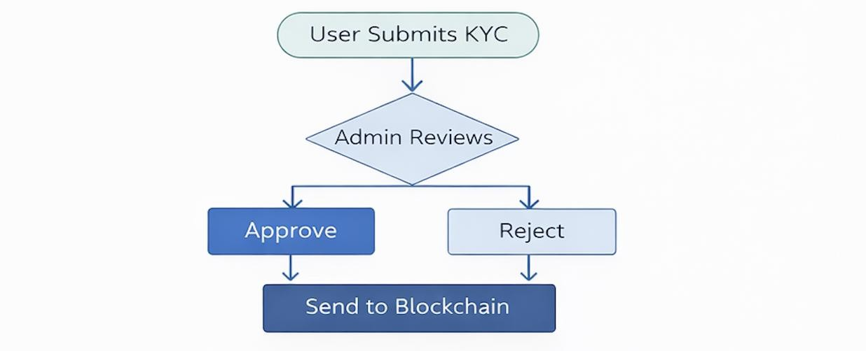
Figure 1. Admin Verification and Decision Flow
This Figure 1 represents the decision-making process of the administrator. After receiving the user’s KYC submission, the admin reviews the documents and decides whether to approve or reject them. Approved data is forwarded to the blockchain, while rejected submissions are sent back for correction.
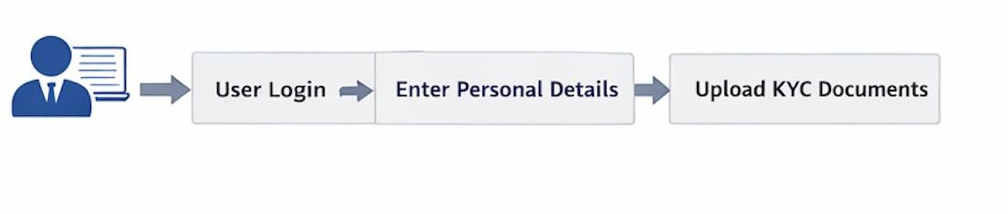

Figure 2. User KYC Submission Process
This Figure 2 represents the steps performed by the user to complete the KYC process. The user logs into the system, enters personal details, uploads the required documents, and submits the application for verification.

Non-Functional Requirements
Non-functional requirements express the quality and performance characteristics of an application. For example, security is a significant requirement; the application provides data integrity, authentication, and tamper resistance via cryptographic methods. Performance is also essential; the application is designed to facilitate transaction and block processing with acceptable latency under most normal operating conditions.
Scalability is also taken into consideration when enabling the addition of new nodes without a major decline in performance; reliability ensures the application will continue to function correctly despite the failure of one or more nodes. Maintainability is accomplished through the use of a modular and well-structured design that simplifies updating, debugging, and extending the application in the future. Table 2 below represents non-functional requirement of Ingrion system.

S. No | Requirement | Description
1 | Security | Ensures data integrity, authentication, and tamper resistance.
2 | Performance | Processes transactions and blocks with acceptable latency.
3 | Scalability | Supports addition of new nodes without major performance issues.
4 | Reliability | Continues to operate even if some nodes fail.
5 | Maintainability | Modular design allows easy updates and extensions.

Table 2: Non-Functional Requirement of Ingrion System
  - Feasibility Study
A feasibility study was conducted in order to determine if the Ingrion blockchain system can be developed, implemented, and used successfully. Additionally, this study investigates all aspects of the proposed project: technical, economic, and operational—to demonstrate that the project is doable within both given limitations and/or budget.
The technical aspects of the proposed system allow it to be feasible because they use only established technology such as the Go programming language, BadgerDB (for database storage), and widely used cryptography protocols. In terms of economics, the proposed system should be financially feasible because it only uses open-source tools and does not require any type of expensive hardware or proprietary software. Operationally, the proposed system has a simple command-line interface and a REST-RPC interface making them very easy to deploy and use.

Risk Analysis
Every computer application has inherent risks associated with it; this also includes the Ingrion Blockchain system. Such risks can include failures of the Ingrion blockchain networks, inconsistencies in data due to issues with synchronization, and weaknesses in security that may affect the performance and reliability of the Ingrion blockchain system.
Minimizing these risks can be accomplished through employing the appropriate testing techniques, utilizing proper coding standards for security, and continually monitoring the Ingrion blockchain system. Another key risk arises from performance or scalability issues as the number of independent nodes and/or transactions increases (this will address future scalability through optimizing components used in our current consensus mechanism, the Ingrion blockchain networking protocols, and our Ingrion blockchain storage strategies).

Summary
The review of the Ingrion blockchain system offered an overview of the current system, proposed systems, functional requirements, non-functional requirements, feasibility studies, and risk assessments to define the capabilities and performance of the system in different conditions. This analysis demonstrates that the proposed system is technically viable, economically viable, and operationally viable and has the potential to meet current system limitations. Furthermore, it emphasizes the need for thorough planning and risk management in developing a secure and reliable blockchain platform for finance and governance

CHAPTER IV SYSTEM DESIGN

Overall System Architecture
The Ingrion blockchain architecture utilizes a layer-oriented structure to create clearly demarcated boundaries for various functions. The main system is comprised of multiple layers: Client Interface, REST-RPC API layer, blockchain core, consensus module, peer-to-peer (P2P) networking module, and Storage Layer. This clear separation of responsibilities allows each component to remain modular, scalable, and maintainable, while permitting the independent evolution of each component.
All external users/applications access the Ingrion via the REST-RPC API layer. The blockchain core is responsible for managing the relationship of all blocks and transactions. The Consensus Module implements a proof-of-stake-like Validator Rotation mechanism to determine which Validator shall propose the next block in line. The P2P Networking Module is responsible for orchestrating communication between Validators (nodes) and organizing/blocking updates across the various nodes within the network. The Storage Layer uses BadgerDB to provide an eternally durable data store for storing all or any combination of: blocks, account states, or metadata.

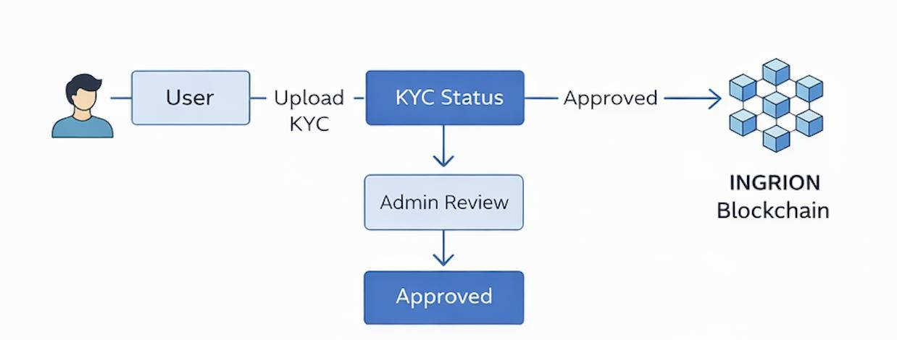

Figure 3. Overall Workflow of KYC and Ingrion Verification System
The Figure 3 illustrates the complete workflow of the proposed system. It begins with the user uploading KYC documents, followed Ingrion inistrative verification. Once approved, the data is securely forwarded to the Ingrion blockchain for validation, and the final verification result is generated.

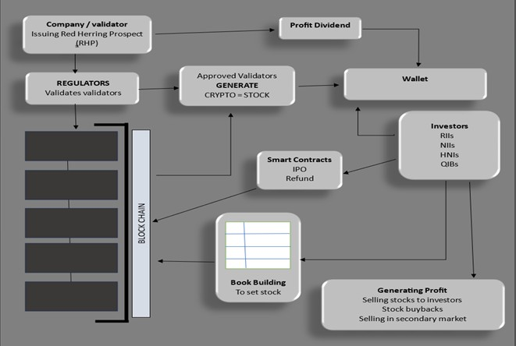

Figure 4. System Architecture of the Proposed System
The Figure 4 represents system architecture consists of multiple layers including the frontend, backend, database, and blockchain. The frontend interface interacts with the node, which processes requests and stores data in the database. Verified data is then transmitted to the Ingrion blockchain for secure and immutable storage.

Module Design
The Ingrion system Figure 5 utilizes a modular design. Each module has a specific function. The core modules can be summarized in the following categories: peer-to-peer networking; consensus; blockchain management; transaction processing; storage; and application programming interface (API). Each of these core modules also utilizes a modular structure which simplifies understanding, development, testing, and maintenance.
The peer-to-peer module is responsible for discovering nodes, exchanging messages, and synchronizing data. The consensus module implements validator selection and validates block finalization procedures (using something similar to proof-of-stake). The transaction processing module validates and executes several transaction types, such as: INR transfers; initial public offerings (IPOs); voting; and dividend payments. The storage module is used to persistently store data within BadgerDB; and the API module provides an interface for the public to query the network via REST-RPC endpoints.

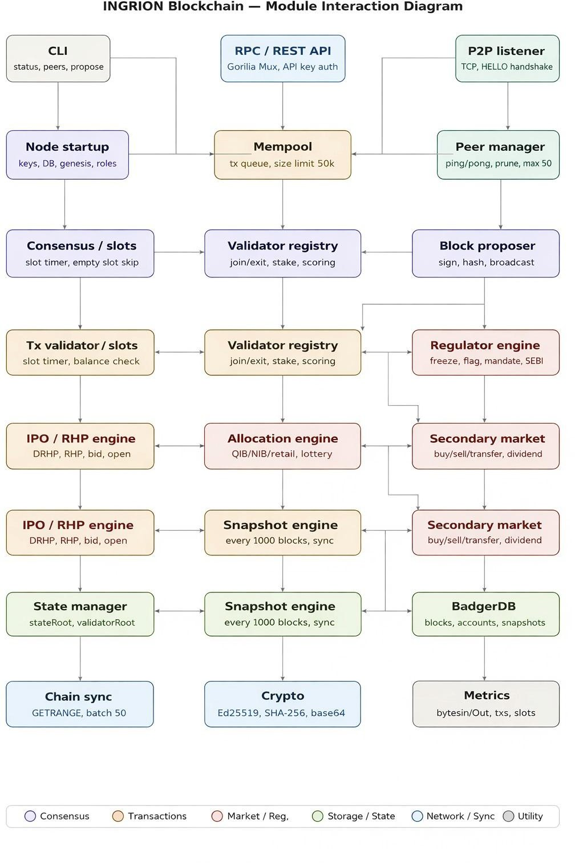
Figure 5. Module Integration Diagram of Ingrion

S. No | Module Name | Function
1 | Blockchain Core | Manages blocks, chain, and state updates.
2 | Consensus Module | Handles validator rotation and block finalization.
3 | P2P Networking | Manages peer discovery and data synchronization.
4 | Transaction Processor | Validates and executes transactions.
5 | Storage Module | Stores blocks and state using BadgerDB.
6 | API Module | Provides REST-RPC interface for external access.

Table 3: Major System Modules of Ingrion System
  - Block and Transaction Design
The blockchain of Ingrion is composed of two parts: a Block Header and the Transaction List. The Block Header contains important data such as the Previous Block Hash, Timestamp, Block Height, and Validator Signature. The Transaction List contains all the different operations, including transfers of INR, the initiation and bidding on IPOs, uploads of DRHP/RHP's, voting, dividends, and management of validators. Table 3 above represents major system modules of Ingrion system.
For each transaction, the Sender Address, Receiver Address, Transaction Type, Amount / Payload, and Digital Signature are required. All transactions are validated through the use of cryptographic techniques prior to being included in a Block, to ensure that every transaction is valid and has not been altered and is authentic to the blockchain. Therefore, the storage of all information in the Blockchain will be tamper-proof, verifiable, and secured. Table 4 below displays the block structure fields of our project, Also Figure 6 represents the system architecture of the proposed system.

Field Name | Description
Block Height | Position of the block in the blockchain
Previous Hash | Hash of the previous block
Timestamp | Time of block creation
Validator ID | Identifier of the block proposer
Transactions | List of transactions included in the block
Signature | Digital signature of the validator

Table 4: Block Structure Fields

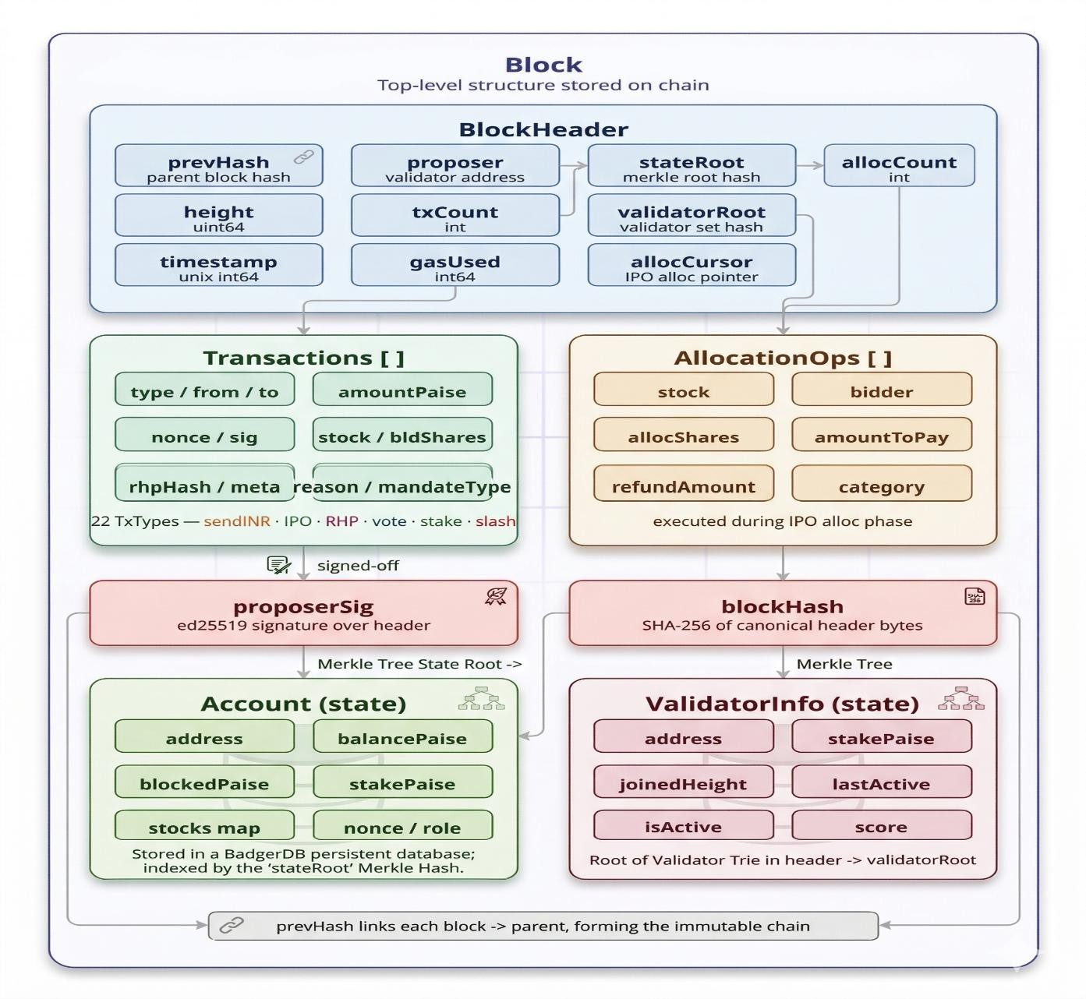
Figure 6. Block Structure of the Ingrion Block chain
  - Peer-to-Peer Network Design
The Ingrion blockchain operates in a distributed fashion with many different nodes that can each communicate with each of the other nodes using a peer-to-peer network model. As per Figure 7, Each node is capable of connecting to other peers, sending and receiving messages, broadcasting new blocks and transactions, and requesting missing data from the other peers when synchronizing.
The peer-to-peer module is responsible for the discovery of peers, connection management, and processing of requests and sends for different types of messages including block requests, message content and state synchronization messages, function registration . This architecture will allow all nodes participating in Ingrion to attain a consistent representation of the Ingrion blockchain absolutely even when the network is experiencing network delay and/or temporary node failures.

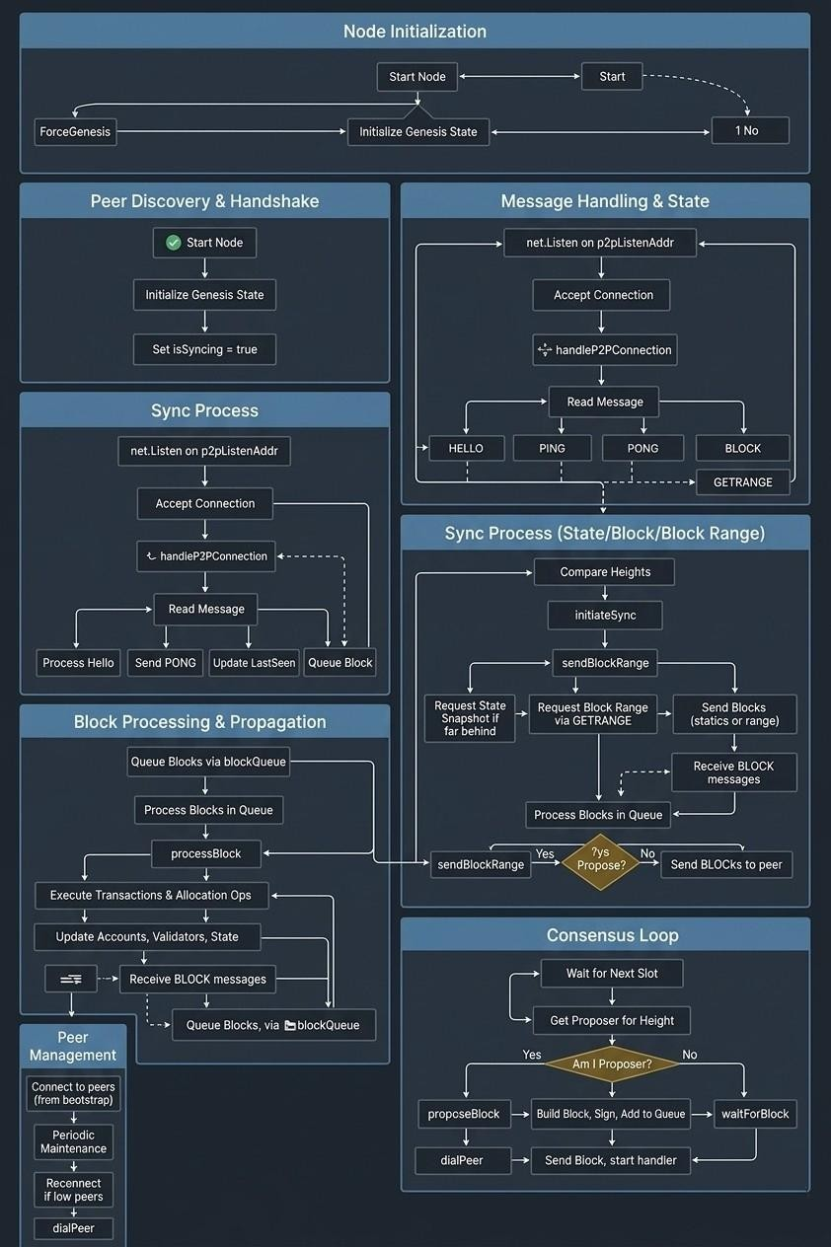

Figure 7. Peer-to-Peer Network and Synchronization Flow

  - Database Design
BadgerDB is a key/value database that is an integral part of the Ingrion blockchain system. This allows for easier data retrieval and management and supports the ability to efficiently synchronize fast access to all the data, while providing durability and reliability.
Data is logically stored based on the use of different key prefixes (namespaces) for each type of data (blocks, state, and metadata). This allows for easier data retrieval and management and supports the ability to efficiently synchronize and recover from system reboots or failures.

API Design
External clients can interact with the blockchain using the system's REST-RPC interface. This interface allows users to retrieve blockchain status, block information, account balances, and transaction histories providing accessibility for all integration to other applications.
The API layer is the bridge between external clients and the internal blockchain core. The API layer manages incoming requests, gathers relevant system data and responds in a structured manner. This architecture enhances usability while also supporting potential future extensions such as web or mobile user interfaces.

CHAPTER V IMPLEMENTATION

Technology Stack
The Ingrion Blockchain Platform is a Go-language-based system designed specifically for creating networked or distributed systems because Go has a highly efficient Congruent system and wide-ranging built-in support for libraries. Go also supports lightweight threads and easy syntax, making concurrency issues such as managing multiple clients simultaneously, performing background processes for updates, and managing the processing of blocks.
With reference to Table 5, To maintain data persistence, the system utilizes BadgerDB, a high- performance key-value store that allows for permanent storage of each block, state data, and related metadata. Systems will use industry-standard hashing and verification algorithms (SHA-256 and Ed25519) to ensure that all data stored within the Ingrion Blockchain Platform maintains its privacy, integrity, authenticity, and non-repudiability. The REST-RPC interface will use standard HTTP libraries and routing functionality to enable external clients to communicate with the Ingrion Blockchain Platform.

Component | Technology Used
Programming Language | Go (Golang)
Database | BadgerDB
Cryptography | SHA-256, Ed25519
Networking | Peer-to-Peer (P2P)
API | REST-RPC
Platform | Cross-platform (Windows/Linux/macOS)

Table 5: Technology Stack used in Ingrion
  - System Setup and Configuration
Operating systems that do not need unique hardware to execute include Windows, Linux, and Mac OS; all of these are compatible operating systems. The Go Toolchain creates and runs applications, and the startup parameters (e.g., network ports, peer addresses, and storage paths) will be defined during the start.
When a node boots up, BadgerDB is used to maintain the local database, and each node connects to one another through the peer to peer network. Once a new node is created, it initializes the required components and will load any atomic blockchain data it may already have from storage into its database. After loading its blockchain data, the new node then can begin to find other peers and synchronize the blocks in the blockchain with the state information in the blockchain.

Implementation of Blockchain Core
The core of the Blockchain is responsible for managing the blocks, processing any incoming transaction, and keeping track of the current state of the entire ledger. The blockchain is responsible for creating new blocks on the blockchain, verifying newly received blocks from other network participants/peers, and updating the local blockchain and the state database.
Every block is created by linking to a previous block, forming a chain of blocks via a cryptographically secure hash to maintain the blockchain's permanent immutability. Every block must be verified for accuracy and validity before it can be added to the chain; any block found invalid will be not accepted. This process results in all data being truthful and consistent when stored in the blockchain.

Implementation of Consensus Mechanism
Ingrion uses a type of consensus mechanism similar to Proof of Stake, known as 'validator rotation'. Validator rotation is the process by which a set of validators is established and the ability to create a block is given to each validator on a rotation basis. This allows for both reduced computational requirements compared to Proof of Work methods, and greater overall energy efficiency.
The Ingrion consensus module guarantees that only validators that have been authorized to produce blocks are able to do so and that there is a consistent agreement among all the nodes of the Ingrion network as to the same block sequence, thereby providing consistency across the Ingrion network.

Implementation of Peer-to-Peer Networking
The peer-to-peer networking component manages the communication between the nodes that comprise the network. It performs all peer discovery activities, oversees connection management, and facilitates the exchange of messages, including broadcasting newly added blocks or transactions.
Different types of messages will be used for block requests, state synchronization, and maintaining active node connections so that every node in the network will have the ability to share information efficiently with one another and achieve a consistent view of the blockchain over time.

Implementation of Transaction Processing
In addition to accepting transaction data, the module also allows for the authorization, validation and execution of multiple transaction types supported by the system (i.e. Inter Bank Transfer (INR), Initial Public offering (IPO), Initial Public Offering (RHP), voting, paying dividends, and validator management).
All transactions sent to the processing module undergo digital signature verification for validation/authorization prior to entering the system as new transactions. Once verified, valid transaction data will be aggregated with other valid transactions and written to new blocks added to the blockchain. Once a block has been added to the blockchain, there will be corresponding changes to the current state of the blockchain (i.e. applying state changes to transactions will be persistently stored).

Implementation of Storage Module
BadgerDB will be utilized as the storage system for the blockchain data stored in the storage module. Examples of this include blocks, account balances and the system state. As an example, if you were to remove the node and then restart it, the data will not be lost.
The database is logically divided into groups of keys based on their individual groups of data (for example: blocks, state etc.). Because of this logical grouping it will also be easier for you to find and manage the data in an efficient manner. The storage module also provides state snapshots. Using state snapshots would allow the node to quickly synchronize with the current state of the network through fast recovery times.

Implementation of REST-RPC API
Ingrion's REST-RPC API allows external applications and clients to interact with its blockchain as well as access the blockchain's current status, block details, account balances and transaction history.
The API processes requests from external clients and sends them back in a structured format. Ingrion's REST-RPC API is easy for users to use and can be accessed from future web app.
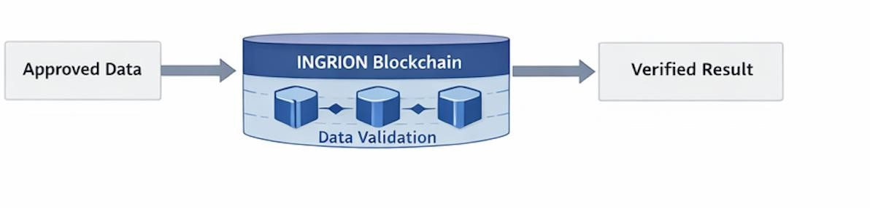

Figure 8. - Secure Data Validation Pipeline
This Figure 8 explains how verified data is processed using the Ingrion blockchain. Approved data is sent for validation, securely stored on the blockchain, and the final verification result is generated.

CHAPTER VI TESTING

Testing Strategy
Testing is crucial for validating the performance and reliability of any software application; it is particularly important when discussing failures in a distributed environment, such as blockchains, that may result in an inconsistency of data or may lead to security issues. The Ingrion blockchain testing strategy contains layers of checks through a collaborative approach. This includes unit testing, integration testing, system testing, and a basic level of acceptance testing before the platform is deployed.
The Ingrion testing framework aims to confirm the system's functional performance and its non-functional attributes, such as performance levels, reliability, and robustness. It is essential to focus on testing the major components of the platform, such as; block creation, transaction validation, peer-to-peer (P2P) communication, consensus functionality, and data stored in persistent storage. There are also additional tests on abnormal edge cases that will test invalid transactions, delayed responses caused by various external sources, node crashes, and data recovery after a system restart, to determine how the system will act in a non-normal condition.

Unit Testing
Unit testing involves checking that a function or module works correctly in isolation. In the Ingrion blockchain platform, unit tests are written to check for certain components, including the blockchain core, transaction processing module, consensus mechanism, networking utilities and storage layer. Each component will be tested using a range of valid and invalid inputs to ensure there is the desired logic is present and that any errors are handled correctly.
For example, unit tests can be used to validate block hash generation, create and validate digital signatures, validate transactions, and read from/write to a database. Additional tests will occur that simulate boundary conditions (i.e., empty blocks, incorrect digital signatures, invalid data entries, etc.) to ensure that the system will not behave unexpectedly. By identifying defects at the module level, unit testing allows for a reduction in the amount of time needed to debug code at a later stage of development, thus enhancing the quality of code.

Integration Testing
Integration tests are conducted to check that various system modules work together correctly after being combined. In the case of Ingrion, a blockchain system, the correct function of the peer-to-peer networking, consensus, blockchain core, storage layer and REST-RPC API modules must be integrated properly to ensure the proper operation of the system as a whole. Integration testing therefore concentrates on validating the data flow or control flow between these components.

Some common scenarios for integration testing include sending a transaction broadcast from one node and checking that it was received, validated, stored, and included in a block by another peer node; and checking to see if the new block(s) created at one peer node are then correctly propagated and synchronized with all other peer nodes that are connected to it. These tests also verify that any change in state from executing the transaction is correctly reflected in persistent storage and that it can be queried through the API. Integration testing confirms that a system is functioning as one whole unit of operation and not just a group of independent modules.

System Testing
System tests have been conducted upon an entire, complete, and fully integrated Ingrion Blockchain platform to confirm the software meets both functional and non-functional requirements. The system will be tested under conditions that closely approximate actual usage of the product with numerous nodes running at the same time and interacting through the network.
During system test, numerous scenarios were used to perform various functions throughout the test including starting/stopping of nodes, adding/removing peers, submitting various types of transaction requests; querying data via the REST-RPC interface; verifying data persists after system reboots; and adding multiple nodes/synching to see how many transactions can be processed at one time. In addition, stress tests with more than one transaction will be conducted to determine how stable/responsive the Ingrion Blockchain platform when there is a significant increase in the number of transaction requests received. Performance bottlenecks, memory corruption issues, and issues related to synchronising nodes will likely be discovered during the performance testing phase versus unit or integration testing phases of validation.

Test Cases and Results
To validate the primary working functionality of the Ingrion Blockchain Platform there are an extensive series of test cases that were created. Included with each test case will be a clearly defined test objective, input data for testing, the steps taken to execute the test, and an expected output. The entire suite of test cases includes major features such as: Successful transactions, failed transactions, creating and validating new blocks, peer synchronisation, database persistence, and validating API responses.
The results from these tests indicate that valid transactions were processed successfully by the platform, all invalid or malformed input data was rejected, and all of the nodes within the platform maintained the same view of the blockchain, reinforcing that the platform maintains a consistent view of what is on the blockchain. The results from API testing reinforce that accurate and up-to-date data is returned from blocks, accounts, and status queries. The overall results from the tests demonstrate that the platform meets its functional requirements and that the platform will continue to operate reliably under normal working conditions.

Bug Tracking and Resolution
There were various minor problems related to synchronisation delays, error handling and edge- case situations that occurred during testing. The bugs were documented, analysed for the root cause, and subsequently repaired by making the appropriate modifications to the code.

Regression testing was carried out on the items repaired to ensure that the modifications did not introduce new defects into previously functioning areas of the system. This iterative cycle of testing, debugging and re-testing further enhanced the overall stability, reliability and robustness of the Ingrion blockchain platform. Additionally, the experience further illustrated the necessity of constant testing during the development of complex distributed systems.

Validation and User Acceptance Testing
Basic validation and user acceptance testing of the Ingrion platform were conducted in addition to technical testing to provide assurance that the platform meets the expectations of its users at the development level as well as the end-user level. One of the items that were tested was the ease of use of both the command-line interface and the REST-RPC endpoints and whether they produce relevant outputs and handle erroneous inputs appropriately.
During User Acceptance Testing, users were able to successfully complete routine activities such as starting nodes, submitting transactions, querying for balances, and checking the status of the blockchain without any difficulty. Feedback from this phase of testing was subsequently incorporated into the enhancement of the error messages, logging outputs, and overall usability of the system. The user acceptance testing also provides further validation that Ingrion is not only technically verified, but also practically verified for both academic and experimental environments. The table 6 displays the technical performance comparison of blockchain networks.

Blockchain Network | Throughput (TPS) | Block Time | Avg. Gas / Transaction | Complexity (Scaled 1–5)
Bitcoin | ~7 TPS | ~10 minutes | $5 – $30 | 1 (Low)
Ethereum (PoS) | ~25–35 TPS | ~12 seconds | $0.5 – $5 | 5 (High)
INGRION | 3,500 – 9,500 TPS | 1.0 – 1.5 sec | $0.0005 – $0.01 | 2 (Low–Medium)
Polygon Variant | ~60 – 70 TPS | ~2 seconds | $0.005 – $0.01 | 3 (Medium)

Table 6: Technical Performance Comparison of Blockchain Networks

CHAPTER VII RESULTS AND DISCUSSION

System Output and Observations
Ingrion Blockchain Technology's distributed nature was assessed by executing numerous node deployments in a distributed execution environment and by tracking the activity of the blockchain platform through several transactions such as creating a new block, processing transactions, synchronizing peers, and querying data using the REST-RPC interface.
When an Ingrion Blockchain Technology node starts, it successfully creates a new database to support the Ingrion blockchain locally, connects itself to the other Ingrion blockchain peer nodes on the network, and begins participating in the consensus protocol. Events occurring when a node starts are marked in the console log or through the use of the system message; these events include events that occur during the build process (e.g., discovering peers, receiving transactions, proposing new blocks to validators, and successfully creating new blocks), which are indications of successful operation of the core components of the Ingrion blockchain technology platform.
The REST-RPC interface was evaluated by issuing requests for blockchain status, block details, and account balances; all responses to these requests were returned consistently in a standard, structured format confirming the API layer interacts correctly with both the core of the Ingrion blockchain and the supporting storage module. All observations of added blocks and updated account balances are reflected immediately in API response, confirming the real- time consistency of the Ingrion blockchain technology system. All defines validate that the Ingrion blockchain technology system is functioning as designed; additionally, all validations equate to proof that for the networking, consensus, storage, and API layers, they are successful. Here the table 7 shows the performance observation of Ingrion system.

Metric | Observation
Block Creation Time | Low latency due to PoS-like mechanism
Transaction Processing | Efficient under normal load
Synchronization Time | Fast for small to medium networks
Resource Usage | Lower than PoW-based systems

Table 7: Performance Observation of Ingrion System

  - KYC Website (National Identity Archive)
The KYC website, titled National Identity Archive, serves as the government-facing citizen portal developed under the Government of India's secure identity infrastructure. It provides citizens and administrators with a structured interface for identity submission and review.
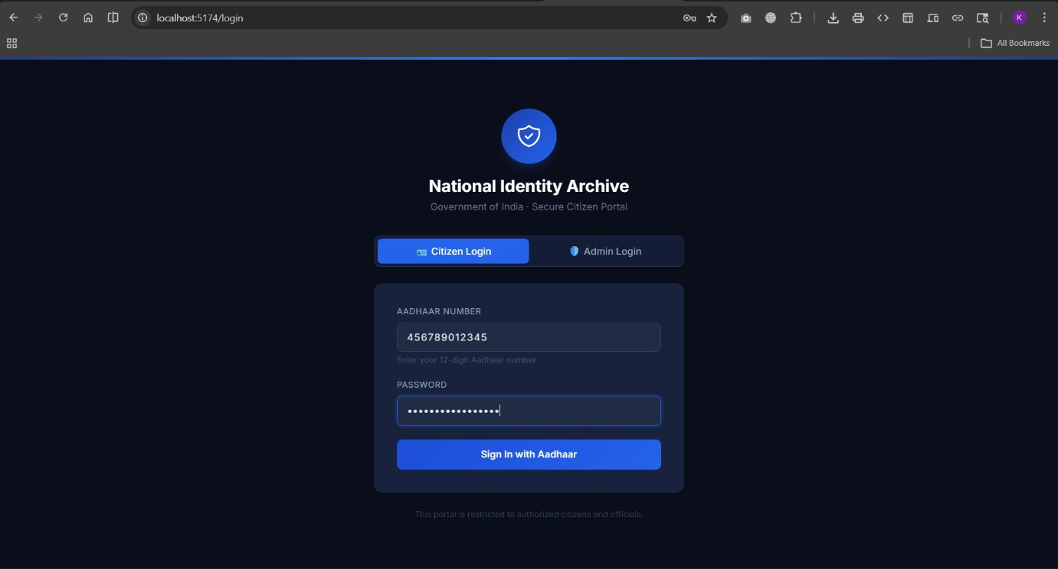

Figure 9. KYC Login Page
Login Page Figure 9 The login page presents two modes of access — Citizen Login and Admin Login. Citizens authenticate using their 12-digit Aadhaar number along with a password, after which they are redirected to their personal dashboard. The interface carries the branding of the National Identity Authority of India and emphasizes that access is restricted to authorized citizens and officials only.
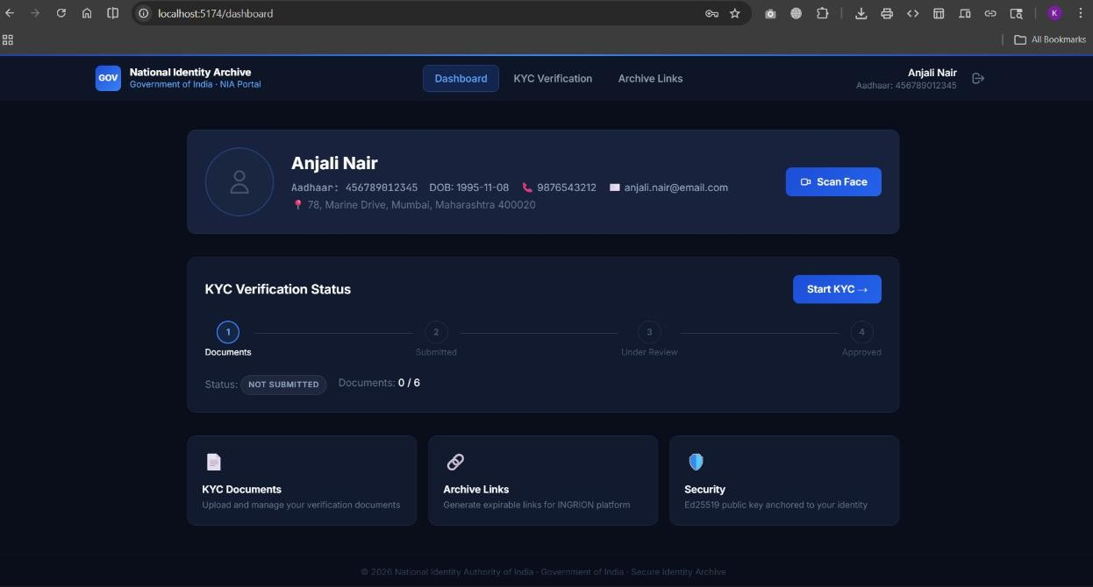

Figure 10. Citizen Dashboard

Citizen Dashboard Figure 10 Upon logging in, citizens are greeted with their profile overview displaying personal details such as Aadhaar number, date of birth, phone number, email address, and residential address. A prominent KYC Verification Status tracker shows the four- stage pipeline — Documents, Submitted, Under Review, and Approved — along with the current document upload progress (e.g., 0/6 documents submitted). The dashboard also provides quick-access cards for KYC Documents, Archive Links for generating expirable links for the INGRION platform, and a Security section anchored to the citizen's Ed25519 public key. A Scan Face button enables biometric registration directly from the dashboard.
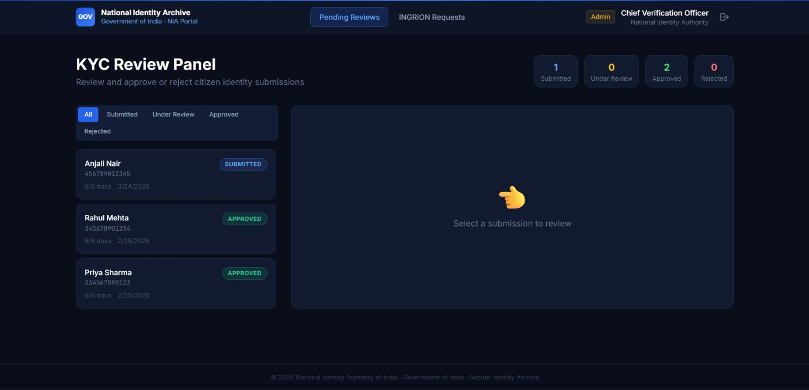

Figure 11. KYC Review Pannel Admin View
KYC Review Panel (Admin View) Figure 11 The admin interface, accessible via the Admin Login tab, presents a KYC Review Panel where government officials can review and approve or reject citizen identity submissions. The panel displays a list of all submissions with their status — Submitted, Under Review, Approved, or Rejected — along with document counts and submission dates. A split-screen layout allows administrators to select a submission on the left and review its details on the right. Summary counters at the top provide a quick overview of total submissions across each status category.

INGRION Website
The INGRION website is the blockchain-facing identity platform that interfaces with the National Identity Archive to perform cryptographic identity verification. It is designed for institutional-grade decentralised identity management.
Landing Page Figure 12 The homepage presents INGRION's core value proposition with the headline "Identity That Cannot Be Forged." The platform is described as anchoring blockchain identity to sovereign government records, utilizing Ed25519 keypairs generated entirely client- side with zero private key storage.

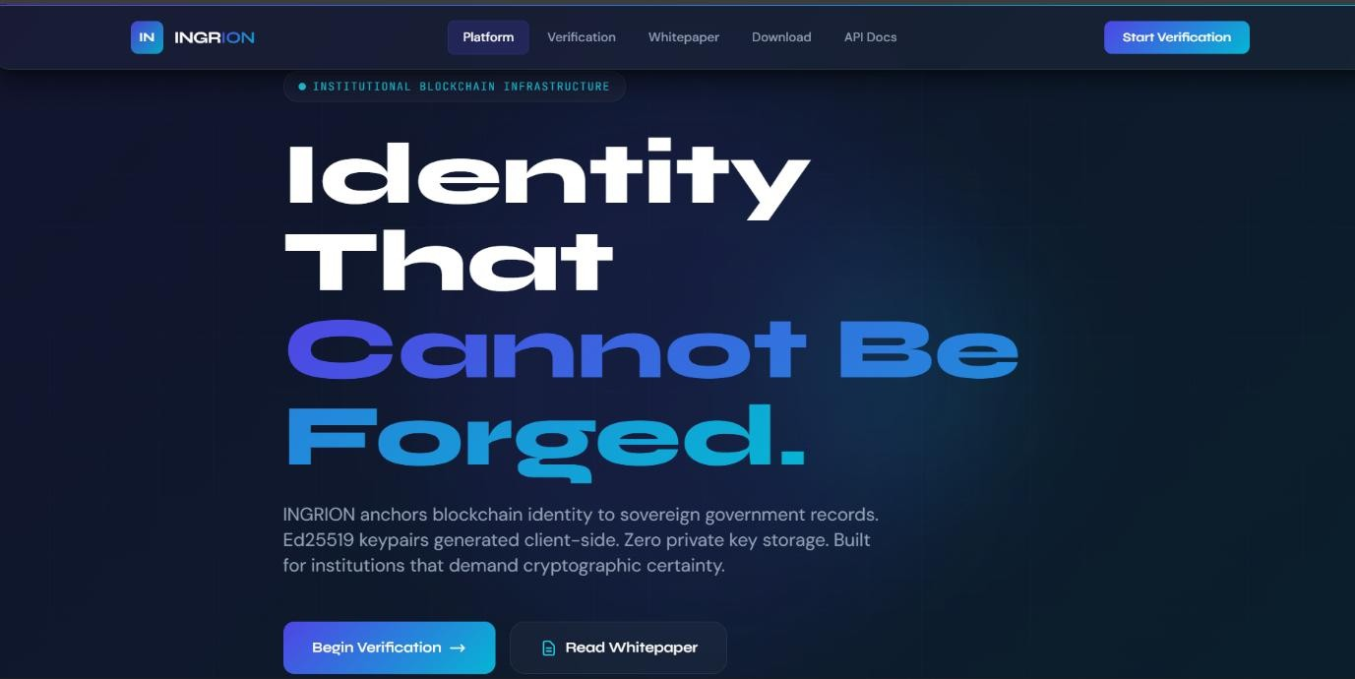

Figure 12. Ingrion Website Landing Page
The navigation includes links to Platform, Verification, Whitepaper, Download, and API Docs sections. Two primary calls to action — Begin Verification and Read Whitepaper — are prominently displayed, targeting institutions that require cryptographic certainty in identity operations.
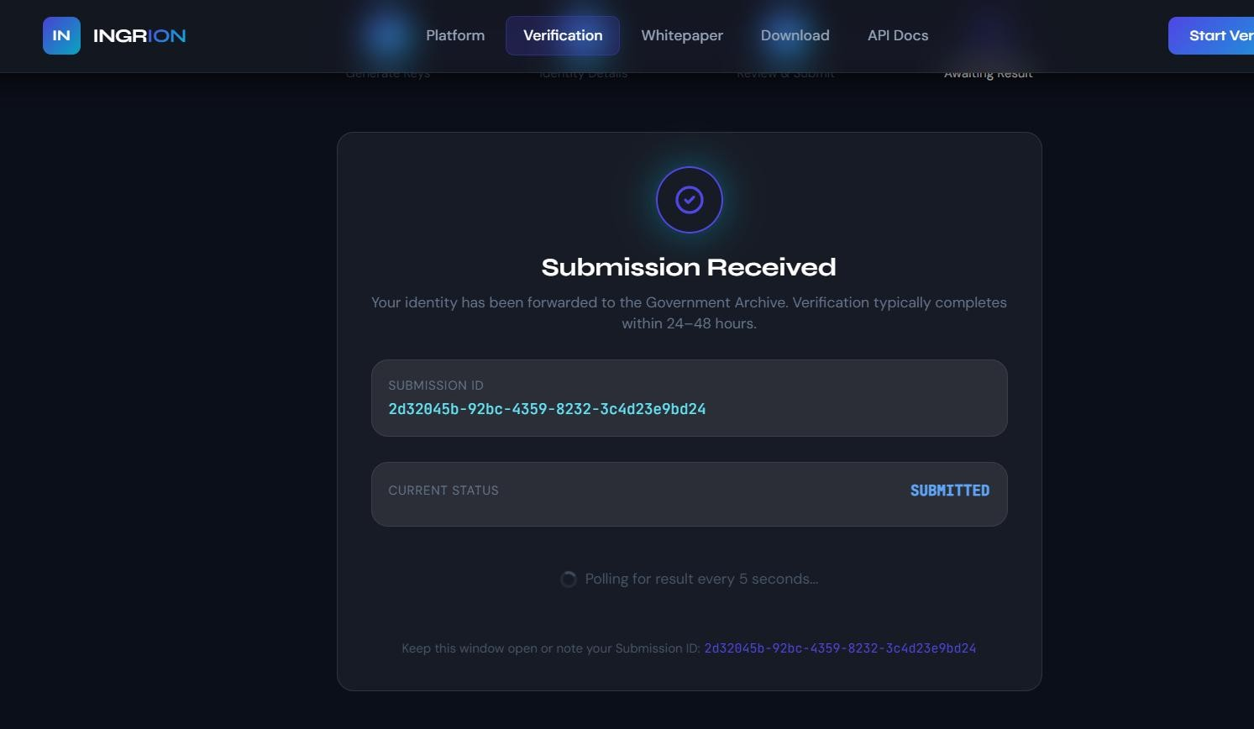

Figure 13. Verification Page
Verification Page (KYC Submission) Figure 13 The Verification page, accessible at / KYC, presents the Identity Details form where users submit their credentials for blockchain-anchored verification. The form requires a Government Archive Link — a URL pointing to the citizen's identity document within the national archive system — and a live facial biometric scan captured through the device camera, with an oval guide overlay to position the face accurately.

The system extracts a float32 face embedding vector locally, ensuring the raw image is never transmitted. Users are also required to set an Identity Password of minimum 12 characters and confirm it. This multi-factor design ensures that identity data is hashed before transmission, preserving privacy while enabling verifiable cryptographic proof on the blockchain.

Ingrion Desktop Application
INGRION is a lightweight desktop application built for permissioned capital markets on a private blockchain network. Developed using Tauri (Rust backend) and React/TypeScript (frontend), it delivers the performance and security of a native application while maintaining a minimal installation footprint — with no browser runtime overhead. The application supports four distinct participant roles — User (QIB/NIB/Retail investor), Validator, Company, and Regulator — each presenting a tailored interface and feature set appropriate to their function on the network. On first launch, a guided five-step setup wizard walks the user through node configuration, private key import or generation, and AES-256-GCM encryption of the keystore, which is persisted locally at AppData, INGRION, keystore.json and never transmitted in plain text. Once initialised, the application connects to a designated blockchain node, runs a background block synchronisation service using SQLite as a local cache, and provides real-time features including a live mempool viewer, IPO bidding, secondary market trading, DRHP/RHP document browsing, INR transfers, portfolio tracking, and validator staking — all signed on-chain using Ed25519 cryptographic signatures. The result is a self- contained, secure, and role-aware capital markets terminal designed to operate on India's permissioned blockchain infrastructure.
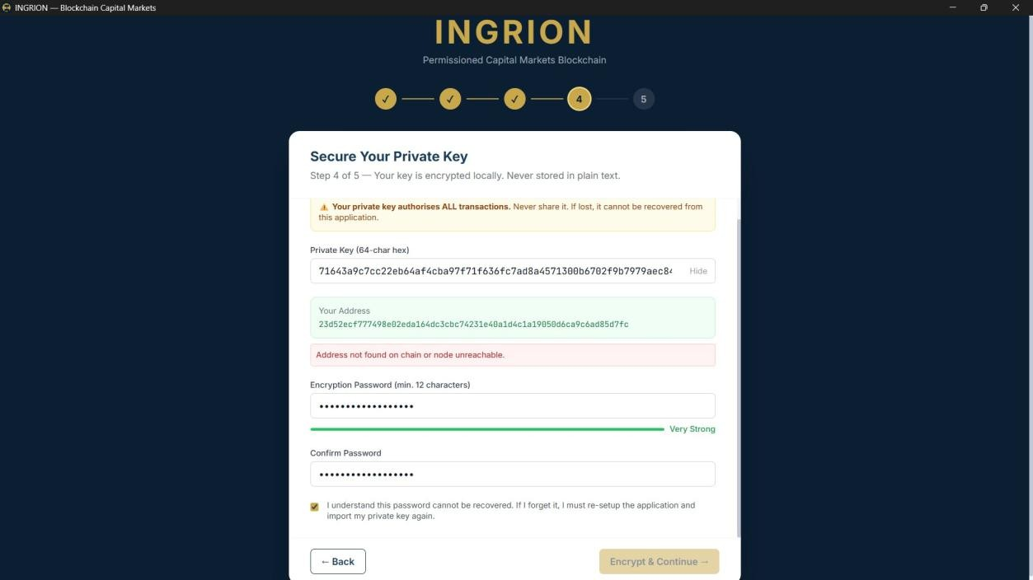

Figure 14. Key Embedding Screen — Importing an existing private key into the INGRION application

The Key Embedding screen Figure 14 is the entry point for users who already possess a blockchain private key and wish to import it into the INGRION desktop application. This interface presents a clean, form-based layout on a dark navy background consistent with the application's overall design language. The screen prompts the user to paste their 64-character hexadecimal private key into a dedicated input field, with an accompanying "Show/Hide" toggle to protect sensitive information from shoulder surfing. A real-time-derived blockchain address is displayed immediately below, giving the user instant visual confirmation that the key has been parsed correctly before proceeding. The design intentionally keeps this step minimal and focused, reducing the risk of accidental data entry errors during a process that is critical to account security.
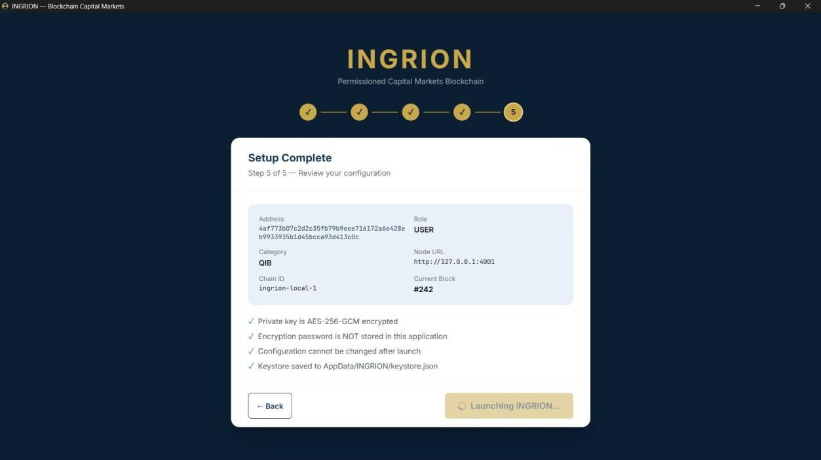

Figure 15. Private key encryption with password protection before finalising setup
The onboarding wizard Figure 15 is dedicated to securing the imported private key through AES-256-GCM encryption. The screen prominently displays a gold-coloured warning banner at the top, reminding the user that the private key authorises all blockchain transactions and must never be shared. The 64-character private key is shown (with a Hide option) alongside the derived wallet address, allowing the user to verify the correct key is being processed. A prominent red alert indicates whether the address has been found on the blockchain network or if the node is currently unreachable. The user is required to create an encryption password of at least twelve characters; a real-time strength meter at the bottom of the password field turns green and displays "Very Strong" as the user meets the security threshold. A mandatory confirmation password field and an acknowledgement checkbox — stating that the password cannot be recovered if forgotten — enforce informed consent before the user can proceed. This multi-layered design ensures that the private key is never stored in plain text anywhere on the system.

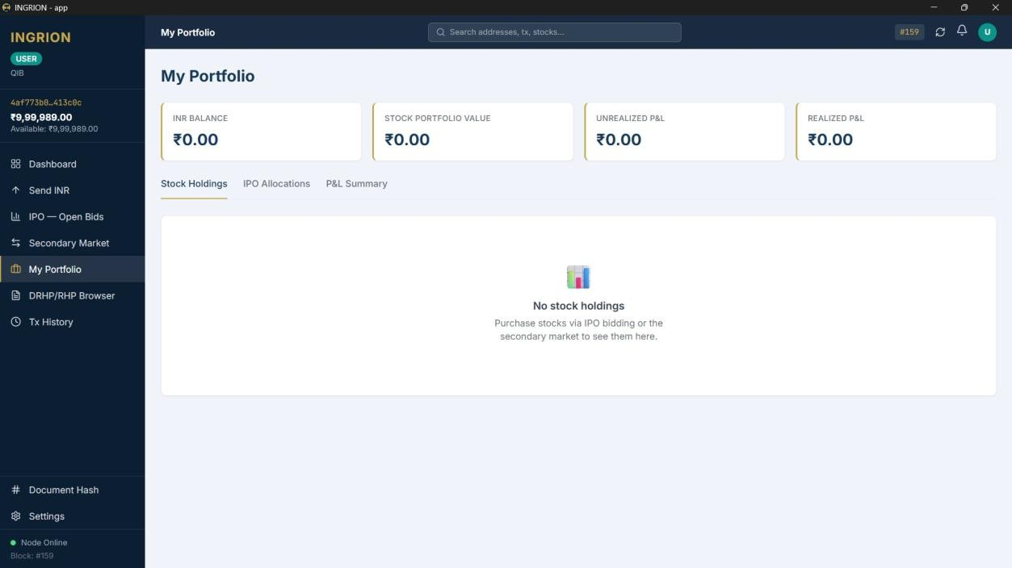

Figure 16. Block Explorer showing live mempool transactions and navigation for a Validator node
The Block Explorer screen Figure 16 is accessible from the left-hand navigation sidebar and provides real-time visibility into the state of the blockchain network. The sidebar identifies the currently logged-in node as a VALIDATOR, displaying a truncated wallet address and the current INR balance available for transactions. The main content area is divided into two panels: the left panel lists the live Mempool — showing transactions that are pending inclusion in the next block — and the right panel is reserved for detailed Block information when a specific block is selected. In the screenshot, eleven pending IPO Bid transactions are shown in the mempool queue, each identified by a transaction hash prefix and attributed to the validator node. The "Recent Blocks" section below the mempool will populate with confirmed blocks as they are mined. The top navigation bar provides a global search bar for querying addresses, transactions, and stock symbols, along with a block counter showing the current chain height (#204). The node status indicator at the bottom-left corner of the sidebar confirms that the node is online and actively syncing with the network.
The My Portfolio screen Figure 17 provides a comprehensive financial overview for a logged- in USER with the QIB (Qualified Institutional Buyer) category. Four prominent metric cards at the top of the screen display the user's current INR Balance, total Stock Portfolio Value, Unrealized Profit & Loss, and Realized Profit & Loss — all denominated in Indian Rupees. In the initial state shown here, all values read ₹0.00, reflecting an account that has not yet participated in any IPO bidding or secondary market transactions; however, the INR balance shown in the sidebar (₹9,99,989.00) represents the on-chain currency available for trading. Below the summary cards, three tabs — Stock Holdings, IPO Allocations, and P&L Summary
— allow the user to drill down into different aspects of their portfolio.

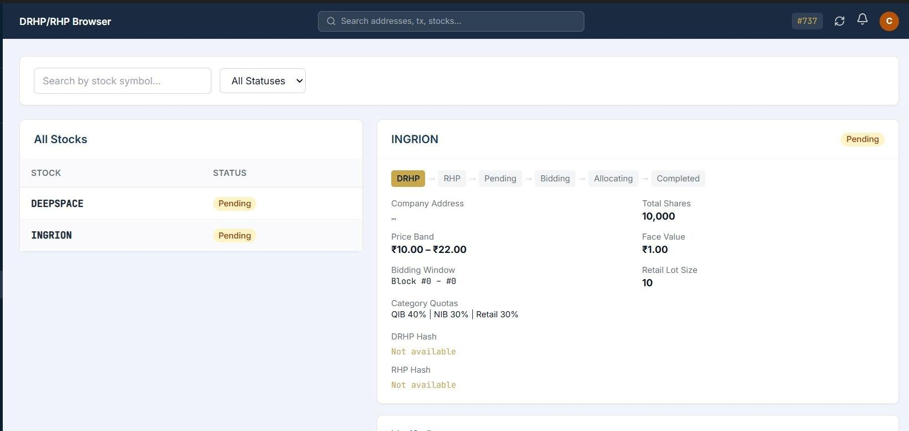

Figure 17. My Portfolio screen showing INR balance, stock holdings, IPO allocations, and P&L summary for a QIB user
The Stock Holdings tab is currently active and displays an empty state with a prompt guiding the user to purchase stocks via IPO bidding or the secondary market. The left navigation sidebar lists all available sections for a USER role, including Send INR, IPO Open Bids, Secondary Market, DRHP/RHP Browser, Document Hash, and Settings, providing a clear and role- appropriate navigation structure.

Performance Evaluation
By monitoring performance metrics such as transaction processing time, block creation time interval, and synchronization delays between nodes, an evaluation of the Ingrion blockchain system's overall performance was performed. The Ingrion blockchain system's preferred consensus mechanism is similar to the proof-of-stake consensus mechanism, which allows it to avoid the large overheads of computational resources that are characteristic of proof-of-work systems, producing blocks in less time, and also using significantly fewer resources than traditional cryptocurrencies. For these reasons, it is a better candidate for deployment on commercially available hardware than most other cryptocurrency systems that require specific computing infrastructure to process the blockchain.
Although the primary focus of ATLAS is as an experimental and academic platform, the system can still provide an acceptable level of performance when utilized in small to mid-sized networks. The use of efficient peer-to-peer communications and a lightweight storage engine provides for consistent response times when responding to regular workloads, even when the number of participating nodes and/or the transaction volume increases. However, performance degradation may be experienced due to the constraints of the current architecture and will require further optimization during the development of future versions of the ATLAS System.

Reliability and Consistency Analysis
The importance of reliability and consistency in any blockchain solution is paramount; it is critical that each of the participating nodes agree on the same version of the ledger. The reliability of the Ingrion platform was evaluated by simulating several scenarios, such as

temporary network disconnections, restarting of nodes, and delay in message delivery over the network. Most nodes were able to recover by reconnecting to their peers and resynchronizing their blockchain data automatically (without any manual assistance).
The consistency of the state of the blockchain between the nodes was assessed by looking at block heights, block hashes and account balances following the completion of synchronization. All active nodes eventually achieved the same state of the blockchain , which indicates that the peer-to-peer synchronization and consensus mechanisms are functioning correctly. The results of the above analysis demonstrate that the system is able to maintain data consistency and provide fault tolerant operation within the normal operating environment.

Comparison with Existing Systems
When looking at mainstream blockchain systems like Bitcoin and Ethereum, the Ingrion system has a simpler, less resource-intensive design and implementation than either Bitcoin or Ethereum. Bitcoin has a primary focus on cryptocurrency transactions, and utilizes a high energy consumption Proof-of-Work consensus mechanism. Ethereum has been designed to support Smart Contracts, but often suffers scaling and transaction fee issues and is therefore resource intensive to be fully deployed.
Ingrion has been specifically designed to facilitate structured financial workflows including IPO processes, voting, and distribution of dividends. The Ingrion cipherproof of stake consensus algorithm is much more efficient than Bitcoin and Ethereum and also provides a much lower energy consumption. The system's modular architecture facilitates ease-of- understanding, making it easier to modify and extend in a university setting. Ingrion is not intended to compete with large scale public blockchains, however its platform serves an educational and practical purpose for conducting research on blockchain system design.

Discussion on Limitations and Challenges
Throughout the evaluation process, several limitations and challenges were uncovered with respect to the Ingrion's successful implementation and testing. The greatest difficulty with implementing a large-scale deployment of Ingrion's technology, is that the current version was designed to support only small-to-medium sized networks. When deploying larger networks, the Ingrion platform may experience performance difficulties as a result of additional nodes or transactions being processed.

CHAPTER VIII CONCLUSION AND FUTURE SCOPE

Conclusion
The Ingrion blockchain platform shows its ability to design and implement a decentralized approach to handling secure financial transactions as well as those related to governance; thus demonstrating the key elements that comprise a total and functional blockchain system (for example a proof-of-stake-like consensus mechanism, peer-to-peer networking, use of BadgerDB for persistent storage, and providing a fully functional REST-RPC interface). All elements of design implementation and testing have been completed on the platform; plus the complex workflows surrounding financial transactions (INR transfers, initial public offering processes, voting on resolution, payment of dividends and managing validators) can be completed using decentralized methods.
Practical experience gained during the project semi-automated the development of a distributed system along with applying cryptography for ensuring data confidentiality and integrity. Furthermore test results confirm that under "normal" operational conditions the Ingrion system remains reliable and consistently replicates all transactional data across all nodes of the Ingrion network; and that regardless of the number of nodes connected to Ingrion, the system will provide the user with timely and accurate responses via its API (application programming interface). Ultimately, Ingrion is an example of an exemplary academic prototype of the basic principles behind blockchain technology; and forms an excellent starting point for continued research and development efforts in the area of decentralized financial technologies.

Future Scope
The Ingrion platform meets its fundamental goals; however, there are many areas of opportunity for improvement in the future. One significant plan for expansion is to allow developers to incorporate smart contract capabilities into the system, so users can establish their own business logic and automate business processes by conducting transactions directly on the blockchain.
Creating a graphical user interface (GUI) or web-based dashboard to make the system usable for individuals who do not understand technology would be another significant enhancement. Improving the program's performance and scalability by optimizing the network layer, enhancing the consensus algorithm, and developing better data storage and indexing methodologies would be additional areas in which future work can be completed. Exploring additional security functionality such as advanced auditing capabilities, access control systems, and using formal proof to validate essential components in the system will be potential enhancements for Ingrion.

REFERENCES
- P. K. Ozili, “Decentralized finance research and developments around the world,” Journal of Financial Innovation, vol.1, no.1, pp.1–6, 2022. DOI: https://doi.org/10.1007/s42786-022- 00044-x

- H. Taherdoost, “A survey of smart contracts in blockchain technology: A critical review,”
Information Journal, vol. 14, no.2, pp.1–6, 2023. DOI: https://doi.org/10.3390/info14020117

- Z. Hussein, “Evolution of blockchain consensus algorithms: A review on the various con sensus techniques used in blockchain networks,” Journal of Blockchain Research, vol. 1,
no. 1, pp. 1–6, 2023. DOI: https://doi.org/10.1186/s42400-023-00163-y

- M. Abdelhamid, “A review on blockchain technology, current challenges and future direc tions,” ACM Computing Surveys, vol. 1, no. 1, pp. 1–6, 2024. DOI: https://doi.org/10.1186/s42400-023-00163-y

- S. Nakamoto, “Bitcoin: A peer-to-peer electronic cash system,” Bitcoin.org Whitepaper,
vol. 1, no. 1, pp. 1–6, 2008. DOI: https://doi.org/10.2139/ssrn.228640975

- R. J. Oben and F. Ozdamlı, “Decentralized Finance (DeFi): Benefits, risks, and risk-mitiga tion strategies,” International Business Review, vol. 53, no. 1, pp.1–6, 2024. DOI: https://doi.org/10.26650/ibr.2024.53.1426335

- Chinnasamy, P., Vinothini, C., Arun Kumar, S., Allwyn Sundarraj, A., Annlin Jeba, S.V., Praveena, V. (2021). Blockchain Technology in Smart-Cities. In: Panda, S.K., Jena, A.K., Swain, S.K., Satapathy, S.C. (eds) Blockchain Technology: Applications and Challenges. Intelligent Systems Reference Library, vol 203. Springer, Cham.
DOI: https://doi.org/10.1007/978-3-030-69395-4_11

- M. Xu et al., “Exploring blockchain technology through a modular lens,” ACM
Transactions on Blockchain, vol. 1,no.1,pp1–6,2024. DOI: https://doi.org/10.1145/3657288

- F. Schär, “Tokenization and decentralized finance (DeFi),” SSRN Electronic Journal, vol.
1, no. 1, pp. 1–6, 2022. DOI: https://doi.org/10.2139/ssrn.3571335

- Chinnasamy, P., Subashini, B., Ayyasamy, R.K. et al. Blockchain based electronic educa
tional document management with role-based access control using machine learning model. Sci Rep 15, 18828 (2025). DOI: https://doi.org/10.1038/s41598-025-99683-5

- D. Gramlich et al., “A multivocal literature review of decentralized finance,” Electronic
Markets, vol. 1, no. 1, pp.1–6,2023. DOI: https://doi.org/10.1007/s12525-023-00637-4

- Mohammed Abdul et al., “Toward the mass adoption of blockchain: Cross-industry insights from DeFi, gaming, and data analytics,” Big Data and Cognitive Computing, vol.9,no.7,pp.1–6,2025. DOI: https://doi.org/10.3390/bdcc9070178

- H. Wu, “Blockchain for finance: A survey,” Blockchain Systems,vol.1,no.1,pp.1–6,2024. DOI: https://doi.org/10.1049/blc2.12067

- Guo and Zhou, “Toward the evolution of financial market infrastructure: From digitalization to tokenization,” International Journal of Innovation Economics,vol.1,no.1,pp.1–6,2023. DOI: https://doi.org/10.56502/IJIE2010002

- W. Li, J. Bu, X. Li, and X. Chen, “A survey of DeFi security: Challenges and opportunities,” Journal of King Saud University – Computer and Information Sciences, vol.34,no.1,pp.1– 6,2022. DOI: https://doi.org/10.1016/j.jksuci.2022.10.028

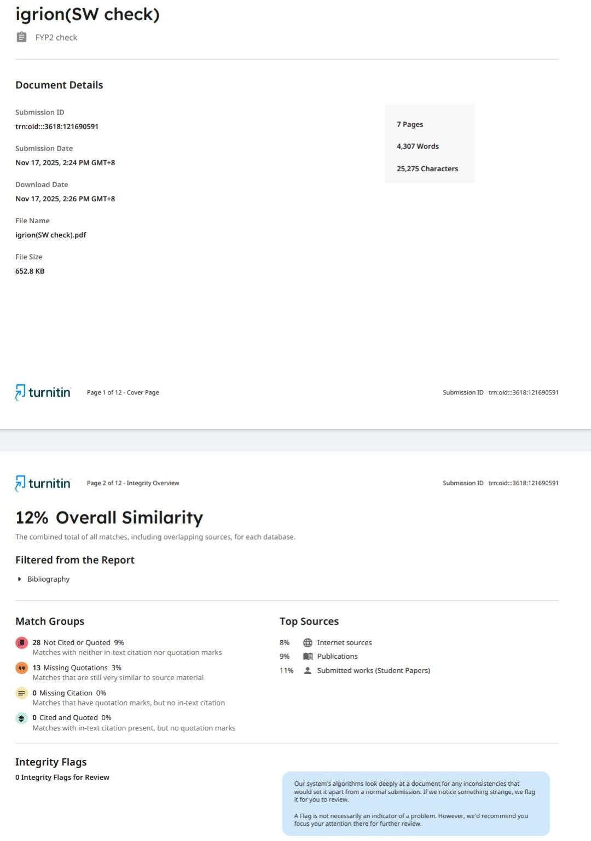

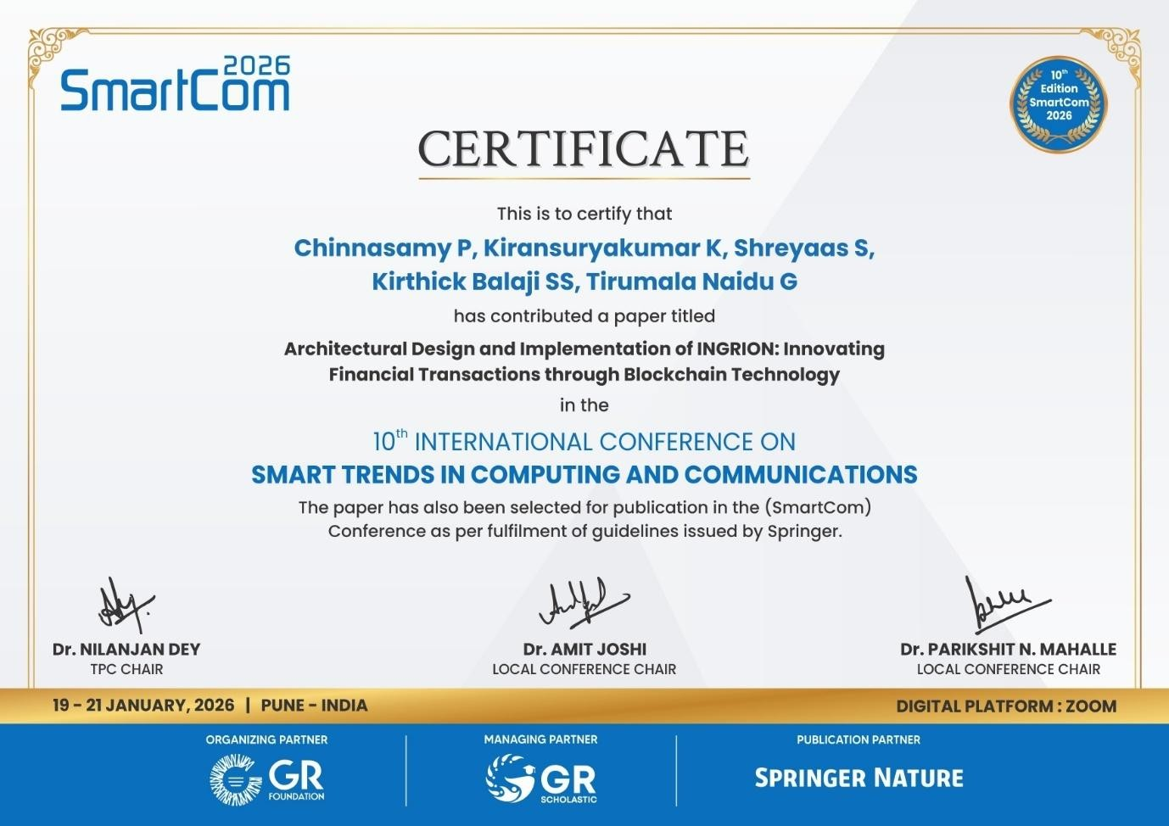

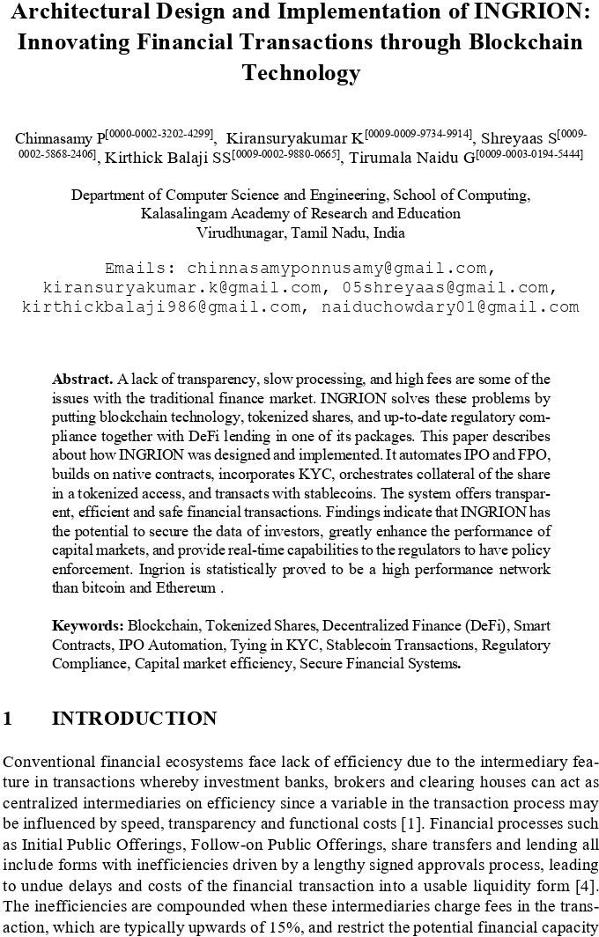



INTERNAL QUALITY ASSURANCE CELL PROJECT AUDIT REPORT

This is to certify that the project work entitled “Architectural Design and Implementation of Ingrion: Innovating Financial Transactions through Blockchain Technology” categorized as an internal project done by Kirthick balaji SS, Kiransuryakumar K, Shreyaas S, Tirumala naidu G of the Department of Computer Science and Engineering, under the guidance of Dr. P. Chinnasamy during the Even semester of the academic year 2025 - 2026 are as per the quality guidelines specified by IQAC.

Quality Grade

Deputy Dean (IQAC)

Administrative Quality Assurance Dean (IQAC)

