**3: Monte-Carlo Simulation**

Schematic

Schematic for Monte Carlo Simulation:

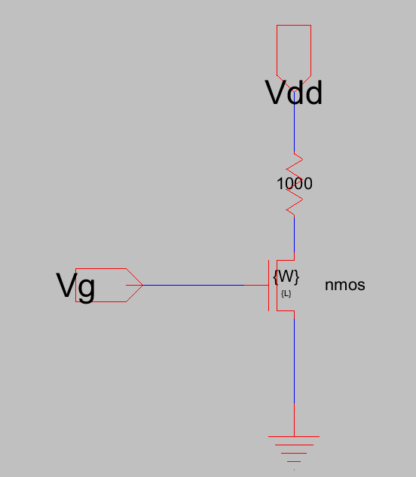

SPICE code:

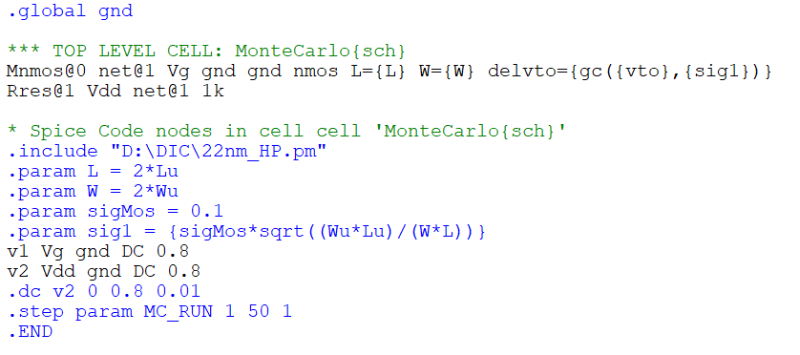

Measurement:

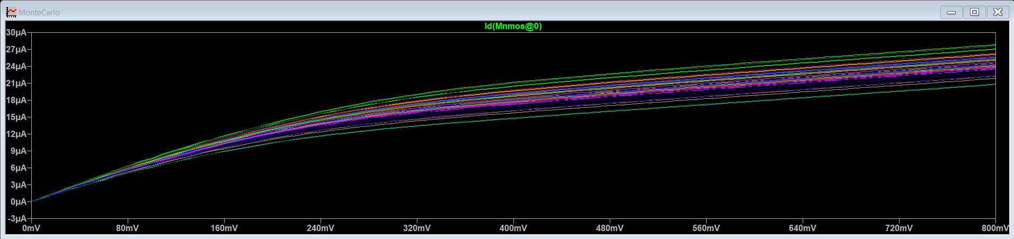

ID vs Vg Curve