**4 – Inverter with 4x Drive Strength**

Schematic:

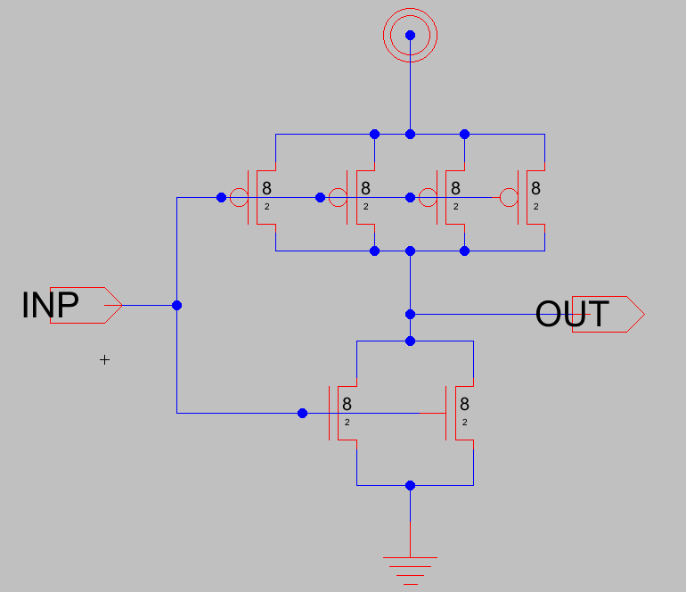

Layout:

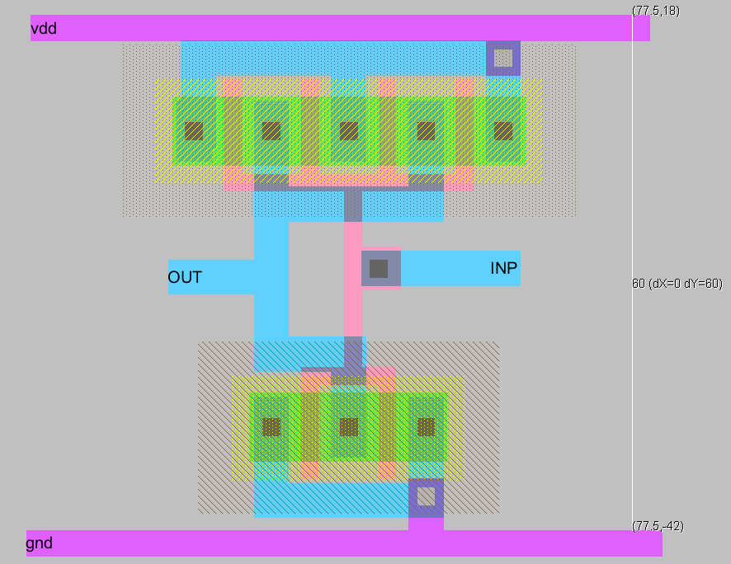

DRC & LVS:

