**T5 – NAND with 1x Drive Strength**

Schematic

Layout of the 2x NAND along with its icon:

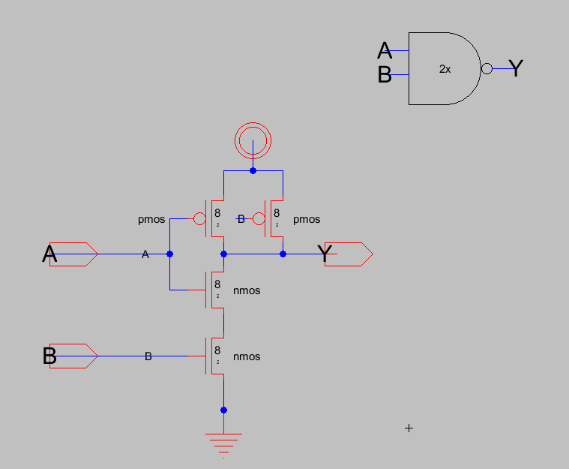

Simulation of Schematic

Simulation of the NAND gate with inputs fed in through buffer:

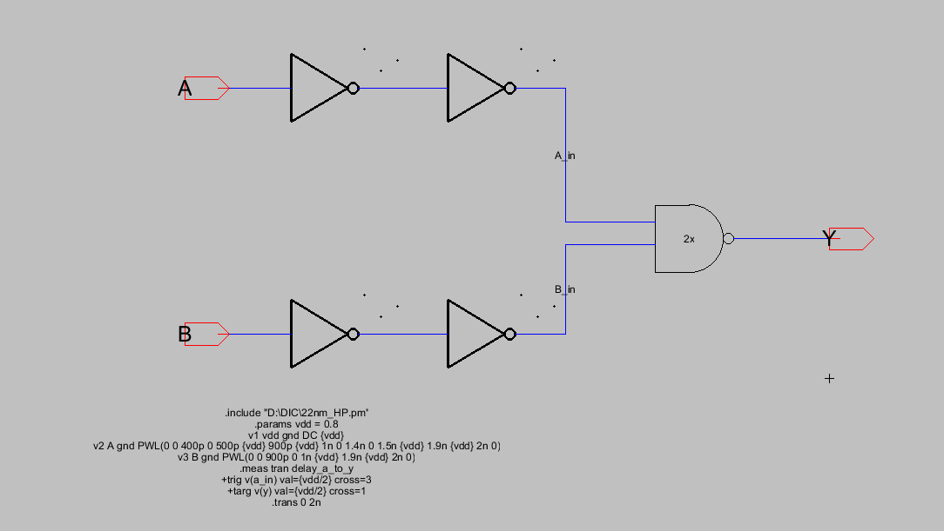

Simulated Waveforms – Output, NAND_inp_A, NAND_inp_B (in order)

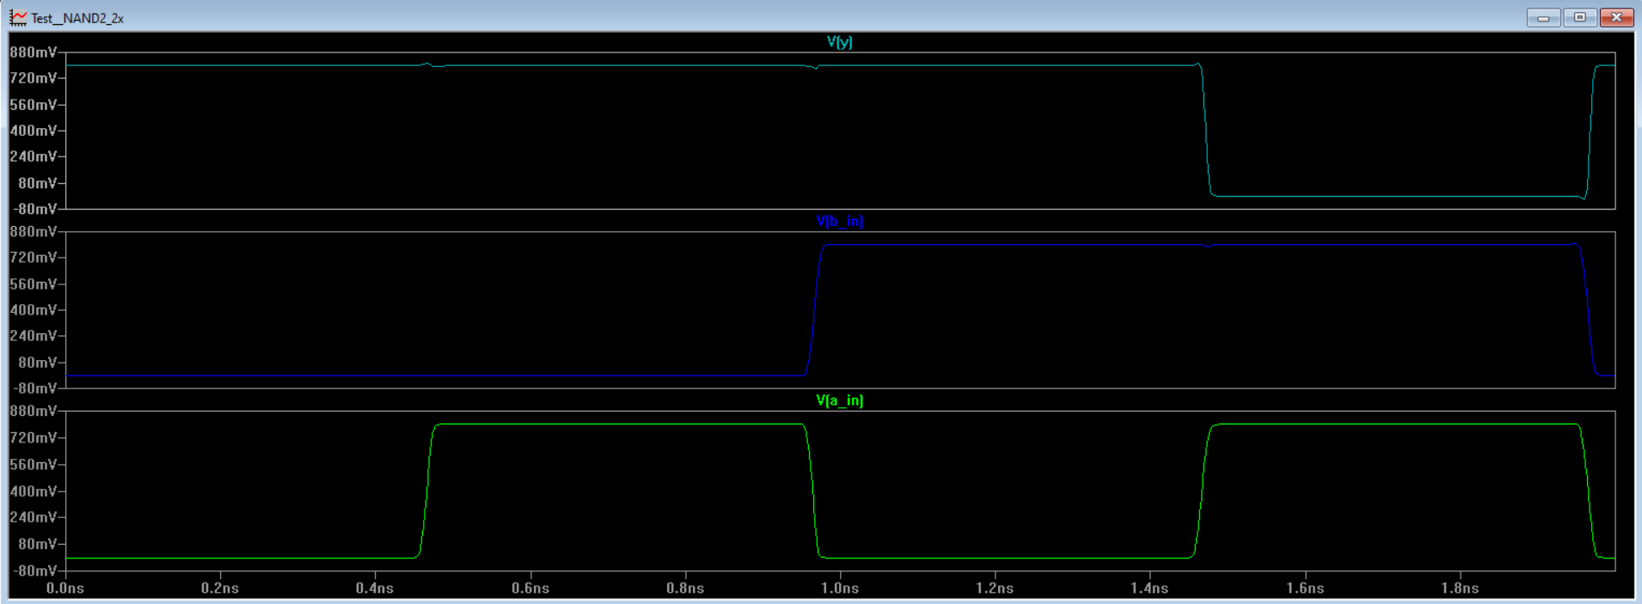

Captured delay:

