**T5 – NAND with 2x Drive Strength**

Schematic

Layout of the 2x NAND along with its icon:

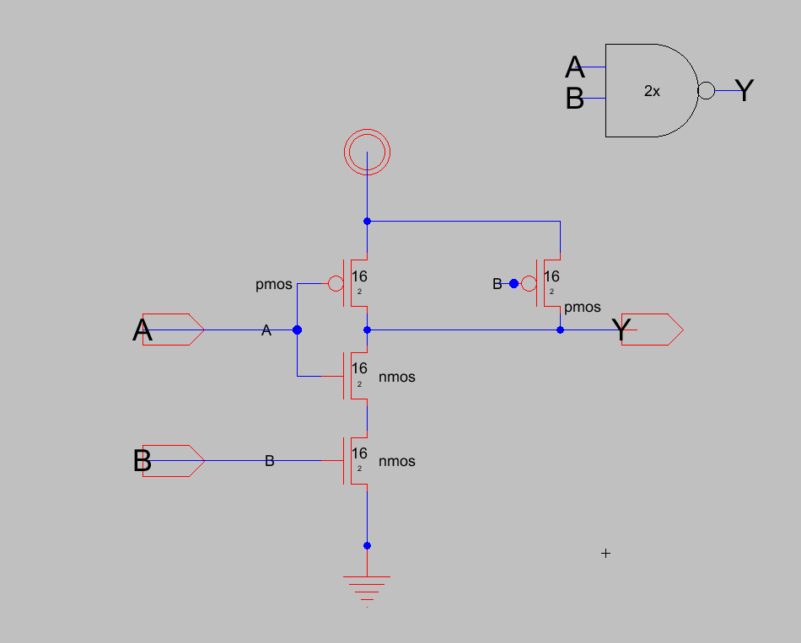

Simulation of Schematic

Simulation of the NAND gate with inputs fed in through buffer:

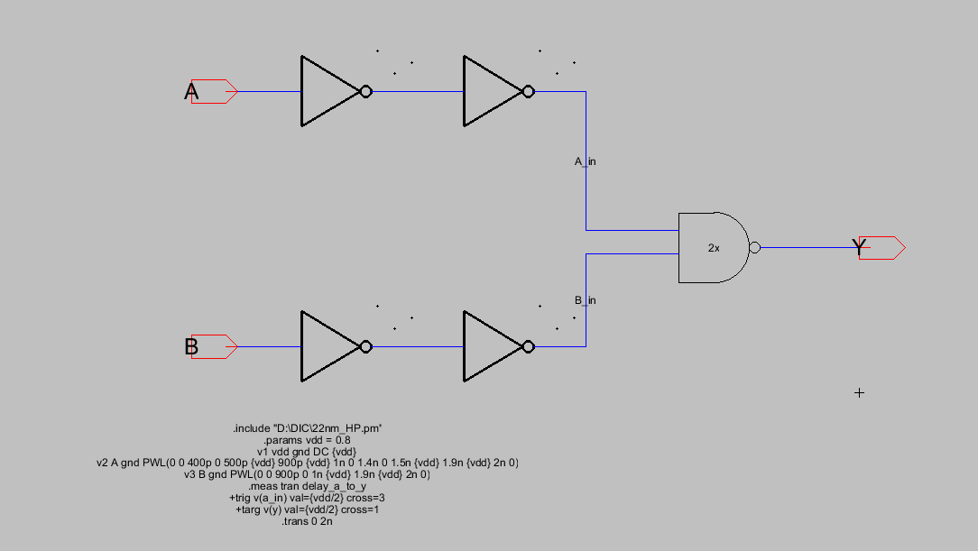

Simulated Waveforms – Output, NAND_inp_A, NAND_inp_B (in order)

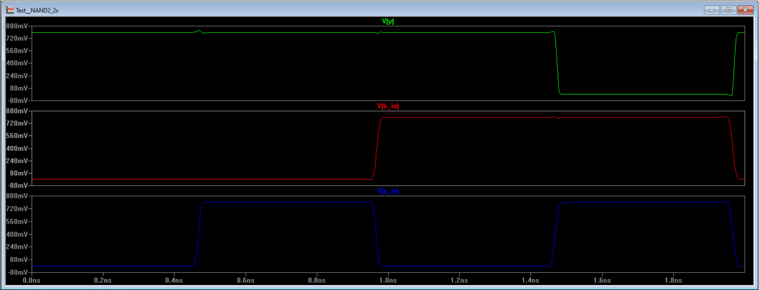

Captured delay:

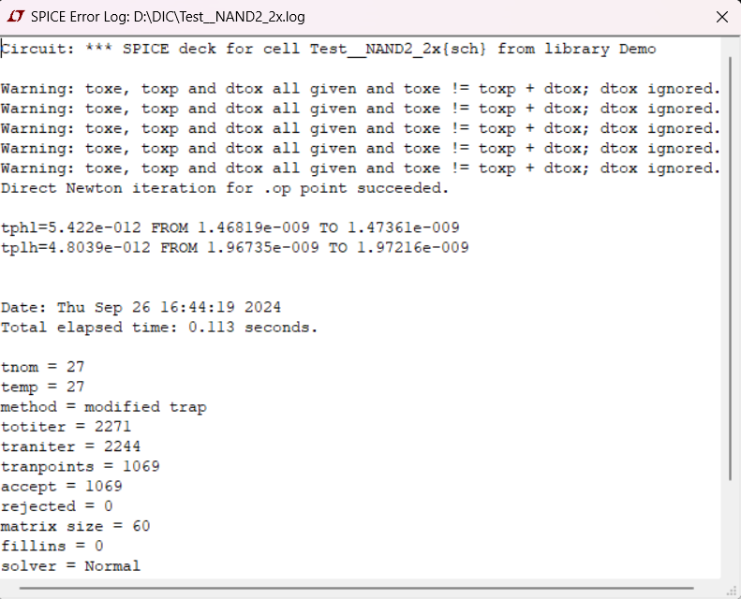

Layout of NAND2 – 2x drive strength

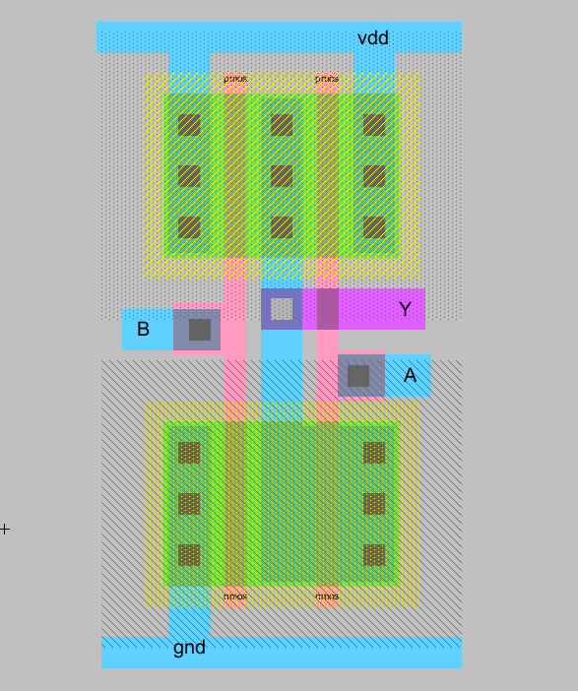

DRC / LVS

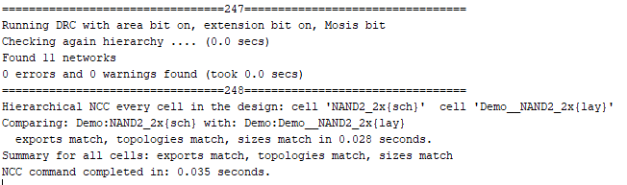

Capturing Delay of RC extracted Layout without passing inputs through buffers:

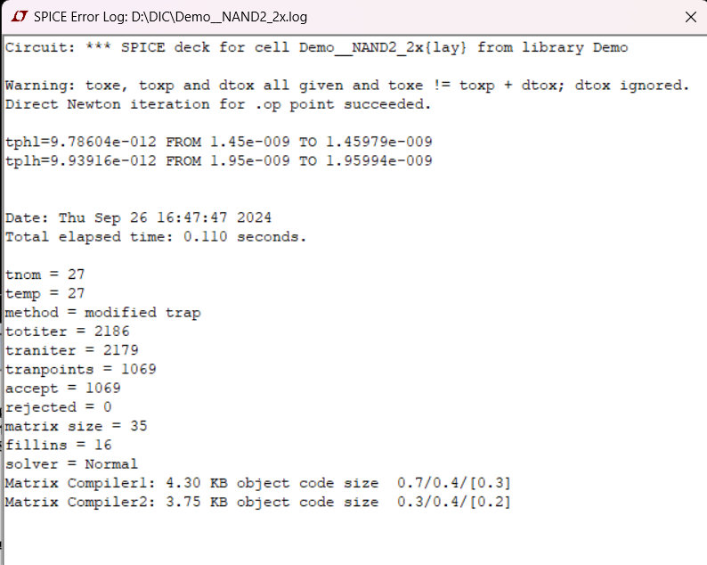

Layout with input Buffers

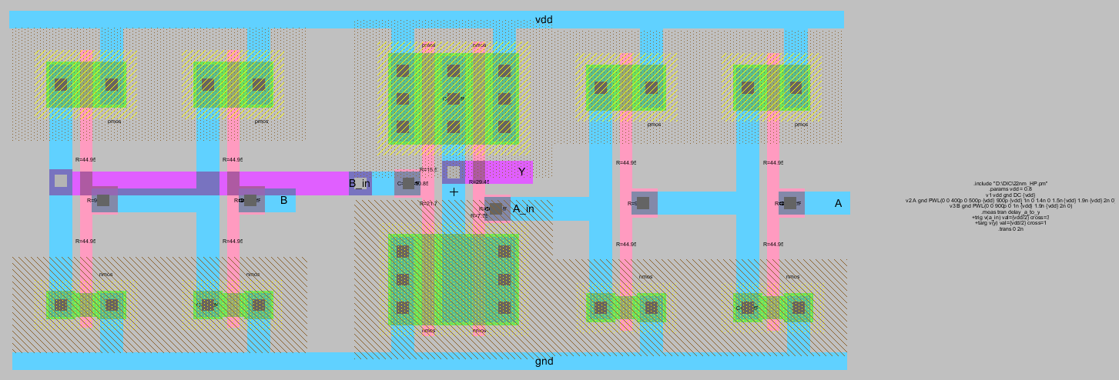

Simulation for the same

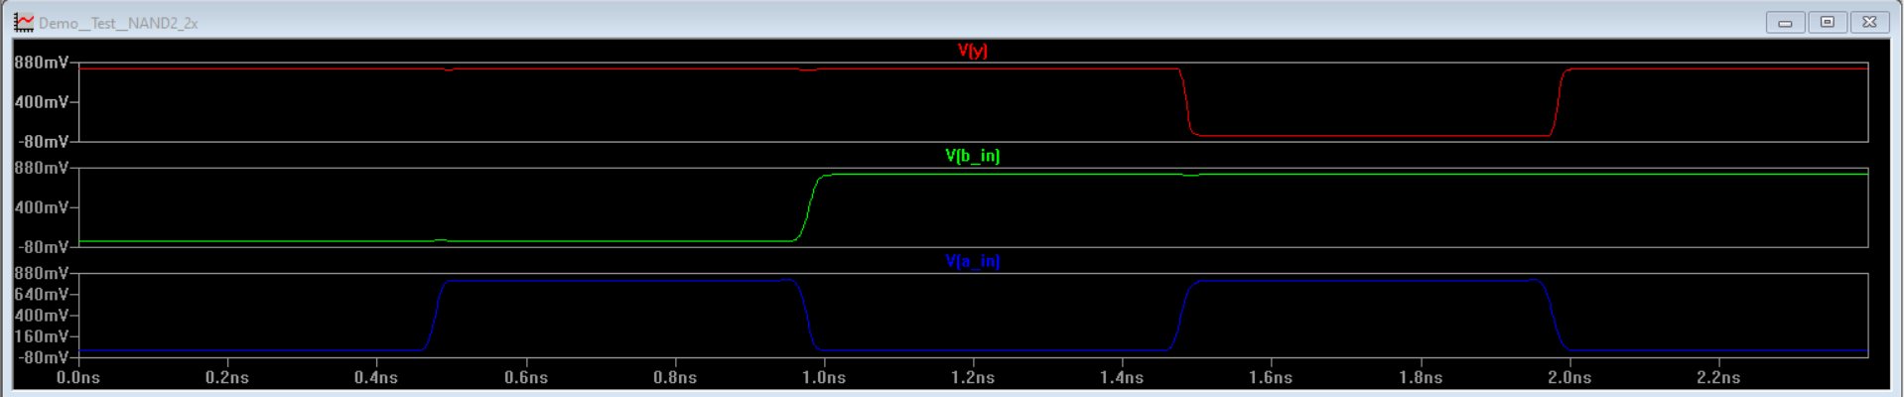

Capturing Delay for the same

