**Batch Tutorial – (6a) – AND2_2x**

Schematic:

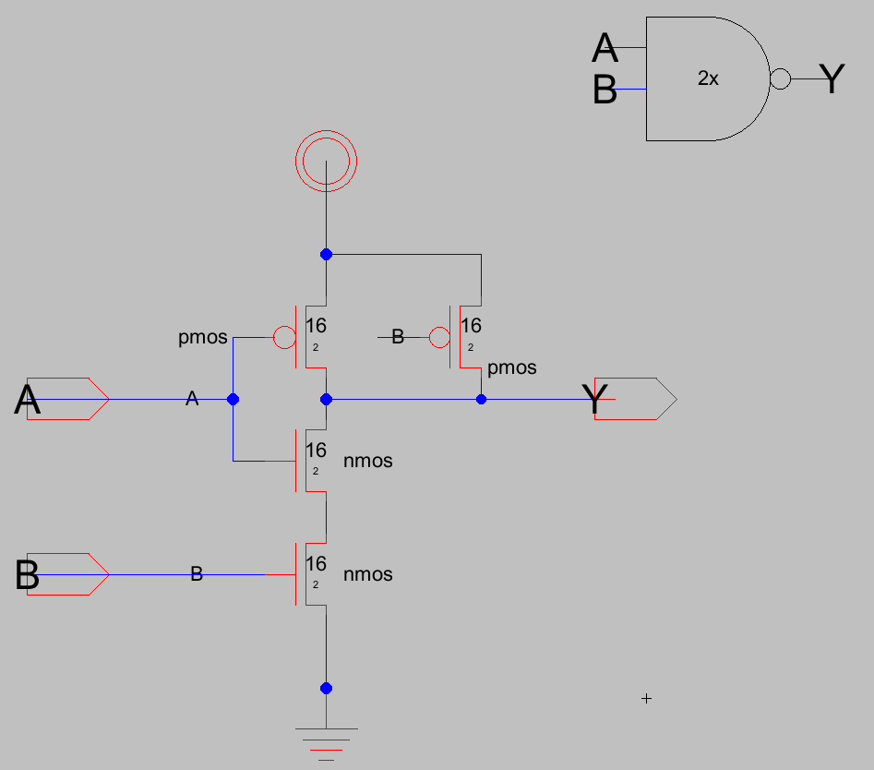

Layout:

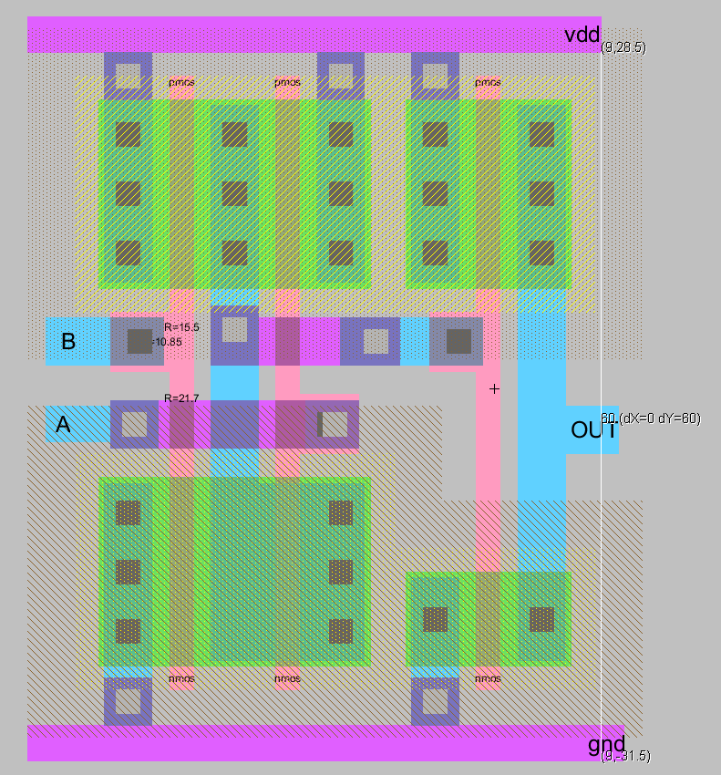

DRS & LVS Reports

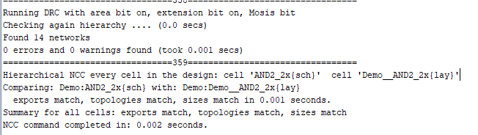

Testbench:

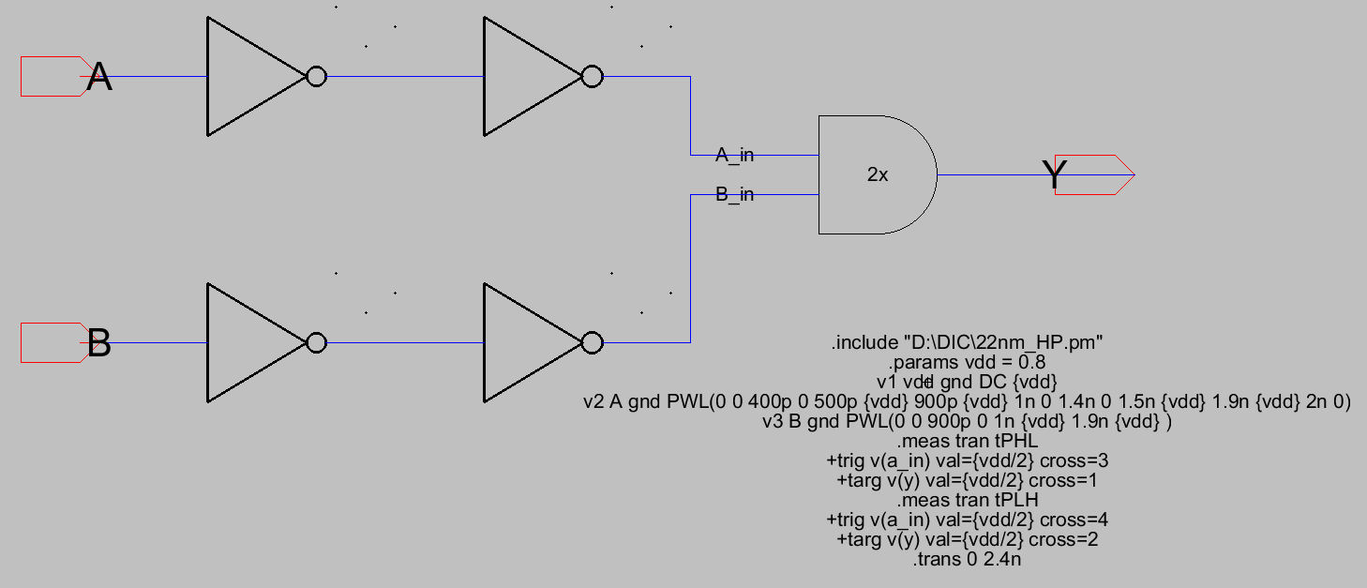

SIMULATION BEFORE RC EXTRACTION:

Simulated Waveforms:

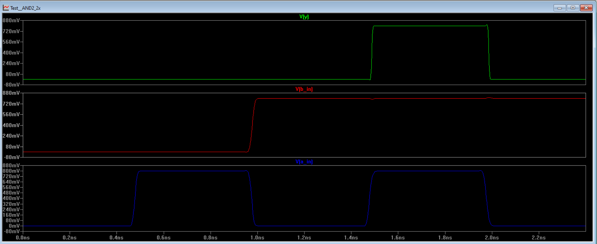

tPLH and tPHL:

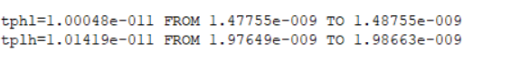

POST RC EXTRACTION:

tPLH and tPHL:

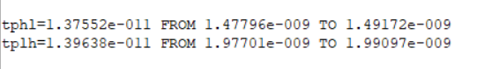

Simulated Waveforms:

