**Batch Tutorial – (6b)**

**Full Adder Carry Generation (3x)**

Schematic:

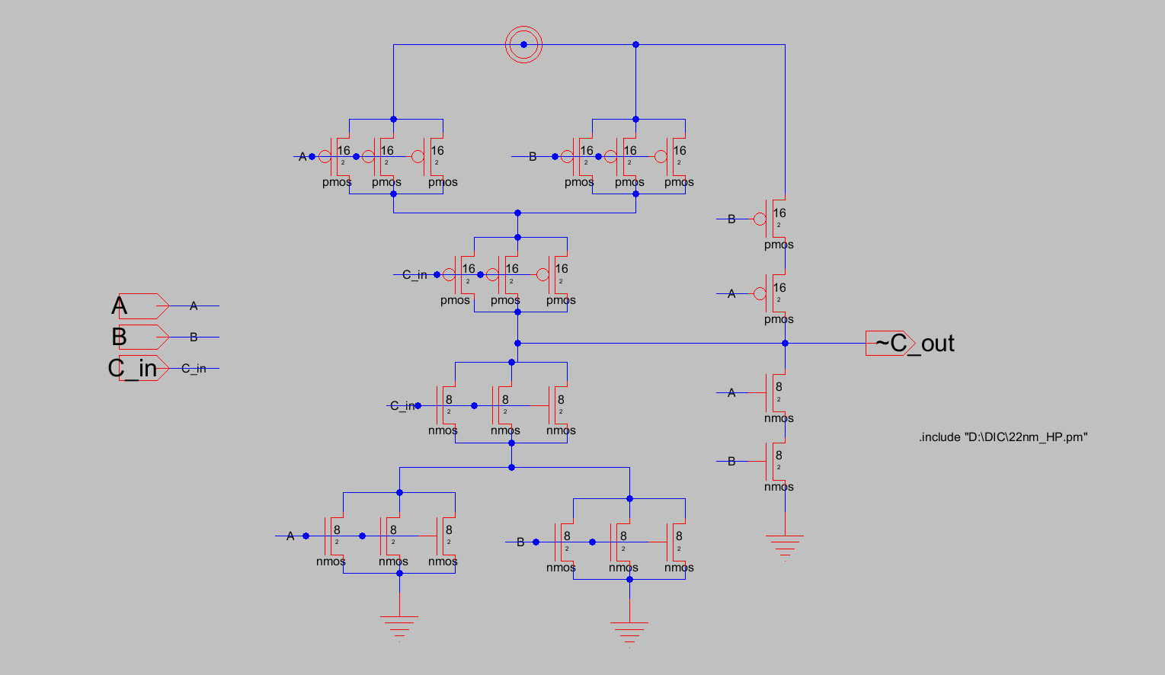

Layout:

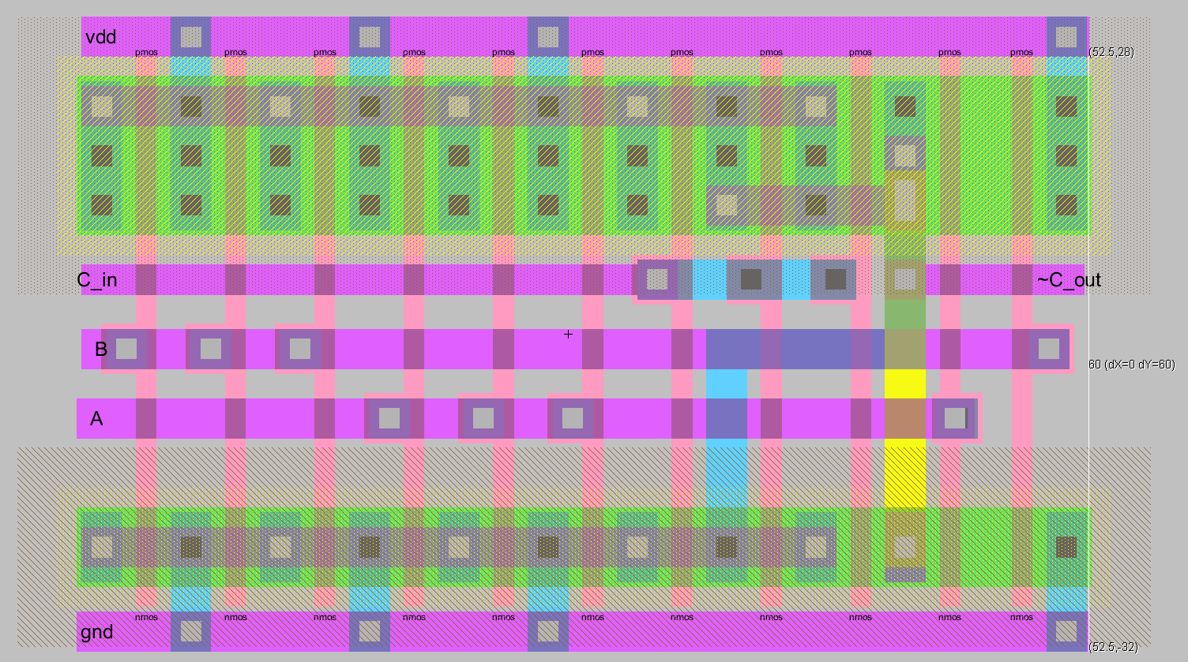

DRS & LVS Reports

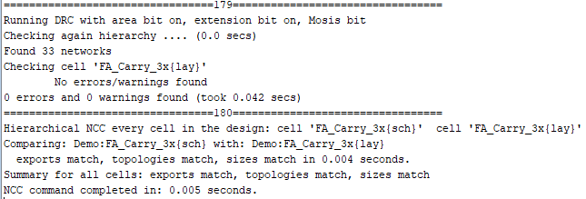

Testbench with RC extracted FA:

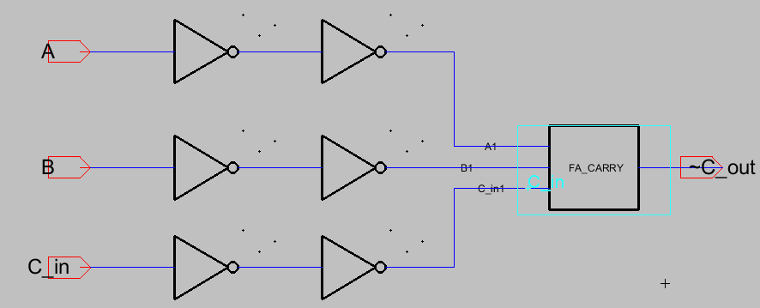

Simulation Inputs:

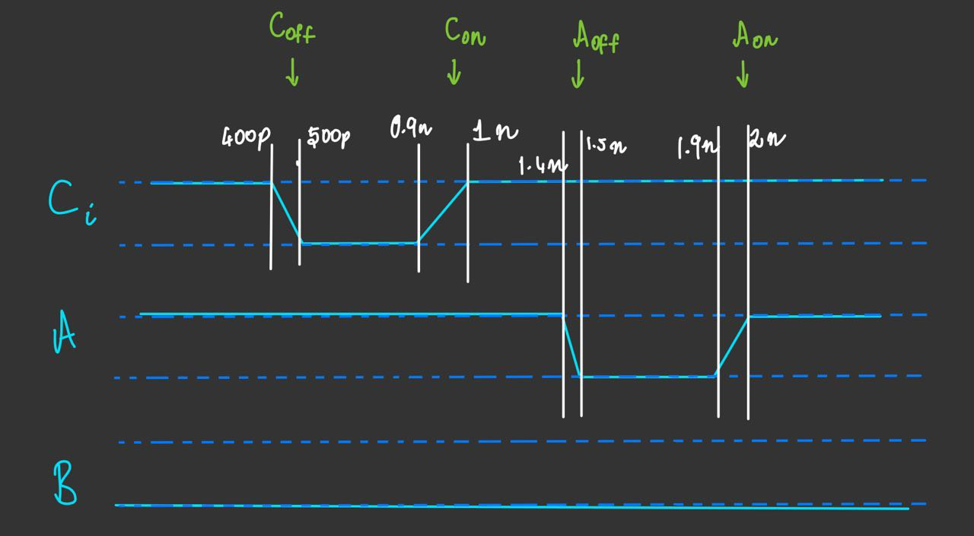

Delay Measurements without RC extraction:

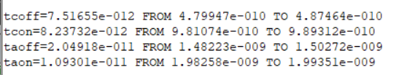

Simulation Waveforms:

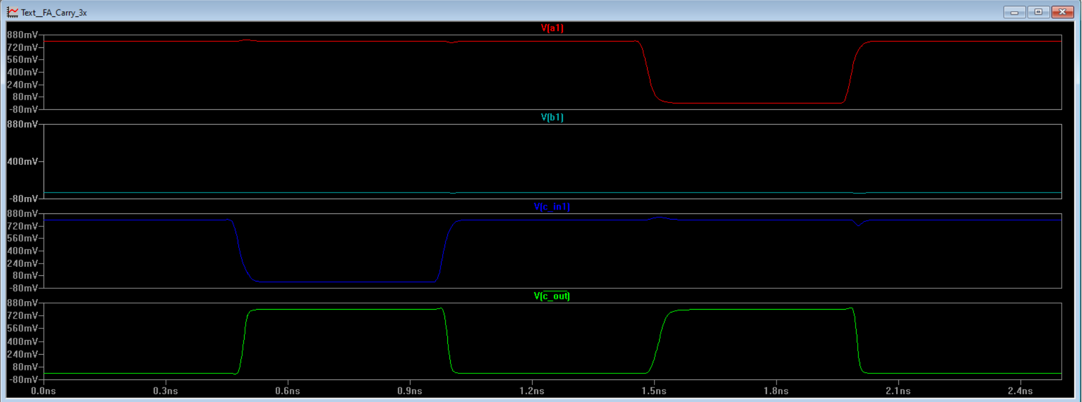

Delay Measurements with RC extraction:

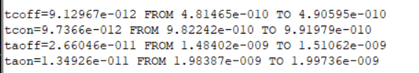

Extra Delay % after RC extraction:

Delay due to transition in Cin: (contributing to Critical Path)

TCoff = 16.95%

TCon = 18.20%

Delay due to transition in A:

TAoff = 29.83%

TAon = 23.44%