**Batch Tutorial – (7a)**

**Full Adder Sum Generation (2x)**

Schematic:

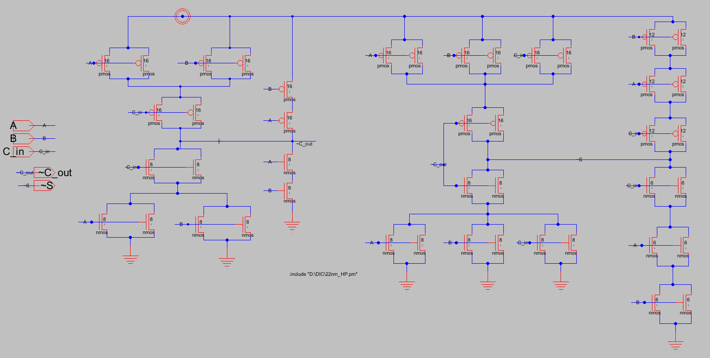

Layout:

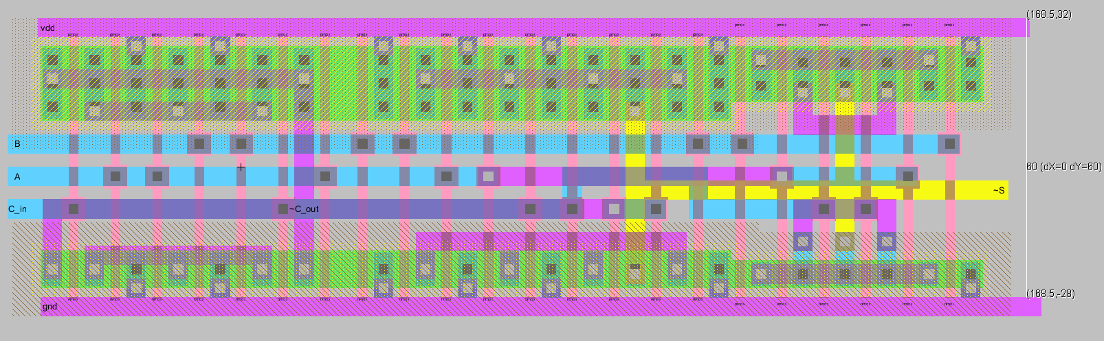

DRC/LVS Reports: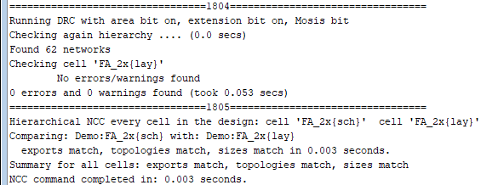

Testbench with RC extracted FA:

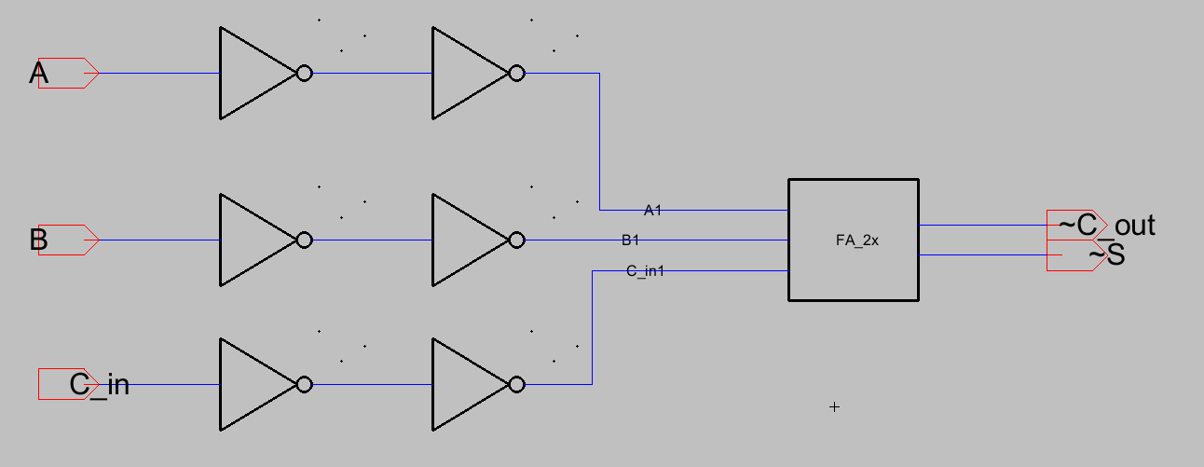

Simulation Inputs:

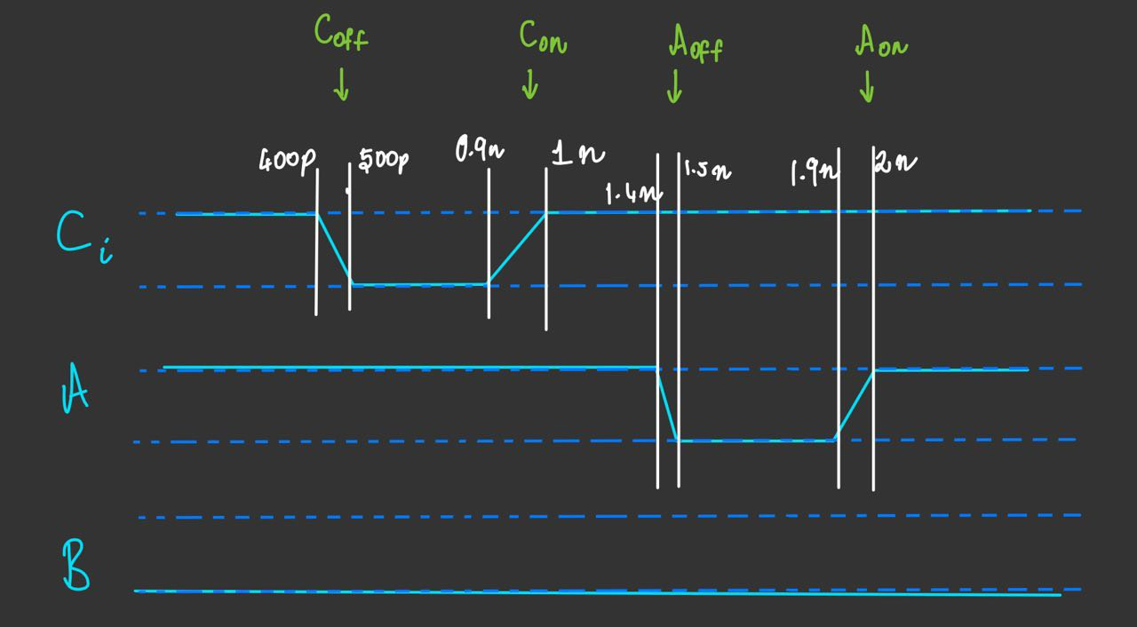

Delay Measurements with RC extraction:

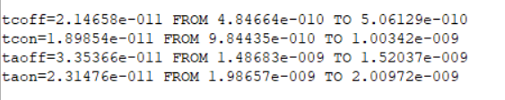

Simulated Waveforms:

