

## 5CS037

## Technology of AI

## Analysis of World Happiness Report:Exploring South Asia and Middle East Perspective

Name: Shreya Bhatta

Group:L5CG16

Student Id: 2408994

Submitted on: Dec 20 2024

**Intoduction**

The World Happiness Report is a publication that ranks countries based on how happy their citizens are. It also looks at various factors linked to quality of life such as income, social support,life expectacy,freedom and corruption.

This report aims to:

#Conduct an in-depth analysis of happiness in South Asia.

#Explore the dataset used in the Wolrd Happiness Report.

#Compare happiness levels between South Asia and the Middle east.

Problem 1 : Data Exploration

After loading the dataset, I displayed the first 10 rows to understand its structure. The data set consist row X and column Y with their corresponding data. I calculated the mean, median, and standard deviation for the score column, identifying the happiest and least happy countries. I checked for missing values and filtered the dataset to show countries with a score above 7.5, sorted by GDP per capita in decending order.

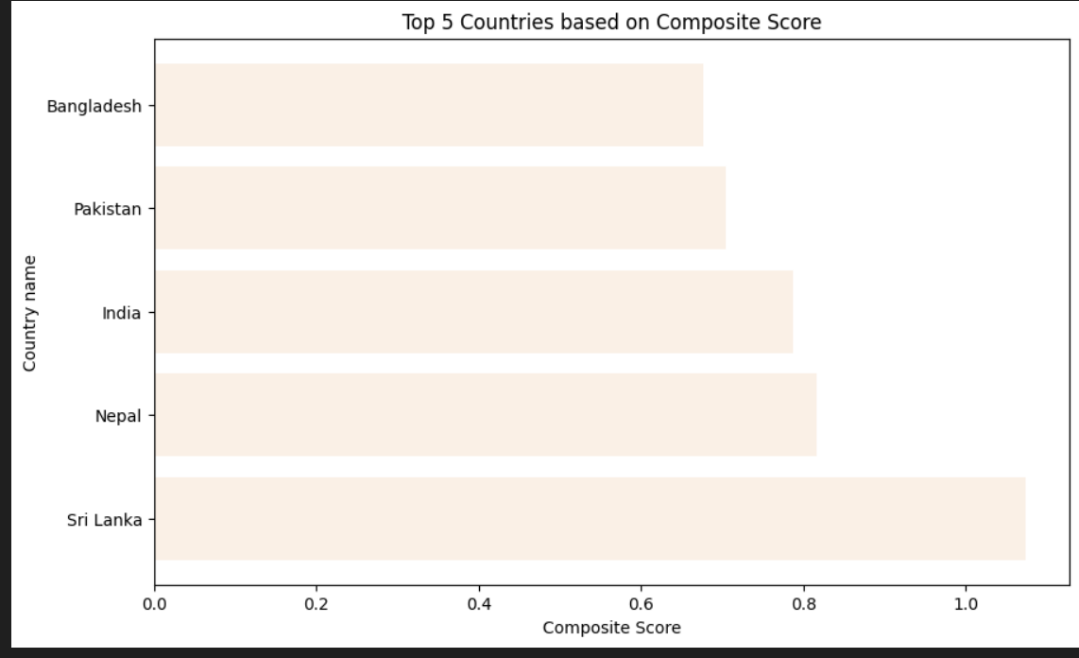

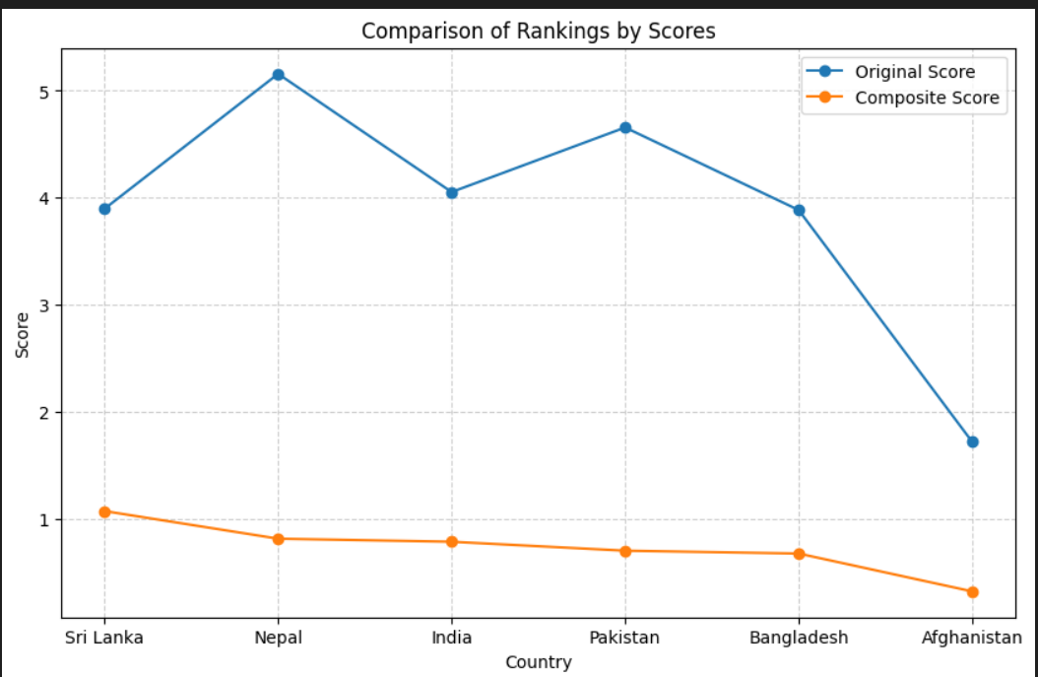

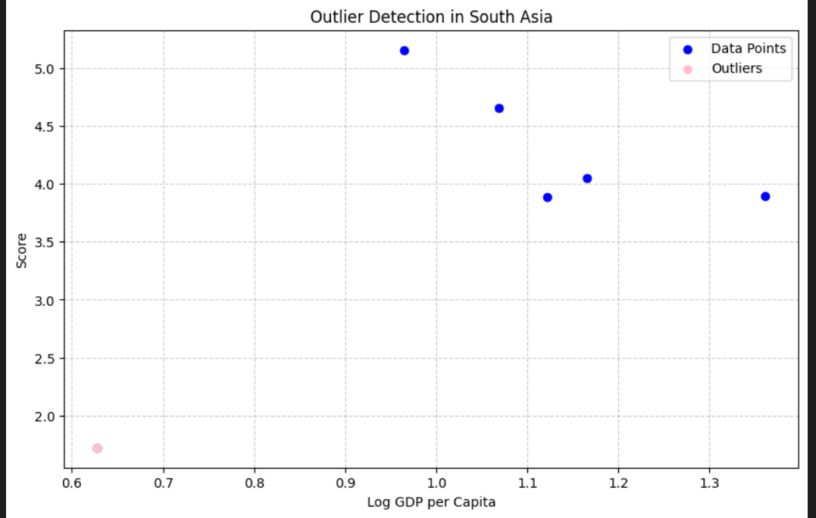

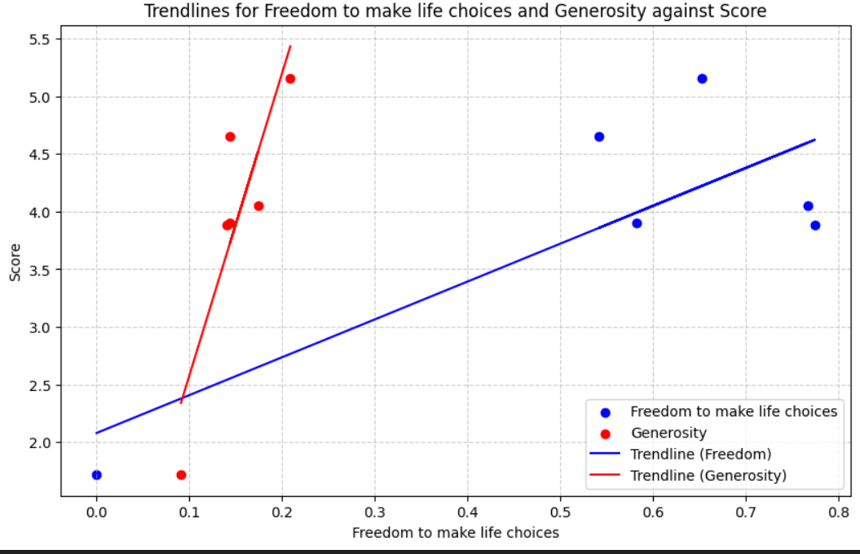

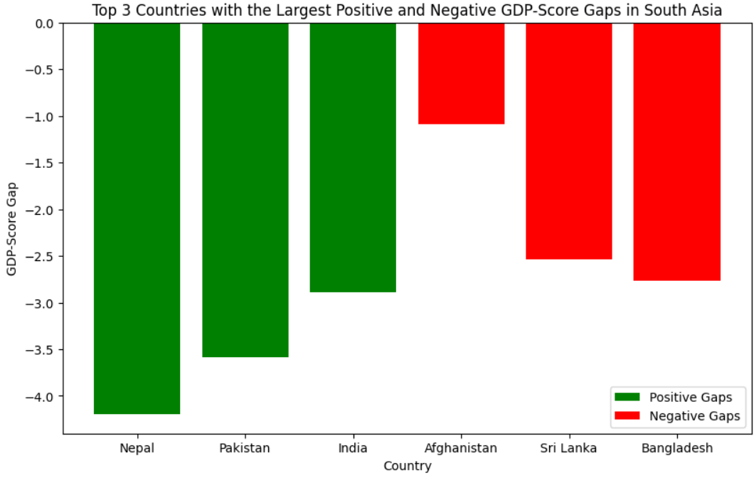

Problem 3: Comparative Analysis

For problem 3, I analyzed the happiness scores of Middle East and South Asia, finding the Middle East had a higher average score.

I identified the top and bottom 3 countries in both regions. Using bar charts, I compared GDP, Social supportand Life expectancy, highlighting the largest differences in social support and GDP.

I calculated the range and coefficient of variation, finding greater variability in the Middle East. Scatter plots were used to explore correlations between scores and metrics life freedom and generosity.

Outlires in both region were identified, and boxplots indicated higher variance in South Asia’s scores.

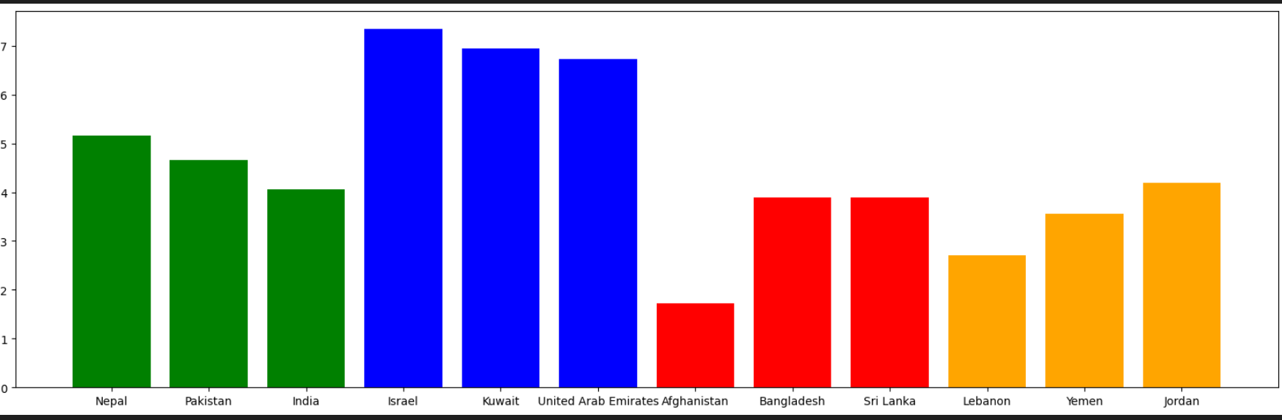

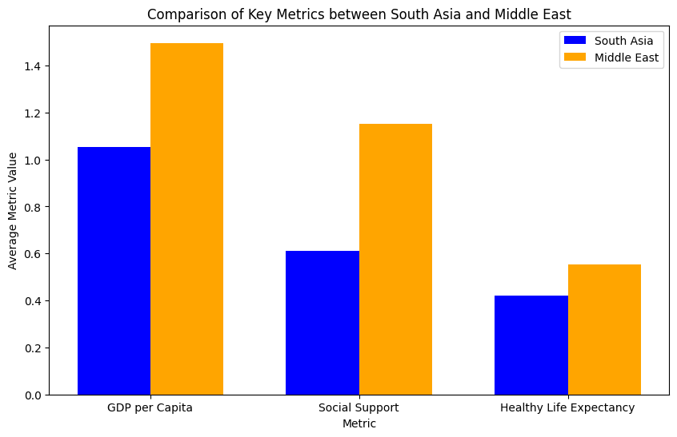

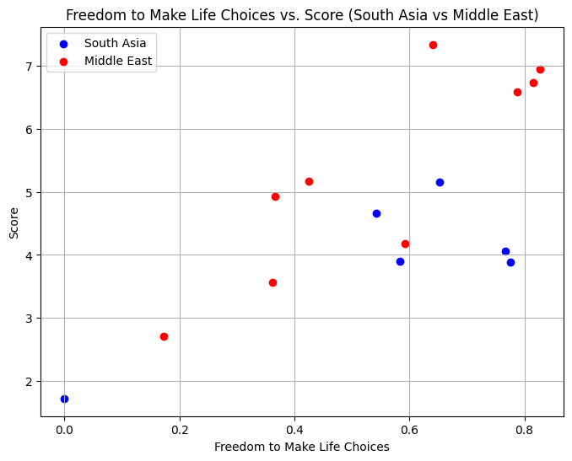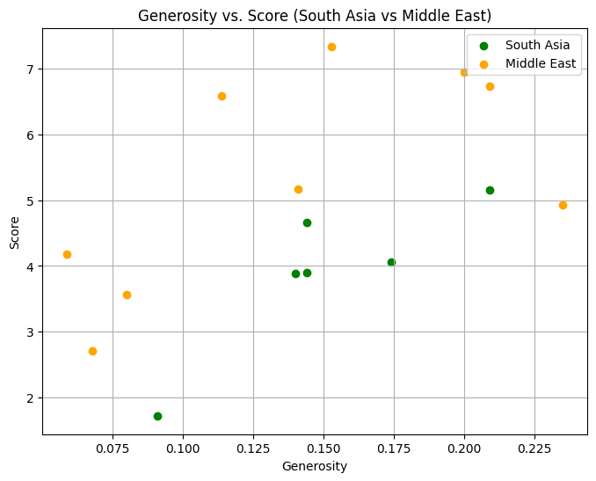

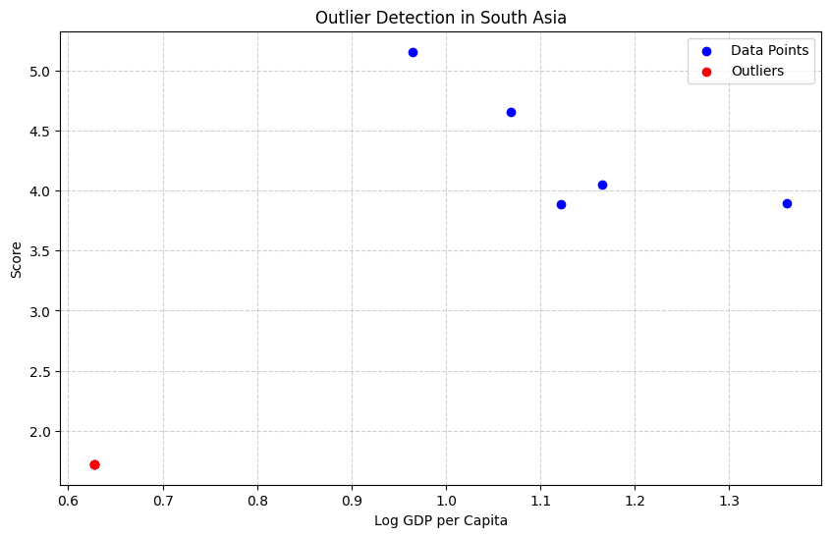

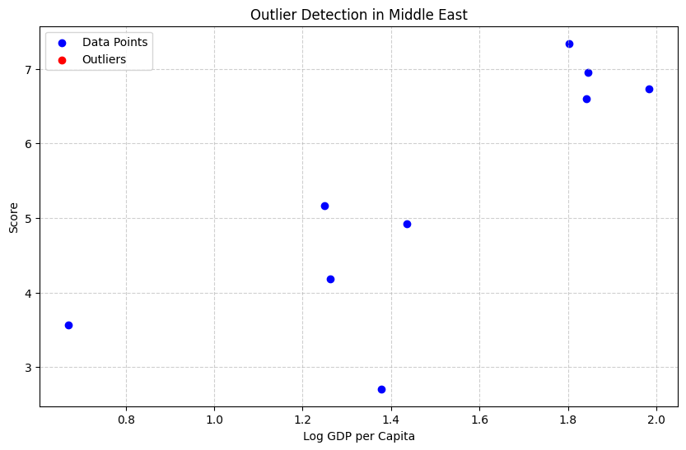

## 

Conclusion

To conclude, the analysis of the dataset offered meaningful insights into the happiness and well-being of countries in South Asia and Middle East.

In problem 1, I examined the dataset by reviewing the first 10 rows, identifying missing values, and calculating key statistics such as the mean,median,and standard deviation for the Score column.

In problem 2, I developed a Composite Score based on GDp per capita,social support, and healthy life expectancy. Then i ranked the countries accordingly and visualized the top performers.

In problem 3, I compared South Asia and Middle East by analyzing descriptive statistics, identifying the best and worst performers, and comparing metrics like GDP per capita and social support.