# Data Collection and Cleaning

The data was collected from the participants using questionnaires.

The data was then captured in an excel worksheet.

The data was cleaned to remove missing values, redundant data and duplicates.

The data was then analyzed using excel after which graphs and charts were drawn to visualize the data.

Below is the questionnaire

|  |  |  |  |  |  |  |
| --- | --- | --- | --- | --- | --- | --- |
| No | Question | Strongly Agree | Agree | Neutral | Disagree | Strongly Disagree |
| 1 | Digital Libraries has had positive impact on users | 5 | 3 | 1 | 1 | 0 |
| 2 | Digital libraries lead to greater efficiency | 6 | 2 | 1 | 0 | 1 |
| 3 | Digital libraries are better than manual libraries | 4 | 3 | 1 | 1 | 1 |
| 4 | Digital libraries are hard to use | 1 | 2 | 3 | 4 | 1 |
| 5 | Digital libraries require more resources thus expensive | 2 | 4 | 2 | 1 | 1 |
| 6 | It is easier to use digital libraries than manual libraries | 5 | 3 | 1 | 1 | 0 |
| 7 | Digital libraries require people who are more technologically advanced | 6 | 3 | 1 | 0 | 0 |
| 8 | Digital libraries lead to duplication of duties if combined with manual systems | 3 | 4 | 2 | 1 | 0 |
| 9 | Digital libraries will take over manual ones | 7 | 2 | 1 | 0 | 0 |
| 10 | Digital libraries lead to greater accessibility of resources | 5 | 3 | 0 | 2 | 0 |

## Results

We had a total of ten respondents who filled the questionnaire.

On the first question which was assessing whether digital libraries had a positive impact, 50% of the respondents strongly agreed. 30% of the respondents agreed while the remaining 20% were neutral.

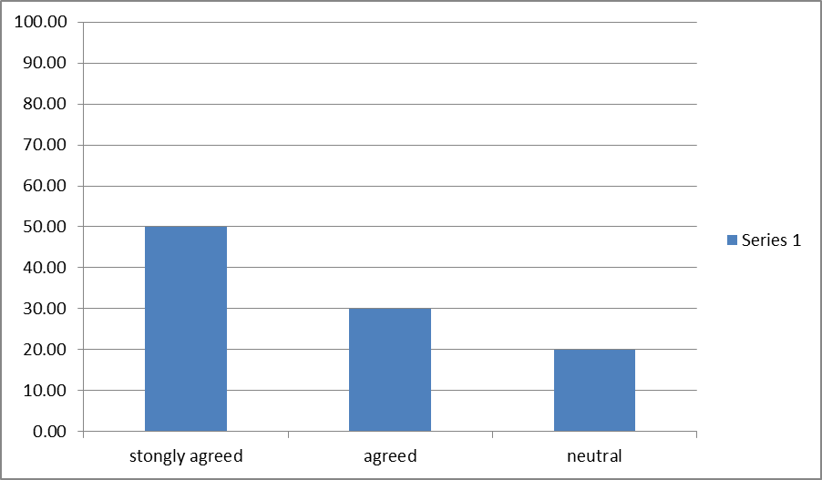

The second question was whether digital libraries led to greater efficiency. Out of the ten responses, 70% strongly agreed, 10% were neutral while 20% of the respondents disagreed.

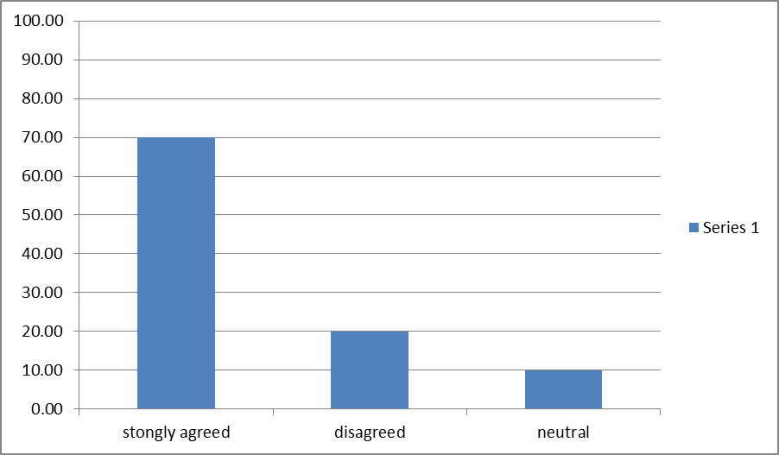

The third question in the questionnaire was whether the digital libraries were better than manual libraries. Of the ten respondents, 80% strongly agreed while the remaining 20% agreed.

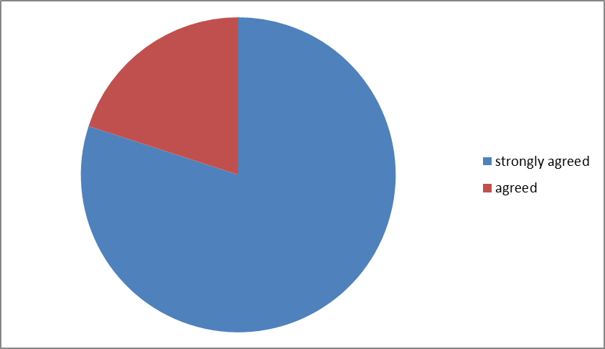

Another issue raised in the questionnaire was the ease of use of digital libraries. 30% of the respondents agreed, 50% were neutral while 20% of the respondents disagreed.

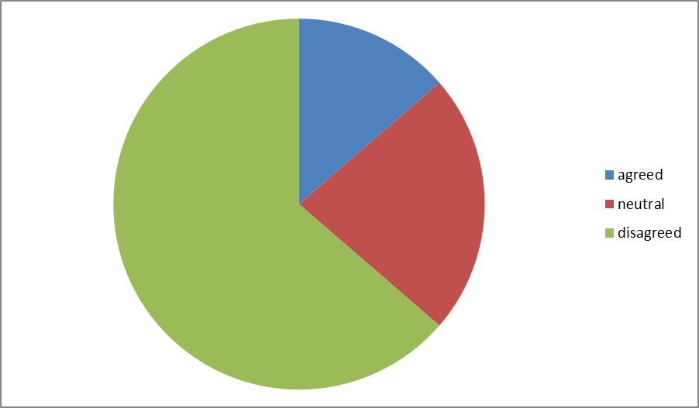

Of the ten respondents, 70% of the respondents agreed that digital libraries require more resources thus more expensive. The remaining 30% were neutral.

50 % strongly agree that digital libraries were easier to use than the manual libraries. 40% agreed with this fact while 10% disagreed.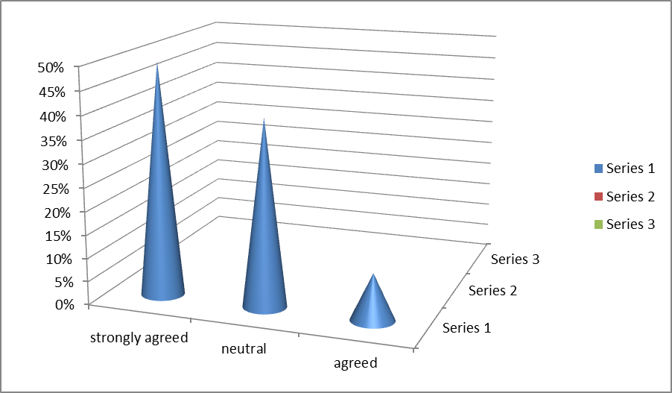

On the issue of whether digital libraries require people who are more technologically advanced, 40% of the respondents agreed, 30% disagreed while the remaining 30% strongly disagreed.

We further went ahead to investigate if digital libraries lead to duplication of duties. Of the respondents, 60% agreed, 20% were neutral while a further 20% disagreed.

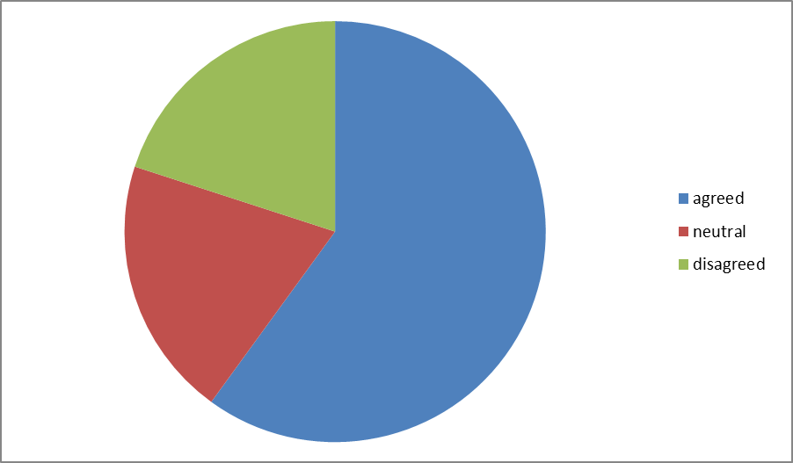

On the issue of whether digital libraries will take over manual systems, 20% strongly agreed, 40% agreed, 10% were neutral while 30% disagreed.

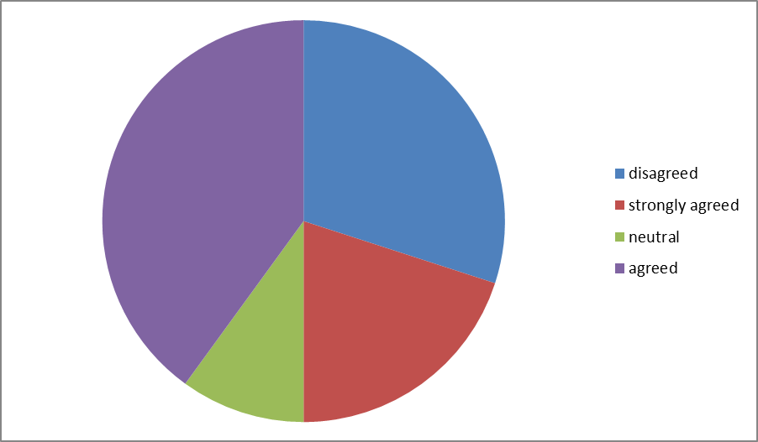

The last question was whether digital libraries lead to greater accessibility of information. 70% strongly agreed while the remaining 30% agreed.