Project 01

In this project, you will develop a simple Node.js application, deploy it on a local Kubernetes cluster using Minikube, and configure various Kubernetes features. The project includes Git version control practices, creating and managing branches, and performing rebases. Additionally, you will work with ConfigMaps, Secrets, environment variables, and set up vertical and horizontal pod autoscaling.

Project 01

Project Steps

1. Setup Minikube and Git Repository

Start Minikube:

1.2 Set Up Git Repository
Create a new directory for your project:
mkdir nodejs-k8s-project
cd nodejs-k8s-project

Initialize Git repository:
git init

Create a .gitignore file:
node_modules/
.env
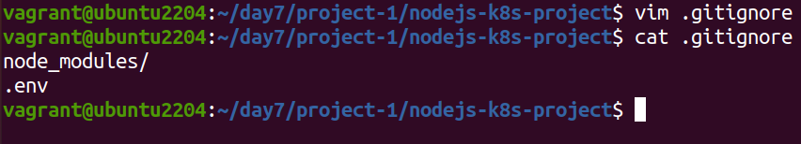

Add and commit initial changes:
git add .
git commit -m "Initial commit"
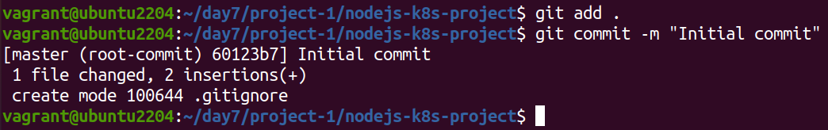

2. Develop a Node.js Application

2.1 Create the Node.js App
Initialize the Node.js project:
npm init -y
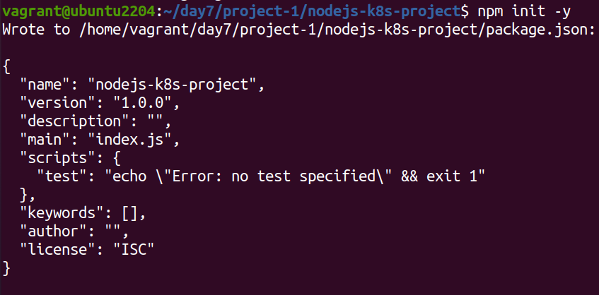

Install necessary packages:
npm install express body-parser
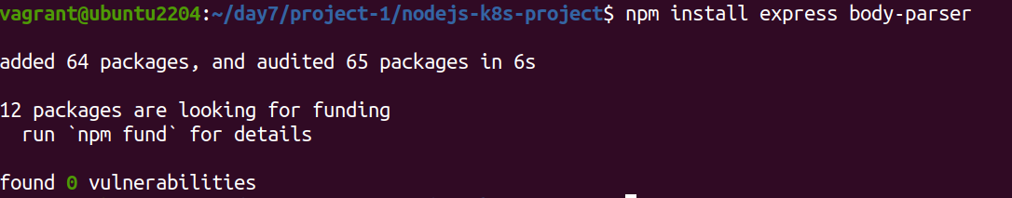

Create app.js:
const express = require('express');
const bodyParser = require('body-parser');
const app = express();
const PORT = process.env.PORT || 3000;

app.use(bodyParser.json());

app.get('/', (req, res) => {
res.send('Hello, World!');
});

app.listen(PORT, () => {
console.log(`Server is running on port ${PORT}`);
});

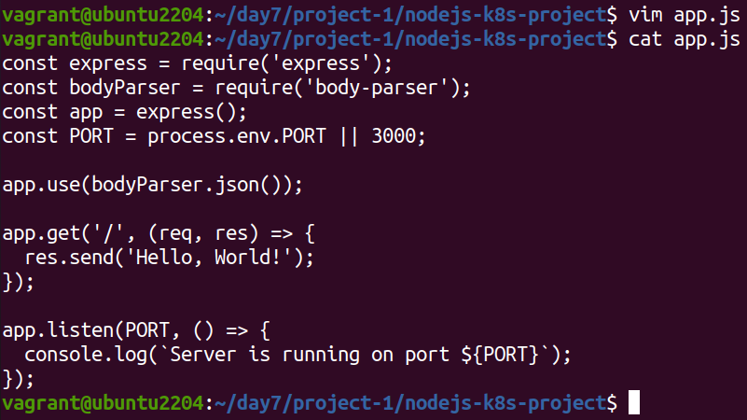
Update package.json to include a start script:
"scripts": {
"start": "node app.js",
}

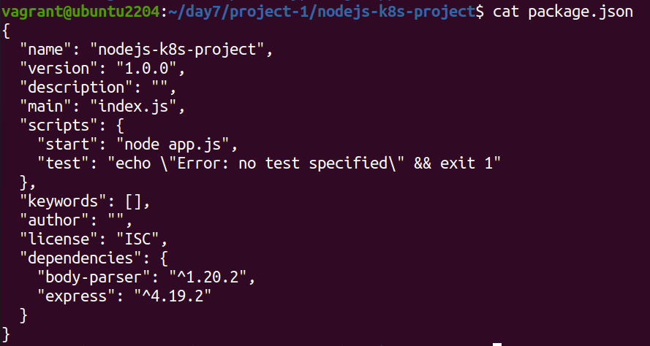
2.2 Commit the Node.js Application
Add and commit changes:
git add .
git commit -m "Add Node.js application code"
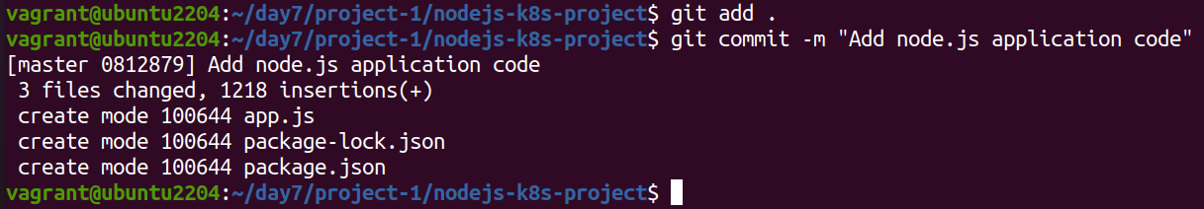

3. Create Dockerfile and Docker Compose

3.1 Create a Dockerfile
Add Dockerfile:
# Use official Node.js image
FROM node:18

# Set the working directory
WORKDIR /usr/src/app

# Copy package.json and package-lock.json
COPY package*.json ./

# Install dependencies
RUN npm install

# Copy the rest of the application code
COPY . .

# Expose the port on which the app runs
EXPOSE 3000

# Command to run the application
CMD [ "npm", "start" ]
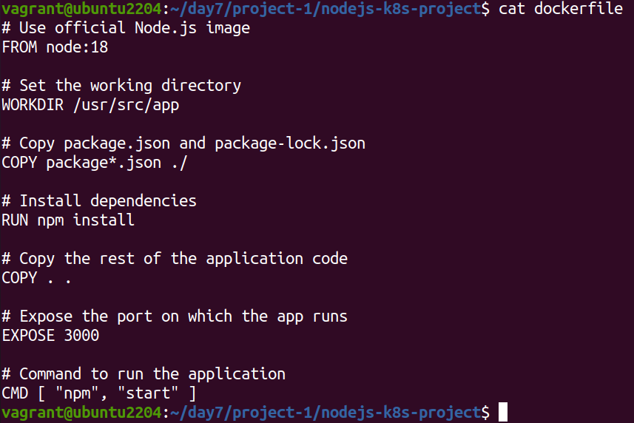

Create a .dockerignore file:
node_modules
.npm
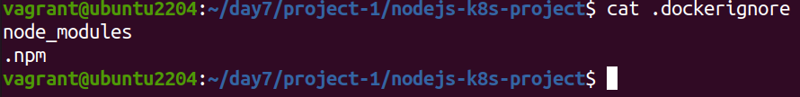

3.2 Create docker-compose.yml (optional for local testing)
Add docker-compose.yml:
version: '3'
services:
app:
build: .
ports:
- "3000:3000"
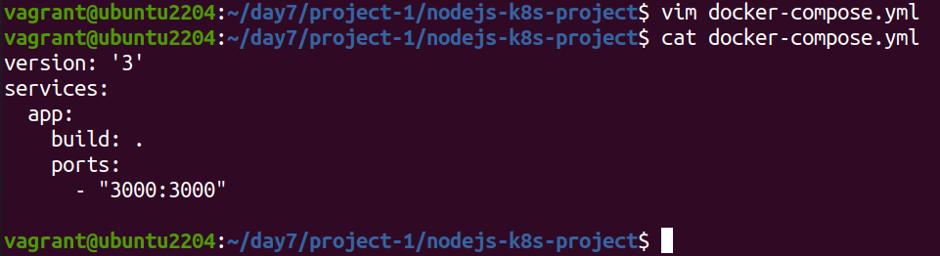

Add and commit changes:
git add Dockerfile docker-compose.yml
git commit -m "Add Dockerfile and Docker Compose configuration"
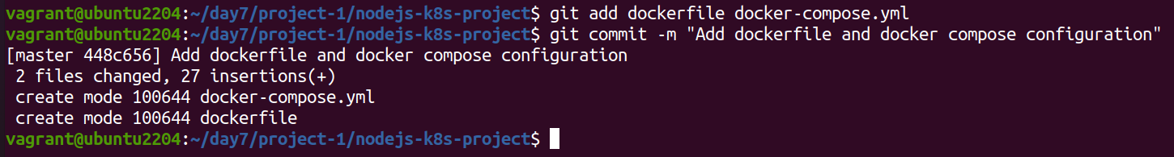

4. Build and Push Docker Image

4.1 Build Docker Image
Build the Docker image:
docker build -t nodejs-app:latest .
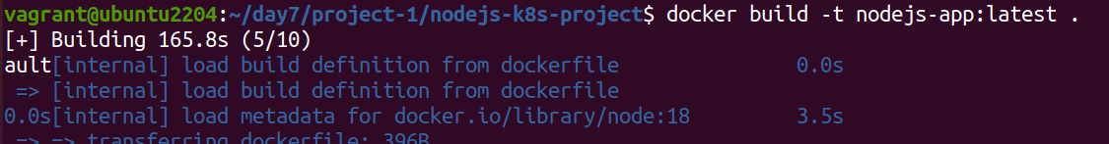

4.2 Push Docker Image to Docker Hub
Tag and push the image:
docker tag nodejs-app:latest your-dockerhub-username/nodejs-app:latest
docker push your-dockerhub-username/nodejs-app:latest
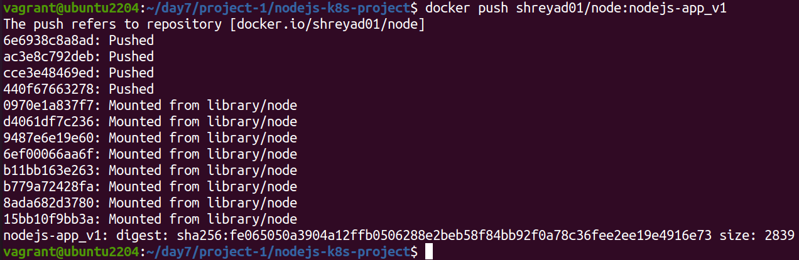

Add and commit changes:
git add .
git commit -m "Build and push Docker image"
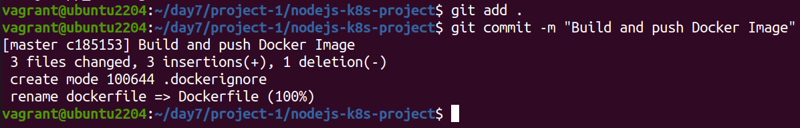

5. Create Kubernetes Configurations

5.1 Create Kubernetes Deployment
Create kubernetes/deployment.yaml:
apiVersion: apps/v1
kind: Deployment
metadata:
name: nodejs-app-deployment
spec:
replicas: 2
selector:
matchLabels:
app: nodejs-app
template:
metadata:
labels:
app: nodejs-app
spec:
containers:
- name: nodejs-app
image: your-dockerhub-username/nodejs-app:latest
ports:
- containerPort: 3000
env:
- name: PORT
valueFrom:
configMapKeyRef:
name: app-config
key: PORT
- name: NODE_ENV
valueFrom:
secretKeyRef:
name: app-secrets
key: NODE_ENV
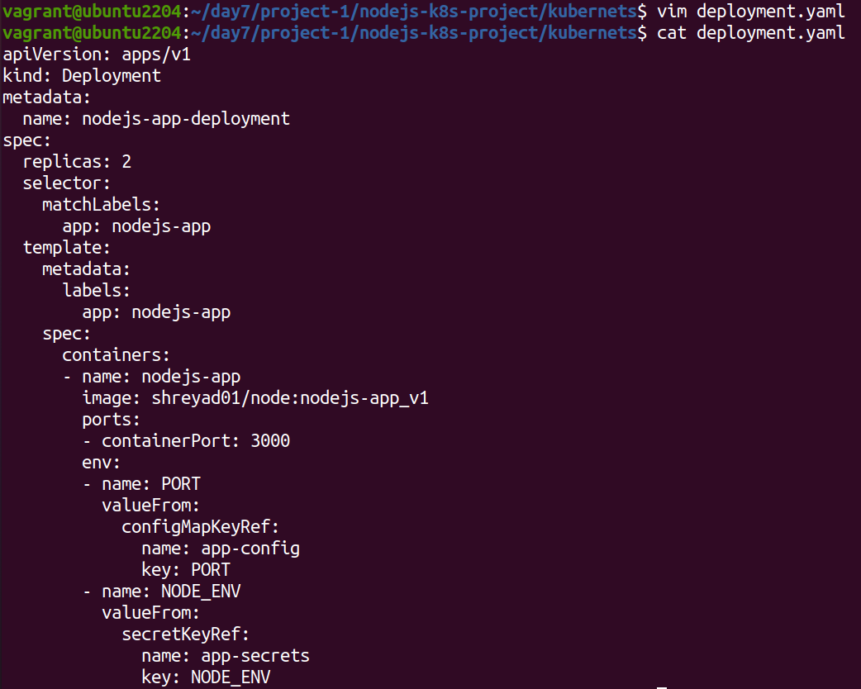

5.2 Create ConfigMap and Secret
Create kubernetes/configmap.yaml:
apiVersion: v1
kind: ConfigMap
metadata:
name: app-config
data:
PORT: "3000"
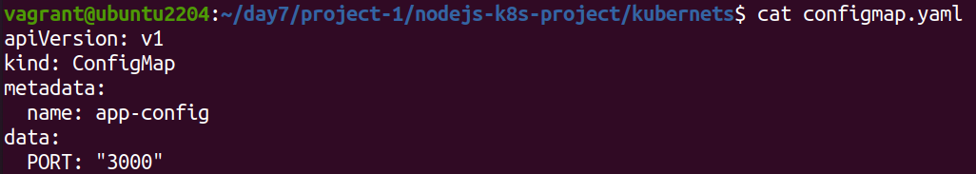
Create kubernetes/secret.yaml:
apiVersion: v1
kind: Secret
metadata:
name: app-secrets
type: Opaque
data:
NODE_ENV: cHJvZHVjdGlvbmFs # Base64 encoded value for "production"
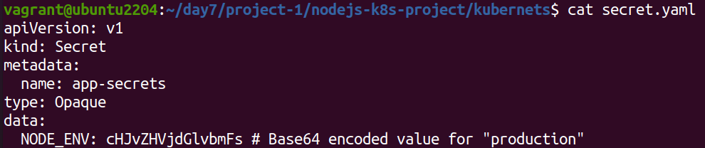

Add and commit Kubernetes configurations:
git add kubernetes/
git commit -m "Add Kubernetes deployment, configmap, and secret"
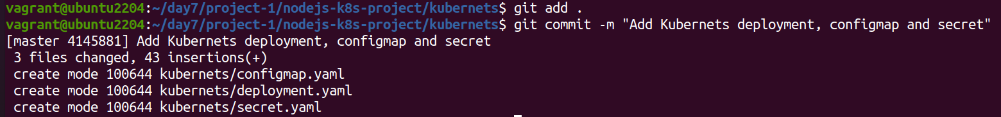

5.3 Apply Kubernetes Configurations
Apply the ConfigMap and Secret:
kubectl apply -f kubernetes/configmap.yaml
kubectl apply -f kubernetes/secret.yaml

Apply the Deployment:
kubectl apply -f kubernetes/deployment.yaml

6. Implement Autoscaling

6.1 Create Horizontal Pod Autoscaler
Create kubernetes/hpa.yaml:
apiVersion: autoscaling/v2beta2
kind: HorizontalPodAutoscaler
metadata:
name: nodejs-app-hpa
spec:
scaleTargetRef:
apiVersion: apps/v1
kind: Deployment
name: nodejs-app-deployment
minReplicas: 2
maxReplicas: 5
metrics:
- type: Resource
resource:
name: cpu
target:
type: Utilization
averageUtilization: 50
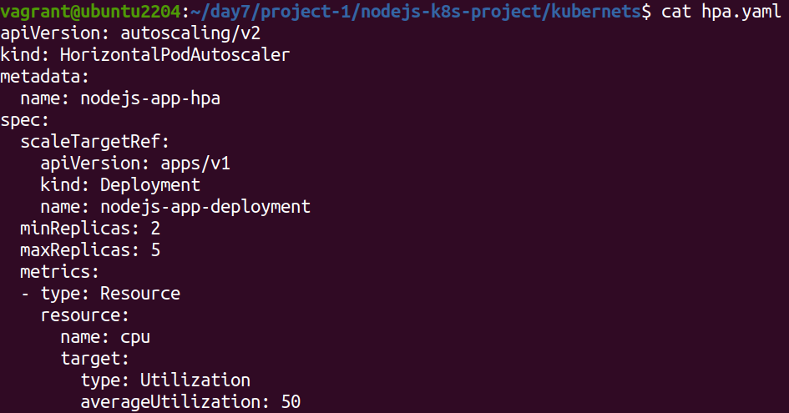

Apply the HPA:
kubectl apply -f kubernetes/hpa.yaml

6.2 Create Vertical Pod Autoscaler
Create kubernetes/vpa.yaml:
apiVersion: autoscaling.k8s.io/v1beta2
kind: VerticalPodAutoscaler
metadata:
name: nodejs-app-vpa
spec:
targetRef:
apiVersion: apps/v1
kind: Deployment
name: nodejs-app-deployment
updatePolicy:
updateMode: "Auto"

Apply the VPA:
kubectl apply -f kubernetes/vpa.yaml

7. Test the Deployment

7.1 Check the Status of Pods, Services, and HPA
Verify the Pods:
kubectl get pods
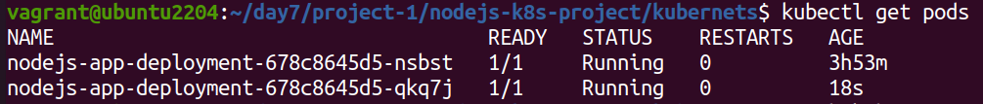

Verify the Services:
kubectl get svc

Verify the HPA:
kubectl get hpa

7.2 Access the Application
Expose the Service:
kubectl expose deployment nodejs-app-deployment --type=NodePort –name=nodejs-app-service

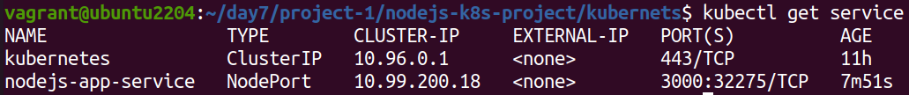
Get the Minikube IP and Service Port:
minikube service nodejs-app-service –url
- Access the Application in your browser using the URL obtained from the previous command.

8. Git Version Control

8.1 Create a New Branch for New Features
Create and switch to a new branch:
git checkout -b feature/new-feature

Make changes and commit:
# Make some changes
git add .
git commit -m "Add new feature"
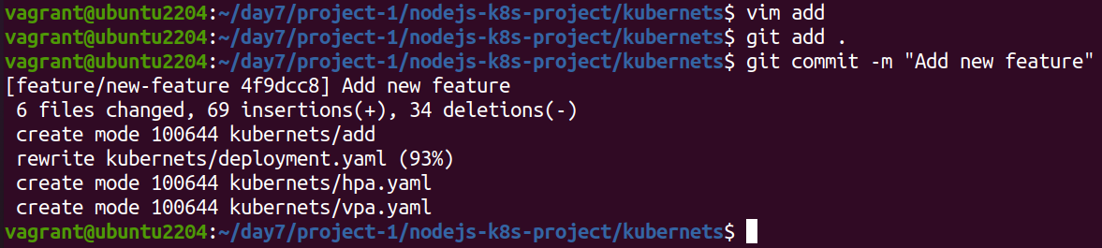

Push the branch to the remote repository:
git push origin feature/new-feature
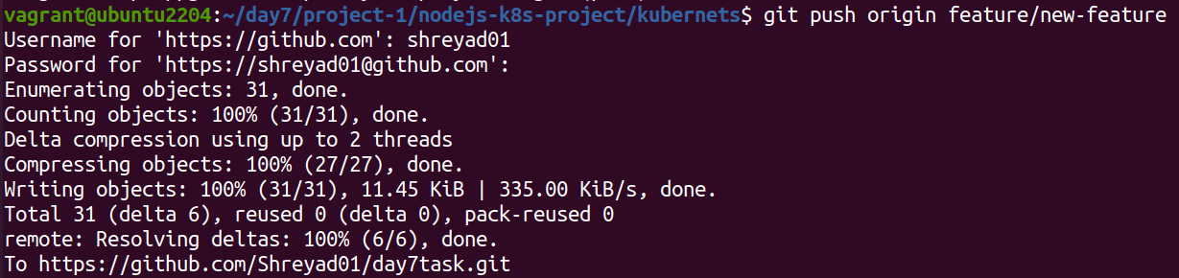

8.2 Rebase Feature Branch on Main Branch
Switch to the main branch and pull the latest changes:
git checkout main
git pull origin main
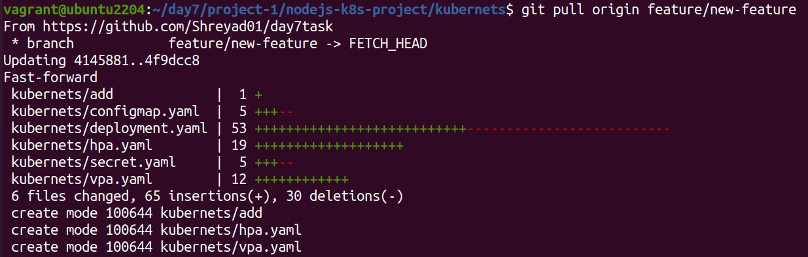

Rebase the feature branch:
git checkout feature/new-feature
git rebase main
Resolve conflicts if any, and continue the rebase:
git add .
git rebase --continue

Push the rebased feature branch:
git push origin feature/new-feature –force

9. Final Commit and Cleanup
Merge feature branch to main:
git checkout main

git merge feature/new-feature
Push the changes to the main branch:
git push origin main
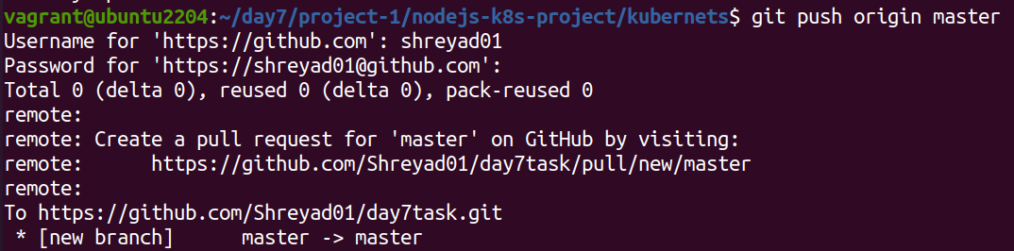

Clean up:
git branch -d feature/new-feature
git push origin --delete feature/new-feature
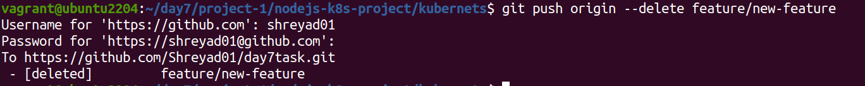

Project 02

Deploy a Node.js application to Kubernetes with advanced usage of ConfigMaps and Secrets. Implement Horizontal Pod Autoscaler (HPA) with both scale-up and scale-down policies. The project will include a multi-environment configuration strategy, integrating a Redis cache, and monitoring application metrics.

Project Setup

1.1 Initialize a Git Repository
Create a new directory for your project and initialize Git:
mkdir nodejs-advanced-k8s-project
cd nodejs-advanced-k8s-project
git init

1.2 Create Initial Files
Create the initial Node.js application and Docker-related files:
npm init -y
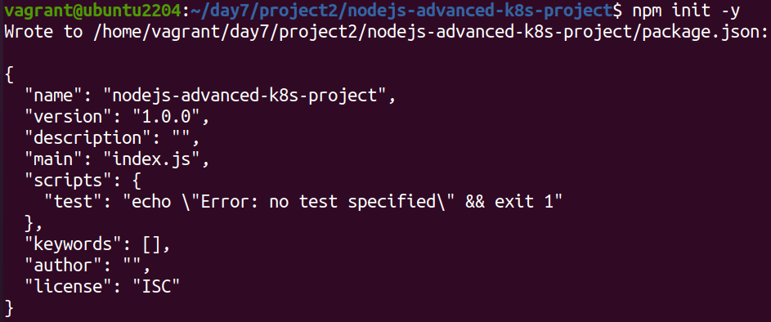
npm install express redis body-parser
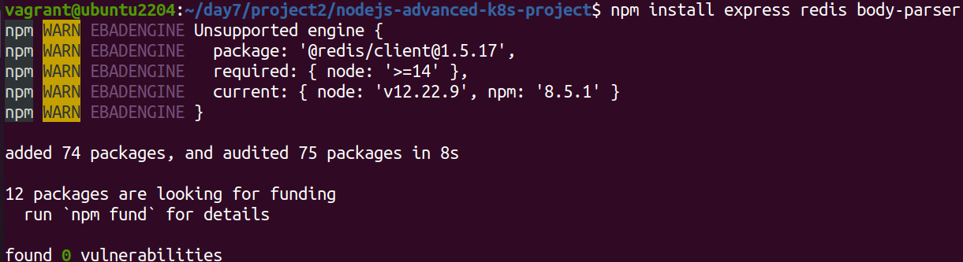

app.js

const express = require('express');
const bodyParser = require('body-parser');
const redis = require('redis');
const app = express();
const PORT = process.env.PORT || 3000;

// Connect to Redis
const redisClient = redis.createClient({
url: `redis://${process.env.REDIS_HOST}:${process.env.REDIS_PORT}`
});
redisClient.on('error', (err) => console.error('Redis Client Error', err));

app.use(bodyParser.json());

app.get('/', async (req, res) => {
const visits = await redisClient.get('visits');
if (visits) {
await redisClient.set('visits', parseInt(visits) + 1);
} else {
await redisClient.set('visits', 1);
}
res.send(`Hello, World! You are visitor number ${visits || 1}`);
});

app.listen(PORT, () => {
console.log(`Server is running on port ${PORT}`);
});
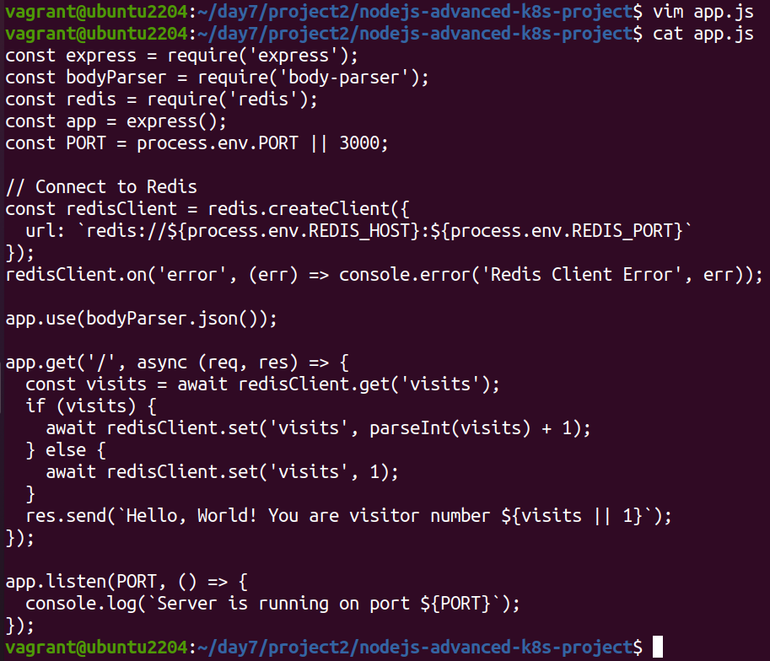

Dockerfile

FROM node:18

WORKDIR /usr/src/app

COPY package*.json ./

RUN npm install

COPY . .

EXPOSE 3000

CMD ["npm", "start"]
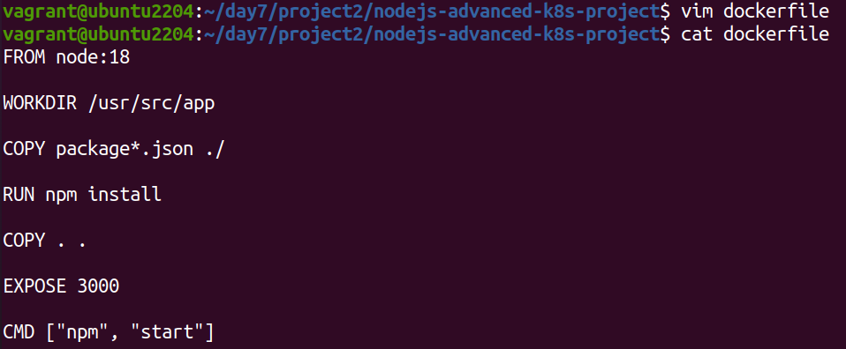

.dockerignore

node_modules
.npm
1. Build and push Docker image:

docker build -t your-dockerhub-username/nodejs-advanced-app:latest .
docker push your-dockerhub-username/nodejs-advanced-app:latest
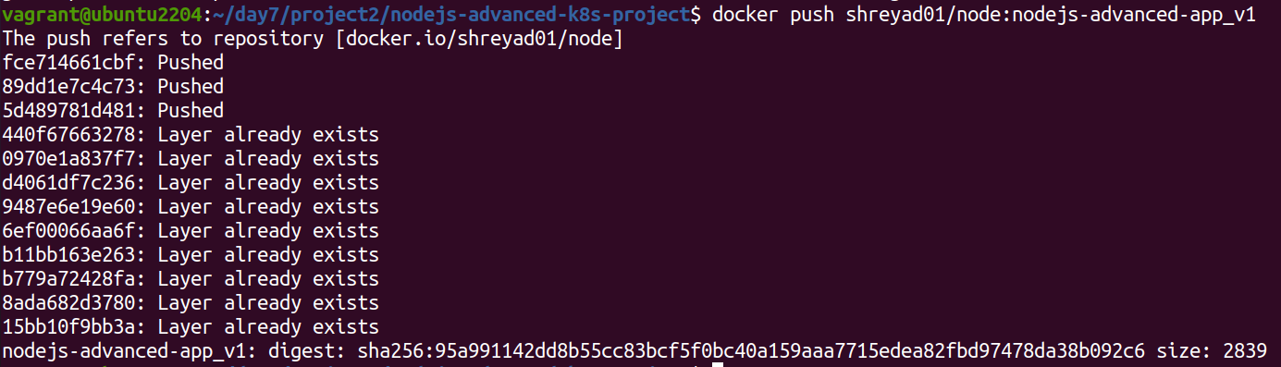
2. Advanced Kubernetes Configuration

2.1 Deployment Configuration

Create `kubernetes/deployment.yaml` to deploy the Node.js application with Redis dependency:

```yaml
apiVersion: apps/v1
kind: Deployment
metadata:
name: nodejs-advanced-app-deployment
spec:
replicas: 2
selector:
matchLabels:
app: nodejs-advanced-app
template:
metadata:
labels:
app: nodejs-advanced-app
spec:
containers:
- name: nodejs-advanced-app
image: your-dockerhub-username/nodejs-advanced-app:latest
ports:
- containerPort: 3000
env:
- name: PORT
valueFrom:
configMapKeyRef:
name: app-config
key: PORT
- name: REDIS_HOST
valueFrom:
configMapKeyRef:
name: redis-config
key: REDIS_HOST
- name: REDIS_PORT
valueFrom:
configMapKeyRef:
name: redis-config
key: REDIS_PORT
- name: NODE_ENV
valueFrom:
secretKeyRef:
name: app-secrets
key: NODE_ENV
- name: redis
image: redis:latest
ports:
- containerPort: 6379

2.2 ConfigMap for Application and Redis
Create kubernetes/configmap.yaml to manage application and Redis configurations:

apiVersion: v1
kind: ConfigMap
metadata:
name: app-config
data:
PORT: "3000"

---
apiVersion: v1
kind: ConfigMap
metadata:
name: redis-config
data:
REDIS_HOST: "redis"
REDIS_PORT: "6379"
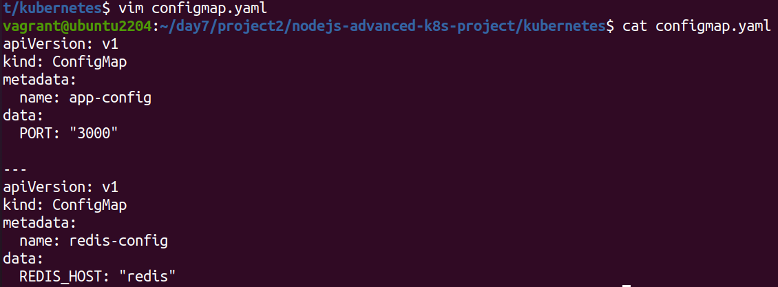

2.3 Secret for Sensitive Data
Create kubernetes/secret.yaml to manage sensitive environment variables:

apiVersion: v1
kind: Secret
metadata:
name: app-secrets
type: Opaque
data:
NODE_ENV: cHJvZHVjdGlvbg== # Base64 encoded value for "production"
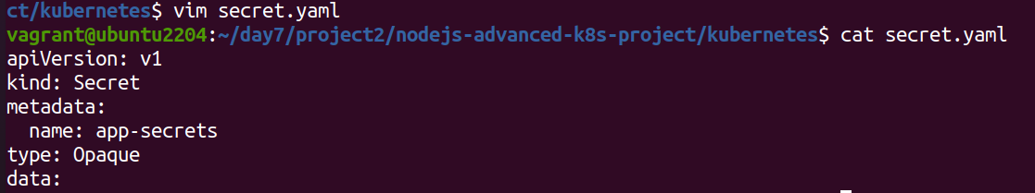

2.4 Service Configuration
Create kubernetes/service.yaml to expose the Node.js application:

apiVersion: v1
kind: Service
metadata:
name: nodejs-advanced-app-service
spec:
selector:
app: nodejs-advanced-app
ports:
- protocol: TCP
port: 80
targetPort: 3000
type: LoadBalancer
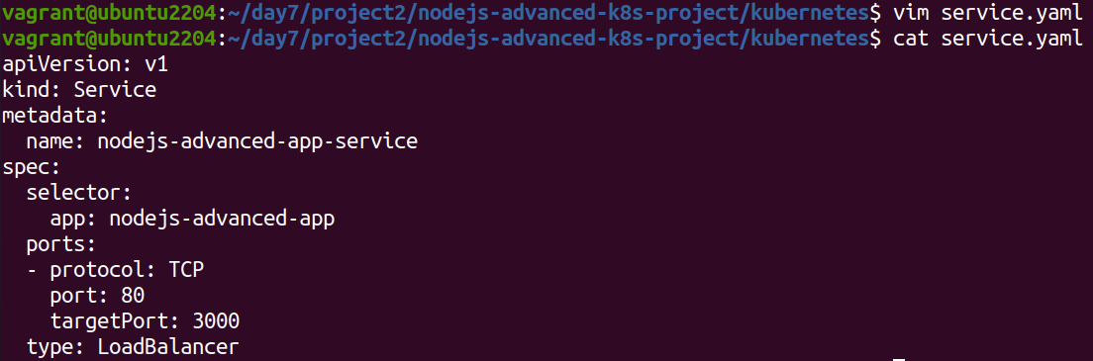

2.5 Horizontal Pod Autoscaler with Scale-Up and Scale-Down Policies
Create kubernetes/hpa.yaml to manage autoscaling:

apiVersion: autoscaling/v2beta2
kind: HorizontalPodAutoscaler
metadata:
name: nodejs-advanced-app-hpa
spec:
scaleTargetRef:
apiVersion: apps/v1
kind: Deployment
name: nodejs-advanced-app-deployment
minReplicas: 2
maxReplicas: 5
metrics:
- type: Resource
resource:
name: cpu
target:
type: Utilization
averageUtilization: 50
- type: Resource
resource:
name: memory
target:
type: Utilization
averageUtilization: 70

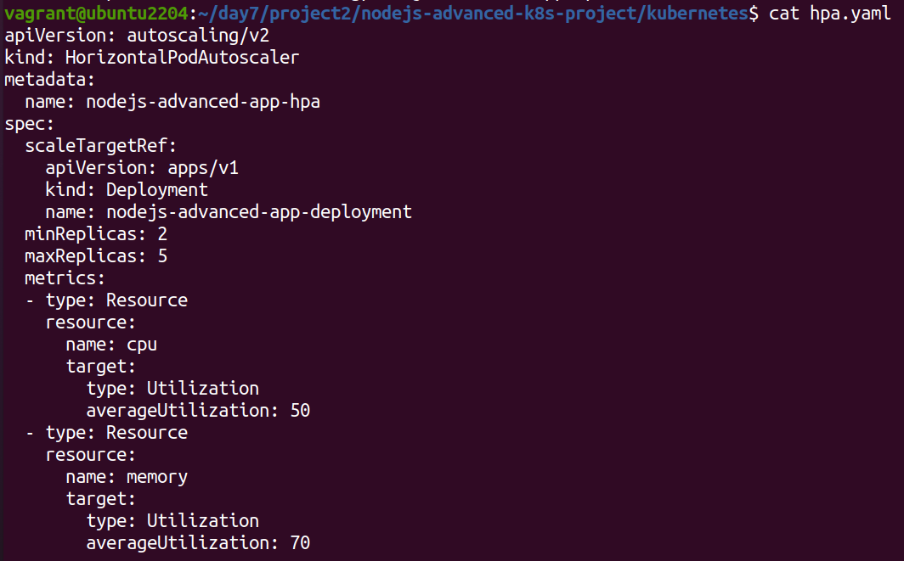

2.6 Vertical Pod Autoscaler Configuration
Create kubernetes/vpa.yaml to manage vertical scaling:

apiVersion: autoscaling.k8s.io/v1beta2
kind: VerticalPodAutoscaler
metadata:
name: nodejs-advanced-app-vpa
spec:
targetRef:
apiVersion: apps/v1
kind: Deployment
name: nodejs-advanced-app-deployment
updatePolicy:
updateMode: "Auto"
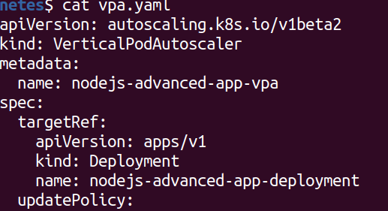

2.7 Redis Deployment
Add a Redis deployment configuration to kubernetes/redis-deployment.yaml:

apiVersion: apps/v1
kind: Deployment
metadata:
name: redis-deployment
spec:
replicas: 1
selector:
matchLabels:
app: redis
template:
metadata:
labels:
app: redis
spec:
containers:
- name: redis
image: redis:latest
ports:
- containerPort: 6379
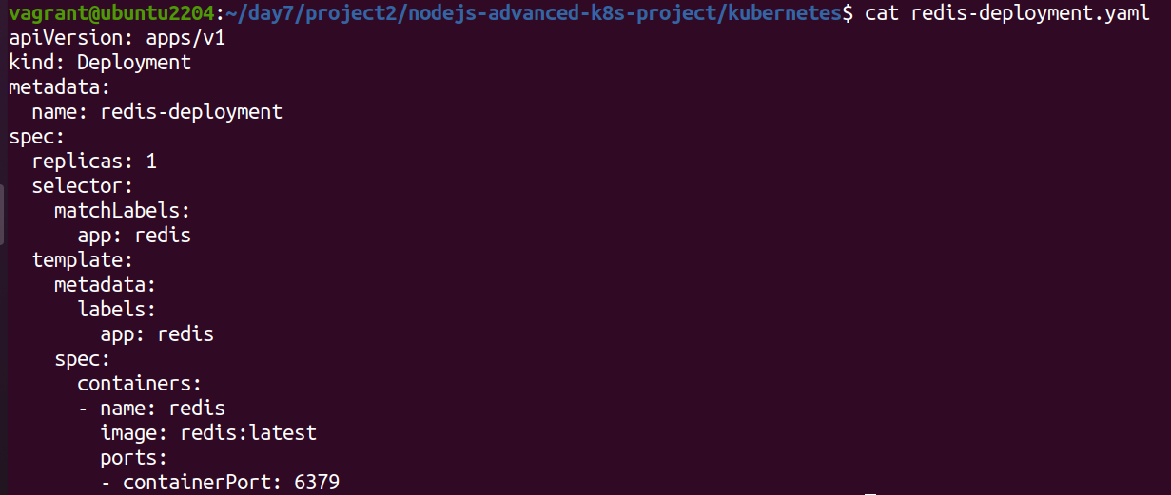

Add Redis service configuration to kubernetes/redis-service.yaml:

apiVersion: v1
kind: Service
metadata:
name: redis-service
spec:
selector:
app: redis
ports:
- protocol: TCP
port: 6379
targetPort: 6379
type: ClusterIP
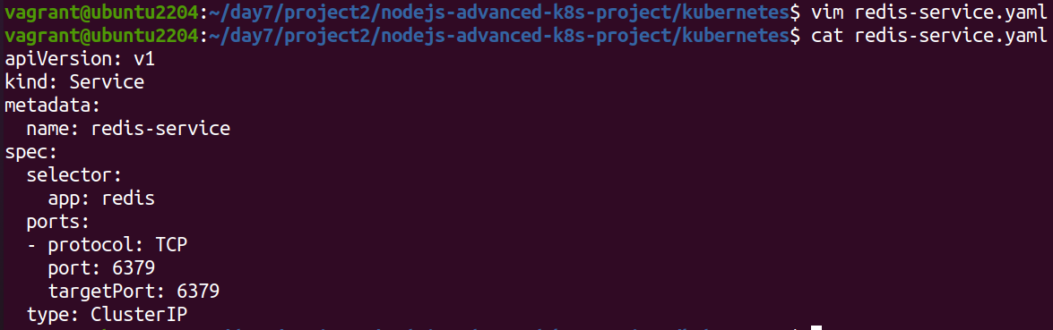

2.8 Apply Kubernetes Configurations
Apply all configurations to your Minikube cluster:

kubectl apply -f kubernetes/redis-deployment.yaml
kubectl apply -f kubernetes/redis-service.yaml
kubectl apply -f kubernetes/configmap.yaml
kubectl apply -f kubernetes/secret.yaml
kubectl apply -f kubernetes/deployment.yaml
kubectl apply -f kubernetes/service.yaml
kubectl apply -f kubernetes/hpa.yaml
kubectl apply -f kubernetes/vpa.yaml

2.9 Verify Deployments and Services
Check the status of your deployments and services:

kubectl get all

Access the application via Minikube:

minikube service nodejs-advanced-app-service –url

2.10 Testing Scaling
Simulate load on the application to test the HPA:

kubectl run -i --tty --rm load-generator --image=busybox --restart=Never -- /bin/sh
# Inside the pod, run the following command to generate load
while true; do wget -q -O- http://nodejs-advanced-app-service; done

2.11 Validate Autoscaling Behavior
Observe the HPA behavior:
kubectl get hpa
Watch the scaling events and verify that the application scales up and down based on the policies you configured.

3. Project Wrap-Up

3.1 Review and Clean Up
After completing the project, review the configurations and clean up the Minikube environment if needed:

minikube delete
