Docker Project 1

Creating a container from a pulled Image

1) first pull nginx image by using docker pull nginx command

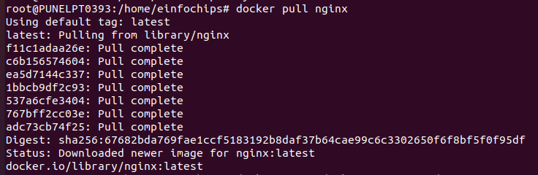
2) run nginx container and verify the container is running by using
docker run --name my-nginx -d -p 8080:80 nginx command

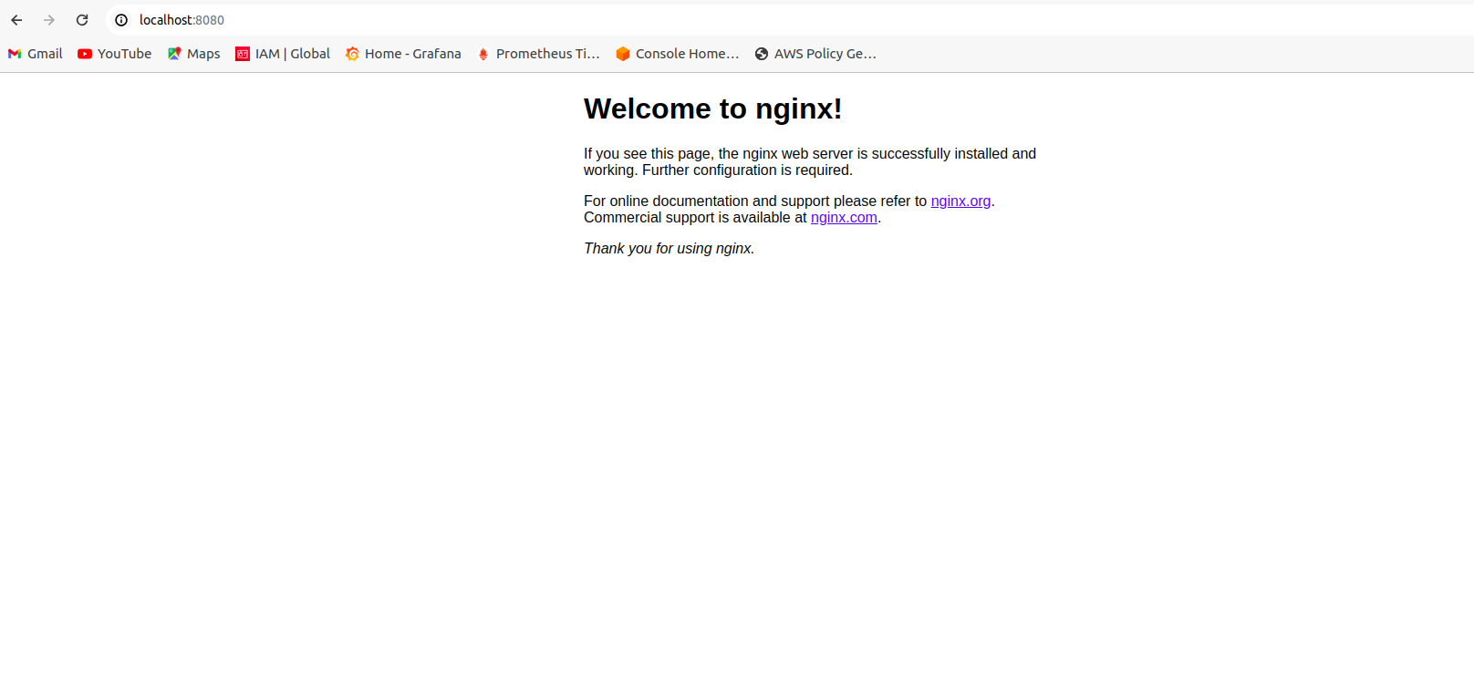
3) verify the container is running byr visiting in browser

Modifying the Container and Creating a New Image

Objective: Modify the running Nginx container to serve a custom HTML page and create a new image from this modified container.
1) Access the Running container by using docker exec -it my-nginx /bin/bash command

and create HTML page by using echo "<html><body><h1>Hello from Docker!</h1></body></html>" > /usr/share/nginx/html/index.html command

2) comit the changes to create new Image by using docker commit my-nginx custom-nginx command

and run the container from new Image by using docker run --name my-custom-nginx -d -p 8081:80 custom-nginx command

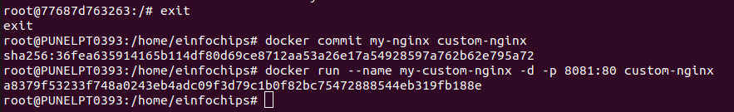
3) verify new container by visiting link in browser

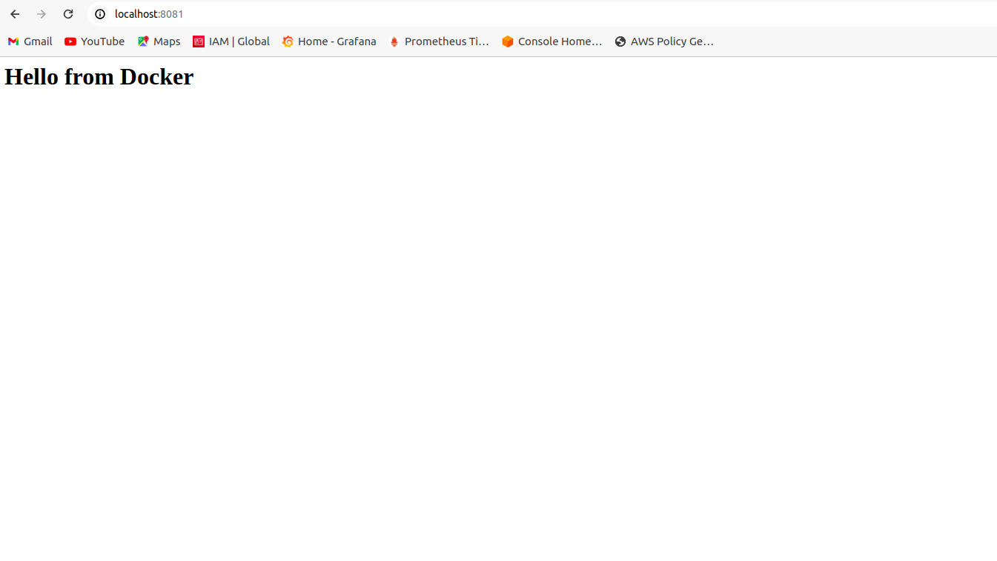

Creating Docker to build and Deploy a web Application
Objective: Write a Dockerfile to create an image for a simple web application and run it as a container.
1) create project directory name “ my-webapp” and move to that directory by using
mkdir my-webapp
cd my-webapp

2) In my-webapp create “ index.html “ file to write html code .

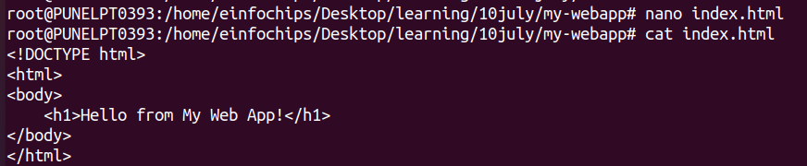
3) create Dockerfile
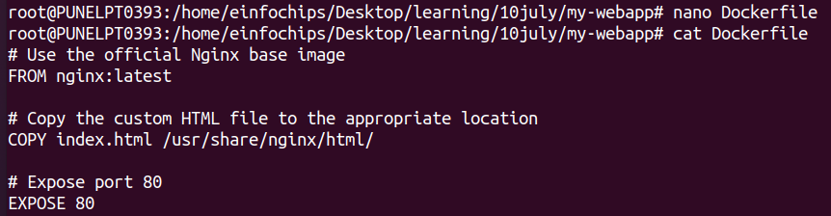

4) Build the docker Image docker build -t my-webapp-image .

and run the container from the build Image

docker run --name my-webapp-container -d -p 8082:80 my-webapp-image

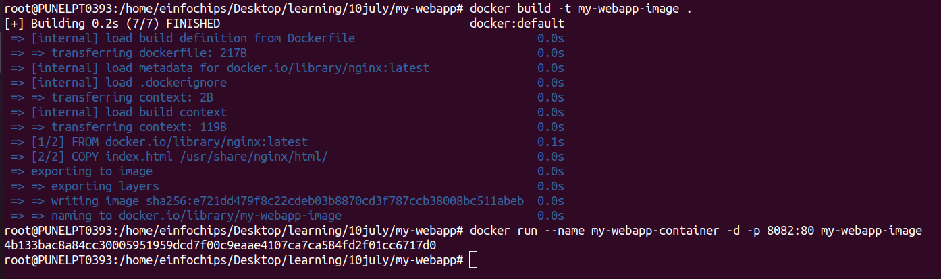
5) verify by visiting browser using URL
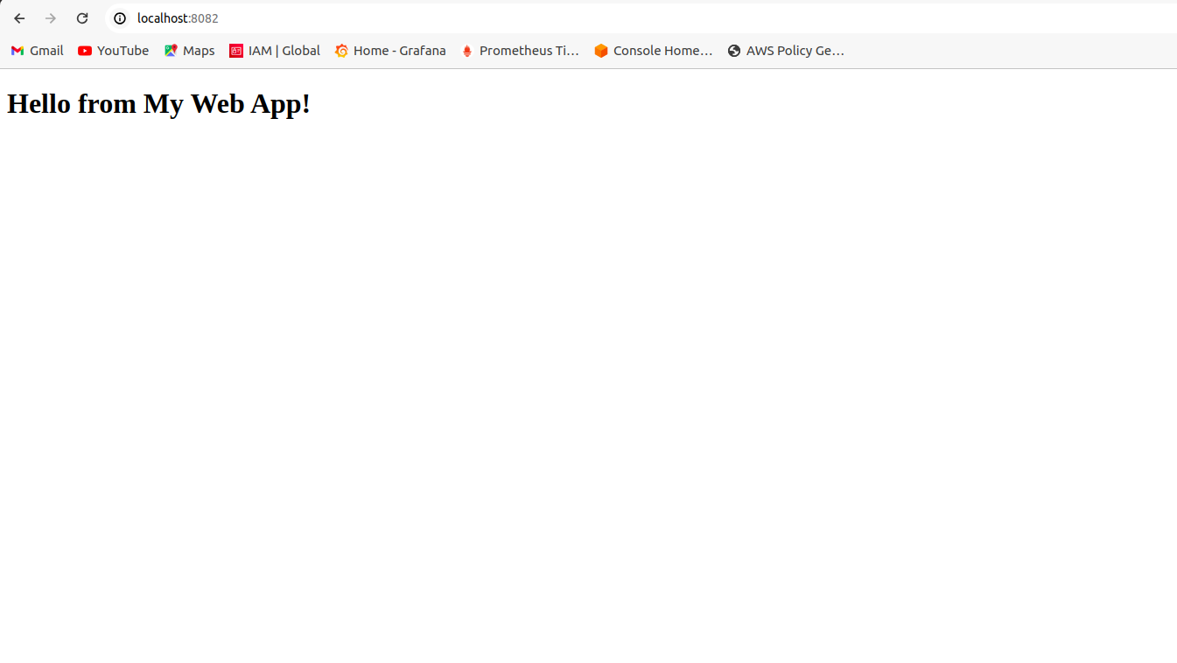

Remove all reated containers and images to clean up environment

1) stop , remove containers and remove Images

docker stop my-nginx my-custom-nginx my-webapp-container
docker rm my-nginx my-custom-nginx my-webapp-container
docker rmi nginx custom-nginx my-webapp-image

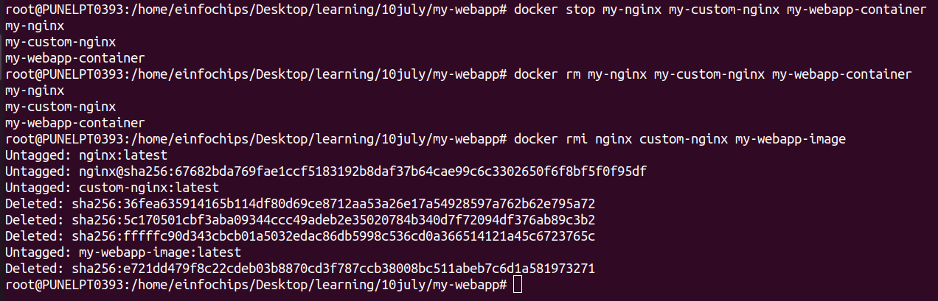

Docker Project 2

build full-stack applicaton using docker.
Applocation consist of front-end web server (Nginx) , back-end appication server (node.js) and postgreSQL database.
For database and handle inter-container communication persistent volume is used

1) create project directory name “ fullstack-docker-app”

mkdir fullstack-docker-app
cd fullstack-docker-app
2) In Directory create subdirectories name “ frontend , backend ,database ” for each service

mkdir frontend backend database

3) create network to allow communication between containers

docker network create fullstack-network

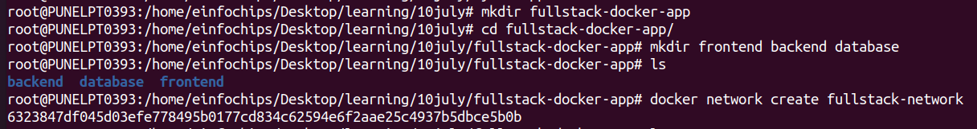
4) create volume for PostgreSQL database

docker volume create pgdata

set up database with docker

1) In “ database ” directory create dockerfile for database

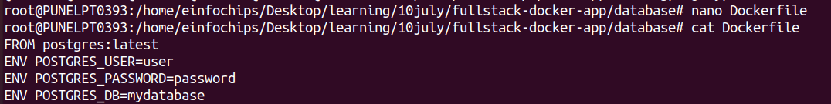

2) build postgreSQL Image

docker build -t my-postgres-db .
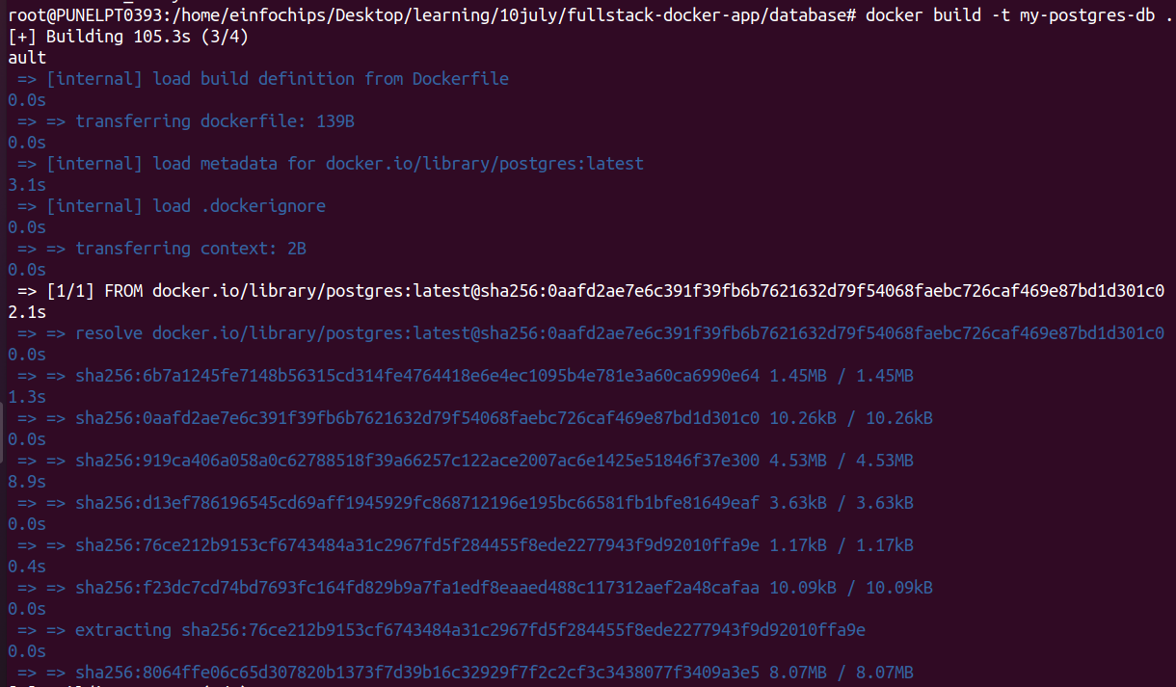

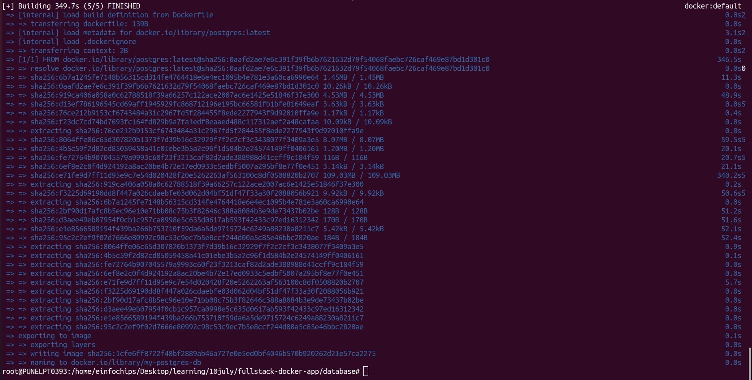

3) Run postgreSQL container
docker run --name postgres-container --network fullstack-network -v pgdata:/var/lib/postgresql/data -d my-postgres-db
create node.js application with Express and set it up with Docker

1)Initialize the node.js Application. Before that we checke version of node and npm

npm init -y

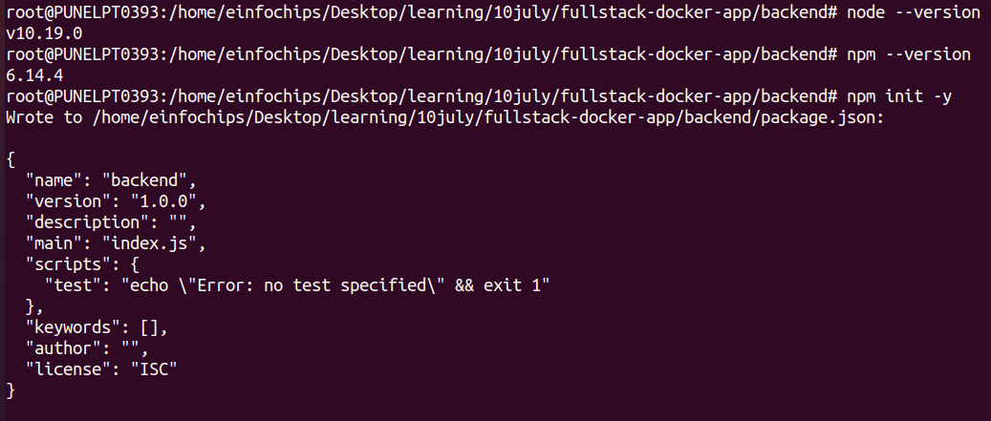

2) install Express and pg . This are postgreSQL client for Node.js

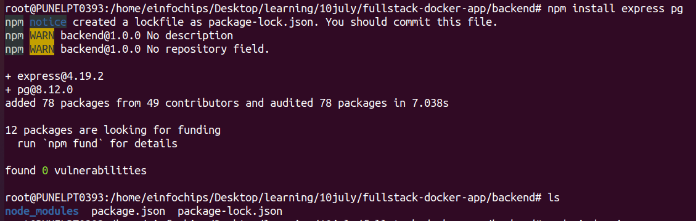
npm install express pg

3) In backend directory create file name “ index.js ”

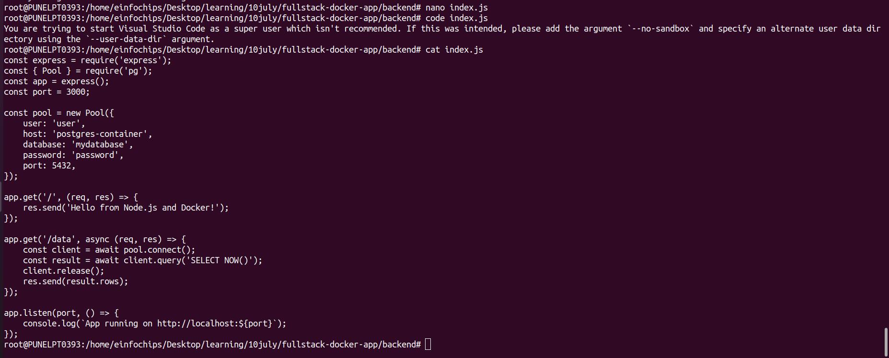
4) create “ dockerfile ” in “ backend ” directory

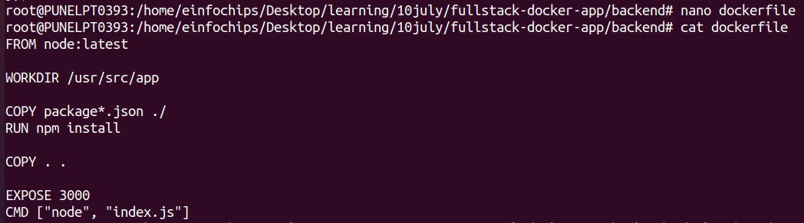

5) build backend image

docker build -t my-node-app .
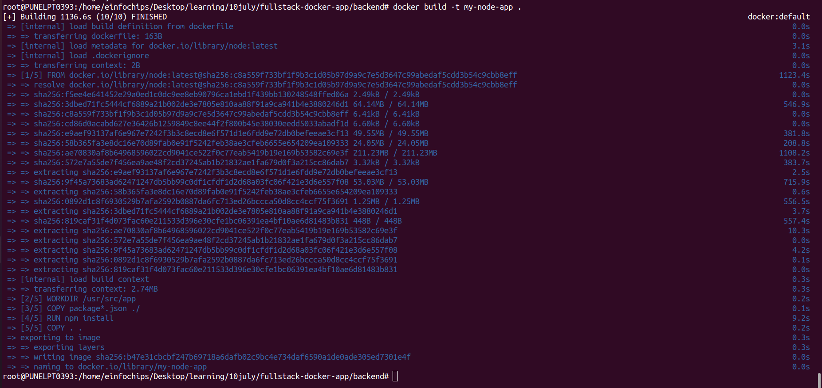
6)run backend container

docker run --name backend-container --network fullstack-network -d my-node-app

create static front-end and set it up with docker

1) in “ frontend ” directory create “ index.html “ file
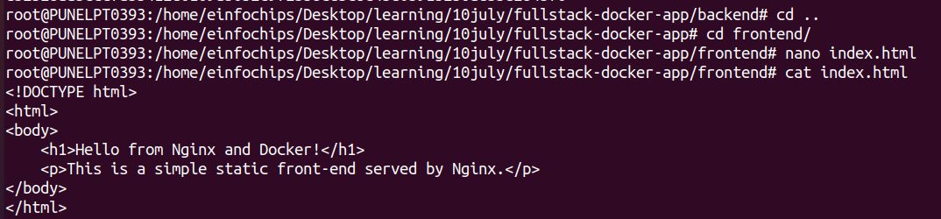

2) in “ frontend ” directory create “ dockerfile ”

3) build frontend Image and Run frontend conatiner

docker build -t my-nginx-app .
cd ..
docker run --name frontend-container --network fullstack-network -p 8080:80 -d my-nginx-app
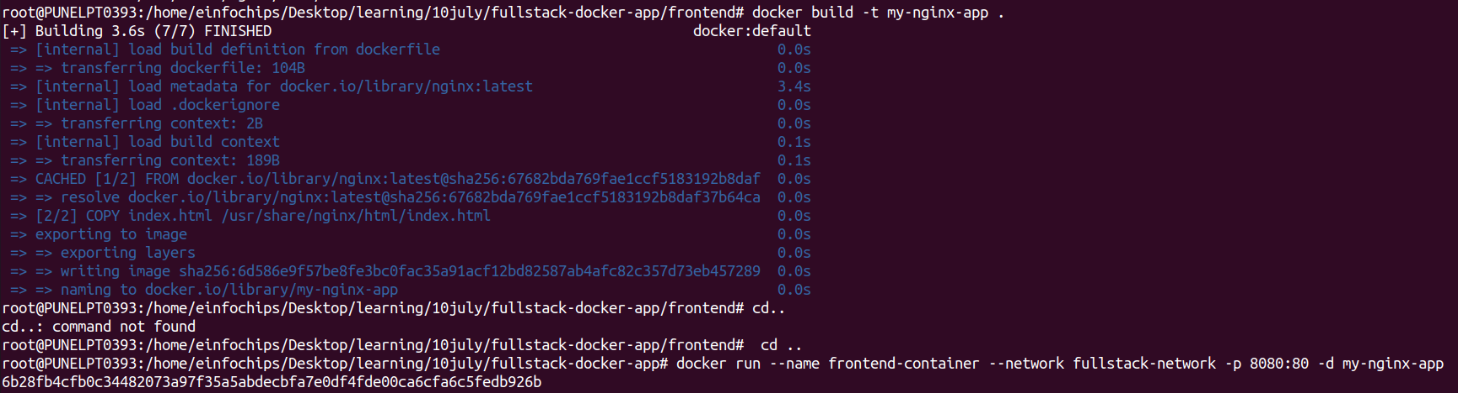
Connecting the Backend and Database

Backend can communicate with database and handle data requests

1) Access backend container

docker exec -it backend-container /bin/bash

2) Test the connection to the database using psql
apt-get update && apt-get install -y postgresql-client
psql -h postgres-container -U user -d mydatabase -c "SELECT NOW();"
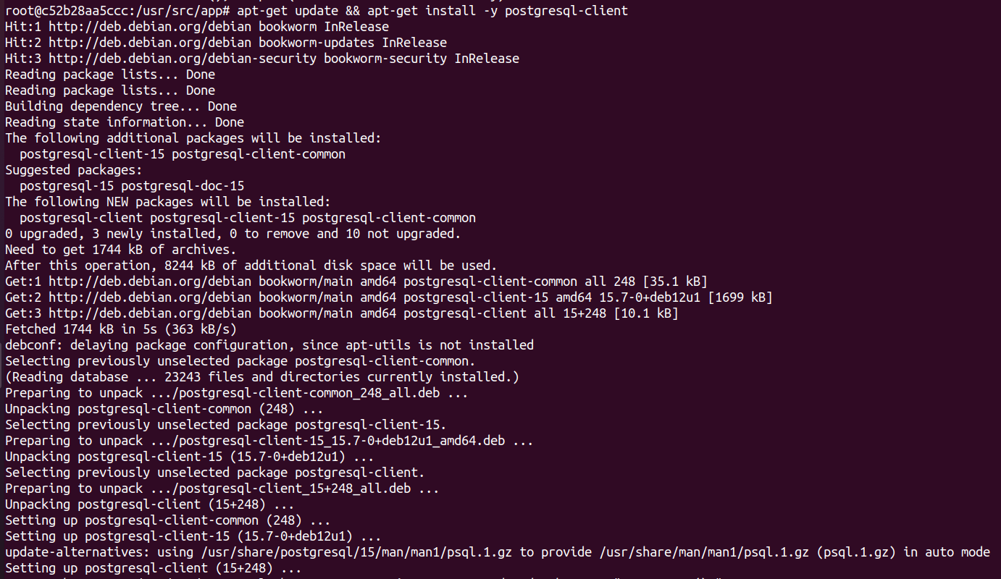
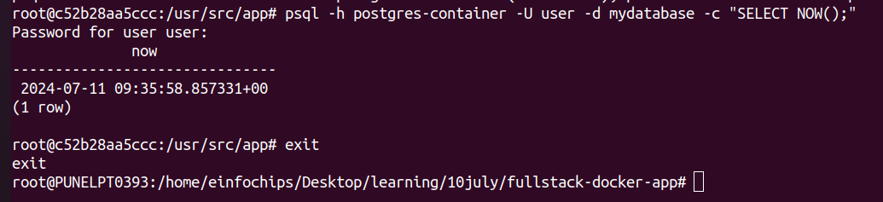
Final Integration and Testing

1) visit the browser use localhost:8080 to se the Nginx welcome page

2) On “ frontend ” branch update “ index.html ” file to include backend link . Using this we will verify full Integration

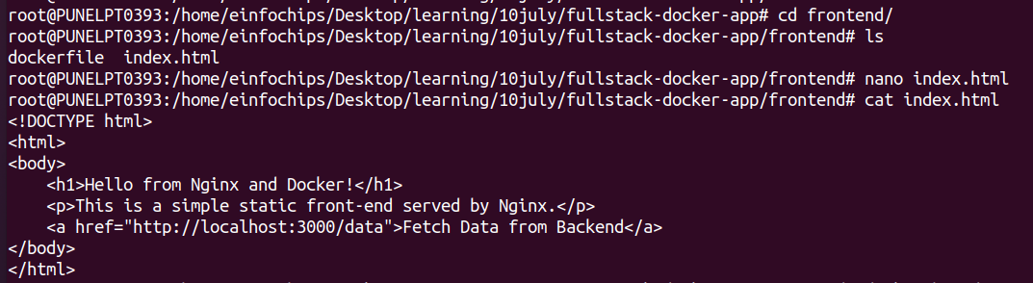

3) Rebuild and run the updated Frontend Container

docker build -t my-nginx-app .
docker run --name frontend-container --network fullstack-network -p 8080:80 -d my-nginx-app

4) to verify visit browser by using localhost:8080

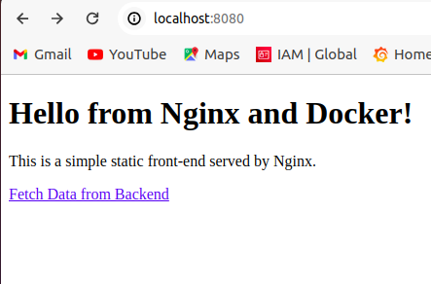

Remove all created containers,Images , networks and volumes to cleanup environment

1) stop and remove the container

docker stop frontend-container backend-container postgres-container
docker rm frontend-container backend-container postgres-container

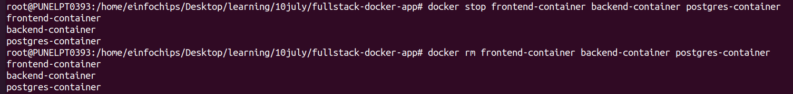

2) Remove the images :

docker rmi my-nginx-app my-node-app my-postgres-db

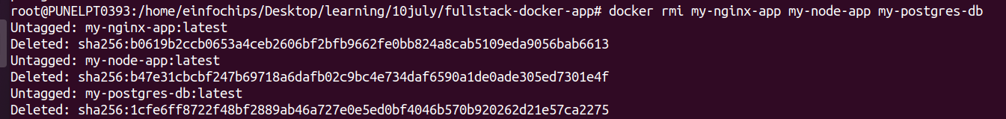

3) remove the network and volume
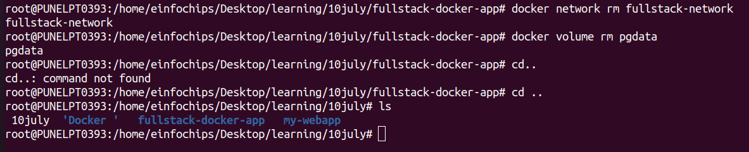
docker network rm fullstack-network
docker volume rm pgdata

