Infosys Springboard Virtual Internship 6.0 Completion Report

Team Details <Do not mention any personally identifiable information like email ID, institute details, mobile phone number etc.>
Batch Number 4
Start date: 13-10-2025
Names: Shreya Agrawal
Internship Duration: 8 Weeks

1. Project Title
Infosys_InsurAI – Corporate Policy Automation & Intelligence System

2. Project Objective
The primary objective of the project is to design and develop a secure, scalable, and intelligent insurance management system that automates policy handling, agent onboarding, and customer interactions.
The system aims to digitalize the insurance workflow, reduce manual verification, and enhance accessibility for customers, agents, and administrators through a role-based web platform.
This project aligns with the evolving digital transformation requirements within the insurance industry by ensuring faster onboarding, secure authentication, and automated processing.

3. Project description in detail
The InsureAI system is developed as a comprehensive insurance management platform using React.js for the frontend with localStorage for data persistence, providing a seamless user experience for policy management and appointment scheduling.
My Approach
The project followed an iterative development approach, starting with core authentication and progressively adding sophisticated features like real-time notifications and admin capabilities. Each feature was implemented as an independent module to ensure stability and easy maintainability.
Key Features Developed
✅ User Authentication & Registration System - Secure login with session management
✅ Policy Information Management - Interactive policy browsing with detailed comparisons
✅ Appointment Scheduling Interface - Intuitive booking system with date/time selection
✅ Real-time Notification System - Bell icon with badge counts and notification history
✅ Automated Appointment Reminders - 24-hour advance notifications with email/SMS simulation
✅ Admin Dashboard - Comprehensive overview of users and appointments with role-based access
✅ Responsive User Dashboard - Personalized activity overview and appointment management
✅ Protected Routing System - Secure navigation with authentication checks
Technologies Used
- State Management: React Hooks (useState, useEffect, useContext)
- Frontend: React.js, React Router, Context API, CSS3, Bootstrap
- Data Persistence: Browser localStorage
- Development Tools: VS Code, Git, GitHub, Chrome DevTools
- Deployment: GitHub Repository

4. Timeline Overview
Week | Activities Planned | Activities Completed
Week 1 | Project planning & React setup, UI design | Completed React application structure, routing setup, component architecture
Week 2 | Implement user authentication system | User login/registration with localStorage, protected routes implementation
Week 3 | Policy management system development | Policy listing page, detailed policy views, interactive policy cards
Week 4 | Appointment booking system | Appointment scheduling interface with form validation, date/time selection
Week 5 | Dashboard & user management | User dashboard with activity overview, appointment history tracking
Week 6 | Notification system implementation | Real-time notification center with bell icon, badge counts, notification history
Week 7 | Advanced features integration | Automated appointment reminders, email/SMS simulation, user preferences
Week 8 | Admin dashboard & final polish | Admin panel with statistics, role-based access, comprehensive testing & deployment

5a. Key Milestones
Milestone | Description | Status
Project Kickoff | Understanding requirements and planning React architecture | Completed
Frontend Foundation | React app setup, routing, component structure | Completed
Core Feature Development | Authentication, policy management, appointment system | Completed
User Experience Enhancement | Dashboard design, notification system, responsive UI | Completed
Mid-term Review | Functional policy browsing and appointment booking | Achieved
Advanced Feature Integration | Real-time notifications, admin dashboard, reminders | Completed
Final Submission | Complete insurance management platform | Completed

5b. Project execution details
The project implementation followed a module-wise approach:
Frontend Architecture Execution
- Designed component hierarchy for reusability and maintainability
- Implemented React Router for seamless navigation between pages
- Created Context API providers for global state management (notifications, user sessions)
- Built localStorage integration for data persistence without backend dependency
Feature Module Implementation
- User Authentication System - Login/register with session management using localStorage
- Policy Management Module - Interactive policy cards with detailed information and filtering .
- Appointment Scheduling System - Date/time selection with form validation and confirmation.

Notification Engine - Real-time bell icon with badge counts and notification history
- Admin Dashboard - Role-based access control with comprehensive statistics overview

6. Snapshots / Screenshots
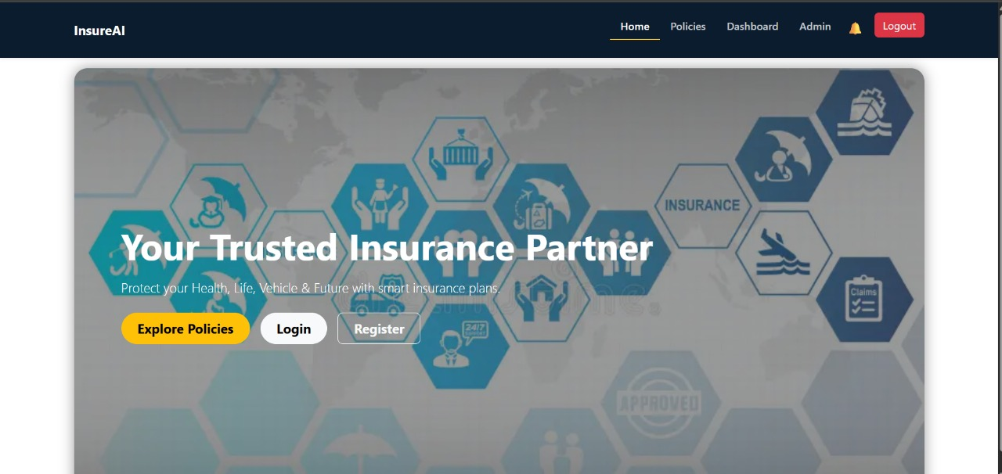

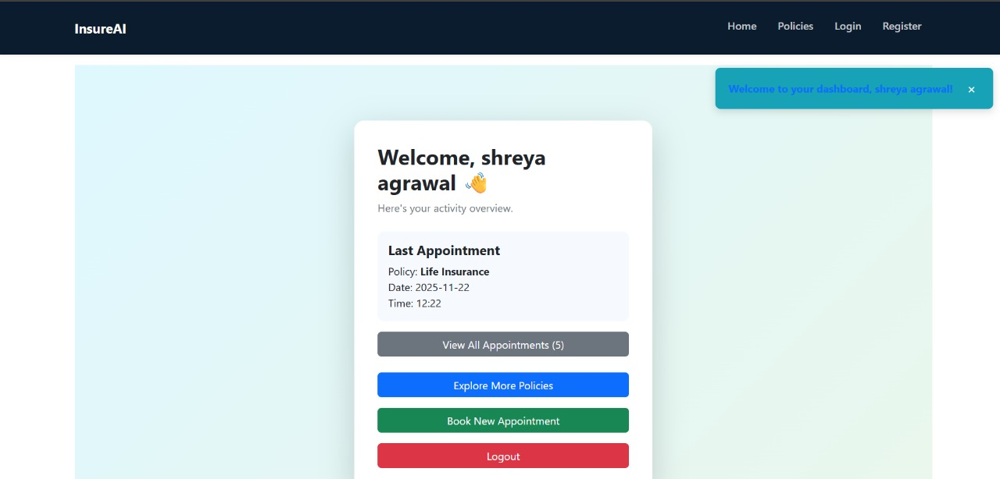
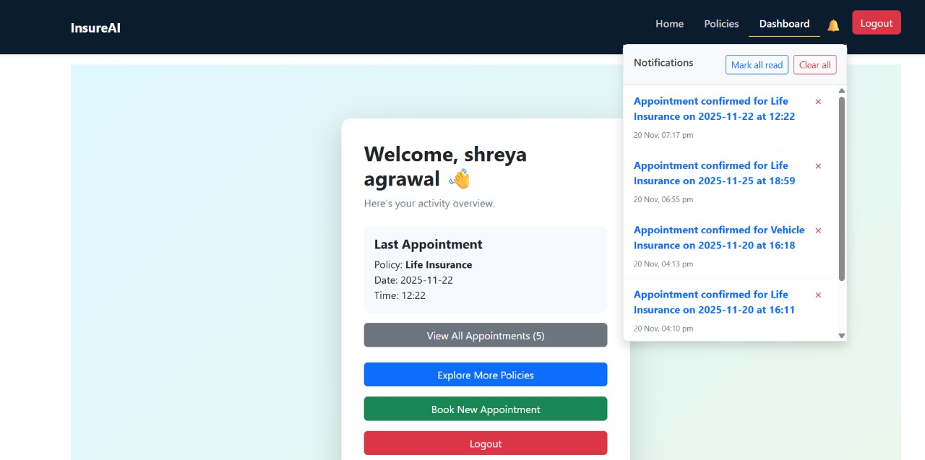

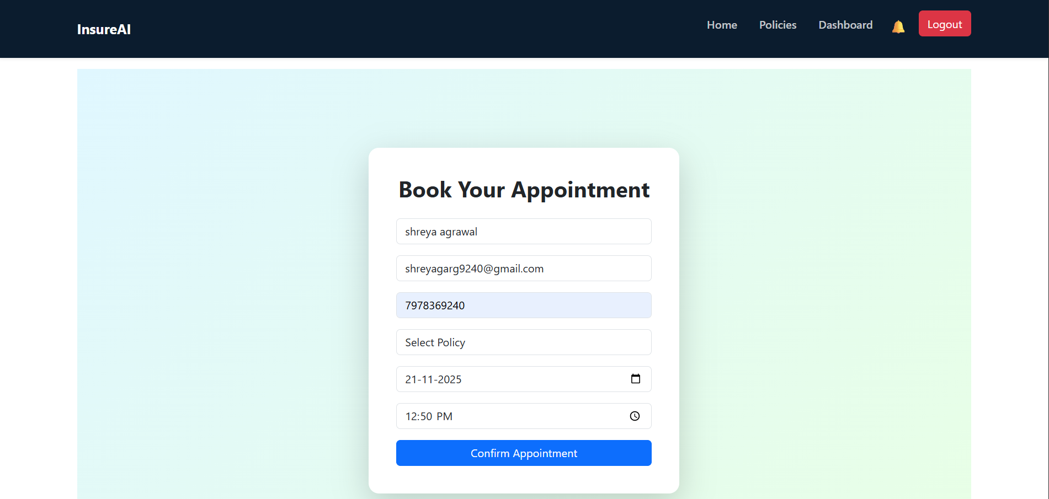

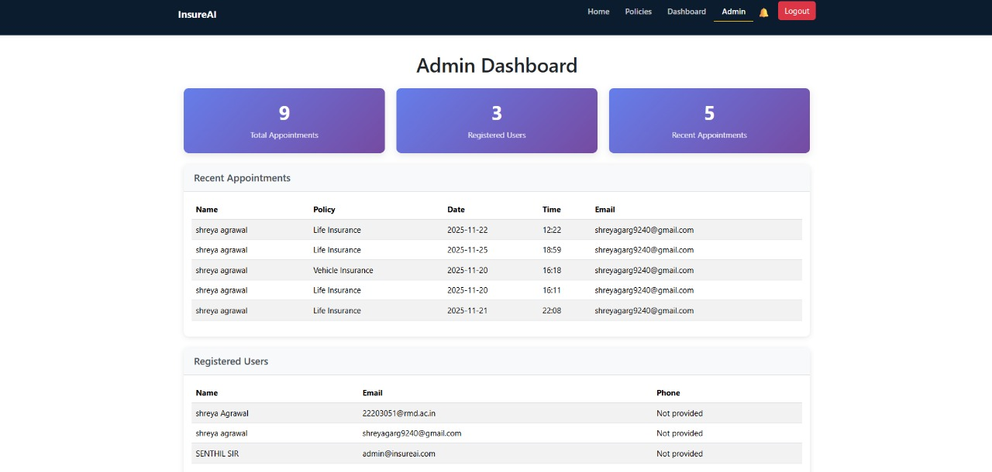

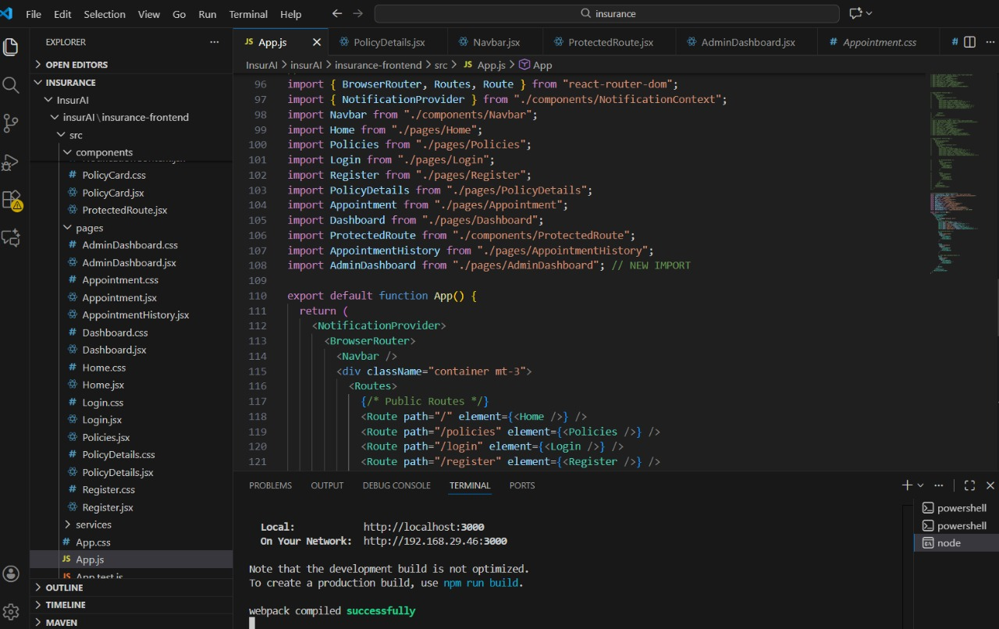

7. Challenges Faced
Throughout the internship, I faced several technical and non-technical challenges:
Technical Challenges
- Implementing real-time notifications using frontend-only solutions
- Managing complex state across multiple components
- Handling data persistence with localStorage
- Implementing role-based access control in React
- Creating responsive CSS layouts without UI frameworks
Development Challenges
- Debugging React component re-rendering issues
- Integrating multiple features without breaking existing functionality
- Maintaining code quality while rapidly adding features
- Testing all user flows without automated frameworks

8. Learnings & Skills Acquired
Technical Skills
- React.js component development and hooks
- Context API for global state management
- React Router for navigation and protected routes
- LocalStorage for data persistence
- CSS3 and responsive design implementation
- React Router for navigation and protected routes
- Frontend notification systems
- Form validation and user input handling
- Git version control and GitHub management
Soft Skills
- Problem-solving
- Time management and task prioritization
- Project planning and feature sequencing
- Independent learning and implementation
- Code organization and maintainability

9. Testimonials from team

This project gave me hands-on experience in building a complete React.js application with real-world features like user authentication, appointment scheduling, and real-time notifications. I gained practical skills in component-based architecture, state management, and responsive UI design.
Developing the InsureAI platform improved my confidence in frontend development and deepened my understanding of user-centric design and feature planning.

10. Conclusion

The InsureAI project was a significant learning experience in frontend development using React.js. It helped me build a functional insurance management system with modern features like notifications and role-based dashboards. This hands-on experience enhanced my technical skills, project execution ability, and understanding of user experience design, supporting my growth as a frontend developer and preparing me for future opportunities.

11. Acknowledgements
I would like to thank:
- Infosys Springboard for providing this valuable internship opportunity
- The mentors and team at Infosys for their guidance and support
- Online developer communities and documentation resources that helped solve technical challenges
- The Infosys Springboard platform for the structured learning modules and project framework

