STUDY ON COVID-19 STRAINS AND ITS AFFECTS ON DIFFERENT ORGANS OF THE HUMAN SYSTEM

BY: SATHISHNATH P, SHAILVI

The highly infectious, novel Coronavirus got its name from the way it looks when observed under the microscope. The virus consists of the genetic material at its core that is enveloped by sharp, spike proteins. The spikes give a crown-like appearance and hence its name.

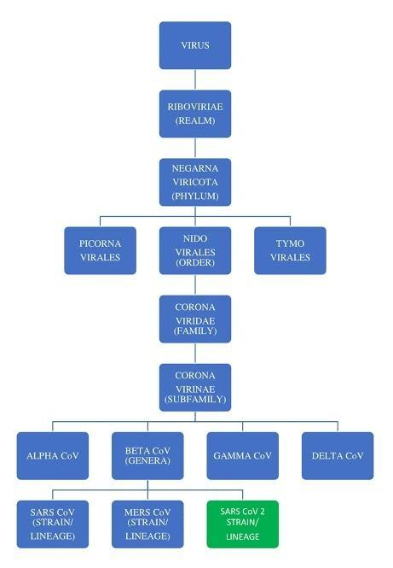

Figure-1: COVID-19 Taxonomy

Viruses undergo subtle changes in its genetic material through mutation and recombination.

A mutation occurs when there is an error in the viral genome.

Recombination occurs through exchange of genetic information between co-infecting viruses, thus, creating a new novel virus.

The COVID-19 virus is linked to the family of viruses of Severe Acute Respiratory Syndrome (SARS). Coronavirus can be categorized into four main groups (genus-classification):

1. Alpha

2. Beta

3. Gamma

4. Delta

The infection in humans is caused by alpha and beta coronavirus. The virus strain is distinguishable by its mutations. If they varied in their transmission or if they elicited different responses from the human immune system, the two strains would have biologically different characteristics. The common strains among human coronavirus are: 229E (alpha), NL63 (alpha), OC43 (beta), HKU1 (beta).

In specific to the SARS-CoV-2, it consists of 3 different types of strains:

* Type A:  common type of virus (mutated at T8782C and C28144T).
* Type B: mutated from the type A
* Type C: the type of strain which is currently spreading.

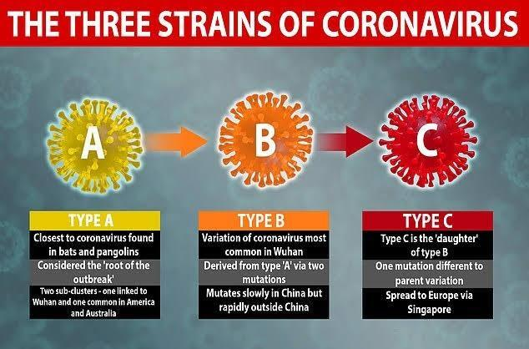

Apart from the symptoms, as released by WHO, some people show symptoms that include pinkeye, rashes, heart problems, blood clots, kidney and liver damage. Coronavirus spares no organs in the human body and it spreads its tentacles to multiple organs, ultimately damaging them. If the virus is not detected at an early stage, then the virus may enter any cell in the body by binding to the receptor present on the cell surface. SARS-CoV-2 especially shows a higher affinity towards ACE2. ACE2 is a protein found on the surface of lung alveolar epithelial cells and enterocytes of the small intestine, which has been proposed as the entry site. Other organs that include the heart, blood vessels, kidney, gut, and brain can be affected by the virus.

It has also been observed that different cell types from different organs show ACE2 expression and the risk of organ failure (using single-cell-RNA seq).

|  |  |  |  |
| --- | --- | --- | --- |
| **Organ** | **Type of cell tested** | **Proportion of ACE2** | **Risk for organ failure** |
| Respiratory Tract/ Lungs/ Alveolar cells | Respiratory epithelial cells/ AT2 cells | 2% | High |
| Nasal and Bronchi | Nasal and bronchial samples | No | Low |
| Heart | Myocardial cells | 7.5 % | High |
| Ileum | Ileal epithelial cells | ∼30 % | High |
| Oesophagus | Oesophagus epithelial cells | >1% | High |
| Stomach and liver |  | <1% | Low |
| Kidney | Kidney proximal tube | 4% | High |
| Urinary bladder | Bladder urothelial cells | 2.4 % | High |

Effects of COVID-19 on other organs:

### COVID-19 and Cardiovascular System

The exact mechanism of cardiovascular involvement in COVID-19 is not known due to several limitations, including heterogeneity in patient selection, outcomes, comparators, and study design, as well as low numbers of included patients. However, elevated cardiac biomarker levels have been observed in several covid 19 patients. ACE2 breaks down angiotensin II (a pro-inflammatory factor in the lung). Inhibition of ACE2 may be another factor in lung damage. The cause of the systemic inflammation with cytokine release results in acute respiratory distress syndrome (ARDS) and multiorgan dysfunction. Disruption in immune system regulation and increased metabolic demand most likely account for some of the increased risks of adverse outcomes in patients with COVID-19-related cardiovascular disease (CVD).

1. COVID 19 and Renal system

The exact pathogenesis of kidney involvement in COVID-19 infection is not clear. However, AKI (Acute Kidney Injury-the sudden loss of kidney function that occurs within seven days) has been observed in COVID-19 patients, accompanied by sepsis, multi-organ dysfunction, and shock. A research focused on single-cell transcriptome analysis (Single-cell transcriptomics investigates the extent of gene expression in individual cells in a given population by simultaneously assessing the concentration of messenger RNA (mRNA) in hundreds to thousands of genes) demonstrated the expression of ACE2 receptors in kidney cells, indicating the likelihood of SARS-CoV-22 direct renal cell injury. This was further proved by the recent detection of SARS-CoV-2 in a urine sample from an infected patient.

3. COVID 19 and Gastrointestinal system

It is observed that during a COVID-19 infection, the ACE2 receptors are highly expressed in the GI tract and hence GI tract is another target for SARS-CoV-2 infection. A large number of patients have reported GI symptoms such as diarrhea, nausea, vomiting, and abdominal pain. A study indicated that 14.8-53.1% of COVID-19 patients showed mild and temporary liver injury, as well as severe liver damage.

Multiorgan involvement has been apparent since the beginning of COVID-19. Although the most frequent, serious manifestation of COVID-19 infection seems to be pneumonia, we cannot overlook the other complications as it leads to the most devastating failures of multiple organs. Thus, the need for rigorous clinical trials is acute which is done that is done quickly and effectively. Until further in-depth study, successful research, or the surfacing of this deadly virus’s vaccine, we have to keep navigating through these unchartered territories.

References:

<https://www.ncbi.nlm.nih.gov/books/NBK8439/#:~:text=They%20undergo%20subtle%20genetic%20changes,information%2C%20creating%20a%20novel%20virus.>

<https://coronavirusexplained.ukri.org/en/article/cad0013/>)

<https://www.sciencefocus.com/news/coronavirus-aggressive-l-type-strain-affecting-70-per-cent-of-cases/>

<https://www.ncbi.nlm.nih.gov/pmc/articles/PMC3322807/>

<https://www.nature.com/articles/d41586-020-00502-w>

<https://www.historyofvaccines.org/content/articles/viruses-and-evolution>

<https://www.ncbi.nlm.nih.gov/pmc/articles/PMC7197627/>

<https://www.ncbi.nlm.nih.gov/pmc/articles/PMC7202812/>

<https://www.sciencedirect.com/science/article/pii/S1359610120300782>

<https://hms.harvard.edu/news/coronavirus-heart>

<https://www.thelancet.com/journals/laninf/article/PIIS1473-3099(20)30402-3/fulltext>

<https://www.ncbi.nlm.nih.gov/pmc/articles/PMC7189394/>

<https://www.ncbi.nlm.nih.gov/pmc/articles/PMC7102542/>