PHASE 2 REPORT
FemCare AI
Parts F–K
Submission detail | Information
Student name | Shreya Jadhav
Roll number | MC2525
Course | MCA Sem 3
Faculty | Dr. Anita Chaware
Project | FemCare AI - Menstrual Health Assistant

Executive Summary
Phase 2 converts the Phase 1 fused CSV into searchable evidence for the FemCare AI assistant and measures the improvement. The original comparison system contained general menstrual-health knowledge and an original-dataset summary. The enhanced system used the same Llama 3.2 model and the same TF-IDF retrieval method, but added Census, CDC PLACES, weather, state summaries and 17,976 fused cycle records.
Before fusion: 32 documents = 31 medical-knowledge sections + 1 original-dataset summary.
After fusion: 18,061 documents = the original 32 + 50 state summaries + 3 fusion-analysis summaries + 17,976 fused cycle records.
Measure | Before fusion | After fusion
Searchable documents | 32 | 18,061
Questions answered correctly | 5 of 10 | 10 of 10
Accuracy | 50% | 100%
Complete answers | 5 of 10 | 10 of 10
Unsupported/hallucinated answers | 0 | 0
Average local response time | 24.8 s | 35.8 s

Main result: The enrichment preserved performance on the five original-domain questions and enabled correct answers to all five questions that required API or fused-data evidence. The larger index increased average local response time by approximately 11.0 seconds. The result demonstrates functional knowledge expansion, but the ten-question test is not clinical validation and should not be generalized beyond the tested dataset.

Contents
The report follows the Phase 2 sequence specified in the assignment. Each part is supported by saved project evidence and is followed by reproducibility information.
Section | Focus
Part F | Before-fusion versus after-fusion dataset comparison
Part G | Seven Finding → Evidence → Interpretation insights
Part H | Fused-data preparation, document creation, indexing, retrieval and LLM use
Part I | Ten-question controlled LLM test with answers, expectations and sources
Part J | Accuracy, completeness, relevance, hallucination and timing comparison
Part K | Code, data, results, validation checklist and run order
Closing material | Conclusion, references and appendices

1. Part F – Before Fusion vs After Fusion

1.1 Dataset Structure
The original dataset was cycle-level. Fusion kept every original row and attached state-level social and public-health context plus state-capital weather for the cycle start date. The record grain therefore remained one row per user and cycle.
Property | Original dataset | Final cleaned fused dataset
Rows | 17,976 | 17,976
Columns | 34 | 56
Users | 2,000 | 2,000
States | 50 | 50
Date range | 1 Jan 2024 to 5 Apr 2025 | Unchanged
Duplicate user-cycle keys | 0 | 0
Missing cells | 5,486 | 2,642 (0.262%)
Join grain | Not applicable | State; and state + cycle start date

1.2 New Attributes Included
Layer | Added fields | Reason for inclusion
Census ACS (7) | State FIPS; total and female population; female ages 20–24, 25–29 and 30–34; median household income | Adds population scale, reproductive-age context and socioeconomic context.
CDC PLACES (7) | State abbreviation; population; obesity, physical inactivity, smoking and depression prevalence; imputation flag | Adds public-health risk context that can be compared with menstrual outcomes at state level.
Open-Meteo (6) | Latitude, longitude, mean temperature, mean humidity, precipitation and mean wind speed | Adds date-linked environmental context using the state capital as a consistent representative location.
Quality flags (2) | has_previous_cycle; coordinates_available | Makes missingness and analytical eligibility explicit.

1.3 Excluded or Restricted Information
Item | Decision | Reason
Overpass healthcare facilities | Not fused into the final CSV | No trustworthy cycle-level or state-level analytical join was established; facility proximity could imply false precision.
USDA nutrition search results | Not fused into the final CSV | Food search records do not describe a specific participant or cycle and would create a many-to-many join.
Direct user_id | Retained in the analytical CSV; excluded from RAG text | Needed for cycle linkage, but not needed for answering aggregate questions.
Latitude and longitude | Retained for weather traceability; excluded from RAG text | Coordinates support the API request but add little conversational value.
Raw API payload fields | Only selected variables retained | Reduces noise, size and accidental dependence on undocumented fields.

1.4 What Became Possible After Fusion
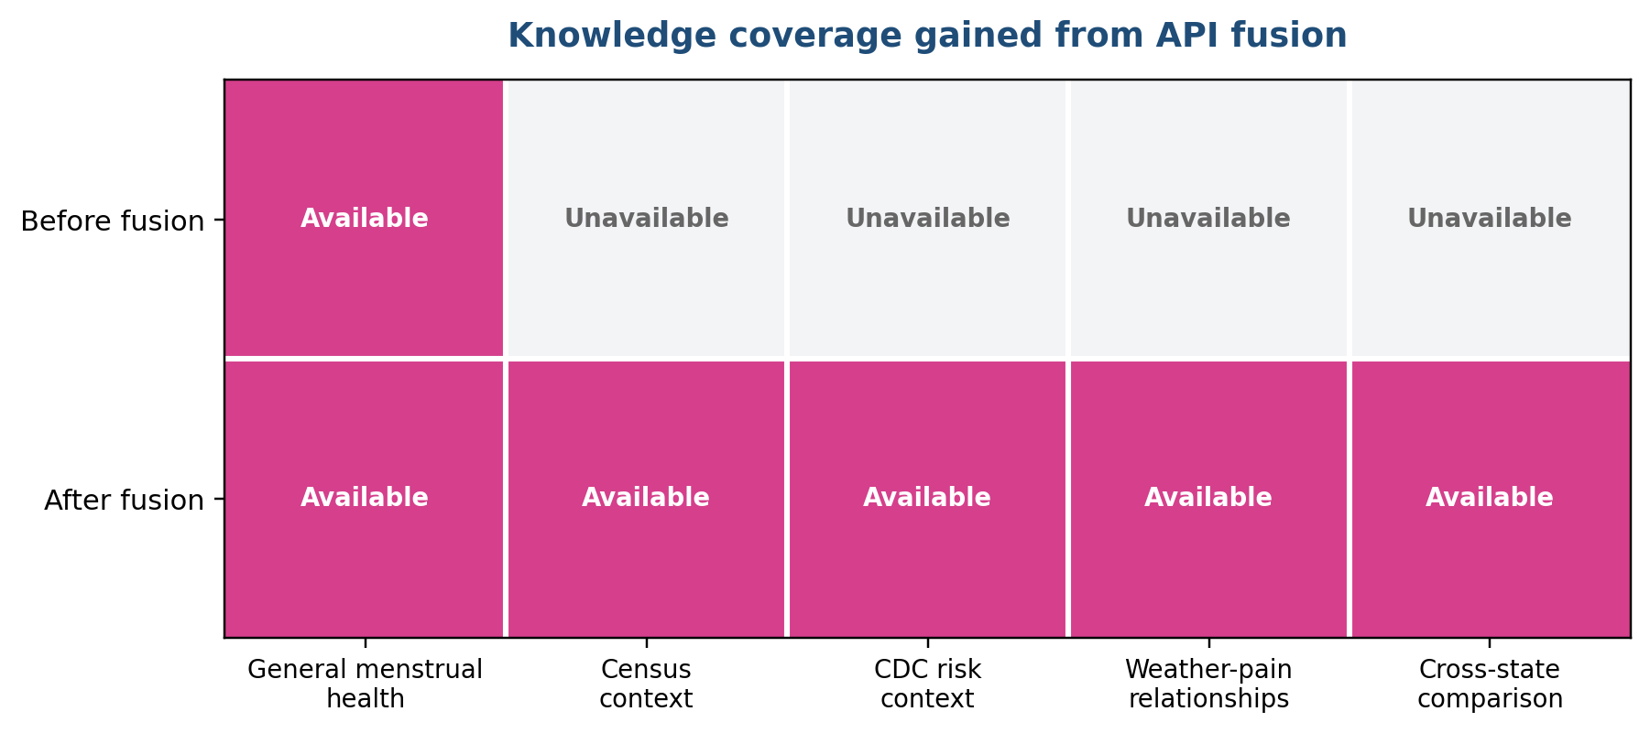
Figure 1. Knowledge coverage before and after API data fusion.
- Compare menstrual pain and stress across states while also seeing population, income and public-health context.
- Test relationships between cycle outcomes and weather observed on the cycle start date.
- Answer state-specific Census and CDC questions from the same knowledge base as menstrual-health guidance.
- Produce source-labelled responses that point to the fused CSV or a derived state/EDA summary.

1.5 Data Quality Effects of Fusion
Quality dimension | Result | Meaning
Row preservation | 17,976 rows before and after | No menstrual-cycle record was lost during the joins.
Key uniqueness | 0 duplicate user-cycle keys | The fusion did not create unintended many-to-many row multiplication.
Completeness | 2,642 missing cells after cleaning | Only previous-cycle length (2,000) and coordinates (321 latitude + 321 longitude) remain missing.
CDC continuity | Imputation flag retained | The project records when a health-context value required a defined fallback rather than hiding the repair.
Temporal alignment | Weather joined by state and start date | Weather varies by cycle date instead of being a single state constant.
Geographic precision | State-capital weather proxy | A consistent method, but it may not represent the participant’s actual local conditions.
Measurement level | Census/CDC values repeated within state | These are contextual state indicators, not individual diagnoses or exposures.

Quality conclusion: The fusion passed structural validation—row count, key uniqueness and required-column checks—, but the results must be interpreted as contextual associations—not personalized medical facts or proof of cause and effect.. State-level associations are ecological; weather uses a representative state location; and the same state value repeats across many cycle records. These limitations are disclosed whenever results are interpreted.

1.6 New Patterns and More Useful Variables
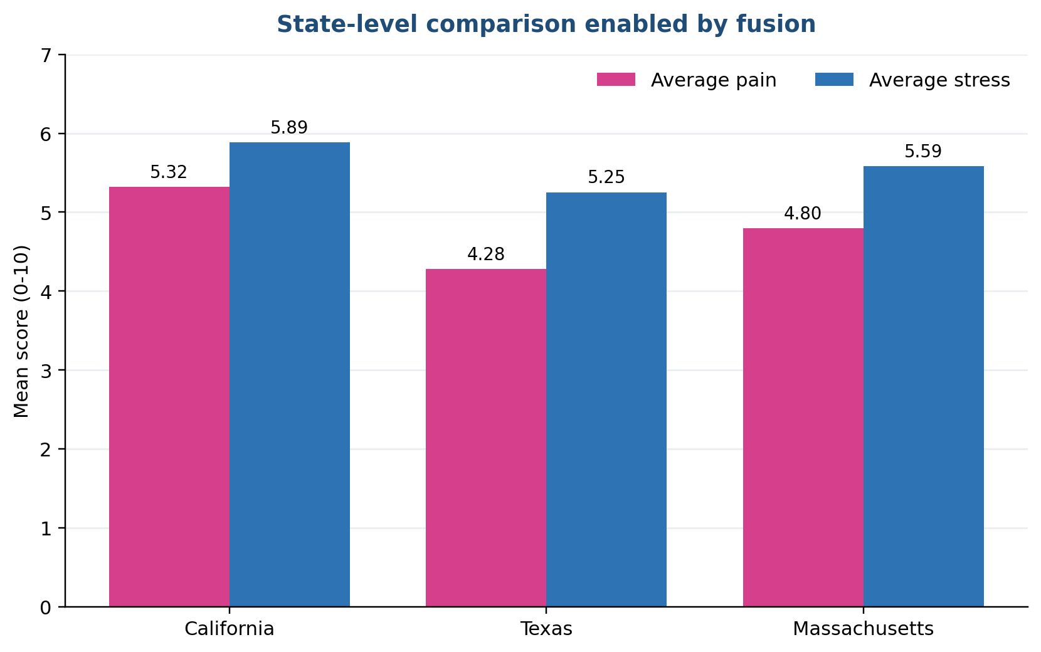
Figure 2. Example state comparison created from original outcomes plus fused context.
Relationship | Observed value | Interpretation
Temperature vs pain | r = -0.0165 | Negligible linear relationship in these records.
Humidity vs pain | r = -0.0036 | Negligible linear relationship.
Precipitation vs pain | r = -0.0020 | Negligible linear relationship.
Wind speed vs pain | r = 0.0125 | Negligible linear relationship.
State depression vs average stress | r = 0.008 | No meaningful state-level linear pattern.
State inactivity vs average pain | r = -0.0862 | Very weak negative state-level association.
State obesity vs median income | r ≈ -0.74 | Strong negative state-level association in the fused data; not a causal result.

2. Part G – Insight Generation
Correlation describes association only; it does not establish causation.

Insight 1
Finding | Weather variables do not explain menstrual pain in this dataset.
Evidence | Pain correlations are -0.0165 with temperature, -0.0036 with humidity, -0.0020 with precipitation and 0.0125 with wind speed.
Interpretation | The integrated weather fields add queryable context, but the observed linear relationships are effectively zero. The application should not imply that weather caused or predicted pain here.

Insight 2
Finding | State obesity prevalence is lower where median household income is higher in this fused sample.
Evidence | Across the 50 state summaries, Pearson r is approximately -0.74 between CDC obesity prevalence and Census median household income.
Interpretation | This is the strongest new contextual pattern found. It is useful for population-level exploration, but it is ecological and cannot be applied to an individual user.

Insight 3
Finding | The original menstrual variables remain more directly related to pain than the added context.
Evidence | Original-data correlations include pain with stress r = 0.607, mood r = -0.646, energy r = -0.707 and overall health r = -0.921; API weather-pain correlations are near zero.
Interpretation | The API data broadens the questions the system can answer, while the original symptoms and wellness measures remain the more useful variables for within-dataset pain patterns.

Insight 4
Finding | California records show higher average pain than Texas records.
Evidence | Mean pain is 5.321 in California and 4.277 in Texas; the fixed LLM test retrieved both values correctly.
Interpretation | Fusion enables an explicit cross-state comparison and lets the assistant attach public-health and income context. It does not show why the difference exists.

Insight 5
Finding | The data enrichment adds knowledge breadth without reducing general health-answer accuracy in the fixed test.
Evidence | Both systems answered all five original-domain questions correctly; only the enhanced system answered all five fusion/API questions correctly.
Interpretation | The added records expanded answerable topics while preserving the tested baseline capability.

Insight 6
Finding | More knowledge increased local response time.
Evidence | Average time rose from 24.8 seconds to 35.8 seconds in the recorded local Ollama run.
Interpretation | The enhanced system is more capable, but production work should optimize retrieval, caching and model serving. These timings are machine-specific and are not a hosted-service benchmark.

3. Part H – Integration with the LLM/RAG System

3.1 Architecture
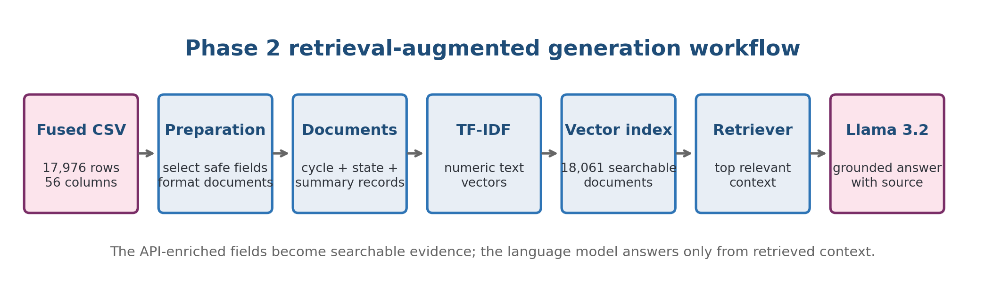
Figure 3. Phase 2 fused-data RAG pipeline.
1. Load the final cleaned fused CSV and the existing medical-knowledge text files.
2. Create one document for each fused cycle record, one summary document for each state, three fusion-analysis summaries, and one original-dataset summary.
3. Exclude direct user identifiers and coordinates from the searchable text.
4. Convert document text into TF-IDF vectors using unigrams and bigrams.
5. Store the sparse matrix, vectorizer and source-labelled documents in a local joblib index.
6. For each question, retrieve the five most similar documents using cosine similarity.
7. Send only the retrieved context and the question to Llama 3.2. The prompt instructs the model to refuse when evidence is missing.

3.2 Knowledge-Base Composition
Document type | Count | Purpose
Medical knowledge sections | 31 | Preserve general menstrual-health capability.
Original dataset summary | 1 | Describe the original dataset and baseline statistics.
Fusion/EDA summaries | 3 | Make overall correlations and dataset-level findings retrievable.
State summaries | 50 | Answer direct Census, CDC and state-average questions.
Fused cycle records | 17,976 | Support record-level questions combining cycle and contextual fields.
Total enhanced documents | 18,061 | Complete Phase 2 searchable collection.

3.3 Why TF-IDF Was Used for the Controlled Comparison
The original FemCare application used MiniLM embeddings with a FAISS vector database. For Phase 2, two new search indexes were created: a baseline index containing the original dataset and an enhanced index containing the original dataset together with the API-enriched fused data.
Both indexes use the same TF-IDF retrieval method, and both systems use the same Llama language model. This makes the comparison fair because the main difference between the two systems is the availability of the fused data. Therefore, any improvement in the answers can be mainly attributed to the additional Census, CDC PLACES, weather and state-level information.
TF-IDF was chosen because it is lightweight, deterministic and easy to reproduce. It is effective for questions containing direct terms such as state names, population, income, pain, stress and weather. It also allows the experiment to be performed locally without requiring a large embedding model or a specialized vector database.
TF-IDF has limitations. It mainly matches important words and may not understand different phrases with the same meaning. For example, it may not always connect “household earnings” with “median household income.” It may also be less effective for long, ambiguous or highly conversational questions. A future product version could use semantic embeddings or a hybrid keyword-and-semantic retrieval system to improve the handling of paraphrased and complex questions.

3.4 How API Information Becomes Available to the LLM
The LLM does not read the CSV file directly. The preparation script converts selected API and dataset fields into readable text summaries. When a user asks a question, the retriever finds the most relevant summary using matching terms such as a state name, population or income. This summary, together with its source label, is placed in the prompt given to the LLM. The LLM then uses this retrieved evidence to generate its answer.

3.5 Implementation Components
Component | Implementation | Output
Preparation | embeddings/build_phase2_knowledge_base.py | Source-labelled medical, summary, state and cycle documents
Vectorization | scikit-learn TfidfVectorizer | Sparse unigram/bigram vectors
Storage | joblib | Portable local vectorizer, matrix and document bundle
Retrieval | rag/phase2_retriever.py | Five cosine-ranked context documents
Generation | Ollama llama3.2:3b | Short answer grounded in supplied context

4. LLM Testing Using the Fused Dataset (Part I)

4.1 Test Design
Control | Setting
Model | Ollama llama3.2:3b for both systems
Temperature | 0; seed 42; maximum 180 generated tokens
Retriever | TF-IDF cosine similarity; top 5 documents
Baseline knowledge | 31 medical sections + one original-dataset summary
Enhanced knowledge | Baseline knowledge + fusion summaries + 50 state summaries + 17,976 fused records
Question set | Five original-domain questions and five fused/API questions
Correctness rule | Required facts/keywords must appear; baseline refusal is relevant but not correct for a fused-data question
Hallucination rule | A fabricated answer or a failed required-fact check is counted as unsupported

The complete machine-readable evidence is saved in report/phase2/assets/phase2_rag_evaluation.csv and phase2_rag_evaluation.json. The following tables reproduce the required question, response, expected answer, source/record and correctness fields.

4.2 Original-Domain Questions – Enhanced System
ID | Question | Recorded response (condensed where marked) | Expected answer | Source/record | Result
O1 | What is the normal range for menstrual cycle length? | A normal menstrual cycle typically ranges from 21 to 35 days, measured from the first day of one period to the first day of the next. | A typical cycle is 21 to 35 days. | knowledge/medical_faq.txt - Normal menstrual cycle length | Correct
O2 | What is PCOS and what menstrual pattern can it cause? | PCOS (Polycystic Ovary Syndrome) is a hormonal disorder that affects women of reproductive age. It is characterized by a combination of symptoms, including irregular menstrual cycles, excess androgen levels, and polycystic ovaries. PCOS can cause irregular menstrual patterns, including: - Irregular cycles - Absent periods (amenorrhea) It is recommended to have a comprehensive evaluation, including a pelvic ultrasound and androgen blood panels, to confirm the diagnosis. | PCOS is a hormonal disorder that can cause irregular or absent menstrual cycles. | knowledge/medical_faq.txt - What is PCOS | Correct
O3 | What causes common menstrual cramps? | Menstrual cramps (dysmenorrhea) are caused by contractions in the uterine muscle driven by hormone-like substances called prostaglandins. Higher levels of prostaglandins are associated with more severe cramping. | Uterine contractions driven by prostaglandins commonly cause menstrual cramps. | knowledge/medical_faq.txt - Causes of menstrual cramps | Correct
O4 | How can high stress affect periods? | High stress can disrupt the hypothalamus, the region of the brain that regulates hormones responsible for the menstrual cycle, leading to delayed periods, irregular cycles, or temporarily missed periods (amenorrhea). | High stress and cortisol can disrupt cycle hormones and cause delayed, irregular or missed periods. | knowledge/medical_faq.txt - Stress and periods | Correct
O5 | When should heavy menstrual bleeding receive medical attention? | Medical attention is advised when bleeding soaks one or more pads/tampons every hour for consecutive hours; other warning signs include large clots, severe pain, fainting, fever or postmenopausal bleeding. [Condensed from the recorded response] | Medical review is advised when bleeding soaks protection every hour for consecutive hours or is persistent or severe. | knowledge/medical_faq.txt - Heavy menstrual bleeding and warning signs | Correct

4.3 Fused/API Questions – Before Fusion
The baseline returned the safe refusal for every fused-data question because those facts were not present in its index. These answers are relevant and non-hallucinatory, but they do not satisfy the requested facts.
ID | Question | Recorded response | Expected answer | Required source | Result
F1 | What Census population and median household income are attached to California records? | I couldn't find enough information in the available knowledge base. No answer is available for this question. | California has a Census population of 39,287,377 and median household income of $99,122. | California state summary derived from femcare_final_cleaned.csv | Not correct
F2 | What CDC obesity and physical inactivity prevalence are attached to Texas records? | I couldn't find enough information in the available knowledge base. | Texas has CDC obesity prevalence of 35.705% and physical inactivity prevalence of 27.917%. | Texas state summary derived from femcare_final_cleaned.csv | Not correct
F3 | How strong is the relationship between mean temperature and menstrual pain in the fused dataset? | I couldn't find enough information in the available knowledge base. | The Pearson correlation is -0.0165, which is negligible. | Phase 2 fused EDA weather and pain summary | Not correct
F4 | Which has higher average menstrual pain in the fused data, California or Texas? | I couldn't find enough information in the available knowledge base. | California is higher: 5.321 compared with 4.277 for Texas. | California and Texas summaries derived from femcare_final_cleaned.csv | Not correct
F5 | What CDC depression prevalence and median household income are attached to Massachusetts records? | I couldn't find enough information in the available knowledge base. | Massachusetts has CDC depression prevalence of 23.835% and median household income of $103,960. | Massachusetts state summary derived from femcare_final_cleaned.csv | Not correct

4.4 Fused/API Questions – After Fusion
ID | Question | Recorded response | Expected answer | Source/record | Result
F1 | What Census population and median household income are attached to California records? | Census population: 39,287,377 Median household income: $99,122 | California has a Census population of 39,287,377 and median household income of $99,122. | California state summary derived from femcare_final_cleaned.csv | Correct
F2 | What CDC obesity and physical inactivity prevalence are attached to Texas records? | CDC obesity prevalence: 35.705 percent. CDC physical inactivity prevalence: 27.917 percent. | Texas has CDC obesity prevalence of 35.705% and physical inactivity prevalence of 27.917%. | Texas state summary derived from femcare_final_cleaned.csv | Correct
F3 | How strong is the relationship between mean temperature and menstrual pain in the fused dataset? | The relationship between mean temperature and menstrual pain in the fused dataset is negligible, with a Pearson correlation of -0.0165. | The Pearson correlation is -0.0165, which is negligible. | Phase 2 fused EDA weather and pain summary | Correct
F4 | Which has higher average menstrual pain in the fused data, California or Texas? | California has a higher average menstrual pain of 5.321 compared to Texas, which has an average menstrual pain of 4.277. | California is higher: 5.321 compared with 4.277 for Texas. | California and Texas summaries derived from femcare_final_cleaned.csv | Correct
F5 | What CDC depression prevalence and median household income are attached to Massachusetts records? | CDC depression prevalence: 23.835 percent. Median household income: $103,960. | Massachusetts has CDC depression prevalence of 23.835% and median household income of $103,960. | Massachusetts state summary derived from femcare_final_cleaned.csv | Correct

5. Part J – Before/After LLM Comparison

5.1 Quantitative Results
Metric | Before fusion | After fusion | Change
Questions tested | 10 | 10 | Same
Correct answers | 5 | 10 | +5
Accuracy | 50% | 100% | +50 percentage points
Complete answers | 5 | 10 | +5
Relevant responses | 10 | 10 | No change
Unsupported/hallucinated answers | 0 | 0 | No change
Average response time | 24.8 s | 35.8 s | +11.0 s

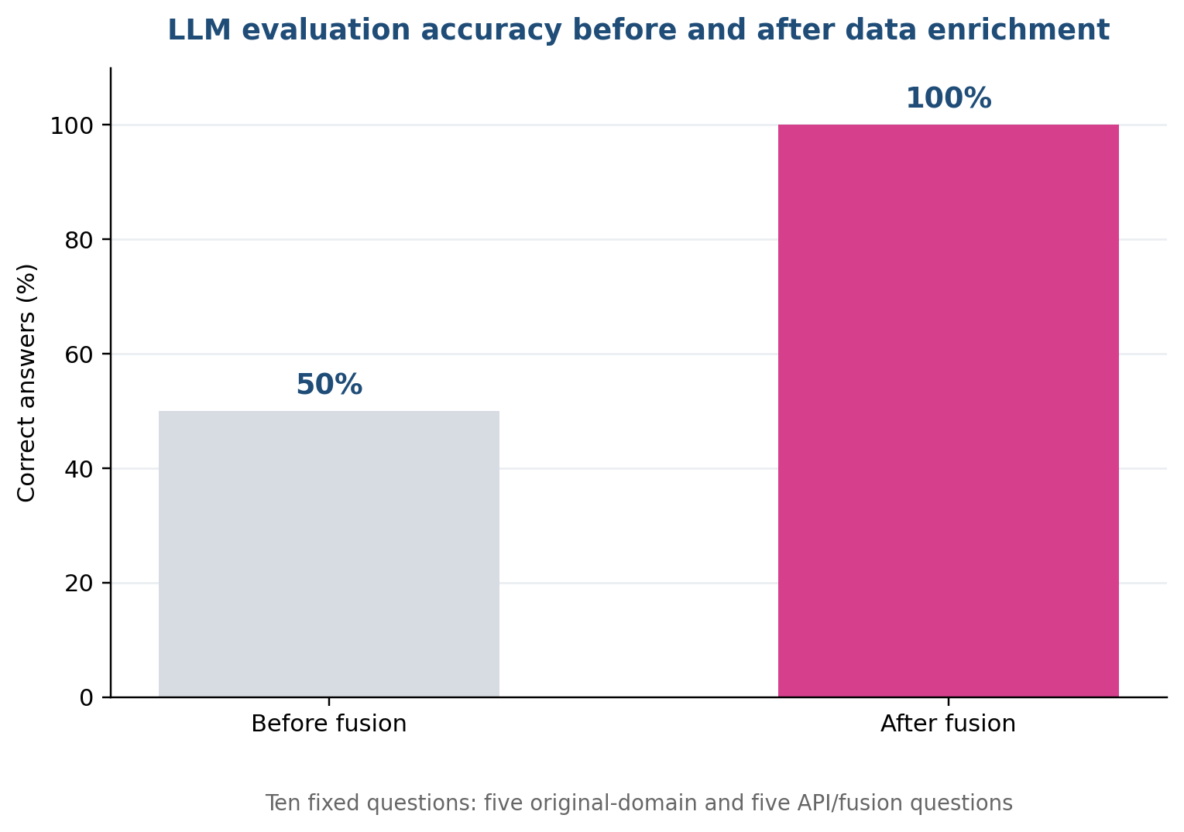
Figure 4. Correct answers increased from 5/10 to 10/10.

5.2 Evidence-Based Usefulness Conclusion
The fused dataset made the application measurably more useful for the tested scope. Before fusion, the assistant could answer general menstrual-health questions but correctly refused questions about state population, income, CDC prevalence, weather-pain correlation and cross-state pain. After fusion, it answered every one of those questions using retrieved evidence while retaining 5/5 accuracy on the original set. This is a direct increase in knowledge coverage and answer completeness.
The conclusion is intentionally limited. Ten hand-designed questions are sufficient to demonstrate the implemented capability, but not to prove broad accuracy, clinical safety, fairness or real-world effectiveness. A product evaluation would require a larger blind question set, clinician review, retrieval metrics, adversarial tests and monitoring.

5.3 Response-Time and Product Trade-off
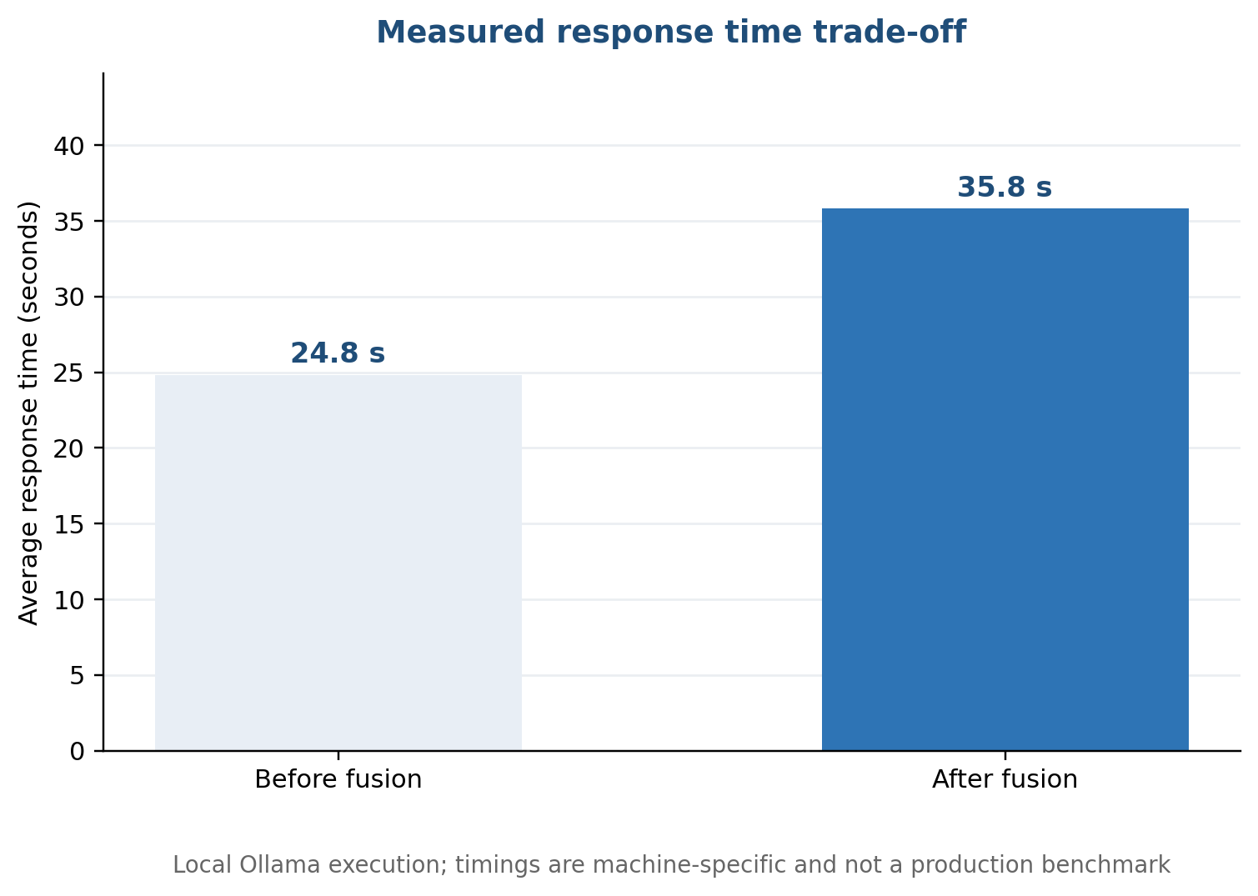
Figure 5. Local average response time before and after enrichment.
The enhanced index was slower in this single local run. The additional time may include local model generation variability as well as retrieval and prompt differences; it should not be interpreted as a precise causal cost of the index. For a product, response time can be improved by using state summaries for aggregate questions, caching repeated results, reducing retrieved context and deploying an optimized inference service.

5.4 Safety and Hallucination Behaviour
- The prompt explicitly requires the model to answer only from retrieved context.
- When evidence is absent, the exact refusal sentence is preferred to guessing.
- Each indexed document carries a source label, enabling response traceability.
- Zero unsupported answers were observed in the fixed test, but this does not guarantee zero hallucinations on unseen questions.
- Clinical claims still require professional review, warning-sign escalation and clear non-diagnostic wording.

6. Part K – Technical Documentation

6.1 Files Involved
Stage | File | Role
Original data | data/menstrual_dataset.csv | Source cycle-level dataset.
Census API | scripts/api_census.py | Collects selected ACS state variables; API key is read from CENSUS_API_KEY.
CDC API | scripts/api_cdc_places.py | Collects county data and produces population-weighted state indicators.
Weather API | scripts/api_open_meteo.py | Uses state capitals and cycle dates to collect historical weather.
Fusion | scripts/final_fusion.py | Joins original, Census, CDC and weather records at the defined grains.
Cleaning | scripts/clean_final_dataset.py | Produces the final validated 56-column CSV and flags.
EDA | scripts/eda_final_dataset.py | Generates summaries, correlations and EDA figures.
RAG preparation | embeddings/build_phase2_knowledge_base.py | Creates baseline/enhanced documents and TF-IDF indexes.
Retrieval | rag/phase2_retriever.py | Ranks documents with cosine similarity and returns labelled context.
LLM interface | rag/llm.py | Calls Ollama, with direct HTTP fallback when the Python client is absent.
Application | app.py | Connects the Streamlit chat interface to the enhanced retriever.
Evaluation | scripts/evaluate_phase2_rag.py | Runs the fixed comparison and writes per-question and summary evidence.

6.2 Data and Result Files
Artifact | Location | Status
Original dataset | data/menstrual_dataset.csv | 17,976 × 34
Census output | data/api_fusion/static/census_state.csv | 52 rows × 8 columns
CDC output | data/api_fusion/static/cdc_places_state.csv | 51 rows × 8 columns
Weather output | data/api_fusion/dynamic/open_meteo_row_level.csv | 17,976 row-level records
Raw fused CSV | data/api_fusion/final/femcare_final_fused_dataset.csv | Intermediate fusion output
Final cleaned CSV | data/api_fusion/final/femcare_final_cleaned.csv | 17,976 × 56
Baseline index | vectorstore/phase2_original_index/index.joblib | 32 documents
Enhanced index | vectorstore/phase2_fused_index/index.joblib | 18,061 documents
Question evidence | report/phase2/assets/phase2_rag_evaluation.csv | 20 system-question runs
Summary evidence | report/phase2/assets/phase2_rag_summary.csv | 2-system comparison

6.3 Reproducible Execution Order
1. Collect or refresh Census data with scripts/api_census.py after setting CENSUS_API_KEY.
2. Collect or refresh CDC PLACES data with scripts/api_cdc_places.py.
3. Collect or refresh date-linked weather data with scripts/api_open_meteo.py.
4. Run scripts/final_fusion.py to create the combined CSV.
5. Run scripts/clean_final_dataset.py and scripts/inspect_final_dataset.py to validate and clean the result.
6. Run scripts/eda_final_dataset.py to regenerate the analytical summaries and figures.
7. Run embeddings/build_phase2_knowledge_base.py to build both controlled-comparison indexes.
8. Ensure Ollama and llama3.2:3b are available, then run scripts/evaluate_phase2_rag.py.
9. Review the CSV/JSON evidence and launch the enhanced app with streamlit run app.py.

6.4 Validation Checklist
Check | Expected condition | Recorded outcome
Schema | 56 expected final columns | Passed
Row count | Equal to original 17,976 | Passed
Unique key | No duplicate user_id + cycle_number | Passed: 0 duplicates
Required API values | Census/CDC fields complete after defined cleaning | Passed
Missingness | Documented, not silently ignored | 2,642 cells documented
Index build | Both joblib files and manifest created | Passed
Retrieval | State question returns matching state summary | Passed for CA, TX and MA tests
LLM evaluation | All 20 system-question runs saved | Passed

6.5 Repository Organization
The project separates collection scripts, datasets, analytical outputs, knowledge-base code, retrieval code, application code and report evidence. The root README now lists the Phase 2 commands, important files, key-handling rule and evaluation boundary. Historical Phase 1 outputs remain in report/phase1; new deliverables are contained in report/phase2.

7. Conclusion
Phase 2 completed the path from API-enriched CSV to a working, testable RAG knowledge base. The final dataset retains all 17,976 cycle records, expands the schema from 34 to 56 columns and introduces Census, CDC and weather context. The integration creates new analytical possibilities, especially state comparisons and contextual questions, while also requiring careful handling of geographic proxies and ecological variables.
In the controlled ten-question test, the baseline system achieved 50% because it correctly answered the five general health questions but lacked evidence for the five fusion questions. The enhanced system achieved 100% and produced no unsupported answers under the defined checks. The principal cost was higher local response time. Within the tested scope, this provides evidence that the fused dataset improves the assistant’s usefulness and knowledge coverage.
The project remains an academic prototype. The next stage should focus on clinical review, privacy governance, larger evaluations, semantic retrieval and production-grade deployment rather than treating the current results as clinical validation.

References
1. Course assignment: LLM–API–Data Fusion and Exploratory Data Analysis, Phase 2 requirements, Parts F–K.
2. Jadhav, S. FemCare AI – Phase 1 Report, 31 August 2026.
3. Kaggle. Menstrual Cycle Data. https://www.kaggle.com/datasets/nikitabisht/menstrual-cycle-data
4. U.S. Census Bureau. 2024 ACS 5-Year API. https://api.census.gov/data/2024/acs/acs5
5. Centers for Disease Control and Prevention. PLACES data API. https://data.cdc.gov/resource/i46a-9kgh.json
6. Open-Meteo. Historical Weather API. https://archive-api.open-meteo.com/v1/archive
7. Ollama. Local model runtime used with llama3.2:3b. https://ollama.com/

Appendix A – Phase 2 Deliverables
Deliverable | Location
Final fused dataset | data/api_fusion/final/femcare_final_cleaned.csv
API source datasets | data/api_fusion/static and data/api_fusion/dynamic
EDA outputs | data/api_fusion/eda
Enhanced RAG index | vectorstore/phase2_fused_index/index.joblib
Evaluation evidence | report/phase2/assets
Source code | scripts, embeddings, rag and app.py
Technical instructions | README.md
Phase 2 report | report/phase2/FemCare_Phase_2_Report.docx

