TATA ONLINE RETAIL
Revenue Drivers and Growth Risks
Power BI Analytics Documentation
Shreya Jha | MSc Business Analytics & Big Data | IE Business School

1. Project Overview
This project analyses 12 months of online retail transaction data for Tata Online Retail to answer one core business question:
"Where is revenue coming from, and what are the risks hiding inside that growth?"
The dashboard identifies which customers, products, and markets drive the most revenue, and surfaces the concentration risks the business needs to manage.

2. Key Metrics at a Glance

Total Revenue | Total Orders | Total Customers | Avg Order Value
£9.75M | 19,313 | 4,373 | £1,340

3. Dashboard Pages

Page 1 — Executive Overview
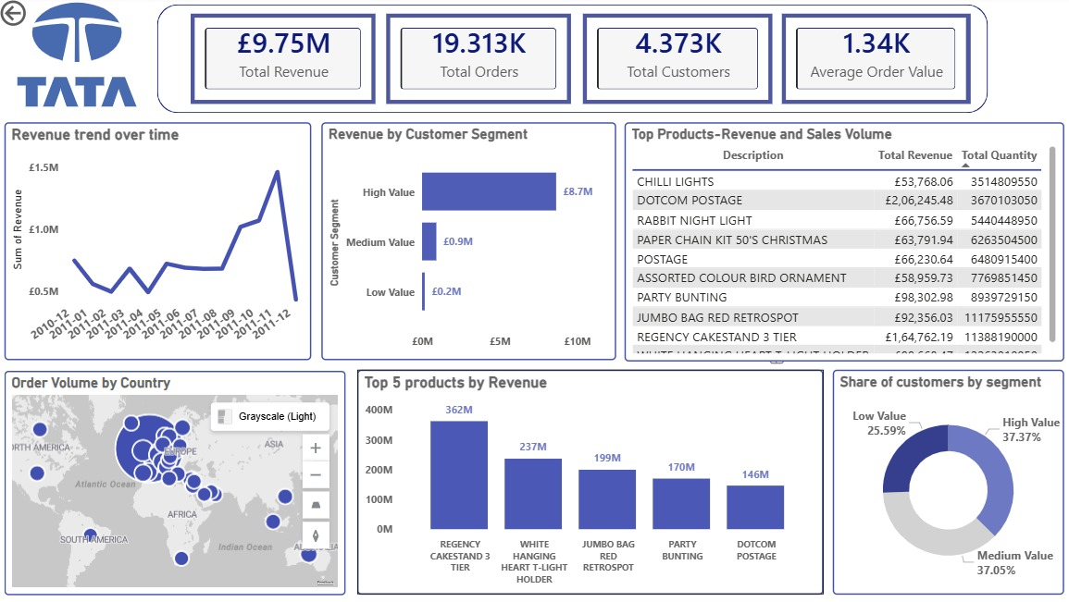

The main dashboard page showing all key metrics in one view: revenue trend over time, order volume by country, top 5 products by revenue, and customer segment breakdown.

What this page shows:
- Revenue trend peaked sharply in mid-2011 before declining — signals a seasonal or churn pattern
- Order volume heavily concentrated in Europe with minimal penetration elsewhere
- Top product by sales volume: Regency Cakestand 3 Tier (362M units)
- Average order value of £1,340 indicates a wholesale or B2B customer base

Page 2 — Customer Segment Analysis
Deep dive into the three customer value segments — High, Medium, and Low — and their revenue contribution.

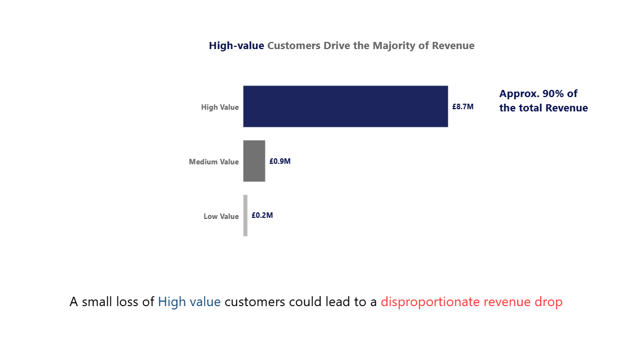

What this page shows:
- High-value customers generate £8.7M — approximately 90% of total revenue
- Medium-value customers contribute £0.9M (9%)
- Low-value customers contribute just £0.2M (2%)
- High-value customers represent only 37% of the customer base but drive nearly all revenue

4. Key Findings

Finding 1 — Revenue Concentration Risk
The most important finding: a small loss of high-value customers could cause a disproportionate revenue drop. With 90% of revenue coming from 37% of customers, the business has a critical retention problem it may not be aware of.Recommendation: Introduce a high-value customer retention programme — personalised outreach, loyalty incentives, dedicated account management.

Finding 2 — Revenue Trend Volatility
Revenue peaked sharply in mid-2011 and then declined significantly by year-end. This pattern suggests either strong seasonality or customer churn that is not being actively managed.
Recommendation: Investigate the drivers of the mid-2011 peak — was it a one-time promotion, a new customer acquisition burst, or organic growth? Understanding the cause determines the strategy.

Finding 3 — Geographic Concentration
Order volume is almost entirely concentrated in Europe. Other regions — Americas, Asia, Africa — are present but represent a negligible share of orders.
Recommendation: Evaluate whether geographic expansion is a growth opportunity or whether European market depth should be prioritised first.

5. Tech Stack
- Power BI Desktop — dashboard development and visualisation
- DAX — calculated measures and customer segmentation logic
- Excel / CSV — data source and cleaning
- RFM Analysis — customer value segmentation methodology

6. Repository Structure
- dashboard/ — Power BI .pbix file (download link in README)
- screenshots/ — dashboard_overview.png, customer_segmentation.png
- data/ — Online_Retail_Data_Set.csv
- README.md — project summary
- Documentation.docx — this file

7. Data Source
Dataset: UCI Machine Learning Repository — Online Retail Dataset
Contains all transactions for a UK-based online retailer between 01/12/2010 and 09/12/2011. The company mainly sells unique all-occasion gifts, and many of its customers are wholesalers.

