**GRAPHICS AND ADZ DATABASE MANAGEMENT SYSTEM**

**ABSTRACT:**

**The Graphics and Adz database management system represents a pivotal component of the company's infrastructure, offering a robust platform for storing, organizing, and accessing critical data. With a focus on client information, customer orders, and machinery maintenance, this system plays a central role in ensuring operational efficiency and informed decision-making.**

**Client Data Management:**

**The system serves as a centralized repository for client data, encompassing fundamental needs and preferences. Each client is assigned a unique identifier, facilitating streamlined data management and personalized service delivery. Through efficient search functionalities, users can access comprehensive client profiles, enabling targeted marketing strategies and tailored service offerings.**

**Order Digitization and Tracking:**

**In addition to client data, the system digitizes and tracks customer orders, providing real-time visibility into project requirements and service requests. With unique IDs assigned to each order, employees can efficiently track order progress, manage timelines, and ensure timely delivery of services. This feature enhances operational agility and customer satisfaction, driving business growth and reputation.**

**Employee and Machinery Management:**

**The database extends its functionality to encompass employee and machinery management, providing comprehensive insights into workforce allocation and equipment utilization. Each employee and machine are assigned a unique identifier, enabling efficient resource allocation and maintenance scheduling. Through detailed machinery information, stakeholders can optimize asset utilization, minimize downtime, and ensure uninterrupted operations.**

**A graphics management system is a specialized tool designed to efficiently store, organize, and retrieve graphical and advertising data. This System is particularly useful for businesses and organization that heavily rely on visual content and advertising materials.**

**Additionally, these systems often provide version control and collaboration tools, enabling multiple users to work on and manage visual content simultaneously. overall, a graphics and adz database management system play a crucial role in simplifying the storage and retrieval of visual assets, ultimately enhancing productivity and streamlining the creative process. In the following, we will delve deeper into the specific functionalities and benefits of utilizing a graphics and adz database management system. Overall, this project is developed using MySQL to help to maintain client orders in best way possible and reduce human effort and increase convenience as well as productivity**

**INTRODUCTION:**

**Graphics and adz data base system plays a central role in the operations of the Graphics and Adz company, providing a structured framework for storing and managing a wide array of data related to clients, orders, employees, and machinery maintenance. With its robust capabilities, GADMS facilitates streamlined processes and informed decision-making across various departments within the organization.**

**Client Data Management: The system stores comprehensive information about clients, including their fundamental needs and preferences. Each client is assigned a unique identifier for efficient tracking and management.**

**Order Management: The system digitizes customer orders, capturing detailed requirements and service specifications. This functionality ensures accuracy and facilitates seamless order processing.**

**Identifier Assignment: Data base generates unique identifiers for customers, employees, orders, and store records, enabling precise data management and retrieval.**

**Search Functionality: The system boasts a powerful search feature, allowing users to swiftly access a vast array of recorded data. Through adept table joins, specific field data can be retrieved with ease, enhancing efficiency in information retrieval.**

**Maintenance Checks: Data base includes functionality for conducting maintenance checks on machinery. These checks are meticulously coordinated by departments to monitor operational functionality and ensure uninterrupted business operations.**

**Machinery Information: Detailed information about machinery is stored within the system, providing valuable insights for decision-making and resource allocation.**

**Streamlined Data Management: system centralizes data storage and management, eliminating redundancies and facilitating efficient access to information.**

**Operational Continuity: The system's maintenance checks help ensure the uninterrupted functionality of machinery, minimizing downtime and optimizing productivity.**

**AIMS AND OBJECTIVES:**

**Aims:**

**Effective data management: The main goal of system is to simplify the storage and management of customer data, order data, employee data and machine data in Graphics and Adz.**

**Improved Decision Making: Data strives to provide comprehensive information on customer needs, order specifications and machine status, enabling decision makers to make informed choices that drive business growth and customer satisfaction.**

**Continuity of Operations: It aims to ensure uninterrupted operation of machines with timely maintenance checks, minimizing downtime and optimizing productivity between different departments of the organization.**

**Objectives:**

**Implement Comprehensive Data Warehousing: Develop and implement a robust database structure in database to efficiently store and organize customer data, order data, employee records and machine data.**

**Improve data accessibility: Add advanced search capabilities and efficient data retrieval mechanisms to ensure quick and easy access to relevant data for all authorized users.**

**Order processing automation: Leverage data automation capabilities to digitize customer orders, capturing detailed requirements and facilitating seamless processing from order to fulfilment.**

**Facilitate Maintenance: Development of system modules to plan and execute machine maintenance inspections, ensuring timely inspections and repairs to minimize downtime and maintain business continuity.**

**Generating Statistics with Analytics: Integrate analytical tools and reporting capabilities with database to generate actionable insights from recorded data, enabling informed decisions and strategic planning.**

**Ensure Data Security and Compliance: Implement strong security measures and adhere to privacy policies to protect sensitive data stored in database and maintain compliance with relevant industry standards.**

**Provide Training and Support: Provide comprehensive training programs and ongoing support to system users to ensure proficient use of system functions and features across all Graphics and Adz departments**

**Problem definition:**

**Graphics and Adz system is particularly useful for businesses and organization that heavily rely on visual content and advertising materials. A client has name, id, phone number who orders for printing related works in order table containing id, client id, staff who attends particular client, there is a particular type of printing work for each order for. There are many Branches with different location. Staff has all necessary information. There are some departments like designer, accountant, service, outdoor, marketing, receptionist many more. Obviously, every printing work is carried out by machines for different purpose. Every machine has to be maintained by staff and service date**

**The possible details can be retrieved with queries:**

**1. Find the total number of male and female staff and display their average salary**

**2. List the names of the staff members who are employed by the department designer.**

**3. List the names of the machines and their associated staff members who are assisting with the Graphics data base.**

**4. List information about the department with the maximum amount of employees.**

**5. Create a method for keeping track of the specifics of each order**

**6. Establish a process to retrieve all machine information**

**7. Build a view to retrieve the name, order type, and pricing information**

**8. Determine in the order after inserting the quantity, size, and type cost into the order database using a trigger**

**HARDWARE/SOFTWARE REQUIREMENTS:**

**Hardware requirements:**

* **Laptop/desktop**
* **CPU: Intel Platform- 3 GHz processor or higher-multi-processor is required**
* **Memory: minimum 1 GB RAM,4 GB or higher is required**
* **Hard disk: minimum 80 GB. The amount of free space required depends on the amount of data that you want to store**

**Software requirement:**

* **Operating system or software application is the physical computer resources**
* **MS SQL Server**

**DATABASE DESIGN:**

**E-R DIAGRAM:**

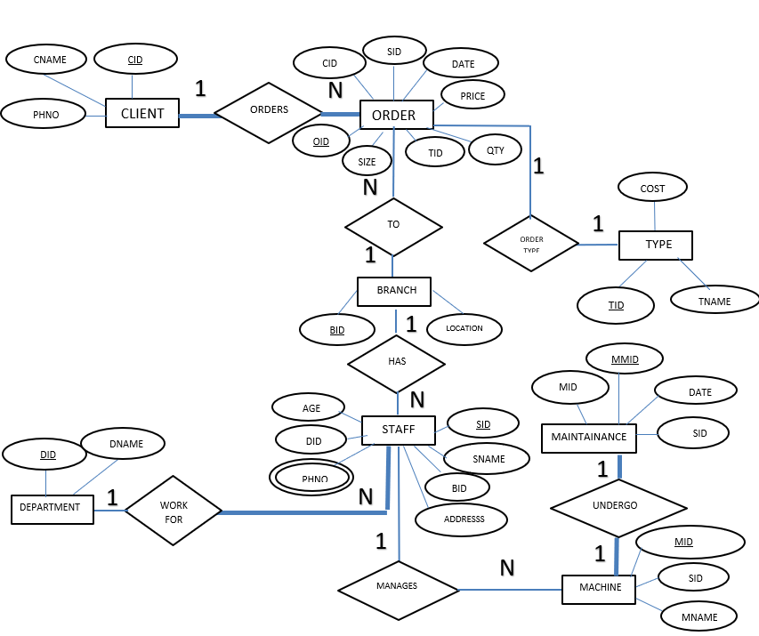

**SCHEMA DIAGRAM:**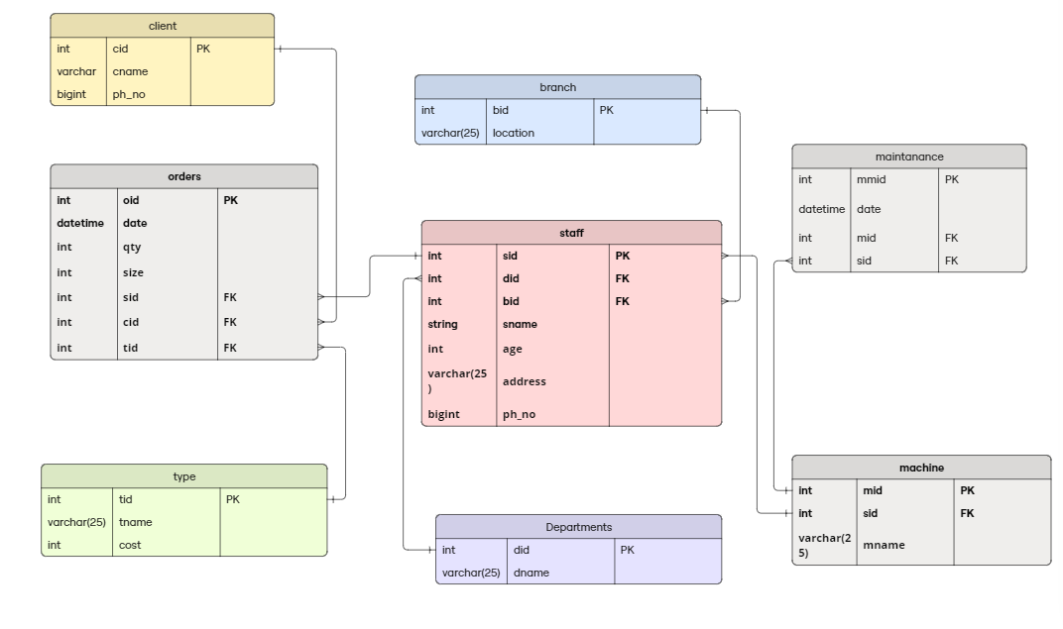

**CREATING TABLES:**

1. **Client table:**

**Create table Client (Cid int primary key, Cname varchar (25) not null, Ph_no bigint);**

**mysql> desc client;**

|  |  |  |  |  |  |
| --- | --- | --- | --- | --- | --- |
| **Field Cid**  **Cname**  **Ph_no** | **Type**  **int**  **varchar (25)**  **bigint** | **Null NO**  **NO**  **YES** | **Key PRI** | **Default NULL**  **NULL**  **NULL** | **Extra** |

1. **Type table:**

**Create table Type (Tid int primary key, Tname varchar (25) not null, Price int);**

**mysql> desc Type;**

|  |  |  |  |  |  |
| --- | --- | --- | --- | --- | --- |
| **Field**  **Tid**  **Tname**  **costs** | **Type**  **int**  **varchar (25)**  **varchar (25)** | **Null**  **NO**  **NO**  **YES** | **Key**  **PRI** | **Default**  **NULL**  **NULL**  **NULL** | **Extra** |

1. **Branch table:**

**Create table Branch (Bid int primary key, Location varchar (25) not null);**

**mysql> desc Branch;**

|  |  |  |  |  |  |
| --- | --- | --- | --- | --- | --- |
| **Field**  **Bid**  **Location** | **Type**  **int**  **varchar (25)** | **Null**  **NO**  **NO** | **Key**  **PRI** | **Default**  **NULL**  **NULL** | **Extra** |

1. **Department table:**

**Create table Department (Did int primary key, Dname varchar (25));**

**mysql> desc Department;**

|  |  |  |  |  |  |
| --- | --- | --- | --- | --- | --- |
| **Field**  **Did**  **Dname** | **Type**  **int**  **varchar (25)** | **Null**  **NO**  **YES** | **Key**  **PRI** | **Default**  **NULL**  **NULL** | **Extra** |

1. **Staff table:**

**Create table Staff (Sid int primary key auto_increment, sname varchar (25) not null, Address varchar (25) not null, Ph_no bigint, Bid int, Did int, age int, salary int, foreign key (Bid) references Branch (Bid), foreign key (Did) references Department (Did));**

**mysql> desc Staff;**

|  |  |  |  |  |  |
| --- | --- | --- | --- | --- | --- |
| **Field**  **Sid**  **Sname**  **Address**  **Ph_no**  **Bid**  **Did**  **Age**  **Salary** | **Type**  **int**  **varchar (25)**  **varchar (25)**  **bigint**  **int**  **int**  **int**  **int** | **Null**  **NO**  **NO**  **NO**  **YES**  **YES**  **YES**  **YES**  **YES** | **Key**  **PRI**  **MUL**  **MUL** | **Default**  **NULL**  **NULL**  **NULL**  **NULL** | **Extra**  **Auto_increment** |

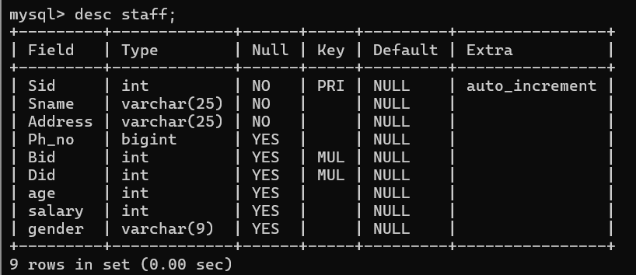

**Altering staff table to add gender column:**

**Alter table Staff add constraint age check (age>18);**

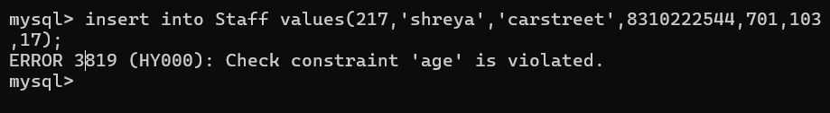

**mysql>alter table Staff add column gender varchar (9);**

**mysql> alter table Staff add constraint gender check (gender in('male','female','other'));**



1. **Orders table:**

**Create table Orders (Oid int primary key auto_increment, Cid int, Sid int, Tid int, Date datetime, Qty int, size int, price int null, foreign key (Cid) references Client (Cid), foreign key (Sid) references Staff (Sid), foreign key (Tid) references Type (Tid));**

**mysql> desc Orders;**

|  |  |  |  |  |  |
| --- | --- | --- | --- | --- | --- |
| **Field**  **Oid**  **Cid**  **Sid**  **Tid**  **date**  **qty**  **size**  **price** | **Type**  **int**  **int**  **int**  **int**  **datetime**  **int**  **int**  **int** | **Null**  **NO**  **YES**  **YES**  **YES**  **YES**  **YES**  **YES**  **YES** | **Key**  **PRI**  **MUL**  **MUL**  **MUL** | **Default**  **NULL**  **NULL**  **NULL**  **NULL**  **NULL**  **NULL**  **NULL**  **NULL** | **Extra**  **Auto_increment** |

1. **Machine table:**

**Create table Machine (Mid int primary key, Mname varchar (25), Sid int, foreign key (Sid) references Staff (Sid));**

**mysql> desc Machine;**

|  |  |  |  |  |  |
| --- | --- | --- | --- | --- | --- |
| **Field**  **Mid**  **Mname**  **Sid** | **Type**  **int**  **varchar (25)**  **int** | **Null**  **NO**  **NO**  **YES** | **Key**  **PRI**  **MUL** | **Default**  **NULL**  **NULL**  **NULL** | **Extra** |

1. **Maintenance table:**

**Create table maintenance (Mmid int primary key, Mid int, Sid int, date datetime, foreign key (Mid) references Machine (Mid), foreign key (Sid) references Staff (Sid));**

**mysql> desc Maintanance;**

|  |  |  |  |  |  |
| --- | --- | --- | --- | --- | --- |
| **Field**  **Mmid**  **Mid**  **Sid**  **date** | **Type**  **int**  **int**  **int**  **datetime** | **Null**  **NO**  **YES**  **YES**  **YES** | **Key**  **PRI**  **MUL**  **MUL** | **Default**  **NULL**  **NULL**  **NULL**  **NULL** | **Extra** |

**INSERTING INTO TABLES:**

1. **Client table:**

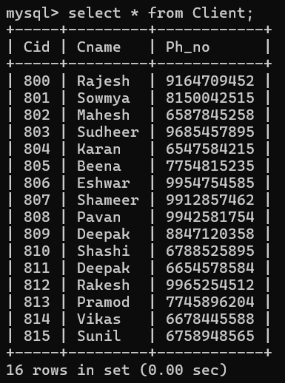**insert into client(cid,cname,ph_no) values(800,'Rajesh',9164709452),(801,'Sowmya',8150042515),(802,'Mahesh',6587845252),(803,'Sudheer',96854557895),(804,'karan',6547584215),(805,'Beena',7754815235),(806,'Eshwar',9954754585),(807,'Shameer',9912857462),(808,'Pavan',9942581754),(809,'Deepak',8847120358),(810,'Shashi',6788525895),(811,'Deepak',6654578584),(812,'Rakesh',9965244512),(813,'Pramod',7745896204),(814,'Vikas',6678445588),(815,'Sunil',6758948565);**

1. **Type table:**

**insert into type (Tid, Tname, cost) values(1,'visiting_card',60), (2,'Flex',10), (3,'Invitation',6), (4,'Mug_print',100), (5,'T-shirt_print',100);**

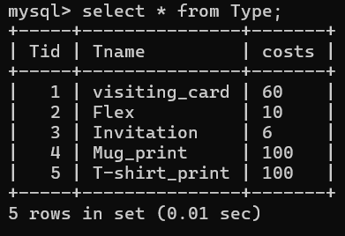

1. **Branch table:**

**insert into Branch (Bid, Location) values (700,'Udupi'), (701,'Mangalore'), (702,'Baikampady'), (703,'Moodbidre'), (705,'Bangalore);**

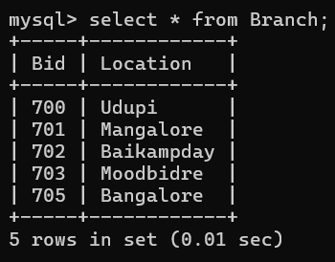

1. **Staff table:**

**Before adding salary and gender:**

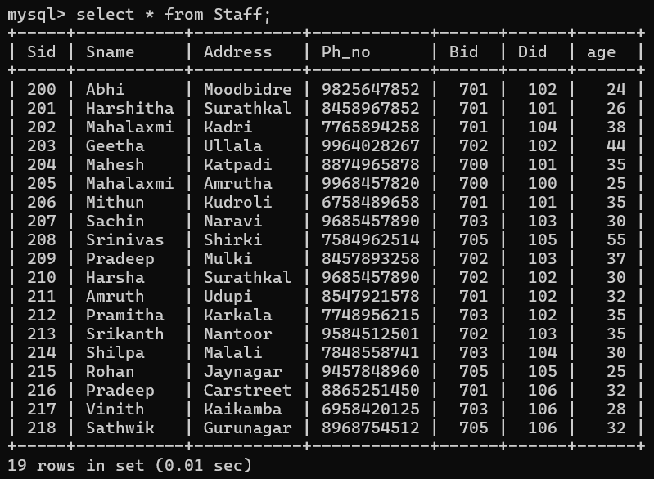

1. **After adding salary and gender column:**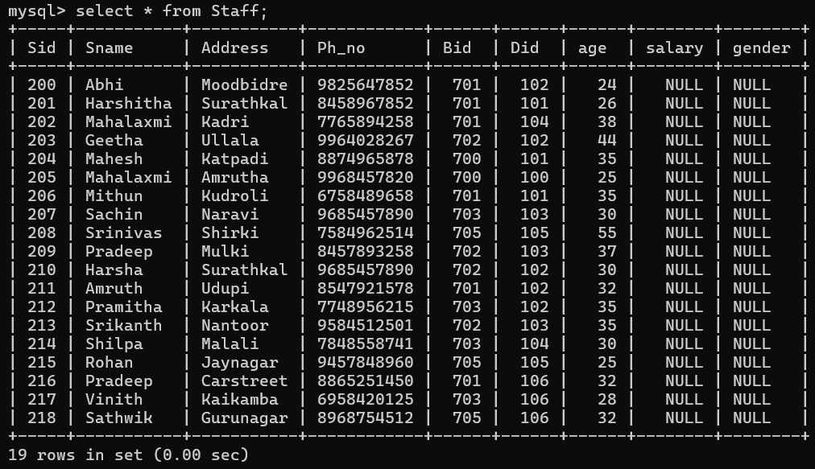

**Updating columns:**

**update Staff set salary=18000 and gender='female' where Sid=201 … Sid=210;….and so on**

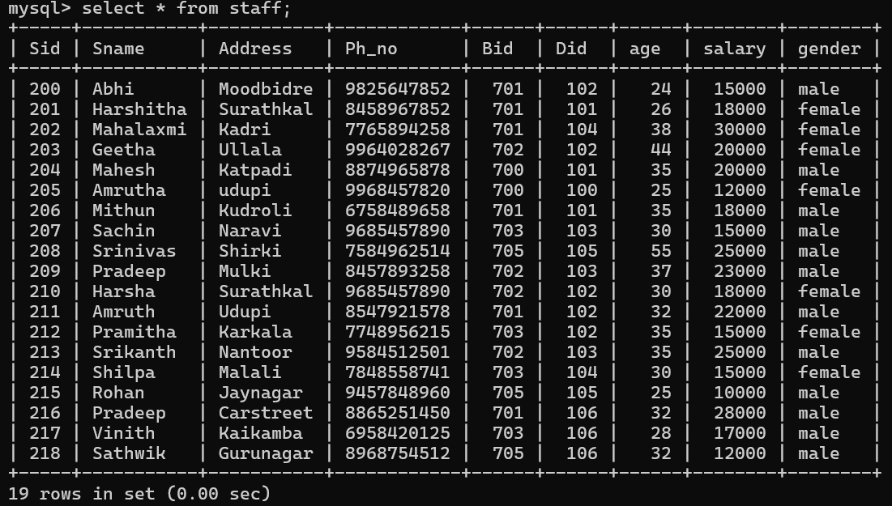

1. **Order table:**

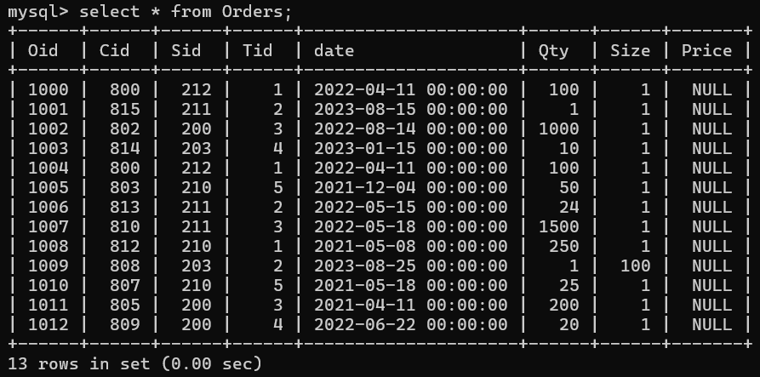

1. **Machine table:**

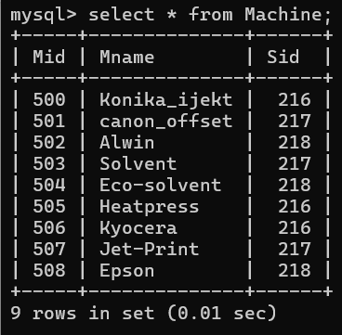

1. **Maintenance table:**

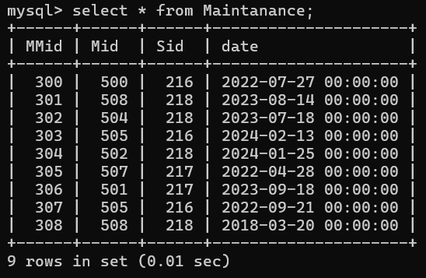

**QUERIES AND RESULTS:**

**1. Find the total number of male and female staff and display their average salary**

**mysql> SELECT gender, COUNT (gender), avg(salary) as average_salary FROM staff group by gender;**

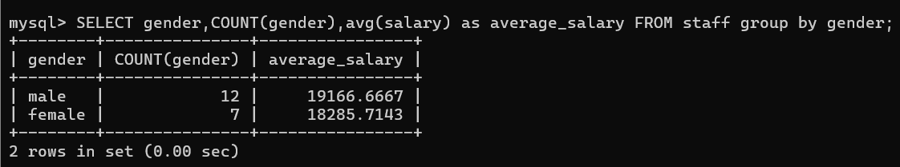

**2. List the names of the staff members who are employed by the department designer.**

**mysql>SELECT sname from staff**

**LEFT JOIN department d**

**on d.did=s.did where dname= ‘designer’;**

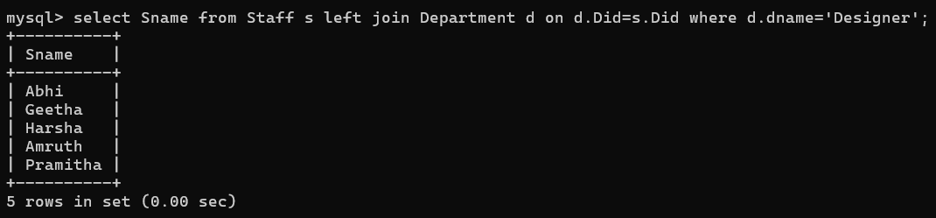

**3.** **List the names of the machines and their associated staff members who are assisting with the Graphics data base.**

**mysql>SELECT distinct sname, mname**

**from machine m, staff s**

**where s.sid=m.sid ORDER BY sname;**

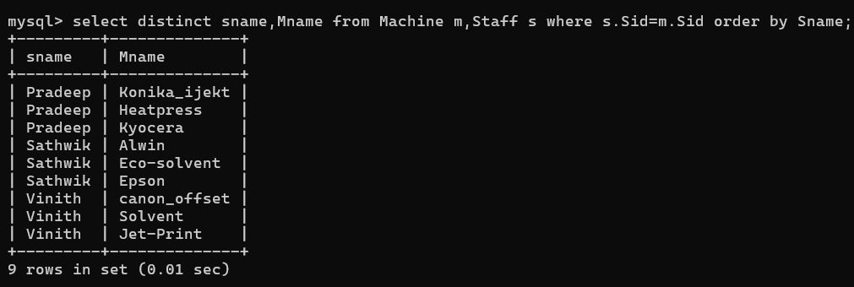

**4. List information about the department with the maximum amount of employees.**

**mysql>Select d. dname, count(s.sid)**

**from department d, staff s**

**where s.did=d.did**

**group by d. dname**

**order by count(s.sid) desc;**

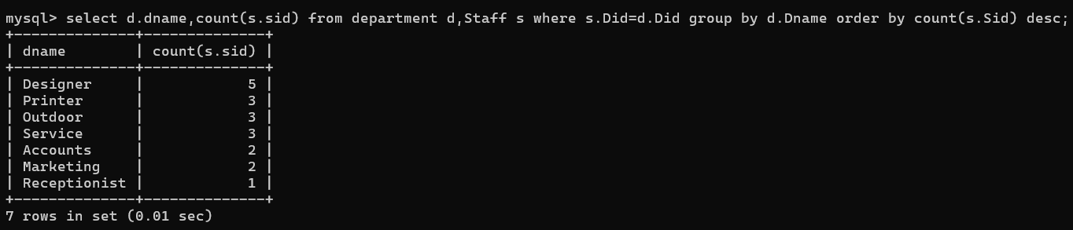

**5. Create a method for keeping track of the specifics of each order**

**mysql>DELIMITER //**

**CREATE PROCEDURE getorderdetails(in order_id int)**

**begin**

**SELECT * FROM orders where oid=order_id;**

**end //**

**DELIMITER ;**

**To call procedure:**

**mysql>call getorderdetails (1000);**

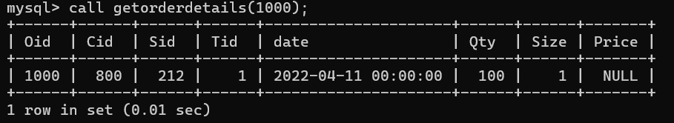

**6. Establish a process to retrieve all machine information**

**mysql> DELIMITER //**

**CREATE PROCEDURE getmachinedetails ()**

**begin**

**select * from machine;**

**select count (*) as total machine from machine;**

**end //**

**DELIMITER;**

**To call procedure:**

**mysql>call getmachinedetails (1000);**

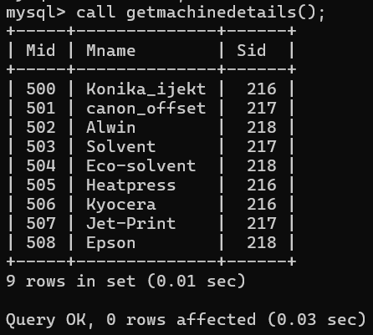

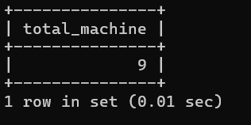

**7. Build a view to retrieve the name, phone, order type, date and pricing information**

**create view info as select cname,ph_no,Tname,date,price from Client c,Type t,Orders o where c.cid=o.cid and t.tid=o. tid;**

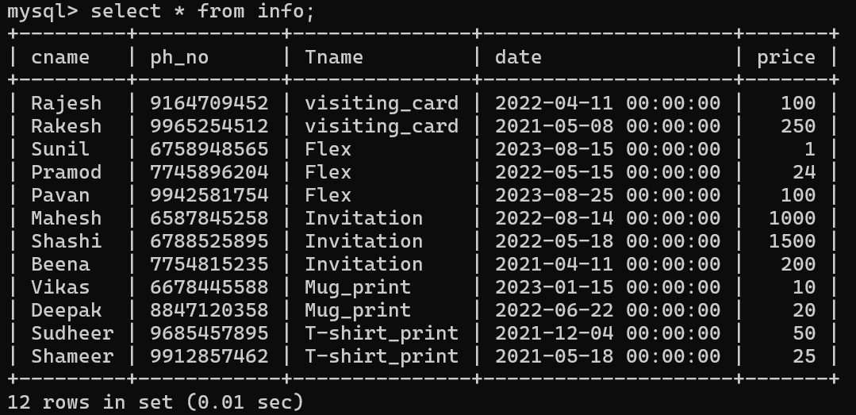

**8. Determine in the order after inserting the quantity, size, and type cost into the order database using a function and trigger**

**mysql> create function order_price (i int)**

**returns int deterministic**

**begin**

**update Orders set price=qty*size where i=oid;**

**return 1;**

**end//**

**to call function: select order_price (1006);**

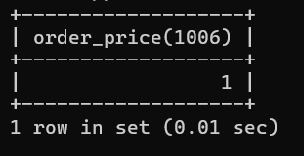

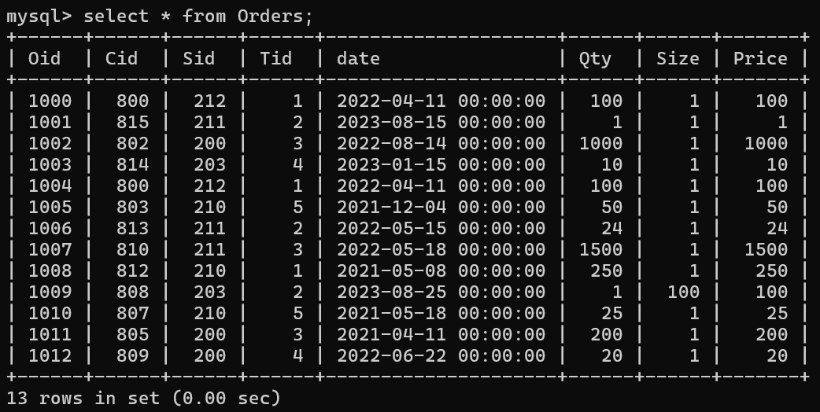

**Mysql>CREATE TRIGGER calculate_order_price**

**before INSERT ON Orders**

**FOR EACH ROW**

**BEGIN**

**DECLARE type_costs int;**

**SELECT costs INTO type_costs FROM Type WHERE tid = NEW.tid;**

**SET new. price=type_costs*new. size*new.qty;**

**END;**

**//**

**Query OK, 0 rows affected (0.02 sec)**

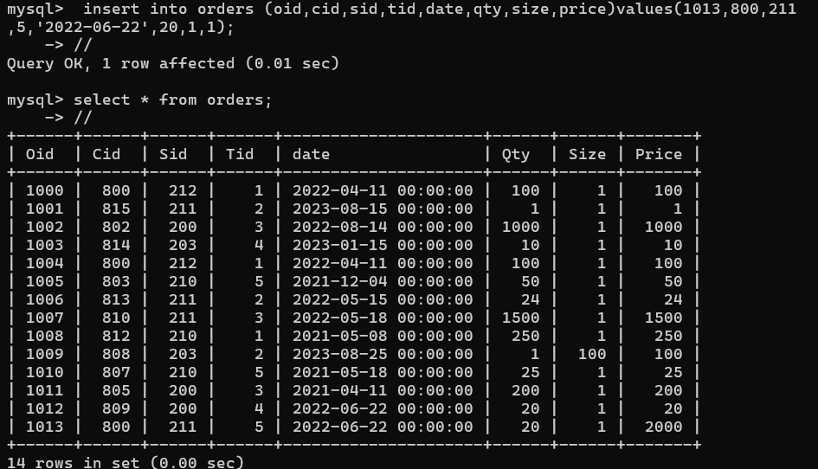

**Conclusion:**

**the integration of a Graphics and Advertising Database Management System, particularly leveraging the capabilities of MySQL, signifies a significant stride towards bolstering efficiency, productivity, and collaboration within businesses reliant on visual assets. By establishing a centralized repository for storing, organizing, and retrieving graphical content, such systems not only streamline operations but also foster a conducive environment for innovation and creativity.**

**The incorporation of version control and collaboration tools within these database management systems represents a paradigm shift in how visual content is created and managed. By empowering multiple users to work concurrently on projects, such systems mitigate the risks of versioning errors and promote a harmonious approach towards content creation. This collaborative environment encourages cross-functional teamwork and facilitates the seamless exchange of ideas, ultimately enhancing the quality and relevance of visual assets produced.**

**Moreover, the inherent advantages of reducing manual effort and increasing convenience offered by these systems cannot be overstated. By automating mundane administrative tasks associated with asset management, businesses can allocate their resources more efficiently, allowing teams to focus their efforts on creative endeavors rather than administrative overhead. This not only boosts operational effectiveness but also cultivates a culture of innovation and experimentation within the organization.**

**Furthermore, by simplifying the storage and retrieval of visual assets, Graphics and Advertising Database Management Systems empower teams to unleash their creative potential. With easy access to a vast repository of graphical content, creative teams can iterate rapidly, explore new concepts, and deliver compelling campaigns that resonate with target audiences. Additionally, the ability to maintain consistency and accuracy across campaigns ensures brand integrity and enhances the overall impact of marketing initiatives.**

**In essence, the adoption of a Graphics and Advertising Database Management System represents more than just a technological upgrade—it signifies a strategic investment in driving business growth and competitiveness. By harnessing the power of centralized asset management, version control, and collaboration tools, businesses can unlock new levels of efficiency, productivity, and creativity, ultimately positioning themselves for success in an increasingly dynamic and competitive marketplace.**

**Future Enhancements:**

**Building a Comprehensive Customer Portal:**

**When imagining how the Graphics and Advertising Database Management System (GADMS) will develop in the future, a number of revolutionary improvements can be made to increase productivity, boost client happiness, and spur company expansion. With these improvements, GADMS will continue to be at the forefront of innovation in the fields of advertising and graphic asset management, as they are intended to capitalize on new developments in technology and industry trends.**

**Shipment Tracking: The site will include integrated shipment tracking functions, enabling clients to track the flow of their products from the production plant to their intended destinations. This is in addition to order status updates. Through the provision of shipping logistics visibility, clients can enhance their operational planning and management skills.**

**Customer Portal: Create a customer portal where clients can log in to view order status, track shipments, and communicate with staff members. Providing clients with self-service capabilities can enhance transparency, communication, and overall satisfaction with the service.**

**Automated Order Processing: Develop automated workflows and processes to streamline order processing, from initial client request to final delivery. Automation can help reduce manual errors, improve turnaround times, and enhance overall efficiency in handling orders.**

**References:**

* **Fundamentals of Database Systems 7th Edition, 2022 Elmasri and Navathe:**
* **Database System Concepts 7th Edition 2022 Silberschatz, Korth and Sudharshan**
* **An Introduction to Database Systems 8th Edition 2013, C.J. Date, A.  Kannan, S.  Swaminathan:**
* **Database Management Systems 1st Edition 2010, Majmudar Arun K, Bhattacharyya pritimoy**