**Assignment No 10**

1. **Creating a Cassandra Cluster**

**Creating 3 Nodes to implement cluster**

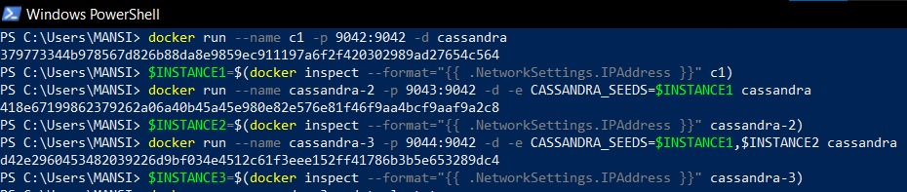

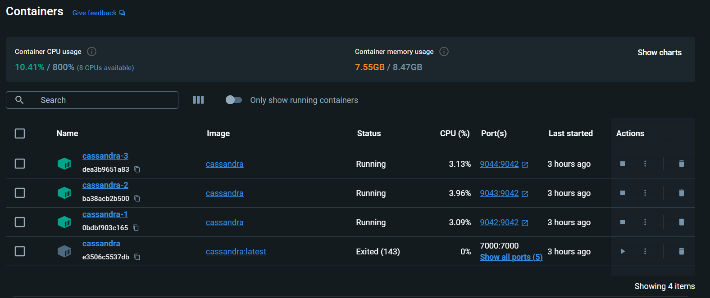

**Creating a keyspace on Node 3**

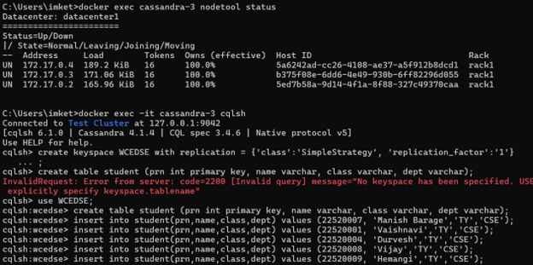

**Entering into Node-2 And fetching the records and inserting one new record**

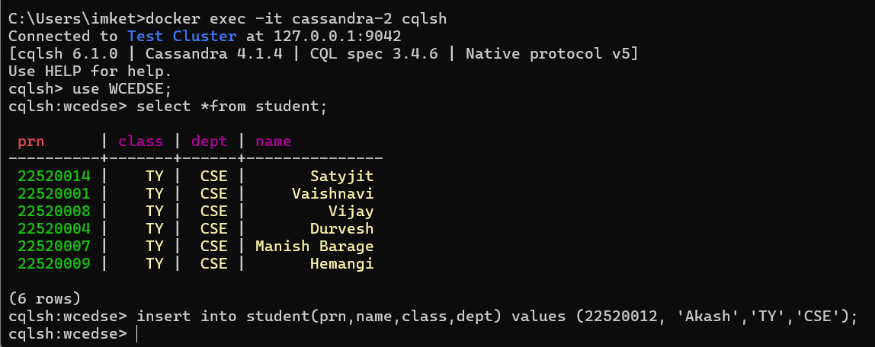

**Entering into Node-1 and fetching the records**

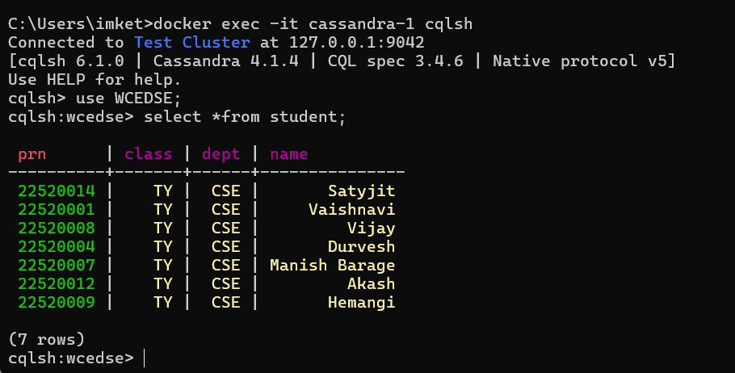

**2)**

**Creating a keyspace for weather**

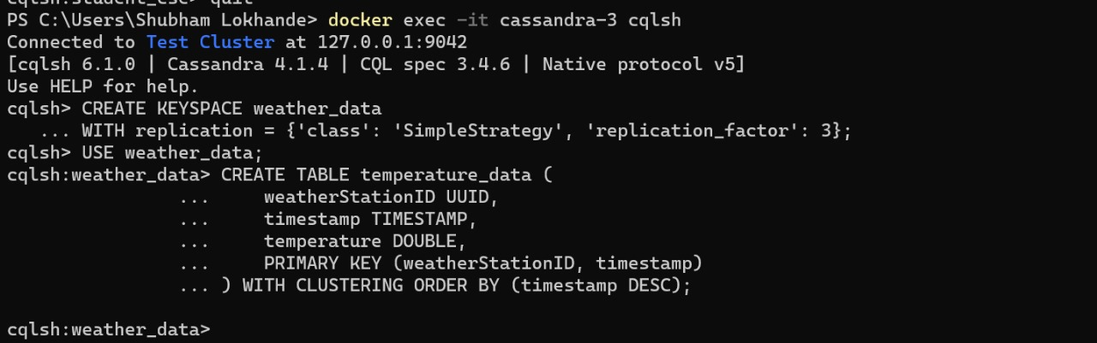

**Inserting records**

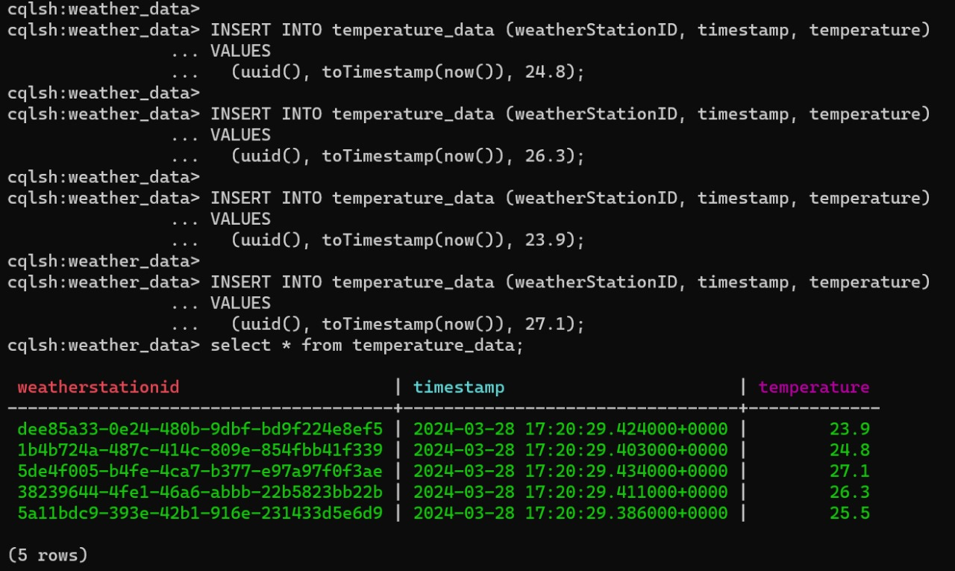

**Retrieve temperature data for a specific weather station**

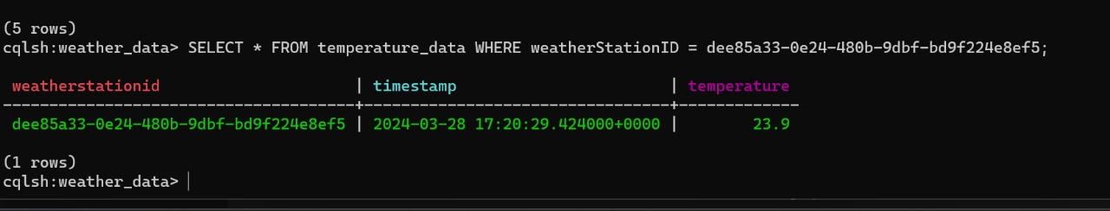

**Retrieve temperature data for a specific time range**

