**Assignment - 11**

Consider the “**Research Papers Database”** scenario as follows :

The research papers have authors (often more than one). Most papers have a classification (what the paper is about). The classifications form a hierarchy in several levels (for example, the classification “Databases” has the subclassifications “Relational” and “Object-Oriented”). A paper usually has a list of references, which are other papers. These are called citations.

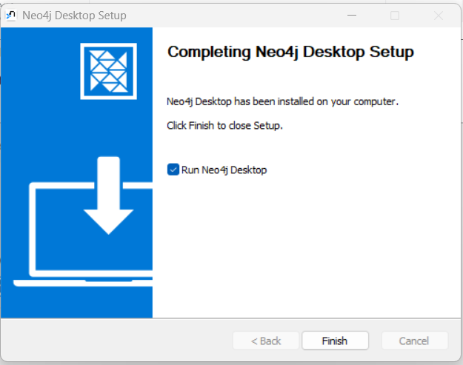

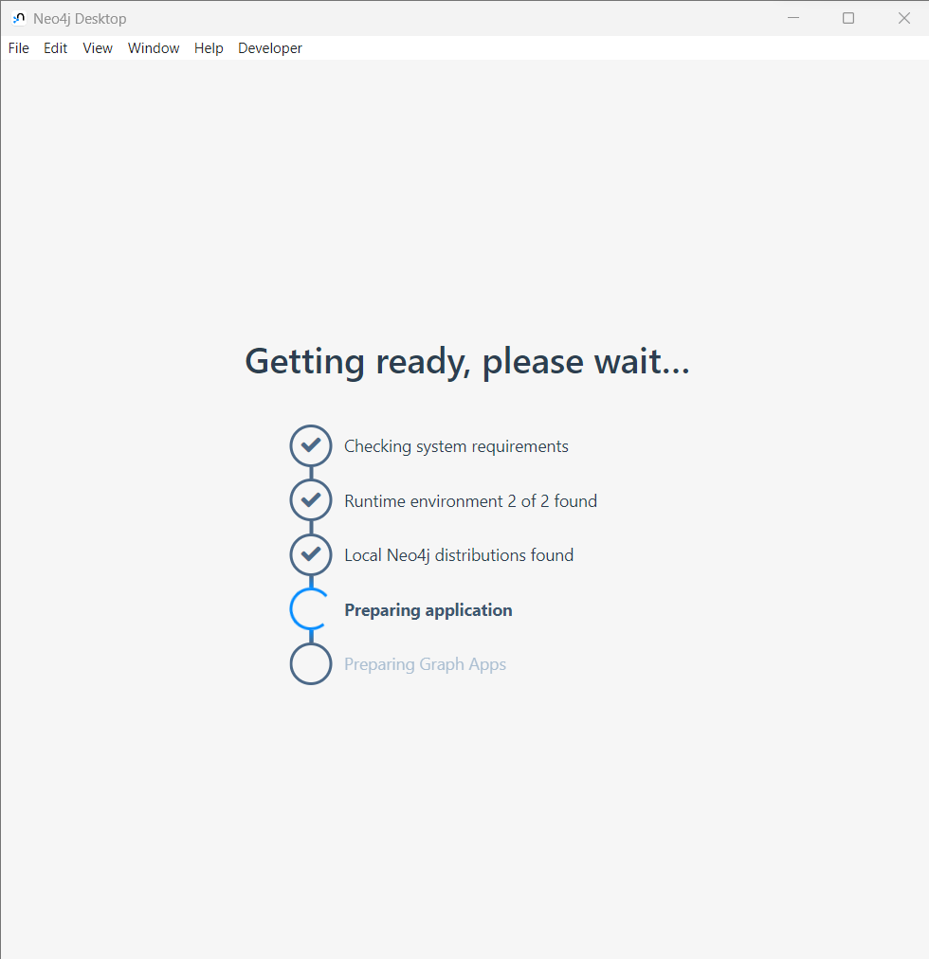

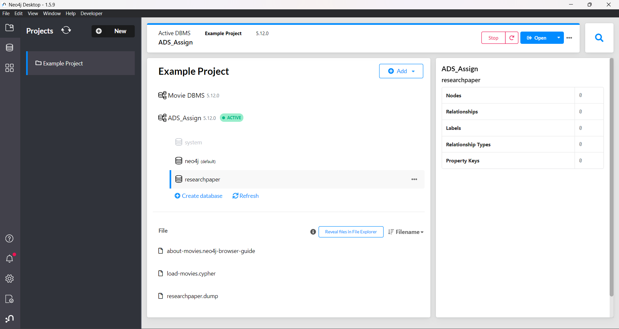

1. Design/model the graph database using Neo4j for above scenario.

1. Download the raw data from **Cora Research Paper Classification Project** : <http://people.cs.umass.edu/~mccallum/data.html>The database contains approximately 25,000 authors, 37,000 papers and 220,000 relationships.

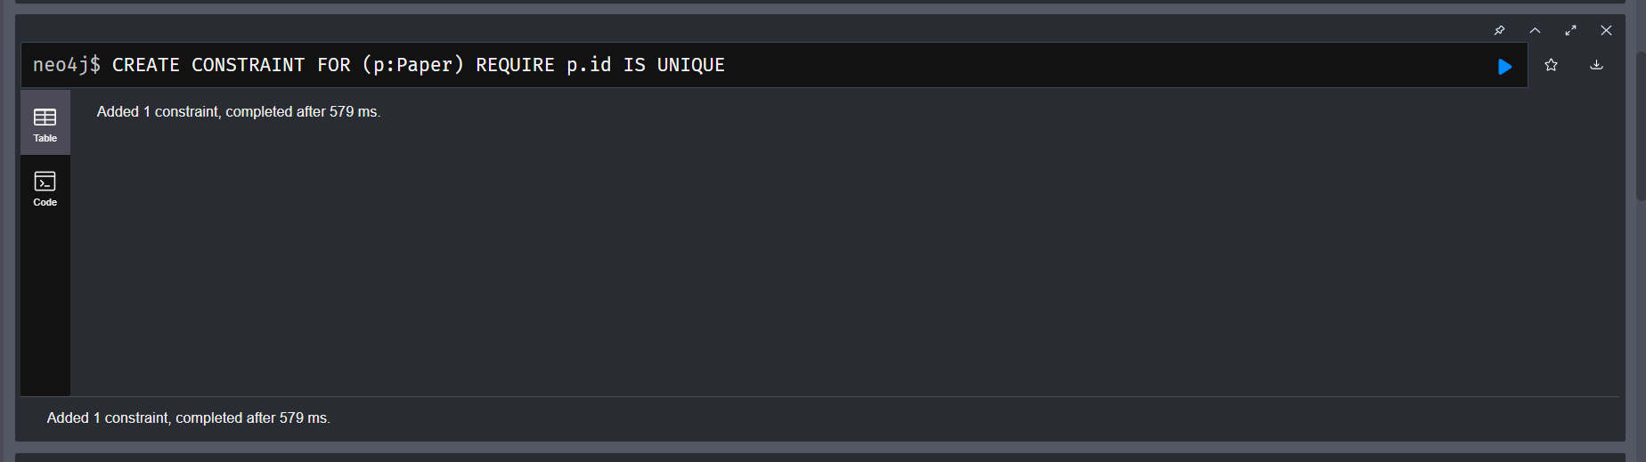

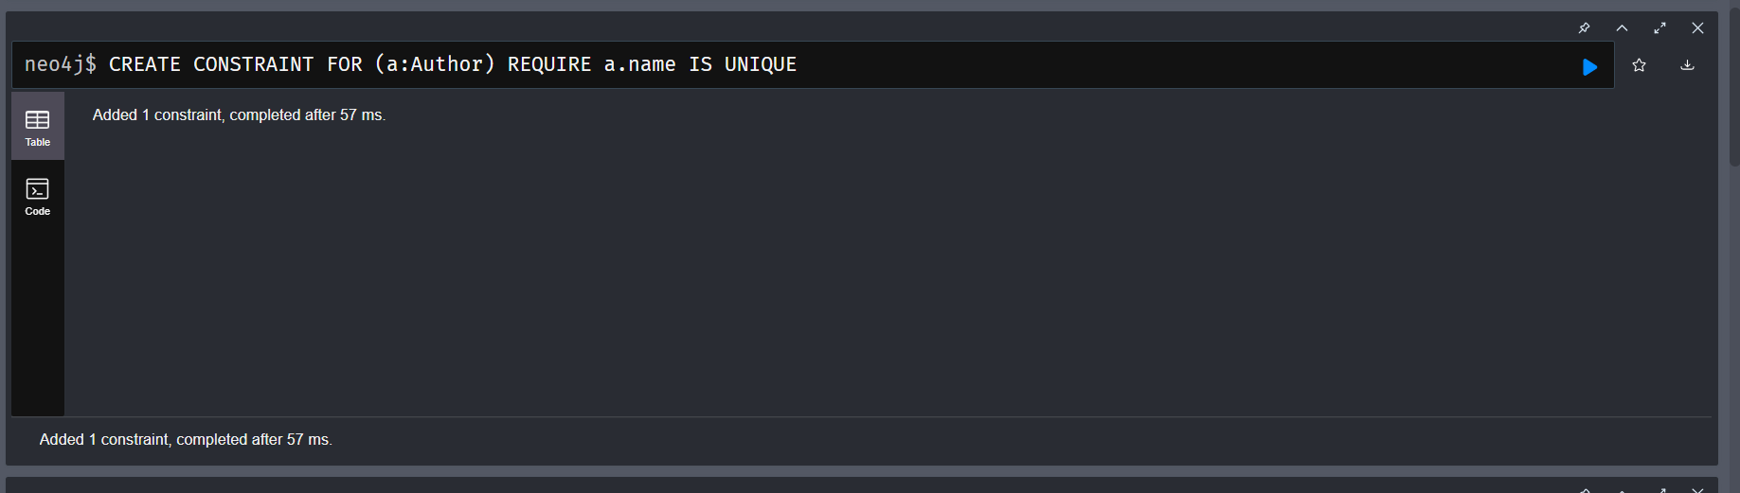

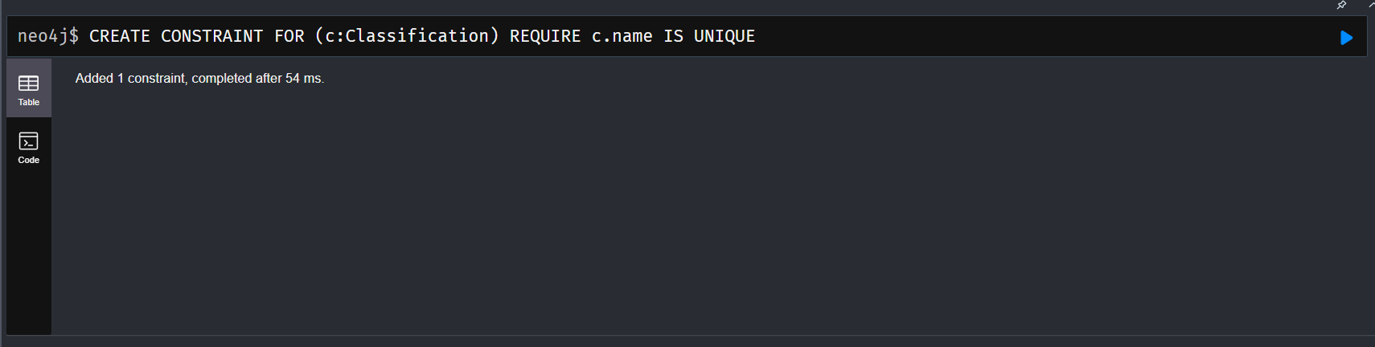

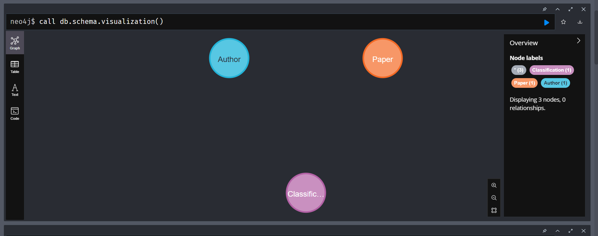

1. Load this data using Neo4j Data Browser

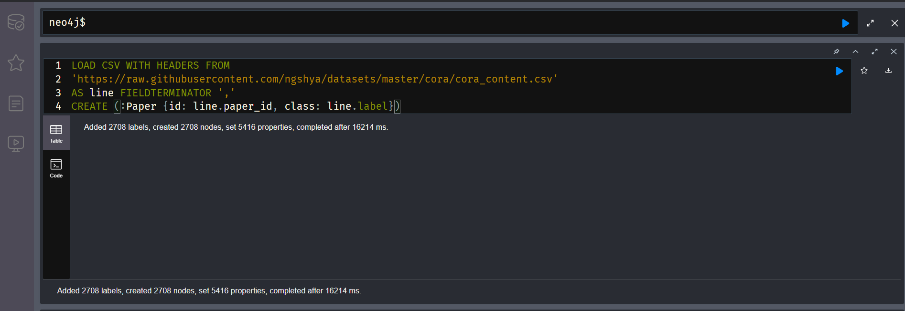

LOAD CSV WITH HEADERS FROM

'https://raw.githubusercontent.com/ngshya/datasets/master/cora/cora_content.csv'

AS line FIELDTERMINATOR ','

CREATE (:Paper {id: line.paper_id, class: line.label})

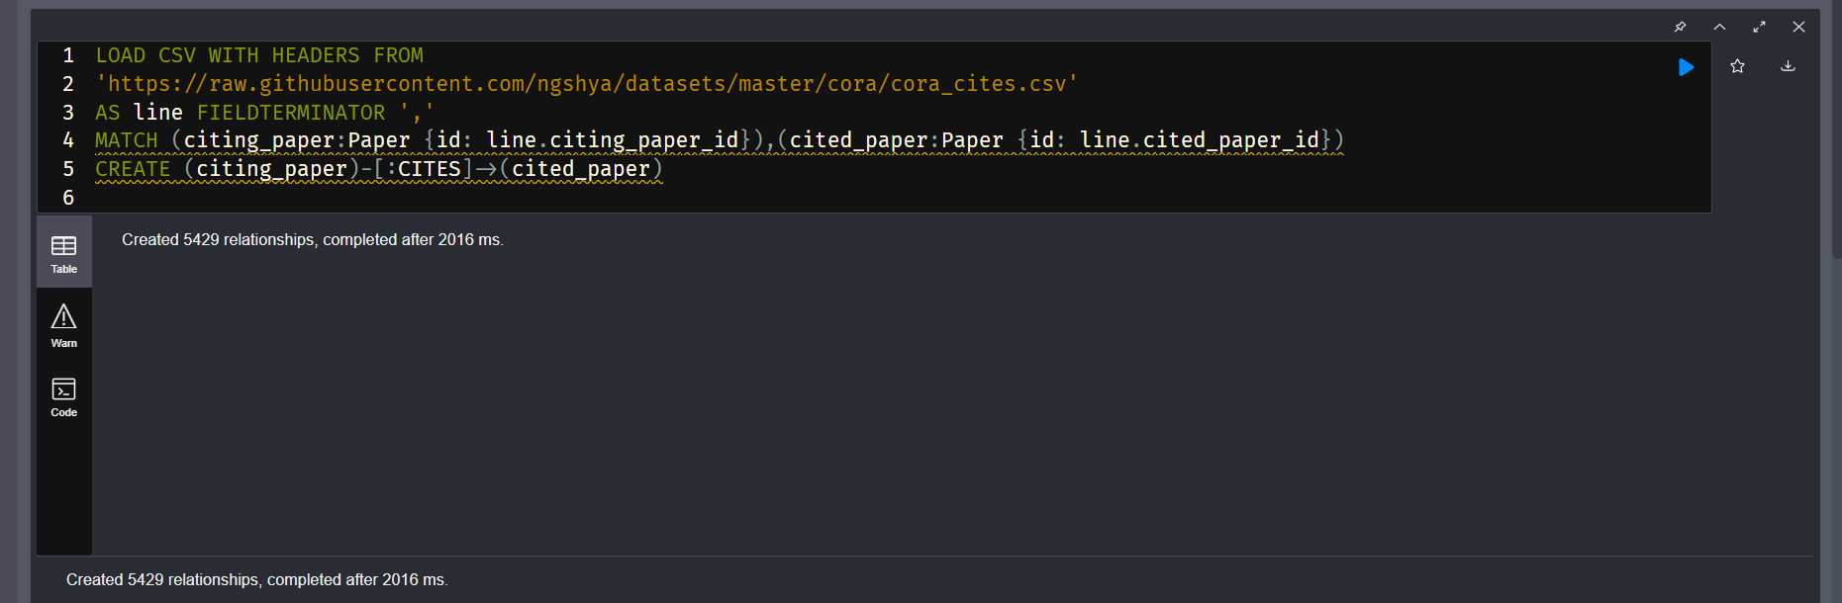

LOAD CSV WITH HEADERS FROM

'https://raw.githubusercontent.com/ngshya/datasets/master/cora/cora_cites.csv'

AS line FIELDTERMINATOR ','

MATCH (citing_paper:Paper {id: line.citing_paper_id}),(cited_paper:Paper {id: line.cited_paper_id})

CREATE (citing_paper)-[:CITES]->(cited_paper)

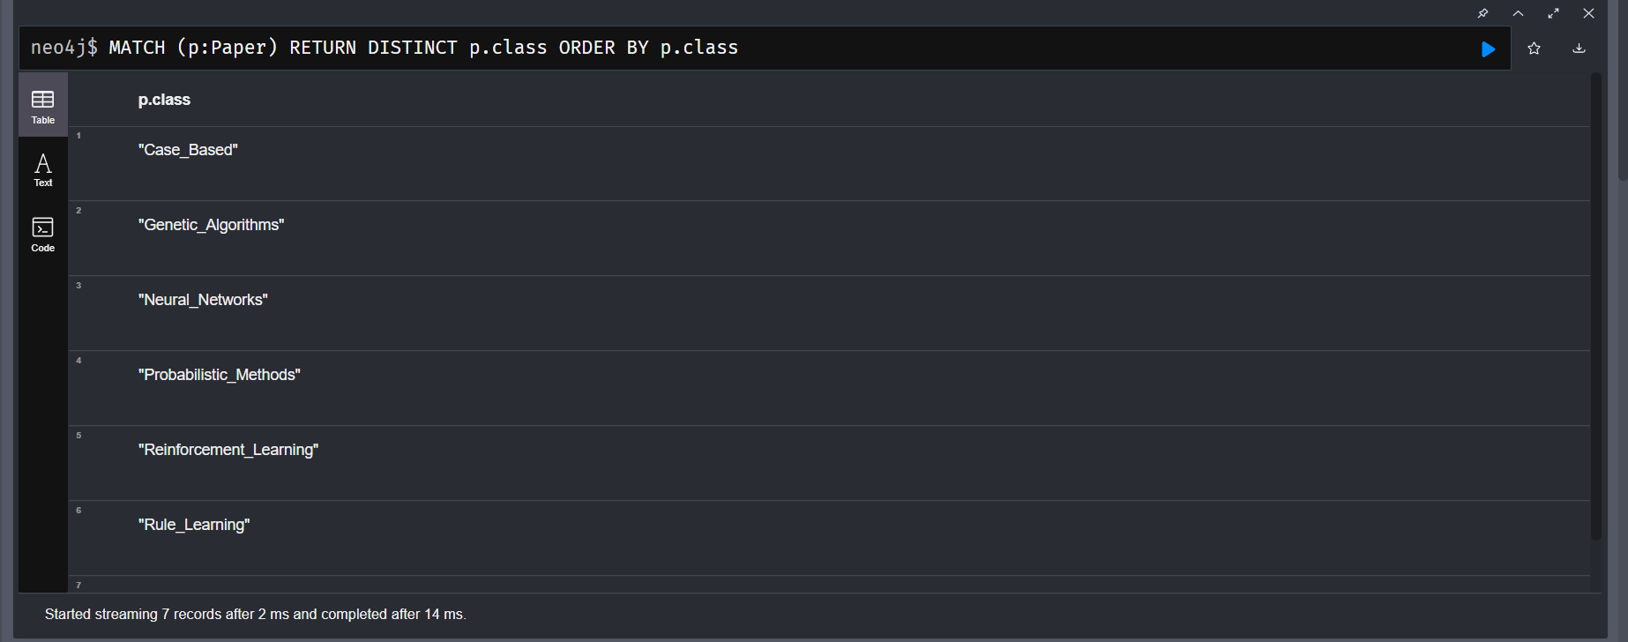

MATCH (p:Paper) RETURN DISTINCT p.class ORDER BY p.class

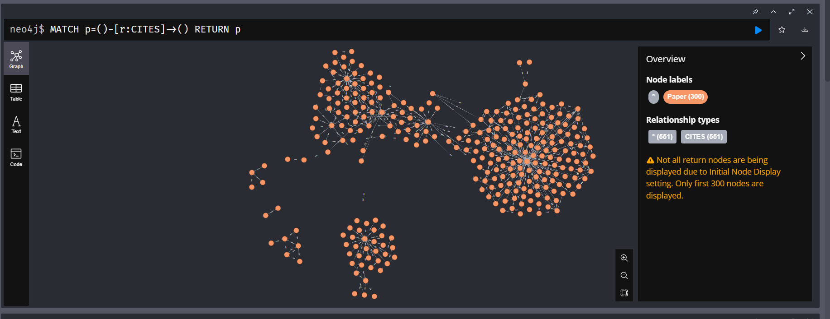

MATCH p=()-[r:CITES]->() RETURN p

1. Design the python-based desktop application for any kind of search on above database. The application should able to answer queries like

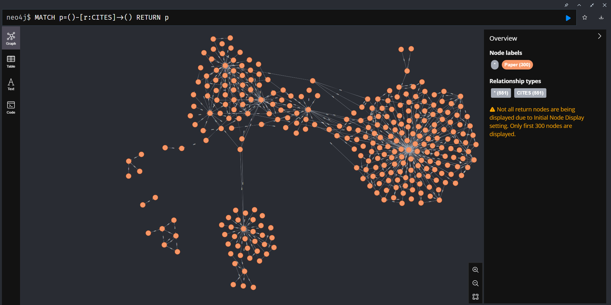

PYTHON APPLICATION:

import tkinter as tk

from neo4j import GraphDatabase

# Neo4j database connection details

uri = "bolt://127.0.0.1:7687"

username = "neo4j"

password = "adsassign"

# Initialize the Neo4j driver

try:

    driver = GraphDatabase.driver(uri, auth=(username, password))

except Exception as e:

    print(f"Failed to connect to Neo4j: {e}")

    exit()

# Function to check if paper A cites paper B

def does_paper_a_cite_paper_b(tx, paper_a_id, paper_b_id):

    query = (

        "MATCH (a:Paper {paper_id: $paper_a_id})-[:CITATION*..3]->(b:Paper {paper_id: $paper_b_id}) "

        "RETURN count(*) > 0"

    )

    result = tx.run(query, paper_a_id=paper_a_id, paper_b_id=paper_b_id)

    return result.single()[0]

# Function to get the full classification of a paper

def get_classification_of_paper(tx, paper_id):

    query = (

        "MATCH (p:Paper {paper_id: $paper_id})-[:CLASSIFICATION*]->(c:Classification) "

        "RETURN c.name"

    )

    result = tx.run(query, paper_id=paper_id)

    return [record['c.name'] for record in result]

# Function to handle search button click

def search():

    # Get the paper IDs from the entry widgets

    paper_a_id = entry_paper_a_id.get()

    paper_b_id = entry_paper_b_id.get()

    paper_id = entry_paper_id.get()

    # Validate input

    if not paper_a_id or not paper_b_id or not paper_id:

        label_a_b.config(text="Please enter all paper IDs")

        label_a_cite_b.config(text="")

        label_classification.config(text="")

        return

    # Open a new Neo4j session

    with driver.session() as session:

        try:

            # Check if paper A cites paper B

            result_a_b = does_paper_a_cite_paper_b(session, paper_a_id, paper_b_id)

            label_a_b.config(text="Yes" if result_a_b else "No")

            # Check if paper A cites a paper that cites paper B

            result_a_cite_b = False

            for i in range(3):

                result_a_cite_b = does_paper_a_cite_paper_b(session, paper_a_id, paper_b_id)

                if result_a_cite_b:

                    break

            label_a_cite_b.config(text="Yes" if result_a_cite_b else "No")

            # Get the full classification of the paper

            result_classification = get_classification_of_paper(session, paper_id)

            label_classification.config(text="/".join(result_classification))

        except Exception as e:

            print(f"Query execution failed: {e}")

            label_a_b.config(text="")

            label_a_cite_b.config(text="")

            label_classification.config(text="Error executing query")

# Create the main window

window = tk.Tk()

window.title("Research Papers Database")

# Create the widgets

label_paper_a_id = tk.Label(window, text="Paper A ID:")

entry_paper_a_id = tk.Entry(window)

label_paper_b_id = tk.Label(window, text="Paper B ID:")

entry_paper_b_id = tk.Entry(window)

button_search_citations = tk.Button(window, text="Search Citations", command=search)

label_a_b = tk.Label(window, text="")

label_a_cite_b = tk.Label(window, text="")

label_paper_id = tk.Label(window, text="Paper ID:")

entry_paper_id = tk.Entry(window)

button_search_classification = tk.Button(window, text="Search Classification", command=search)

label_classification = tk.Label(window, text="")

# Pack the widgets

label_paper_a_id.pack()

entry_paper_a_id.pack()

label_paper_b_id.pack()

entry_paper_b_id.pack()

button_search_citations.pack()

label_a_b.pack()

label_a_cite_b.pack()

label_paper_id.pack()

entry_paper_id.pack()

button_search_classification.pack()

label_classification.pack()

# Run the main loop

window.mainloop()

