**Assignment 06**

To design and implement a data warehouse for a customer order

processing system in a company

1] Introduction:

Designing and implementing a data warehouse for a customer order processing system in a company involves creating a centralized repository of data from various sources related to customer orders and item stock. The scope of this warehouse encompasses gathering, integrating, storing, and analyzing data to support decision-making processes, improve operational efficiency, and enhance customer service.

1. Scope:

a. Data Integration: The data warehouse will integrate data from multiple sources within the company, such as order management systems, inventory systems, sales systems, and customer relationship management (CRM) systems. This includes data related to customer orders, order status, item details, stock levels, pricing, customer information, etc.

b. Historical Data Storage: The warehouse will store historical data over a long period, allowing analysis of trends and patterns in customer orders and stock levels. This historical perspective enables the company to make informed decisions regarding inventory management, demand forecasting, and resource allocation.

c. Data Cleansing and Transformation: Data quality is crucial for accurate analysis. The warehouse will include processes for cleansing and transforming data to ensure consistency, completeness, and accuracy. This may involve standardizing formats, resolving discrepancies, and removing duplicates.

d. Dimensional Modeling: The warehouse will use dimensional modeling techniques to organize data into dimensions (e.g., time, customer, product) and facts (e.g., sales, inventory levels). This facilitates efficient querying and analysis using OLAP (Online Analytical Processing) tools and techniques.

e. Analytics and Reporting: The warehouse will support various analytical and reporting needs of the company. This includes generating standard reports, ad-hoc queries, and advanced analytics such as sales forecasting, inventory optimization, and customer segmentation.

f. Scalability and Performance: The warehouse design should be scalable to accommodate growing data volumes and evolving business requirements. It should also ensure optimal performance for querying and analysis, considering factors such as indexing, partitioning, and data storage optimization.

2. Objective:

a. Improve Decision Making: By providing comprehensive insights into customer orders and stock levels, the warehouse enables better decision-making at all levels of the organization. This includes strategic decisions regarding inventory planning, pricing strategies, and customer relationship management.

b. Enhance Operational Efficiency: The warehouse streamlines business processes related to order processing and inventory management by providing real-time visibility into stock levels, order status, and customer demand. This leads to improved efficiency, reduced lead times, and enhanced customer satisfaction.

c. Optimize Inventory Management: By analyzing historical data and current trends, the warehouse helps optimize inventory levels, minimize stockouts, and reduce excess inventory. This leads to cost savings, improved cash flow, and better utilization of resources.

d. Increase Sales and Revenue: Insights derived from the warehouse can identify cross-selling opportunities, target marketing campaigns more effectively, and improve customer retention. This ultimately leads to increased sales and revenue for the company.

e. Support Strategic Planning: The warehouse supports long-term strategic planning by providing valuable insights into market trends, customer preferences, and competitive analysis. This enables the company to adapt its strategies and stay ahead in a dynamic marketplace.

In summary, the scope of the data warehouse for a customer order processing system includes integrating data from various sources, storing historical data, ensuring data quality, enabling analytics and reporting, and supporting scalable and efficient operations. Its objectives include improving decision-making, enhancing operational efficiency, optimizing inventory management, increasing sales and revenue, and supporting strategic planning initiatives.

2] Business Requirement – Application Specification of the Data Warehousing for Users:

The data warehousing system aims to provide users with a comprehensive platform for analyzing customer orders and item stock. Users include managers, analysts, and operational staff involved in order processing, inventory management, and strategic planning. The system should offer easy access to historical and real-time data, support various analytical needs, and facilitate informed decision-making.

3] Functional Specification – Input and Output Specification of the Data Warehousing:

Input:

- Data from various sources such as order management systems, inventory systems, and customer relationship management (CRM) systems.

- Historical and real-time data related to customer orders, order status, item details, stock levels, pricing, and customer information.

Output:

- Standard reports showing key metrics like sales performance, inventory levels, and customer behavior.

- Ad-hoc queries for specific data analysis needs.

- Advanced analytics for sales forecasting, inventory optimization, and customer segmentation.

- Data cubes for multidimensional analysis.

4] Data Warehousing Design – Stepwise Procedure Methodology of Designing the Data Warehousing Including Star Schema:

1. Identify Business Requirements: Understand the business objectives, data sources, and user requirements.

2. Data Modeling: Design a star schema with a central fact table (e.g., Orders) surrounded by dimension tables (e.g., Customer, Product, Time).

3. Extract, Transform, Load (ETL): Develop ETL processes to extract data from source systems, transform it to fit the data warehouse schema, and load it into the warehouse.

4. Indexing and Partitioning: Optimize data storage by creating indexes and partitions to enhance query performance.

5. Data Quality Assurance: Implement measures for data cleansing, validation, and quality control to ensure accuracy and consistency.

6. Metadata Management: Establish metadata repositories to document data definitions, transformations, and lineage.

7. Testing and Deployment: Conduct thorough testing of the data warehouse to validate functionality and performance before deploying it for production use.

5] Data Cube Implementation – Computer Automation of Implementing the Data Warehousing Loading Data into Data Cubes:

Implement automated processes for loading data into data cubes:

- Define cube dimensions representing various attributes (e.g., time, product, customer).

- Populate the cubes by aggregating and summarizing data from the data warehouse based on different combinations of dimensions.

- Automate cube refreshment at regular intervals or triggered by data updates in the warehouse.

6] Observations:

a. Online Analytical Processing (OLAP) Reports:

- Users can invoke commands or panels to generate OLAP reports.

- Reports should provide multidimensional views of data, allowing users to analyze trends, patterns, and relationships.

b. Data Verification:

- Verify the accuracy and consistency of OLAP reports by comparing the data with the source relational tables.

- Conduct periodic data reconciliation to ensure alignment between OLAP reports and source data.

7] Conclusion:

The implementation of a data warehousing system for customer order processing and inventory management facilitates data-driven decision-making, enhances operational efficiency, and improves strategic planning. By providing users with access to comprehensive, reliable data and analytical tools, the system empowers organizations to optimize inventory levels, increase sales, and deliver better customer service. Moving forward, continuous monitoring, maintenance, and adaptation of the data warehousing system are essential to meet evolving business needs and maximize its value to the organization.

Ques 1]

Query is: select city_name, state,phone,description,size,weight,unit_price

from Items,stores,Headquarters ;

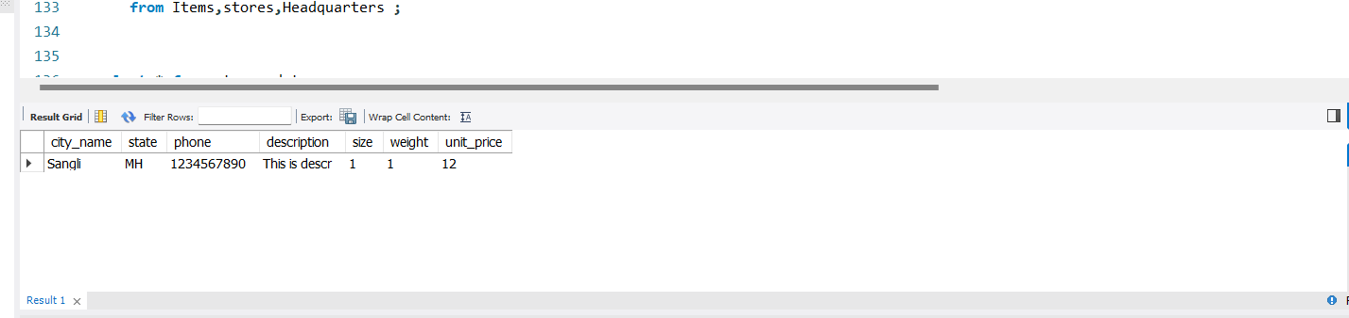

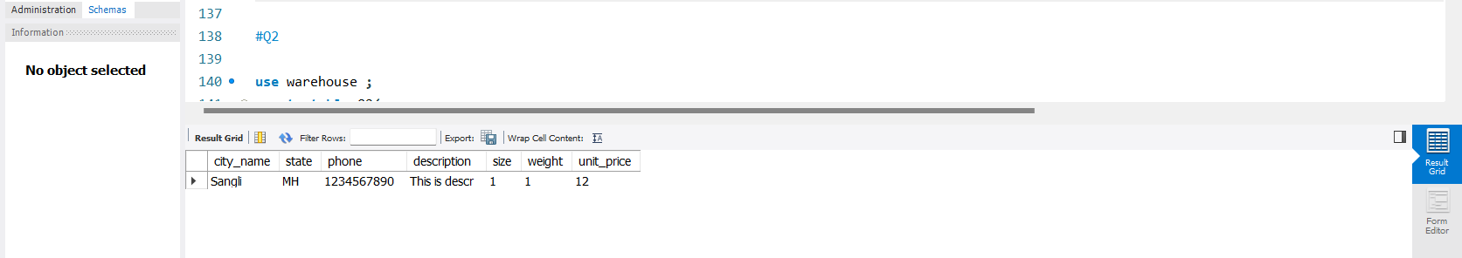

Ques 2]

Query is : select stores.store_id,orders.order_no,customer_name,order_date

from stores,orders,Ordered_items,customer,Stored_Items

where quantity_ordered <= quantity_held ;

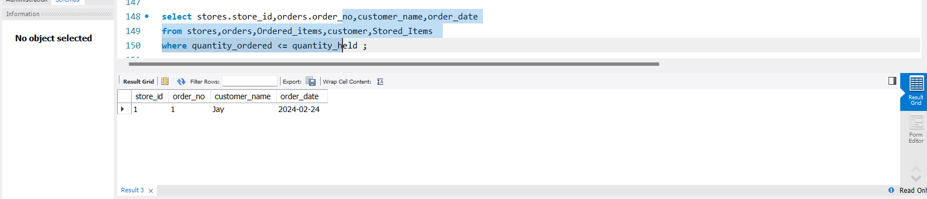

Ques 3]

Query is : select customer.customer_id,stores.store_id,city_name,phone

from orders,customer,Stored_Items,Stores,Headquarters ;

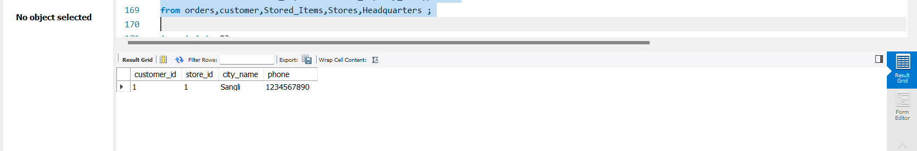

Ques 4]

Query is : select customer.customer_id,stores.store_id,city_name,phone

from orders,customer,Stored_Items,Stores,Headquarters ;

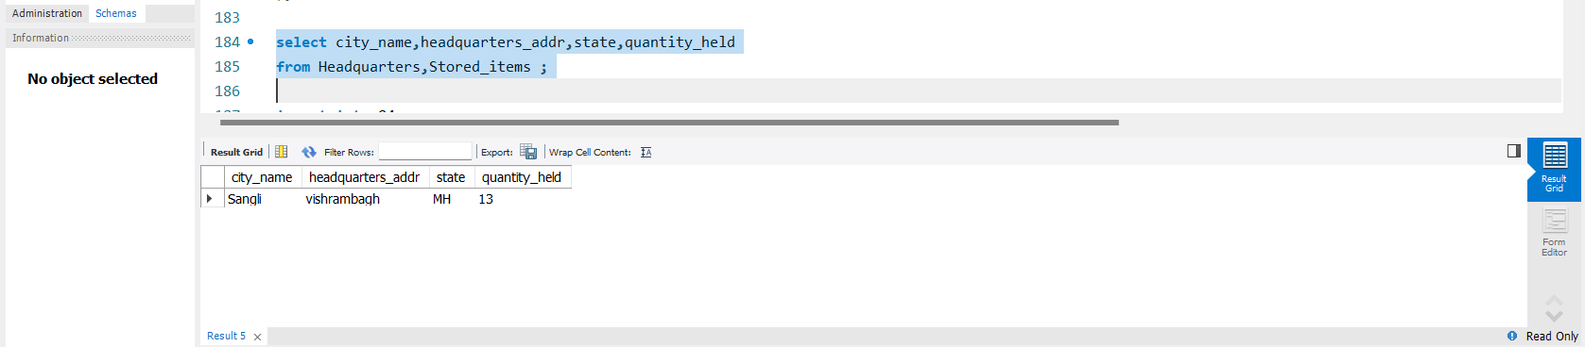

Ques 5]

Query is: select order_no,item_id,description,store_id,city_name

from orders,((Stored_Items natural join items) natural join Stores) natural join Headquarters ;

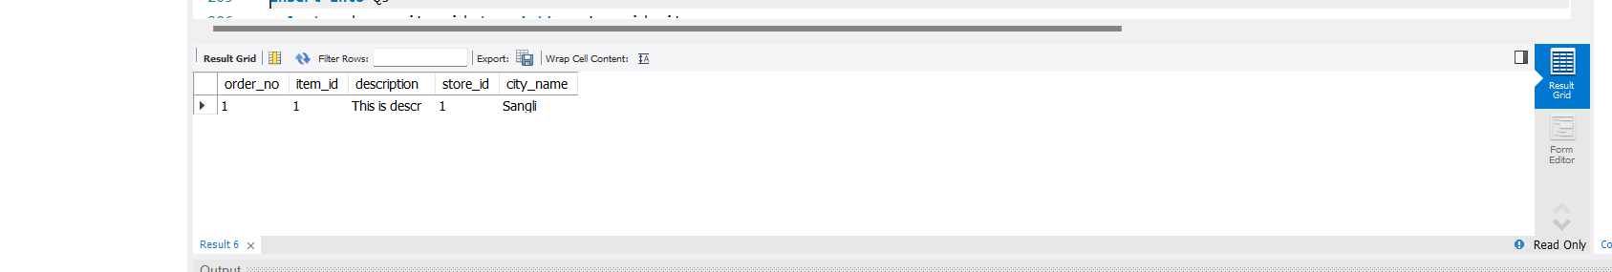

Ques 6]

Query is : select customer_id,city_name,state

from customer natural join Headquarters ;

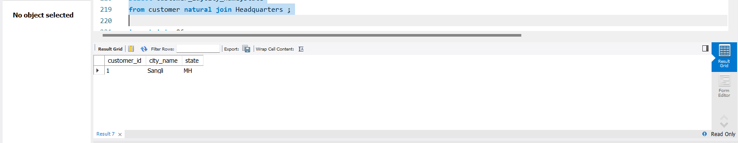

Ques 7]

Query is: select sum(quantity_held),item_id,city_name

from (Stored_items natural join stores) natural join Headquarters ;

Ques 8]

Query is: select order_no,item_id,quantity_ordered,customer_id,store_id,city_id

from (Ordered_items natural join orders natural join stored_items) natural join stores ;

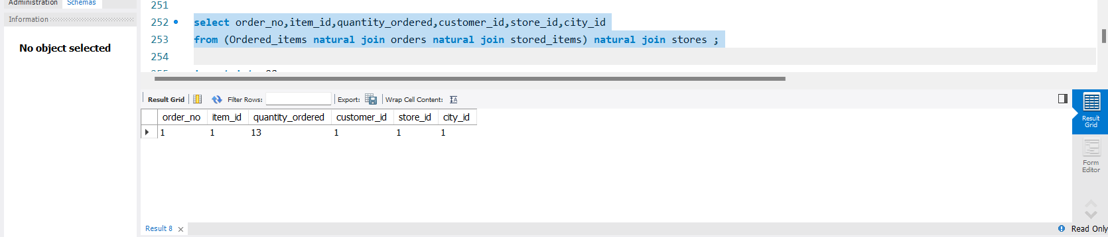

Ques 9]

Query is: select customer_id

from walk_in_customers natural join mail_order_customers ;

