DBMS ASSISNMENT 4
NAME: SHREYAN DASGUPTA
ROLL.NO.-002511001006

In an educational institute, various numbers of courses are offered. In each course, 7 numbers of subjects are taught. One student can select minimum 5 and maximum 6 numbers of subjects for that course. Each course has maximum intake capacity. The same subject may be taught in various courses. The system must be able to handle course, subject, student, marks grade and enrollment information. Assumptions also can be made. Design an ER diagram and database schema for the system. Specify the primary key, foreign key and other constraints for all required tables. Draw the ER diagram in MS Word.
1. Insert at least five tuples in each table.

Code==
-- Insert Students
INSERT INTO STUDENT VALUES (1, 'Alice', 'alice@mail.com');
INSERT INTO STUDENT VALUES (2, 'Bob', 'bob@mail.com');
INSERT INTO STUDENT VALUES (3, 'Charlie', 'charlie@mail.com');
INSERT INTO STUDENT VALUES (4, 'David', 'david@mail.com');
INSERT INTO STUDENT VALUES (5, 'Emma', 'emma@mail.com');

-- Insert Courses
INSERT INTO COURSE VALUES (10, 'Computer Science', 60);
INSERT INTO COURSE VALUES (20, 'Information Technology', 50);
INSERT INTO COURSE VALUES (30, 'Data Science', 40);
INSERT INTO COURSE VALUES (40, 'Software Engineering', 45);
INSERT INTO COURSE VALUES (50, 'Cyber Security', 35);

-- Insert Subjects
INSERT INTO SUBJECT VALUES (101, 'DBMS');
INSERT INTO SUBJECT VALUES (102, 'Data Structures');
INSERT INTO SUBJECT VALUES (103, 'Operating Systems');
INSERT INTO SUBJECT VALUES (104, 'Computer Networks');
INSERT INTO SUBJECT VALUES (105, 'Software Engineering');

-- Insert Course_Subject mapping
INSERT INTO COURSE_SUBJECT VALUES (10, 101);
INSERT INTO COURSE_SUBJECT VALUES (10, 102);
INSERT INTO COURSE_SUBJECT VALUES (20, 101);
INSERT INTO COURSE_SUBJECT VALUES (30, 103);
INSERT INTO COURSE_SUBJECT VALUES (40, 104);

--Insert Enroll
INSERT INTO ENROLL (ENROLL_ID, SID, CID, SUBID, MARKS_GRADE, ENROLL_DATE)
VALUES (1, 1, 10, 101, 'A', TO_DATE('2026-09-01', 'YYYY-MM-DD'));

INSERT INTO ENROLL (ENROLL_ID, SID, CID, SUBID, MARKS_GRADE, ENROLL_DATE)
VALUES (2, 2, 10, 102, 'B', TO_DATE('2026-09-01', 'YYYY-MM-DD'));

INSERT INTO ENROLL (ENROLL_ID, SID, CID, SUBID, MARKS_GRADE, ENROLL_DATE)
VALUES (3, 3, 20, 101, 'A', TO_DATE('2026-09-02', 'YYYY-MM-DD'));

INSERT INTO ENROLL (ENROLL_ID, SID, CID, SUBID, MARKS_GRADE, ENROLL_DATE)
VALUES (4, 4, 30, 103, 'C', TO_DATE('2026-09-02', 'YYYY-MM-DD'));

INSERT INTO ENROLL (ENROLL_ID, SID, CID, SUBID, MARKS_GRADE, ENROLL_DATE)
VALUES (5, 5, 40, 104, 'B', TO_DATE('2026-09-03', 'YYYY-MM-DD'));

[I have entered many records. Code is shown for 5]

2. At the time of creation if we forget to create a field enrollment date (ENROLL_DATE) in ENROLL table so add the field.

CODE ==

ALTER TABLE ENROLL ADD ENROLL_DATE DATE;
(ALREADY DONE)

3. Course name cannot be blank, therefore add the criteria in the specific table.

ALTER TABLE COURSE MODIFY CNAME VARCHAR(100) NOT NULL;
(already done)
4. Find the Course which has more than 3 students
SELECT C.CID, C.CNAME
FROM COURSE C
JOIN ENROLL E ON C.CID = E.CID
GROUP BY C.CID, C.CNAME
HAVING COUNT(DISTINCT E.SID) > 3;
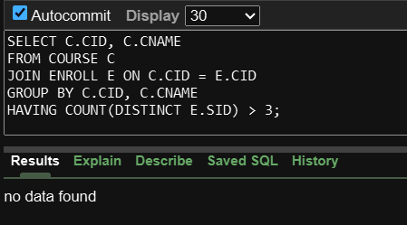
5. Give the details of a STUDENT with all Subjects and Grade where he/she enroll (Enter the sid value as input).
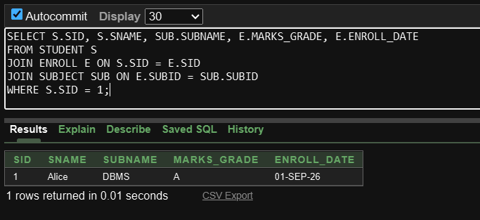
6. Display the course where the maximum number of students enrolls.
Code
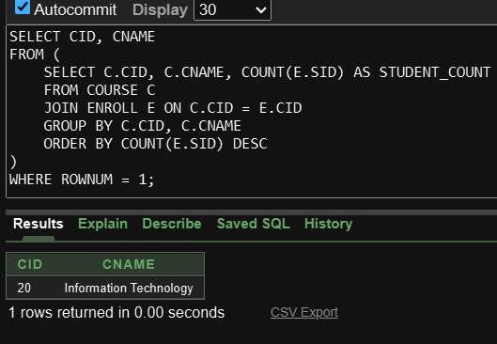
7. Find out the course where no student is enrolled.
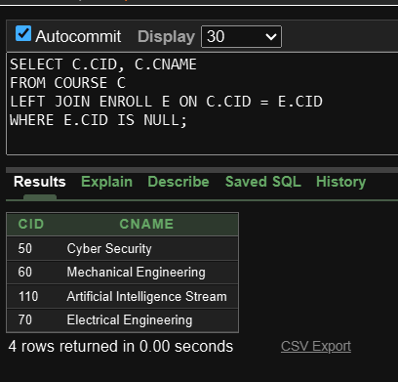
8. Delete Course no 30 from COURSE table.
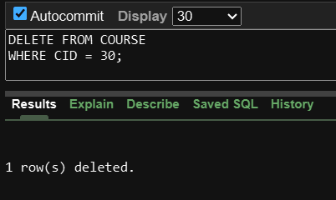
9. Rename the COURSE table as DEPARTMENT.
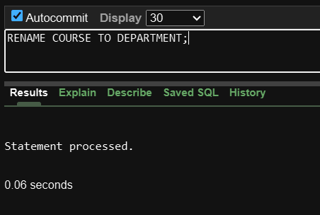
10. Change the Marks Grade of Student “A” to “B” who is Enroll in the subject DBMS.
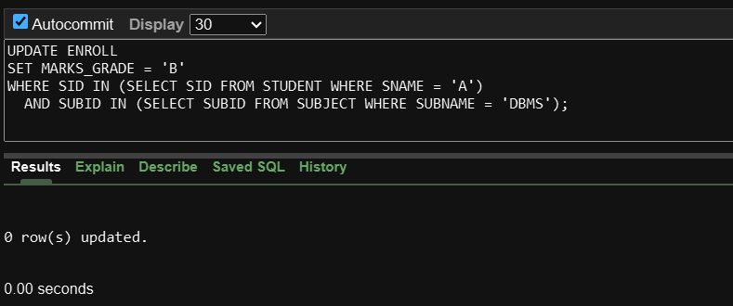
11. Delete the record of the student who is enrolled in the course ‘IT’.
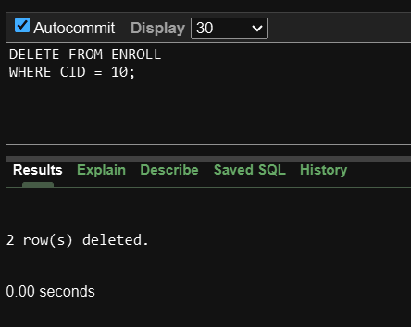
12. Change the enroll date to ‘16-08-2018’ whose student id is 18069 (first convert the date
into the default format).
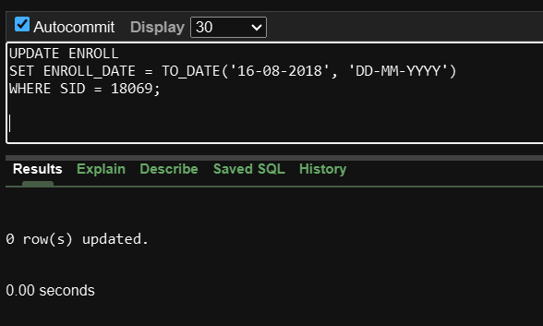

SUBJECT table
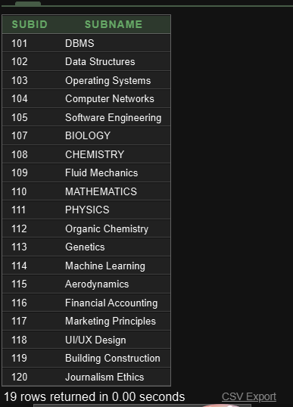
STUDENT TABLE
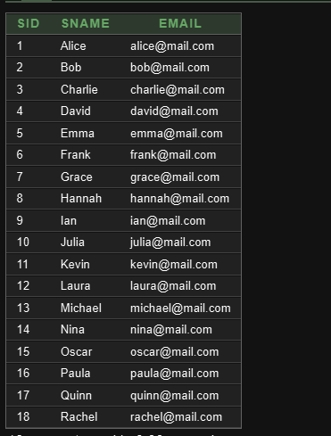
Department table
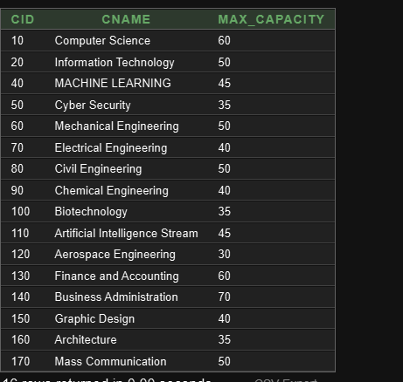
ENROLL table
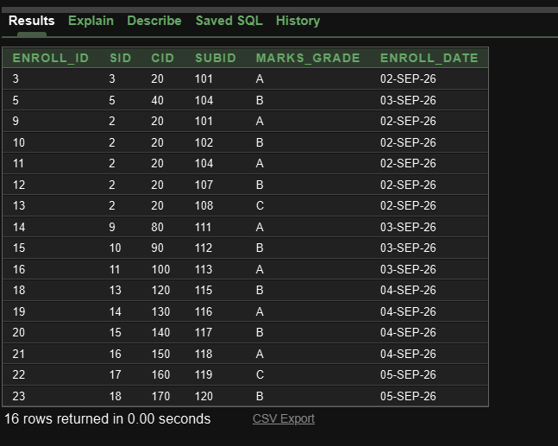
Course_subject


