ASSIGNMENT 1
SHREYAN DASGUPTA
002511001006

CREATE TABLE EMP (
EMPNO INT NOT NULL,
ENAME VARCHAR(10),
JOB VARCHAR(9),
MGR INT,
HIREDATE DATE,
SAL DECIMAL(7,2),
COMM DECIMAL(7,2),
DEPTNO INT,
PHONENO BIGINT,
ADDRESS VARCHAR(20)
);
INSERT INTO EMP VALUES(7369, 'SMITH', 'CLERK', 7902, '1980-12-17', 800, NULL , 20,NULL ,NULL );
INSERT INTO EMP VALUES(7499, 'ALLEN', 'SALESMAN', 7698, '1981-02-20', 1600, 300, 30,NULL ,NULL );
INSERT INTO EMP VALUES(7521, 'WARD', 'SALESMAN', 7698, '1981-02-22', 1250, 500, 30,NULL ,NULL );
INSERT INTO EMP VALUES(7566, 'JONES', 'MANAGER', 7839, '1981-04-02', 2975, NULL, 20,NULL ,NULL );
INSERT INTO EMP VALUES(7654, 'MARTIN' , 'SALESMAN' , 7698, '1981-09-28', 1250, 1400 ,30,NULL ,NULL );
INSERT INTO EMP VALUES(7698, 'BLAKE' , 'MANAGER' , 7839, '1981-05-01', 2850, NULL,30,NULL ,NULL );
INSERT INTO EMP VALUES(7782, 'CLARK', 'MANAGER', 7839, '1981-01-09', 2450,NULL,10,NULL ,NULL );
INSERT INTO EMP VALUES( 7788, 'SCOTT', 'ANALYST', 7566, '1987-04-19', 3000, NULL,20,NULL ,NULL );
INSERT INTO EMP VALUES( 7839, 'KING', 'PRESIDENT', null, '1981-11-17', 5000, NULL, 10,NULL ,NULL );
INSERT INTO EMP VALUES(7844, 'TURNER', 'SALESMAN', 7698, '1981-09-08', 1500 , 0, 30,NULL ,NULL );
INSERT INTO EMP VALUES(7876, 'ADAMS', 'CLERK', 7788, '1987-05-23' , 1100 , NULL, 20,NULL ,NULL );
INSERT INTO EMP VALUES(7900, 'JAMES', 'CLERK', 7698, '1981-12-03', 950,NULL,30,NULL ,NULL );
INSERT INTO EMP VALUES(7902, 'FORD', 'ANALYST', 7566, '1981-12-03', 3000, NULL, 20,NULL ,NULL );
INSERT INTO EMP VALUES(7934, 'MILLER', 'CLERK', 7782, '1982-01-23', 1300 ,NULL,10, NULL ,NULL );
CREATE TABLE DEPT (
DEPTNO INT,
DNAME VARCHAR(14),
IOC VARCHAR(13),
CONSTRAINT PK_DEPT PRIMARY KEY (DEPTNO)
);
INSERT INTO DEPT VALUES(10, 'ACCOUNTING', 'NEW YORK');
INSERT INTO DEPT VALUES(20, 'RESEARCH', 'DALLAS');
INSERT INTO DEPT VALUES(30, 'SALES', 'CHICAGO');
INSERT INTO DEPT VALUES(40, 'OPERATIONS', 'BOSTON');

CREATE TABLE SALGRADE (
GRADE INT,
LOSAL INT,
HISAL INT
);
INSERT INTO SALGRADE VALUES (1, 700, 1200);
INSERT INTO SALGRADE VALUES (2, 1201, 1400);
INSERT INTO SALGRADE VALUES (3, 1401, 2000);
INSERT INTO SALGRADE VALUES (4, 2001, 3000);
INSERT INTO SALGRADE VALUES (5, 3001, 9999);

- Show Details of all employees.
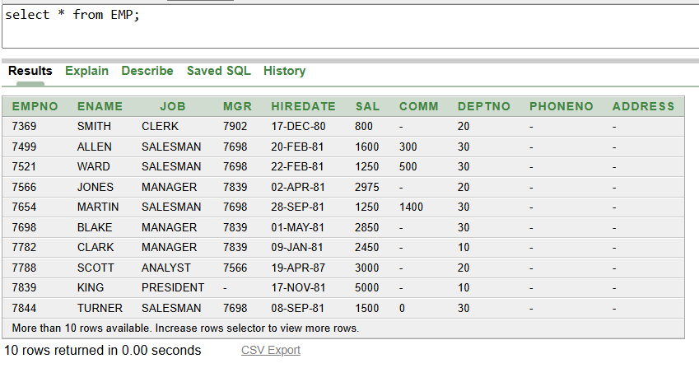

- Show the department no. and name of all departments.
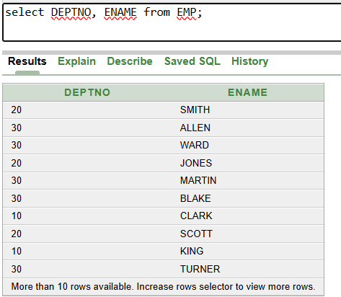

- Display the employee id, name and department no of all employees whose department no is 20.
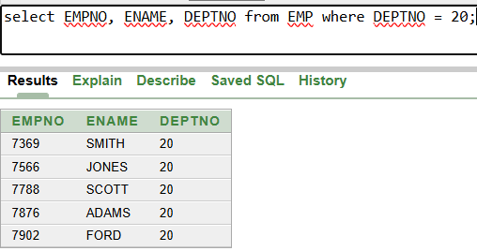
- 4. Display the details of all employees where department no should be in descending order.
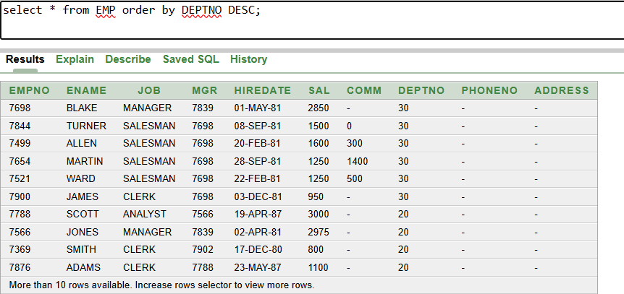

- Show all available jobs in the employee table.
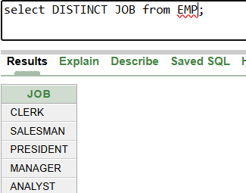

6. Show the name, Annual Salary and department no of employees who works as a clerk in department 20.

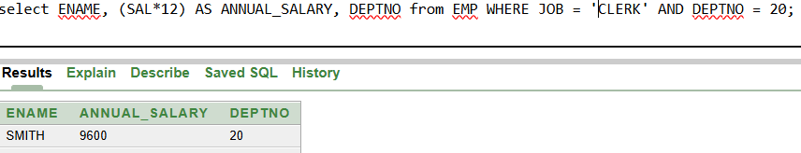7. Show the name and HIRED date of those employee whose name start with ‘S’ or second character is ‘C’.
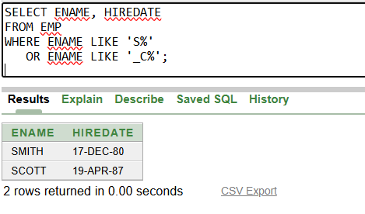
8. Show the name, hire date and salary of those employee who are not a manager.
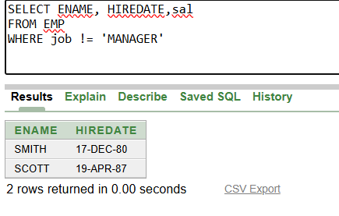
9. Display all employee names in title case and length of the name
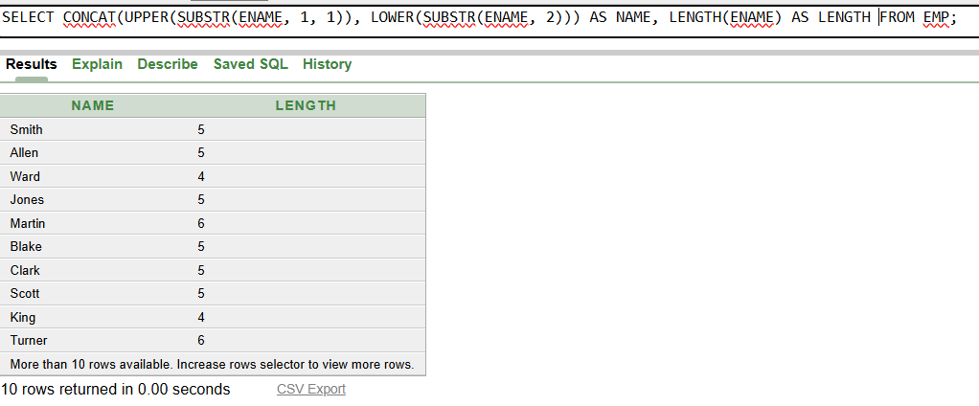
10. Display the name of employee who gets the salary between 4000 to 6000
