DBMS ASSISNMENT 3
NAME: SHREYAN DASGUPTA
ROLL.NO.-002511001006

CREATE TABLE RESEARCHER (
Researcher_ID VARCHAR(10) PRIMARY KEY,
Researcher_Name VARCHAR(50),
Department VARCHAR(50),
Institution VARCHAR(100)
);

CREATE TABLE PAPER (
Paper_ID VARCHAR(10) PRIMARY KEY,
Title VARCHAR(100),
Conference VARCHAR(50),
Year INT,
Citation_Count INT
);

CREATE TABLE AUTHORSHIP1 (
Researcher_ID VARCHAR2(10),
Paper_ID VARCHAR2(10),
Author_Order INT,

PRIMARY KEY (Researcher_ID, Paper_ID),

FOREIGN KEY (Researcher_ID)
REFERENCES RESEARCHER1(Researcher_ID),

FOREIGN KEY (Paper_ID)
REFERENCES PAPER1(Paper_ID)
);
RESEARCHER
INSERT INTO RESEARCHER1
(Researcher_ID, Researcher_Name, Department, Institution)
VALUES
('R1', 'Alice', 'Computer Science', 'Jadavpur University');

INSERT INTO RESEARCHER1
(Researcher_ID, Researcher_Name, Department, Institution)
VALUES
('R2', 'Bob', 'Information Technology', 'Jadavpur University');

INSERT INTO RESEARCHER1
(Researcher_ID, Researcher_Name, Department, Institution)
VALUES
('R3', 'Charlie', 'Electrical Engineering', 'MIT');

INSERT INTO RESEARCHER1
(Researcher_ID, Researcher_Name, Department, Institution)
VALUES
('R4', 'David', 'Mechanical Engineering', 'Stanford');

PAPER
INSERT INTO PAPER1
(Paper_ID, Title, Conference, Year, Citation_Count)
VALUES
('P1', 'AI Basics', 'AIDML', 2024, 20);

INSERT INTO PAPER1
(Paper_ID, Title, Conference, Year, Citation_Count)
VALUES
('P2', 'ML Advanced', 'AIDML', 2024, 40);

INSERT INTO PAPER1
(Paper_ID, Title, Conference, Year, Citation_Count)
VALUES
('P3', 'DB Systems', 'SIGMOD', 2023, 60);

INSERT INTO PAPER1
(Paper_ID, Title, Conference, Year, Citation_Count)
VALUES
('P4', 'Vision Tech', 'CVPR', 2023, 50);

INSERT INTO PAPER1
(Paper_ID, Title, Conference, Year, Citation_Count)
VALUES
('P5', 'SQL Magic', 'SIGMOD', 2022, 100);

AUTHORSHIP
INSERT INTO AUTHORSHIP1
(Researcher_ID, Paper_ID, Author_Order)
VALUES
('R1', 'P1', 1);

INSERT INTO AUTHORSHIP1
(Researcher_ID, Paper_ID, Author_Order)
VALUES
('R2', 'P1', 2);

INSERT INTO AUTHORSHIP1
(Researcher_ID, Paper_ID, Author_Order)
VALUES
('R2', 'P2', 1);

INSERT INTO AUTHORSHIP1
(Researcher_ID, Paper_ID, Author_Order)
VALUES
('R1', 'P3', 1);

INSERT INTO AUTHORSHIP1
(Researcher_ID, Paper_ID, Author_Order)
VALUES
('R3', 'P3', 2);

INSERT INTO AUTHORSHIP1
(Researcher_ID, Paper_ID, Author_Order)
VALUES
('R1', 'P4', 1);

INSERT INTO AUTHORSHIP1
(Researcher_ID, Paper_ID, Author_Order)
VALUES
('R2', 'P5', 1);

-- QUERIES
-- Q1-Find researchers who have published papers in more than one conference.
ANS-
SELECT A.Researcher_ID, R.Researcher_Name FROM AUTHORSHIP1 A
JOIN PAPER 1 P ON A.Paper_ID = P.Paper_ID
JOIN RESEARCHER1 R ON A.Researcher_ID = R.Researcher_ID
GROUP BY A.Researcher_ID, R.Researcher_Name HAVING COUNT(DISTINCT P.Conference) > 1;
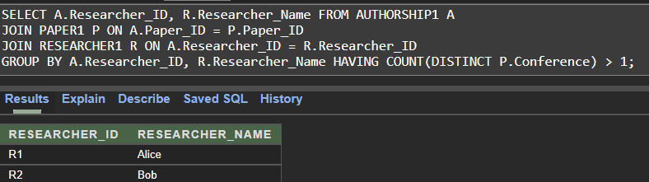

-- Q2-Find the average citation count of papers published in each year.
ANS-
SELECT Year, AVG(Citation_Count) AS Average_Citations FROM PAPER1 GROUP BY Year;
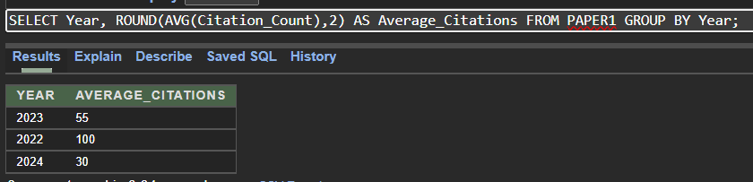

Q3- Find researchers who have not authored any paper.
ANS-
SELECT Researcher_ID, Researcher_Name FROM RESEARCHER1
WHERE Researcher_ID NOT IN (SELECT Researcher_ID FROM AUTHORSHIP1);
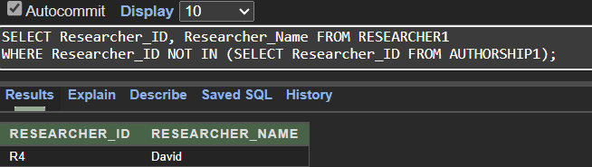

Q4 (Assuming researcher is R1)- Find researchers who have co-authored papers with a particular researcher.
ANS-
SELECT DISTINCT A1.Researcher_ID, R.Researcher_Name FROM AUTHORSHIP1 A1
JOIN RESEARCHER1 R ON A1.Researcher_ID = R.Researcher_ID
WHERE A1.Paper_ID IN (SELECT Paper_ID FROM AUTHORSHIP1 WHERE Researcher_ID = 'R1')
AND A1.Researcher_ID <> 'R1';
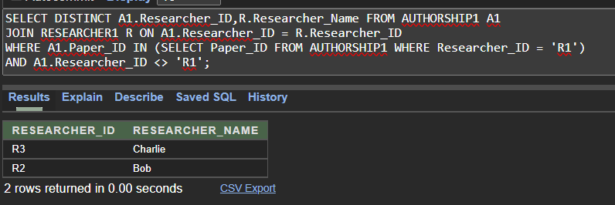
Q5- Display the researcher name and paper title for every researcher-paper association.
ANS-
SELECT R.Researcher_Name, P.Title FROM AUTHORSHIP1 A
JOIN RESEARCHER1 R ON A.Researcher_ID = R.Researcher_ID
JOIN PAPER1 P ON A.Paper_ID = P.Paper_ID;
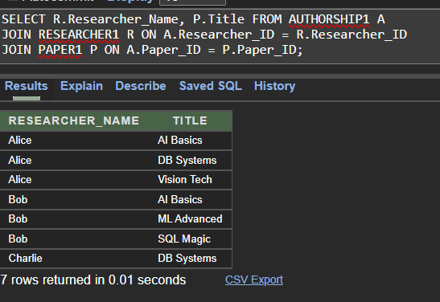
Q6-Display the paper title, researcher name, and author order for all papers.
ANS-
SELECT P.Title, R.Researcher_Name, A.Author_Order FROM AUTHORSHIP1 A
JOIN RESEARCHER1 R ON A.Researcher_ID = R.Researcher_ID
JOIN PAPER1 P ON A.Paper_ID = P.Paper_ID order by P.Title;
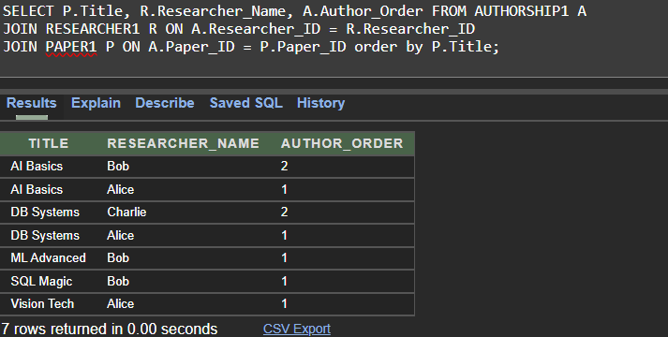
Q7-Display the titles of papers authored by researchers from Jadavpur University.
ANS-
SELECT DISTINCT P.Title FROM AUTHORSHIP1 A
JOIN RESEARCHER1 R ON A.Researcher_ID = R.Researcher_ID
JOIN PAPER1 P ON A.Paper_ID = P.Paper_ID
WHERE R.Institution = 'Jadavpur University';
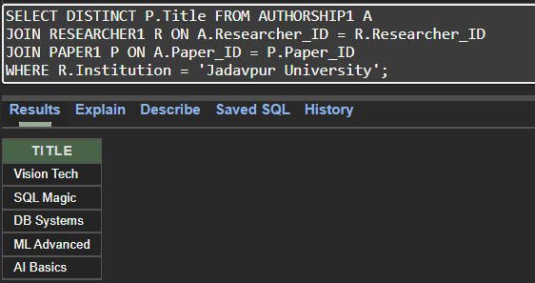

Q8-Display the names of researchers who have authored papers published at the AIDML conference.
ANS-
SELECT DISTINCT R.Researcher_Name FROM AUTHORSHIP1 A
JOIN RESEARCHER1 R ON A.Researcher_ID = R.Researcher_ID
JOIN PAPER1 P ON A.Paper_ID = P.Paper_ID
WHERE P.Conference = 'AIDML';
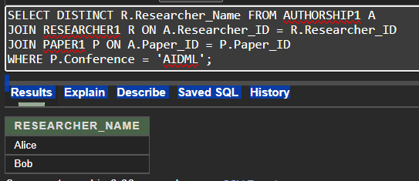

Q9 - Display the title of each paper along with the names of all its authors, ordered by Author_Order.
ANS-
SELECT P.Title, R.Researcher_Name, A.Author_Order FROM AUTHORSHIP1 A
JOIN RESEARCHER1 R ON A.Researcher_ID = R.Researcher_ID
JOIN PAPER1 P ON A.Paper_ID = P.Paper_ID
ORDER BY P.Title, A.Author_Order;
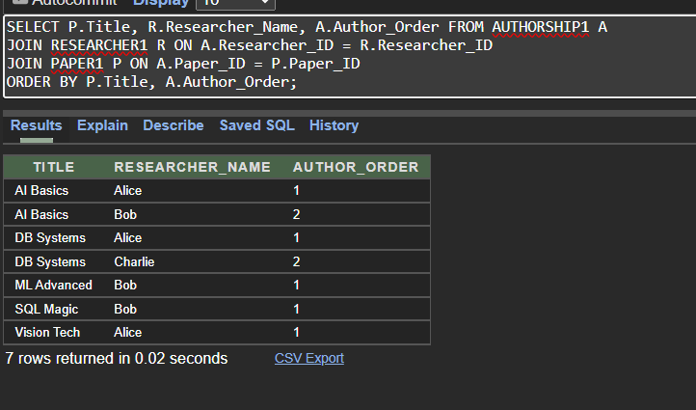

Q10-Find the total number of papers in the database.
ANS-
SELECT COUNT(*) AS Total_Papers FROM PAPER1;
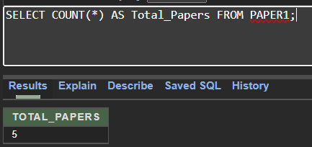

Q11-Find the maximum, minimum, and average citation count of all papers.
ANS-
SELECT MAX(Citation_Count) AS Max_Citations, MIN(Citation_Count) AS Min_Citations,
AVG(Citation_Count) AS Avg_Citations FROM PAPER1;
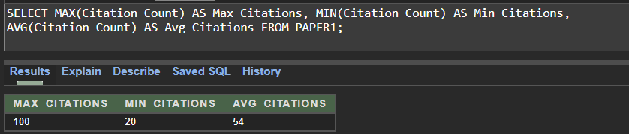

Q12-Find the number of papers authored by each researcher.
ANS-
SELECT R.Researcher_ID, R.Researcher_Name, COUNT(A.Paper_ID) AS Paper_Count FROM RESEARCHER1 R
LEFT JOIN AUTHORSHIP1 A ON R.Researcher_ID = A.Researcher_ID
GROUP BY R.Researcher_ID, R.Researcher_Name order by COUNT(A.Paper_ID);
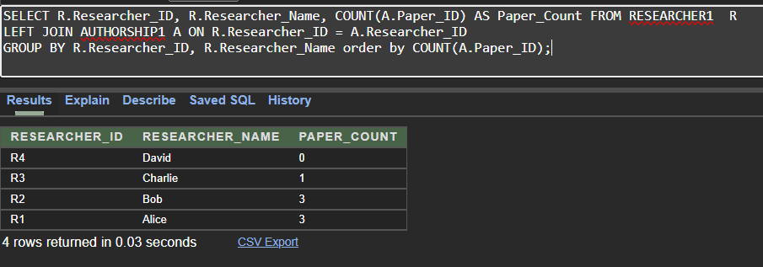
Q13-Find the average citation count of papers for each conference.
ANS-
SELECT Conference, AVG(Citation_Count) AS Avg_Citations FROM PAPER GROUP BY Conference;
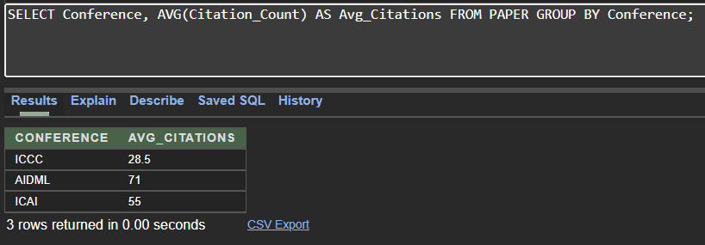

Q14-Find the number of researchers who have contributed to each paper.
ANS-
SELECT P.Paper_ID, P.Title, COUNT(A.Researcher_ID) AS Author_Count FROM PAPER1 P
LEFT JOIN AUTHORSHIP1 A ON P.Paper_ID = A.Paper_ID
GROUP BY P.Paper_ID, P.Title;
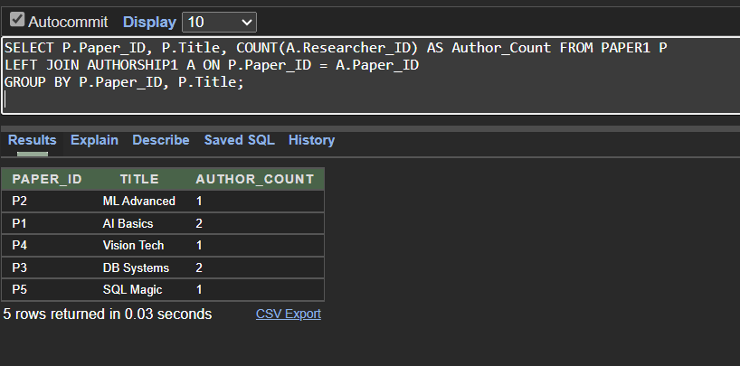

Q15-Find institutions whose researchers have collectively authored at least three papers.
ANS-
SELECT R.Institution FROM RESEARCHER R
JOIN AUTHORSHIP A ON R.Researcher_ID = A.Researcher_ID
GROUP BY R.Institution HAVING COUNT(DISTINCT A.Paper_ID) >= 3;
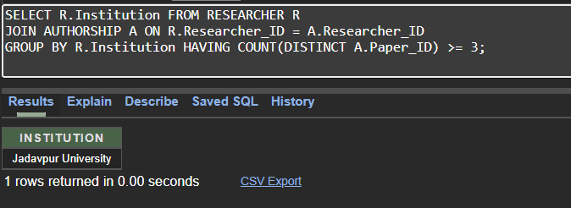

Q16-Find the publication years having an average citation count greater than 40.
ANS-
SELECT Year FROM PAPER GROUP BY Year HAVING AVG(Citation_Count) > 40;
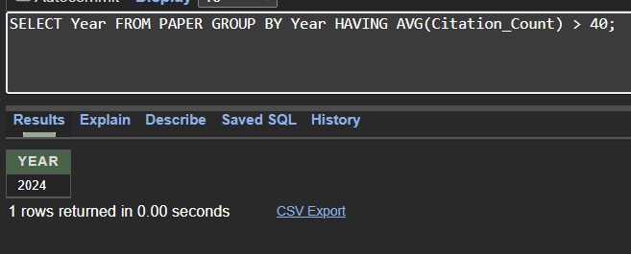

Q17-Find the researcher(s) who have authored the maximum number of papers.
ANS-
SELECT R.Researcher_ID, R.Researcher_Name FROM RESEARCHER1 R
JOIN AUTHORSHIP1 A ON R.Researcher_ID = A.Researcher_ID
GROUP BY R.Researcher_ID, R.Researcher_Name HAVING COUNT(A.Paper_ID) = (
SELECT MAX(Paper_Count) FROM (
SELECT COUNT(Paper_ID) AS Paper_Count FROM AUTHORSHIP1 GROUP BY Researcher_ID
) Temp
);
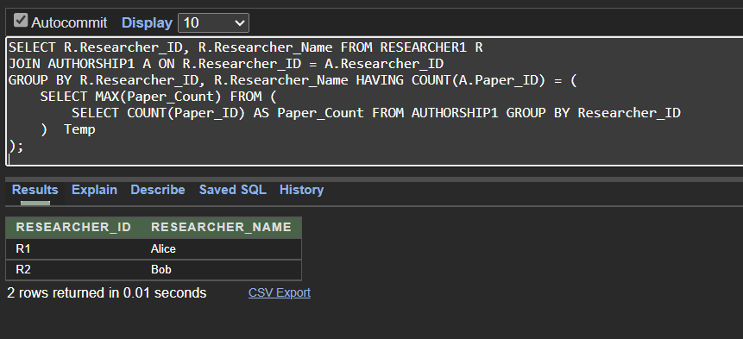

Q18-Find papers whose citation count is greater than the average citation count of papers published in 2024.
ANS-
SELECT Paper_ID, Title, Citation_Count FROM PAPER1 WHERE Citation_Count > (
SELECT AVG(Citation_Count) FROM PAPER1 WHERE Year = 2024
);
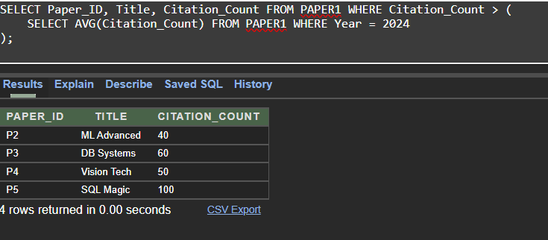
Q19-Find the conference having the highest average citation count.
ANS-
SELECT Conference FROM PAPER GROUP BY Conference
HAVING AVG(Citation_Count) = (
SELECT MAX(Avg_Citations)
FROM (
SELECT AVG(Citation_Count) AS Avg_Citations FROM PAPER GROUP BY Conference
) Temp
);
