**INTRODUCTION TO PROJECT**

## RAILWAY RESERVATION MANAGEMENTSYSTEM

* 1. **Brief description**
* The mini-project entitled “Railway reservation management system“ is developed as apart of the fifth semester DBMS laboratory, for the partial fulfillment of the

requirement for the BE( Information Science) course.

* Our website has various kinds of information that helps regarding booking of tickets via railways .
* Users will be able to search the train availability ,the exact fare ,the arrival and departuretime of the train and they can also book the ticket by using the debit ,credit or master card and after booking the ticket if the user want to cancel it then they can easily do it also.

## Objectives

The objective of the online railway reservation management system

Project is to design software to fully automate the process of issuing a railway ticket. That is:-

1. To create a database of the trains
2. To search the trains it’s arrival and departure time,distance between source and destination.
3. To check the availability of the ticket.
4. To calculate fare. 5.To book the ticket.

6.To cancel the ticket if necessary

## Scope

* Railway passengers frequently need to know about their ticket reservation status, ticket availability on a particular train or for a place, train arrival or departure details, special trains etc.. Customer information centers at the railway stations are unable to serve such queries at peak periods.
* The number of the reservation counters available to the passengers and customers are very less.
* On most of the reservation systems there are long queues, so it takes a long time for any individual to book the ticket.As now there are no call centers facilities available to solve the queries of the passengers.
* The online railway ticket reservation system aims to develop a web application which aims at providing trains details, trains availability, as well as the facility to book ticket in online for customers.
* So, we thought of developing a web based application which would provide the users all these facilities from his terminal only as well as help them in booking their tickets. The Application was to be divided into two parts namely the user part , and the administrator part. And each of these has their corresponding features.We decided to give the name of the website “RAILWAY RESERVATION MANAGEMENT SYSTEM”.The online railway ticket reservation system is developed using ASP.NET with C# as the backend in the .NET Framework.

## Analysis

Railway reservation management system is a online ticket booking website, which is capable of booking ticket and serach the train availavility . This website is mainly created to fulfil the following requirements, it comprises of the following properties:-

* A central database that will store all information.
* An online website that will provide real- time information about the availability of tickets their prices .
* Every registered user is able to view his booking id that has been made in his/her name.
* Every registered user can change his password any time he wants to change.

# Table description

## USERINFO

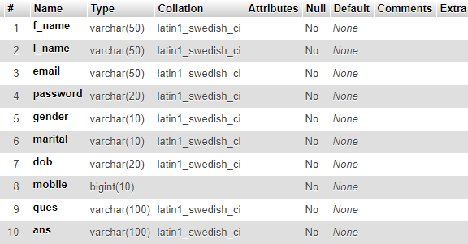USERINFO table has a attributes f_name ,I_name ,email,password,gender, marital,dob,mobile,ques,ans is used shown in table 2.1

**TABLE 2.1 STRUCTURE OF USER INFO**

## TRAIN LIST

TRAIN LIST table has a atrributes number,name,origin,destination,arrival,departure, mon,tue,wed,thu,fri,sat,sun,1A,2A,3A,SL,General and number is used as a primary key as shown in table 2.

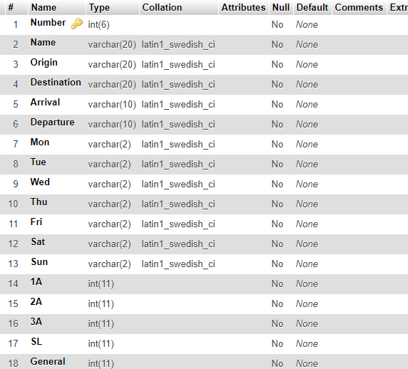

**TABLE 2.2 STRUCTURE OF TRAIN LIST**

## SEATS

SEATS table has the attribute train_no,train_name,doj,1A,2A,3A,AC,CC,SL is used shown in the table 2.3

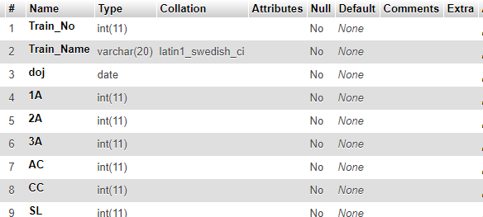

**TABLE 2.3 STRUCTURE OF SEATS**

## INTERLIST

INTERLIST table has the attribute number,st1,st1arri,st2,st2arri,st3,st3arri,st4,st4arri, st5,st5arri,ori,oriarri,dest,desarri,name,mon,tue,wed,thu,fri,sat,sun as shown in

Table 2.4

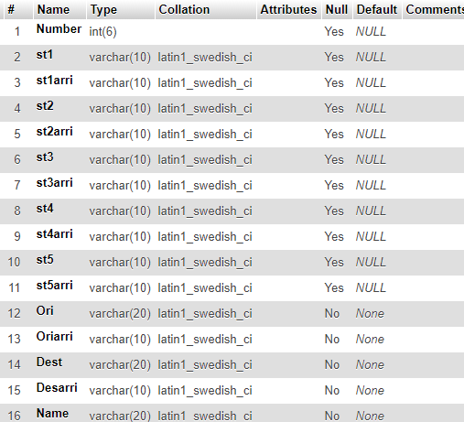

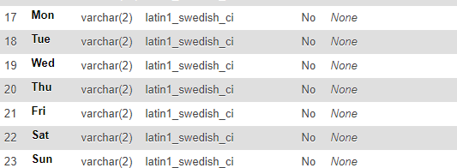

**TABLE 2.4 STRUCTURE OF INTERLIST**

## BOOKING

BOOKING table has theattributeuname,Tnumber,class,doj,DOB,fromstn,tostn, name,age,sex,status as shown in table 2.5

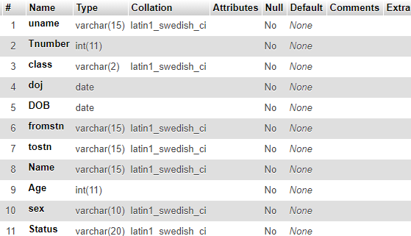

**TABLE 2.5 STRUCTURE OF BOOKING**

# TRIGGERS

A trigger is a special type of stored procedure that automatically executes when a event occurs in the database server.

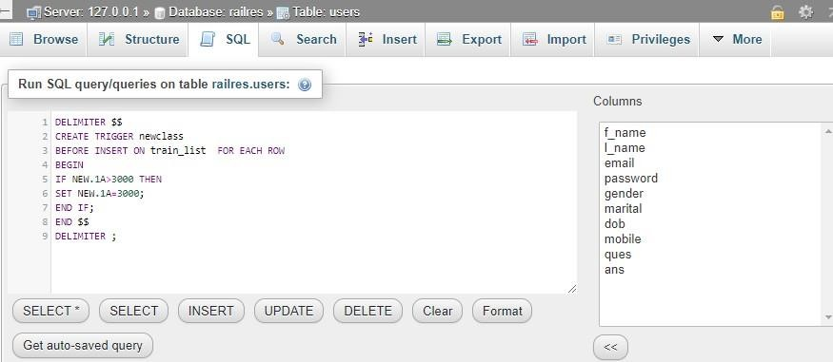

**TABLE 2.6 Trigger in Train list**

# Chapter 3

## 3.1. ER Diagram

**DESIGN**

An entity–relationship model describes inter-related things of interest in a specific domain of knowledge. An ER model is composed of entity types and specifies relationships that can exist between instances of those entity types.

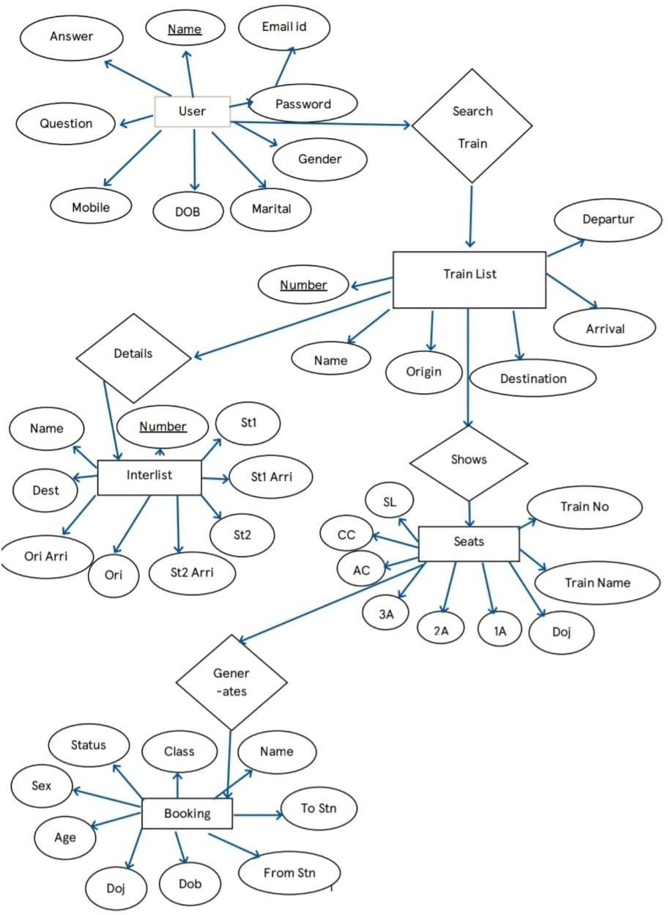

### Figure 3.1 E R Diagram

This ER Diagram gives a brief idea about the relations existing between the tables and tells about the primary and the foreign keys being used in this Database.

# 3.2 NORMALIZATION

## First Normal Form (1NF)

As the domain of all attributes of all relations in the database has atomic value and no tuples can have a set of these values, all relations are in 1NF.

## Second Normal Form (2NF)

As there is no partial dependency in the database, i.e. all nonprime attributes of a relation are fully functionally dependent on the primary key of the relation schema, all relations are in 2NF.

## Third Normal Form (3NF)

As all relations are in 2NF and no non-prime attribute of a relation schema is transitively dependent on the primary key, all relations are in 3NF.

## 3.3 SCHEMA DIAGRAM

A database schema can be represented in a visual diagram, which shows the database object and their relationship which represents the logical view of the database and how the relationships among them are represented.

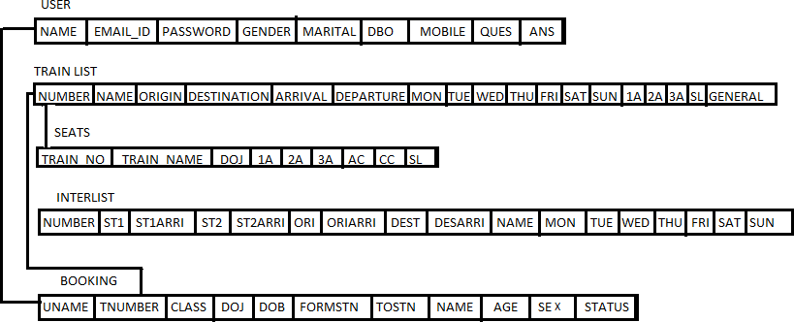

### Figure 3.2 SCHEMA DIAGRAM

This Schema Diagram in Fig 3.2 represents different tables used

# CHAPTER - 4

**HARDWARE AND SOFTWARE REQUIREMENTS**

## FUNCTIONAL AND NON FUNCTIONAL REQUIREMENTS

* + 1. **Functional or specific Requirements**

The required software is used for ordering food online. The system should satisfy the following requirements:

1. Logging into the system
2. Signup option
3. View Menu Details
4. Order Option
5. View User Orders
6. Logout option

## Non functional Requirements

All of the application data is stored in an Oracle database, and therefore an Oracle Database must also be installed on the host computer. As with Apache2, this software is freely available and can be installed and run under most operating systems. The server hardware can be any computer capable of running both the web and database servers and handling the expected traffic. For a small scale restaurant that is not expecting to see much web traffic, an average personal computer may be appropriate. Once the site starts generating more hits, though, it will likely be necessary to upgrade to a dedicated host to ensure proper performance. The exact cut-offs will need to be determined through a more thorough stress testing of the system.

# Hardware requirement

* A desktop or laptop with a proper internet connection
* 2 500GB or 60GB of the hard disk
* 3.4GB 2GB of the RAM
* 4 Windows 7 or 8 or 10 Operating system

# Software requirements

## Server side

1. Programming language: PHP 5.6.31
2. Web Server: Apache 2.4.27
3. Database: SQL 5.7.19

## Client side

1. Programming language: JAVASCRIPT, HTML, CS
2. OS: windows7/8/10
3. MYSQL server

### PHP

PHP is a server-side scripting language designed primarily for web development but also used as a general programming language PHP code may be embedded into HTML or HTML5 markup or it can be used in combination with various web template systems, web content management systems, and web frameworks. PHP code is usually processed by a PHP interpreter implemented as a module in the web server. The web server software combines the results of the interpreted and executed PHP code, which may be any type of data, including images, with the generated webpage.

### WEB SERVER: APACHE

Apache is the most widely used web server software. Developed and maintained by Apache Software Foundation, Apache is open-source software available for free. It runs on 67% of all web servers in the world. It is fast, reliable, and secure. It can be highly customized to meet the needs of many different environments by using extensions and modules. Most WordPress hosting providers use Apache as their web server software. However, WordPress can run on other web server software as well.

### HTML

HTML is an acronym that stands for HyperText Markup Language.

HyperText: HyperText simply means "Text within Text". A text has a link within it, is a hypertext. Every time you click on a word that brings you to a new webpage, you have clicked on a hypertext.

Markup language: A markup language is a programming language that is used to make text more interactive and dynamic. It can turn a text into images, tables, links, etc. An HTML document is made of many HTML tags and each HTML tag contains different content

.

### JAVASCRIPT

Javascript is a dynamic computer programming language. It is lightweight and most commonly used as a part of web pages, whose implementations allow client-side script to interact with the user and make dynamic pages. It is an interpreted

# CONCLUSION

Our system can successfully give information on any train,find trains running between twostations ,book tickets and cancel tickets.This system could be used for official trainbooking.However several other features could be added like booking meals on trains etc.

Also payment gateways have to be implemented to make sure the transactions happen securely.

# FUTURE ENHANCEMENT

* + - * + We can even further make it private and secured by implementing Log- in IDs and encrypting them with passwords.
        + We can give away this software for more number of people and organizations to conduct a Beta Testing and based upon the results we can just make those changes and be assured of the application developed.
        + We can make it more space and resource efficient so that this application consumes lesser RAM and ROM and battery power (if available).

# REFERENCES

1. https://github.com/samgakii123/
2. <http://php.net/>
3. https://[www.](http://www/)<http://en.wikipedia.org/wiki/PHP>
4. https://[www.w3shools.com](http://www.w3shools.com/)

# APPENDIX ‘A’- CODE SNIPPETS

## DATABASE CONNECTION

The connect() / mysqli_connect() function opens a new connection to the MySQL server with the following syntax :

mysqli_connect(*host, username, password, dbname, port, socket*)



**FIG A.1 DATABASE CONNECTION**

## INSERT QUERY

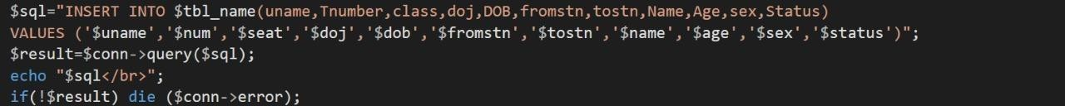This query is used to insert a booking .

**FIG A.2 INSERT QUERY**

## SELECT QUERY

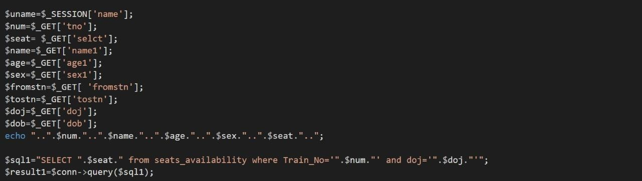In this query,all the details are fetched using SELECT* command

**FIG A.3 SELECT QUERY**

## UPDATE QUERY

Here the update query is called to update the user of an already existing based on its name and category id,address etc respectively.

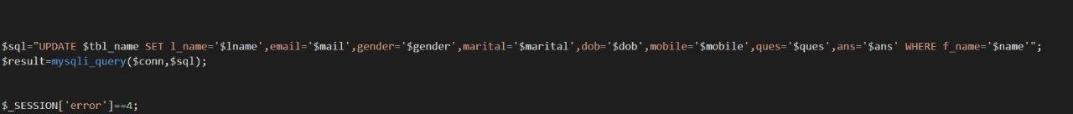

**FIG A.4 UPDATE QUERY**

# APPENDIX ‘B’- SCREENSHOTS

## HOME PAGE

This is the first window when the application is executed as shown in Fig B.1

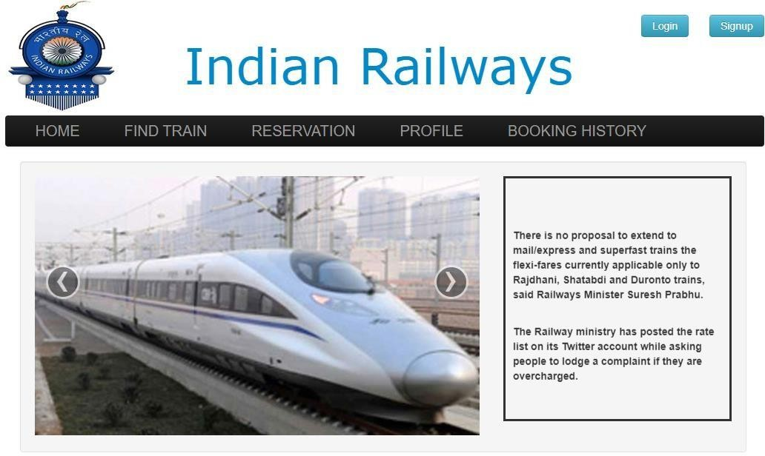

**FIG B.1 HOME PAGE**

## SIGN UP PAGE

The page allows admin to sign up to database as shown in Fig B.2

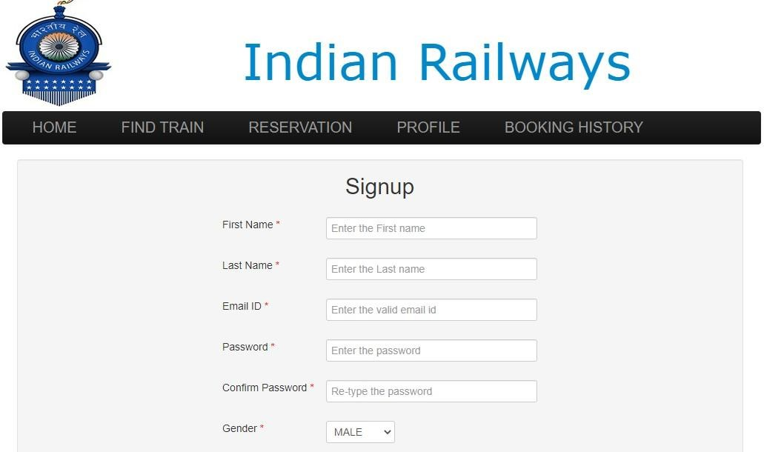

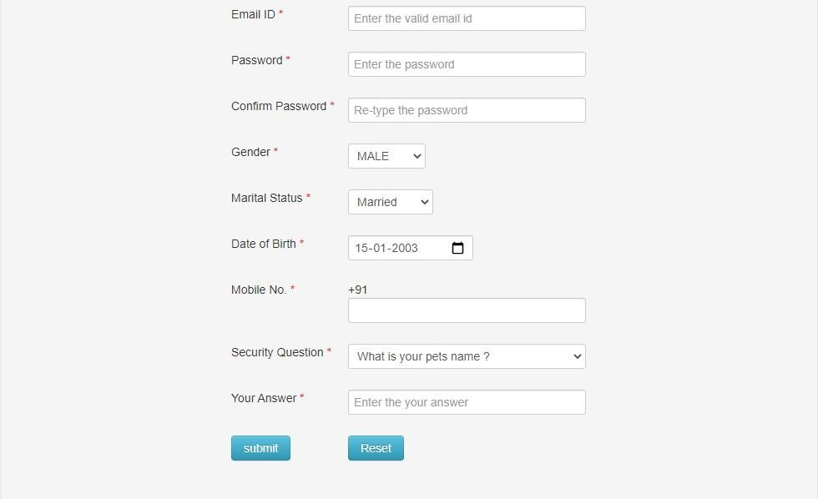

**FIG B.2 SIGN UP PAGE**

## ADMIN LOGIN PAGE

This page allows admin to login and make changes to data base as shown in Fig B.3

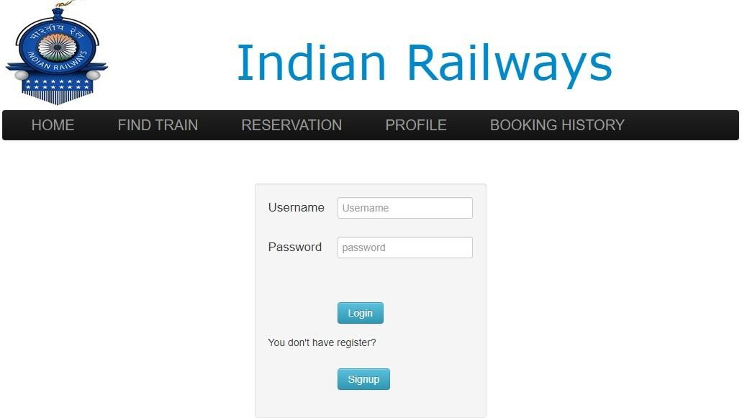

**FIG B.3 ADMIN LOGIN PAGE**

## ADMIN FIND TRAIN PAGE

This page allows admin to find the train as shown in the FigB.4

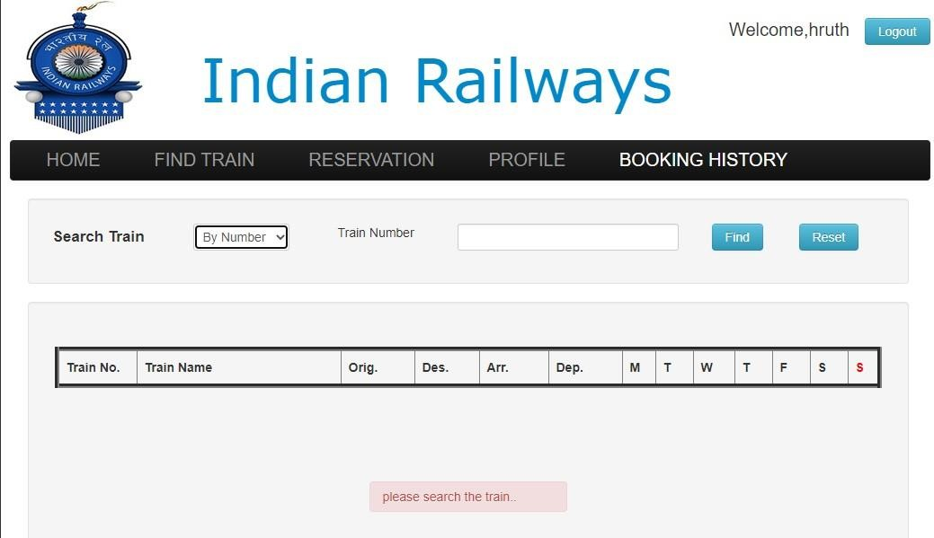

**FIG B.4 ADMIN FIND TRAIN PAGE**

## ADMIN BOOKING RESERVATION PAGE

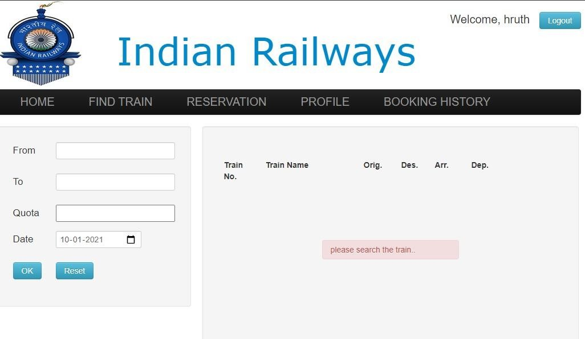This page allows admin to book the tickets as show in the Fig B.5

**FIG B.5 ADMIN BOOKING RESERVATION PAGE**

## ADMIN BOOKING HISTORY

This page allows admin to see the Booking history as shown in the fig B.6

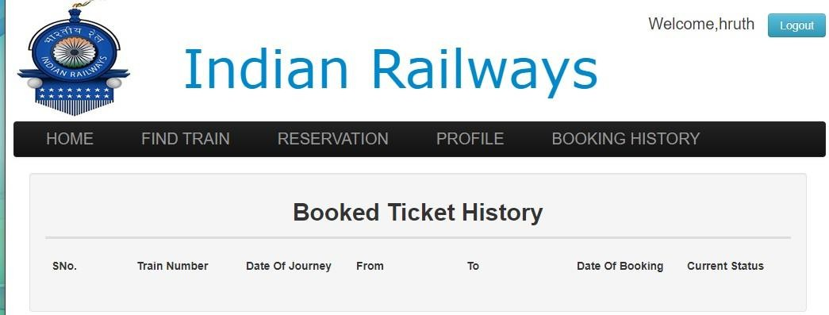

**FIG B.6 ADMIN BOOKING HISTORY**