View Resolver

*These are given to map the given LVN with physical view comp and return view object having the name and location physical view component
*All view resolver are pre defined classes implementing ViewResolver(I) eg
a. InternalResourceViewResolver
b.UrlBasedViewResolver
c.ResourceBundleViewResolver
d.TileViewResolver

*We generally use one of these pre defined view resolvers and dont need any custom VR
*Every vr must be registered with vrRegistry by getting the registry thru WebMvcCnfigurer class development
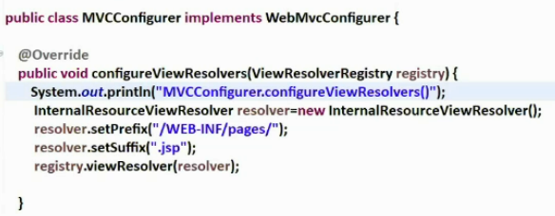
*Disable the prefix and suffix in the properties file if u need to enable the custom view resolver
*If both are given then the CustomConfiguration classes gets the priority

UrlBasedViewResolver
*Allows to take any tech components as the view cmps including servlet,jsp comps
*We must set view class explicitly to decide the ViewTechnology to use
*View classes are the classes implementing the View(I) like JstlView , InternalResourceView etc
*To use servlet,jsp comps as view cmps we can use Irview(jstl tags are not used) or JstlView(if jstl tags aree used) i.e If JSTL View class is used then JSTL tags and its Library must be imported but whereas in the Irview we can use jstl library if only necessary
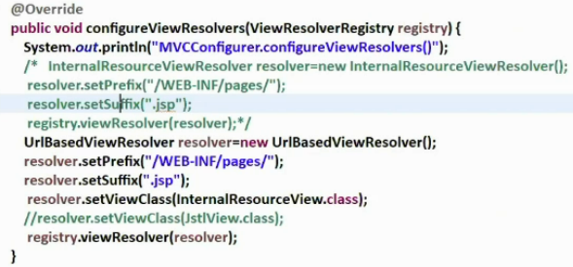
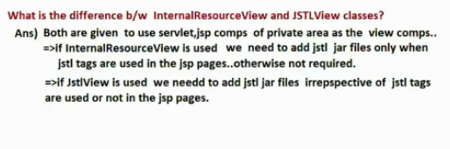

*UrlBasedViewResolver is super class of the InternalResourceViewResolver

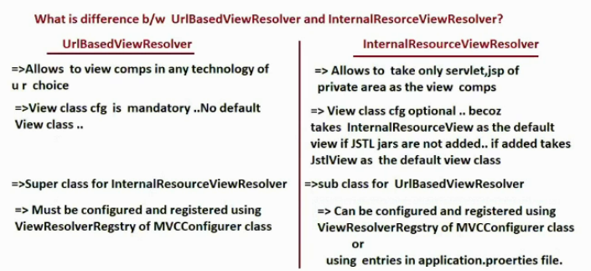
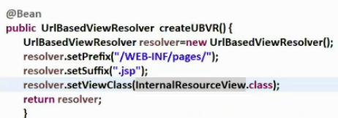

*(We can also use this as the bean instead of making a seperate component)

*The biggest limitation in both viewResolvers is that the LVN given by the controller class handler method must be taken as the view comp also all the comps must be in the same location even if its of different technologies
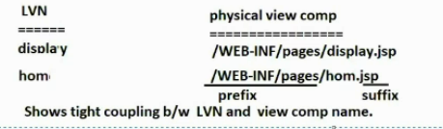

* we can register all the resolvers thru @Bean method or even @Component method and using the prefix thru proprty file is for IRViewResolver only
*To overcome the limitations use ResourceBundleViewResolver or XmlViewResolver

ResourceBundleViewResolver
*Allows us to take different view comps in different location and in diff technologies
*We can get loose coupling bw LVN and physical view comps
*We must use seperate properties file to specify the view comp details
*The default filename properties is views.properties of class path src/main/java

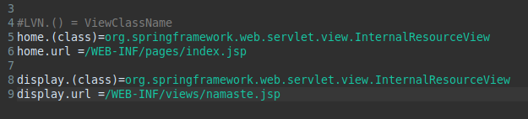
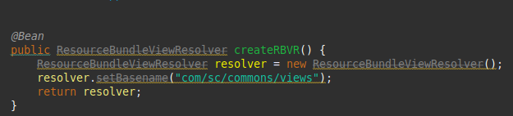

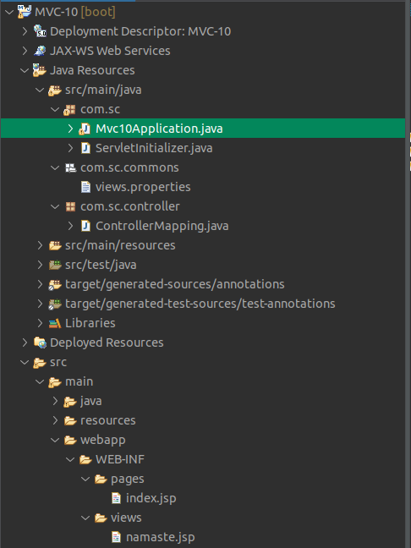

* We can avoid mentioning the basename also if we keep the view.properties in src/main/java folder
* We cant use directly HTML file view without thymleaf tech as view comps in sprinb MVC web app

XmlViewResolver
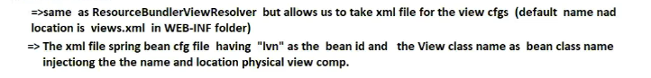
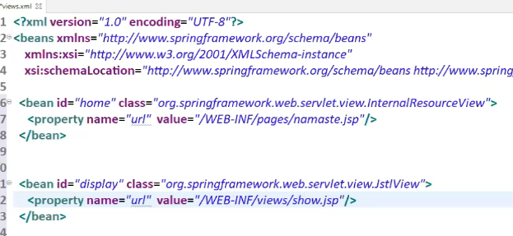
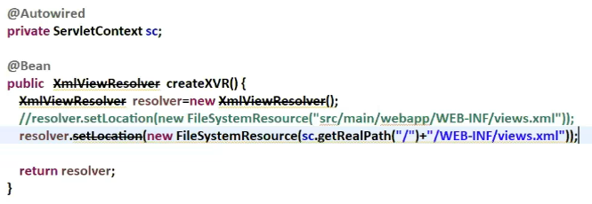

Generating Report as Excel and Pdf document
*In Sboot we have view as an abstract entity i.e we can take anything as view component i.e we can take anything as view component (like jsp , html , thymleaf,velocity,tiles etc)
*To generate report as excel sheet we need the support of the POI api for pdf report , we need the support of the itext api To place thesee third party apis we need to tkae java classes / spring bean as the view comps implementing the View(I) directly or indirectly
*To use Spring Beans as view comp based in the recieved LVN we need to work with BeanViewResolver (This supports view resolver chain ) This vr maps given LVN with View cmp which is spring bean having LVN as the bean id
*Generally InternalResourceView , JstlView class obj acts as the View obj to render the jsp pages as the view comps but placing the POI api , itext api in JSP pages is bad practice
*To overcome this problems we develop our own View class adding POI api , Itext Api support

// See MVC-11 Github

Spring Boot with Tiles Framework

*Tiles framework is pluggable fw to any other mvc fw to display web pages of web app having composite Design pattern and layout control based on template page

Layout Controller
*All web pages of the website will be created based on the common layout page/template page to have uniform look for all the web pages . So any change in the template reflects to all the webpages of the website
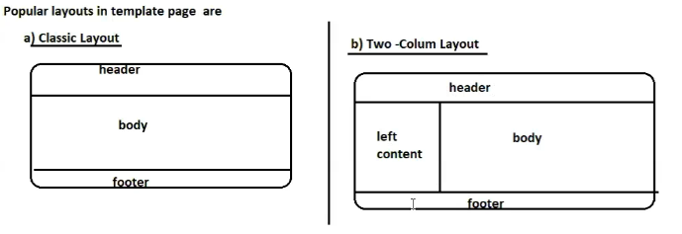
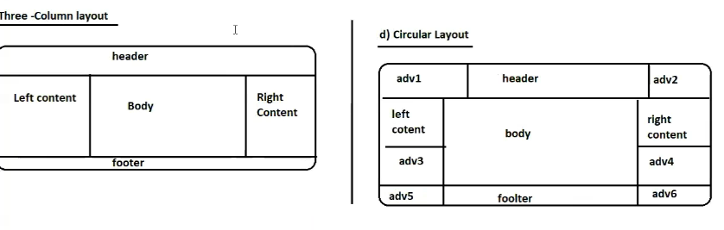

* Tile is a logical portion of a webpage eg header tile , footer tile etc
*No webpages comes as the output given by single web comp but every web page comes having multiple tiles based on the layout page containing composite output given by the multiple web comp together
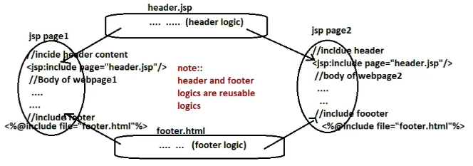
Composite view design pattern

Procedure to work with Tiles Framework
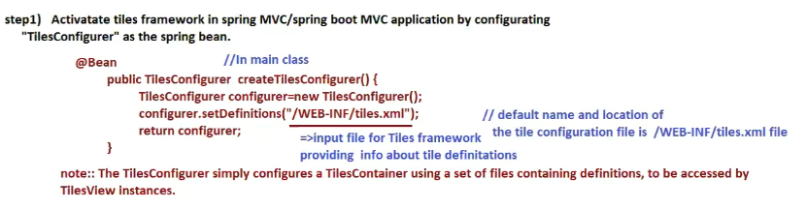
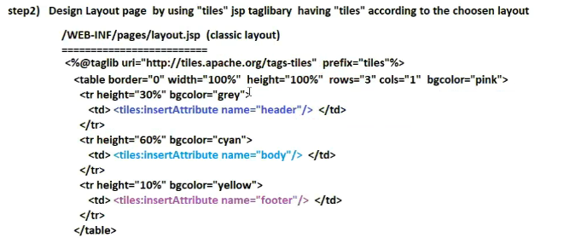
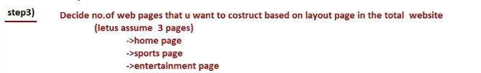
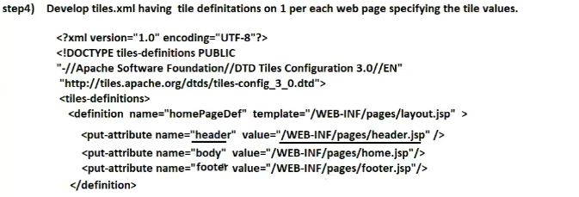

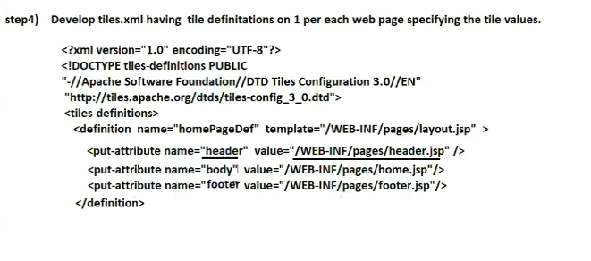
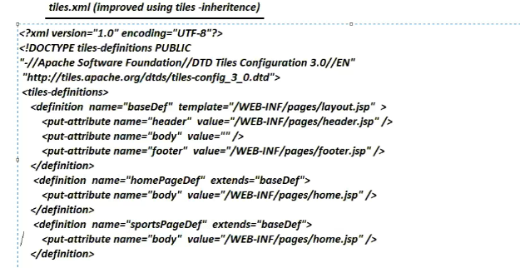
* Thru tiles inheritence we dont need to mention header footer body again and again we can override the parents components if we want else same as the parent
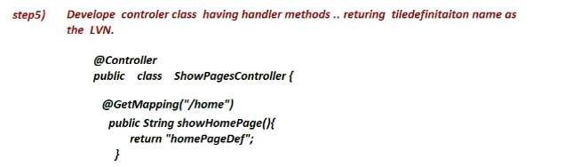

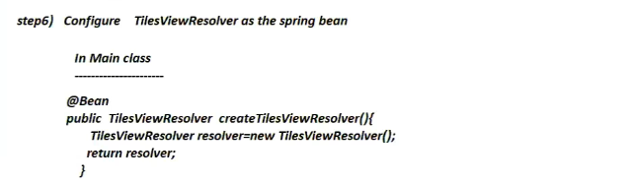
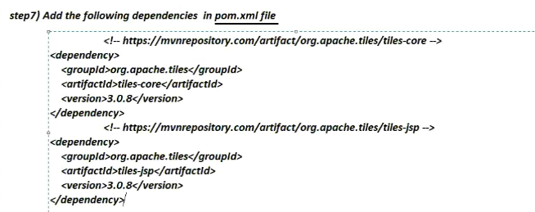

Thymeleaf
*Another UI tech that is build on top of HTML for dynamic web pages
*Only HTML gives static Thymeleaf +HTML gives dynamic webpages It is light weight alternate to heavy weight jsp pages
*In JSP execution lot of memory and time is required bcz internally translates the jsp equivalent servlet comp and creates multiple implicit objs if used or not for all these lot of memory is required
*Hence Thymeleaf is used which is very light weight
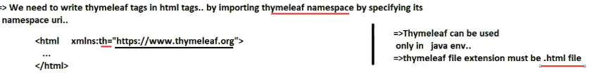
* Thymeleaf gives default prefix and suffix
*We cant mix Thymeleaf and JSP pages together in single Spring MVC app
*Use thymeleaf dependencies while working with thymeleaf
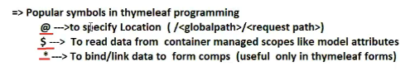
*Symbols in Thymeleaf

