**Experiment No.10**

**Title :** Implementation of Binary search.

**Problem Statement:** Implement a C++ program to perform binary search.

**Algorithm:**

1. Compare x with the middle element of the sorted array.

2. If x matches with middle element, we return the mid index.

3. Else If x is greater than the mid element, then x can only lie in right half subarray after the mid element. So we recur for right half.

4. Else (x is smaller) recur for the left half.

**CODE:**

// Binary Search using Recursion

#include <iostream>

using namespace std;

// If found, location of x in the array is returned.

// otherwise -1 is returned.

int binarySearch(int arr[], int first, int last, int x)

{

if (last >= first) {

int mid = first + (last- first) / 2;

// If the element is present at the middle of the array

if (arr[mid] == x)

return mid;

// If element is smaller than mid, then

// it can only be present in left subarray

if (arr[mid] > x)

return binarySearch(arr, first, mid - 1, x);

// Else the element can only be present

// in right subarray

return binarySearch(arr, mid + 1, last, x);

}

// If the element is not found.

return -1;

}

int main()

{

int arr[20],n,x,i;

cout<<"How many elements:";

cin>>n;

cout<<"\nEnter elements of the array\n";

for(i=0;i<n;++i)

cin>>arr[i];

cout<<"\nEnter element to search:";

cin>>x;

int result = binarySearch(arr, 0, n - 1, x);

if (result == -1)

cout << "Element is not present in array.";

else

cout << "Element is present at index " <<

result;

return 0;

}

**Output:**

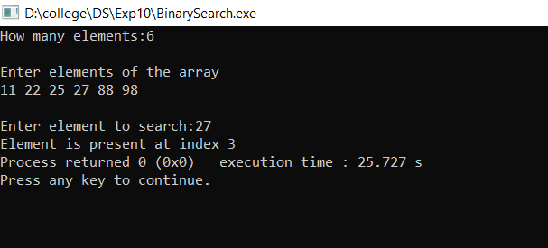

**Analysis (Limitation)**:

Binary Search is a method to find the required element in a sorted array by repeatedly halving the array and searching in the half.

This method is done by starting with the whole array. Then it is halved. If the required data value is greater than the element at the middle of the array, then the upper half of the array is considered. Otherwise, the lower half is considered. This is done continuously until either the required data value is obtained or the remaining array is empty.