**Experiment No. 3a**

**Title :** Implementation of Factorial using recursion

**Problem Statement :** Implementing factorial of any number using recursion

**Algorithm :**

**S1 :** Start

**S2 :** Declare an integer variable and a function factorial().

**S3 :** Call the function and send the value whose factorial has to be found.

**S4 :** in factorial function if the integer is equal to 1 return else call the function by sending the value one less than previous integer.

**S5 :** Stop

**Code :**

#include<iostream>

using namespace std;

int fact(int n)

{

if(n == 1)

{

return(1);

}

else

return(n*fact(n-1));

}

int main()

{

int n,ans;

cout<<"Enter the number : ";

cin>>n;

ans = fact(n);

cout<<"The factorial is : "<<ans<<endl;

}

**Output :**

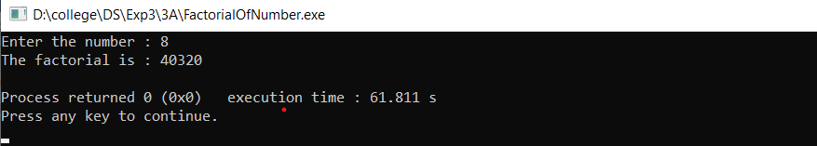

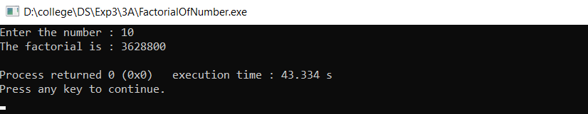

**Analysis :**

* Since recurtion calls function within itself it takes more execution time as compared to loop.
* Since the return value is integer from function, if a factorial value is out of integer range it might lead to error.