**AgroNutrition**

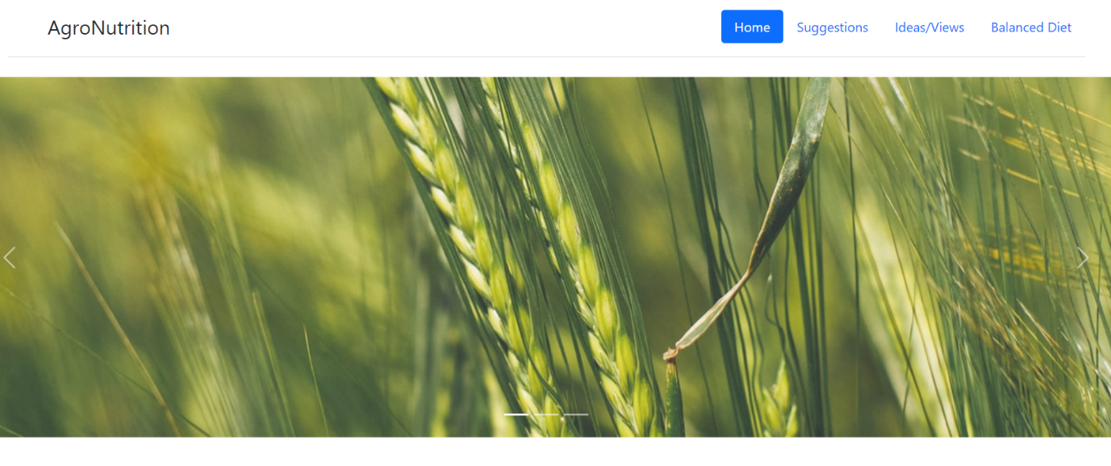

**AgroNutrition is all about providing information about sustainable farming methods and sustainable food resources to the masses.**

**After searching for numerous resources over the internet and always ending up frustrated about the lack of resources, we decided to change this once and for all.**

**This website will help anyone who is looking to improve his farming methods and will provide valuable information on sustainable food.**

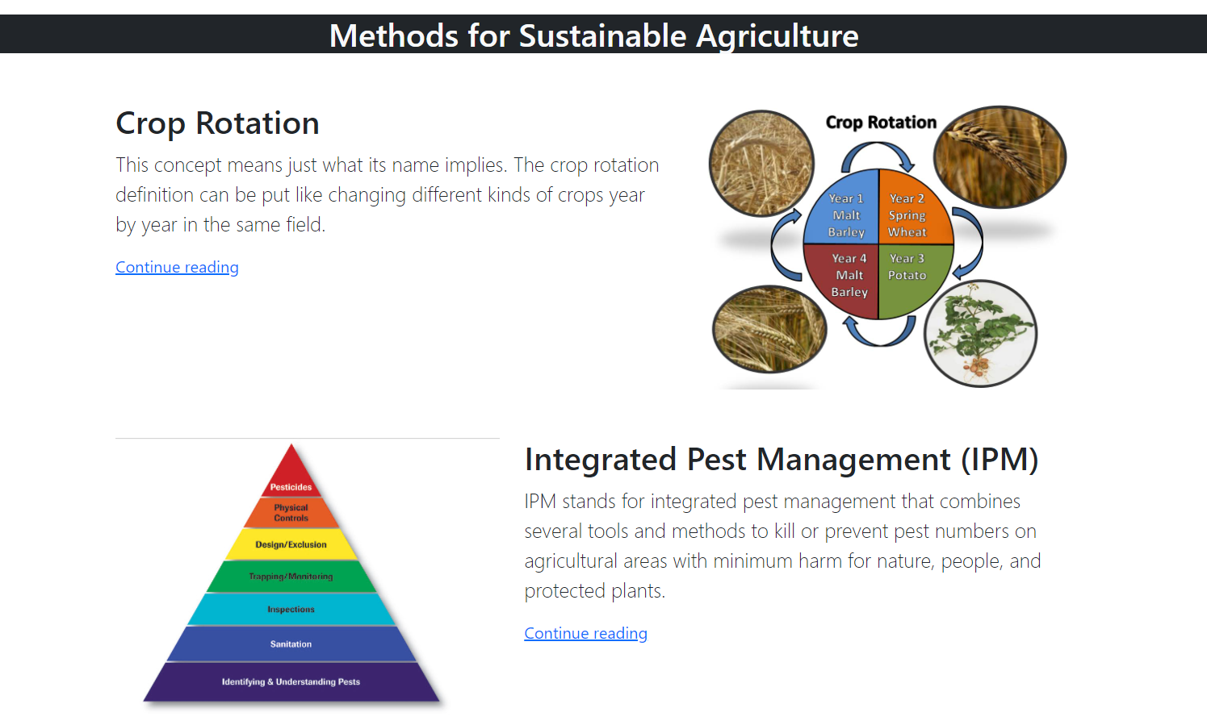

**Opening the site you’ll get to know all the methods for sustainable agriculture with good resources to learn more about them.**

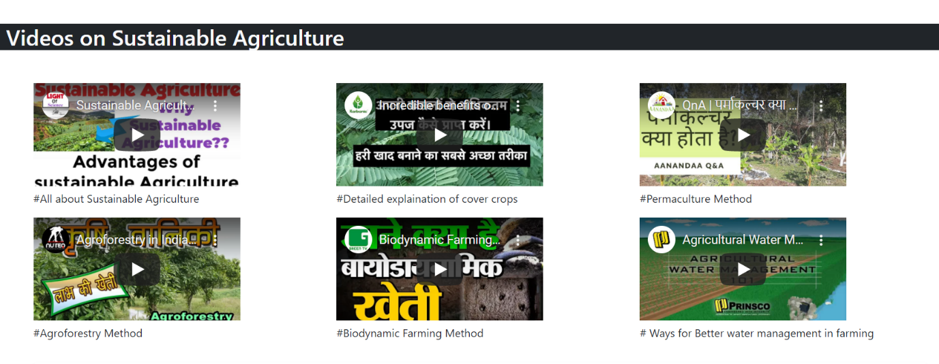

**Videos are an important medium to learn new things and we surely didn’t miss out on that.**

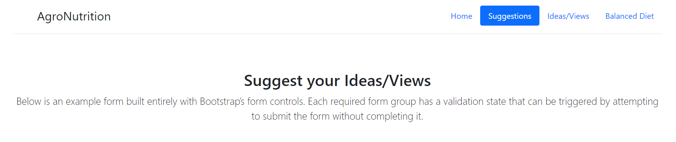

**Suggestions tab is for your ideas and views related to the site and your valuable feedback is very important for us to improve our site and its resources. You can also seek help and the people viewing your information will get a chance to help you.**

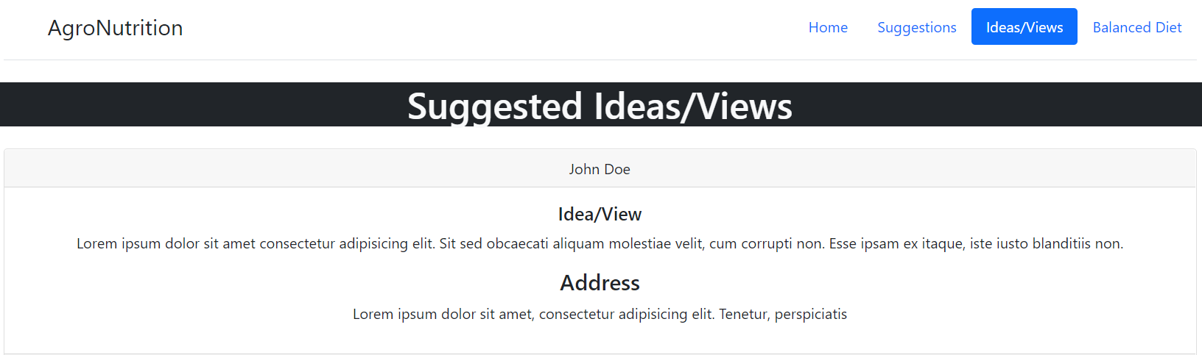

**All your suggestions or ideas will be posted on the forum for others and any help related posts will be added so that other visitors can help people in need.**

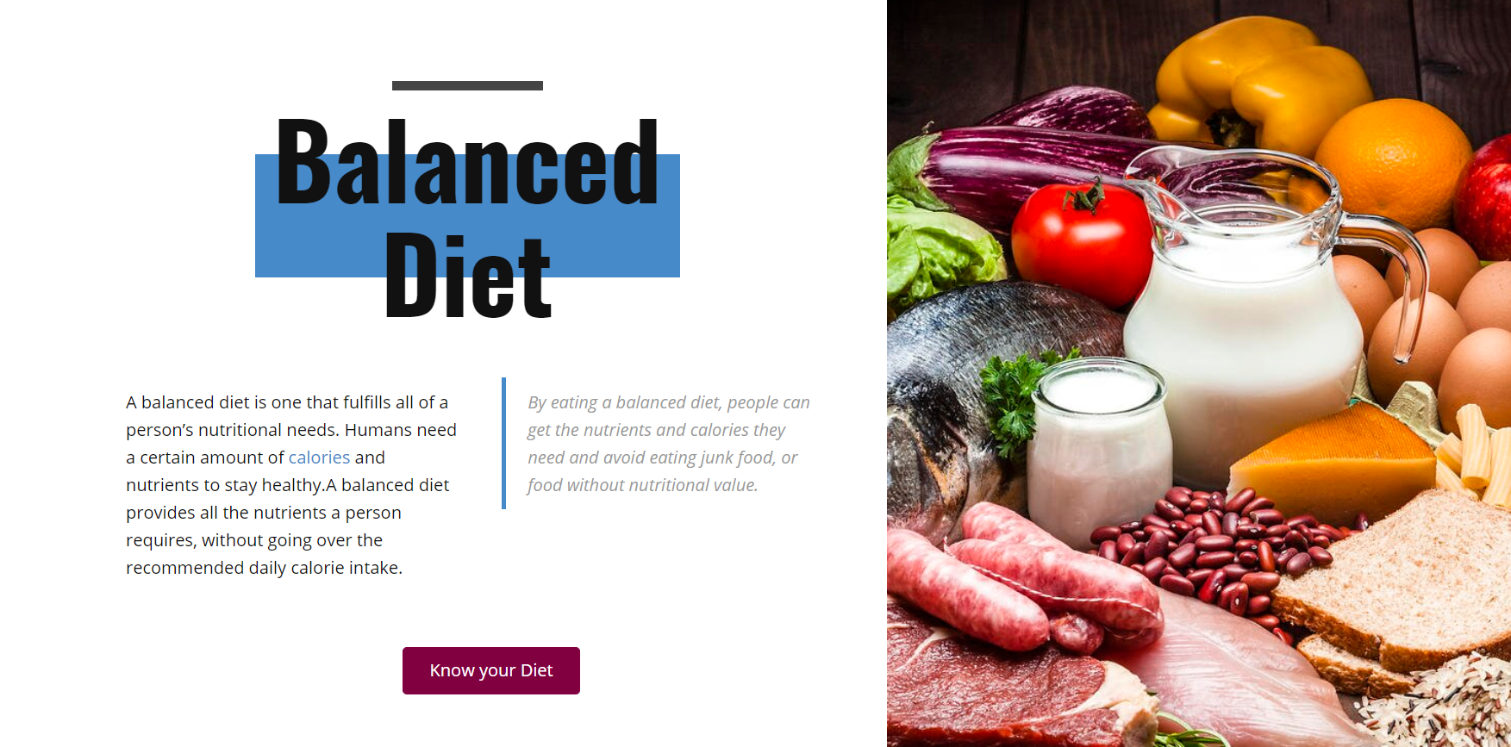

**The Balanced Diet page is for all those people looking to improve their daily diet to stay healthy.**

**You can get your respective diet supplements by just clicking the “Know your Diet” button.**



**No resource is perfect so if you still have any doubts after going through the site and its resources then you can always seek help.**