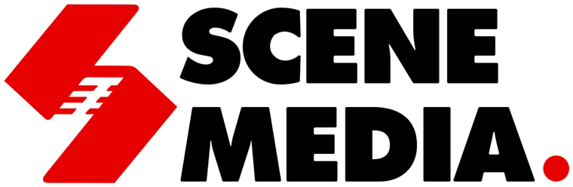 | META ADS · INSTAGRAM + FACEBOOK

PREPARED FOR MEMORABLE WALK
CLIENT ONBOARDING FORM.
Please fill in this form so we can finalise your ad targeting, budget and ad copy before launch. Type your answers in the boxes. For options, type an “X” next to each one that applies. If you are not sure about something, write “Not sure” and we will discuss it on a call.
Please do not write any passwords in this form. Scene Media will get access to your Facebook and Instagram through partner access in Meta Business Suite (see Section 5).
Your details
Business name
Contact person
Phone / WhatsApp
Email
Date filled
SECTION 1
YOUR BUSINESS & SERVICES.
1. Service area (A4)
Which areas, pin codes or towns do you serve? How far will you travel for an event?
2. Priority event types
Mark the events you want to promote, then tell us which to push first. Do you do full wedding decor, single functions, or both?
☐ Wedding ☐ Haldi ☐ Mehndi ☐ Engagement ☐ Birthday party ☐ Festival decor ☐ Other
3. Ideal customer
Home events or venues? Typical event size? Who usually books (couple, parents, family)?
4. Capacity
How many events can you handle per day, or per festival?
5. Seasonal calendar
Your busiest wedding months, the festivals you decorate for, and how far ahead people usually book.
SECTION 2
BUDGET, PRICING & BOOKING.
6. Monthly ad budget
Which budget tier would you like, and for how long? (Ad spend is paid to Meta. Scene Media management is ₹12,000/month.)
☐ Starter ₹15,000 ☐ Growth ₹30,000 ☐ Scale ₹60,000 ☐ Other
7. Pricing and booking value
Starting price or price ranges, minimum order, and your average booking value.
8. Booking process
Steps from first inquiry to confirmed booking: site visit, advance payment, lead time needed.
9. Offers
Any early-booking or package offers you are happy for us to advertise?
SECTION 3
INQUIRIES & CONTACT.
10. Preferred contact method (A3)
How should customers contact you from the ads? Is 6351748335 on WhatsApp Business?
☐ WhatsApp ☐ Phone call ☐ Instagram DM ☐ Quote form
11. Who replies, and when
Who will answer inquiries, your working hours, and a realistic reply time.
12. Languages (A5)
Which languages do you prefer to use with customers?
☐ English ☐ Gujarati ☐ Hindi
SECTION 4
BRAND & CONTENT.
13. Brand name and visual style (A1)
Official business name, logo, brand colours, and your signature decor style.
14. Photo and video library (A6)
What photos and videos of past setups can we use? Do we have permission to show clients’ homes or faces? Please share a Google Drive link if possible.
15. Website or landing page
Do you have a website? Can we install the Meta Pixel on it?
16. Past client list
Can you share past client contacts (with their consent) so Meta can find similar people?
SECTION 5
FACEBOOK & INSTAGRAM ACCOUNTS.
17. Facebook & Instagram account IDs (A7)
Fill in what you have. We can help you find the IDs on a call.
Facebook Page link
Facebook Page ID
Instagram username
Instagram account ID
Meta Business ID
Ad account ID
18. Account access for Scene Media
In Meta Business Suite, go to Business settings › Partners › Add, enter the Scene Media Business ID we send you, and give access to your Facebook Page, Instagram account and ad account. No passwords needed.
☐ Partner access given
19. Payment method and GST details
The card or payment method for Meta ad spend, and your GST number for invoices.
Confirmation
Name
Signature
Date
Thank you! Please send the completed form back to Scene Media on WhatsApp or email.

