Daya Patel – LinkedIn Profile Revamp
Founder & Director, Wudly Toys · Profile mockup and copy text · October 2026
Each section shows a mockup of how it will look on LinkedIn, with the text to copy into LinkedIn under it. Text in [brackets] still needs her real details.

Profile header
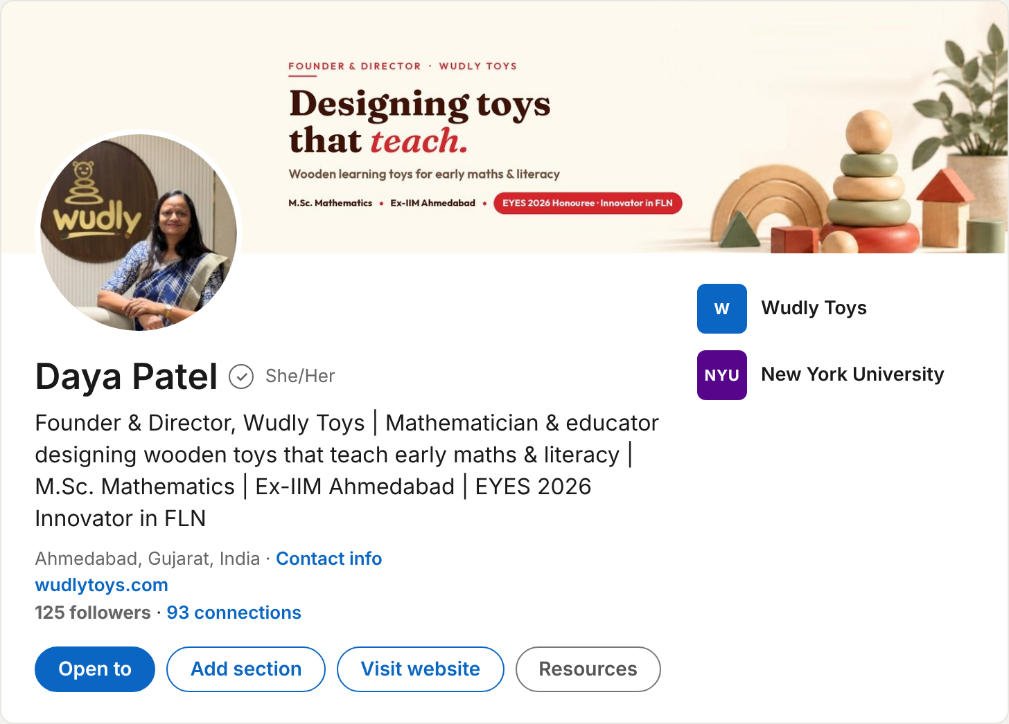
TEXT TO COPY
Field | Text
Name | Daya Patel
Pronouns | She/Her
Headline | Founder & Director, Wudly Toys | Mathematician & educator designing wooden toys that teach early maths & literacy | M.Sc. Mathematics | Ex-IIM Ahmedabad | EYES 2026 Innovator in FLN
Location | Ahmedabad, Gujarat, India
Website | wudlytoys.com
Current company | Wudly Toys
Education shown | New York University
Cover banner text
- Top line: Founder & Director · Wudly Toys
- Main line: Designing toys that teach.
- Sub line: Wooden learning toys for early maths & literacy
- Tags: M.Sc. Mathematics · Ex-IIM Ahmedabad · EYES 2026 Honouree: Innovator in FLN

About
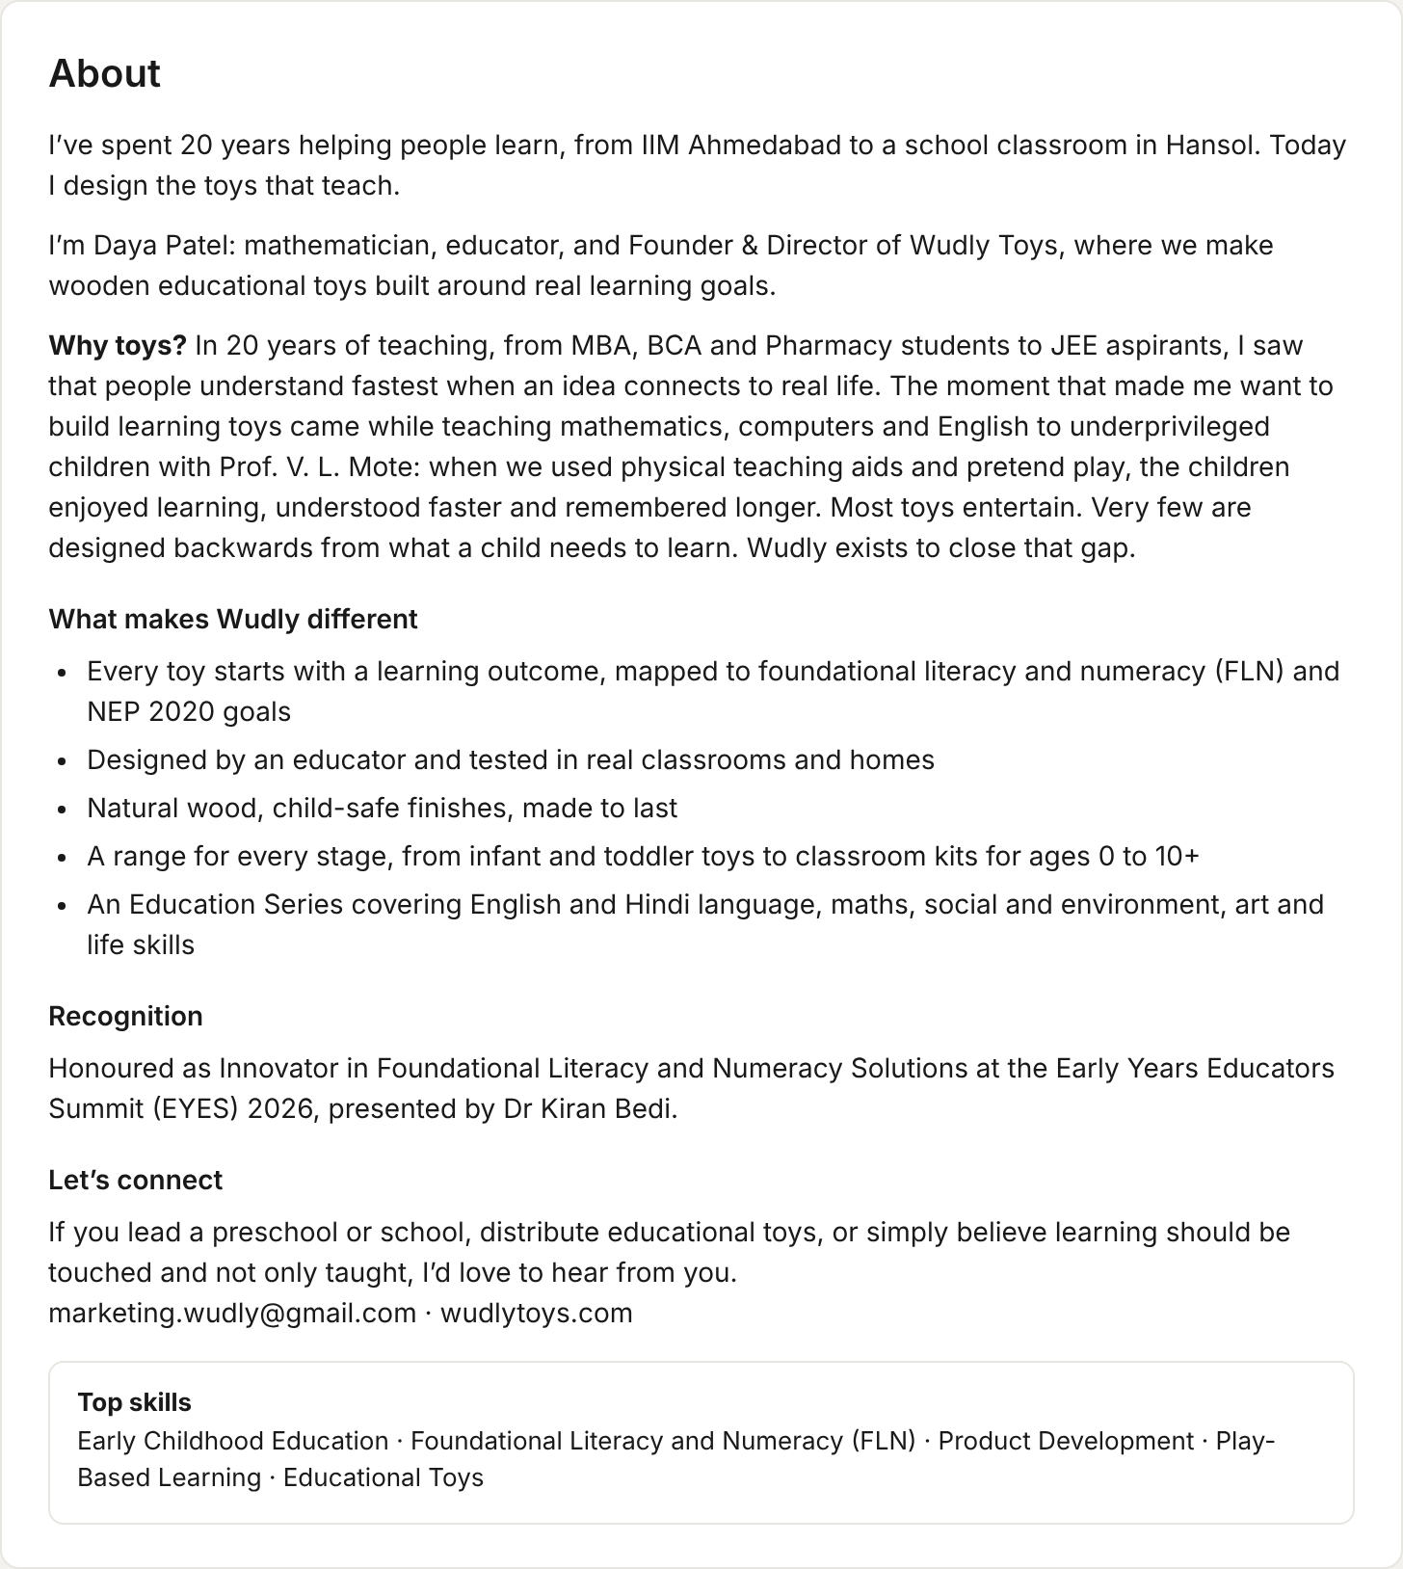
TEXT TO COPY
I’ve spent 20 years helping people learn, from IIM Ahmedabad to a school classroom in Hansol. Today I design the toys that teach.
I’m Daya Patel: mathematician, educator, and Founder & Director of Wudly Toys, where we make wooden educational toys built around real learning goals.
Why toys? In 20 years of teaching, from MBA, BCA and Pharmacy students to JEE aspirants, I saw that people understand fastest when an idea connects to real life. The moment that made me want to build learning toys came while teaching mathematics, computers and English to underprivileged children with Prof. V. L. Mote: when we used physical teaching aids and pretend play, the children enjoyed learning, understood faster and remembered longer. Most toys entertain. Very few are designed backwards from what a child needs to learn. Wudly exists to close that gap.
What makes Wudly different
- Every toy starts with a learning outcome, mapped to foundational literacy and numeracy (FLN) and NEP 2020 goals
- Designed by an educator and tested in real classrooms and homes
- Natural wood, child-safe finishes, made to last
- A range for every stage, from infant and toddler toys to classroom kits for ages 0 to 10+
- An Education Series covering English and Hindi language, maths, social and environment, art and life skills
Recognition
Honoured as Innovator in Foundational Literacy and Numeracy Solutions at the Early Years Educators Summit (EYES) 2026, presented by Dr Kiran Bedi.
Let’s connect
If you lead a preschool or school, distribute educational toys, or simply believe learning should be touched and not only taught, I’d love to hear from you.
marketing.wudly@gmail.com · wudlytoys.com
Top skills (shown under About): Early Childhood Education · Foundational Literacy and Numeracy (FLN) · Product Development · Play-Based Learning · Educational Toys

Featured
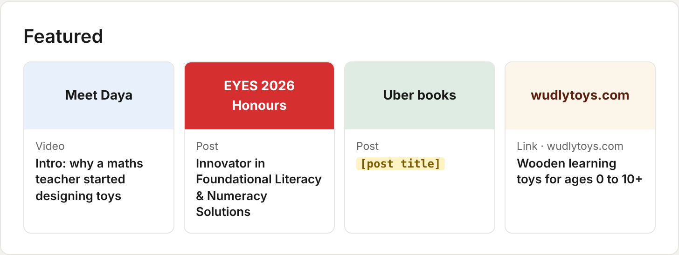
TEXT TO COPY
Order | Type | Thumbnail | Title
1 | Video | Meet Daya | Intro: why a maths teacher started designing toys
2 | Post | EYES 2026 Honours | Innovator in Foundational Literacy & Numeracy Solutions
3 | Post | Uber books | [post title]
4 | Link · wudlytoys.com | wudlytoys.com | Wooden learning toys for ages 0 to 10+

Experience
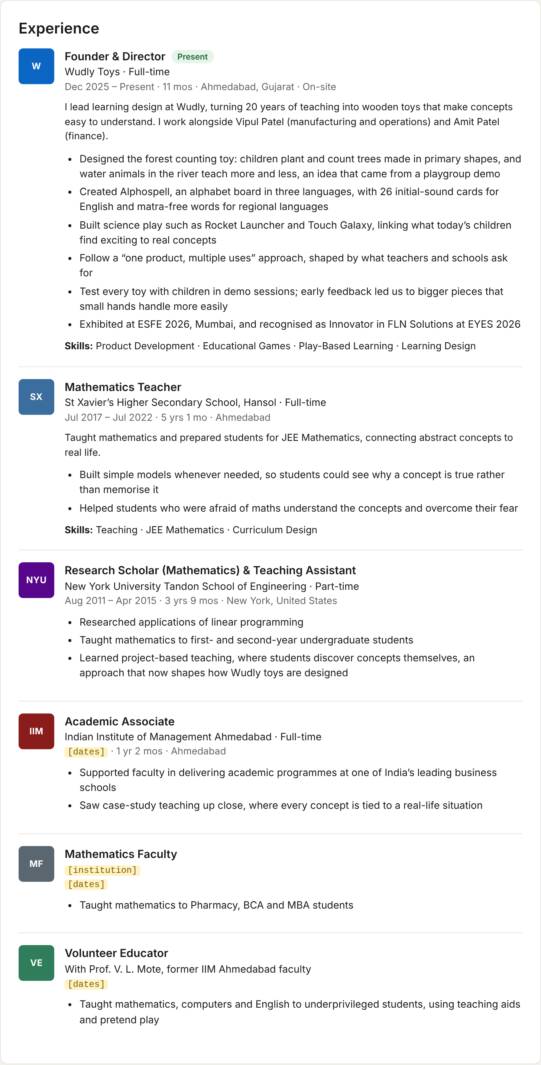
TEXT TO COPY

Founder & Director
Wudly Toys · Full-time
Dec 2025 – Present · 11 mos · Ahmedabad, Gujarat · On-site
I lead learning design at Wudly, turning 20 years of teaching into wooden toys that make concepts easy to understand. I work alongside Vipul Patel (manufacturing and operations) and Amit Patel (finance).
- Designed the forest counting toy: children plant and count trees made in primary shapes, and water animals in the river teach more and less, an idea that came from a playgroup demo
- Created Alphospell, an alphabet board in three languages, with 26 initial-sound cards for English and matra-free words for regional languages
- Built science play such as Rocket Launcher and Touch Galaxy, linking what today’s children find exciting to real concepts
- Follow a “one product, multiple uses” approach, shaped by what teachers and schools ask for
- Test every toy with children in demo sessions; early feedback led us to bigger pieces that small hands handle more easily
- Exhibited at ESFE 2026, Mumbai, and recognised as Innovator in FLN Solutions at EYES 2026
Skills: Product Development · Educational Games · Play-Based Learning · Learning Design

Mathematics Teacher
St Xavier’s Higher Secondary School, Hansol · Full-time
Jul 2017 – Jul 2022 · 5 yrs 1 mo · Ahmedabad
Taught mathematics and prepared students for JEE Mathematics, connecting abstract concepts to real life.
- Built simple models whenever needed, so students could see why a concept is true rather than memorise it
- Helped students who were afraid of maths understand the concepts and overcome their fear
Skills: Teaching · JEE Mathematics · Curriculum Design

Research Scholar (Mathematics) & Teaching Assistant
New York University Tandon School of Engineering · Part-time
Aug 2011 – Apr 2015 · 3 yrs 9 mos · New York, United States
- Researched applications of linear programming
- Taught mathematics to first- and second-year undergraduate students
- Learned project-based teaching, where students discover concepts themselves, an approach that now shapes how Wudly toys are designed

Academic Associate
Indian Institute of Management Ahmedabad · Full-time
[dates] · 1 yr 2 mos · Ahmedabad
- Supported faculty in delivering academic programmes at one of India’s leading business schools
- Saw case-study teaching up close, where every concept is tied to a real-life situation

Mathematics Faculty
[institution]
[dates]
- Taught mathematics to Pharmacy, BCA and MBA students

Volunteer Educator
With Prof. V. L. Mote, former IIM Ahmedabad faculty
[dates]
- Taught mathematics, computers and English to underprivileged students, using teaching aids and pretend play

Education
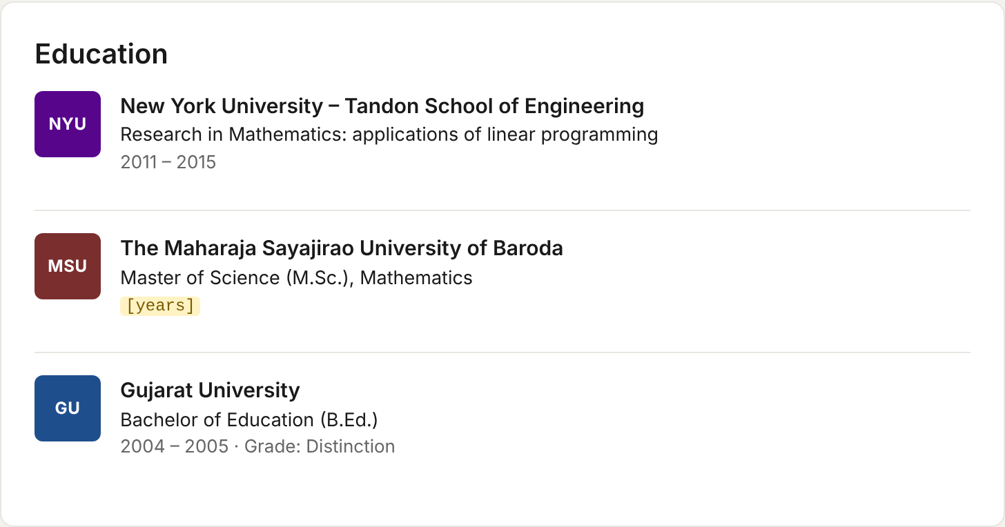
TEXT TO COPY
School | Degree / focus | Years
New York University – Tandon School of Engineering | Research in Mathematics: applications of linear programming | 2011 – 2015
The Maharaja Sayajirao University of Baroda | Master of Science (M.Sc.), Mathematics | [years]
Gujarat University | Bachelor of Education (B.Ed.), Grade: Distinction | 2004 – 2005

Honours & awards
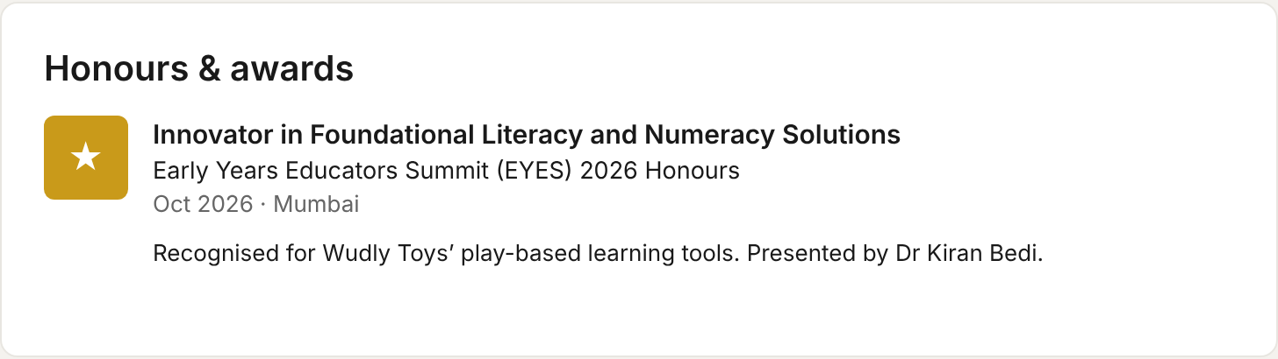
TEXT TO COPY
Innovator in Foundational Literacy and Numeracy Solutions
Early Years Educators Summit (EYES) 2026 Honours · Oct 2026 · Mumbai
Recognised for Wudly Toys’ play-based learning tools. Presented by Dr Kiran Bedi.

Skills
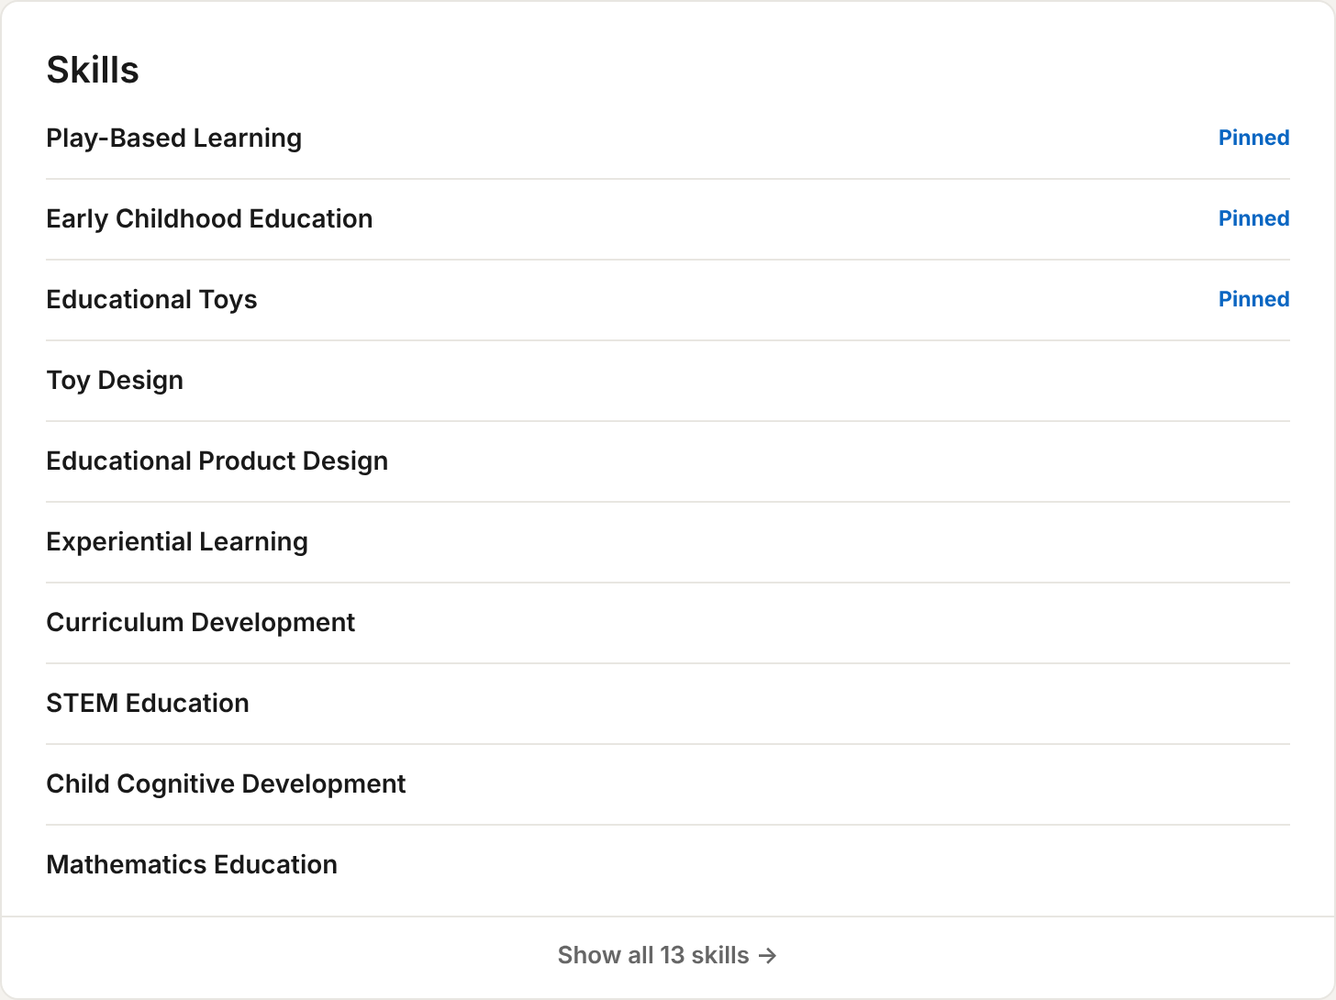
TEXT TO COPY
Pin the first three. The profile lists 13 skills in total; these are the 10 shown.
- Play-Based Learning (pinned)
- Early Childhood Education (pinned)
- Educational Toys (pinned)
- Toy Design
- Educational Product Design
- Experiential Learning
- Curriculum Development
- STEM Education
- Child Cognitive Development
- Mathematics Education

Languages
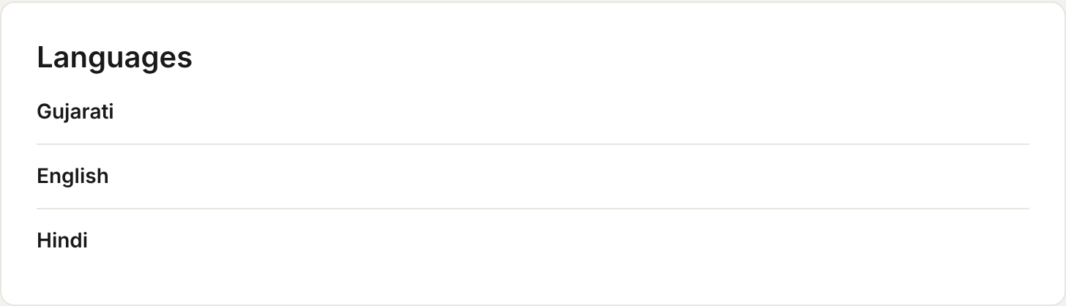
TEXT TO COPY
- Gujarati
- English
- Hindi

Public profile & URL
www.linkedin.com/in/dayapatel [if available]

What changed
- New cover banner with role, promise and the EYES 2026 award
- One clear headline that leads with Founder & Director, Wudly Toys
- About rewritten with a hook, the why, proof and a call to action
- New Featured row with the award post, website and an explainer
- Experience rewritten from her own stories, with teaching and volunteer roles added
- New Honours & awards section
- Skills cleaned up, with three pinned
- New Languages section

Details still needed
- IIM Ahmedabad Academic Associate: dates
- Mathematics Faculty: institution name and dates
- Volunteer Educator with Prof. V. L. Mote: dates
- M.Sc. Mathematics, MSU Baroda: years
- Featured post 3 (“Uber books”): post title
- Custom URL linkedin.com/in/dayapatel: check it is available

