Problem Definition :
Display event lists, student profiles, notices, or FAQs from external JSON files using Fetch API. Implement dynamic rendering, search, filter, sorting, and pagination.

A.Theory :

1. How is JSON fetched, parsed, and rendered?
JSON data is fetched using fetch(), parsed using the .json() method, and then rendered dynamically on the webpage by creating or updating DOM elements with the retrieved data.
2. Which array methods are used for search, filter, sort, and pagination?
Methods such as filter() are used to search and filter data, sort() is used to arrange data, and slice() can be used to implement pagination by displaying a specific set of items at a time.
3. How are loading and error states handled?
A loading message or indicator is displayed while the data is being fetched. If the request fails, an error message is shown to inform the user and provide appropriate feedback.
4. How is modularity maintained in JavaScript files?
Modularity is maintained by separating functionality into different JavaScript files or functions. Related tasks such as data fetching, DOM manipulation, filtering, and event handling are kept separate, making the code easier to understand, maintain, and reuse.

B.Output :
1.Announcements :
i. All Announcements :
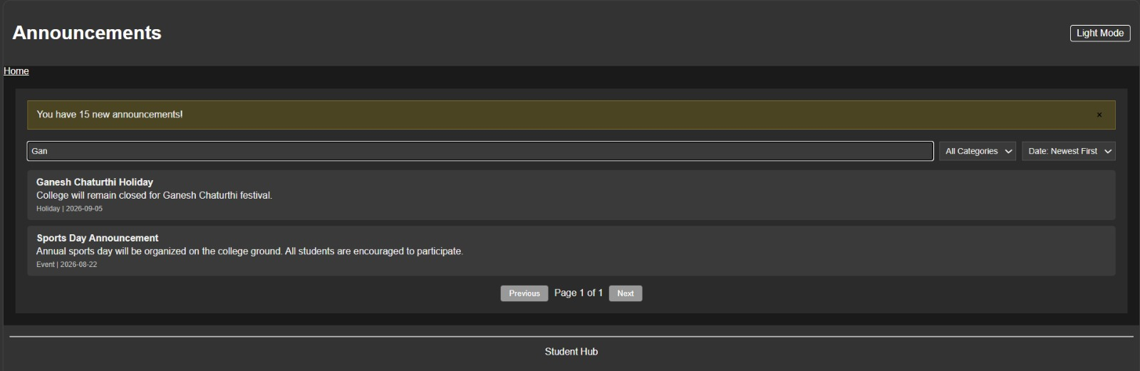

ii. Search Feature :
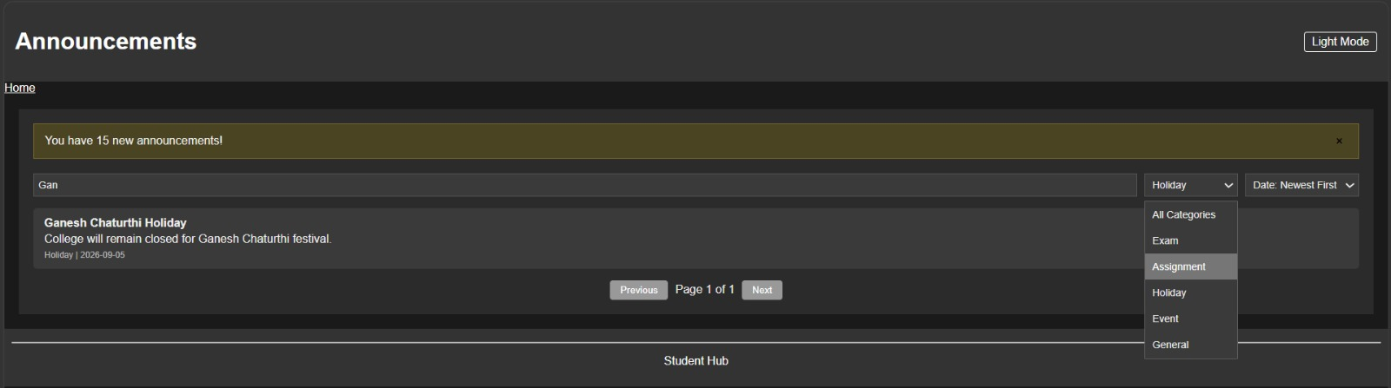

iii. Categorized Announcements :
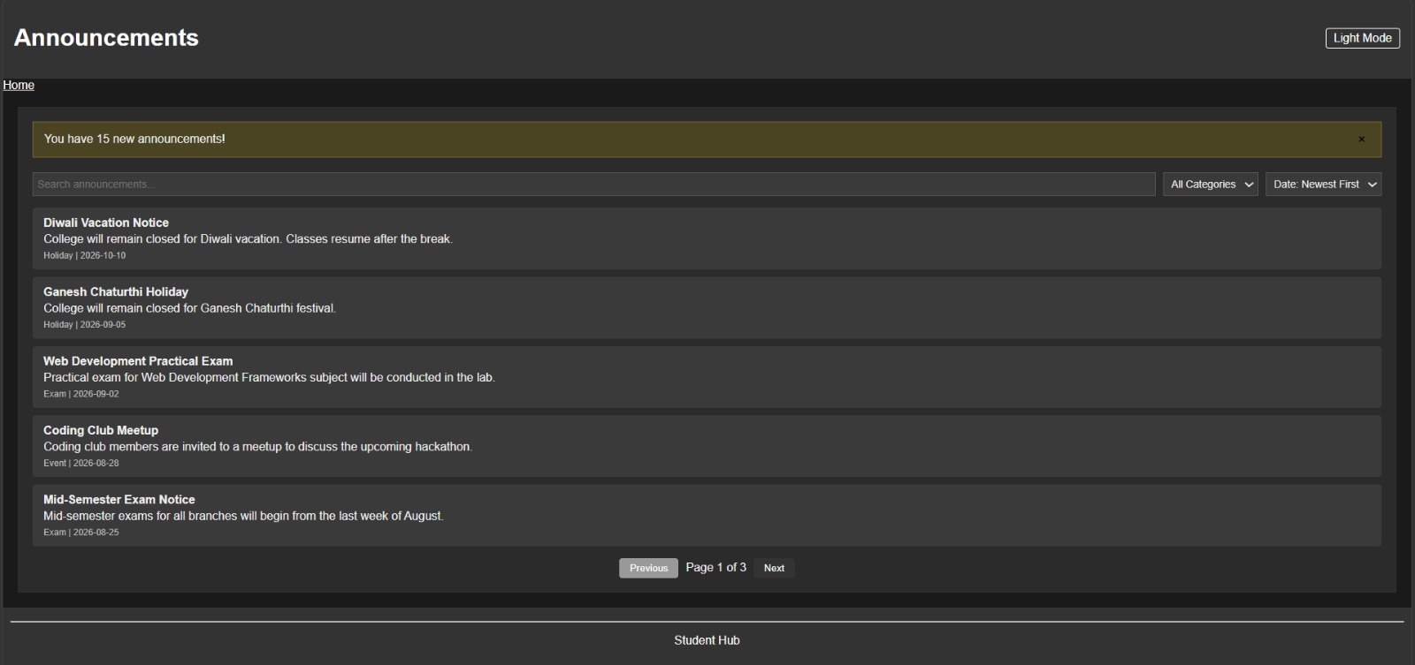

2. Assignment :

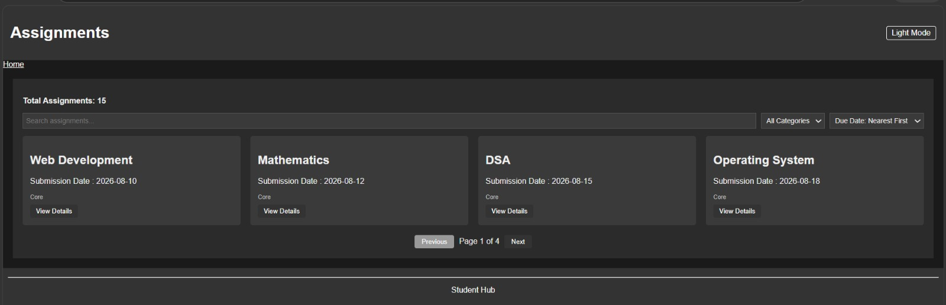

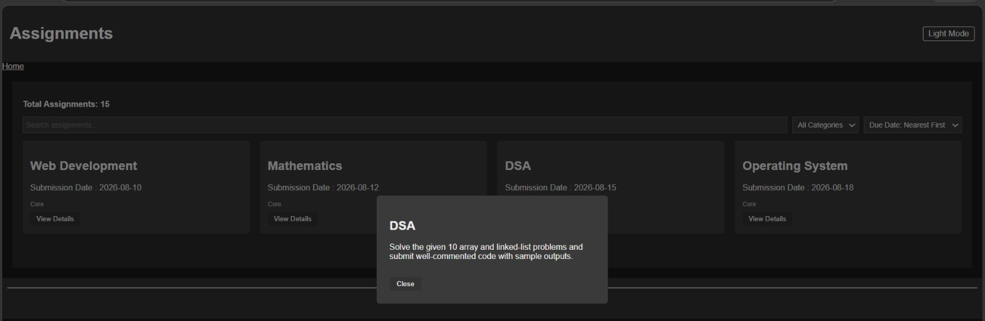

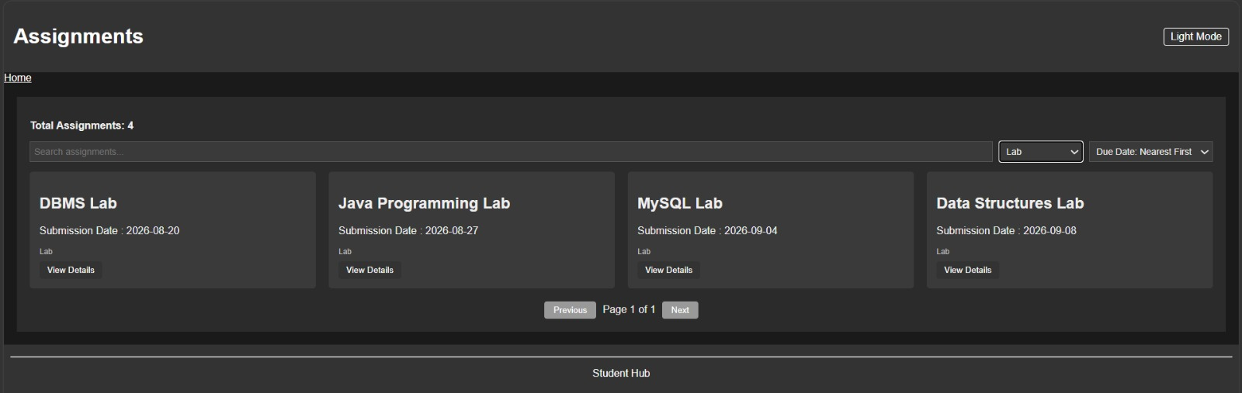
3. Attendance :
i. Theory Attendance :
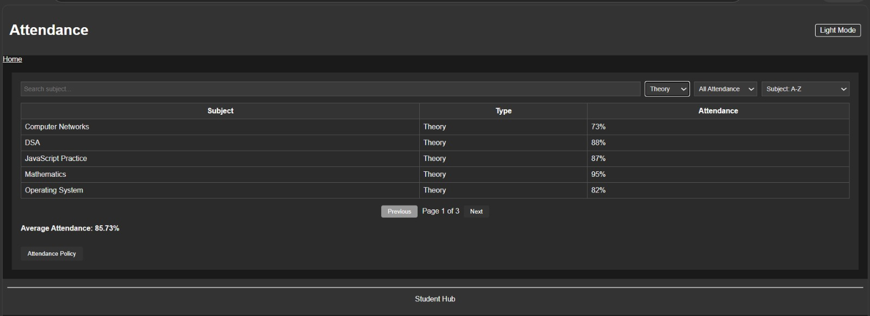

ii. Lab Attendance :

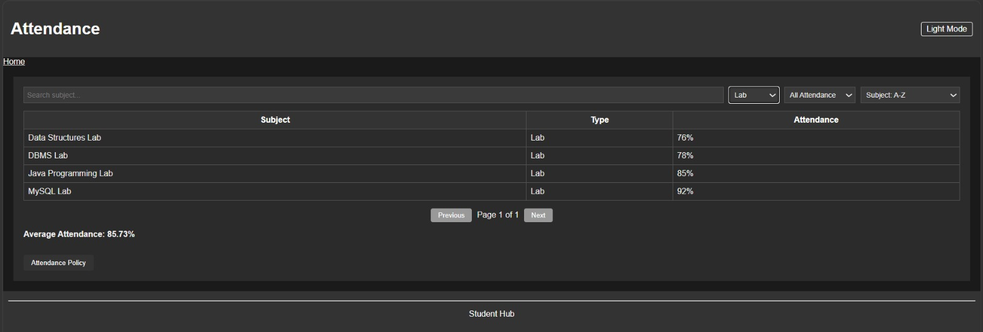

iii. Below 75% :

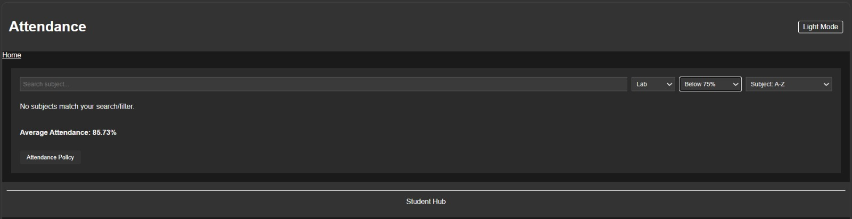

iv. Above 75% :

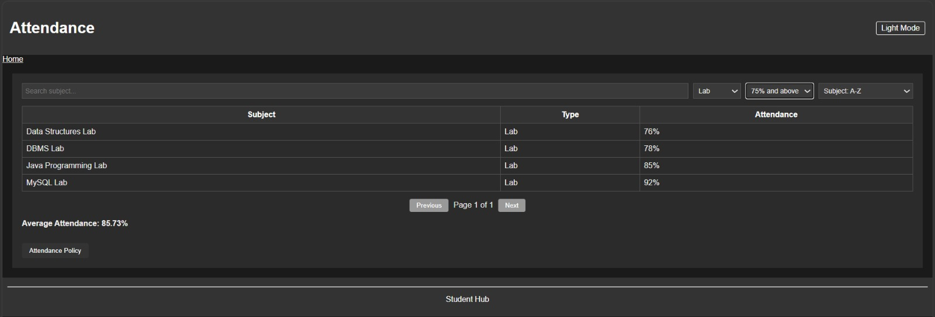

C.Learning Outcome :
Learned to separate content from structure by storing data in JSON and rendering it dynamically with fetch()
Learned to use array methods (.filter(), .sort(), .slice()) together to build search, filter, sort, and pagination
Understood asynchronous loading — handling "loading" and "error" states while waiting for data.
Github Repository :
https://github.com/Shreyansh2210/Web-Devlopment

Faculty Remarks :

