Problem Definition :
Add dynamic UI components such as collapsible FAQ, modal popup, image/content slider, notification banner, hamburger menu, and light/dark theme switcher using JavaScript.
A.Theory :
1. How are DOM elements selected and modified?
DOM elements are selected using methods such as getElementById(), querySelector(), and querySelectorAll(). They can then be modified by changing their textContent, innerHTML, style, attributes, or CSS classes using methods such as classList.add() and classList.remove().
2. Are event listeners attached correctly?
Yes. Event listeners should be attached using addEventListener(). This allows actions such as clicks, form submissions, and keyboard interactions to trigger JavaScript functions without using inline event handlers.
3. Is localStorage used for remembering theme choice?
Yes, localStorage can be used to save the user's selected theme. The theme is stored in the browser and retrieved when the page loads, allowing the user's preference to persist between visits.
4. Does interactivity improve usability without breaking accessibility?
Yes, when implemented correctly. Interactive features should provide clear visual feedback, support keyboard navigation, use appropriate semantic HTML, and maintain sufficient color contrast. This allows the interactivity to improve usability while remaining accessible to users with different needs.

B.Output :
1.Index :
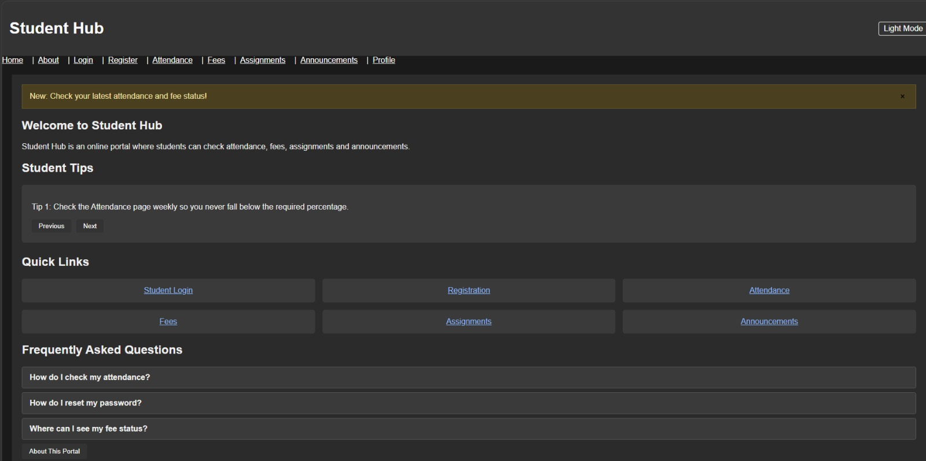

2.About :


3.Login :
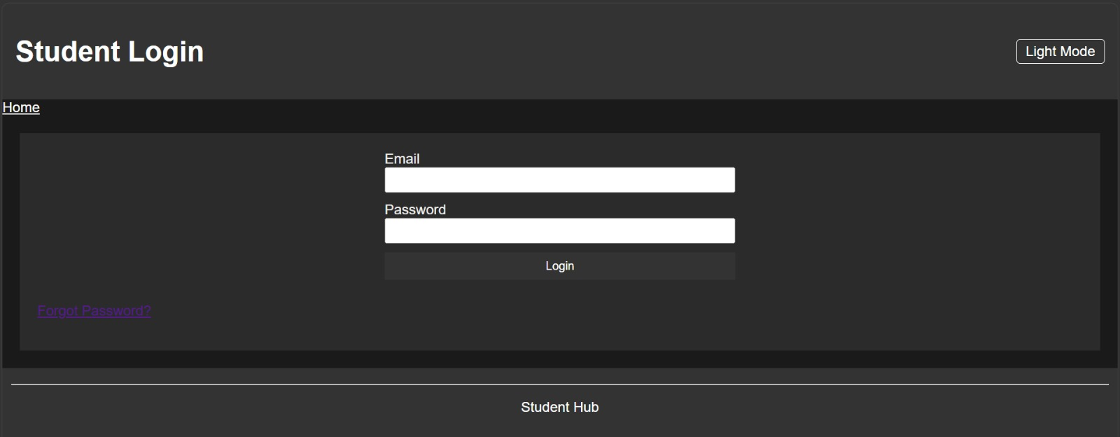

4.Register :
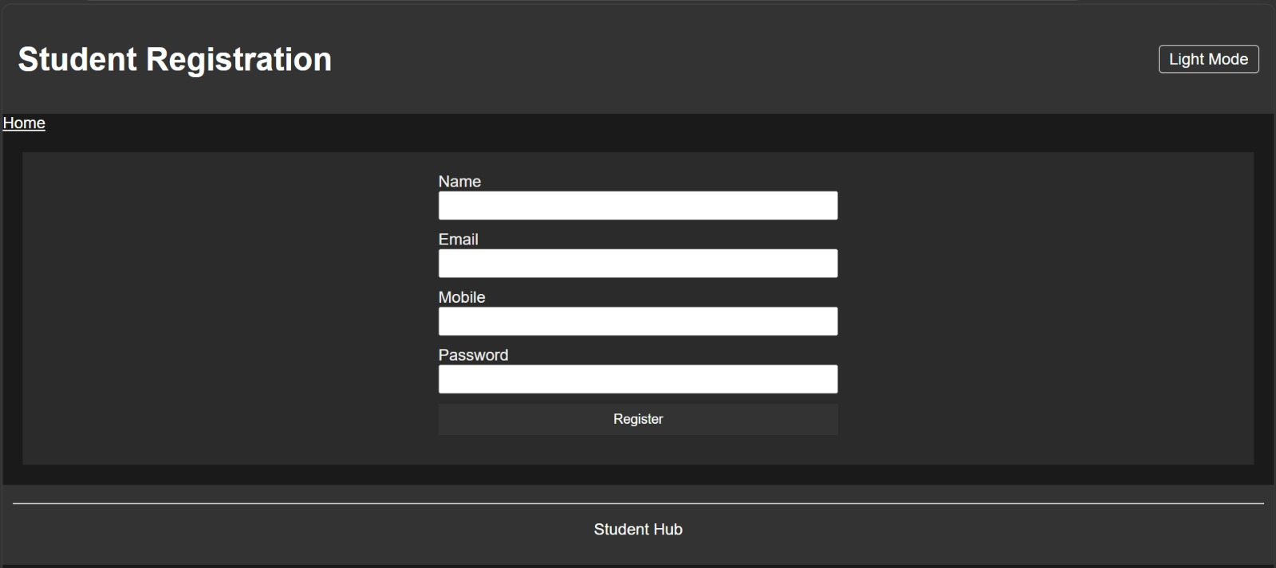

5.Attendance :
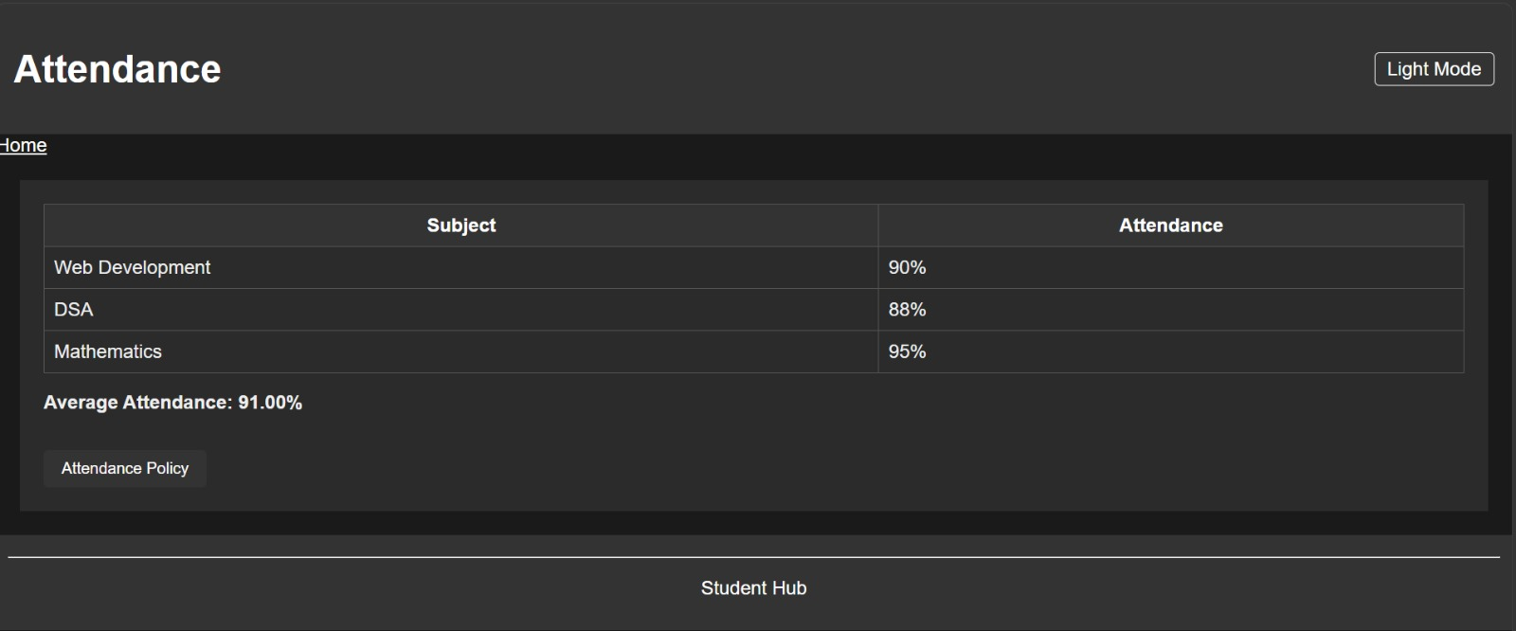

6.Fees :
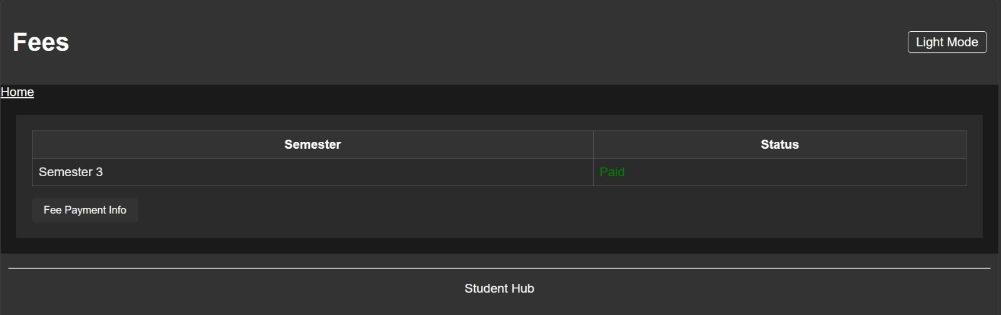

7.Assignments :

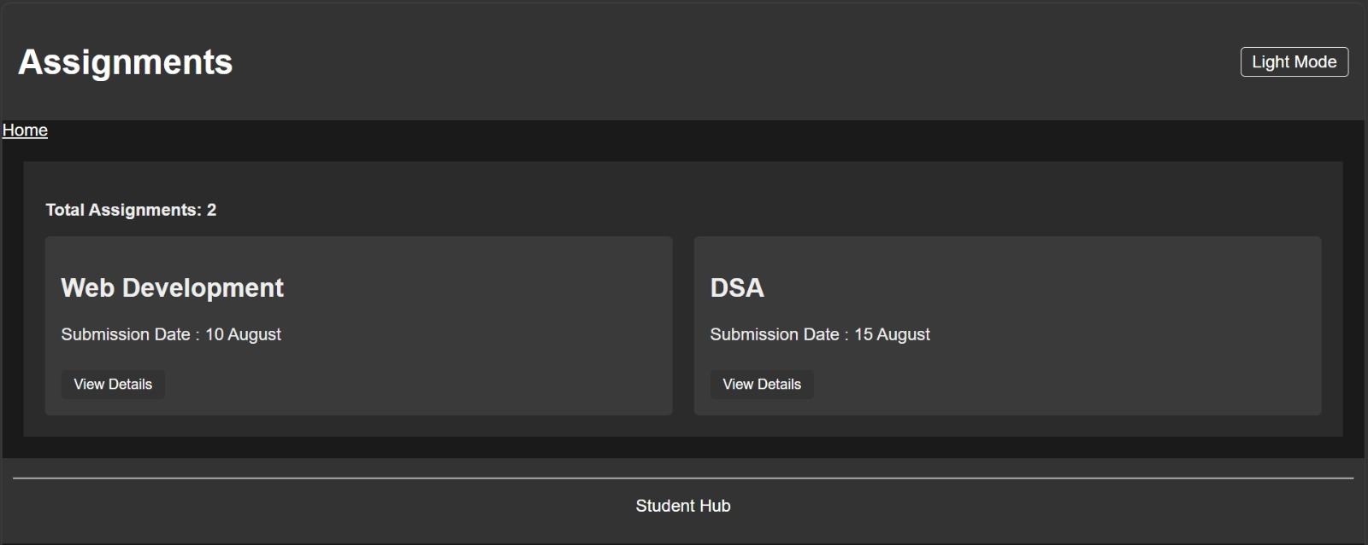

8.Announcements :
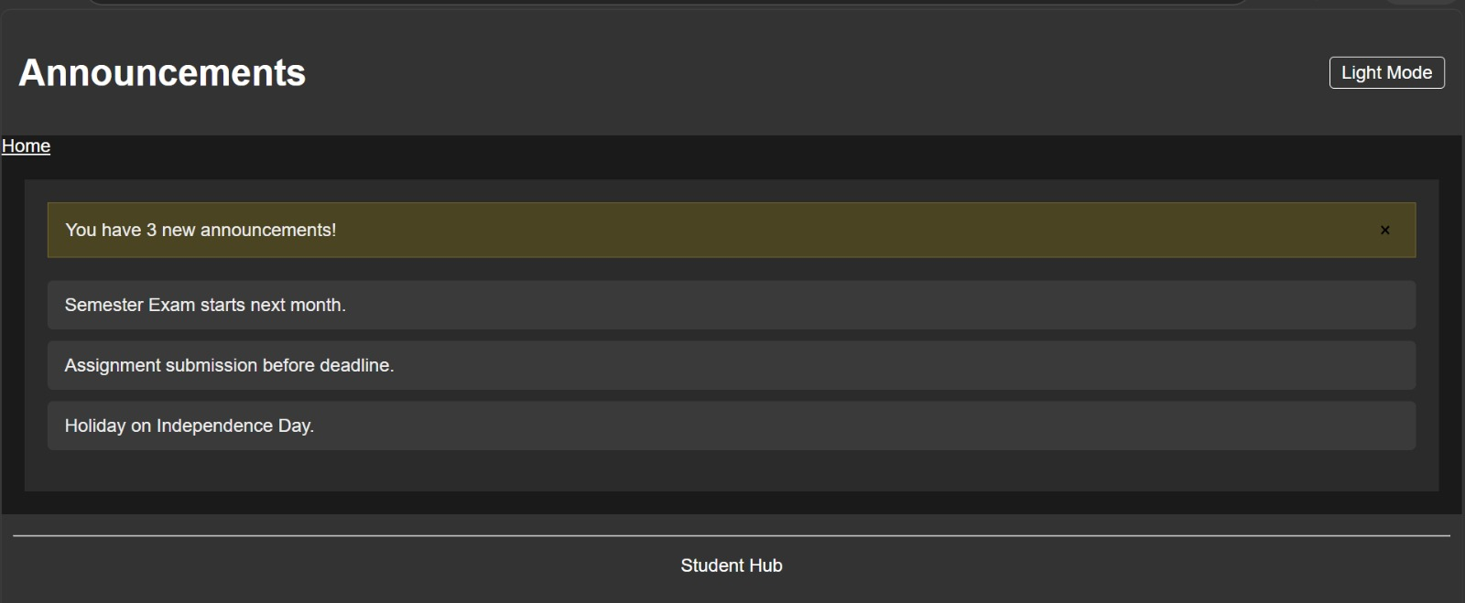

9.Profile :
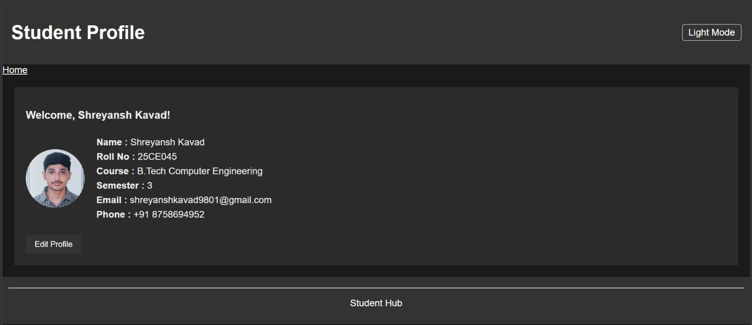

Learning Outcome
Learned to select and manipulate DOM elements with addEventListener(), classList.toggle(), and getElementById() (hamburger menu, theme switcher, modals)
Learned to use localStorage to remember a user's choice (dark/light theme) across page reloads
Understood how JS can update page content and UI state without reloading the page
Github Repository :
https://github.com/Shreyansh2210/Web-Devlopment

Faculty Remarks :

