Problem Definition :
Process submitted registration/contact form data using PHP. Validate and sanitize inputs on the server side and store records in CSV or JSON file format. Display success/error messages.

A.Theory :
1. Is the form submitted using POST?
Yes. The form should be submitted using the POST method so that form data is sent securely to the server without appearing in the URL.
2. Are inputs validated and sanitized server side?
Yes. All user inputs should be validated and sanitized on the server side before processing or storing them. This helps prevent invalid data and security issues such as injection attacks.
3. Is file writing handled safely?
Yes. File writing should be handled carefully by validating file names and paths, restricting file permissions, and preventing unauthorized access or overwriting of important files.
4. Are success and error responses displayed clearly?
Yes. Clear success and error messages should be displayed after form submission. Users should be informed whether their request was completed successfully or if they need to correct something.

B.Output :
1. XAMMP :
i. Local Host : 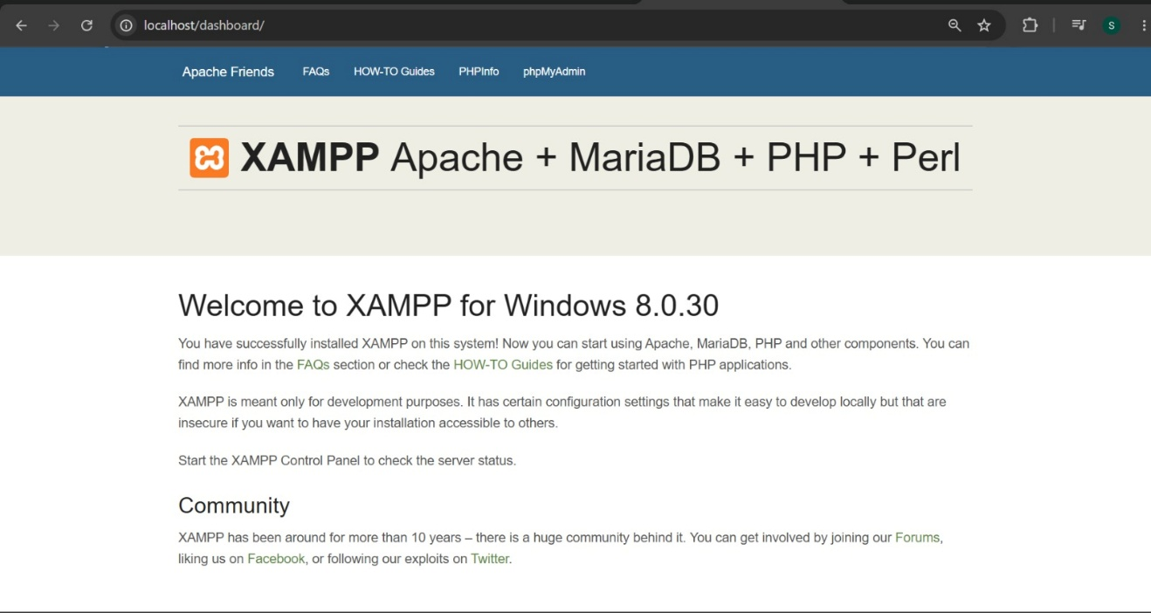

ii. Register Via Live Server :

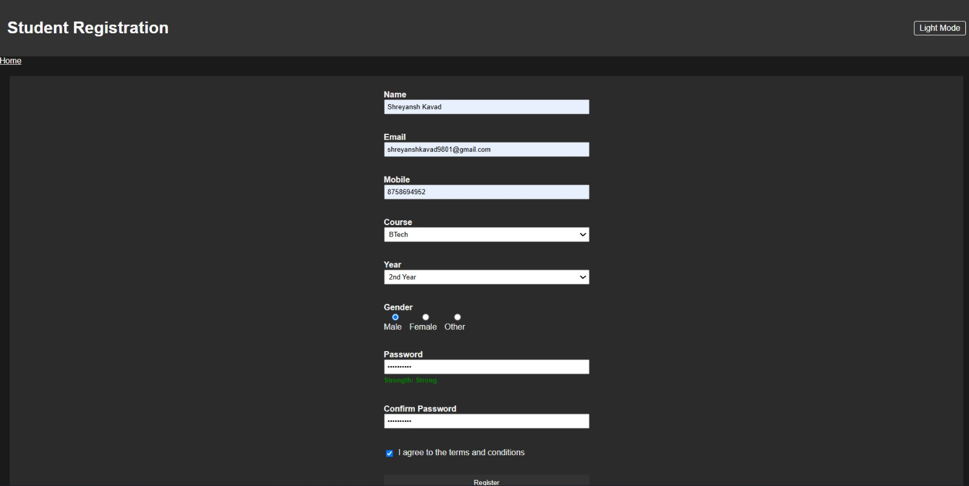

iii. Register Form Response :
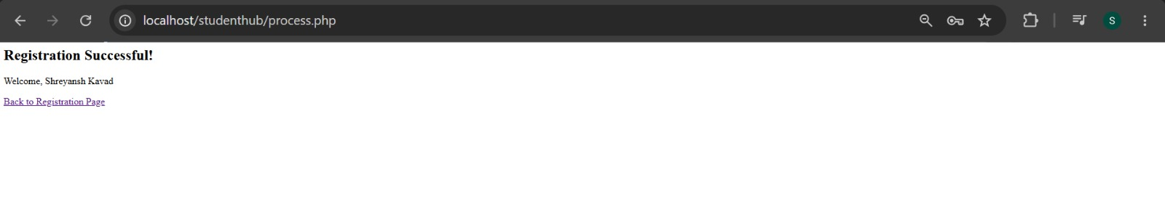

2. Submission File Created :

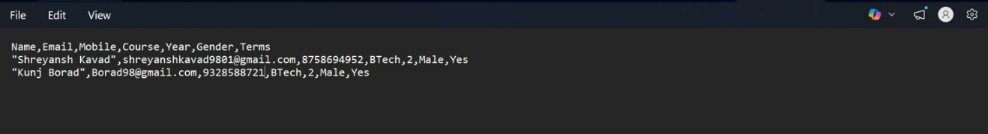

C.Learning Outcome :
Learned that server-side validation is required even when client-side validation exists, since JS can be bypassed
Learned to handle POST data in PHP using $_POST[], and to sanitize input with htmlspecialchars()
Learned to persist data outside the browser for the first time, by writing to a CSV file on the server using fopen()/fputcsv() .
Github Repository :
https://github.com/Shreyansh2210/Web-Devlopment

Faculty Remarks :

