Problem Definition :
Design responsive layouts for Home, About, Registration, Dashboard, and Events pages using CSS Grid and Flexbox. Optional to use CSS framework such as Bootstrap or Tailwind. Ensure mobile-first responsiveness.

A.Theory :
1. How does the layout adapt for mobile, tablet, and desktop screens?
- The layout is designed to adjust according to different screen sizes.
- On mobile screens, content is arranged in a simple single-column layout.
- On tablets, the content gets more space while maintaining proper alignment.
- On desktop screens, multiple sections can be displayed side by side.
- This makes the website responsive and user-friendly on all devices.

2. Which layout technique is used and why?
- CSS Flexbox is used to arrange the main elements of the webpage.
- Flexbox makes it easy to align and distribute elements properly.
- It automatically adjusts the layout according to available screen space.
- Media queries can be used to change the layout for smaller screens.
- This technique keeps the design simple, flexible, and responsive.

3. Are typography, spacing, colors, and contrast readable?
- Yes, the typography is clear and easy to read.
- Proper spacing is maintained between headings, paragraphs, and sections.
- Colors are selected to provide good visibility and readability.
- Sufficient contrast is maintained between text and background.
- Overall, the design provides a comfortable reading experience.

4. Is the framework used consistently without unnecessary inline CSS?
- Yes, the framework and its classes are used consistently throughout the website.
- Common styles are applied using reusable CSS classes.
- Unnecessary inline CSS is avoided wherever possible.
- This keeps the HTML code clean, organized, and easier to maintain.
- Consistent framework usage also helps maintain the same design across pages.

B.Output :
1.Index :
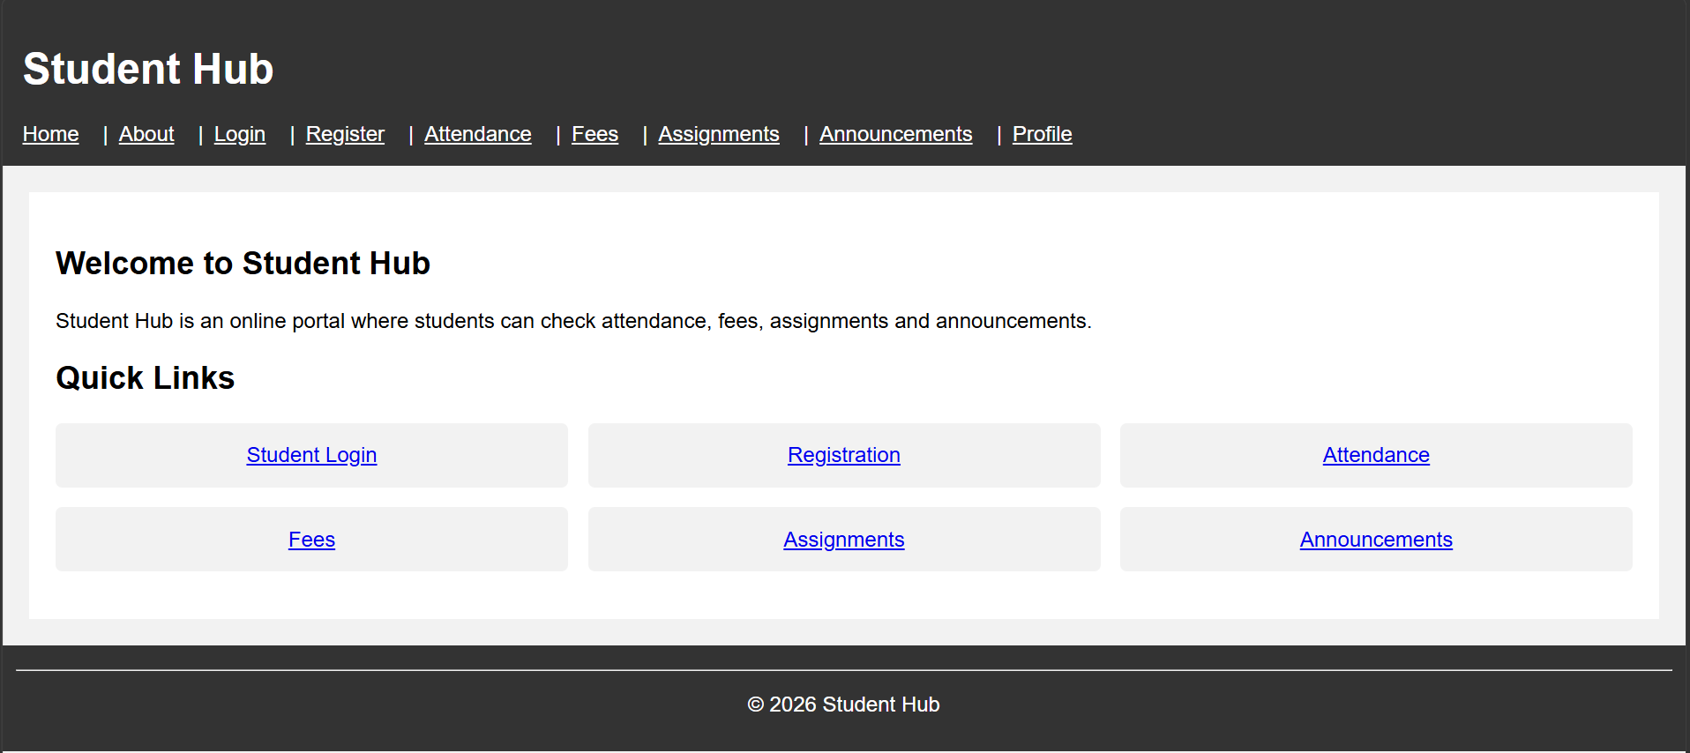
2.About :
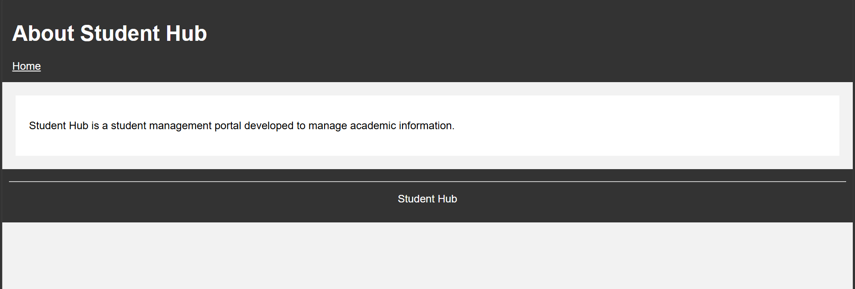

3.Login :
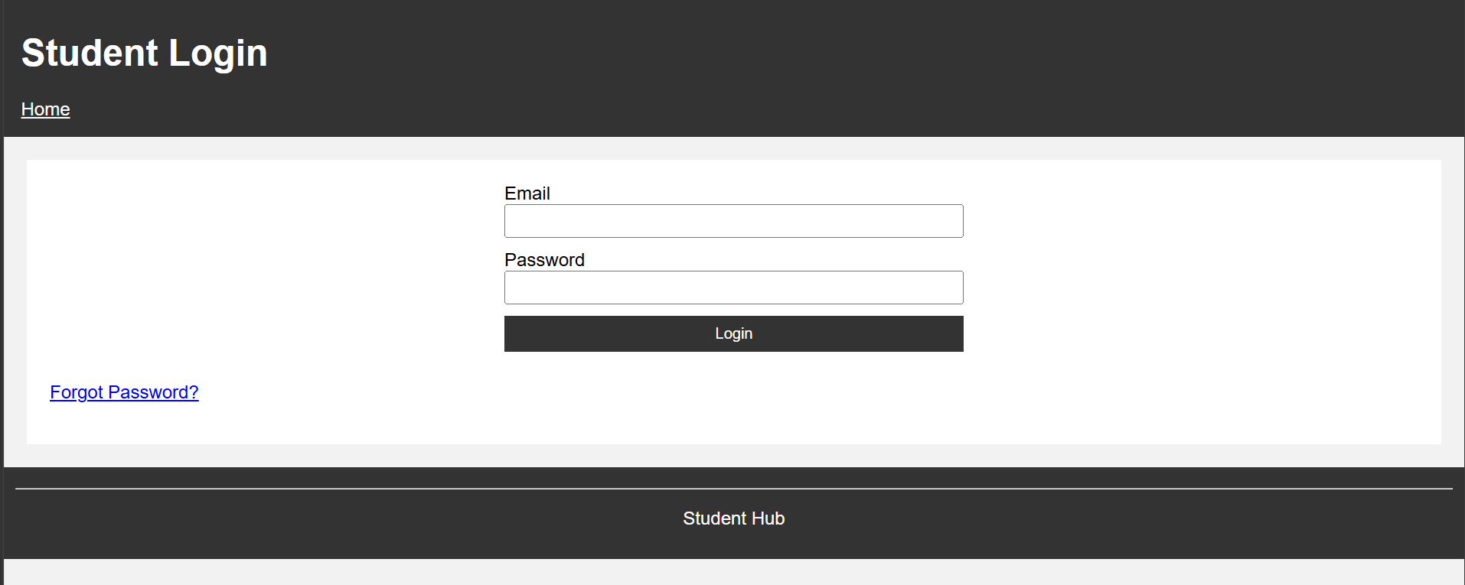

4.Register :
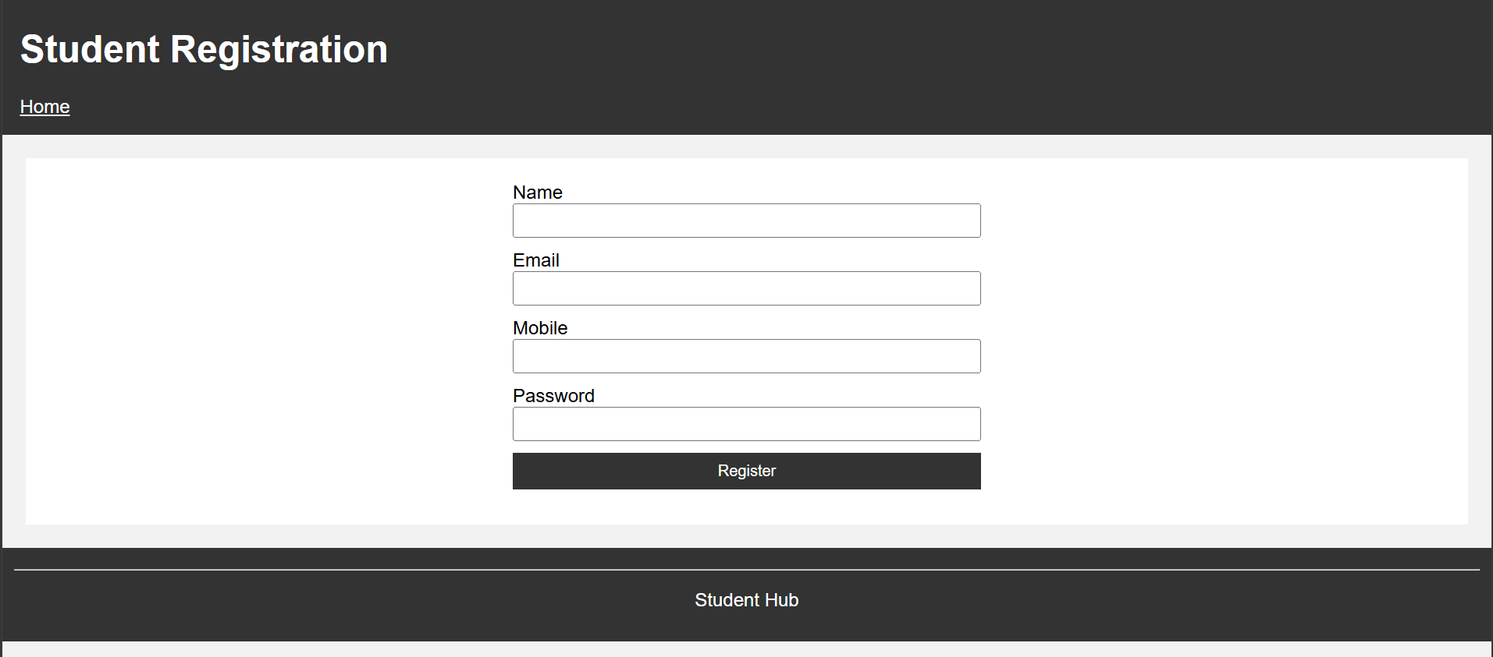

5.Attendance :
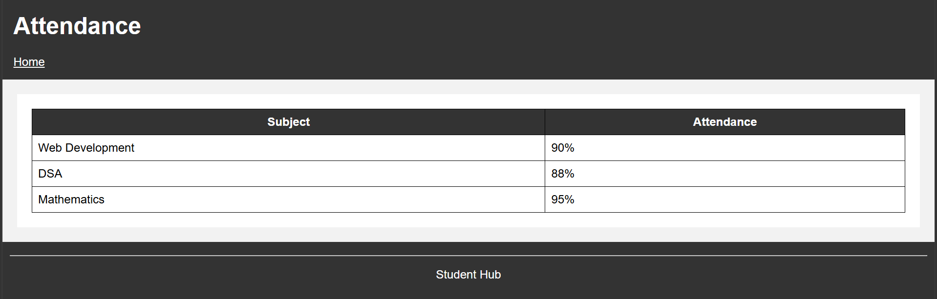

6.Fees :
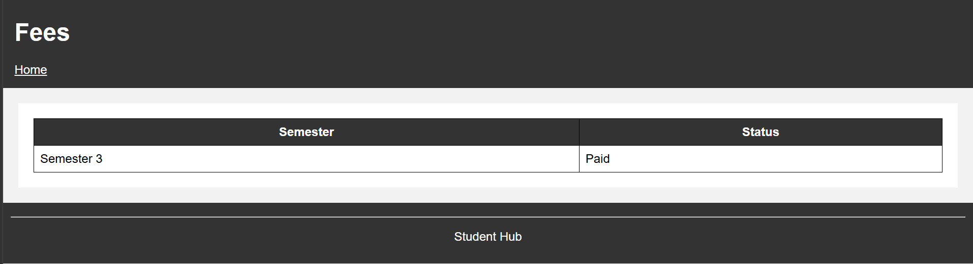

7.Assignments :
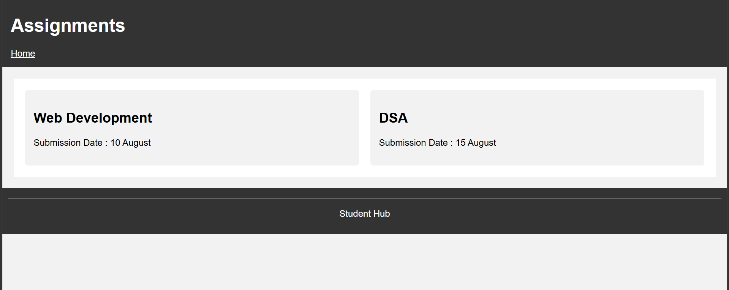

8.Announcements :
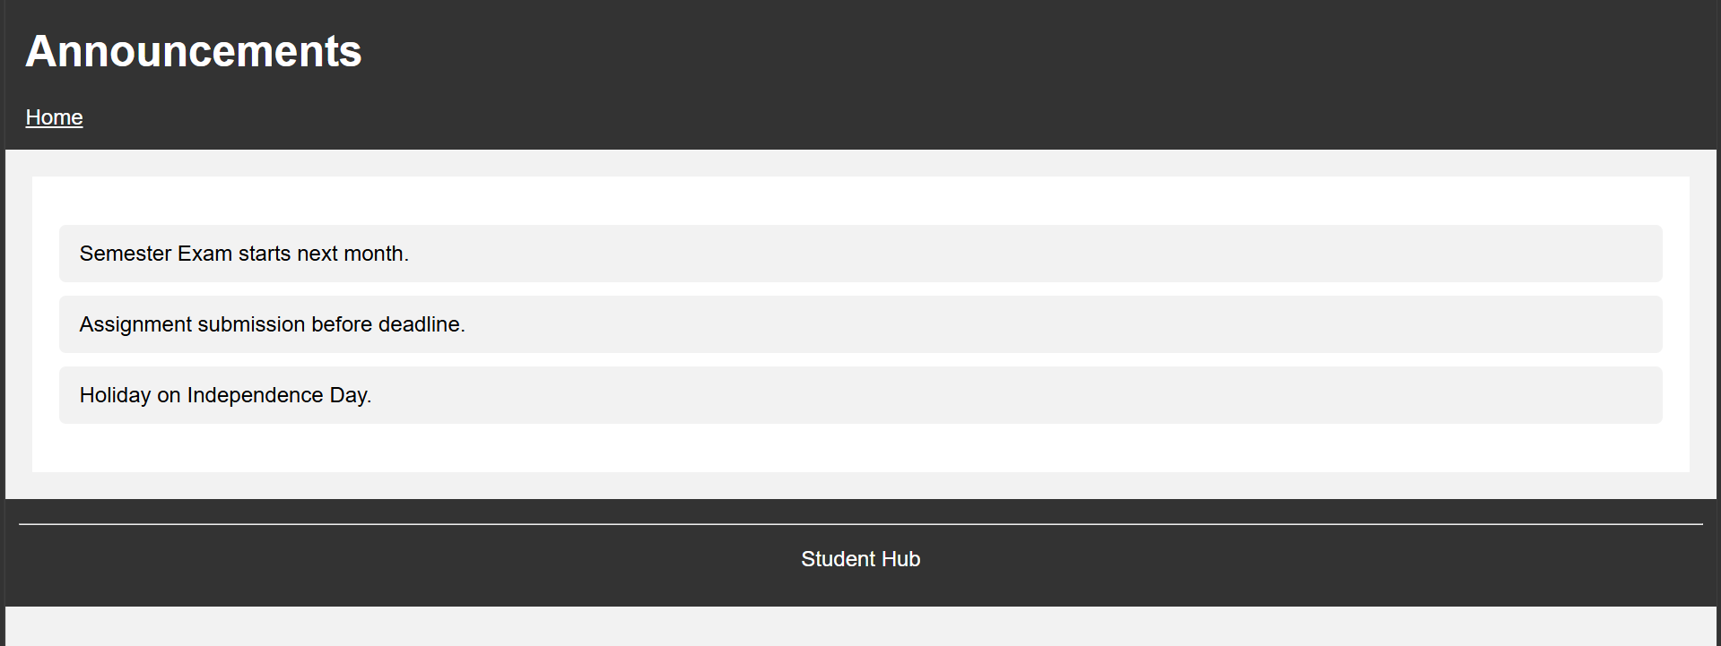

9.Profile :

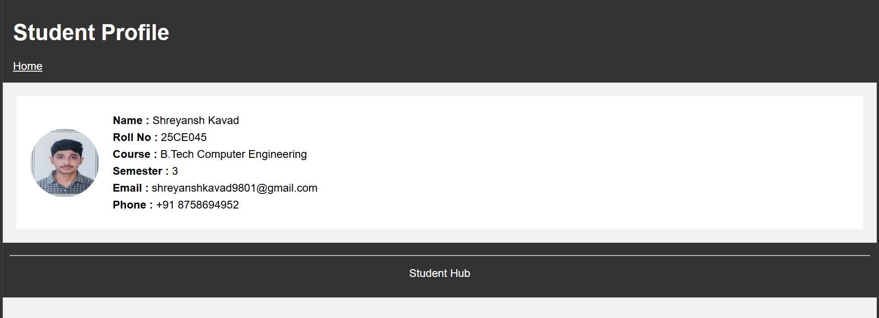

10.Forget password :
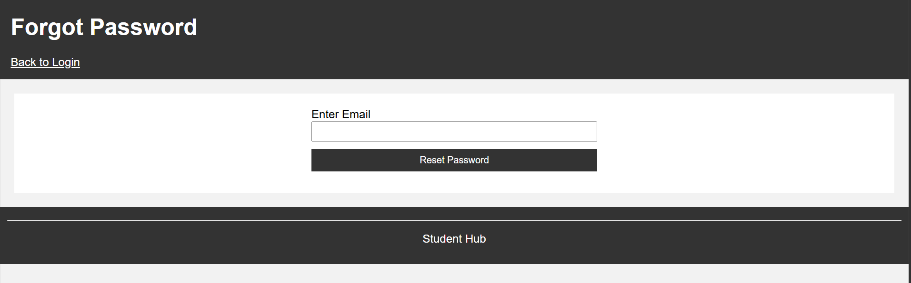

Learning Outcome
- Learned how to create responsive web pages using CSS Grid and Flexbox.
- Understood the mobile-first approach and how layouts adapt to different screen sizes.
- Gained experience in designing consistent layouts for Home, About, Registration, Dashboard, and Events pages.
Challenges Faced
- Adjusting the layout to work properly on mobile, tablet, and desktop screens.
- Managing spacing, alignment, and element sizes using Grid and Flexbox.
- Maintaining a consistent design across all pages while keeping the code simple and organized.
Github Repository :
https://github.com/Shreyansh2210/Web-Devlopment

Faculty Remarks :

