Problem Definition :
Develop static HTML5 skeletons for at least 10 StudentHub pages such as Home, About, Register, Login, Dashboard, Events, Profile, Contact, Admin, FAQ, and Feedback. Use semantic tags and accessibility-friendly structure
Questions :
1. Are semantic tags such as header, nav, main, section, article, aside, and footer used properly?
Answer :
Yes, semantic HTML tags are used properly to organize the webpage.
<header> is used for the top section, such as the website title and logo.
<nav> is used for navigation links between different pages.
<main>, <section>, and <article> are used to organize the main content.
<aside> and <footer> are used for additional information and bottom-page content.

2. Are form labels, headings, image alt text, and navigation links accessible?
Answer :
Yes, form fields have clear and meaningful <label> elements.
Headings are arranged properly using <h1>, <h2>, <h3>, etc.
Images include suitable alt text to describe their content.
Navigation links have clear names that explain where they lead.
These features make the website easier to use for all users, including users with disabilities.

3. Is the page structure consistent across all pages?
Answer :
- Yes, the overall page structure is consistent across all pages.
- The header and navigation menu remain in the same position.
- Similar pages use the same heading and content organization.
- The footer is also placed consistently at the bottom of each page.
- This consistency makes the website easy to understand and navigate.

Output :

  - Index :
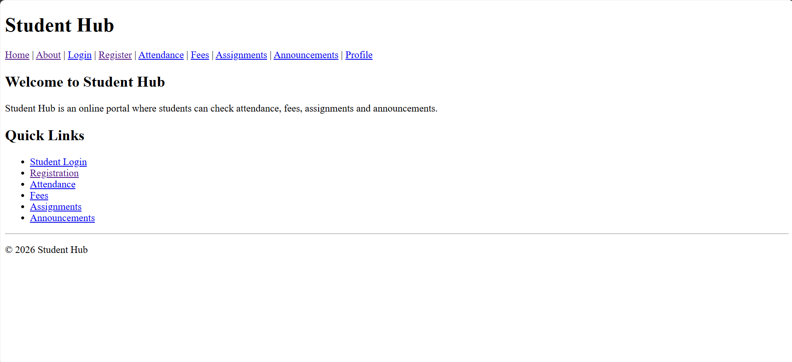

  - About :
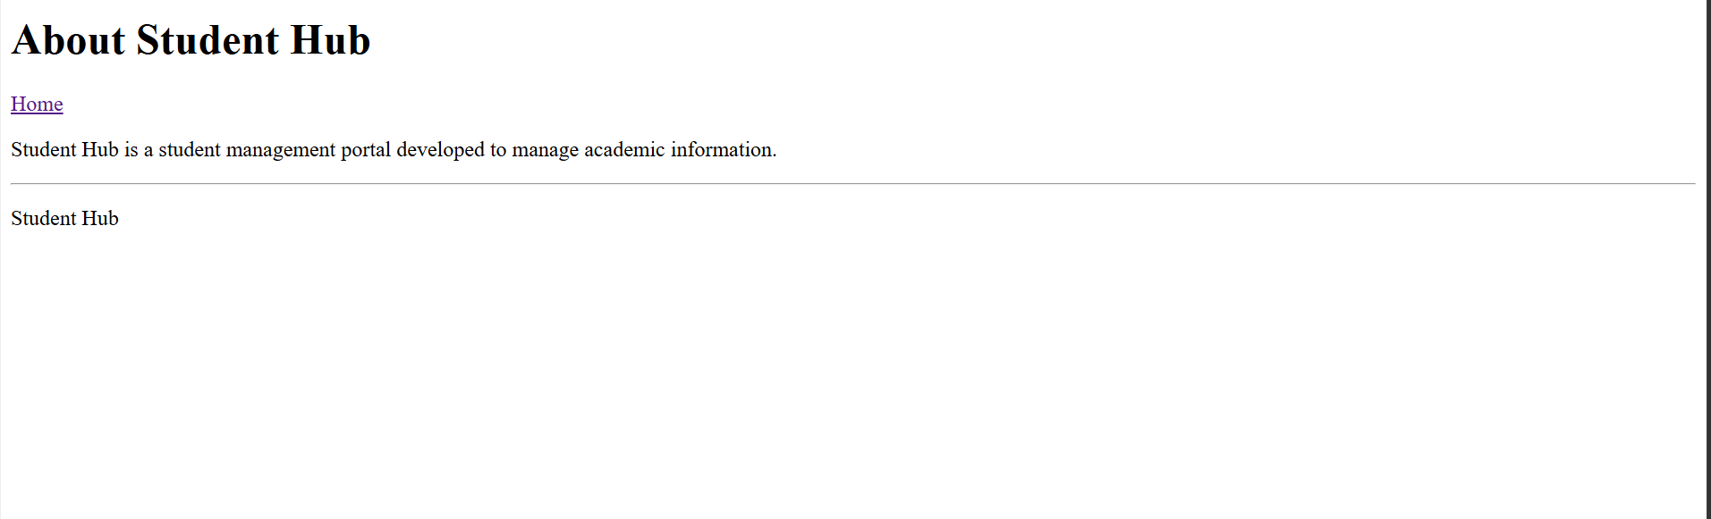

3.Login :
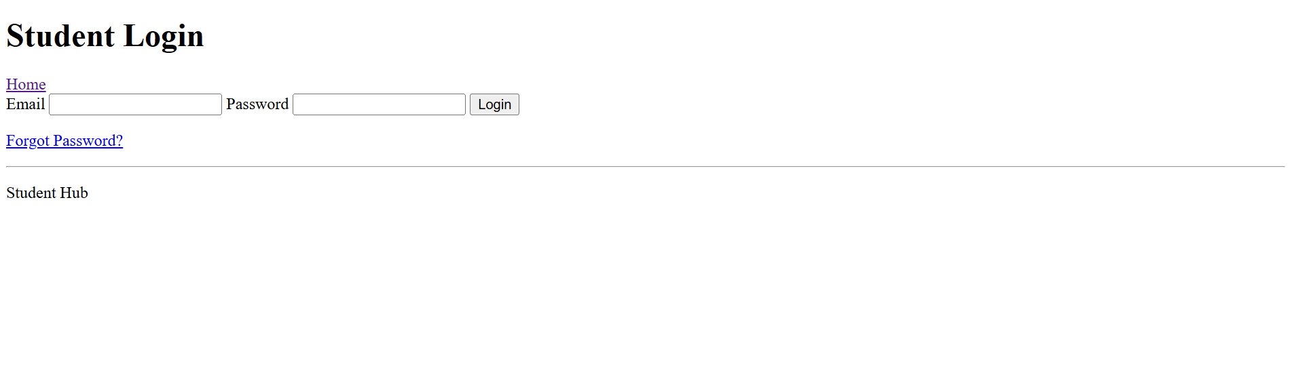

4.Forget Password :
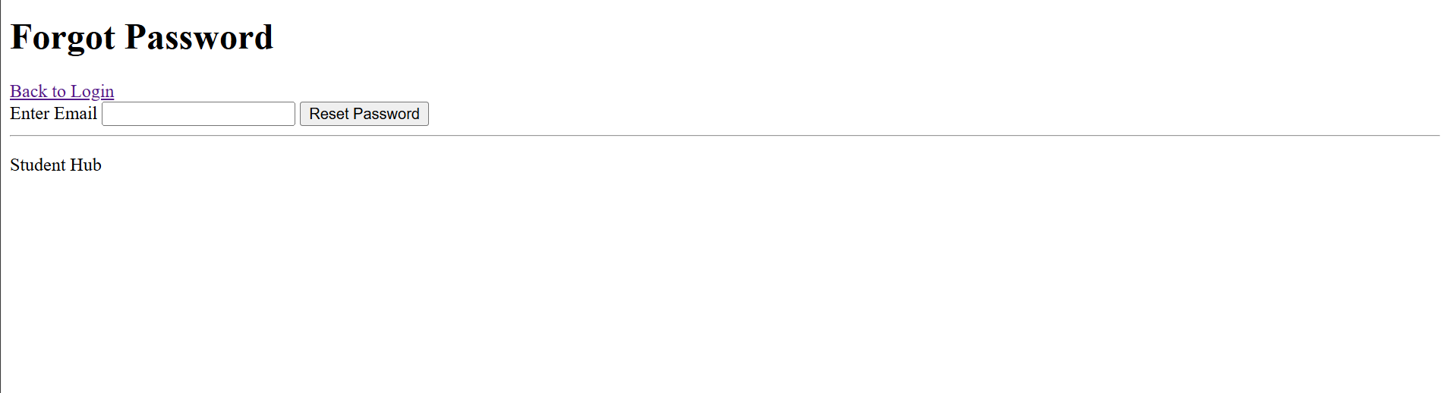

5.Register :
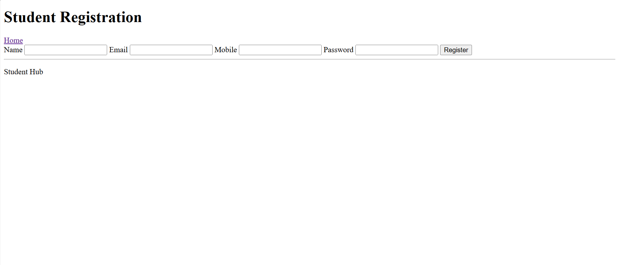

6.Attendance :
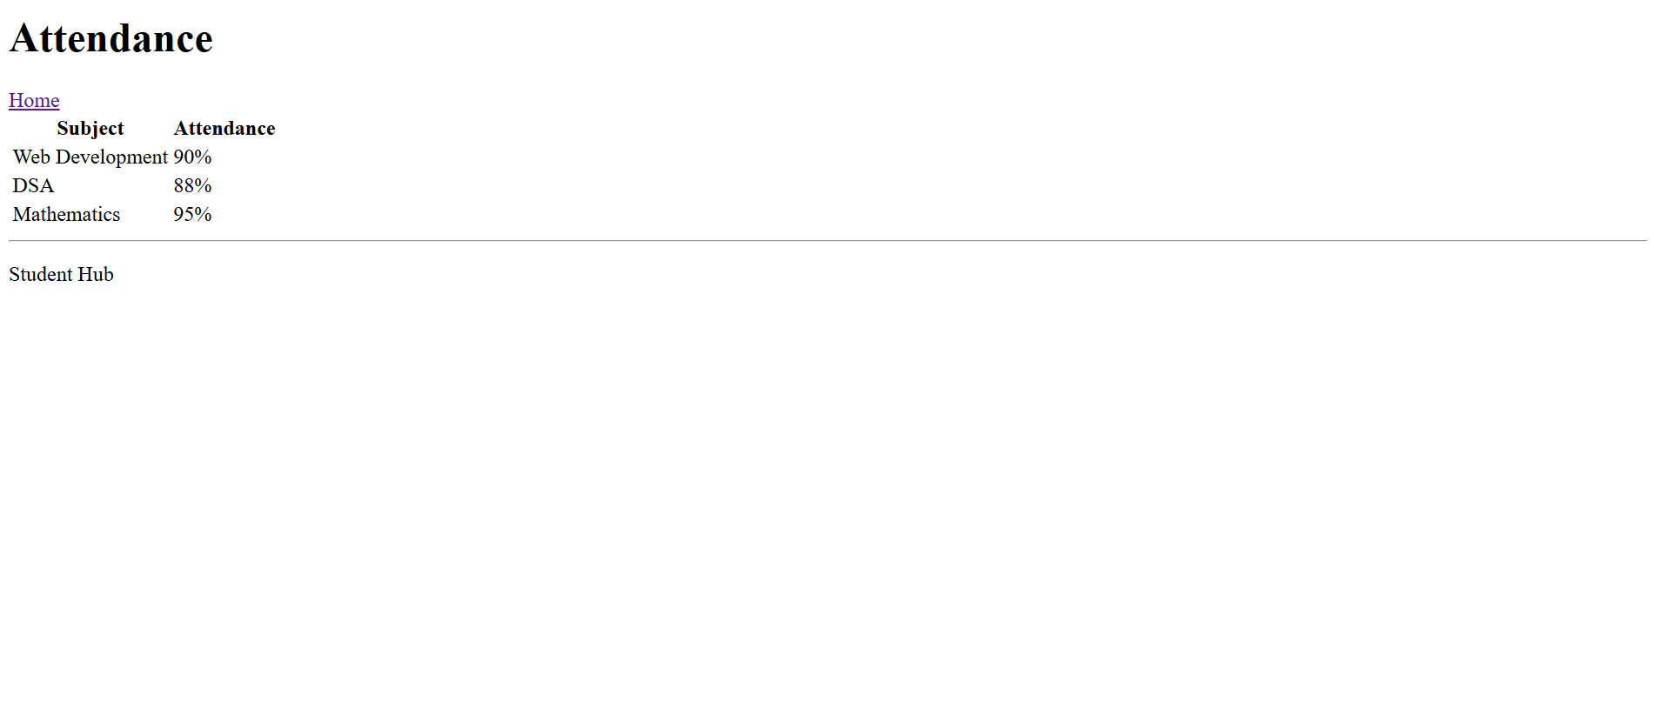

7.Fees :
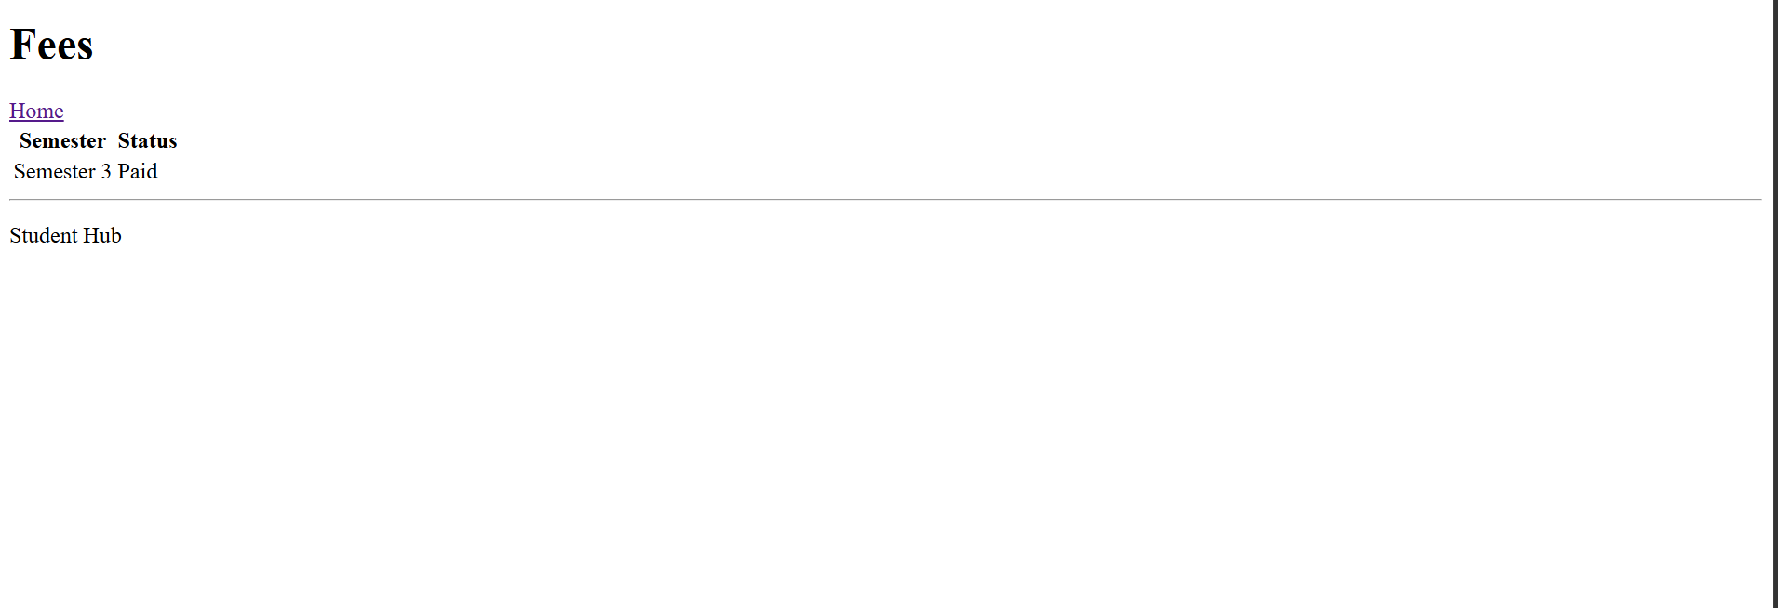

8.Assignments :
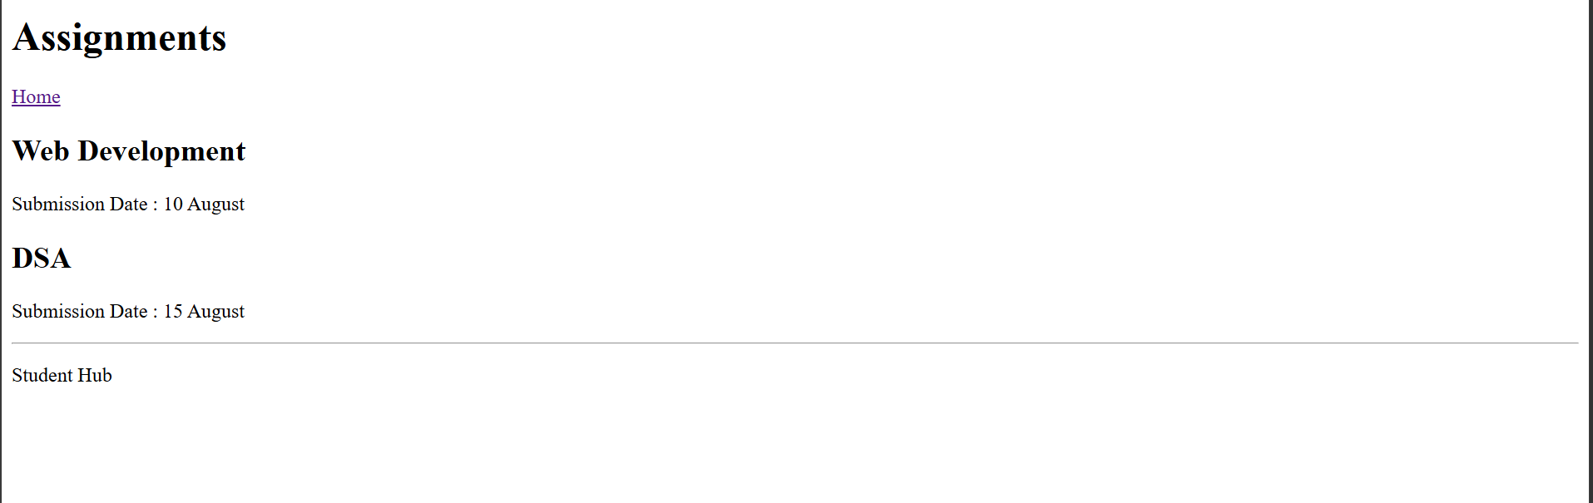

9.Announcements :
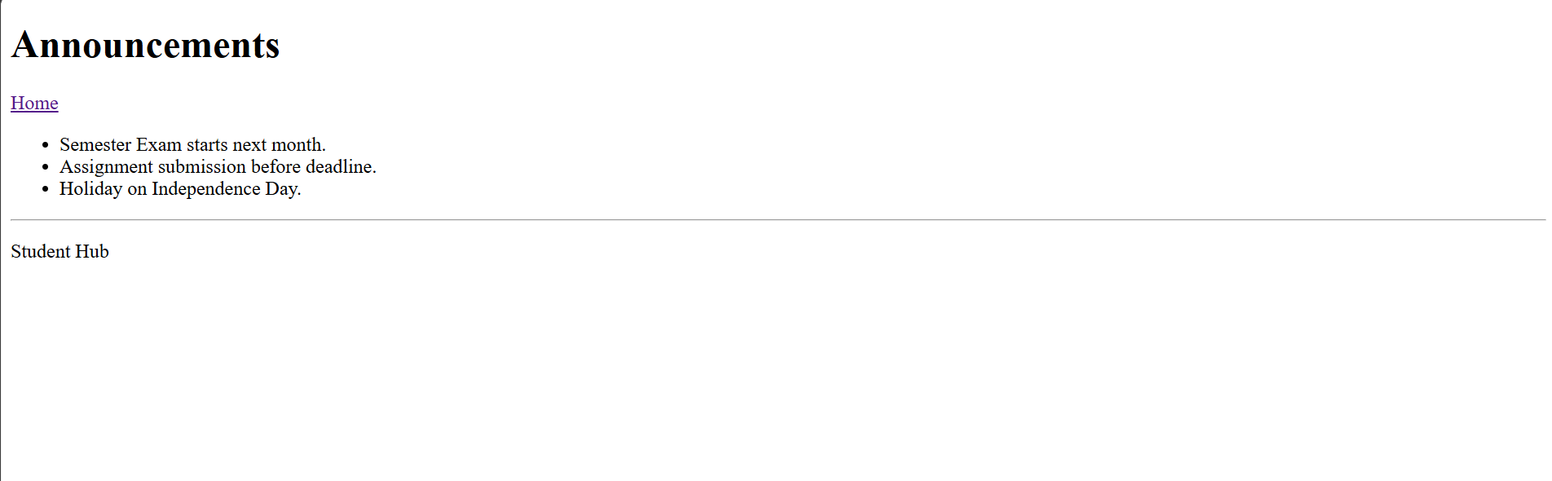

10.Profile :
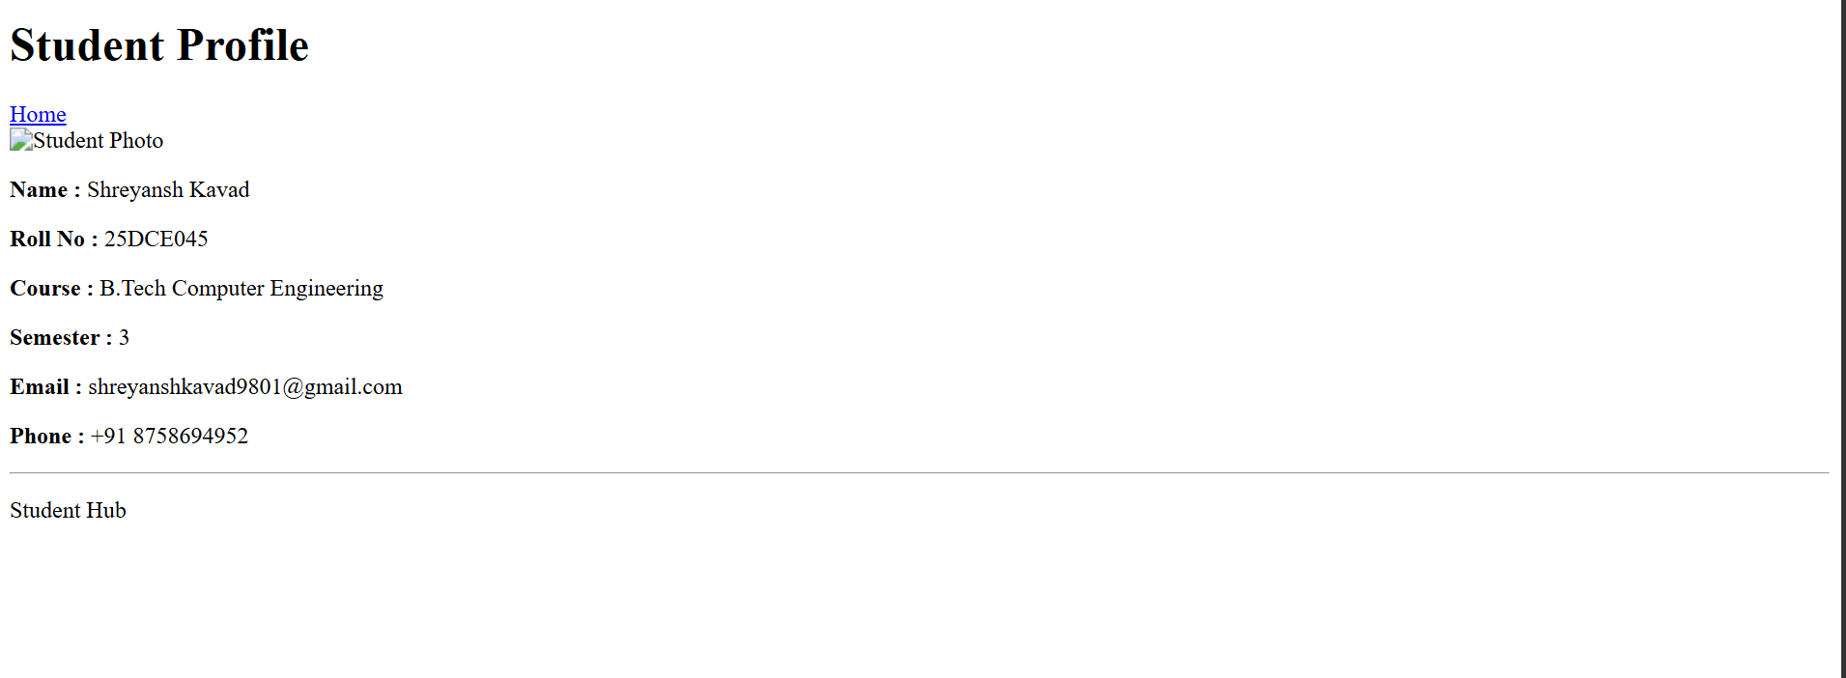

Repository Link :
https://github.com/Shreyansh2210/Web-Devlopment

Faculty Remark

