SwarmSort
Real-Time Waste Detection with PSO-Tuned YOLOv8

Project Report
Soft Computing, Semester V, Unit V: Swarm Intelligence
Submitted by
Shreyansh Jain
[Roll No.]
[Department / College]
Under the guidance of
[Guide / Faculty]
[Date]

Abstract
Segregating household waste at source into wet and dry streams is required in India, but it is still done by hand and often done badly. SwarmSort is a real-time detector that finds waste items in a photo, assigns each one to one of six classes (biodegradable, cardboard, glass, metal, paper and plastic) and tells the user which bin it belongs in. It is built on the single-stage YOLOv8n detector. The soft-computing part of the project is a hand-written Particle Swarm Optimiser (PSO) that tunes six training hyperparameters of the detector. To judge PSO fairly, three arms were compared under identical conditions: Ultralytics' default hyperparameters (A), random search (B) and PSO (C), where B and C each had the same budget of 32 short proxy trainings. The public dataset (10,464 images) was first re-split, because its provided folders were split by class. On the proxy, both searches beat the defaults (PSO 0.495 and random search 0.500 validation mAP@50, against 0.476 for the defaults), and the PSO swarm clearly converged. After full 100-epoch training, however, the three models scored 0.676 (A), 0.672 (B) and 0.668 (C) test mAP@50, and paired bootstrap confidence intervals show that none of the differences is statistically significant. The honest conclusion is that the default hyperparameters were already close to optimal for this dataset. The contribution of the project is a controlled, reproducible comparison with an untouched test set, together with a working demo app that runs at about 31 ms per image on a laptop CPU.
Keywords: particle swarm optimisation, hyperparameter tuning, YOLOv8, object detection, waste segregation, bootstrap.

Table of Contents
Abstract 1
1 Introduction 5
1.1 Problem statement 5
1.2 Objectives 5
1.3 Contributions 5
2 Background and Literature Review 5
2.1 Base paper 5
2.2 YOLO object detectors 6
2.3 Hyperparameter optimisation 7
2.4 Particle Swarm Optimisation 7
3 Theory: Particle Swarm Optimisation 8
3.1 Update equations 8
3.2 Inertia schedule, velocity clamp and boundary handling 9
3.3 Ask/tell interface 9
3.4 Why PSO rather than a genetic algorithm 9
3.5 Algorithm 9
3.6 Validation on benchmark functions 10
4 Dataset 11
4.1 Source 11
4.2 The provided split is by class 11
4.3 Stratified, duplicate-aware re-split 11
4.4 Quality checks 12
5 Methodology 13
5.1 Experimental design 13
5.2 Search space 13
5.3 Proxy fitness 14
5.4 Proxy validity check 14
5.5 Equal budgets 14
5.6 Fixed training recipe 14
5.7 Evaluation protocol 15
6 Implementation 15
6.1 Tools and hardware 15
6.2 System architecture and repository layout 15
6.3 Project phases 17
6.4 Resumable, reproducible searches 17
6.5 PSO code 18
7 Results 18
7.1 Baseline (Arm A) 18
7.2 Proxy validity 18
7.3 Search results 19
7.4 Full training 21
7.5 Final test comparison 22
7.6 Per-class results 23
7.7 Confusion matrices 23
7.8 Sample detections 24
7.9 Inference speed 25
8 Demo Application 25
8.1 Features 25
8.2 Bin rules 26
8.3 Default model 27
8.4 Screenshots 27
9 Discussion 28
9.1 Why the three arms tie 28
9.2 The gap between proxy and full training 28
9.3 PSO convergence against random search's luck 29
9.4 Per-class observations 29
9.5 Threats to validity 29
10 Limitations and Future Work 29
11 Conclusion 30
References 30
Appendix A: Full Hyperparameters 31
Appendix B: How to Reproduce 31

List of Figures
Figure 1: YOLOv8n at imgsz 416 (schematic). Shapes were checked with a forward pass of the trained model: strides 8/16/32 give 52×52, 26×26 and 13×13 grids. 7
Figure 2: One PSO velocity update drawn as vectors: inertia, the pull towards the particle's own best (pbest) and the pull towards the swarm's best (gbest) add up to the new velocity. 8
Figure 3: Flowchart of the PSO search as implemented. Each fitness evaluation is one 12-epoch proxy training. 10
Figure 4: The hand-written PSO on 6-D Sphere and Rastrigin (20 particles × 50 rounds, 10 seeds; best value so far, log scale). 10
Figure 5: Share of boxes per class in each split: the provided folders (left) against the stratified re-split used in this project (right), from results/dataset_report.json. 11
Figure 6: Near-duplicate pairs found by the duplicate rules (each tile shows the two images of one pair; arranged in a grid from results/plots/label_check/near_duplicate_pairs.jpg). 12
Figure 7: Experimental design: one dataset, three arms with equal treatment, full training and a single test evaluation, followed by the demo app. 13
Figure 8: (a) How one particle becomes a fitness value; the example is the PSO winner r4_p3. (b) The final test evaluation of the three trained models. 14
Figure 9: System architecture: data, search, training, evaluation and application layers, the files that pass between them, and where each part runs. 16
Figure 10: End-to-end project flow from Phase 1 to Phase 6, with the proxy decision and the artefacts produced at each step. 17
Figure 11: Best proxy val mAP@50 found so far for PSO (Arm C) and random search (Arm B) at equal budget; faint markers are individual evaluations, the dashed line is the defaults on the same proxy. 20
Figure 12: Real search data in the lr0-momentum plane. Left: the 32 PSO evaluations by round, with arrows joining each particle's successive positions. Right: the 32 random-search samples, shaded by proxy fitness. Stars mark each arm's winner, crosses the defaults. 21
Figure 13: Validation mAP@50 per epoch of the three full trainings. 22
Figure 14: Per-class AP@50 of the three models on the test split. 23
Figure 15: Normalised confusion matrices on the test split (boxes at conf ≥ 0.25, IoU 0.45). 24
Figure 16: Sample test images (one per class): ground truth and the predictions of A, B and C at conf ≥ 0.25. 25
Figure 17: Data flow of the demo app, from the input photo to the annotated image and bin advice. 26
Figure 18: The app with a biodegradable test image: 16 items found in 39 ms with model A, all for the green bin. 27
Figure 19: The app with a paper test image: one PAPER item (confidence 0.91), for the blue bin. 28
Figure 20: The app with a real phone photo of household waste [to be added by the student]. 28

List of Tables
Table 1: The base paper compared with this project. 6
Table 2: PSO symbols and the values used in this project (from src/pso.py and src/search.py). 8
Table 3: Images and boxes per class in the re-split (images are counted by their source class; boxes exclude the 17 zero-size boxes). 12
Table 4: Dataset quality checks (results/dataset_report.json). 12
Table 5: The 6-D search space and the Ultralytics defaults (Arm A). 13
Table 6: Repository layout (https://github.com/Shreyansh303/SwarmSort). 16
Table 7: Proxy-validity check: val mAP@50 of the 12-epoch proxy and of the 40-epoch run (results/proxy_check.json). 19
Table 8: Hyperparameters of the three arms and their proxy fitness. 19
Table 9: PSO statistics per round (computed from results/search_pso.json). 20
Table 10: Full 100-epoch trainings: validation metrics of best.pt and training time on the Tesla T4. 21
Table 11: Final comparison on the test split. CIs: 95% percentile intervals from 1,000 paired bootstrap resamples. P and R at Ultralytics' max-F1 confidence; latency on the laptop CPU. 22
Table 12: Pairwise differences from the paired bootstrap. P(Δ>0) is the share of resamples in which the first arm of the pair scored higher. 22
Table 13: Per-class AP@50 on the test split (best value per class in bold). 23
Table 14: Bin rules used by the app (BIN_RULES in app/helpers.py). 27
Table 15: Training arguments of the three full trainings. 31

1 Introduction

1.1 Problem statement
Indian cities produce large amounts of mixed municipal waste, and most of its value is lost once wet and dry waste are thrown into the same bin. Food waste contaminates paper and cardboard, and recyclable plastic, metal and glass end up in landfills. The Solid Waste Management Rules, 2016 [1] therefore make every waste generator responsible for segregating waste at source into separate streams, and municipal practice usually gives households a green bin for wet (biodegradable) waste and a blue bin for dry (recyclable) waste. In practice, segregation is still manual. It depends on people knowing which item goes where, and sorting staff further down the chain often have to separate mixed waste by hand.
A camera-based detector can help at both ends. At home it can tell a person which bin an item belongs in, and at a sorting point it can locate and label several items in one image. Such a detector must be accurate, but it must also be light enough to run in real time on cheap hardware. This project builds such a detector and uses it to study a soft-computing question: can a swarm-intelligence method, Particle Swarm Optimisation, find better training hyperparameters for the detector than the defaults that come with it?

1.2 Objectives
- Train a single-stage object detector (YOLOv8n) that locates six classes of waste and runs in real time on a laptop CPU.
- Implement PSO from scratch and use it to tune six training hyperparameters of the detector.
- Test whether PSO really helps by comparing it, at an equal search budget, with the default hyperparameters and with random search, on a held-out test set with confidence intervals.
- Build a simple demo application that turns the detections into bin advice based on India's wet/dry segregation rules.

1.3 Contributions
- A duplicate-aware, stratified 70/20/10 re-split of a public waste dataset whose own folders turned out to be split by class.
- A hand-written PSO of about 70 lines with an ask/tell interface, checked on standard benchmark functions before use.
- A cheap proxy fitness (12 epochs on a 40% subset) whose ranking of configurations was validated against longer trainings (Spearman ρ = 0.976).
- A controlled three-arm experiment (defaults, random search, PSO) with equal budgets, a fixed training recipe, a test split used only once and a paired bootstrap for significance. The result is negative, and it is reported as it is.
- A Streamlit demo app that runs any of the three trained models and gives per-item bin advice.
Section 2 reviews the base paper and the background. Section 3 explains PSO. Sections 4 to 6 cover the dataset, the method and the implementation. Section 7 presents the results, Section 8 the demo app and Section 9 the discussion. Sections 10 and 11 list the limitations and conclude.

2 Background and Literature Review

2.1 Base paper
The base paper for this project is Majchrowska et al. [2], "Deep learning-based waste detection in natural and urban environments". The authors review more than ten public waste datasets and point out that earlier studies are hard to compare because they use different data and metrics. They merge the open datasets into two benchmarks, detect-waste and classify-waste, with unified categories (bio, glass, metal and plastic, non-recyclable, other, paper and unknown). Their system is a two-stage pipeline: an EfficientDet-D2 detector first localises litter as a single class, and an EfficientNet-B2 classifier, trained semi-supervised with unlabelled images, then sorts each detected object into one of seven categories. They report up to 70% average precision for waste detection and around 75% classification accuracy on their test data.
The paper is a strong baseline for waste detection, but it leaves two gaps that this project addresses. First, two networks must run one after the other, which makes inference heavier than a single-stage detector that localises and classifies in one pass. Second, the hyperparameters of both networks are chosen by hand, and the paper does not ask whether a systematic search would improve them. Table 1 summarises the differences. The numbers are not directly comparable, because the datasets and the task definitions differ.
Table 1: The base paper compared with this project.
Aspect | Majchrowska et al. [2] | SwarmSort (this project)
Pipeline | Two-stage: EfficientDet-D2 detector + EfficientNet-B2 classifier | Single-stage: YOLOv8n detects and classifies in one pass
Classes | 7 categories (detector itself is single-class) | 6 classes, detected directly
Hyperparameters | Chosen manually | Tuned by PSO, compared with defaults and random search
Evaluation | Benchmark test sets | Untouched test split, paired bootstrap 95% CIs
Deployment target | Not the focus | Laptop CPU, Streamlit demo with bin advice

2.2 YOLO object detectors
Two-stage detectors first propose candidate regions and then classify each one. YOLO (You Only Look Once), introduced by Redmon et al. [3], instead treats detection as a single regression problem: one pass of one network over the image predicts boxes and class scores on a grid, which makes it fast enough for real-time use. YOLOv8 [4] is a later version maintained by Ultralytics. Its backbone is a CSPDarknet built from C2f blocks, its neck is a PAN-FPN that mixes features from three scales, and its head is anchor-free and decoupled: every grid cell predicts the distances from its centre to the four sides of a box, and separate branches predict the box and the class scores. The nano variant used here, YOLOv8n, has about 3.0 million parameters with six classes. Figure 1 shows its structure at the 416×416 input size used in this project: the three detection scales have strides 8, 16 and 32, so the grids are 52×52, 26×26 and 13×13, which gives 3,549 candidate boxes per image before non-maximum suppression (NMS). The models are initialised from weights pretrained on the COCO dataset [5].
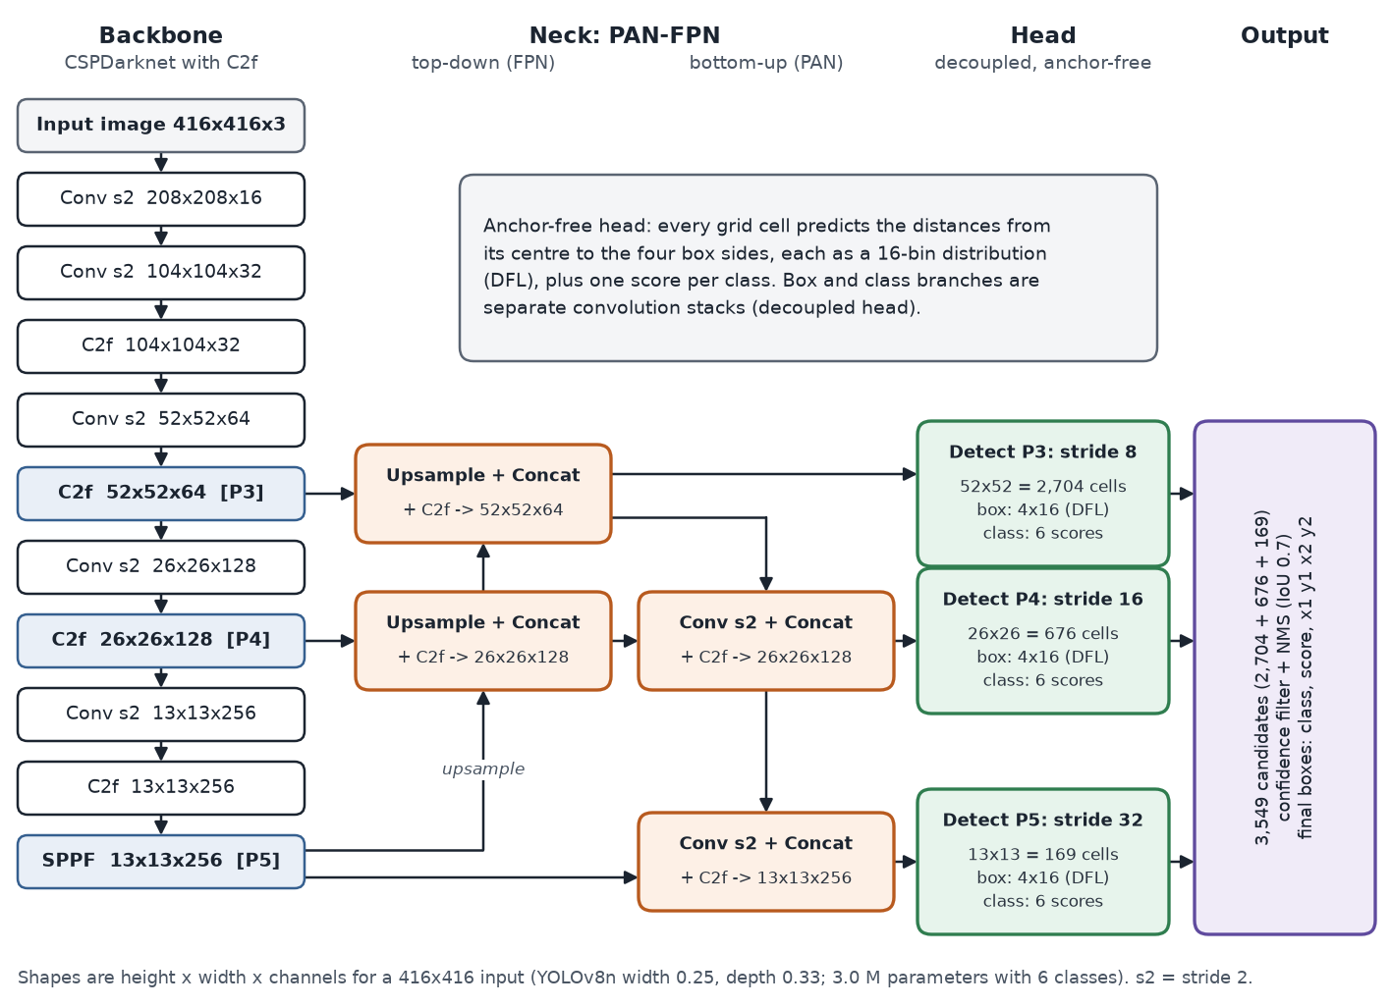
Figure 1: YOLOv8n at imgsz 416 (schematic). Shapes were checked with a forward pass of the trained model: strides 8/16/32 give 52×52, 26×26 and 13×13 grids.
Detectors are scored with mean average precision (mAP). For one class, the predictions are sorted by confidence and matched to ground-truth boxes; a prediction counts as correct if its intersection over union (IoU) with an unmatched true box is at least a threshold. Average precision (AP) is the area under the resulting precision-recall curve. mAP@50 is the mean AP over the classes at IoU 0.5, and mAP@50-95 averages mAP over the IoU thresholds 0.50, 0.55, ..., 0.95, as in COCO [5]. This project uses validation mAP@50 as the fitness and reports both metrics on the test split.

2.3 Hyperparameter optimisation
Training a detector involves hyperparameters, such as the learning rate, momentum and data augmentation, that are not learned from the data. Grid search tries every combination of a few values per hyperparameter, so its cost grows exponentially with the number of dimensions. Bergstra and Bengio [6] showed that random search is usually more efficient than grid search, because only a few hyperparameters matter for a given problem and random sampling tries many more distinct values of each. Random search is therefore the standard baseline that any smarter method must beat. Metaheuristics such as genetic algorithms and PSO go further and use the results of earlier evaluations to decide where to sample next. For deep networks every evaluation is a full training run, so the budget is small (tens of runs, not thousands), and cheap low-fidelity proxy trainings are often used in place of full ones.

2.4 Particle Swarm Optimisation
PSO was introduced by Kennedy and Eberhart [7], inspired by the movement of bird flocks and fish schools. A swarm of particles moves through the search space; each particle remembers the best position it has found, and the swarm shares the best position found by anyone. Each particle is pulled towards both, so good regions attract the swarm without any gradient information. Shi and Eberhart [8] added the inertia weight w, which scales the previous velocity, and showed that a weight decreasing linearly over the run gives a good balance between exploring the space early on and refining the best region later. This inertia-weight PSO is the version implemented here.

3 Theory: Particle Swarm Optimisation

3.1 Update equations
Each particle i has a position x_{i} (one candidate set of hyperparameters), a velocity v_{i} and a memory pbest_{i} of the best position it has visited. The swarm remembers gbest, the best position visited by any particle. In every update step, each particle's velocity and position change as follows:
$v_{i}^{t+1} = wv_{i}^{t} + c_{1}r_{1}({pbest}_{i} - x_{i}^{t}) + c_{2}r_{2}(gbest - x_{i}^{t})$ (1)
$x_{i}^{t+1} = x_{i}^{t} + v_{i}^{t+1}$ (2)
The three terms of Equation (1) are the inertia (keep moving in the same direction), the cognitive pull towards the particle's own best position, and the social pull towards the swarm's best position. Table 2 lists the symbols and the values used in this project, and Figure 2 draws one update as vectors.
Table 2: PSO symbols and the values used in this project (from src/pso.py and src/search.py).
Symbol | Meaning | Value used
x_{i}, v_{i} | position and velocity of particle i (6-D, in search units) | x: uniform in bounds; v: uniform in ±10% of range
pbest_{i} | best position particle i has visited | updated after each round
gbest | best position any particle has visited | updated after each round
w | inertia weight | linear 0.9 → 0.4 (0.9, 0.65, 0.4)
c₁, c₂ | cognitive and social acceleration coefficients | 1.5, 1.5
r₁, r₂ | random numbers, fresh for every particle and dimension | uniform on [0, 1]
swarm size × rounds | evaluation budget | 8 × 4 = 32
v_{max} | velocity limit per dimension | 20% of the dimension's range

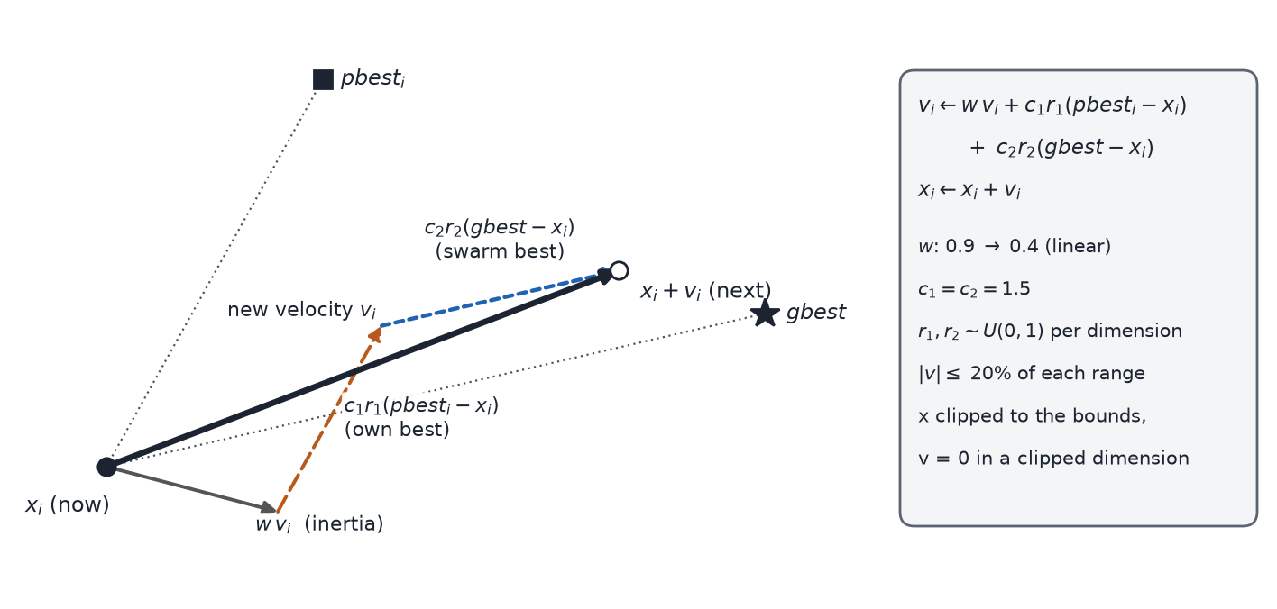
Figure 2: One PSO velocity update drawn as vectors: inertia, the pull towards the particle's own best (pbest) and the pull towards the swarm's best (gbest) add up to the new velocity.

3.2 Inertia schedule, velocity clamp and boundary handling
Three details keep the swarm stable inside a small, bounded search space:
- Linear inertia decay. The inertia weight falls linearly from 0.9 to 0.4 over the update steps. With 4 rounds there are 3 update steps, so w takes the values 0.9, 0.65 and 0.4. A large w early on lets particles explore; a small w later lets them settle near the best region.
- Velocity clamp. After each update every velocity component is limited to ±20% of that dimension's range, so one step can never cross more than a fifth of the space.
- Position clipping. If a particle leaves the bounds, its position is clipped back to the boundary and the velocity component of that dimension is set to zero, so the particle stops at the wall instead of pushing further out in the next step.

3.3 Ask/tell interface
The optimiser never trains a model itself. ask() returns the eight positions to evaluate, and tell(fitnesses) receives their scores, updates pbest and gbest and moves the swarm (except after the last round, when a move would never be evaluated). This keeps the PSO independent of YOLO: the same class runs the benchmark functions in Section 3.6 and the real hyperparameter search. Round 1 is the random initial swarm, followed by three update steps, so the budget is exactly 8 × 4 = 32 evaluations, the same as random search. A seeded random generator is the only source of randomness, so a run can be repeated exactly.

3.4 Why PSO rather than a genetic algorithm
All six hyperparameters are continuous, and two of them span two orders of magnitude. PSO works directly on real-valued vectors: there is no encoding, and a move is just a vector addition. It has only three main parameters (w, c₁, c₂) with well-known default values, and through pbest and gbest every evaluation influences the next round. A genetic algorithm can also handle real values, but it needs choices of encoding, crossover, mutation and selection pressure, each of which would have to be tuned with the same tiny budget. With only 32 trainings available, a method with fewer design choices is the safer option, and PSO is also the swarm-intelligence method studied in Unit V of the course.

3.5 Algorithm
The pseudocode below follows src/pso.py and src/search.py, and Figure 3 shows the same loop as a flowchart.
Algorithm: PSO hyperparameter search (8 particles, 4 rounds)
input : bounds low, high (6-D, search units); seed 42
x[i] <- Uniform(low, high); v[i] <- Uniform(-0.1*range, +0.1*range)
pbest_f[i] <- -inf; gbest_f <- -inf
for round = 1 .. 4:
for each particle i:
f[i] <- val mAP@50 of a 12-epoch proxy training with decode(x[i])
if f[i] > pbest_f[i]: pbest[i] <- x[i]; pbest_f[i] <- f[i]
gbest <- pbest[argmax pbest_f]
if round < 4:
w <- 0.9, 0.65, 0.4 for update step 1, 2, 3
r1, r2 <- Uniform(0, 1) per particle and dimension
v <- w*v + c1*r1*(pbest - x) + c2*r2*(gbest - x)
v <- clip(v, -0.2*range, +0.2*range)
x <- x + v; where x is outside [low, high]: clip x, set v = 0
return gbest, gbest_f

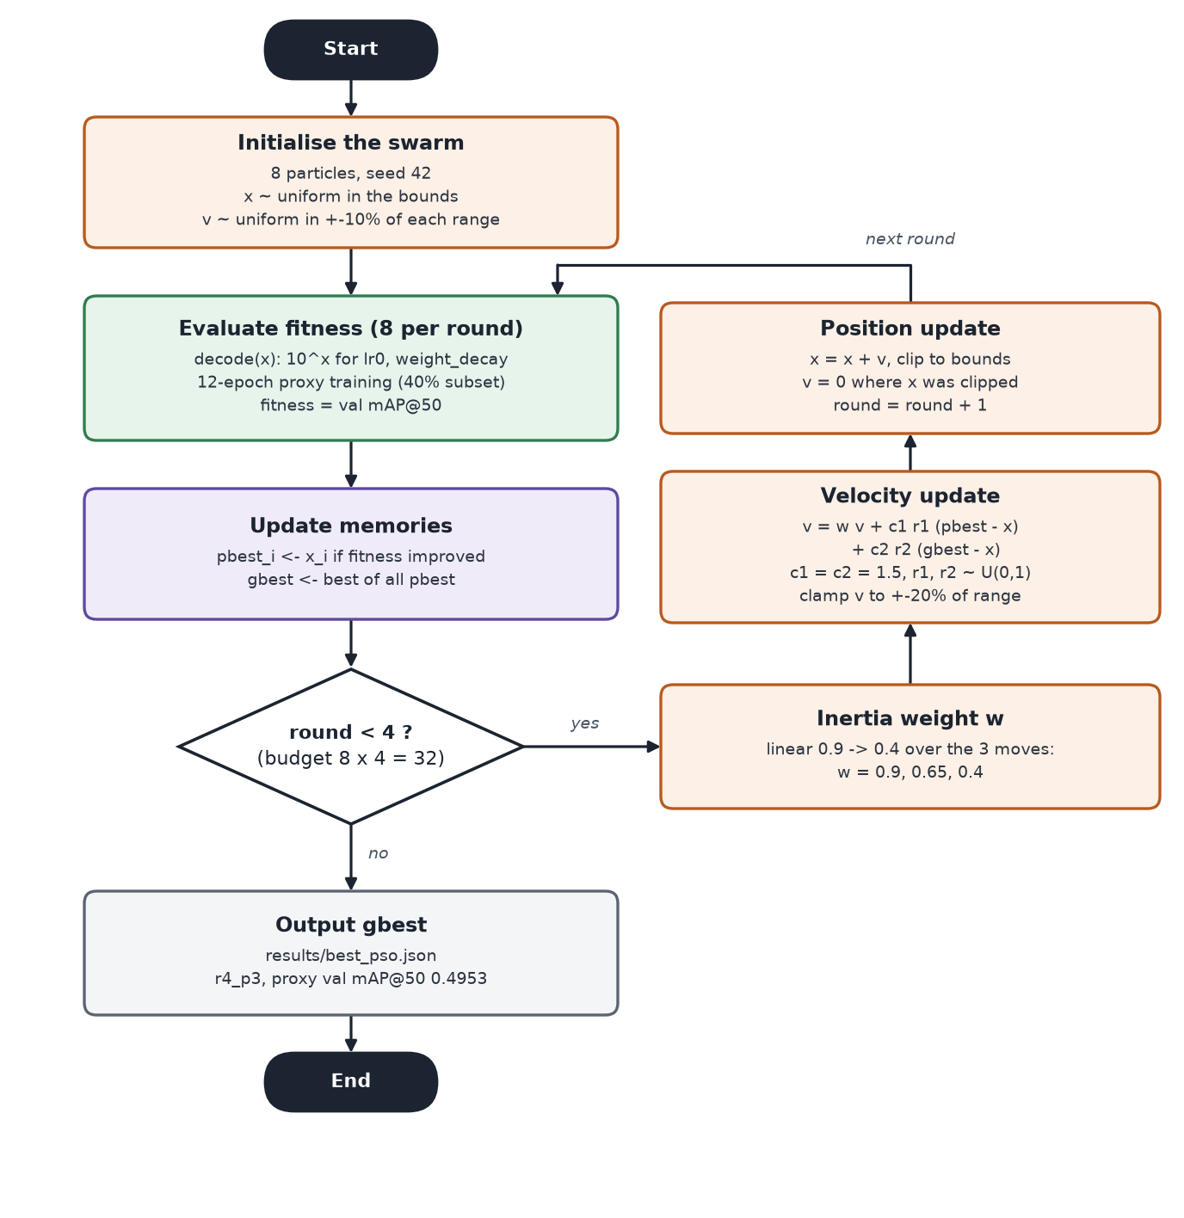
Figure 3: Flowchart of the PSO search as implemented. Each fitness evaluation is one 12-epoch proxy training.

3.6 Validation on benchmark functions
Before the PSO was trusted with expensive trainings, it was tested on two standard minimisation problems in six dimensions, the same number as the hyperparameter space: the Sphere function (one smooth bowl) and the Rastrigin function (a bowl covered in many local minima), both on [−5.12, 5.12]⁶ with the minimum 0 at the origin. The script src/pso_benchmark.py runs 20 particles for 50 rounds with 10 different seeds. On Sphere, the median best value fell from 21.9 after the first round to 1.9 × 10⁻⁵ after 50 rounds (min 1.36 × 10⁻⁵, max 6.76 × 10⁻⁵), so the swarm converges to the optimum. On Rastrigin, the median fell from 65.5 to 6.96 (min 2.1, max 14): the swarm makes steady progress but, as expected for this function, it usually ends in a good local minimum rather than the global one (Figure 4). Both results match the known behaviour of inertia-weight PSO, which confirms that the implementation is correct.
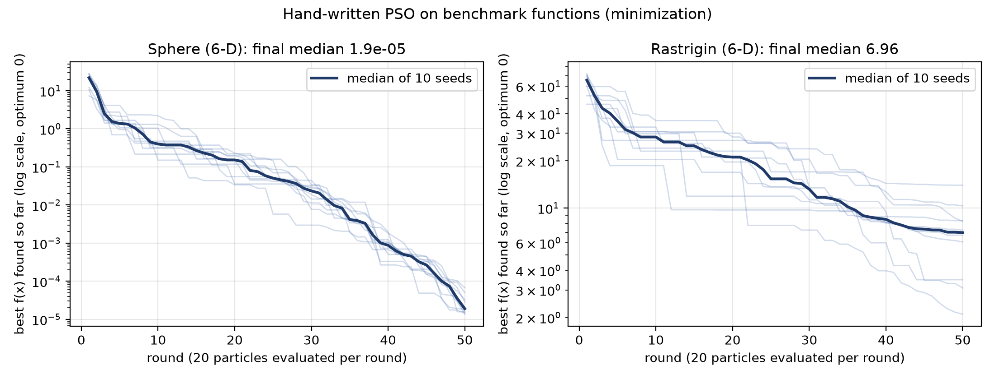
Figure 4: The hand-written PSO on 6-D Sphere and Rastrigin (20 particles × 50 rounds, 10 seeds; best value so far, log scale).

4 Dataset

4.1 Source
The project uses the Kaggle dataset "Garbage Detection – 6 Waste Categories" [9], released under CC BY 4.0. It contains 10,464 images of 416×416 pixels with YOLO-format bounding boxes, 74,073 boxes in total, in six classes: BIODEGRADABLE, CARDBOARD, GLASS, METAL, PAPER and PLASTIC. Many images show several objects, especially fruit and vegetables, and small objects are common: 36.4% of the boxes cover less than 1% of the image, and the median box covers 1.99% of it.

4.2 The provided split is by class
The dataset comes with train, valid and test folders, but the first verification run (src/verify_dataset.py) showed that they are split by class: the valid folder has no paper or plastic images, and the test folder has no glass, biodegradable or cardboard images. The few boxes of those classes in the left panel of Figure 5 come from mixed images of other classes; the provided test folder, for example, holds 49 biodegradable, 20 cardboard and 0 glass boxes out of 3,562. A model validated on such a split would be tuned and scored mostly on the classes that happen to be present, so the provided split could not be used.
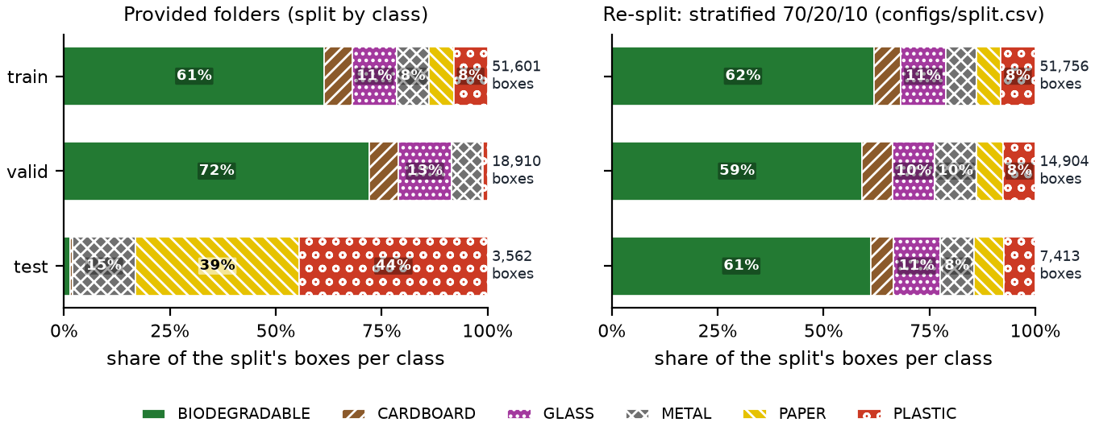
Figure 5: Share of boxes per class in each split: the provided folders (left) against the stratified re-split used in this project (right), from results/dataset_report.json.

4.3 Stratified, duplicate-aware re-split
All images were pooled and re-split 70/20/10 into train, validation and test, stratified by source class with seed 42. The split is stored in configs/split.csv and reused on every machine, so the images are never moved or modified. Public datasets often contain copies of the same photo, and a copy in train with its twin in test would leak information and inflate the test score. Images are therefore grouped, and each group is kept in one split. Two images count as copies if any of these rules holds:
- identical bytes (same MD5 hash);
- the same Roboflow source image (same file stem before the .rf. suffix);
- 256-bit difference hashes (dHash) at most 10 bits apart;
- dHashes at most 40 bits apart and 64×64 grayscale thumbnails with a Pearson correlation of at least 0.90, which catches shifted, watermarked and re-coloured copies.
The rules found 138 matching pairs (43 by the dHash rule and 95 by the dHash-plus-correlation rule; none by MD5 or file stem), which form 47 groups containing 133 images. After the split, no MD5, stem or near-duplicate match crosses any pair of splits. Figure 6 shows examples of the detected pairs, and Table 3 gives the final class balance.
Table 3: Images and boxes per class in the re-split (images are counted by their source class; boxes exclude the 17 zero-size boxes).
Class | Train images | Val images | Test images | Train boxes | Val boxes | Test boxes
BIODEGRADABLE | 1,605 | 452 | 230 | 32,049 | 8,815 | 4,531
CARDBOARD | 1,059 | 293 | 150 | 3,239 | 1,065 | 392
GLASS | 1,878 | 538 | 268 | 5,509 | 1,478 | 822
METAL | 1,330 | 383 | 185 | 3,786 | 1,467 | 588
PAPER | 1,232 | 355 | 181 | 2,905 | 955 | 527
PLASTIC | 1,022 | 304 | 138 | 4,268 | 1,124 | 553
Total | 7,324 | 2,094 | 1,046 | 51,756 | 14,904 | 7,413

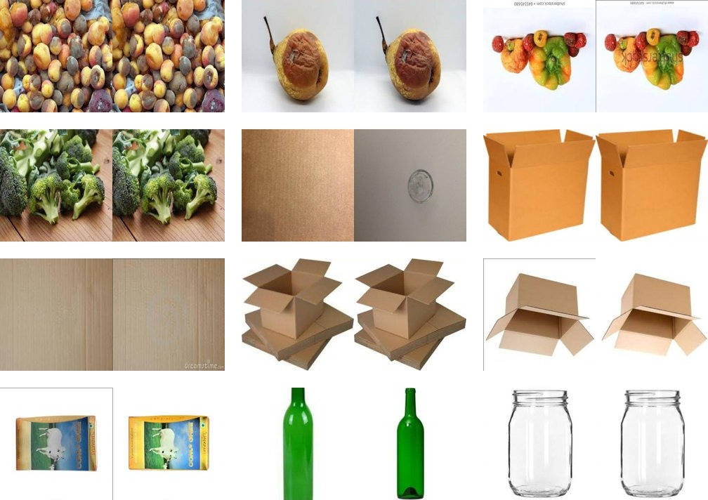
Figure 6: Near-duplicate pairs found by the duplicate rules (each tile shows the two images of one pair; arranged in a grid from results/plots/label_check/near_duplicate_pairs.jpg).

4.4 Quality checks
The verification script also runs automated quality checks, summarised in Table 4. All automated checks passed; the visual check of the 15 label grids in results/plots/label_check was done by hand.
Table 4: Dataset quality checks (results/dataset_report.json).
Check | Status | Detail
Label pairing | pass | 0 images without a label file, 0 label files without an image
Label format | pass | no fatal label issues, 0 corrupt images; 17 zero-size boxes ignored
Split leakage | pass | 0.00% of val + test images have a copy in another split
Degenerate boxes | pass | 1.89% of boxes cover more than 90% of the image
Class balance | pass | smallest train class has 2,905 boxes; every class has ≥ 30 boxes in val and test
Ultralytics loader | pass | loader accepted 7,324 / 2,094 / 1,046 images
Visual check | manual | 15 label grids inspected by hand

5 Methodology

5.1 Experimental design
The experiment compares three ways of choosing the six hyperparameters, called arms (Figure 7). Arm A uses Ultralytics' default values without any search. Arm B evaluates 32 random configurations. Arm C runs the PSO with 8 particles for 4 rounds, also 32 evaluations. B and C score each configuration with the same proxy fitness, and their winners are then trained in full with exactly the recipe used for A. Finally, all three models are scored once on the test split. Because everything except the six hyperparameters is identical, any difference in test accuracy can be attributed to the search method.
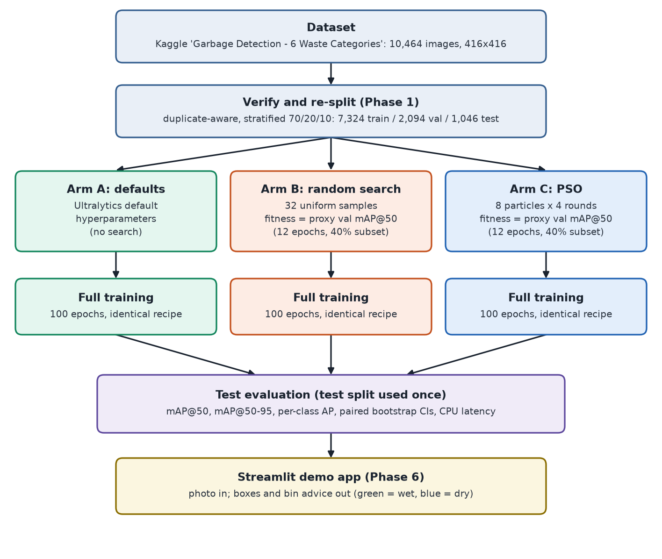
Figure 7: Experimental design: one dataset, three arms with equal treatment, full training and a single test evaluation, followed by the demo app.

5.2 Search space
Table 5 lists the six searched hyperparameters. The learning rate and the weight decay span two orders of magnitude, so they are searched on a log10 scale: a particle coordinate of −3.2 means lr0 = 10^{−3.2}. The other four are searched on a linear scale. Both search arms use exactly the same bounds (src/search_space.py).
Table 5: The 6-D search space and the Ultralytics defaults (Arm A).
Hyperparameter | What it controls | Range | Scale | Default (A)
lr0 | initial learning rate | 10⁻⁴ to 10⁻² | log10 | 0.01
lrf | final learning rate as a fraction of lr0 | 0.01 to 0.2 | linear | 0.01
momentum | SGD momentum | 0.6 to 0.98 | linear | 0.937
weight_decay | L2 weight decay | 10⁻⁵ to 10⁻³ | log10 | 0.0005
mosaic | probability of mosaic augmentation | 0 to 1 | linear | 1.0
scale | random scaling gain (±) | 0.2 to 0.8 | linear | 0.5

5.3 Proxy fitness
A full training takes over an hour on the Kaggle GPU, so 64 full trainings for the two searches would have been far too expensive. Each configuration is therefore scored with a proxy training: YOLOv8n starts from the COCO-pretrained weights and trains for 12 epochs at imgsz 416 on a stratified 40% subset of the training split (2,930 of 7,324 images, drawn per class with a fixed seed). The fitness is the mAP@50 of the last epoch on the full validation split (2,094 images). Figure 8(a) follows one particle through this pipeline. A proxy run takes about 3.5 to 4.5 minutes on a Tesla T4, so a whole search of 32 evaluations took 1.91 hours (PSO) and 2.12 hours (random search).
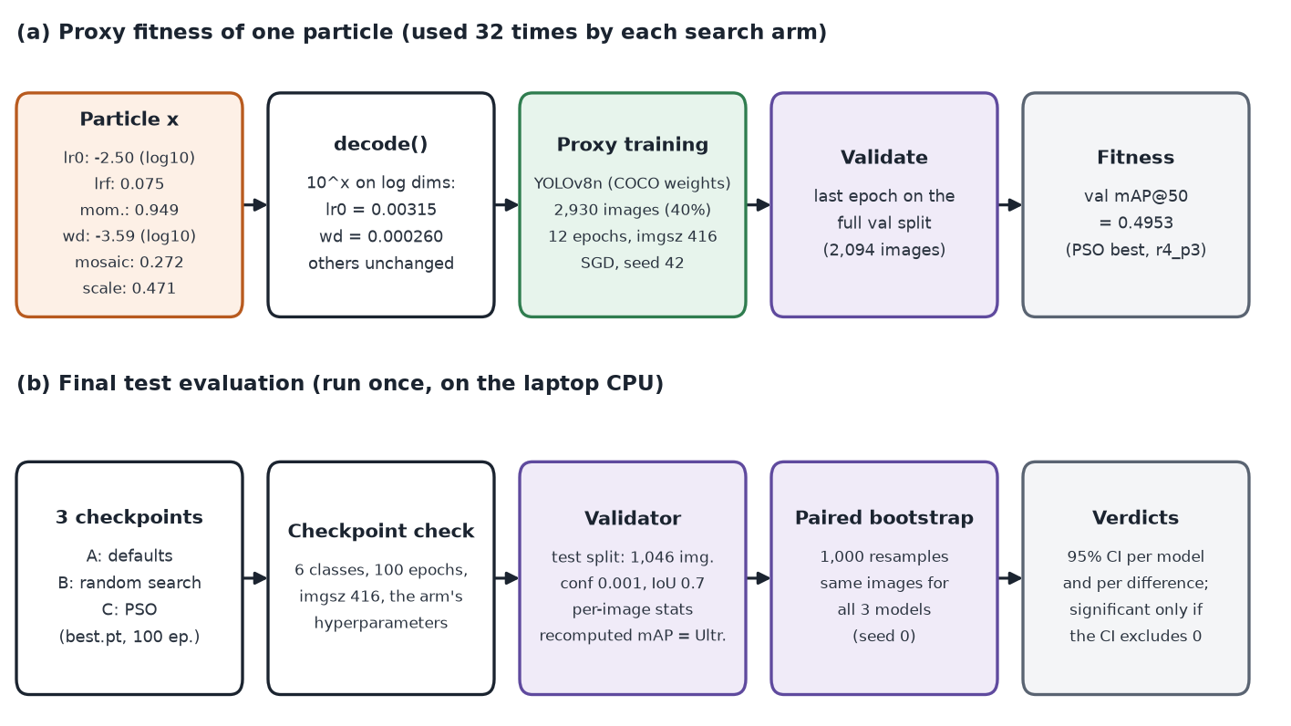
Figure 8: (a) How one particle becomes a fitness value; the example is the PSO winner r4_p3. (b) The final test evaluation of the three trained models.

5.4 Proxy validity check
A proxy is only useful if it ranks configurations in the same order as longer trainings. This was tested before any search. Seven configurations were drawn by Latin hypercube sampling [10], which spreads a few points evenly over every dimension, and the defaults were added as an eighth. Each was trained twice: once as a proxy and once as a 40-epoch "medium" run on the full training split. The agreement of the two rankings was measured with Spearman's rank correlation ρ [11]. The rule fixed in advance was to accept the proxy if ρ ≥ 0.6, and otherwise to rerun the proxies with 20 epochs. With only 8 points this is a practical check rather than a formal significance test, so the p-value is reported as well. The results are in Section 7.2.

5.5 Equal budgets
Both search arms get exactly 32 proxy evaluations with identical proxy settings. The PSO uses seed 42 for its swarm, random search uses seed 123 for its samples, and every training itself uses seed 42. Random search samples uniformly in the same search units, so it also benefits from the log scale. The comparison is therefore between two ways of spending the same budget, which is the fair test of whether PSO's guided search is worth having.

5.6 Fixed training recipe
Every training in the project, proxy or full, goes through one function (train_run in src/training.py), so only the six searched values can differ between arms:
- pretrained yolov8n.pt, imgsz 416 (the images' native size), batch 16;
- explicit SGD optimiser, seed 42, deterministic mode;
- full trainings: 100 epochs, validation every epoch, metrics of best.pt reported;
- mosaic closing (close_mosaic) at 10% and learning-rate warm-up (warmup_epochs) at 3% of the epochs, so a 12-epoch proxy follows the same schedule shape as a 100-epoch run (1 and 0.36 epochs for the proxy, 10 and 3 for full runs).
Two Ultralytics defaults were avoided on purpose, because each would have silently broken the experiment:
- optimizer=auto (the default) ignores lr0 and momentum and picks the optimiser by run length, so two of the six searched values would have had no effect. The code sets SGD explicitly and records the optimiser and initial learning rate that were really used.
- The fraction argument does not draw a random sample; it keeps the first N images of the sorted list, which here would have meant mostly one class. The proxy subset is instead built by stratified random sampling and passed in as its own data file.

5.7 Evaluation protocol
The test split was used exactly once, for the final comparison; all searches and checks used only the training and validation splits. src/evaluate.py first checks every checkpoint (6 classes, 100 epochs, imgsz 416 and the hyperparameters of its arm), so a model in the wrong slot is refused. Each model is then validated with Ultralytics' own validator and the same settings as the validation during training (conf 0.001, IoU 0.7, the max_det stored in the checkpoint), while the statistics of every image are recorded. As a consistency check, mAP is recomputed from these per-image statistics and must match Ultralytics' value; it matched exactly for all three models (difference 0.0).
Small differences between arms can be pure luck in which images ended up in the test split. A paired bootstrap [12] measures this: the 1,046 test images are resampled with replacement 1,000 times (seed 0), each resample is scored for all three models on the same images, and the 2.5th and 97.5th percentiles give a 95% confidence interval for each model and for each pairwise difference (B−A, C−A, C−B). A difference is called significant only if its interval excludes 0 (Figure 8(b)). Speed is the median batch-1 latency over 100 test images on the laptop CPU, after 10 warm-up predictions.

6 Implementation

6.1 Tools and hardware
The project is written in Python 3.13 with Ultralytics 8.4.169 (pinned, so local and Kaggle runs train identically), PyTorch, NumPy, SciPy (Latin hypercube sampling and Spearman's ρ), pandas and Matplotlib. All trainings ran on Kaggle notebooks with a Tesla T4 GPU. The test evaluation, the figures and the demo app ran locally on a laptop CPU (Intel Core Ultra 5 125H). The demo app uses Streamlit.

6.2 System architecture and repository layout
Figure 9 shows the system as five layers and marks which parts run on the Kaggle GPU and which run locally. Table 6 lists the main files of the repository.
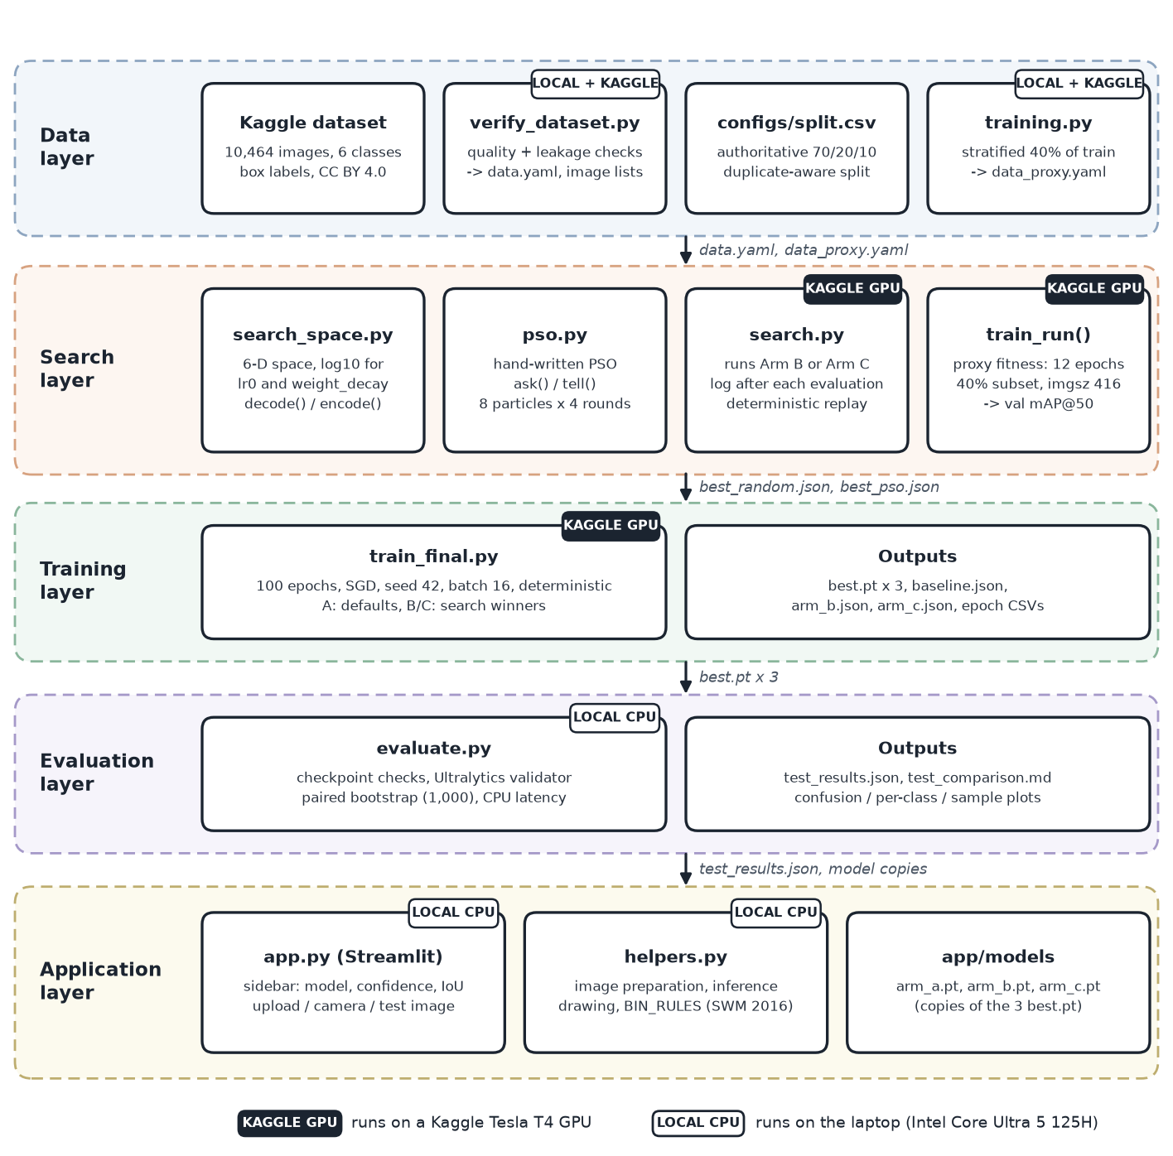
Figure 9: System architecture: data, search, training, evaluation and application layers, the files that pass between them, and where each part runs.
Table 6: Repository layout (https://github.com/Shreyansh303/SwarmSort).
Path | Purpose
src/verify_dataset.py | Phase 1: quality checks, duplicate-aware re-split, data.yaml and image lists
src/training.py | shared train_run() for every training; stratified proxy subset
src/proxy_check.py | Phase 2: proxy-validity check (8 configurations, proxy vs 40-epoch runs)
src/train_final.py | full 100-epoch training of one configuration (Arms A, B, C)
src/search_space.py | the 6-D space, decode()/encode(), random and Latin hypercube sampling
src/pso.py | the hand-written PSO (ask/tell)
src/search.py | runs Arm B or Arm C with logging and resume
src/pso_benchmark.py, src/plot_search.py | benchmark test of the PSO; convergence plot
src/evaluate.py | Phase 5: final test evaluation, bootstrap and figures
app/app.py, app/helpers.py, app/models/ | Phase 6: Streamlit demo and the three model copies
notebooks/ | six Kaggle notebooks (Phases 2a, 2b, 4a, 4b, 5a, 5b)
configs/, results/, tests/ | split and data configs; all JSON results and plots; unit tests

6.3 Project phases
The work was organised in six phases, each producing files that the next phase reads (Figure 10). The only decision point was the proxy check: had ρ been below 0.6, the proxy would have been lengthened to 20 epochs before the searches. It passed, so the 12-epoch proxy was used.
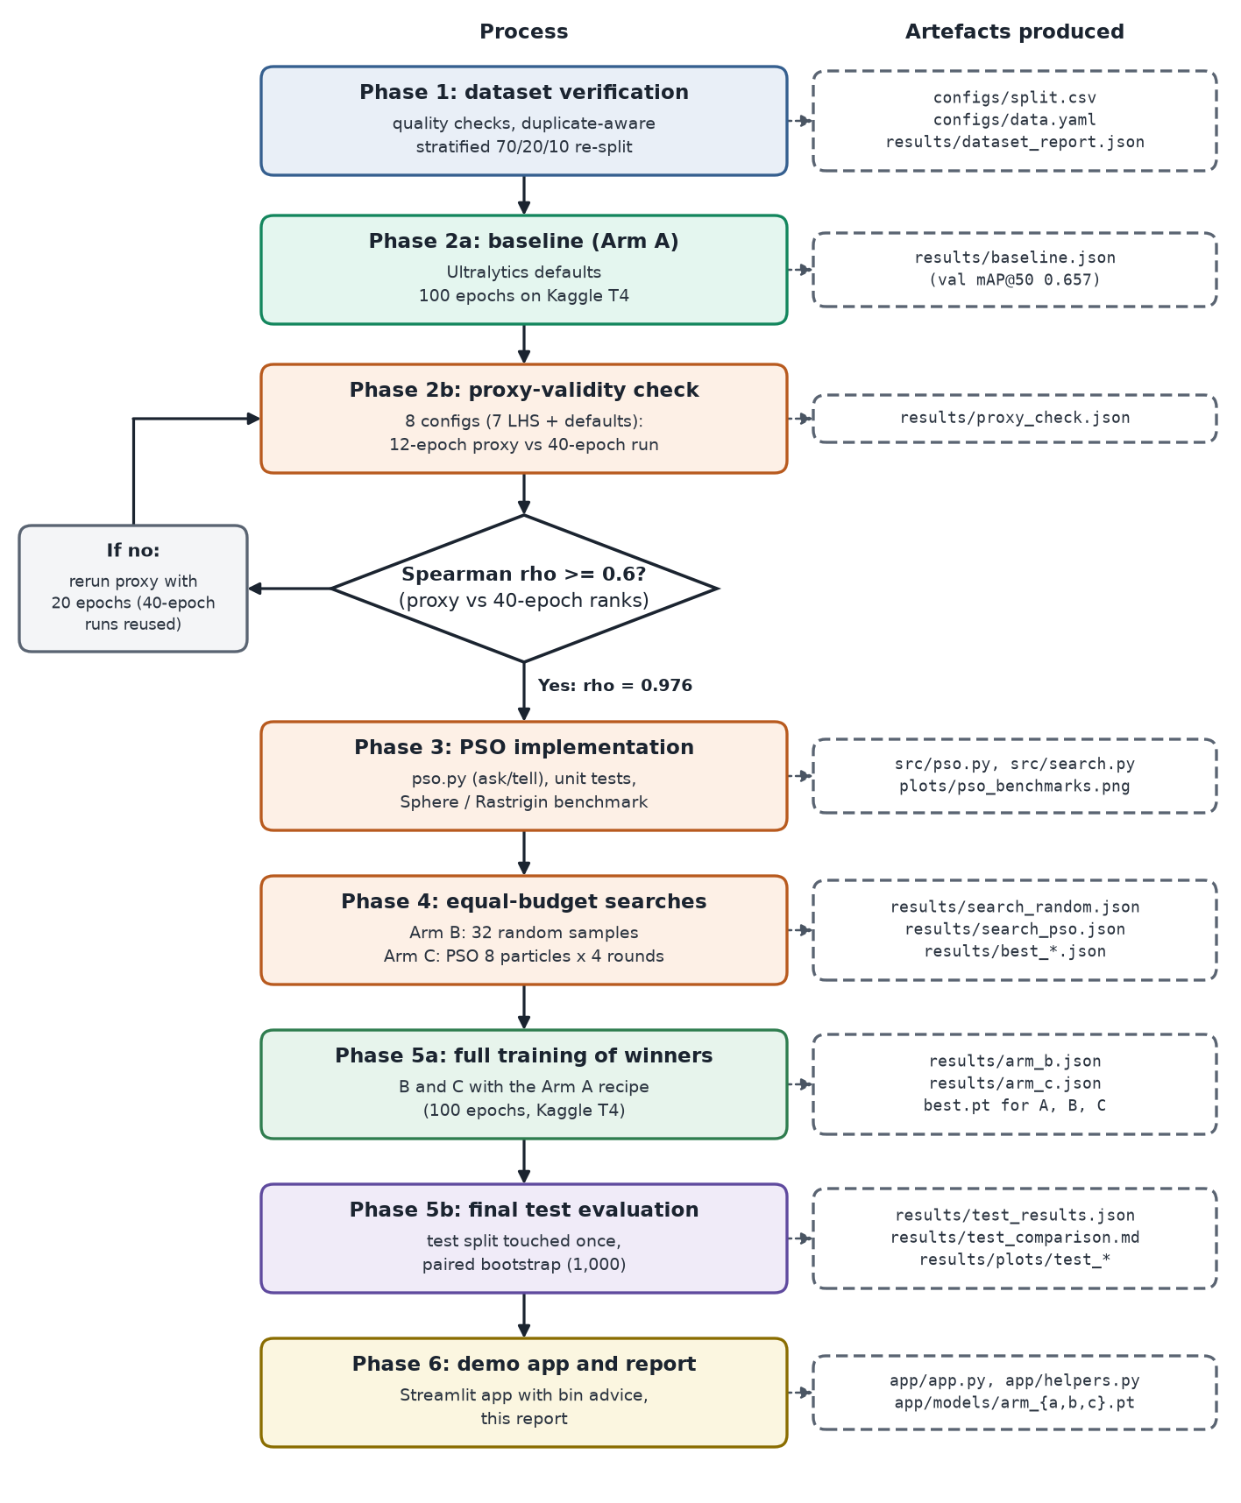
Figure 10: End-to-end project flow from Phase 1 to Phase 6, with the proxy decision and the artefacts produced at each step.

6.4 Resumable, reproducible searches
Kaggle sessions can stop without warning, and each search ran for about two hours. src/search.py therefore rewrites its JSON log after every evaluation, using an atomic write so that a killed session never leaves a broken file. On restart, the algorithm is replayed from its seed: every evaluation already in the log reuses the logged fitness (after checking that the replayed position equals the logged one), and training continues with the first missing evaluation. A log made with different settings is refused, and a training that returns a non-finite score is logged as a failed run with fitness 0.0, so it can never become the best. At most one proxy training is lost when a session dies.

6.5 PSO code
The two methods of src/pso.py that do the actual optimisation are shown below (comments shortened); the constructor only draws the initial swarm and stores the coefficients, and ask() returns a copy of the positions. The update rule of Equation (1) is the first line of _move.
def tell(self, fitness):
f = np.asarray(fitness, dtype=float)
if f.shape != (len(self.x),):
raise ValueError(f"expected {len(self.x)} fitness values, got shape {f.shape}")
f = np.where(np.isfinite(f), f, -np.inf) # a failed evaluation counts as the worst
better = f > self.pbest_f # particles that beat their own best
self.pbest_x[better], self.pbest_f[better] = self.x[better], f[better]
i = int(np.argmax(self.pbest_f))
if self.pbest_f[i] > self.gbest_f: # new swarm best
self.gbest_x, self.gbest_f = self.pbest_x[i].copy(), float(self.pbest_f[i])
... # (history bookkeeping)
self.round += 1
if self.round < self.n_iters: # no move after the final round
self._move(self.weights[self.round - 1]) # weights = linspace(0.9, 0.4, n_iters - 1)

def _move(self, w):
r1, r2 = self.rng.random(self.x.shape), self.rng.random(self.x.shape)
self.v = w * self.v + self.c1 * r1 * (self.pbest_x - self.x) + self.c2 * r2 * (self.gbest_x - self.x)
self.v = np.clip(self.v, -self.v_max, self.v_max) # v_max = 0.2 * (high - low)
self.x = self.x + self.v
outside = (self.x < self.low) | (self.x > self.high)
self.x = np.clip(self.x, self.low, self.high)
self.v[outside] = 0.0 # stop at the wall

7 Results

7.1 Baseline (Arm A)
With the default hyperparameters, the 100-epoch training took 71.1 minutes on the Tesla T4 and reached a validation mAP@50 of 0.657 and mAP@50-95 of 0.462 (precision 0.768, recall 0.570). This is the score the searches have to beat.

7.2 Proxy validity
Table 7 shows the eight configurations of the proxy check. The two rankings agree almost perfectly: Spearman ρ = 0.976 (p < 0.001; the JSON stores p as 0 after rounding, and recomputing it from the eight pairs gives about 3.3 × 10⁻⁵). This is far above the threshold of 0.6, so the 12-epoch proxy was accepted and no escalation to 20 epochs was needed. Note also that the best LHS configuration (lhs4) beat the defaults on both the proxy and the 40-epoch run, which made a hyperparameter search look promising.
Table 7: Proxy-validity check: val mAP@50 of the 12-epoch proxy and of the 40-epoch run (results/proxy_check.json).
Config | lr0 | momentum | mosaic | Proxy (12 ep., 40%) | Medium (40 ep., full)
lhs1 | 0.000126402 | 0.683235 | 0.790063 | 0.0869 | 0.2842
lhs2 | 0.00041752 | 0.799455 | 0.349345 | 0.2308 | 0.4945
lhs3 | 0.000224026 | 0.955929 | 0.232743 | 0.2949 | 0.5671
lhs4 | 0.00612648 | 0.830275 | 0.692244 | 0.4955 | 0.6384
lhs5 | 0.00160759 | 0.607676 | 0.129403 | 0.3019 | 0.5520
lhs6 | 0.00475516 | 0.755902 | 0.432757 | 0.4429 | 0.6216
lhs7 | 0.000842148 | 0.913396 | 0.93755 | 0.3756 | 0.6125
defaults | 0.01 | 0.937 | 1 | 0.4765 | 0.6288

7.3 Search results
Table 8 compares the configurations chosen by the two searches with the defaults. On the proxy both searches found configurations better than the defaults (0.4765): random search reached 0.4995 and PSO 0.4953. The two winners are quite different: random search kept a learning rate near the default (0.00702571 against 0.01) with a moderate mosaic probability, while PSO chose a learning rate about three times smaller than the default (0.00315345), slightly higher momentum and much less mosaic augmentation (0.271828).
Table 8: Hyperparameters of the three arms and their proxy fitness.
Hyperparameter | A: Defaults | B: Random search | C: PSO
lr0 | 0.01 | 0.00702571 | 0.00315345
lrf | 0.01 | 0.0625491 | 0.0751247
momentum | 0.937 | 0.911507 | 0.949322
weight_decay | 0.0005 | 0.000602262 | 0.000259703
mosaic | 1.0 | 0.51297 | 0.271828
scale | 0.5 | 0.346979 | 0.470742
Chosen evaluation | (no search) | s02 (evaluation 2 of 32) | r4_p3 (evaluation 27 of 32)
Proxy val mAP@50 | 0.4765 | 0.4995 | 0.4953

Figure 11 shows how the best fitness found so far grew during each search. Random search got lucky early: its best configuration was its second sample, and the remaining 30 samples never improved on it. Only 4 of its 32 samples beat the defaults' proxy score, and its mean fitness was 0.3327, because many random configurations had a learning rate that was far too small for 12 epochs. PSO started from a random swarm whose best member (0.4894) was already above the defaults, and then improved in rounds 3 and 4 to 0.4953. Over its 32 evaluations, 11 beat the defaults and its mean fitness was 0.4371.
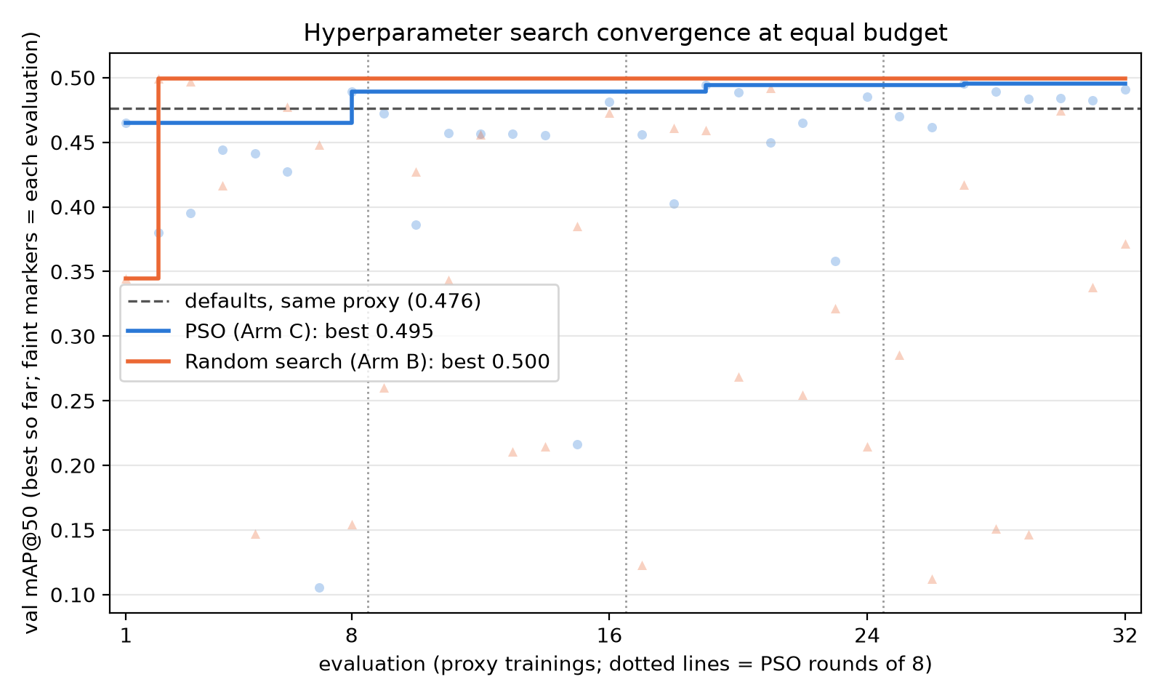
Figure 11: Best proxy val mAP@50 found so far for PSO (Arm C) and random search (Arm B) at equal budget; faint markers are individual evaluations, the dashed line is the defaults on the same proxy.
The round-by-round statistics in Table 9 show the swarm behaving as PSO should. The round mean rose from 0.3935 to 0.4822, the worst particle improved from 0.1055 to 0.4618, and the spread of fitness values shrank by a factor of about ten, from 0.1137 to 0.0105. In the last round, 6 of the 8 particles beat the defaults.
Table 9: PSO statistics per round (computed from results/search_pso.json).
Round | w used to reach it | Mean | Best | Worst | Std. dev. | gbest after round | Above defaults
1 | (random init.) | 0.3935 | 0.4894 | 0.1055 | 0.1137 | 0.4894 | 1 of 8
2 | 0.9 | 0.4228 | 0.4816 | 0.2163 | 0.0825 | 0.4894 | 1 of 8
3 | 0.65 | 0.4499 | 0.4942 | 0.3579 | 0.0443 | 0.4942 | 3 of 8
4 | 0.4 | 0.4822 | 0.4953 | 0.4618 | 0.0105 | 0.4953 | 6 of 8

Figure 12 makes the difference between the two searches visible. It plots all 32 evaluations of each arm in two of the six dimensions, the learning rate and the momentum. The PSO particles start spread out and, pulled by pbest and gbest, move into a tight cluster around lr0 ≈ 10^{−2.5} and momentum 0.85 to 0.95. The random samples cover the plane evenly and do not learn from each other; their good configurations are simply the ones that happened to land in the high-learning-rate region.
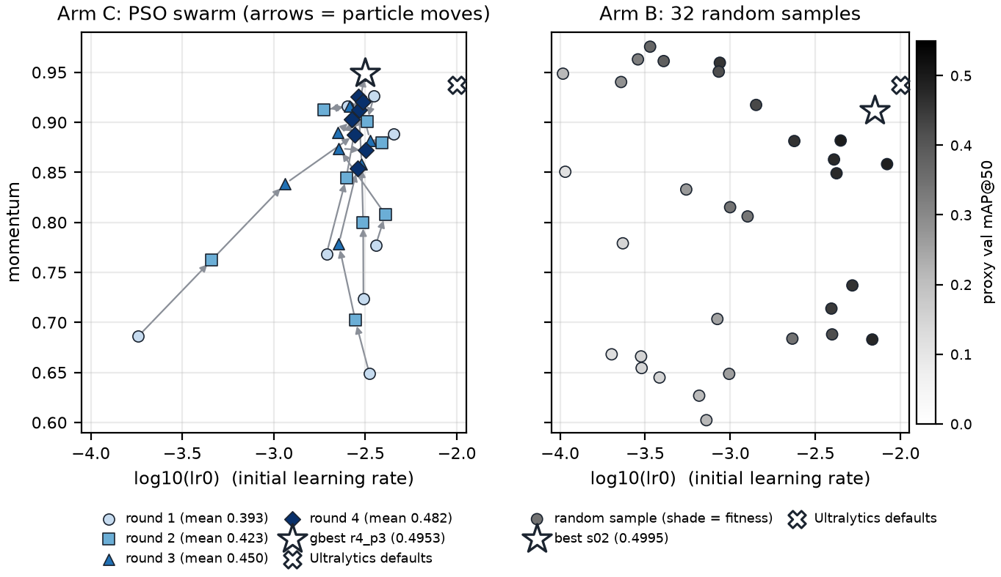
Figure 12: Real search data in the lr0-momentum plane. Left: the 32 PSO evaluations by round, with arrows joining each particle's successive positions. Right: the 32 random-search samples, shaded by proxy fitness. Stars mark each arm's winner, crosses the defaults.

7.4 Full training
The winners of both searches were trained for 100 epochs with the Arm A recipe. Table 10 compares the validation scores of best.pt. The proxy advantage did not carry over: the PSO configuration matched the defaults (0.657 against 0.657 mAP@50), and the random-search winner, which had the best proxy score of all, ended below the defaults (0.643).
Table 10: Full 100-epoch trainings: validation metrics of best.pt and training time on the Tesla T4.
Arm | Proxy mAP@50 | Val mAP@50 | Val mAP@50-95 | Precision | Recall | Time (min)
A: Defaults | 0.4765 | 0.657 | 0.462 | 0.768 | 0.570 | 71.1
B: Random search | 0.4995 | 0.643 | 0.458 | 0.756 | 0.563 | 69.3
C: PSO | 0.4953 | 0.657 | 0.463 | 0.756 | 0.578 | 86.9

Figure 13 shows the validation mAP@50 of each epoch. All three curves rise together and level off after about 60 epochs. B and C learn slightly faster in the first 40 epochs, but A catches up, and from epoch 60 onwards the three curves lie within about 0.015 of each other. Arm B's curve peaks at 0.648 in epoch 74, but Ultralytics 8.4 saves best.pt by mAP@50-95, which for B was highest in epoch 90, so its reported mAP@50 is 0.643.
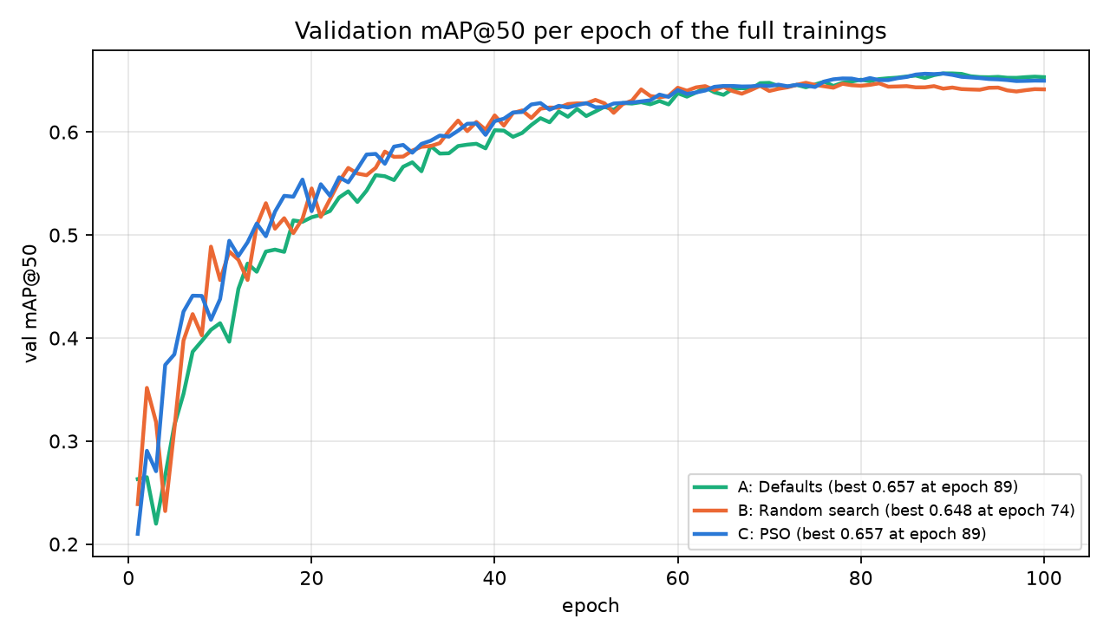
Figure 13: Validation mAP@50 per epoch of the three full trainings.

7.5 Final test comparison
Table 11 gives the final scores on the 1,046 test images (7,415 boxes; the validator also counts the 2 zero-size boxes that Table 3 leaves out). Arm A has the highest mAP@50 (0.676), followed by B (0.672) and C (0.668), but the 95% confidence intervals of the three models overlap almost completely. On mAP@50-95 the order changes (B 0.475, A 0.474, C 0.471).
Table 11: Final comparison on the test split. CIs: 95% percentile intervals from 1,000 paired bootstrap resamples. P and R at Ultralytics' max-F1 confidence; latency on the laptop CPU.
Arm | Test mAP@50 [95% CI] | Test mAP@50-95 [95% CI] | P | R | ms/img | FPS
A: Defaults | 0.676 [0.639, 0.722] | 0.474 [0.441, 0.518] | 0.747 | 0.581 | 31.4 | 31.8
B: Random search | 0.672 [0.634, 0.717] | 0.475 [0.441, 0.519] | 0.746 | 0.587 | 38.3 | 26.1
C: PSO | 0.668 [0.627, 0.717] | 0.471 [0.437, 0.516] | 0.747 | 0.586 | 31.7 | 31.5

The paired bootstrap answers the real question, whether the differences are larger than chance (Table 12). For every pair and both metrics, the 95% interval of the difference contains 0. The largest gap, PSO against the defaults, is −0.008 mAP@50 with an interval of [−0.021, +0.007], and PSO scored higher than the defaults in only 16% of the resamples. None of the differences is statistically significant: on this test split the three arms are tied.
Table 12: Pairwise differences from the paired bootstrap. P(Δ>0) is the share of resamples in which the first arm of the pair scored higher.
Pair | Δ mAP@50 [95% CI] | P(Δ>0) | Δ mAP@50-95 [95% CI] | P(Δ>0) | Verdict
Random search − Defaults (B−A) | −0.004 [−0.016, +0.009] | 0.30 | +0.001 [−0.008, +0.010] | 0.59 | not significant
PSO − Defaults (C−A) | −0.008 [−0.021, +0.007] | 0.16 | −0.003 [−0.012, +0.007] | 0.34 | not significant
PSO − Random search (C−B) | −0.004 [−0.015, +0.007] | 0.24 | −0.003 [−0.011, +0.004] | 0.19 | not significant

7.6 Per-class results
Table 13 and Figure 14 break mAP@50 down by class. METAL and GLASS are detected best and PAPER worst, for all three arms. The arms differ most on PLASTIC, where PSO scored 0.638 against 0.699 for the defaults, while PSO was best on BIODEGRADABLE (0.643) and GLASS (0.765). These per-class numbers have no confidence intervals and the classes have only a few hundred test boxes each, so they should be read as hints rather than findings.
Table 13: Per-class AP@50 on the test split (best value per class in bold).
Class | A: Defaults | B: Random search | C: PSO
BIODEGRADABLE | 0.632 | 0.631 | 0.643
CARDBOARD | 0.641 | 0.628 | 0.623
GLASS | 0.747 | 0.757 | 0.765
METAL | 0.753 | 0.736 | 0.754
PAPER | 0.583 | 0.590 | 0.588
PLASTIC | 0.699 | 0.693 | 0.638
mAP@50 (all) | 0.676 | 0.672 | 0.668

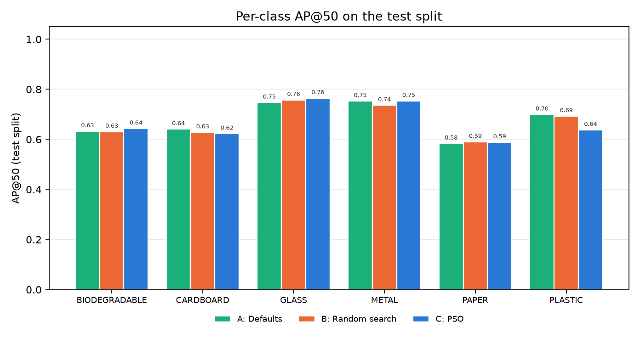
Figure 14: Per-class AP@50 of the three models on the test split.

7.7 Confusion matrices
Figure 15 shows the normalised confusion matrices at confidence 0.25 (columns are true classes, rows are predictions). Mix-ups between waste classes are rare; the largest one is METAL predicted as PLASTIC (0.05 for A, 0.06 for B and 0.07 for C of the true metal boxes), which fits PSO's weaker PLASTIC AP. The dominant error is missed objects (the bottom "background" row): for example, 43% of the true biodegradable boxes are missed by A at this threshold, largely because biodegradable images often contain dozens of small, overlapping fruit and vegetables. The last column shows detections with no matching object; about half of them are biodegradable.
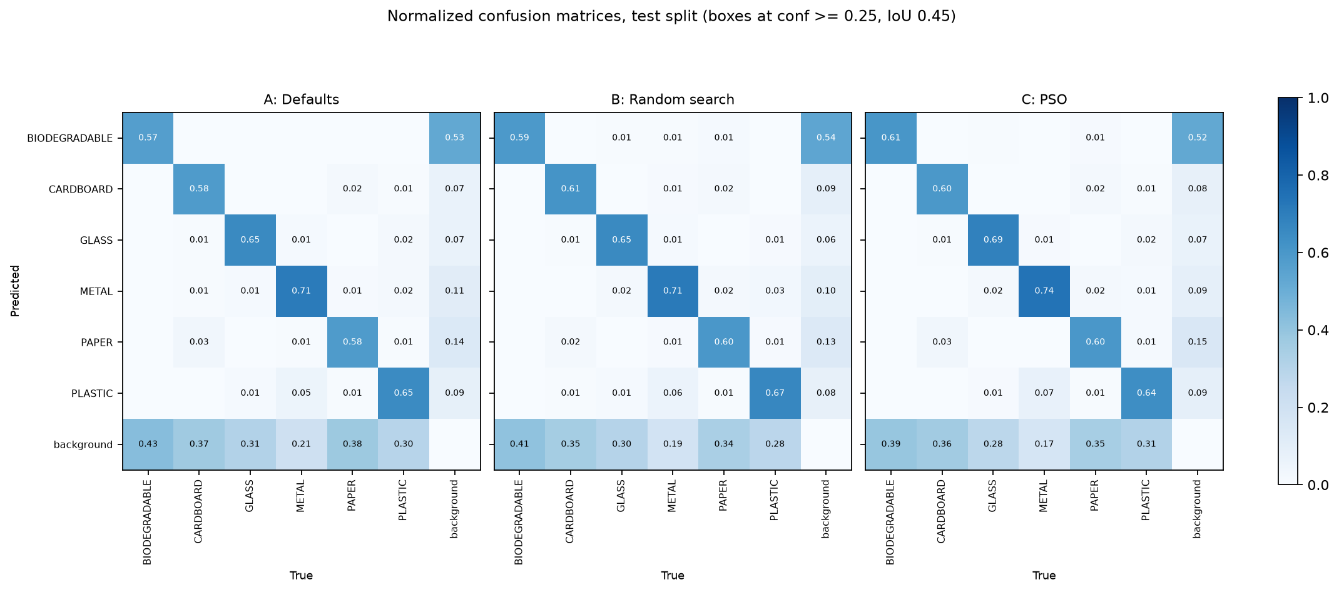
Figure 15: Normalised confusion matrices on the test split (boxes at conf ≥ 0.25, IoU 0.45).

7.8 Sample detections
Figure 16 shows one test image per class with the ground truth and the predictions of the three models. The models behave almost identically. Typical errors are visible: on the METAL sample the small metal cap of a glass bottle is missed, and on PAPER and PLASTIC the models draw one large box where the annotation has several smaller ones, or the reverse.
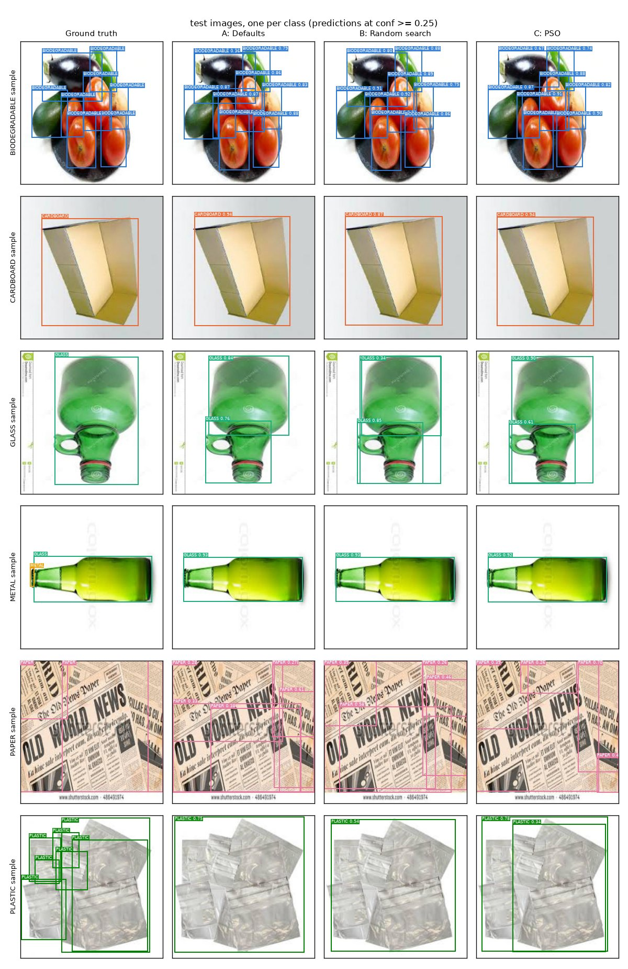
Figure 16: Sample test images (one per class): ground truth and the predictions of A, B and C at conf ≥ 0.25.

7.9 Inference speed
At imgsz 416 and batch size 1, the median CPU latency on the Intel Core Ultra 5 125H was 31.4 ms per image for A (31.8 FPS), 38.3 ms for B (26.1 FPS) and 31.7 ms for C (31.5 FPS). The three networks are architecturally identical, so they do the same amount of computation; the higher value for B is measurement noise from other processes on the laptop rather than a property of the model. Either way, all three run in real time on a CPU without a GPU, which meets the goal of a light detector.

8 Demo Application

8.1 Features
The demo is a Streamlit app (app/app.py, with the logic in app/helpers.py) started with streamlit run app/app.py. Figure 17 shows how a photo becomes bin advice. Its features are:
- Three inputs: upload one or more photos (JPG, PNG or WebP), take a photo with the camera, or pick a random test-split image when the local dataset is present. The last option is clearly labelled as a dataset image.
- Model choice: a sidebar selector for A, B or C, each shown with its test mAP@50 read from results/test_results.json, and a note that the three are statistically tied. Each model is loaded once and cached.
- Controls: a confidence slider (default 0.35) and an NMS IoU slider (default 0.7). Inference always runs at imgsz 416, the training size.
- Robust image handling: the EXIF rotation of phone photos is applied, transparent images are put on a white background, every image is converted to RGB, and very large photos are shrunk to at most 1,280 pixels on the long side. A damaged or unsupported file gives a friendly error message instead of a crash.
- Output: the annotated image, the inference time in milliseconds, the number of items, the number of items per bin, and a table with each item's class, confidence, bin and disposal tip. If nothing is found, the app suggests a lower confidence or a clearer photo.
- Explanations: an "About this project" section with the test comparison table and the honest conclusion, and a section listing the bin rules.
The boxes are drawn in one colour per item type: BIODEGRADABLE green, CARDBOARD brown, GLASS purple, METAL grey, PAPER yellow and PLASTIC red-orange. Only biodegradable items get a green box, and none of the dry types is blue, so a box colour is never mistaken for a bin colour; the bin is always given in the table.
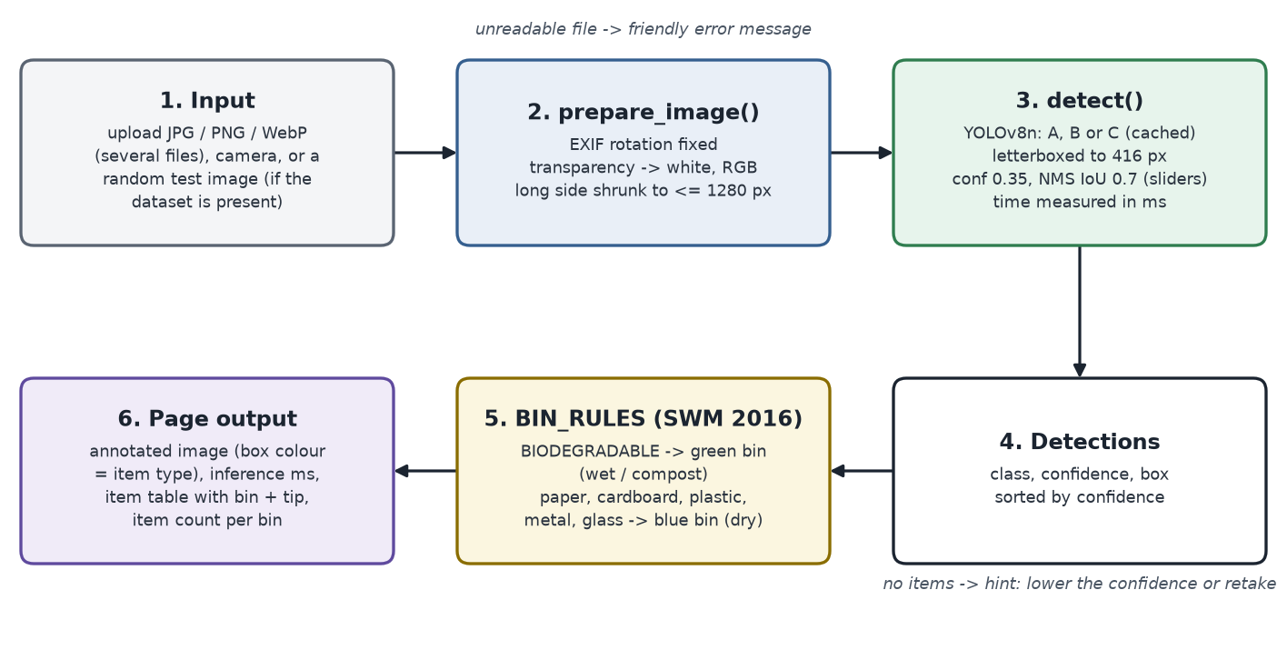
Figure 17: Data flow of the demo app, from the input photo to the annotated image and bin advice.

8.2 Bin rules
The bin advice follows the wet/dry colour coding used under India's Solid Waste Management Rules 2016 [1]: biodegradable items go in the green (wet) bin and all five dry classes in the blue (dry recyclables) bin. The rules are kept in one dictionary, BIN_RULES in app/helpers.py, so they are easy to explain and to change (Table 14).
Table 14: Bin rules used by the app (BIN_RULES in app/helpers.py).
Item class | Bin | Disposal tip
BIODEGRADABLE | Green bin (wet / compost) | Compost
PAPER | Blue bin (dry recyclables) | Paper recycling; keep it dry and clean
CARDBOARD | Blue bin (dry recyclables) | Paper recycling; flatten boxes
PLASTIC | Blue bin (dry recyclables) | Plastic recycling; rinse containers
METAL | Blue bin (dry recyclables) | Metal recycling; rinse cans
GLASS | Blue bin (dry recyclables) | Glass recycling; handle with care, keep separate if broken

8.3 Default model
The app selects the model with the highest test mAP@50 by default, which is Arm A (0.676). Since the three models are statistically tied, this choice makes no measurable difference, and B and C can be selected in the sidebar to show that they behave the same. Model A is also the simplest to explain: it needed no search at all.

8.4 Screenshots
Figure 18 and Figure 19 show the running app with two test-split images, and Figure 20 is reserved for a real phone photo.
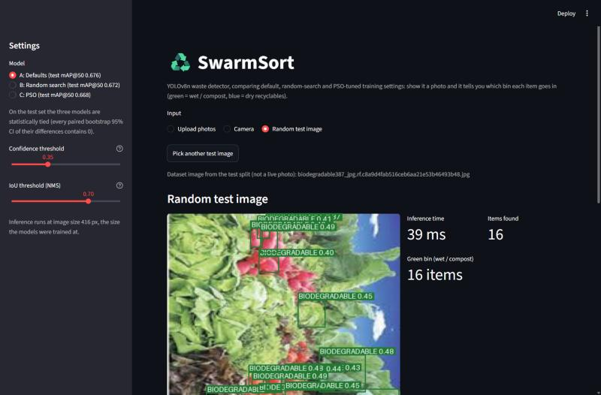
Figure 18: The app with a biodegradable test image: 16 items found in 39 ms with model A, all for the green bin.
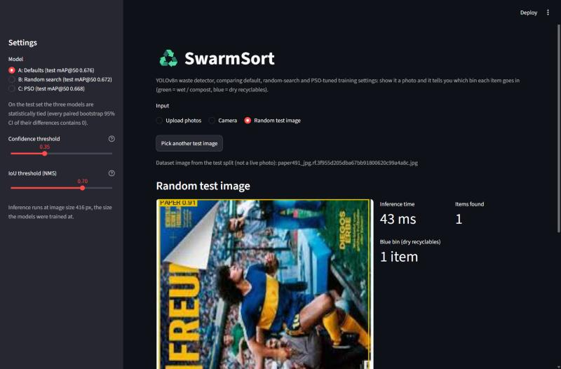
Figure 19: The app with a paper test image: one PAPER item (confidence 0.91), for the blue bin.
[Screenshot: app with a real phone photo]
Figure 20: The app with a real phone photo of household waste [to be added by the student].

9 Discussion

9.1 Why the three arms tie
The most likely reason is that Ultralytics' defaults are already well tuned. They were chosen by the Ultralytics team over many datasets, and YOLOv8n is trained here in the regime those defaults were made for: COCO-pretrained weights, SGD and a standard 100-epoch schedule. The searched values also mostly matter for how fast the model learns. B and C indeed learned faster early in training (Figure 13), but after 100 epochs all three runs reached the same plateau. When the default is already near the top of a flat region, a search can only find small gains, and gains of this size are within the noise of a single training run and a 1,046-image test set.

9.2 The gap between proxy and full training
The proxy did its job overall: it ranked eight very different configurations almost perfectly (ρ = 0.976), and it correctly told good regions of the space from bad ones. But the differences that matter at the end of a search are tiny. The top configurations differed by only about 0.02 mAP@50 on the proxy (0.4765 to 0.4995), and a correlation measured across a wide range of quality says little about the order within such a narrow band. A 12-epoch run on 40% of the data rewards configurations that learn quickly, such as a high learning rate and less augmentation, and these advantages fade over 100 epochs. Random search's winner is the clearest example: the best proxy score of the whole project, and a full-training validation score below the defaults (0.643 against 0.657).

9.3 PSO convergence against random search's luck
As an optimiser, the PSO behaved exactly as theory predicts: the round mean rose from 0.393 to 0.482, the spread shrank about tenfold and the swarm concentrated in one region (Figure 12). Random search found a slightly higher single proxy score, but only because its second sample happened to land in a good spot; its later 30 samples added nothing, and 28 of its 32 samples were worse than the defaults. With such a small budget, one lucky draw can beat a guided search, so a single run of each method cannot rank them. What PSO offers is reliability: by its last round almost every particle was a good configuration. In this experiment that reliability did not turn into test accuracy, because the proxy itself could not separate the top configurations.

9.4 Per-class observations
PSO's model was slightly better on BIODEGRADABLE and GLASS and clearly worse on PLASTIC (0.638 against 0.699 and 0.693). Its confusion matrix shows more metal boxes predicted as plastic, so the PLASTIC score suffers from false positives. One plausible cause is PSO's low mosaic probability (0.271828 against 1.0): mosaic augmentation shows the model objects in new contexts and at new sizes, which may matter for shiny, transparent items that look alike. This is a hypothesis, not a tested result. The per-class gains and losses roughly cancel, which is why the overall mAP is tied.

9.5 Threats to validity
- One seed per arm. Each arm was trained once with seed 42. Run-to-run variation of a full training was not measured, and it may be as large as the differences between arms.
- One dataset. The images are mostly product-style photos on clean backgrounds. The conclusion may not hold for real street or household scenes.
- Short proxy. The 12-epoch, 40% proxy favours fast learners. A longer proxy might rank the top configurations differently.
- Detection cap. Validation uses max_det 321, taken from the checkpoints. One test image contains 358 labelled objects, so some of its boxes can never be matched. This affects all three arms equally and does not change the comparison.
- CPU latency. The latency was measured on a laptop with other processes running, which explains why B appears slower although the networks are identical.
- Per-class differences. Only the overall metrics have bootstrap intervals; the per-class differences are descriptive.

10 Limitations and Future Work
- Several seeds. Train each arm with 3 to 5 seeds to measure the noise of a single training, and compare arms on the mean.
- Better fidelity. Use a longer proxy, or multi-fidelity methods such as successive halving or Hyperband, which start many short runs and give more epochs only to the promising ones.
- Larger searches. More particles, more rounds and more dimensions (for example other augmentation settings, image size or box-loss weights).
- PSO variants. A ring (local-best) topology to keep diversity longer, or the constriction-factor PSO, which bounds the velocities without a hard clamp.
- Data. Larger and real-world datasets with cluttered household and street scenes, and photos taken in Indian homes.
- Deployment. Export the model to ONNX or TensorFlow Lite and run it on a phone or an edge device beside a bin.

11 Conclusion
SwarmSort is a working real-time waste detector: a YOLOv8n model with 0.676 test mAP@50 over six classes, running at about 31 ms per image on a laptop CPU, with a demo app that turns detections into green-bin and blue-bin advice. The project's main question was whether a hand-written Particle Swarm Optimiser could improve the detector by tuning its training hyperparameters. The PSO worked as an optimiser: it was verified on benchmark functions, its swarm converged during the search, and it found configurations that beat the defaults on a validated proxy. After full training, however, the defaults, the random-search winner and the PSO winner were statistically indistinguishable on an untouched test set. The correct conclusion is that, for this dataset and model, Ultralytics' defaults were already near-optimal, and small proxy gains did not survive full training. This negative result is still useful. It came from a controlled design with equal budgets, a fixed training recipe, a test split used once and a paired bootstrap, and it shows why claims that a metaheuristic improved a model need exactly this kind of check.

References
[1] Ministry of Environment, Forest and Climate Change, Government of India, “Solid Waste Management Rules, 2016,” The Gazette of India, 2016.
[2] S. Majchrowska, A. Mikołajczyk, M. Ferlin, Z. Klawikowska, M. A. Plantykow, A. Kwasigroch, and K. Majek, “Deep learning-based waste detection in natural and urban environments,” Waste Management, vol. 138, pp. 274–284, 2022.
[3] J. Redmon, S. Divvala, R. Girshick, and A. Farhadi, “You only look once: Unified, real-time object detection,” in Proc. IEEE Conf. Computer Vision and Pattern Recognition (CVPR), 2016, pp. 779–788.
[4] G. Jocher, A. Chaurasia, and J. Qiu, “Ultralytics YOLOv8,” software, version 8.0.0, 2023. [Online]. Available: https://github.com/ultralytics/ultralytics
[5] T.-Y. Lin, M. Maire, S. Belongie, J. Hays, P. Perona, D. Ramanan, P. Dollár, and C. L. Zitnick, “Microsoft COCO: Common objects in context,” in Proc. European Conf. Computer Vision (ECCV), 2014, pp. 740–755.
[6] J. Bergstra and Y. Bengio, “Random search for hyper-parameter optimization,” Journal of Machine Learning Research, vol. 13, pp. 281–305, 2012.
[7] J. Kennedy and R. Eberhart, “Particle swarm optimization,” in Proc. IEEE Int. Conf. Neural Networks (ICNN), Perth, Australia, 1995, vol. 4, pp. 1942–1948.
[8] Y. Shi and R. Eberhart, “A modified particle swarm optimizer,” in Proc. IEEE Int. Conf. Evolutionary Computation, Anchorage, AK, USA, 1998, pp. 69–73.
[9] viswaprakash1990, “Garbage Detection – 6 Waste Categories,” Kaggle dataset, CC BY 4.0. [Online]. Available: https://www.kaggle.com/datasets/viswaprakash1990/garbage-detection
[10] M. D. McKay, R. J. Beckman, and W. J. Conover, “A comparison of three methods for selecting values of input variables in the analysis of output from a computer code,” Technometrics, vol. 21, no. 2, pp. 239–245, 1979.
[11] C. Spearman, “The proof and measurement of association between two things,” The American Journal of Psychology, vol. 15, no. 1, pp. 72–101, 1904.
[12] B. Efron and R. J. Tibshirani, An Introduction to the Bootstrap. New York, NY, USA: Chapman & Hall, 1993.

Appendix A: Full Hyperparameters
Table 15 lists every training argument of the three full trainings, taken from results/baseline.json, results/arm_b.json and results/arm_c.json. Only the six searched values differ.
Table 15: Training arguments of the three full trainings.
Argument | A: Defaults | B: Random search | C: PSO
lr0 | 0.01 | 0.00702571 | 0.00315345
lrf | 0.01 | 0.0625491 | 0.0751247
momentum | 0.937 | 0.911507 | 0.949322
weight_decay | 0.0005 | 0.000602262 | 0.000259703
mosaic | 1.0 | 0.51297 | 0.271828
scale | 0.5 | 0.346979 | 0.470742
epochs | 100 | 100 | 100
imgsz | 416 | 416 | 416
batch | 16 | 16 | 16
optimizer | SGD | SGD | SGD
seed | 42 | 42 | 42
deterministic | true | true | true
close_mosaic | 10 | 10 | 10
warmup_epochs | 3.0 | 3.0 | 3.0

Appendix B: How to Reproduce
The code, configurations, results and Kaggle notebooks are in the repository https://github.com/Shreyansh303/SwarmSort. GPU phases run in the Kaggle notebooks in notebooks/ (GPU T4, Internet on, dataset viswaprakash1990/garbage-detection attached). The main commands, from the repository root, are:
python -m venv .venv
.venv/Scripts/python -m pip install -r requirements.txt

# Phase 1: dataset verification (reuses configs/split.csv)
.venv/Scripts/python src/verify_dataset.py --root "GARBAGE CLASSIFICATION"
# Phase 2: baseline, proxy subset and proxy-validity check
.venv/Scripts/python src/train_final.py
.venv/Scripts/python src/training.py
.venv/Scripts/python src/proxy_check.py
# Phase 3: PSO benchmark and unit tests
.venv/Scripts/python src/pso_benchmark.py
.venv/Scripts/python -m unittest discover -s tests -v
# Phase 4: the two searches (Kaggle notebooks 4a and 4b)
.venv/Scripts/python src/search.py --method pso
.venv/Scripts/python src/search.py --method random
.venv/Scripts/python src/plot_search.py
# Phase 5: full training of the winners (Kaggle notebooks 5a and 5b), then the test evaluation
.venv/Scripts/python src/train_final.py --config results/best_random.json --name arm_b --out results/arm_b.json
.venv/Scripts/python src/train_final.py --config results/best_pso.json --name arm_c --out results/arm_c.json
.venv/Scripts/python src/evaluate.py
# Phase 6: demo app
.venv/Scripts/python -m streamlit run app/app.py

