AWS MULTI-TIER WEB APPLICATION
Job-Oriented Cloud Project Report
Scalable and Highly Available Application Architecture on AWS
Region: Asia Pacific (Mumbai) - ap-south-1
Prepared for Cloud / DevOps Portfolio

1. Project Overview
This project demonstrates the design and implementation of a multi-tier web application architecture on Amazon Web Services (AWS). The architecture separates the public entry point, application compute layer and database layer while using load balancing and automatic scaling to improve availability and scalability.
The implementation work covered VPC networking, public and private subnet design, routing, security groups, Bastion Host access, EC2 application servers, a Launch Template, an Application Load Balancer, a Target Group, Auto Scaling and health checks. The project configuration observed in the AWS console uses App-ASG with desired capacity 2, minimum 2, maximum 4, and target tracking based on average CPU utilization at 70%.

Project Goals
- Build a structured multi-tier AWS architecture.
- Separate public-facing resources from private application resources.
- Distribute application traffic using an Application Load Balancer.
- Maintain application capacity automatically using EC2 Auto Scaling.
- Use health checks to detect unhealthy application instances.
- Apply security-group rules to control tier-to-tier communication.
- Prepare the environment for a managed database tier using Amazon RDS.

2. Logical Architecture
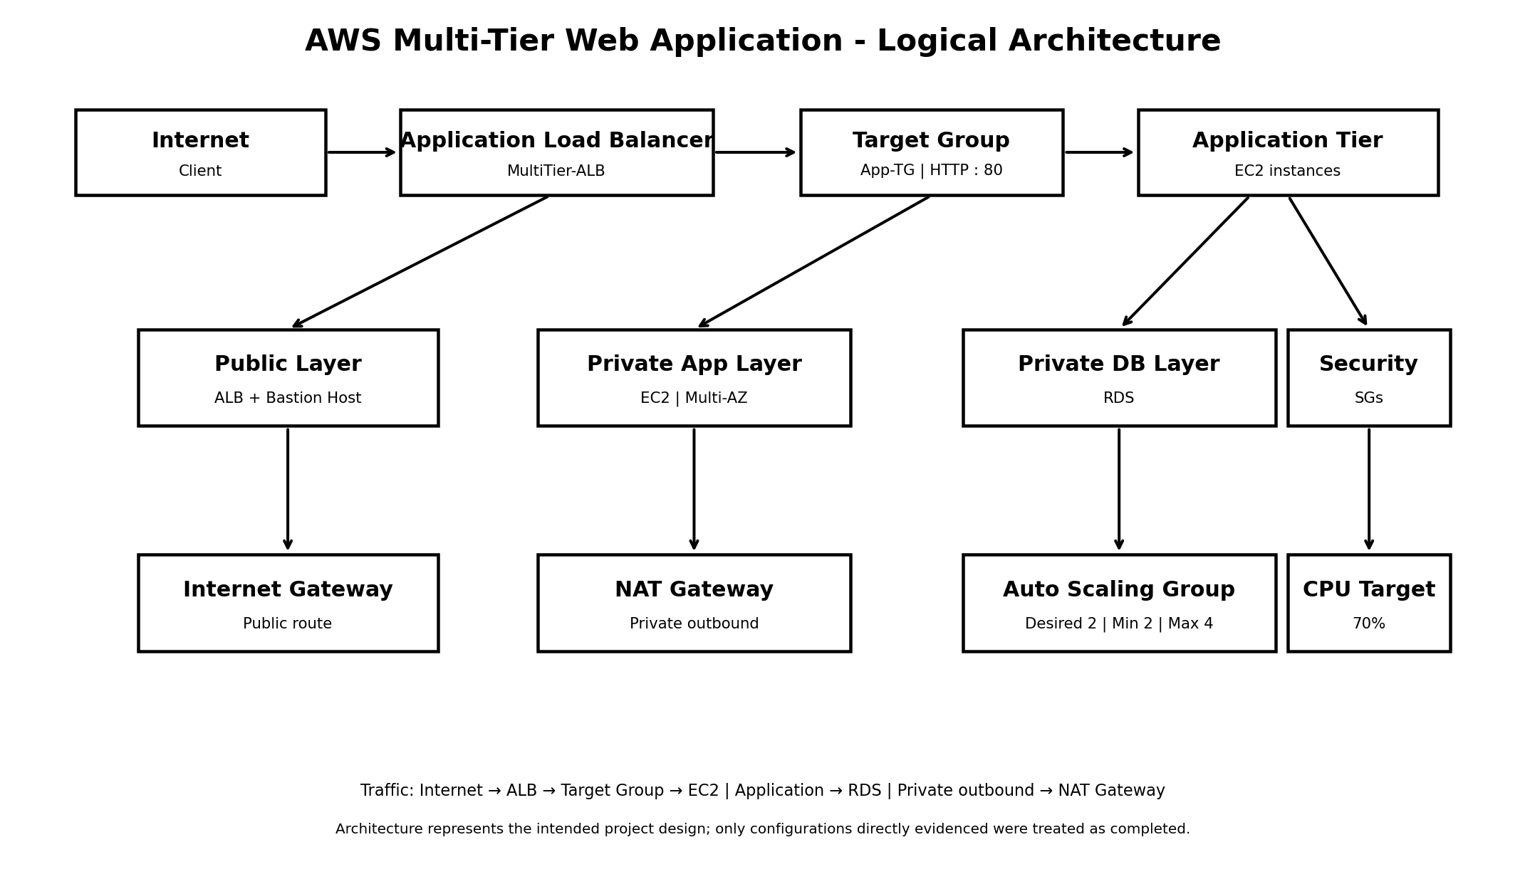
Figure 1. Logical architecture of the AWS multi-tier project. The diagram is a logical representation, not a screenshot.
The intended request path is Internet → Application Load Balancer → Target Group → EC2 application instances. The application tier is managed by an Auto Scaling Group. The database tier is intended to remain private, while private resources can use a NAT Gateway for outbound internet access when required.

3. AWS Services and Why They Were Used
AWS Service / Component | Role in the Project | Why It Was Used
Amazon VPC | Network boundary | Provides isolated networking for project resources.
Public / Private Subnets | Network segmentation | Separates internet-facing and internal resources.
Internet Gateway | Public connectivity | Provides internet routing for public resources.
NAT Gateway | Private outbound access | Allows private resources to reach the internet without public exposure.
Route Tables | Traffic routing | Controls traffic paths for public and private subnets.
Security Groups | Network security | Restricts traffic between application tiers.
Amazon EC2 | Application compute | Hosts the web/application workload.
Bastion Host | Administrative access | Provides controlled access to private instances.
Launch Template | Instance configuration | Provides a repeatable EC2 configuration for Auto Scaling.
Application Load Balancer | Traffic distribution | Routes HTTP requests to healthy application instances.
Target Group | Backend registration | Defines the EC2 targets used by the ALB.
EC2 Auto Scaling | Capacity management | Maintains and adjusts application capacity automatically.
Amazon RDS | Database tier | Provides a managed relational database layer.

4. VPC and Networking

4.1 VPC
The project uses a custom VPC as the main network boundary. The implementation materials refer to the project VPC as MyAppVPC and use the example CIDR 10.0.0.0/16. The AWS console evidence later shows the project operating in ap-south-1.

4.2 Public and Private Subnets
The architecture separates public and private resources. The public layer contains the internet-facing ALB and administrative Bastion Host. Application and database resources are placed in private layers so they are not directly exposed to the internet.
Layer | Typical Resources | Purpose
Public | ALB, Bastion Host | Controlled internet-facing access
Private Application | EC2 application servers | Run application workload
Private Database | RDS | Store application data

4.3 Internet Gateway and NAT Gateway
The Internet Gateway provides a public route for resources in public subnets. The NAT Gateway provides outbound internet access for private resources when required, without assigning public internet reachability to those private instances.

4.4 Route Tables
Route Table | Typical Default Route | Associated Layer
Public Route Table | 0.0.0.0/0 → Internet Gateway | Public subnets
Private Route Table | 0.0.0.0/0 → NAT Gateway | Private subnets

5. Security Design
The security model is based on least-necessary network access between tiers. The ALB accepts application traffic, application instances accept traffic from the ALB and administrative SSH through the controlled access path, and the database accepts database traffic only from the application layer.
Security Group | Expected Access | Purpose
ALB-SG | HTTP 80 / HTTPS 443 from permitted clients | Public entry point
App-SG | Application port from ALB-SG; SSH from Bastion-SG | Application tier
DB-SG | Database port from App-SG only | Database tier
Bastion-SG | SSH from administrator source | Administrative access
The database should not be exposed directly to the public internet. SSH access should also be restricted to a controlled source rather than opened broadly.

6. Bastion Host
The Bastion Host is the administrative access point for private EC2 instances. It is placed in a public subnet while application servers remain private. This avoids making every application server directly reachable from the internet.
Administrative access flow:
Administrator → Bastion Host → Private Application EC2

7. EC2 / Application Tier
The application tier uses EC2 instances in private subnets. The supplied console evidence shows t3.micro instances across ap-south-1a and ap-south-1b, including an instance named Bastion-Host. The application instances are intended to be registered behind the ALB through App-TG.
Item | Observed / Intended Configuration
Instance type | t3.micro
Region | ap-south-1
Availability Zones observed | ap-south-1a and ap-south-1b
Application access | Through ALB
Private access | Through Bastion / controlled network path

8. Launch Template
App-Launch-Template provides the standard EC2 configuration used by the Auto Scaling Group. A launch template improves consistency because newly launched instances use the same base configuration.
- AMI / operating system selection.
- Instance type.
- Key pair.
- Application security group.
- Storage configuration.
- Optional user-data configuration for automatic application setup.

9. Application Load Balancer
MultiTier-ALB acts as the public entry point for the application. It receives HTTP requests and forwards them to healthy EC2 targets through App-TG.
ALB Setting | Observed Value
Name | MultiTier-ALB
Type | Application Load Balancer
Listener | HTTP : 80
Target Group | App-TG
Region | ap-south-1
Traffic flow:
Client → MultiTier-ALB → App-TG → EC2 Application Instances

10. Target Group and Health Checks
App-TG is configured as an instance target group using HTTP on port 80. It is associated with MultiTier-ALB. Target health determines whether the load balancer can send traffic to an instance.
Target Group Setting | Observed Value
Name | App-TG
Target type | Instance
Protocol | HTTP
Port | 80
Load Balancer | MultiTier-ALB

Health Checks
Health Check Setting | Observed Value
EC2 health checks | Always enabled
ELB health checks | Enabled
Grace period | 300 seconds

11. Auto Scaling

11.1 Auto Scaling Group
App-ASG manages the application EC2 fleet. It uses App-Launch-Template and maintains the configured capacity boundaries.
Parameter | Observed Value
Auto Scaling Group | App-ASG
Launch Template | App-Launch-Template
Desired capacity | 2
Minimum capacity | 2
Maximum capacity | 4

11.2 Target Tracking
The scaling policy uses Average CPU utilization as the target metric. The configured target is 70%, with a 300-second instance warm-up.
Policy | Observed Value
Type | Target Tracking Scaling Policy
Metric | Average CPU utilization
Target | 70%
Instance warm-up | 300 seconds
Conceptually, sustained CPU utilization above the target can cause the ASG to add capacity, while lower utilization can allow the group to move back toward the desired capacity, subject to AWS scaling behavior.

11.3 Self-Healing
With health checks enabled, an unhealthy instance can be removed and replaced by the Auto Scaling Group. The replacement then becomes available to the load balancer after it passes the relevant health checks.

12. Database Tier
The multi-tier design includes a private database tier using Amazon RDS. The database should be placed in private subnets and protected by a database security group that allows connections only from the application layer.
Database Design Element | Recommended Project Configuration
Service | Amazon RDS
Network | Private subnet(s)
Public access | Disabled
Access source | Application security group
Database port | Engine-specific port, e.g. MySQL 3306
RDS deployment details were not directly visible in the supplied final screenshot set, so this section documents the database-tier design rather than claiming unverified configuration values.

13. Monitoring and Self-Healing
The project uses health checks as an operational control. EC2 health checks and ELB health checks allow unhealthy capacity to be detected. For a production deployment, CloudWatch alarms and dashboards should be added for CPU, target health, application errors and scaling activity.
CloudWatch and Route 53 were not treated as completed implementation components in this report because they were not part of the verified final configuration evidence. They are listed later as production improvements where appropriate.

14. Testing and Validation
Test | Expected Result | Evidence / Status
ALB access | Application responds through ALB DNS | Final browser validation required
Target health | Application targets become healthy | Recheck final steady state
Multi-AZ placement | Instances distributed across AZs | Observed in EC2 console
ASG capacity | Desired 2, Min 2, Max 4 | Observed
Target tracking | CPU target 70% | Observed
Health checks | EC2 + ELB enabled | Observed
Self-healing | Failed instance replaced | Requires final controlled test
Scale-out | Capacity increases under sustained load | Requires final controlled test
Scale-in | Capacity moves toward desired after load falls | Requires final controlled test

15. Troubleshooting / Problems Solved

15.1 Target Group State
A point-in-time target-group view showed zero registered targets while the ASG evidence later showed multiple instances. This can occur during resource initialization or before registration/health propagation completes. The correct operational response is to verify the ASG attachment, target registration, security groups and target health after stabilization.

15.2 Route Table Deletion Dependency
AWS prevented deletion of Private-Multi-Route because the route table still had associations. The correct cleanup sequence is to remove subnet/edge associations first and then delete the route table.

15.3 Unhealthy / Initializing Instances
During instance startup, an instance can temporarily appear as initializing or unhealthy. The correct troubleshooting sequence is to check instance status checks, application startup, security-group rules, target-group health-check configuration and the ASG activity history.

16. Results
The verified infrastructure configuration demonstrates a scalable AWS application tier with an Application Load Balancer, target group, Auto Scaling Group, multi-AZ EC2 placement, health checks and CPU-based target tracking.
Capability | Observed Result
Load balancing | MultiTier-ALB configured with App-TG
Backend protocol | HTTP : 80
Auto Scaling | Desired 2 / Min 2 / Max 4
Scaling policy | Average CPU target 70%
Health checks | EC2 + ELB enabled
Instance distribution | ap-south-1a and ap-south-1b observed
Launch consistency | App-Launch-Template

17. Skills Demonstrated

AWS / Cloud
- Amazon VPC
- Amazon EC2
- Application Load Balancer
- EC2 Auto Scaling
- Target Groups
- Security Groups
- Route Tables
- Internet Gateway
- NAT Gateway
- Amazon RDS concepts
- IAM concepts

Networking
- CIDR and subnetting
- Public/private subnet architecture
- Routing
- NAT
- Load-balancer traffic flow
- Tier-to-tier security

Cloud / DevOps Concepts
- High availability
- Horizontal scaling
- Self-healing
- Health checks
- Infrastructure troubleshooting
- Repeatable EC2 configuration using Launch Templates

18. Future Production Improvements
- Enable HTTPS using AWS Certificate Manager (ACM).
- Use Route 53 for custom DNS and domain routing.
- Add CloudWatch alarms and dashboards for CPU, target health and application metrics.
- Add AWS WAF for web-application protection.
- Use AWS Secrets Manager for database credentials and other secrets.
- Introduce CI/CD using GitHub Actions, AWS CodePipeline or another pipeline.
- Use Terraform or CloudFormation for Infrastructure as Code.
- Configure Multi-AZ RDS and automated backups where required.
- Add centralized logging and application-level observability.

19. Conclusion
This project demonstrates practical AWS cloud architecture rather than isolated service configuration. The design separates network tiers, places application compute behind an Application Load Balancer, uses an Auto Scaling Group to manage capacity, and applies health checks to support availability. The verified configuration of App-ASG with desired 2, minimum 2, maximum 4 and 70% CPU target tracking demonstrates the core scalability model.
The project also provided hands-on troubleshooting experience with target registration, instance health and AWS resource dependencies. For a production-ready implementation, the next steps would be stronger observability, HTTPS, managed secrets, Infrastructure as Code and CI/CD.

20. References
- AWS Management Console - project implementation environment.
- AWS documentation for Amazon VPC, EC2, Application Load Balancer, Auto Scaling and Amazon RDS.
- Project assignment material supplied for the AWS Multi-Tier implementation.

