AWS Organizations: Create OU, Create Account, and Move Account

Objective: To open AWS Organizations, create a new organizational unit (OU), create a new AWS member account, move the account into the target OU, and verify the final hierarchy.
New OU Name: Web-Dev
New AWS Account Name: Suraj
Target Hierarchy Action: Move the member account into the Web-Dev OU

Step 1: Log In to the AWS Management Console
Open the AWS Management Console and sign in using the management account. After successful authentication, the Console Home page is displayed.
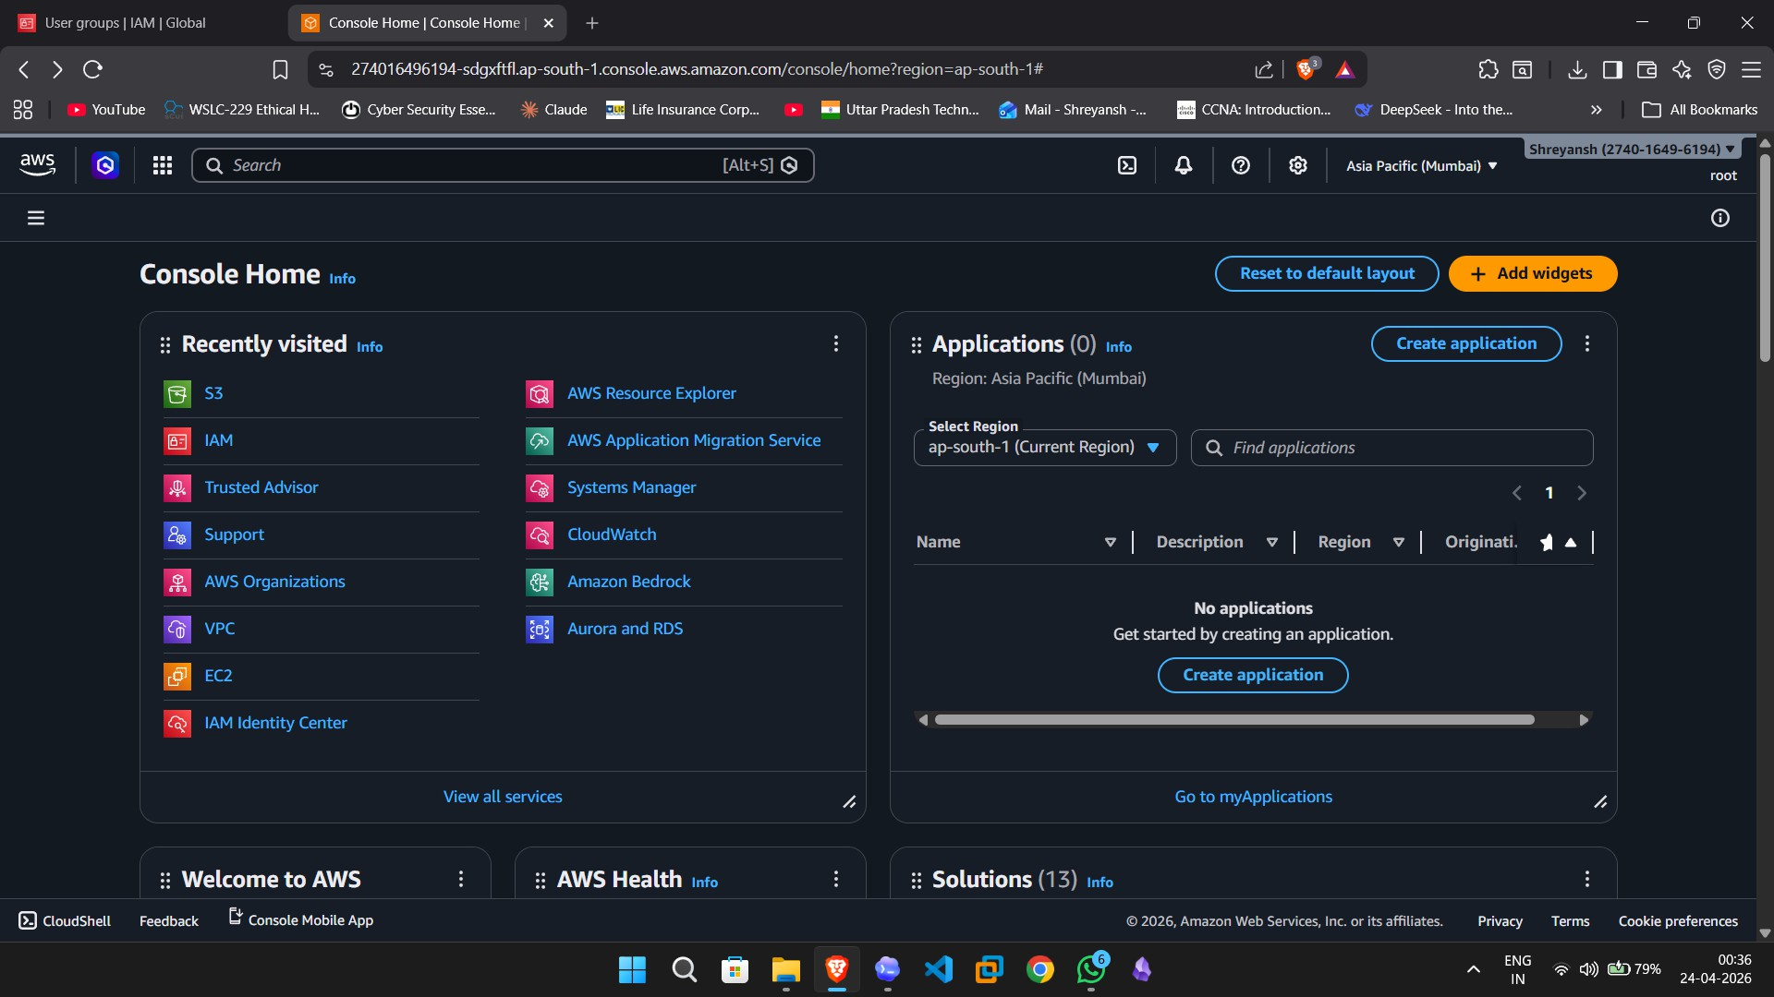

Step 2: Search for AWS Organizations
Use the AWS search bar to find AWS Organizations. Select the service from the search results to open the organizational management console.
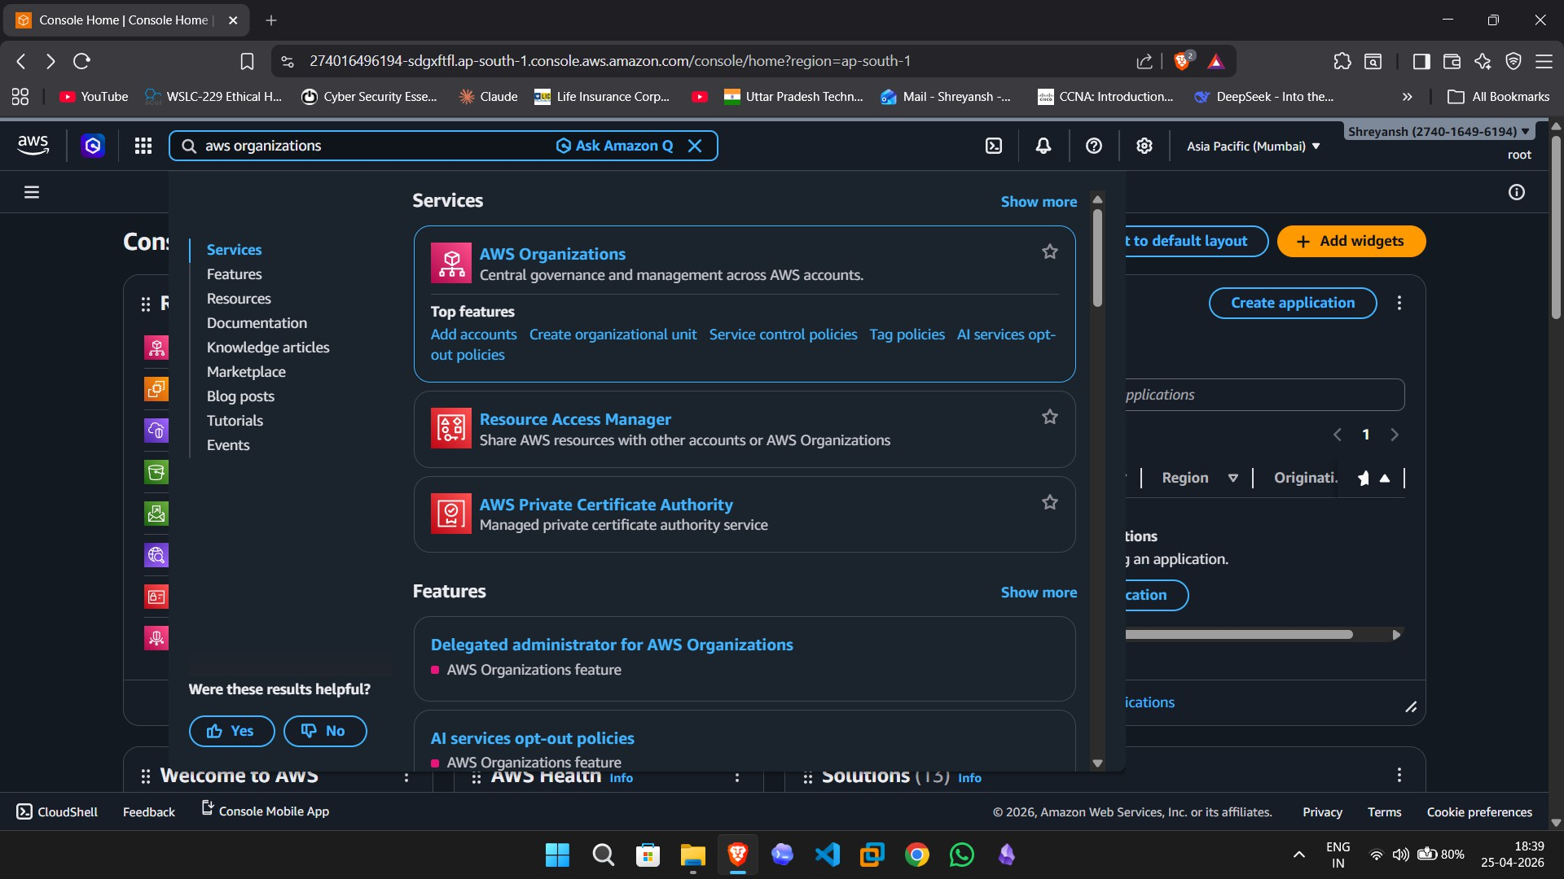

Step 3: Open the AWS Accounts View
In AWS Organizations, open the AWS accounts section to review the current organizational structure. The hierarchy view shows the root and existing organizational units.
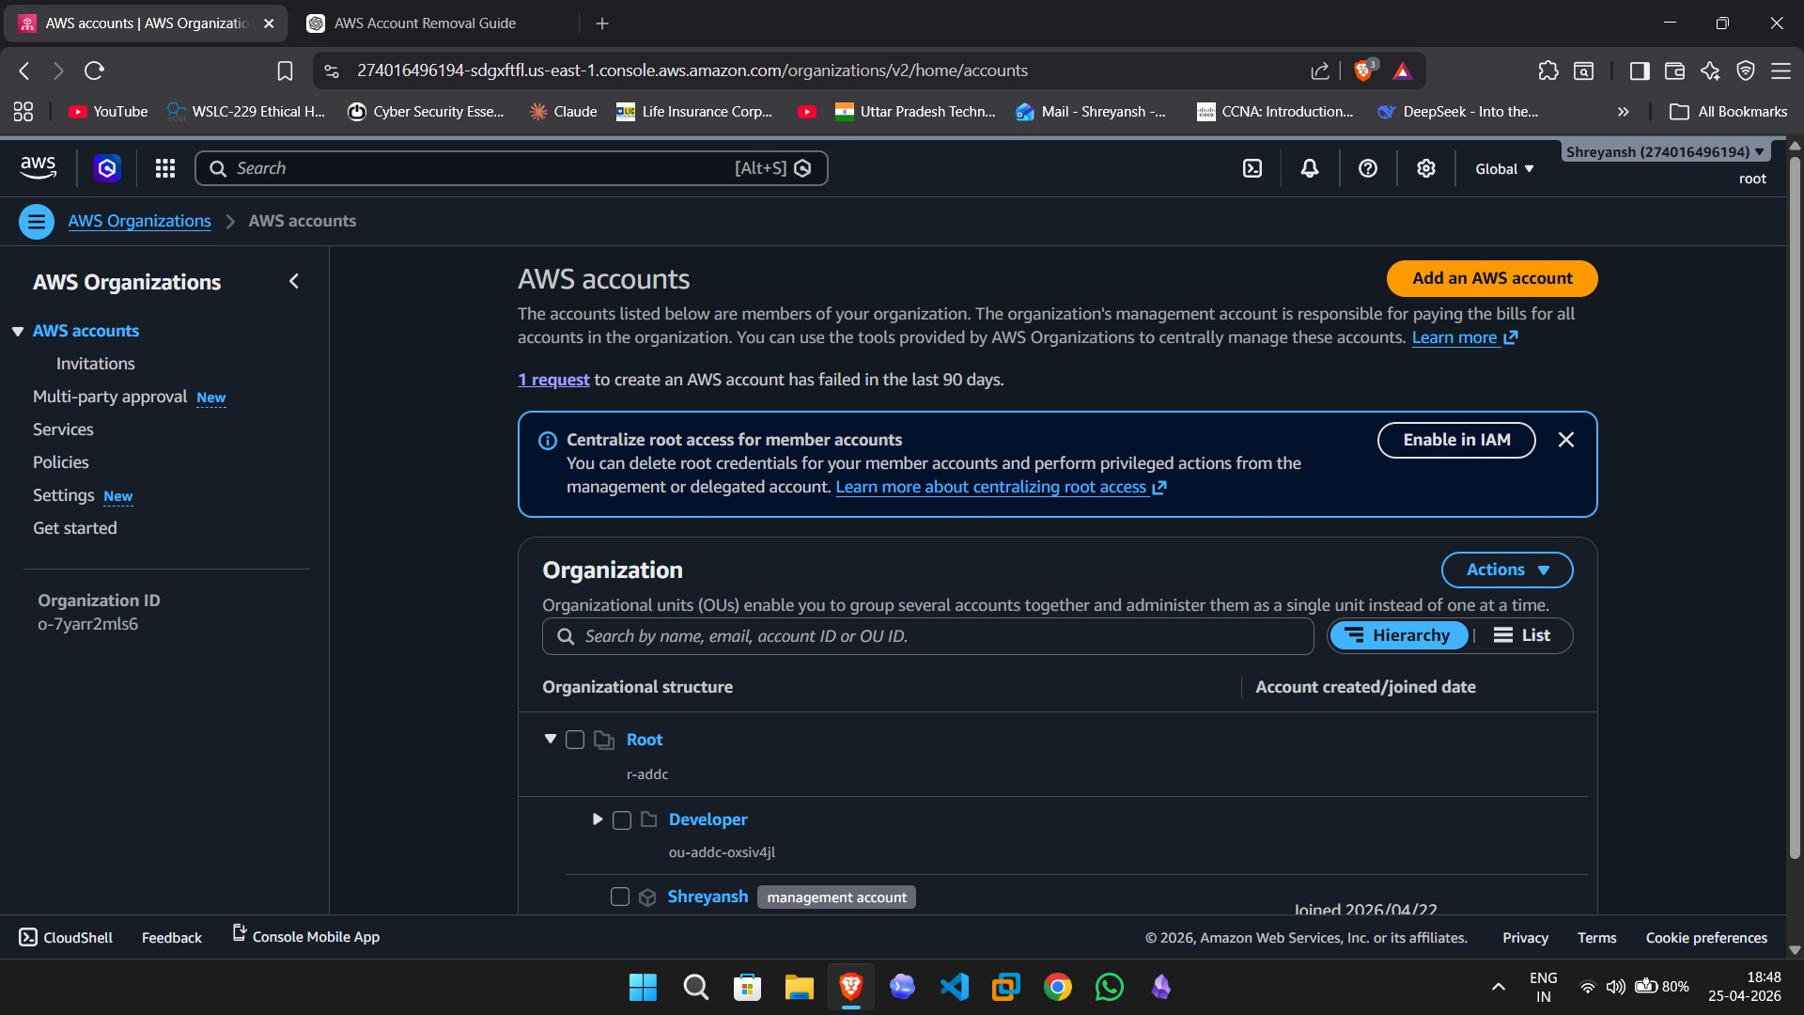

Step 4: Start Creating a New Organizational Unit
Select the root container, open the Actions menu, and choose Create new under organizational units. This begins the process of creating a new OU.
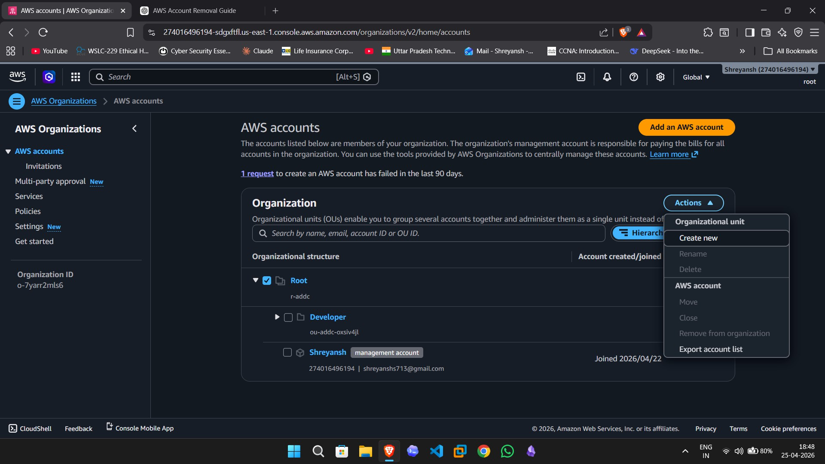

Step 5: Enter the OU Details
Provide the organizational unit name Web-Dev and continue with the OU creation process. This OU will be used to organize web-development-related AWS accounts.
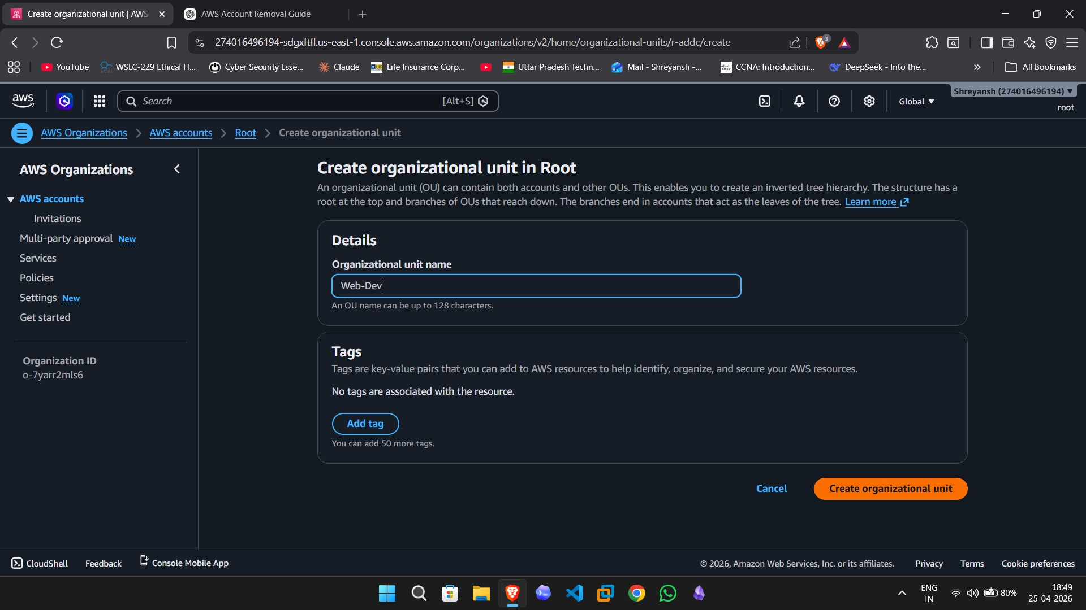

Step 6: Verify That the Web-Dev OU Was Created
After creation, return to the hierarchy view and confirm that the new OU Web-Dev appears under the root.
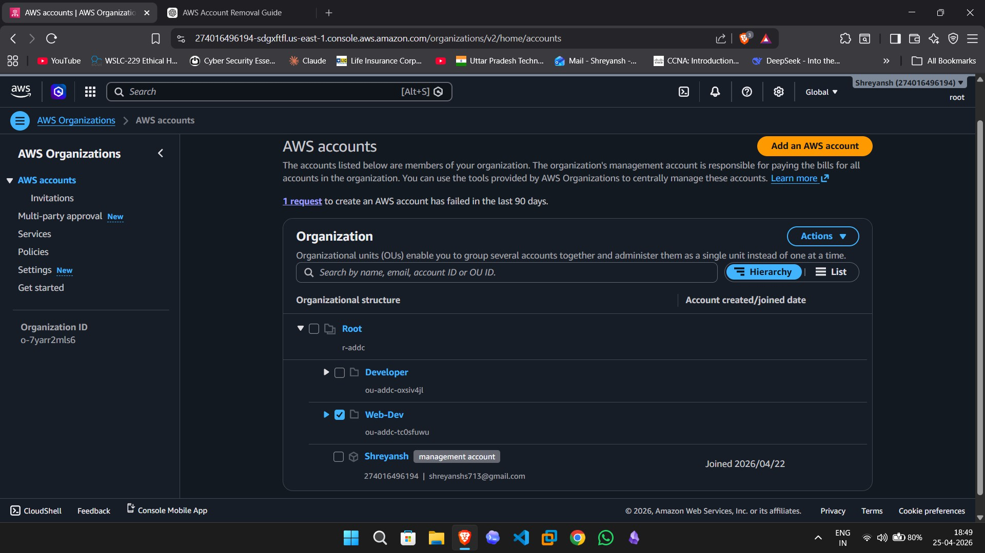

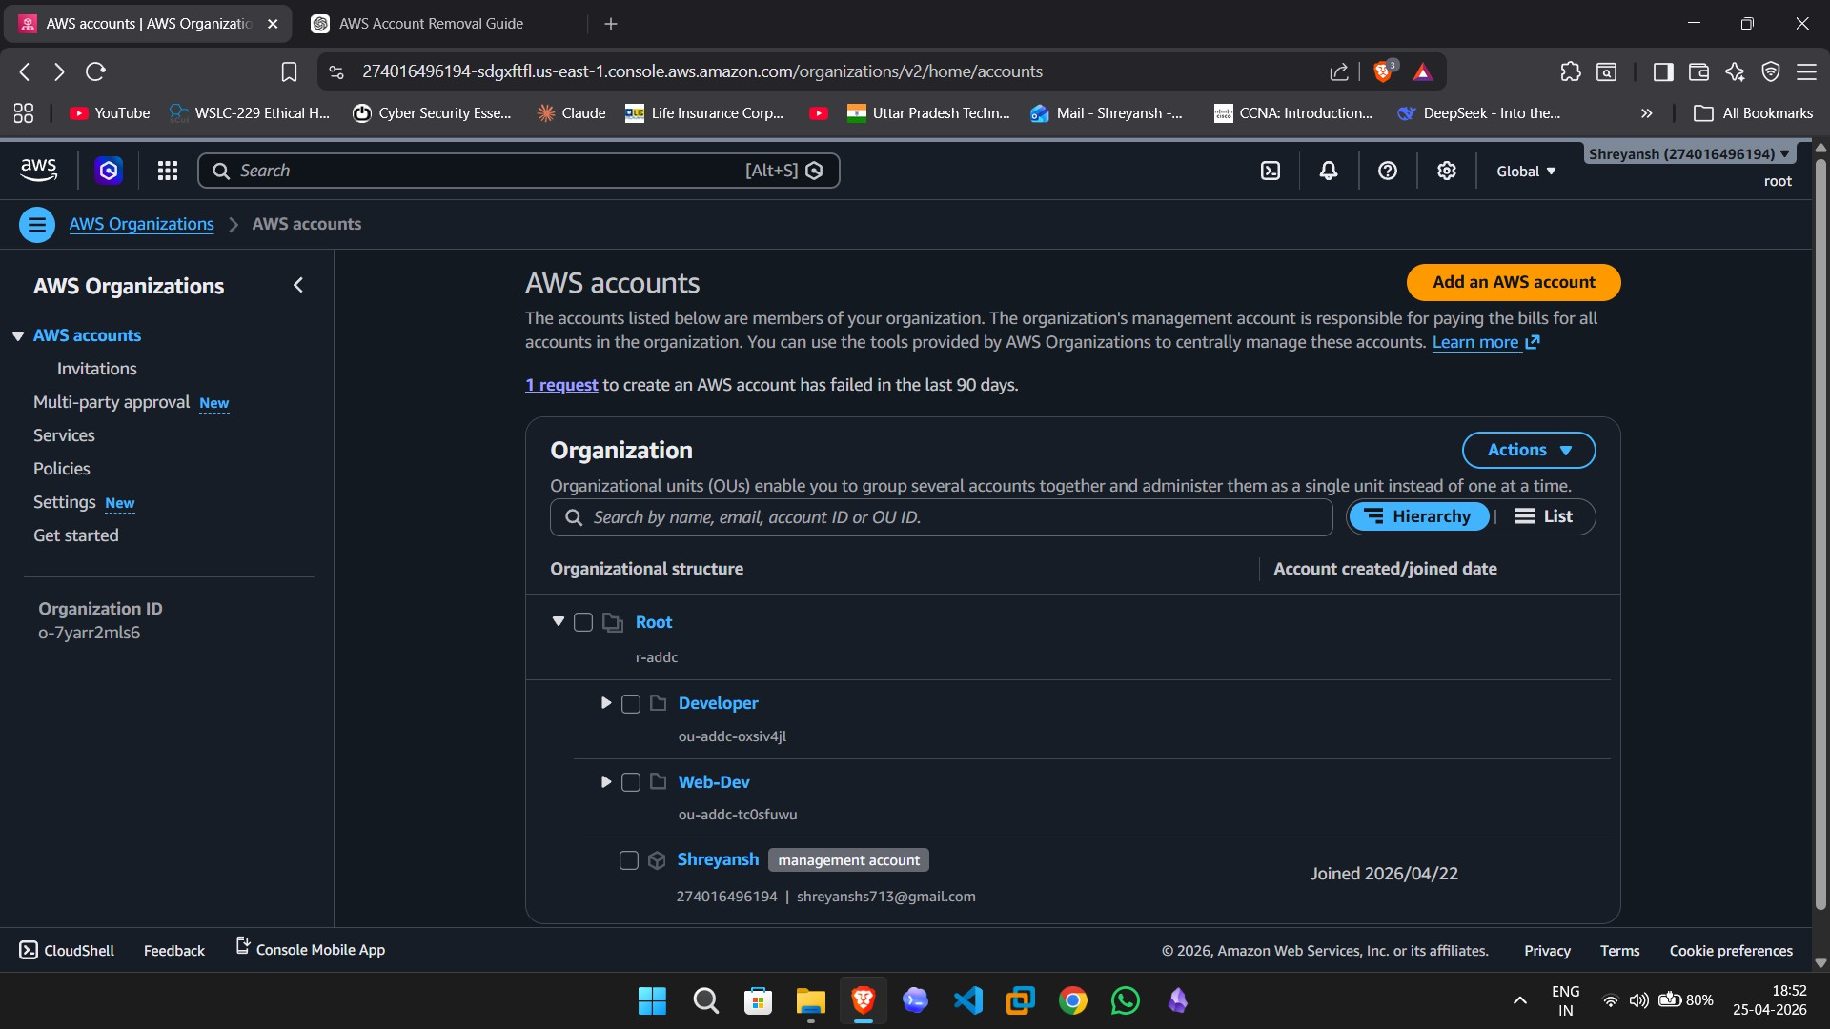

Step 7: Create a New AWS Account
Click Add an AWS account and choose the option to create a new AWS account. Enter the account name Suraj, the owner email address, and keep the default IAM role name.
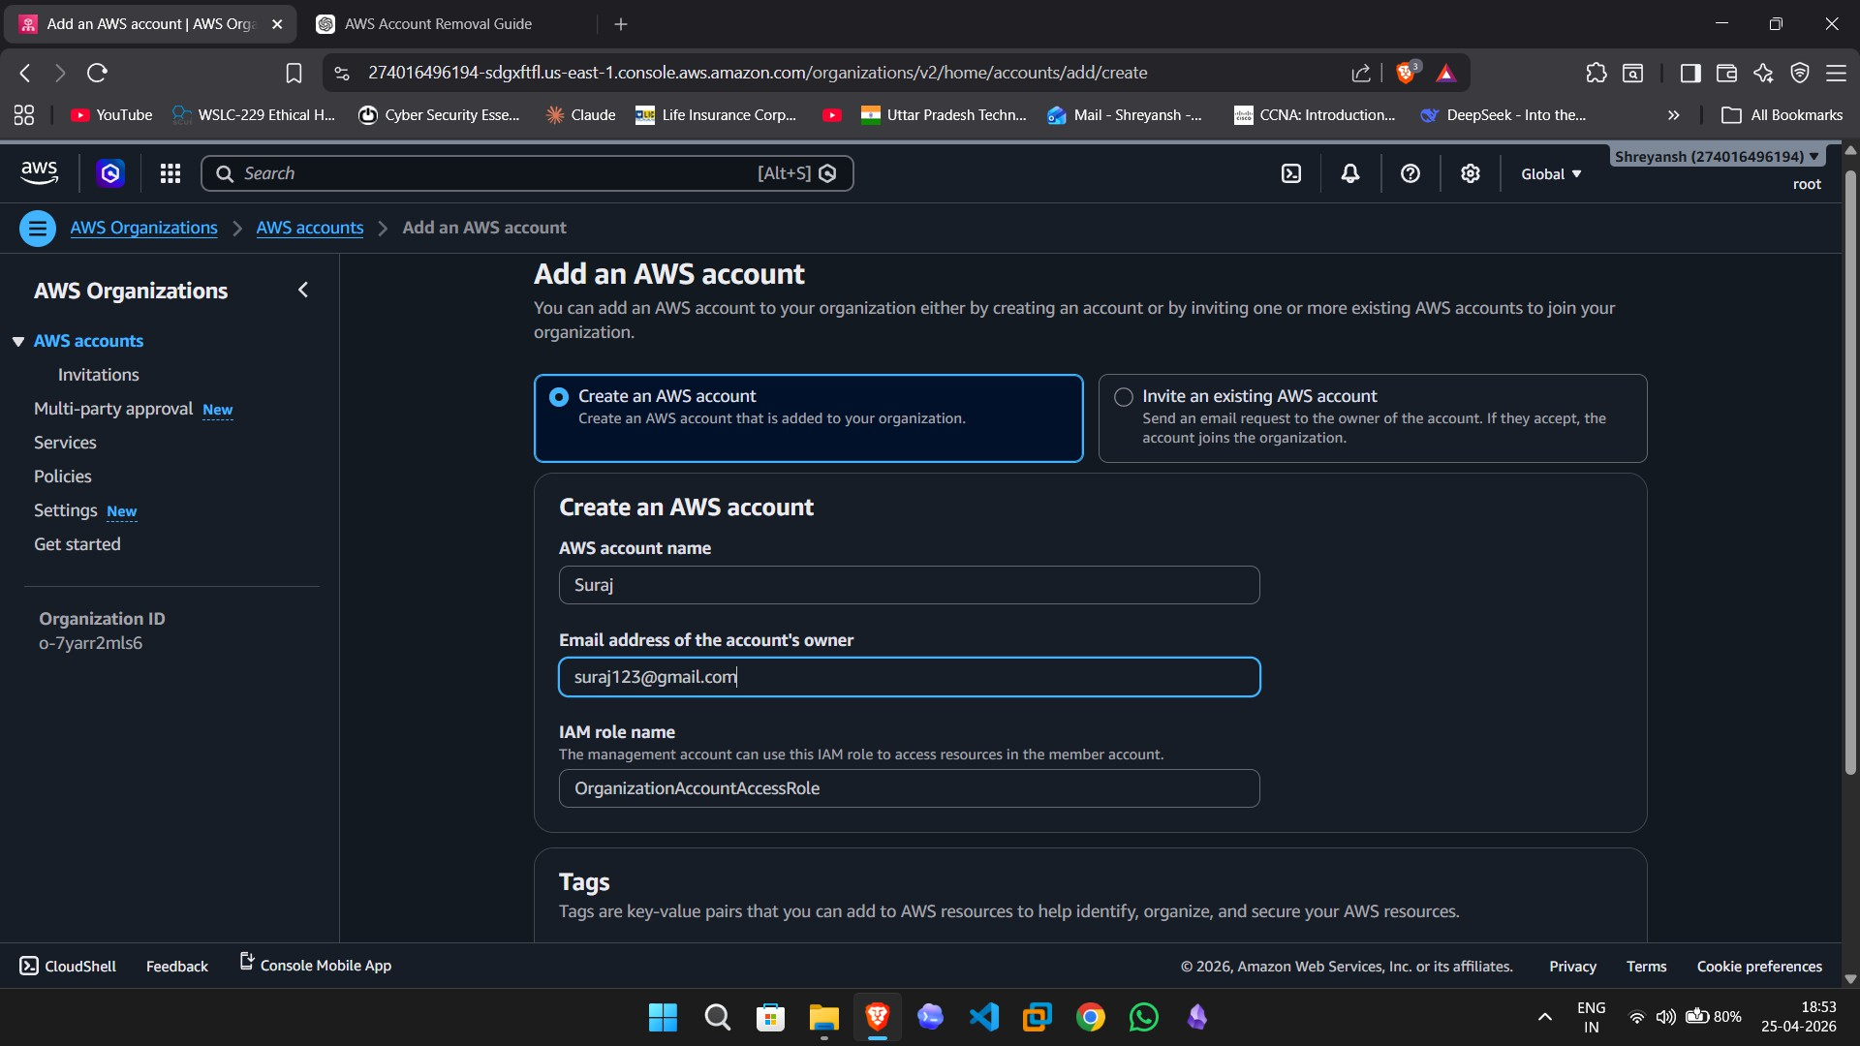

Step 8: Verify That the New Account Was Added
After the account creation request completes, confirm that the new member account Suraj appears in the hierarchy.

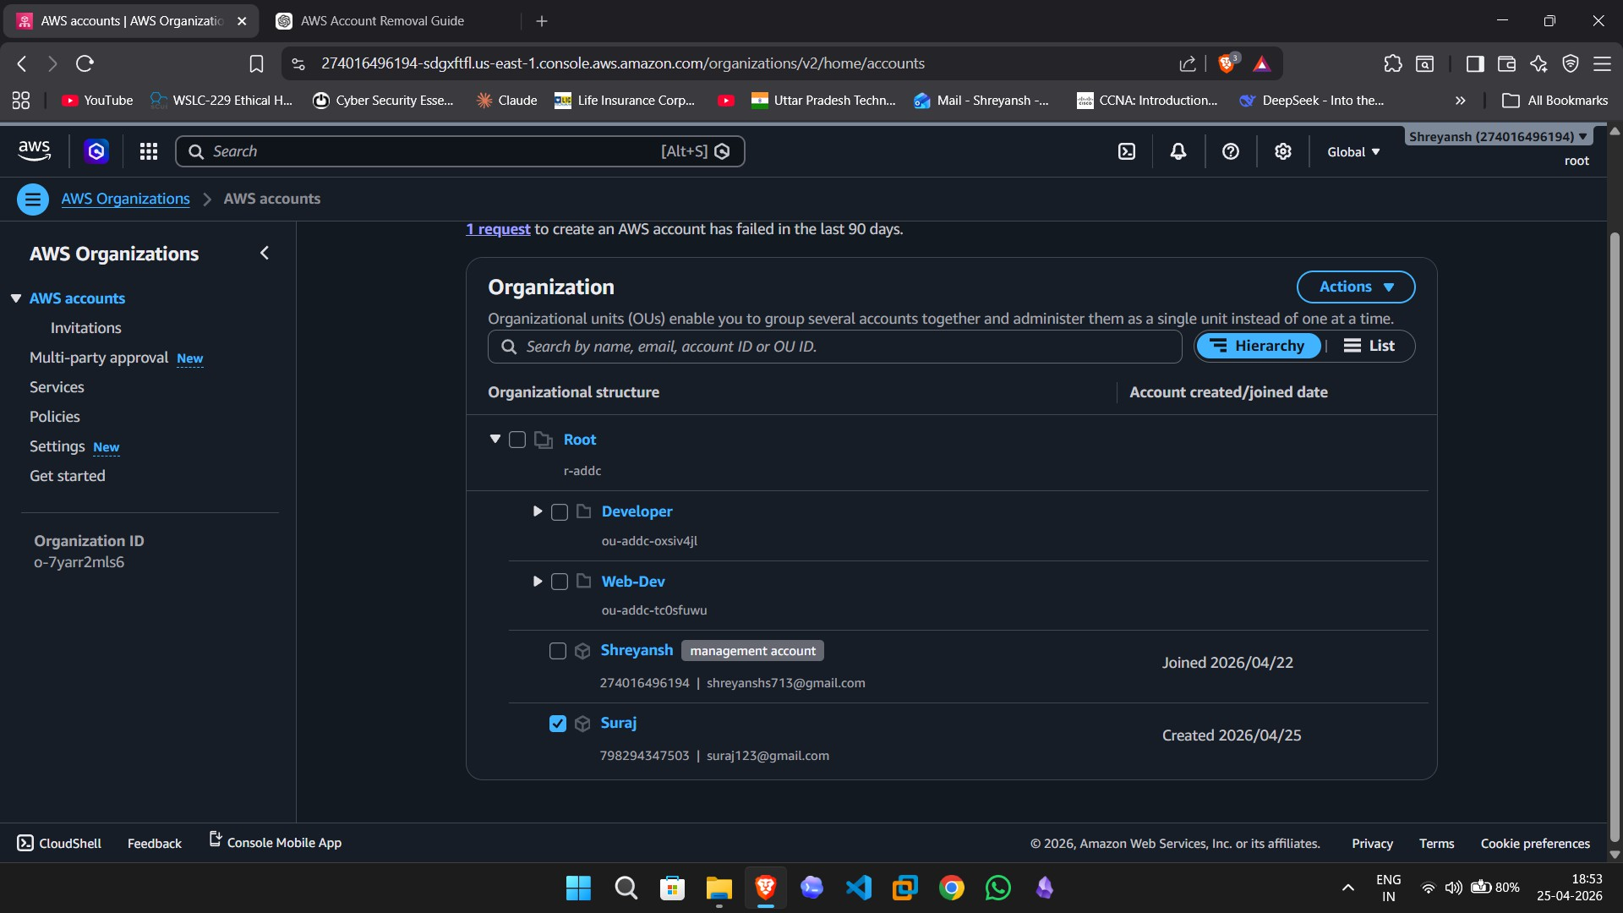

Step 9: Start the Account Move Operation
Select the Suraj account, open the Actions menu, and choose Move under the AWS account section. This allows the account to be reassigned to a different organizational unit.
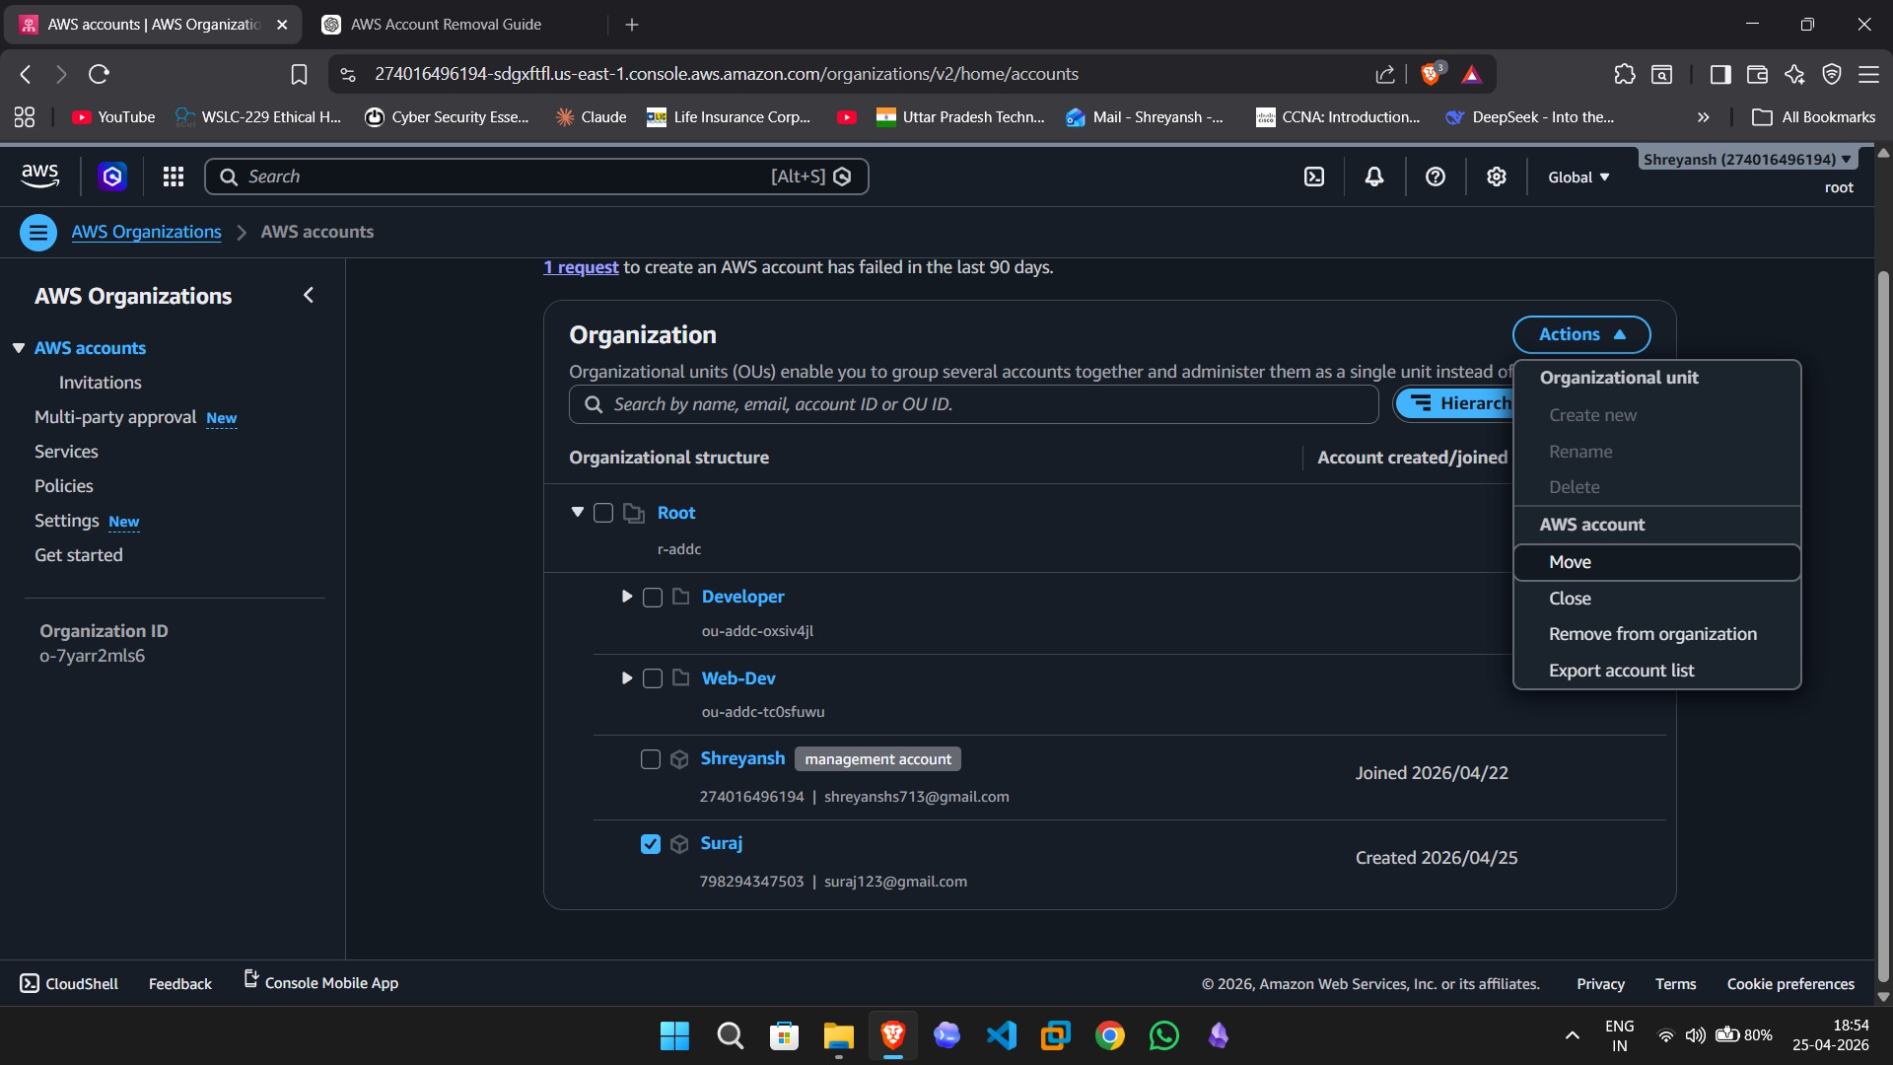

Step 10: Choose the Destination OU
In the move dialog, select Web-Dev as the destination organizational unit and proceed with the account move.

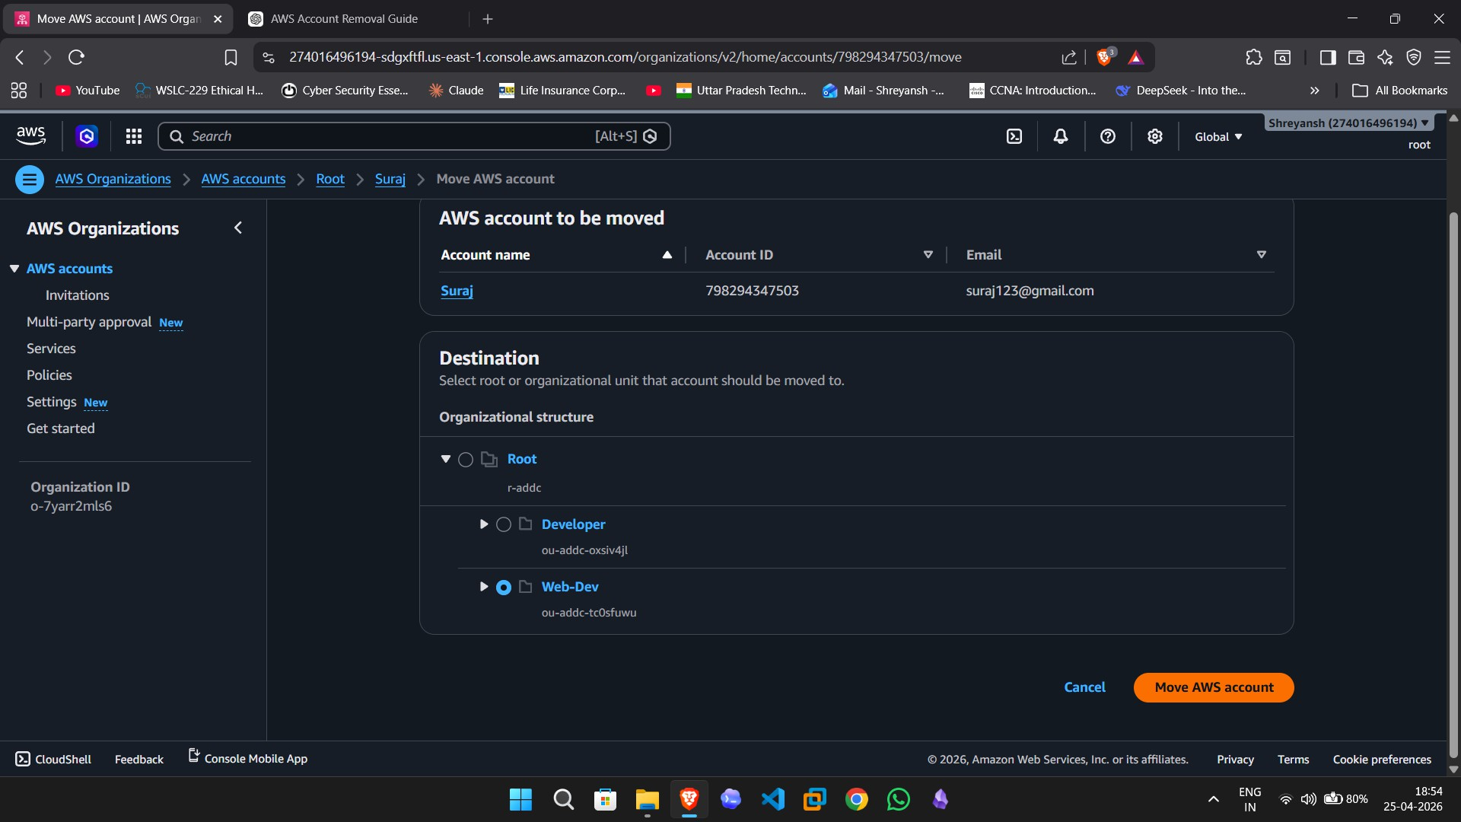

Step 11: Verify the Final Organizational Structure
Finally, review the hierarchy and confirm that the Suraj account is now located inside the Web-Dev OU. This verifies that the move operation was completed successfully.

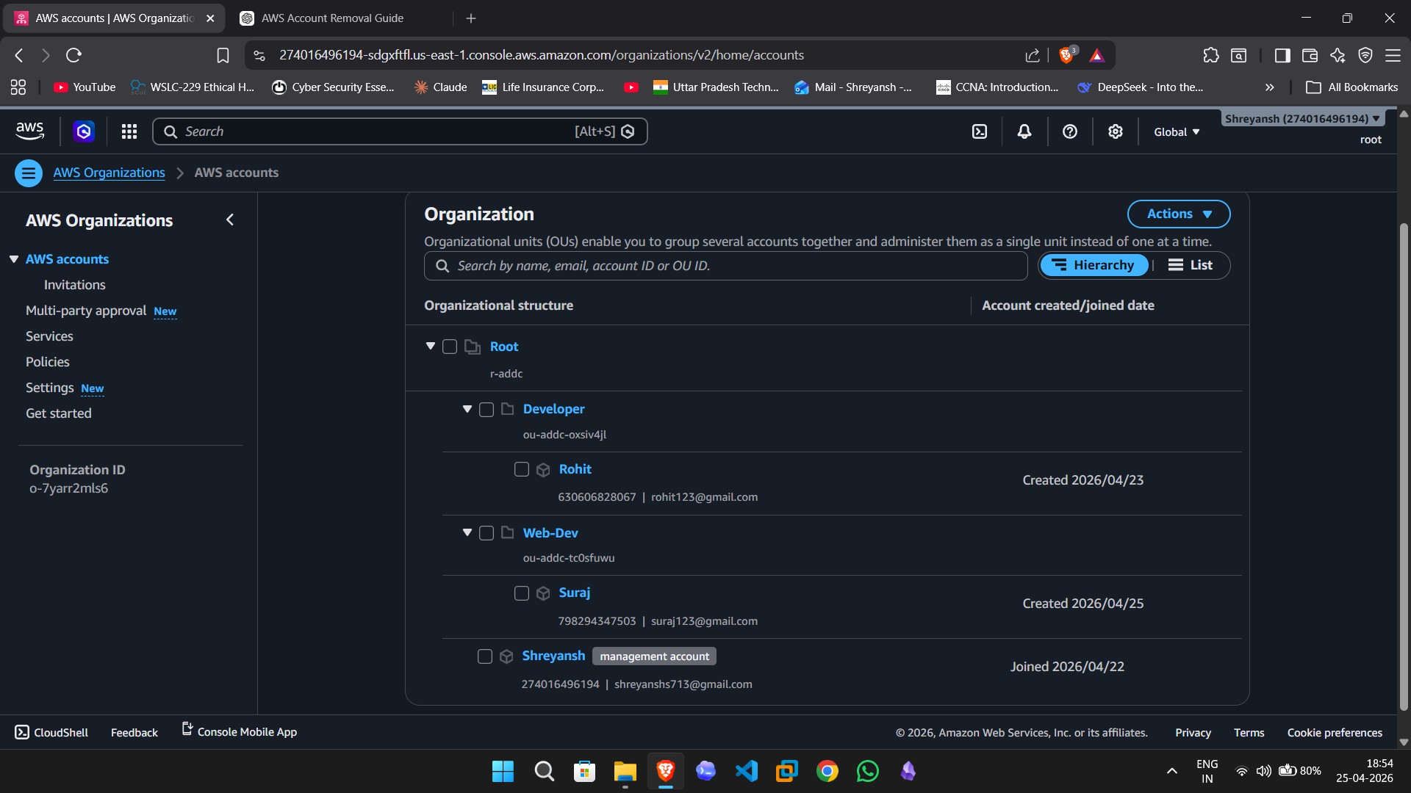

Result

The AWS Organizations practical was completed successfully. The Web-Dev organizational unit was created, a new AWS member account named Suraj was added, and the account was moved into the Web-Dev OU. The final hierarchy view confirmed the correct placement of the account.

