

Object Oriented Programming
Capstone Project Report

Project Title: CineStream
Members: Shreyansh Singhal (590011979), Soumil Dubey (590016651)
Course/Batch: BT-CSE-IV-SPZ-CSF-B8
Submission Date: 07 May 2026

Project Overview
Cinema ticket booking systems are widely used to automate the process of movie reservation and seat management. Traditional manual booking systems are inefficient, time-consuming, and prone to errors such as double booking or incorrect seat allocation. The CineStream project solves this problem by providing a desktop-based movie ticket booking platform developed in Java using Swing GUI components.
The project simulates a real-world cinema booking workflow, including user registration, login authentication, mall selection, movie browsing, seat selection, and payment checkout.
- To develop a Java-based desktop application using Swing GUI.
- To implement user registration and login authentication.
- To manage movies, malls, and seat bookings using object-oriented programming concepts.
- To provide interactive seat selection and booking confirmation.
- To calculate GST and generate booking summaries automatically.

Requirement Analysis

Functional Requirements
- User registration and login with credential validation.
- Browse malls and currently available movies.
- Select cinema halls/screens for different movies.
- Interactive seat selection system.
- Booking summary generation with GST calculation.
- Payment confirmation and seat reservation persistence during runtime.

Software Requirements
- Java JDK 17 or above
- VS Code / IntelliJ IDEA / Eclipse
- Java Swing
- Git & GitHub
- Windows / Linux / macOS

System Design

Module Description
Login Module: Handles user registration and authentication.
Dashboard Module: Displays available malls and movies.
Seat Selection Module: Allows users to select and reserve seats.
Booking Module: Generates booking summary and payment confirmation.
Data Management Module: Stores users, malls, and bookings using HashMap and ArrayList.

Simple Flow Diagram
Start → Login/Register → Dashboard → Select Mall → Select Movie → Choose Seats → Payment Checkout → Booking Confirmation → Exit

Database Design (In-Memory Data Structures)
Data Structure | Purpose | Description
HashMap<String, User> | User Storage | Stores registered users and credentials
ArrayList<Mall> | Mall Management | Stores list of malls and movies
boolean[][] | Seat Management | Tracks reserved and available seats

Implementation

Technologies Used
- Java
- Java Swing
- Object-Oriented Programming (OOP)
- HashMap & ArrayList
- Git / GitHub

Screenshots of GUI
Login Screen
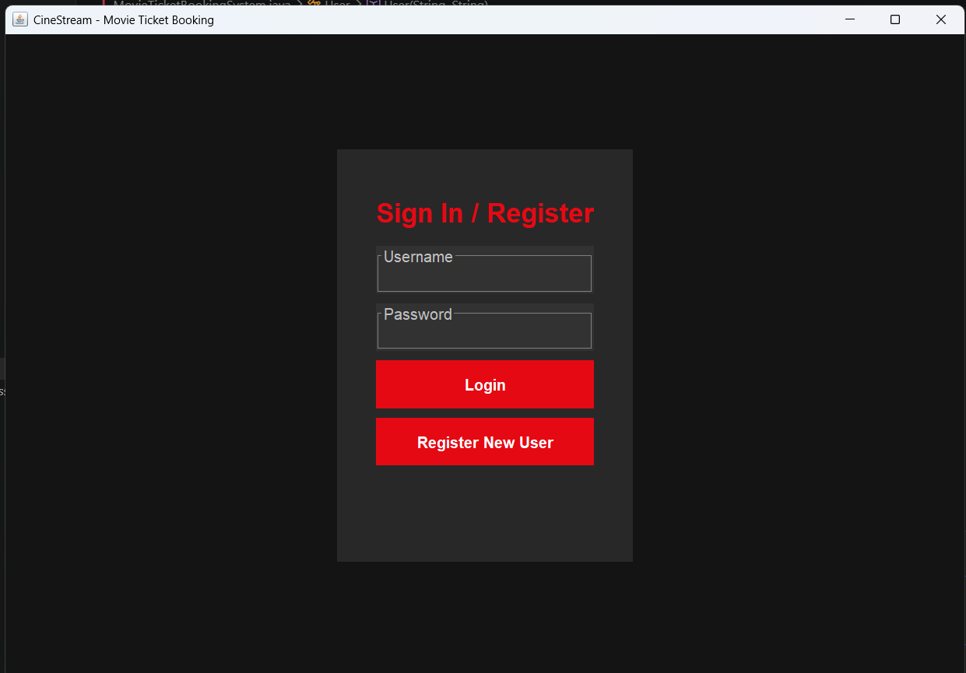

Dashboard / Mall Selection
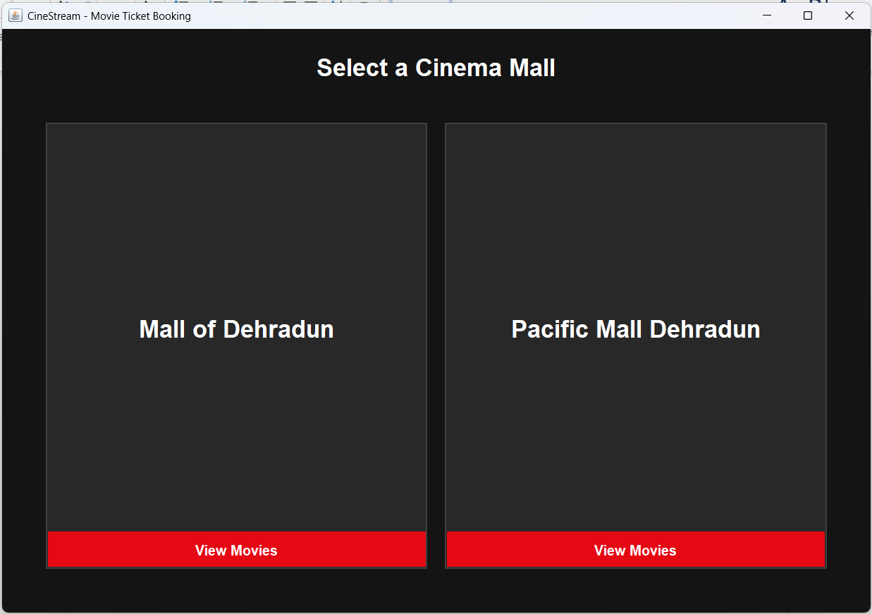
Movie Selection Screen
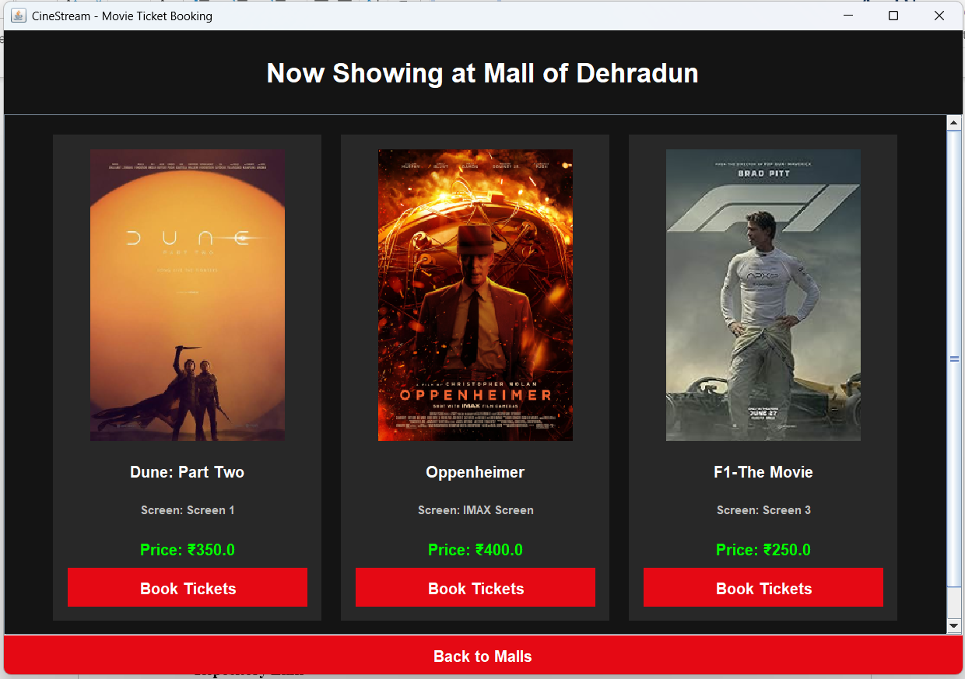
Seat Booking Interface
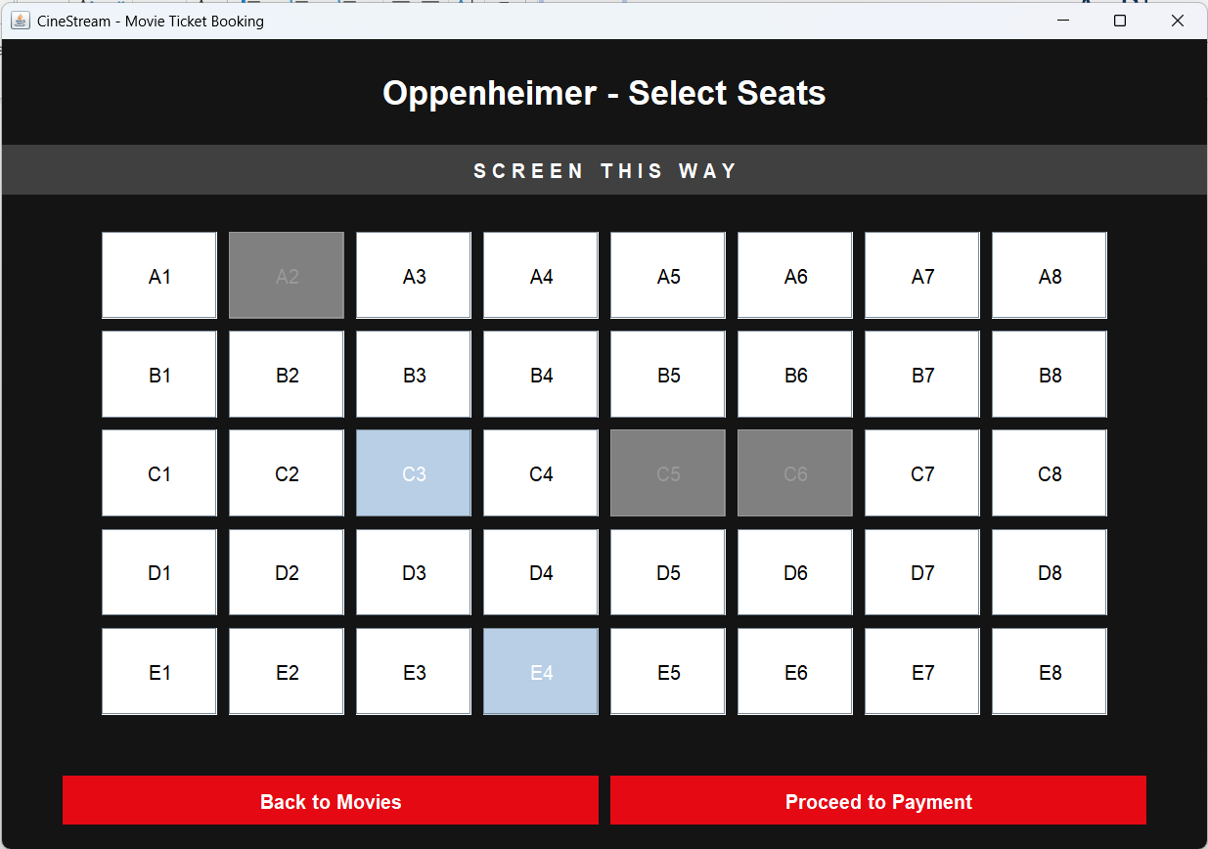
Payment & Booking Confirmation
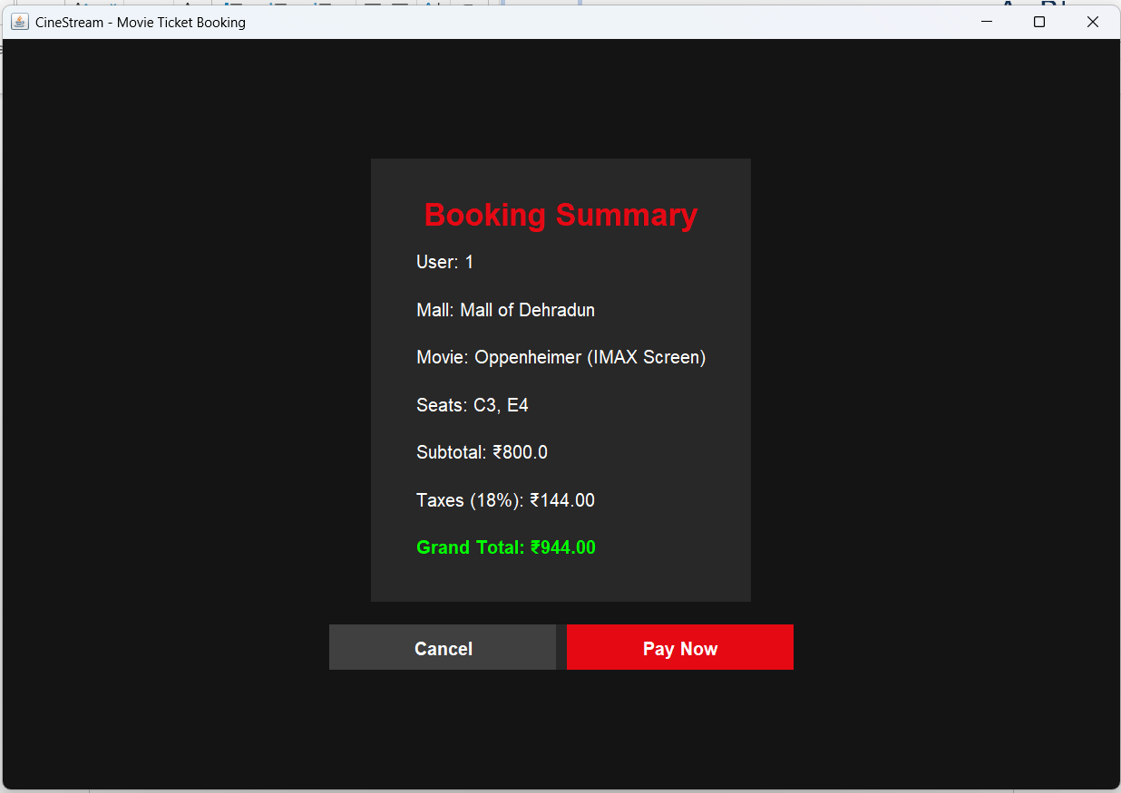
Important Code Snippets
User Login Authentication
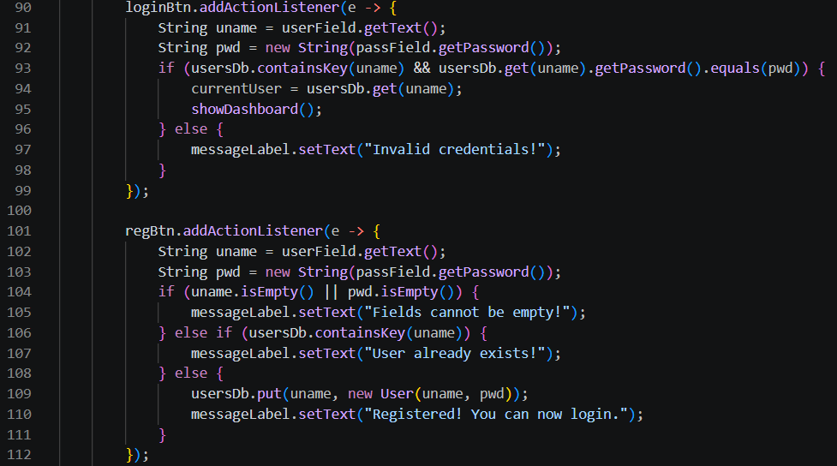
In-Memory Database using HashMap & ArrayList
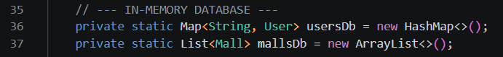
Encapsulation
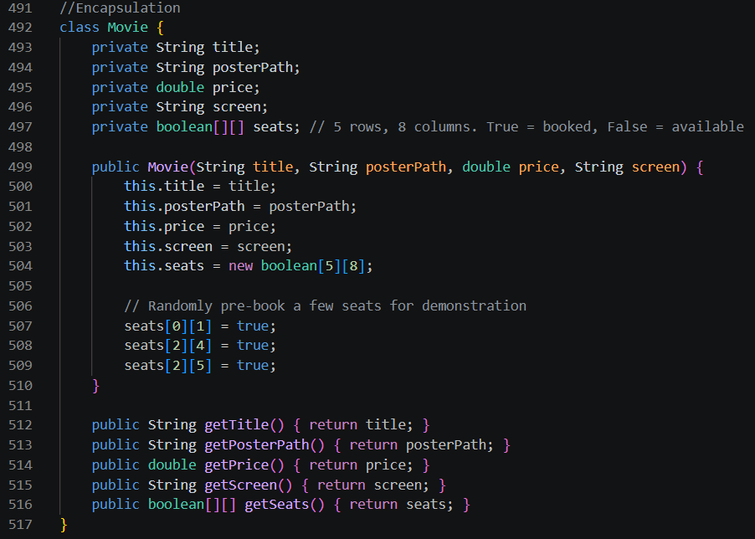
Swing GUI Button Styling
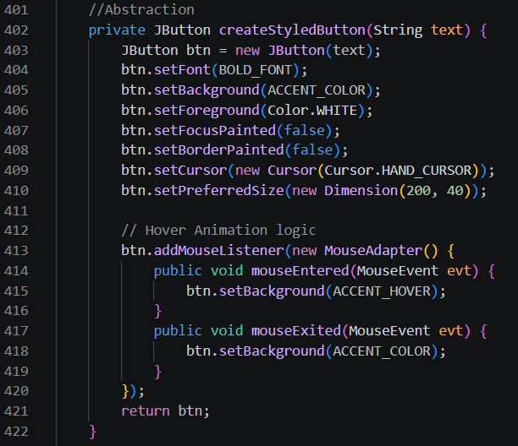

GitHub and Version Control
Repository Link
https://github.com/Shreyansh779/CineStream

