Quantum Shield
Spacetime error detection as a game
Team Schrodinger's Hackers (Shreyansh Agarwal, Vihan Karnik, Sarthak Sharma) IITJ QFF'26 Hackathon, Advanced Track

1. Project at a glance
Item | Value
Track | Advanced Track - low-overhead spacetime error detection
Repository | Open the public repository on GitHub
Live game | https://gamify-error-detection-with-spaceti-sand.vercel.app/
Stack | Next.js 16 / React 19 / TypeScript; FastAPI; Qiskit 2.5.2, Aer 0.17.2, qiskit-paulice 0.2.1; Vercel Hobby.
Quantum Shield teaches players to protect a fixed quantum computation with coherent Pauli checks. Six Flight Schools introduce the physics and ten main missions test check placement. The experiments show why a useful check can improve retained-shot fidelity, yet excessive checking can lose more than it recovers. Current game scores use Trusted Fidelity with an explicit shot budget.

2. Problem and learning goals
The track asks for a game that makes genuine low-overhead spacetime error detection tangible, rather than decorating a game with QEC vocabulary. Our interpretation is a circuit-protection game: the player surrounds part of a fixed payload circuit with controlled Pauli checks read out on helper (ancilla) qubits, and is scored on a trade-off between how accurate the kept results are and how many shots survive.
Three ideas we wanted players to leave with:
- Detection is not correction. Detection discards runs where a check fires. Mitigation estimates an observable from scaled-noise runs. Correction encodes and recovers. They cost different things and give different kinds of output (Flight School 2).
- A check is an invariant. A single opening Pauli P needs a closing P’ = U P U†. A mismatched closure can create false alarms even without noise; it need not produce syndrome 1 on every shot (Flight Schools 3-4).
- Checks have a price, and non-Clifford gates limit them. Every controlled check adds gates and noise, and across a T gate only I or Z checks remain a single Pauli (Flight Schools 5-6 and the main missions).
The main game implements error detection. Flight School 2 also demonstrates restricted mitigation and repetition-code recovery. This is not a general fault-tolerant decoder or a surface-code/qLDPC implementation, and we make no quantum-advantage claim.

3. Scientific method

3.1 Check construction
For each helper: apply H, controlled opening Pauli factors, the selected payload interval, the matching controlled inverse closing product, H, and terminal measurement. A valid noiseless shell preserves every data input and returns the helper to zero. An intervening fault that anti-commutes with the check at its location can flip the syndrome; commuting faults can escape.

3.2 Signed Pauli propagation
For Clifford gates the closing operator is again a Pauli: P' = U P U†. We compute this with Qiskit Clifford tableaus (backend/quantum_core/pauli.py). Examples used in the tutorials: H swaps X and Z; S sends X to Y; S† sends X to -Y; CNOT sends X on the control to X on both qubits. Signs matter: closing with the wrong sign is physically a different operator unless the controlled relative phase is corrected, and the checks module emits that compensation (backend/quantum_core/checks.py).

3.3 The T-gate restriction
T X T† = (X + Y)/sqrt(2), while T Z T† = Z. The implemented validator allows only I/Z support at each T/T† crossing. It rejects X/Y there even if later gates might recombine the operator into a Pauli. This is the game's restricted check family, inspired by Martiel and Javadi-Abhari [1]; it is not a complete search over all possible non-Clifford invariants.

3.4 Dynamic invariant check (green/red line)
The backend derives a check window from the ordered authored helper operations, rather than a fixed visual column. It transports opening factors through the actual enclosed payload gates and validates the complete noiseless input isometry, including relative phases and interacting helper loops. The frontend draws that result green or red. Green certifies ideal closure, not complete error coverage or a high noisy score.

3.5 Metrics
Let B be the un-normalized data block of the noisy joint density matrix with every measured helper syndrome equal to 0.
- Kept-shot fraction: S_keep = Tr(B)
- Post-selected fidelity: F_ps = Tr(rho_ideal B) / S_keep
- Trusted Fidelity game score: F_ps x min(1, S_keep / S_min)
- Sampling overhead: 1 / S_keep
S_min is the per-level shot budget. Above it, the score equals kept-shot fidelity; below it, the score is reduced in proportion to retention. If S_keep is about zero, fidelity is undefined and the score is zero. The former product, F_ps x S_keep, remains correct_shot_yield in research data. Trusted Fidelity is a game design choice based on simulation-only full-state fidelity, not a hardware-counts fidelity estimator. Exact density evolution makes scores repeatable; illustrative shot counts use seed 2026 and do not determine passing.
Ideal reference. Clifford payloads use a stabilizer-based reference; T-doped payloads use a Qiskit statevector from |0...0>. No stabilizer simulator is applied to a non-Clifford circuit (backend/quantum_core/scoring.py).

4. From physics to game

4.1 Levels
Level | What the player does
FS1 | Compare X, Z and T1/T2 errors on states; Bloch and QSphere views
FS2 | Build a payload; see detection, mitigation (noise scales 1/3/5) and a small repetition-code correction as read-only transformed circuits
FS3 | Guided S payload: place H and an opening check, observe X to Y, inject a fault, read the syndrome
FS4 | Guided H and CNOT payload: multi-wire product closing
FS5 | Guided T gate: Z passes (green), X or Y rejected (red); T-doped sandbox
FS6 | Two data qubits, one helper, a locked four-gate Clifford payload with a noise hotspot; build the shell and reach the target score
Main 1-3 | Clifford payloads; player places both opening P and closing P'
Main 4-7 | Larger Clifford payloads; closing P' is generated automatically from the player's P
Main 8-10 | T-doped payloads with 1, 3 and 5 T/T† gates; only I/Z checks may cross them
Main payloads and helper counts are fixed. Main 1-3 require manual opening and closing checks; Main 4-10 generate the signed closing product automatically. Editable columns can be inserted inside main payloads for short protection windows; tutorials have no insertion control. FS6 and Main 1 use two data qubits and one helper. Main 2-7 use three data qubits; Main 8-10 use four. Main helper counts are 1, 1, 2, 2, 2, 2, 3, 3, 3, 3; the last three missions contain 1, 3 and 5 T/T† gates.

4.2 Architecture and data flow
- The player drags gates, or edits a restricted source view, in the React workspace.
- The typed circuit draft is sent as JSON to same-origin /api routes (16 KiB request cap).
- FastAPI validates bounds and the immutable level definition server-side. Source text is parsed with an AST allowlist and never executed.
- The backend discovers the dynamic invariant and, in levels 4-10, generates the locked closing checks.
- Qiskit builds the ideal reference; Qiskit Aer evolves the noisy density matrix exactly.
- The all-zero-syndrome block gives F_ps and S_keep; the central scoring function applies the level shot budget to obtain Trusted Fidelity.
- The UI shows a compact result, and progress is stored in the browser (localStorage, key quantum-shield-qed-v2). There is no server database or global leaderboard.
Clifford-only research calls go to qiskit-paulice; T-doped circuits use our own finite search, because qiskit-paulice does not accept non-Clifford input.

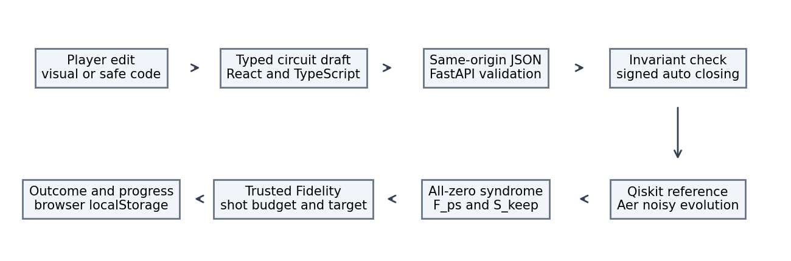
Figure 1. Shared data flow. Native Paulice research and the custom T search are separate from the authoritative live scorer.

4.3 Use of Qiskit, Aer and qiskit-paulice
- Qiskit: circuits, Clifford and Pauli transport, stabilizer and statevector references, and the circuit images in the tutorials.
- Qiskit Aer: exact density-matrix simulation with composed noise channels and seeded diagnostic sampling.
- qiskit-paulice: a guarded Clifford-only wrapper (backend/quantum_core/paulice.py) calls native gamma/windowed check insertion with a disclosed synthetic noise model and seed 2026. Its native objective and observable estimator are distinct from the game's state-based Trusted Fidelity. No game optimum is called Paulice-certified.
- T-doped missions: backend/missions/reference.py enumerates player-reachable single-helper Pauli products over five declared windows. Candidates must have I/Z support at each actual T/T† crossing and pass the ordinary validator. Aer scores them. Best found means the exact maximum within that family, not a global optimum over arbitrary placements or multiple helpers.

5. Experimental protocol and disclosed noise
All noise models are synthetic and chosen by us. We make no hardware-calibration or QPU claim.
Workload | Synthetic noise protocol
Main missions | After every occupied layer on live wires: X=0.00015, Z=0.00015 and depolarizing strength=0.0002. Each controlled check adds two-qubit depolarization 0.025. At the designated CX, q1 relaxes for (74 + 2*level) microseconds with T1=100 and T2=200 microseconds.
FS6 defaults | X and Z probability 0.001 each; 70-microsecond q1 hotspot; T1=100, T2=200 microseconds; controlled-check depolarization 0.02.
FS2 and sliders | Independent X, Z, depolarizing and thermal channels compose on live wires. Probabilities range 0-1; elapsed relaxation time 0-120 microseconds; T2 <= 2*T1.
Matched study | Uniform one-qubit depolarizing strength 0.01 after every serialized gate on every live wire, including check gates, T gates and identity doping slots. Separate Paulice observable experiments have their own disclosed gate/readout model.
The matched study (scripts/run_track_experiments.py, docs/TRACK_EXPERIMENTS.json, notebooks/track_experiments.ipynb) uses a three-data-wire backbone with 1 or 3 repetitions and 0, 1, 2 or 4 T-type gates in identical slot structures, so that Clifford and T-doped circuits are compared like for like. For every configuration we record unchecked fidelity, post-selected fidelity, kept fraction, and the added ancilla, two-qubit gate and depth cost.

6. Results

6.1 Level reference scores
Trusted Fidelity scores from the current stored player drafts. Baseline is no checks; blanket is broad checking; reasonable is a valid non-optimal reference; best found is restricted to the declared search family. S_min is shown explicitly. Full resource counts, additional strategies and paired physical metrics are in docs/LEVEL_VALIDATION.md.
Level | S_min | Baseline | Blanket | Reasonable | Best found | Target
FS6 | 0.99 | 0.4941 | 0.4616 | 0.6749 | 0.6930 | 0.62
M1 | 0.99 | 0.4667 | 0.4402 | 0.6822 | 0.6885 | 0.63
M2 | 0.97 | 0.4559 | 0.4186 | 0.6929 | 0.6932 | 0.64
M3 | 0.94 | 0.4454 | 0.3575 | 0.7079 | 0.7081 | 0.65
M4 | 0.92 | 0.4361 | 0.3608 | 0.7166 | 0.7168 | 0.66
M5 | 0.90 | 0.4244 | 0.3534 | 0.7058 | 0.7214 | 0.66
M6 | 0.87 | 0.4150 | 0.3696 | 0.7202 | 0.7386 | 0.67
M7 | 0.86 | 0.4054 | 0.3212 | 0.7203 | 0.7387 | 0.67
M8 | 0.83 | 0.3907 | 0.2553 | 0.7238 | 0.7440 | 0.67
M9 | 0.82 | 0.3812 | 0.2490 | 0.7231 | 0.7432 | 0.67
M10 | 0.80 | 0.3720 | 0.2718 | 0.7315 | 0.7518 | 0.67
Run-to-run spread is 0 for every row because scores are exact density-matrix expectations.
Physical metrics of the reasonable strategies (F_ps, S_keep): FS6 (0.8162, 0.8186); M1 (0.8224, 0.8213); M2 (0.8193, 0.8204); M3 (0.8144, 0.8170); M4 (0.8100, 0.8139); M5 (0.7918, 0.8022); M6 (0.7838, 0.7994); M7 (0.7780, 0.7962); M8 (0.7588, 0.7917); M9 (0.7518, 0.7886); M10 (0.7448, 0.7858). Full paired metrics for all seven strategies remain in LEVEL_VALIDATION.md.
What the table shows:
- Blanket checking loses in these authored missions. Main 10 scores 0.2718 for blanket checking versus 0.3720 unchecked. Both retained-state damage and retention penalties contribute; it would be incorrect to attribute every loss only to discarded shots.
- Targeted checks improve the game's objective. FS6's reasonable reference scores 0.6749 versus baseline 0.4941. Main 10 reaches 0.7315 against target 0.67. These gains use the disclosed synthetic hotspot model.
- Every baseline and blanket result is at least 0.05 below target; every reasonable reference is at least 0.03 above it. A strictly better best-found reference remains available. Targets occupy 60-80% of the baseline-to-best interval, so passing does not require the exact winner. Repeated exact score spread is zero.
- Unchecked scores fall across the authored progression, from 0.4667 in Main 1 to 0.3720 in Main 10. Width, depth, relaxation duration and T content also change, so this progression alone does not isolate the causal effect of T gates. The matched experiment below holds the backbone and doping slots fixed.
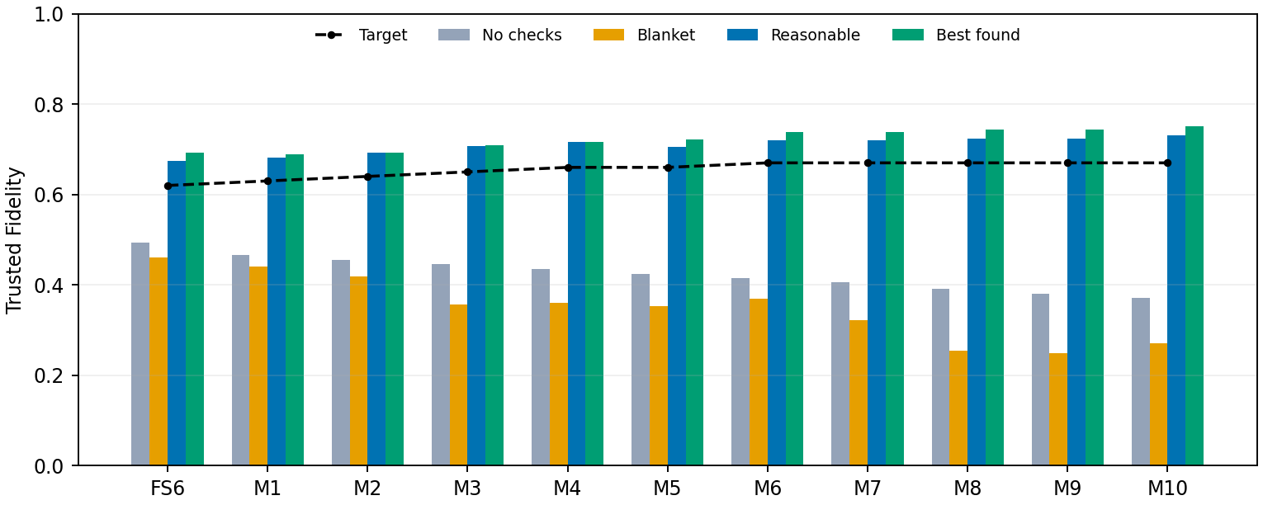
Figure 2. Stored Trusted Fidelity scores and calibrated targets. Best found is limited to the declared candidate family.

6.2 Matched Clifford vs T-doped study
Table 4 selects the valid checked candidate with greatest correct_shot_yield for each matched setting, excluding unchecked execution. It reports conditional fidelity together with retention. There is no game shot budget in this study, so Trusted Fidelity is not assigned. Unchecked execution has the highest yield in all eight settings. Checked candidates exist in seven settings, and each has lower yield than its unchecked counterpart; the remaining setting has no admissible checked candidate in this restricted family.
Rep. | T | Valid | Unchecked F | F_ps | S_keep | Yield | Extra a/2Q/depth
1 | 0 | 7 | 0.8541 | 0.8377 | 0.8774 | 0.7349 | 1/3/5
1 | 1 | 3 | 0.8541 | 0.8389 | 0.8699 | 0.7297 | 1/3/5
1 | 2 | 1 | 0.8541 | 0.8386 | 0.8699 | 0.7294 | 1/3/4
1 | 4 | 0 | 0.8541 | N/A | N/A | N/A | N/A
3 | 0 | 7 | 0.7157 | 0.7578 | 0.7935 | 0.6013 | 1/2/4
3 | 1 | 3 | 0.7157 | 0.7578 | 0.7935 | 0.6013 | 1/2/4
3 | 2 | 3 | 0.7157 | 0.7578 | 0.7935 | 0.6013 | 1/2/4
3 | 4 | 3 | 0.7157 | 0.7578 | 0.7935 | 0.6013 | 1/2/4
With one backbone repetition, admissible checked candidates fall from 7 to 3 to 1 to 0 as T count rises from 0 to 1 to 2 to 4. At three repetitions the counts are 7, 3, 3 and 3: placement and Clifford transport matter, not T count alone. At three repetitions and T=0, the selected check raises fidelity from 0.7157 to 0.7578 but keeps only 0.7935, giving yield 0.6013. With one repetition and T=0, even the best-yield checked candidate has lower fidelity than unchecked execution. These are limited-family findings under uniform depolarization, not a universal postselection improvement.
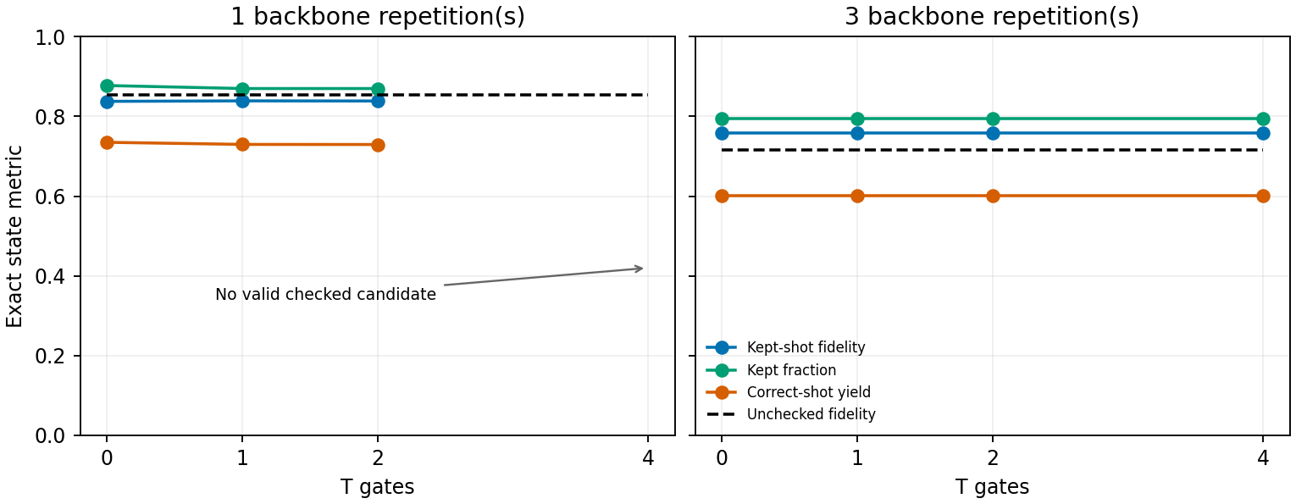
Figure 3. Best-yield valid checked candidates under uniform noise. Fidelity and retention are paired; gaps mean no admissible checked candidate, not a zero metric. Trusted Fidelity is not assigned to this study.

6.3 Paulice vs game optimum
The stored actual Paulice run for FS6 used at most one helper and chose zero added ancillas, with native gamma cost 1.020235. The separate one-helper coherent-shell search finds game score 0.693050. These results optimize different objectives and noise protocols; their numbers are not interchangeable. The matched Paulice observable benchmarks also remain separate from the coherent state-fidelity table.

7. Verification
Evidence | Observed result | Scope
Backend | 240 passed; three existing dependency warnings | Local cleanup run
Frontend | 43 unit tests passed; strict typecheck and production build passed | Local cleanup run
Browser | 64 passed; zero skipped, flaky or unexpected | Full local production desktop/mobile suite; 266.41 seconds
All-level validation | FS1-6 references; seven strategies per scored level; target margins and zero exact spread | scripts/validate_all_levels.py
Notebook | 24 executed cells; all 16 summaries agree; zero numeric disagreements | Latest notebook execution, checked by scripts/run_notebook.py
T scorer | Maximum Clifford metric difference 9.99e-16; independent small-Clifford density 3.33e-16; maximum small-T density difference 2.22e-16 | Stored T_SCORING_VERIFICATION.json; clean Z and rejected X/Y crossings
T scorer timing | M8 0.121 s; M9 0.130 s; M10 0.168 s | Stored local uncached maxima; seven active physical wires; not cloud cold starts
Hosted API | 114 requests passed; max 2.130 seconds; score agreement within 1e-9 | Independent hosted cleanup smoke; Trusted Fidelity protocol
Hosted browser | Owner reported the earlier suite passed after changing network | No fresh hosted 64-case browser run claimed
The verification table distinguishes local production browser tests from hosted API checks. Some earlier Wi-Fi paths timed out while mobile data worked; that observation does not establish accessibility on every organization network. The newer shared client request queue serializes same-tab POSTs to prevent previews racing a run; server admission limits remain in place.

8. Limitations
- Noise is synthetic. Improvements under a hotspot are not hardware advantage.
- Density-matrix simulation grows exponentially. Main missions are capped at seven physical wires; tutorial/custom experiment models impose their own bounded register sizes.
- The T-level optimum is the best within a declared finite family of single-helper checks, not a global optimum over every multi-helper placement.
- Terminal helper measurements and restricted layouts are deliberate. Arbitrary mid-circuit helper reuse is not supported.
- A green line means ideal closure. It does not mean every error is caught.
- No decoder, no fault-tolerance threshold, no general QEC.
- Progress is stored per browser and origin. There is no account, sync or leaderboard.
- Free hosting means cold starts, finite quotas and best-effort rate limiting.

9. Reproduction
python -m venv .venv
.venv/Scripts/python.exe -m pip install -r requirements.lock.txt
npm install -g pnpm@11.25.0
pnpm install --frozen-lockfile
pnpm dev:all # frontend http://127.0.0.1:3000, API on port 8000
.venv/Scripts/python.exe -m pytest tests -q
.venv/Scripts/python.exe scripts/validate_all_levels.py
.venv/Scripts/python.exe scripts/verify_paulice.py
.venv/Scripts/python.exe scripts/validate_t_scoring.py
.venv/Scripts/python.exe scripts/run_track_experiments.py
Set OMP_NUM_THREADS, OPENBLAS_NUM_THREADS and MKL_NUM_THREADS to 1 before numeric imports for timing comparisons. Linux/macOS use .venv/bin/python. No credentials are required. README contains local/Vercel setup and hosted checks. Run scripts/generate_report_figures.py to regenerate this report's figures and numeric extract from stored experiment results.

10. AI-use disclosure and credits

10.1 Implementation, AI Assistance, and Authorship Disclosure
Human expertise drove the core design, experimental validation, and domain-specific logic of this project. The authors conducted all initial experiments, designed every level, and created the scoring mechanisms for all levels using custom criteria and qiskit-paulice. The project team was solely responsible for supplying the functional requirements, pedagogical goals, gameplay architecture, difficulty progression, organizer clarifications, and iterative review feedback.
To accelerate technical execution, AI tools were integrated into the development workflow:
- Codex / OpenAI assisted with code generation and scaffolding for UI/UX, circuit interactions, state visualization, game progression, backend physics adapters, reference code, fixtures, unit tests, validation scripts, analysis notebooks, deployment scripts, and report formatting. AI assistance went beyond visual polish to include supporting code infrastructure.
- Claude was utilized for prompt refinement and drafting initial report and presentation materials.
- Gemini was used for early prompt drafting.
Upstream algorithms and execution backends were provided by Qiskit, Aer, and qiskit-paulice. Circuit figures were generated programmatically via Qiskit. No AI-generated artwork or trained machine learning/inference pipeline drives the runtime game logic.
All verification results, metrics, and figures presented in this report stem from actual repository executions conducted and validated by the team. The team takes full responsibility for reviewing all implementations, understanding the underlying physics, selecting findings, and delivering the final project.

10.2 Software credits
Qiskit 2.5.2, Aer 0.17.2 and qiskit-paulice 0.2.1 provide the quantum stack. NumPy/SciPy, matplotlib, FastAPI/Pydantic/Starlette/Uvicorn, Next.js/React/TypeScript, Tailwind CSS, Lucide, Zod, Vitest and Playwright support the app and verification. Vercel Hobby hosts it. Exact resolved versions, license metadata and purposes are preserved in docs/SOFTWARE_CREDITS.md and dependency locks; preserve upstream notices.

10.3 Published methods and references
- [1] Simon Martiel and Ali Javadi-Abhari. Low-overhead error detection with spacetime codes (2025). https://arxiv.org/abs/2504.15725. Scientific basis for localized checks and non-Clifford support constraints. This game does not reproduce the paper's large-device experiments or reuse its figures.
- [2] Wenyu Sun, QFF 2026 Hackathon: Gamifying Error Detection, Mitigation and Correction. Advanced Track brief provided by IBM Quantum; the brief identifies the author as a McGill University undergraduate.
- [3] Qiskit, Qiskit Aer and qiskit-paulice documentation and source; pinned package versions and licenses in docs/SOFTWARE_CREDITS.md.
- [4] Daniel Gottesman. Stabilizer Codes and Quantum Error Correction (1997). https://arxiv.org/abs/quant-ph/9705052. Stabilizer formalism and Clifford background.
- [5] Coherent-parity-check code, Error Correction Zoo. https://errorcorrectionzoo.org/c/cpc. Background resource listed in the brief.
- [6] Daniel Litinski. A Game of Surface Codes. Quantum 3, 128 (2019). https://arxiv.org/abs/1808.02892. Organizer-listed context; no surface-code game implementation is claimed.
- Surface-code and qLDPC discussions are introductory context from the track resources, not implemented decoder experiments. No additional performance or threshold results for those codes are claimed.

