Spontaneous Parametric Down Conversion (SPDC): Maximizing Pair Rate for Type-II SPDC With PPKTP

Shreyansh Agarwal¹, Tomis Prajapati¹, and V. Narayanan^{1,2}
1. Department of Physics, Indian Institute of Technology Jodhpur-342030, India
2. IDRP-Quantum Information and Computation (IDRP-QIC), Indian Institute of Technology Jodhpur-342030, India

Entangled photons for essential for quantum communication and computation, where high heralding efficiency—i.e., the likelihood of detecting a photon given its entangled counterpart is detected—is critical for reliable operations [1,2]. Spontaneous Parametric Down Conversion (SPDC), a second-order nonlinear optical process (ꭓ²), is the most common technique for generating such photons. The efficiency and generation rate depend upon factors like crystal type, crystal length, pump power, and the beam waists of the pump, signal and idler.
In this work, we theoretically modelled the optimal parameters for high photon pair generation using a type-II SPDC process in a periodically poled KTiOPO₄ (PPKTP) crystal with a poling period of 10µm and a length of 2mm. Based on quasi-phase matching conditions, (i) K_{p} = K_{s} cos(θ_{s}) + K_{i} cos(θ_{i}) + 2π/Λ and (ii) ω_{p} = ω_{s} + ω_{i} , with K_{j} = 2πn_{j} / λ_{j} and refractive indices n_{j} given by temperature-dependent Sellmeier equations [3-5]—we found the quasi-phase matching temperture for degenerate, collinear case to be 40.66 ºC for a 405 nm pump. Fig. 1 (a) shows how the quasi-phase matching temperature varies with SPDC emission angle.
Now, we proceed to calculate the photon pair generation rate and heralding efficiency in a non-collinear, degenerate SPDC setup, with emission angles θ_{s} = θ_{i} = 3°. For such small angles (≤3°), the effects of the Poynting vector and spatial walk-off can be neglected. The method outlined by Rockovich et. al. [6] is used to perform these calculations. Photon pair rates (in pairs/s.mW) are computed using the following expression:
$$\begin{aligned}R=\frac{η_{s}η_{i}Pd_{eff}^{2}ω_{s}ω_{i}}{\sqrt{2}π^{3/2}ϵ_{0}c^{3}n_{s}n_{i}n_{p}B_{p}}\int_{-∞}^{∞}{T_{s}\left(ω_{s}\right)\int_{-∞}^{∞}{T_{i}\left(ω_{p}-ω_{s}\right){\left|Φ\left(ω_{s},ω_{i}\right)\right|}^{2}dω_{s}dω_{p}}}\#\left(1\right)\end{aligned}$$
where η (=1 ideal) is efficiency of filters, B_{p} (=30Thz) is pump beam spectral bandwidth, d_{eff} (=2d₂₄/π) is effective second order nonlinear coefficient, T_{j} are filter transmission functions (unit bandpass filter here) and Joint Spectral Amplitude Ф is given in [6]. We obtained highest pair rate of 2595.60 pairs/s.mW at pump beam waist of 119.22 µm as shown in Fig. 1 (b). Further we show variation of pair rate with signal and idler beam waist [Fig. 1 (c)], power of pump beam [Fig. 1 (d)] and length of the crystal [Fig. 1 (e)].

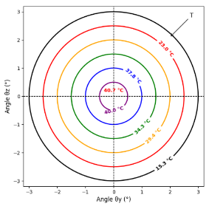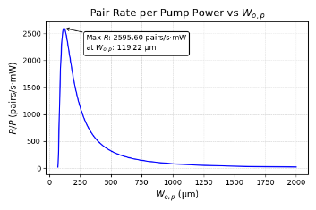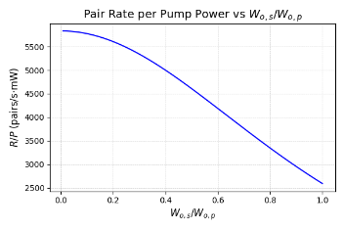
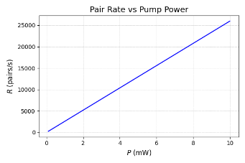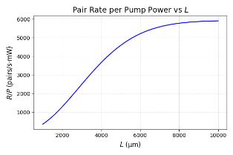
Fig. 1. (a) Qusai-phase matching temperature at different angles. (b) The pair production rate as a function of the pump beam waist. (c) Pair production rate as a function of W_{o,s} /W_{o,p}. (d) The pair production rate as a function of the power of the pump beam. (e) The pair production rate as a function of the length of the crystal.
References
[1] Lynden K. Shalm, Evan Meyer-Scott, Bradley G. Christensen, and et al. Strong loophole-free test of local realism. Phys. Rev. Lett., 115:250402, Dec 2015.
[2] B. Hensen and et al. Loophole-free bell inequality violation using electron spins separated by 1.3 kilometres. Nature, 526(7575):682–686, Oct 2015.
[3] S. Emanueli and A. Arie, “Temperature-dependent dispersion equations for KTiOPO4 and TiOAsO4,” Applied Optics, vol. 42, no. 33, pp. 6661–6665, 2003.
[4] K. Fradkin, A. Arie, A. Skliar, and G. Rosenman, “Tunable midinfrared source by difference frequency generation in bulk periodically poled KTiOPO4,” Applied Physics Letters, vol. 74, no. 7, pp. 914–916, 1999.
[5] K. Kato and E. Takaoka, “Sellmeier and thermo-optic dispersion formulas for KTP,” Applied Optics, vol. 41, no. 24, pp. 5040–5044, 2002.
[6] Andrew Rockovich, Daniel Gauthier, and Shu’an Wang, “Maximizing the Purity and Heralding Efficiency of Down-Converted Photons Using Beam Focal Parameters,” arXiv preprint arXiv:2312.06663, 2023.

