Q1—A company stores employees and their departments. Display employees whose salary is greater than the average salary of their own department, but only from departments having at least 3 employees.
Display Department Name, Employee Name, and Salary.
Constraint: Only a solution using JOINS and SUBQUERIES is allowed. Window Functions are not allowed.

ANS-
select d.dept_name as Department,e.emp_name as Employee,salary from employee e
left join department d
on d.dept_id=e.dept_id
where e.salary>(
select avg(e1.salary)
from employee e1
where e.dept_id=e1.dept_id and (select count(dept_id) from employee e2 where e1.dept_id=e2.dept_id)>2
);

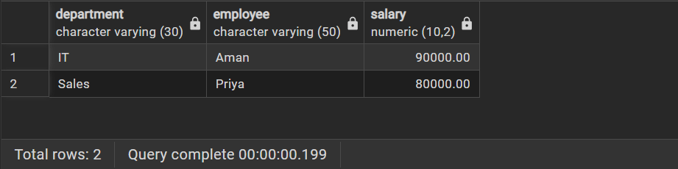

Q2—
A bank maintains customer information in bank_customer. Create a PostgreSQL trigger that automatically stores a log in customer_audit whenever a customer is inserted or deleted. Store Customer ID, Customer Name, action (ADDED/REMOVED), and current timestamp.
ANS-
CREATE OR REPLACE FUNCTION log_customer_changes()
RETURNS TRIGGER AS $$
BEGIN
IF TG_OP = 'INSERT' THEN
INSERT INTO customer_audit(customer_id, customer_name, action, action_time)
VALUES(NEW.customer_id, NEW.customer_name, 'ADDED', CURRENT_TIMESTAMP);
RETURN NEW;
ELSIF TG_OP = 'DELETE' THEN
INSERT INTO customer_audit(customer_id, customer_name, action, action_time)
VALUES(OLD.customer_id, OLD.customer_name, 'REMOVED', CURRENT_TIMESTAMP);
RETURN OLD;
END IF;
END;
$$ LANGUAGE plpgsql;
CREATE TRIGGER customer_audit_trigger
AFTER INSERT OR DELETE ON bank_customer
FOR EACH ROW
EXECUTE FUNCTION log_customer_changes();

INSERT INTO bank_customer VALUES (3, 'Amit', 60000);
DELETE FROM bank_customer
WHERE customer_id = 1;
SELECT * FROM customer_audit;

