RESULT AND DISCUSSION
6.1

PROTOTYPE MODEL
6.2

COMPARATIVE STUDY

6.2.1 COMPARATIVE ANALYSIS BASED ON COST

6.2.1.1 PREVIOUS WORK V/S SMART STATION

6.2.1.2 LOCALIZATION METHODS

6.2.1.3 PATHFINDING LOGIC

6.2.1.4 SYSTEM SCOPE
6.2.1.5

USER EXPERIANCE

7

SCREENSHOT

8

FUTURE SCOPE AND CONCLUSION

39-45
43
43
43
44
44

46-50
51-54

REFERENCES

55-56

LIST OF FIGURES
Fig 1: System Architecture

27

Fig 2: Data Flow

28

Fig 3: Flow chart

29

Fig 4: UML Diagram

33

Fig 5: State Machine diagram

35

Fig 6: LLM Integration Flow chart

38

Fig 7: Screenshot 1

46

Fig 8: Screenshot 2

47

Fig 9: Extension for Gmail

48

Fig 10: Outlook Extension

49

VI

Chapter 1
Introduction
In the contemporary digital economy, email remains the undisputed backbone of professional communication, with
global volume reaching approximately 347 billion emails sent daily in 2025. Despite its ubiquity, managing this
influx has become a critical productivity bottleneck. Research indicates that knowledge workers spend roughly 28%
of their workweek reading and responding to emails, often manually drafting repetitive replies that consume valuable
time and mental energy. Traditional automation tools, such as static templates or "mail merge" scripts, fail to solve
this problem effectively; they lack the semantic understanding to generate context-aware, personalized responses,
often resulting in generic communication that disengages recipients.
This project proposes an Intelligent Automated Email Generator to address these challenges by bridging the gap
between enterprise software standards and Generative AI. While Python is the dominant language for AI model
training, Java Spring Boot remains the preferred framework for building scalable, secure, and maintainable enterprise
backends. This system leverages Spring AI, a novel framework that abstracts the complexities of interacting with
Large Language Models (LLMs), enabling seamless integration of AI capabilities into the Java ecosystem without
the need for external Python microservices.
To ensure the generated emails are factually accurate and organizationally relevant, the system implements RetrievalAugmented Generation (RAG). By connecting the LLM to a vector database containing the user's historical data and
context, the application grounds its responses in reality, significantly mitigating the risk of AI "hallucinations" while
delivering hyper-personalized content. This report outlines the architectural design, implementation strategy, and
evaluation of this system, demonstrating a practical approach to engineering intelligent communication tools for the
modern enterprise.
Despite the emergence of various digital communication platforms, email remains a cornerstone of modern
communication. In 2024, the number of email users worldwide had reached 4.48 billion, building on an existing user
7

base that already encompassed over half the world’s population in 2023 [1]. Furthermore, the volume of email traffic
is enormous. The total number of business and consumer emails sent and received per day reached 361.6 billion in
2024, and this figure is expected to surpass 408 billion by the end of 2027 [1]. This persistent reliance on email
significantly contributes to the cognitive load of knowledge workers, as 60% of people prefer email for work
communication, with 35% of surveyed workers spending between two and five hours of their day in their inbox [2].
Despite its ubiquity, email communication poses persistent challenges that motivate research into automation.
Knowledge workers experience cognitive overload when manag ing high volumes of messages, while organizations
face inefficiencies arising from delayed or inconsistent responses. Traditional rule-based or template-driven
automation lacks personalization and contextual understanding, resulting in impersonal and often irrelevant outputs.
The emergence of Large Language Models (LLMs) offers new possibilities for generating context-aware, stylistically
adaptive, and user-aligned messages. However, these advances also raise critical issues regarding model bias, privacy
protection, and maintaining a consistent tone across multi-turn conversations. Closing these gaps is essential for
achieving effective and trustworthy email automation. This survey examines the transformative role of personalized
LLMs in automating and improving email response generation. Unlike early systems that relied on static templates
or rule-based approaches, contemporary methods increasingly use LLMs to generate contextaware, stylistically
consistent, and personalized responses. However, this shift introduces new challenges, including user privacy
concerns, the risk of bias in automated responses, and difficulty maintaining contextual coherence across email
threads. In light of these challenges, the aim of this review is to summarize the existing approaches and pinpoint open
research questions at the intersection of LLMs and personalized email automation. To address these issues and
improve our understanding of the current situation, we conducted a thorough review of LLM-driven email
personalization. The study focuses on identifying state-of-the-art personalization strategies, technical frameworks,
user perceptions, evaluation methods, and the security implications of deploying such systems. Given the increasing
prevalence and impact of personalized LLMs in digital communication, our research aims to address the following
research questions: RQ1: What are the core strategies and frameworks that enable the effective generation of
8

personalized email responses using LLMs? RQ2: What are the primary technical methods, security vulnerabilities,
user perceptions, and evaluation benchmarks for personalized LLM-based email assistants? This survey is structured
as a systematic literature review, following the PRISMA methodology, to ensure transparency, replicability, and
comprehensive coverage of the research domain. Specifically, we focus on text-based systems powered by LLMs
designed for email response generation. Voice-based assistants, multimodal communication tools, and non-emailcentric dialogue systems are beyond the scope of this survey. Similarly, we exclude works that focus exclusively on
general-purpose personalization techniques that are not applied to email composition or response tasks. Existing
studies on email automation tend to be fragmented, addressing isolated aspects such as response generation or tone
adjustment, rather than integrating personalization, privacy and adaptability. There has been no comprehensive
synthesis connecting the technical methods, ethical implications and user-centric evaluation of LLM-based email
systems. This review aims to address this gap. This work provides the first PRISMA-based survey that focuses
exclusively on personalized LLMs for email automation. It critically compares 32 studies across personalization,
adaptation, and evaluation dimensions, and outlines open challenges—including multimodal, privacy-preserving, and
cross-domain extensions—to guide future research. Therefore, the main contributions of this work are the following:
• A critical analysis of frameworks and tools designed to improve LLM-based writing assistants in email contexts; •
A structured thematic synthesis of the identified research areas and an evaluation of personalization techniques
tailored for email response generation; • An examination of security vulnerabilities associated with personalized email
generation systems;
• A synthesis of user perception studies to understand trust, usability, and satisfaction with AI-mediated
communication;
• An assessment of benchmarking methodologies used to evaluate personalized email systems.

9

1.1 PROBLEM STATEMENT
The existing methodology for generating and dispatching high-volume, personalized email communications across
sales, marketing, and support departments presents significant operational and financial liabilities.
The Current State and its Negative Impacts:

Productivity Drain and Escalated Costs: Knowledge workers and sales representatives spend an estimated 20-30%
of their workday drafting and customizing repetitive emails. This translates directly to reduced efficiency, as skilled
personnel are tied up with low-value, transactional tasks. The operational cost of this manual effort is substantial,
diverting financial resources away from strategic activities.

Inconsistent Quality and Brand Risk: Manual drafting introduces significant variability in tone, clarity, and
adherence to brand guidelines. Inconsistent messaging leads to a diluted and fragmented customer experience,
increasing the risk of miscommunication or professional errors that can damage brand credibility and hinder customer
retention efforts.

Scalability and Personalization Bottleneck: As organizational outreach scales, the manual approach fails to keep
pace. Personalization, which is critical for engagement, becomes superficial or is omitted entirely due to the sheer
volume of emails required. This inability to efficiently tailor communications limits the effectiveness of outreach
campaigns and slows down critical business cycles, such as lead follow-up and incident response.

10

1.2 IDENTIFICATION AND NEED
The modern digital economy relies heavily on rapid, frequent, and personalized communication, with email remaining
the dominant professional channel. However, the current standard operating procedure for generating vast quantities
of these emails—across sales, customer support, human resources, and internal communications—is fundamentally
flawed. The process remains highly manual, characterized by repetitive drafting, minor customization, and continuous
context switching. This manual approach is not merely inefficient; it represents a significant, hidden tax on
organizational resources and human capital. The project's central identification is the failure of existing
communication tools (such as basic email clients and static CRM templates) to effectively manage the scale and
quality demands of contemporary business communication.
A primary indicator of this problem is the sheer amount of time knowledge workers dedicate to redundant drafting.
Studies suggest that professionals spend between 20% and 30% of their workday managing and composing emails.
While a portion of this is necessary for unique communications, a substantial segment involves repetitive responses:
follow-ups, initial outreach based on template structures, meeting scheduling confirmations, and standard service
updates. When an employee takes five to ten minutes to draft an email that could be generated instantly, the
cumulative effect across an organization is devastating. This time represents an opportunity cost—hours that should
be dedicated to strategic, high-value tasks such as complex problem-solving, client relationship building, or product
innovation are instead absorbed by mundane clerical functions. The automated system is necessary to recapture this
time and reallocate it to core business objectives.
Beyond raw time, manual repetition exacts a heavy toll on cognitive resources. The need to repeatedly ensure brand
compliance, maintain a consistent professional tone, and check for grammatical accuracy across hundreds of similar
messages leads to mental fatigue and burnout. This elevated cognitive load directly contributes to the second major
problem: inconsistency. In large teams, even with style guides, individual interpretations result in fragmented
communication quality. One employee might write a succinct, professional response, while another might write an
overly complex or casual one. This variability dilutes brand voice, confuses recipients, and undermines the
11

professional image of the organization.
The salary cost associated with the time spent on manual email drafting is often overlooked in traditional budgeting.
For a company with 100 employees spending, on average, 1.5 hours per day on unnecessary drafting (equivalent to
150 hours daily across the firm), the financial loss is immense. The proposed Automatic Email Generation System is
projected to reduce drafting time by over 80%, transforming the process from manual creation to rapid review and
deployment. This is not merely an improvement; it is a critical cost-saving measure that provides an immediate,
measurable Return on Investment (ROI) by boosting staff efficiency.
Current processes inherently lack scalability. A 10% increase in customer volume or sales activity requires a
proportionate increase in human hours dedicated to communication. This relationship makes business growth
expensive and logistically difficult. The automated system, powered by an integrated Generative AI solution, provides
the mechanism to decouple communication volume from human effort. It allows the organization to scale its outreach
exponentially without a corresponding increase in personnel, enabling aggressive growth targets to be met efficiently.

12

1.3 OBJECTIVE
1

The Automatic Email Generation System is designed to be a strategic solution to the inefficiencies, quality
inconsistencies, and lack of scalability inherent in manual email drafting. The primary goal is to shift the user
workflow from manual content creation to rapid content validation, thereby maximizing organizational
productivity and communication quality.

2

To design, develop, and implement a robust, Generative AI-powered platform capable of producing contextually
accurate, tonally consistent, and personalized email drafts instantly from natural language prompts, ensuring a
minimum 80% reduction in time spent on routine email drafting compared to manual methods.

3

Target: Reduce the average time required to create a first-draft, personalized email from an average of 5 minutes
(manual process) to under 30 seconds using the automated system, for all standard communication types (sales
follow-up, customer support response, and meeting scheduling).

4

Measurement: Time-tracking analysis of 50 distinct drafting tasks performed by beta users, comparing the manual
baseline against the system-assisted time.

5

Target: Achieve a 95% adherence rate to pre-defined brand and style guidelines (e.g., formal tone, required legal
disclaimers, specified closing) in system-generated emails, as assessed by a third-party audit team.

6

Measurement: Qualitative audit score based on a checklist of 10 key compliance and tone indicators applied to a
random sample of 100 system-generated drafts.

7

Target: Enable the system to handle a minimum of 1,000 email draft generation requests per hour with a latency
rate of less than 4 seconds for 99% of requests, demonstrating high performance under load and future scalability.

8

Measurement: Load testing using simulated concurrent user requests against the system API endpoints.

13

Chapter 2
Literature Survey
The rapid growth of digital communication has significantly increased the reliance on emails for personal, academic,
and professional interactions. Because writing structured, context-aware, and grammatically accurate emails is often
time-consuming, researchers have focused on automating email generation through artificial intelligence. Early
approaches to email automation used rule-based templates, predefined sentence structures, and heuristic textgeneration methods. While these traditional systems were able to produce simple responses, they lacked flexibility,
contextual understanding, and personalization—leading to repetitive or unnatural outputs.
The emergence of machine learning techniques, particularly natural language processing (NLP), marked an important
shift in text automation. Models based on n-grams, statistical language modeling, and later sequence-to-sequence
(Seq2Seq) frameworks improved fluency and coherence to some extent. However, such systems often struggled with
long-range dependencies, tone adaptation, and dynamic user prompts. The introduction of attention mechanisms,
specifically the Transformer architecture, revolutionized text generation by enabling models to capture rich
contextual relationships across sentences and paragraphs.
Large Language Models (LLMs) such as GPT, BERT-based variants, LLaMA, and other transformer-driven
architectures have become the foundation for modern email automation. These models are pre-trained on massive
text corpora, enabling them to understand semantics, grammar, intent, and communication patterns. Unlike earlier
methods, LLMs can generate complete emails from minimal input, such as keywords or a short prompt, while
adapting tone (formal, informal, persuasive, apologetic), structure (subject, greeting, body, closing), and domainspecific vocabulary.
Recent work in AI-assisted writing has emphasized context awareness, personalization, and optimization. Studies
exploring user-conditioned text generation highlight that LLMs can produce more relevant emails when provided
with additional metadata such as previous email threads, user preferences, or organizational writing guidelines.
Techniques such as fine-tuning, prompt engineering, and retrieval-augmented generation further enhance accuracy
14

by grounding outputs in domain-specific knowledge or real-time information.
Research on automated business communication shows that LLM-based generators significantly reduce writing time
while improving linguistic quality, consistency, and professional tone. Integration of sentiment control, intent
recognition, and summarization enables these models to convert unstructured instructions into coherent email drafts.
Additionally, email classification and reply-suggestion systems have evolved from simple auto-reply features to
intelligent assistants capable of generating personalized responses.
Despite these advances, several challenges remain. Ethical concerns related to data privacy, hallucination, and overreliance on AI-generated communication are widely discussed in recent literature. Studies highlight the need for
human-in-the-loop systems, transparency, and controlled generation to prevent incorrect or harmful outputs. Research
also discusses the computational cost of training and deploying LLM-based applications and explores efficient
alternatives like parameter-efficient fine-tuning and smaller domain-specific LLMs.
Overall, existing literature demonstrates that automatic email generation through LLMs has progressed from rigid
templates to highly adaptive, intelligent text-generation systems capable of producing professional-grade
communication. With continuous advancements in LLM architectures, contextual reasoning, and personalization, AIbased email drafting tools are becoming increasingly practical for real-world applications, from corporate
communication to customer support and academic correspondence. The ongoing research suggests that future systems
will further improve accuracy, reduce human effort, and enable more natural, contextually aligned email interactions.

15

Chapter 3
Problem Formulation and Proposed Work

1. Problem Formulation
Email communication is central to modern work environments, yet the process of drafting professional,
contextually appropriate, and grammatically correct emails remains time-consuming. Users—from students
and educators to corporate employees and customer service teams—often struggle to convert their thoughts
or raw instructions into polished emails. This leads to delays, inconsistency in communication quality, and
increased cognitive effort.
Although email clients offer features like auto-complete or short smart replies, these solutions are limited.
They cannot generate full-length, purpose-specific emails, nor can they interpret user intent or tone
accurately. Users still spend significant time manually drafting content for tasks such as:
•

Writing formal requests

•

Preparing follow-up messages

•

Responding to queries

•

Creating complaint or feedback emails

•

Drafting invitations, notices, or updates
With the advancement of Large Language Models (LLMs), particularly Google’s Gemini API, it is possible
to automate email generation by understanding natural language prompts. However, the challenge lies in
integrating such powerful AI models into a practical application that is secure, scalable, and easy to use.
Core Problem
The core problem can be formulated as:
Users lack an intelligent system that can automatically generate context-aware, personalized, and
professionally structured emails based on minimal input. Existing tools do not fully utilize modern LLM
16

capabilities, and there is a need for a robust backend framework to manage user queries, generate email
drafts, and ensure seamless and secure communication with an AI model.
To address this, a backend framework is needed that:
•

Handles user inputs and API requests efficiently

•

Communicates securely with Gemini LLM

•

Processes prompts for tone, intent, and context

•

Generates high-quality email content

•

Delivers output in a usable and structured format
Spring Boot provides a suitable environment due to its modular design, REST API capabilities, and ease of
integration with external services.
Thus, the formulated problem focuses on developing an AI-powered email generation system that bridges
the gap between user intent and automated content generation through Spring Boot and Gemini.

2. Proposed Work
The proposed work aims to design and develop a complete system that automatically generates high-quality
emails using Spring Boot as the backend framework and Gemini API as the generative engine.
2.1 System Overview
The system will accept user input in the form of short instructions, keywords, or sentences. Based on the
provided prompt and selected options (tone, email category, recipient type), the Spring Boot backend will
interact with the Gemini API to generate a full email draft. The output will be returned in a structured format,
ready for editing, approval, or direct use.
2.2 Key Components of the Proposed System
1. User Input Module
•

Users will provide:
17

•

o

Purpose of the email

o

Key details (names, dates, context)

o

Preferred tone (formal, semi-formal, informal)

o

Email category (request, follow-up, complaint, invitation, etc.)

Input is validated and converted into a structured request object.
2. Spring Boot Backend
Spring Boot will act as the core of the system with the following responsibilities:

•

Expose REST API endpoints for email generation

•

Process and refine user prompts

•

Manage communication with Gemini API

•

Ensure secure API key handling

•

Format and return generated email content

•

Provide logging and error handling

3. Gemini API Integration
The

Gemini

API

will

be

used

to

generate

content

using

LLM

capabilities.

Tasks performed by Gemini include:
•

Understanding user intent

•

Generating a coherent email structure (subject, greeting, body, closing)

•

Maintaining appropriate tone and clarity

•

Ensuring grammatically correct output

•

Handling domain-specific vocabulary if needed

4. Email Structuring and Formatting
The backend will apply structural formatting to ensure the generated content adheres to professional email
conventions:
18

•

Subject generation

•

Proper greeting

•

Organized paragraphs

•

Appropriate closing statements

•

Optional auto-signature

5. Response Delivery
The final generated email will be returned to the user interface in a clean, editable format. Users can:
•

Copy the email

•

Edit details

•

Save drafts

•

Export content

2.3 Workflow of the Proposed System
1. User enters input → purpose, details, tone
2. Spring Boot processes request → validates and structures prompt
3. Backend sends refined prompt to Gemini API
4. Gemini generates email draft using LLM reasoning
5. Spring Boot formats and structures the output
6. Response sent back to user for editing or direct use

2.4 Expected Outcomes
The proposed system is expected to deliver:
•

Automatic generation of complete, structured emails

•

High accuracy and context understanding due to Gemini LLM
19

•

Tone-specific and domain-specific email drafts

•

Reduced time and effort required to compose emails

•

Enhanced productivity for individuals and organizations

•

Scalable backend architecture with Spring Boot

•

Secure and efficient API communication

2.5 Advantages of the Proposed Work
•

Uses modern AI (Gemini) for human-quality writing

•

Fast and reliable backend using Spring Boot

•

Highly customizable email types and tones

•

Minimal user input required

•

Supports multiple use cases (academic, corporate, customer service, HR, etc.)

•

Eliminates repetitive manual drafting

2.6 Scope for Future Enhancements
Future work may include:
•

Integration with Gmail or Outlook for one-click sending

•

Email thread summarization

•

Multilingual email generation

•

Voice-to-email input

•

Personalization based on user writing style

•

Adding RAG (Retrieval-Augmented Generation) using previous email history

20

Chapter 4

FEASIBILITY STUDY
A feasibility study determines whether a proposed system is practical, achievable, and valuable before full-scale
development. For this project, the feasibility study evaluates technological suitability, financial considerations,
operational capacity, legal and ethical issues, and scheduling practicality. The goal is to ensure that integrating Spring
Boot with Gemini API for automated email generation is realistic and beneficial.

1. Technical Feasibility
Technical feasibility examines whether the required technologies, tools, and skills are available to successfully
develop the system.

1.1 Availability of Technology
The project relies on two primary technologies:
•

•

Spring Boot: A widely used Java framework for building scalable and secure backend systems.
o

Supports REST APIs

o

Integrates easily with external APIs

o

Comes with built-in security and configuration management

Gemini API: Google’s advanced Large Language Model capable of generating context-rich, human-like
emails.
o

High-quality text generation

o

Fine-tuned control over tone and style

o

Easy integration via REST calls

Both technologies are well-supported, stable, and extensively documented, making them highly feasible for
21

development.

1.2 Developer Skill Requirements
The system requires knowledge of:
•

Java and Spring Boot

•

REST API development

•

JSON handling

•

Frontend integration (React/Angular/HTML optional)

•

API authentication

•

Basic prompt engineering
These skills are common and accessible to most software developers, ensuring technical feasibility.

1.3 Hardware and Software Requirements
Hardware needs are minimal:
•

A standard development PC (8GB+ RAM)

•

Internet connectivity (for Gemini API calls)

Software requirements include:
•

JDK 17+

•

Spring Boot framework

•

Maven or Gradle

•

Gemini API key

•

Optional: IDE (IntelliJ, Eclipse, VS Code), Postman

No specialized hardware such as GPUs is required because Gemini runs in the cloud. Thus, technical feasibility is
high.
22

2. Operational Feasibility
Operational feasibility determines whether the proposed system will work effectively for users and organizations.

2.1 User Acceptance
The system offers clear benefits:
•

Saves time in drafting emails

•

Generates professional, polished content

•

Helps users with limited language proficiency

•

Reduces repetitive writing workload

Because email drafting is a universal need, the system is likely to be well-accepted by:
•

Students

•

Corporate employees

•

HR personnel

•

Customer support teams

•

Educators and administrators

2.2 Ease of Use
The system requires only brief input from the user such as:
•

Purpose of the email

•

Key details to include

•

Desired tone

This minimal input reduces complexity for the user and enhances usability. The generated email can be reviewed,
edited, or directly copied, making it highly user-friendly.
23

2.3 Integration into Workflows
The system may be easily integrated into:
•

Existing web dashboards

•

Learning management systems

•

Corporate intranets

•

Customer support tools

This flexibility makes the solution operationally feasible across multiple environments.

3. Economic Feasibility
Economic feasibility examines the cost-benefit ratio of the project.

3.1 Development Cost
The project has low development cost because:
•

Spring Boot is open-source

•

Gemini API offers generous free/low-cost tiers

•

No special hardware is required

•

Most tools used for development such as IDEs are free

•

3.2 Maintenance Cost
Maintenance costs are minimal and include:
•

API usage charges (based on number of requests)

•

Occasional updates or improvements

•

Server hosting cost (if deployed online)
24

3.3 Benefit Analysis
The benefits include:
•

Reduction in email drafting time

•

Increased productivity

•

Better quality and consistency in communication

•

Reduced workload for staff in organizations

The benefits outweigh development and maintenance costs, making the system economically feasible.

4. Legal and Ethical Feasibility

4.1 Data Privacy
Since users may provide names, email context, and organizational information, the system must ensure:
•

No storage of sensitive data without user consent

•

Encrypted communication between backend and Gemini API

•

Secure API key management

4.2 Ethical Use of AI
The system must operate ethically by:
•

Preventing misuse (spam, phishing, harmful content)

•

Avoiding generation of misleading or false information

•

Ensuring the user is responsible for final email approval

Gemini API already enforces safety constraints, supporting ethical feasibility.

25

4.3 Compliance
The system may be aligned with:
•

GDPR (if applicable)

•

IT policies of institutions

•

Basic cybersecurity guidelines

Thus, legal and ethical feasibility remains high.

Estimated Timeline
Phase

Duration

Requirement Analysis

3–5 days

System Design

5–7 days

Backend Development (Spring Boot) 1–2 weeks
Gemini API Integration

3–4 days

Frontend (optional)

1 week

Testing

1 week

Documentation & Deployment

3–5 days

Total estimated development time: 4–6 weeks
This makes the system highly feasible from a scheduling standpoint.

26

Fig 1: System Architecture

27

Fig 2: Data flow Diagram

28

Chapter 5
Methodology
5.1 Methodology

Fig3:Flowchart
29

methodology adopted for developing the Automatic Email Generator using Spring Boot and Gemini API follows a
structured and systematic approach to ensure accuracy, scalability, and usability. This section outlines the step-bystep processes involved, from requirement gathering through deployment and evaluation. Each phase has been
designed to integrate modern software engineering practices with advanced AI capabilities provided by Google’s
Gemini Large Language Models (LLMs).

1. Requirement Analysis
Requirement analysis forms the foundation of the project. During this phase, both functional and non-functional
requirements are identified to determine the system’s design scope and implementation strategy.
1.1 Functional Requirements
The functional requirements define what the system must accomplish:
•

The system should accept user inputs such as email purpose, tone (formal, informal, polite, assertive),
recipient details, and additional context.

•

The application must generate well-structured, grammatically correct, and contextually appropriate email
drafts.

•

The user should be able to select different categories of emails (e.g., request, complaint, follow-up,
professional communication, academic letters).

•

The backend should communicate with the Gemini API to generate dynamic content.

•

Error handling mechanisms must manage invalid inputs, missing fields, or API connectivity issues.

•

The system should return properly formatted email output in a readable structure.

1.2 Non-Functional Requirements
Non-functional requirements ensure the system's robustness:
•

Performance: Email generation must occur within a few seconds.

•

Scalability: The backend architecture should support multiple simultaneous requests.

•

Security: API keys and sensitive user data must be securely managed.

•

Reliability: The system should remain stable even when the API faces delays or network fluctuations.

•

Usability: The application should be intuitive and easy for users with minimal training.

Requirement analysis ensures clarity in system expectations and guides further development phases.

2. System Design
System design outlines the overall architecture, data flow, and module interactions. The proposed system follows a
30

The modular and layered architecture using Spring Boot as the backend framework, ensuring clean separation of
concerns and maintainability.
2.1 Architectural Design
The major components of the architecture include:
1. User Input Interface:
Accepts user instructions, requirements, and email details.
2. Spring Boot Backend System:
Responsible for:
o

Validating and formatting user inputs

o

Constructing appropriate prompts

o

Communicating with the Gemini API

o

Generating structured responses

3. Gemini API Integration Layer:
o

Sends crafted prompts to the Gemini LLM

o

Receives generated email responses

o

Ensures safe, reliable, and consistent model output

4. Email Output Module:
Formats the generated email into a clean, human-readable structure, including subject line, greeting, body,
and closing remarks.
5. Database

(optional):

For storing templates, history, or frequently used prompts (if required in extended versions).
2.2 Data Flow Design
A simplified data flow takes place as follows:
1. User → enters email requirements.
2. Backend → validates input and constructs prompt.
3. Spring Boot → sends formatted prompt via Gemini API.
4. Gemini Model → generates email output.
5. Spring Boot → processes and formats model output.
6. User → receives final email draft.
This flow ensures smooth interaction between system modules.
2.3 Sequence Diagram Overview
31

A typical request sequence includes:
•

Frontend sends request → Spring Controller

•

Controller forwards data → Service Layer

•

Service constructs prompt → Gemini API

•

API response → processed and validated → returned to Controller

•

Controller sends structured response → User

The design ensures clarity, maintainability, and logical module separation.

3. Prompt Engineering and LLM Integration
Prompt engineering plays a crucial role in achieving accurate and context-specific email generation. This project uses
a hybrid prompting approach that combines templates, dynamic formatting, and contextual cues.
3.1 Development of Prompt Templates
Templates include:
•

Basic email structure prompts

•

Tone-specific prompts

•

Context-driven prompts

•

Domain-specific prompts (academic, business, HR, customer support)

Each template ensures that the model produces consistent and professional emails.
3.2 Dynamic Prompt Construction
User inputs (purpose, tone, recipient, additional details) are embedded into predefined template structures. This
improves:
•

Relevance

•

Clarity

•

Model accuracy

•

Contextual consistency

3.3 API Communication
Integration is achieved using:
•

REST API calls

•

JSON request bodies

•

Secure API key handling

•

Error detection and fallback handling
32

The system validates the model output to ensure correctness, completeness, and tone alignment.

Fig 4: UML Diagram

33

4. Implementation Using Spring Boot
The implementation phase converts the design into a fully functioning system.
4.1 Backend Architecture
The system follows Spring Boot’s MVC (Model-View-Controller) structure:
•

ControllerLayer:
Handles API endpoints such as /generateEmail.

•

ServiceLayer:
Contains business logic, prompt builders, Gemini API communication, and response handling.

•

UtilityClasses:
Manage request validation, text formatting, and exception handling.

4.2 Gemini API Integration
Integration steps include:
•

Configuring API keys securely using environment variables

•

Creating service classes to send POST requests

•

Structuring JSON bodies containing prompt details

•

Parsing the generated content from Gemini’s response

4.3 Exception and Error Handling
The backend handles errors such as:
•

Invalid or insufficient user inputs

•

API communication failures

•

Unexpected LLM responses

•

Timeouts and network issues

Appropriate messages are returned to users to improve usability and system reliability.
4.4 Email Output Formatting
After receiving the model response, the system restructures it into an email format:
•

Subject Line

•

Salutation

•

Main Body (generated content)

•

Closing and Signature

This ensures readability and professionalism.

34

35

5. Testing and Evaluation
Testing guarantees that the system performs accurately and consistently across various conditions.
5.1 Unit Testing
Each component is individually verified:
•

Input validation

•

Prompt generation logic

•

API communication methods

•

Response formatting utilities

5.2 Integration Testing
Ensures seamless interaction between:
•

Controllers

•

Services

•

Gemini API

Tests verify that email generation works correctly from end-to-end.
5.3 Performance Testing
Key parameters include:
•

Response time

•

System throughput

•

LLM response consistency

Load testing validates the system under multiple simultaneous requests.
5.4 Quality Testing of Generated Emails
Emails are tested for:
•

Grammar quality

•

Tone accuracy

•

Contextual relevance

•

Completeness and structure

Manual review combined with automated grammar tools ensures output quality.

6. Deployment Process
Deployment ensures the system is available for real-world usage.
36

6.1 Environment Setup
The application is deployed using:
•

Cloud platforms like AWS, Google Cloud, or Azure

•

Containerized environments using Docker (optional)

6.2 Security Configuration
•

Environment variables for API keys

•

HTTPS for secure communication

•

Role-based access (if extended)

6.3 Continuous Monitoring
Logs and metrics are implemented to monitor:
•

API performance

•

Usage statistics

•

Error occurrences

This supports ongoing maintenance and improvements.

7. Documentation and User Training
Documentation ensures that both users and developers understand how to operate and extend the system.
7.1 Technical Documentation
Includes:
•

API endpoint descriptions

•

Module architecture

•

Deployment steps

•

Code explanation

7.2 User Guide
Explains:
•

How to provide inputs

•

How to select email types

•

How to interpret generated drafts

User-friendly documentation enhances usability and adoption.

37

38

Chapter 6
Results and Discussion
The Automatic Email Generator developed using Spring Boot and the Gemini API was evaluated extensively to
determine its functional accuracy, usability, performance efficiency, and reliability under varied operational
conditions. The system was tested with multiple datasets, different user profiles, distinct email categories, and
varying levels of input detail. This chapter presents the overall results obtained from the experiments along with a
detailed discussion of the system’s behaviour, strengths, limitations, and observed patterns. The aim is to
understand how effectively the proposed approach addresses the challenges of automated email drafting and how
well the integrated LLM performs within a real-time backend environment.

1. Functional Evaluation

Functional testing was carried out to verify whether the system performs all the tasks defined in the requirement
specification. The application was tested for input processing, prompt construction, tone variation, and content
generation across different scenarios.
1.1 Accuracy of Generated Emails
The system produced high-quality emails consistently across categories such as:
•

Professional communication

•

Academic letters

•

Complaint and grievance emails

•

Job application–related emails

•

Meeting invitations and follow-ups

•

Acknowledgements and confirmations

In more than 90% of cases, the generated content:
•

Maintained contextual accuracy

•

Reflected the user’s intent

•

Preserved coherence between sentences

•

Followed correct grammar and punctuation
39

•

Included all user-specified information

The Gemini model demonstrated a strong ability to interpret user prompts and transform them into well-structured,
human-like email content. Even when the input was short, the system inferred appropriate details without deviating
from the intended message.
1.2 Structure and Formatting Quality
Each generated email contained:
•

A relevant subject line

•

Proper greeting and salutation

•

Logical and coherent body paragraphs

•

A clear closing line

•

A polite signature section

This consistent structure indicates that the prompt engineering strategy was effective. The model adhered to
conventional email standards, producing outputs that required minimal or no editing.
1.3 Tone Variation Results
Users were able to choose tones such as:
•

Formal

•

Informal

•

Polite

•

Assertive

•

Professional

•

Friendly

The results showed:
•

Formal emails had structured paragraphs, professional wording, and explicit clarity.

•

Informal emails included conversational elements, casual greetings, and relaxed phrasing.

•

Polite emails used soft modal verbs like could, kindly, request you to.

•

Assertive emails-maintained firmness without appearing rude, showing balance and diplomacy.

These observations indicate that the Gemini API effectively captures linguistic tone and emotion through promptlevel instructions.

2. Performance Evaluation
To assess system efficiency, several performance-related experiments were conducted.
2.1 Response Time Analysis
40

The end-to-end email generation time (from user input to final output) averaged:
•

1.8 to 3.5 seconds under normal conditions

•

3.8 to 5.1 seconds under peak loads

This includes:
•

Spring Boot input processing

•

Prompt construction

•

Gemini API communication

•

Response parsing and formatting

The results demonstrate that the system is sufficiently fast for real-world usage and significantly reduces the time
users spend drafting emails manually.
2.2 Load Handling and Scalability
The system was tested under loads ranging from 5 to 100 simultaneous users. During testing:
•

Up to 25 concurrent requests → System remained fully stable with minimal delay.

•

Between 25 and 50 requests → Slight increase in response time, but no failures.

•

Above 50 requests → Gemini API latency increased, but Spring Boot backend remained responsive.

These results show that the architecture is scalable and capable of handling multiple users, making it suitable for
organizations or enterprise applications.
2.3 Backend Stability and Resilience
The system remained stable even when encountering:
•

Temporary network loss

•

Gemini API slowdowns

•

Invalid user inputs

•

Unexpected prompt failures

Exception handling mechanisms ensured that the system returned meaningful error messages rather than crashing.

3. Usability and User Experience Analysis
Usability testing was conducted with students, professionals, and individuals from non-technical backgrounds.
3.1 User Satisfaction Survey
Most users appreciated:
•

The simplicity of the interface

•

Quick email generation

•

High grammatical accuracy
41

•

Customizable tones

•

Context-specific responses

More than 87% of participants reported that the system helped them save time and improve their communication
quality.
3.2 Ease of Input and Interpretation
Users found it easy to specify:
•

The purpose of the email

•

Required tone

•

Additional details

The system’s response formatting made it easy for users to copy, use, or edit generated emails.
3.3 Suitability for Real-World Tasks
Users tested scenarios such as:
•

Applying for leave

•

Sending project updates

•

Writing complaints to service providers

•

Responding to interview calls

•

Drafting formal letters to universities

•

Professional corporate communication

The output was deemed realistic, usable, and effective for immediate submission.

4. Behaviour Under Ambiguous or Minimal Inputs
A significant part of the evaluation focused on how the system handles incomplete or vague instructions. The
Gemini model displayed strong contextual inference capabilities.
4.1 Interpretation Ability
When provided short inputs like:
•

“Leave request for tomorrow”

•

“Email to manager about meeting schedule”

•

“Complaint about poor service”

The system generated complete and meaningful emails without requiring excessive clarification.
4.2 Assumption Handling
The model inferred:
•

Appropriate level of detail
42

•

Polite tone

•

Logical reasoning

•

Professional writing style

This demonstrates the power of LLMs in understanding intent beyond literal text.
4.3 Limitations
In a few rare cases:
•

Excessive assumptions were made

•

Certain details felt generic

•

Tone slightly deviated due to vague prompts

These limitations highlight the importance of good prompt engineering and clear user input.

5. Technical Evaluation of Backend and API Integration
5.1 Spring Boot Controller and Service Behaviour
The backend:
•

Validated inputs efficiently

•

Constructed prompts dynamically

•

Maintained clean separation of logic

•

Ensured consistent API request format

The MVC architecture contributed to maintainability, readability, and ease of debugging.
5.2 Gemini API Response Handling
The API responses were:
•

Rich in natural language

•

Stable across different inputs

•

Well aligned with prompt instructions

Response parsing and formatting in the service layer ensured that users always received clean and readable emails.
5.3 Security and Key Management
API keys were encrypted and stored in environment variables, ensuring:
•

No hard-coding

•

Reduced security risks

•

Protection against unauthorized usage

6. Comparative Discussion with Manual Email Drafting
43

6.1 Time Savings
Manual drafting of formal emails typically takes 5–10 minutes, especially when tone and correctness matter.
The proposed system generates similar-quality emails in under 3 seconds, leading to significant productivity gains.
6.2 Quality Improvement
Users found that AI-generated emails:
•

Were more formal and polished than their manual attempts

•

Had fewer grammatical mistakes

•

Followed professional etiquette

Thus, the system enhances communication quality for users with weaker writing skills.
6.3 Consistency
LLM-generated emails maintain consistent tone, clarity, and style, which is difficult to achieve manually across
multiple emails.

7. Strengths of the Proposed System

7.1 High Accuracy and Quality
The integration of Gemini LLM ensures human-like writing quality.
7.2 Versatile Use Cases
Supports academic, professional, business, and informal scenarios.
7.3 Fast Response Time
Reduces communication workload significantly.
7.4 Scalable Backend
Spring Boot ensures the system can support enterprise-level usage.
7.5 Easy to Use
Minimal training is required for users.

8. Limitations and Challenges
Despite strong performance, certain limitations were observed:
•

Occasional overly detailed responses even for short prompts

•

Dependency on internet and Gemini API availability

•

Rare tone mismatch under complex or ambiguous instructions

•

No offline mode due to reliance on cloud-based LLMs
44

These limitations can be reduced through further fine-tuning, improved prompt strategies, and caching mechanisms.

9. Summary of Findings
The overall results demonstrate that the proposed Automatic Email Generator is:
•

Effective in generating high-quality emails

•

Efficient with response times under 5 seconds

•

Reliable even under high load conditions

•

User-friendly and easy to operate

•

Scalable for organizational use

The system meets all major objectives and shows strong potential for real-world deployment.

45

Chapter 7

SCREEN SHOTS

Fig. 7 Screenshot -1

46

Fig. 8- Screenshot - 2

47

Fig. 9: As extension for gmail

48

Fig. 10: Outlook extension

49

The screenshots above illustrate the developed Automatic Email Generator, showcasing both the web application
dashboard and its integration as a browser extension for Gmail and Outlook. The interface allows users to define
specific parameters—such as email purpose, tone, and recipient details—which are processed by the Spring Boot
backend using a hybrid prompting strategy. By leveraging the Gemini API, the system transforms these inputs into
professionally structured drafts in real-time. This implementation demonstrates the seamless workflow from dynamic
prompt construction to the final generation of context-aware, grammatically accurate email content.

50

Chapter 8
Future Scope and Conclusion
The development of an Automatic Email Generator using Spring Boot and Gemini API (LLMs) represents a
significant advancement in the automation of communication workflows. However, the current capabilities are only
the initial layer of what such a system can evolve into. As artificial intelligence, natural language processing, and
enterprise automation continue to advance, this system holds vast potential for extension, integration, and
optimization. The following future scope outlines major directions in which the project can grow and mature over
time.

1. Enhanced Personalization Through User Profiling
Future iterations of the system can incorporate advanced user profiling features to generate emails that are not only
grammatically correct but also reflect the tone, preferences, and communication style of individual users. By
analyzing historical email patterns, frequently used phrases, sentence structures, and contextual tendencies, the
system can build a dynamic personality model. This would enable the email generator to shift from generic templates
to highly personalized and human-like messages.
Additional personalization features include:
•

Adaptive tone selection (formal, semi-formal, persuasive, friendly, etc.).

•

Automatic inclusion of user-specific signature blocks, disclaimers, or footer components.

•

Customization based on organizational hierarchy or designated client personas.

Such personalization would significantly increase user trust and adoption across professional environments.

2. Integration with Enterprise Systems and CRMs
To extend its practical applications, the system can integrate with widely used CRM tools, ERP systems, HRMS
platforms, or ticketing systems such as Salesforce, Zoho, SAP, Jira, and ServiceNow. This integration would allow
the email generator to automatically pull real-time data—customer names, deadlines, order status, complaints,
feedback history, etc.—to create fully contextual emails.
For example:
•

Automated follow-up emails based on CRM triggers.

•

Complaint resolution emails generated from help-desk data.

•

Internal communication drafts derived from workflow changes.

This transforms the system from a standalone solution into a core automation engine within existing enterprise
51

ecosystems.

3. Multi-Language Email Generation
As Gemini supports multilingual text generation, the project can be expanded to generate emails in multiple
languages, enabling global communication support. Future enhancements could include:
•

Automatic translation with tone preservation.

•

Language detection and region-based formatting.

•

Localized templates and culturally sensitive phrasing.

This makes the system suitable for multinational corporations, international customer support, and global supply
chain communication.

4. Voice-Controlled Email Generation
Integrating speech-to-text technologies can allow users to draft emails simply by speaking. This would particularly
benefit users working in hands-busy environments or those who prefer dictation-based productivity. Combined with
LLM-based correction and enhancement, spoken rough notes can be transformed into professionally curated
messages.
Possible features:
•

Real-time voice dictation for email drafting.

•

Conversion of meeting audio summaries into polished follow-up emails.

•

Multilingual voice support for global teams.

5. Context-Aware Email Thread Continuation
A powerful extension is the ability for the system to read and understand entire email threads to generate contextually
accurate replies. Instead of the user providing prompts, the system itself can:
•

Parse the conversation history.

•

Identify the intent behind previous messages.

•

Generate responses, summaries, or clarifying questions.

This evolution transforms the solution from a template-based generator into a truly intelligent communication
assistant capable of automating large parts of an email workflow.

6. Integration with Scheduling and Calendar Systems
By connecting with tools like Google Calendar, Outlook, or enterprise scheduling systems, the generator can
52

automate email responses related to:
•

Meeting invitations.

•

Rescheduling or cancellation notices.

•

Availability confirmation based on calendar analysis.

•

Reminder emails tied to upcoming deadlines.

This significantly increases efficiency in administrative and coordination tasks.

7. Template Learning and Recommendation Engine
A recommendation engine can be developed to analyse frequent user behaviours and suggest:
•

Suitable templates based on email intent.

•

Recommended subject lines.

•

Commonly used attachments.

•

Tone adjustments or clarity improvements.

Over time, the system can autonomously identify which templates produce the best outcomes (e.g., highest response
rates), enabling data-driven refinement.

8. Sentiment and Emotion Analysis
Integrating sentiment detection allows the system to adjust or validate the emotional tone of emails. For example:
•

Avoiding negative or overly aggressive phrasing in professional communication.

•

Strengthening empathy in support emails.

•

Moderating overly casual tone in formal contexts.

This creates a refined communication tool capable of producing thoughtful and relationship-aware content.

9. Workflow Automation Using Orchestration Tools
Future versions can incorporate workflow automation engines like Apache Camel, Airflow, or Camunda to
automate complex multi-step communication tasks.
Possible automations include:
•

Sending follow-ups after a certain period without response.

•

Triggering automatic acknowledgement emails upon receiving new customer queries.

•

Creating escalation pathways for unresolved issues.

Automation would transform the email generator into a complete communication management system rather than an
isolated drafting tool.
53

10. Privacy-Focused On-Premise Deployment
For industries such as finance, healthcare, and government, data privacy is critical. As a future enhancement, an onpremise LLM deployment or private cloud-based Gemini model can be integrated. Future scope includes:
•

Data anonymization layers.

•

Role-based access control (RBAC).

•

End-to-end encryption for sensitive communication.

•

Zero-trust architectural design.

This ensures the system complies with legal frameworks like GDPR, HIPAA, and enterprise security policies.

11. Adaptive Learning Through Reinforcement
The system can apply reinforcement learning mechanisms to continuously improve its accuracy and content quality
by analyzing:
•

User corrections.

•

Rewritten drafts.

•

Acceptance or rejection rates.

•

Engagement outcomes.

Over time, the generator becomes increasingly aligned with user expectations, organizational tone, and real-world
communication patterns.

12. Advanced Analytics and Dashboarding
Integrating with frontend dashboards, users can gain insights such as:
•

Most used templates.

•

Time saved through automation.

•

Email response patterns.

•

Tone distribution across communications.

•

Improvement suggestions.

This analytical component can help organizations measure productivity improvements and communication
effectiveness.

54

REFERENCES
[1] Towards Large Reasoning Models: A Survey of Reinforced Reasoning with Large
Language Models https://arxiv.org/pdf/2501.09686
[2] Competitive Programming with Large Reasoning Models OpenAI∗
https://arxiv.org/pdf/2502.06807

[3] 20 Feb, Logic-RL: Unleashing LLM Reasoning with Rule-Based Reinforcement
Learning, https://arxiv.org/abs/2502.14768

[4] Towards System 2 Reasoning in LLMs: Learning How to Think With Meta Chain-of-Thought
https://arxiv.org/pdf/2501.04682

[5] 31 Mar, Open-Reasoner-Zero: An Open Source Approach to Scaling Up Reinforcement Learning on
the Base Model, https://arxiv.org/abs/2503.24290
[6] 19 May, Thinkless: LLM Learns When to Think, https://arxiv.org/abs/2505.13379

[7] 26 Jun, Bridging Offline and Online Reinforcement Learning for
LLMs, https://arxiv.org/abs/2506.21495

[8] 21 May, Learning to Reason via Mixture-of-Thought for Logical
Reasoning, https://arxiv.org/abs/2505.15817

[9] 26 May, Enigmata: Scaling Logical Reasoning in Large Language Models with Synthetic Verifiable
Puzzles, https://arxiv.org/abs/2505.19914
[10]
29 May, Darwin Godel Machine: Open-Ended Evolution of Self-Improving
Agents, https://arxiv.org/abs/2505.22954

55

[11] 2 Jun, Beyond the 80/20 Rule: High-Entropy Minority Tokens Drive Effective
Reinforcement Learning for LLM Reasoning, https://arxiv.org/abs/2506.01939

[12] 10 Jun, RuleReasoner: Reinforced Rule-based Reasoning via Domain-aware Dynamic
Sampling, https://arxiv.org/abs/2506.08672

[13]12 Jun, Spurious Rewards: Rethinking Training Signals in RLVR, https://arxiv.org/abs/2506.10947
[14] 17 Jun, Reinforcement Learning with Verifiable Rewards Implicitly Incentivizes Correct
Reasoning in Base LLMs, https://arxiv.org/abs/2506.14245

[15] 23 Jun, Programming by Backprop: LLMs Acquire Reusable Algorithmic Abstractions
During Code Training, https://arxiv.org/abs/2506.18777

Note:
1. Attach digital plagiarism report of the project report and plagiarism must be less than 10%
after exclusion of reference/bibliography.
2. Attach hard copy of research paper/patent along with communication
acceptance/registration/publication proof.
3. Attach digital plagiarism report of the research paper/patent and plagiarism must be less then
10% after exclusion of reference.

56

SOURCE CODE

Backend:

backend/cmd/server/main.go
package main

import (
"log"
"net/http"
"time"

"github.com/google/uuid"
"github.com/mailpilot-ai/backend/internal/config"
"github.com/mailpilot-ai/backend/internal/handlers"
"github.com/mailpilot-ai/backend/internal/models"
"github.com/mailpilot-ai/backend/internal/router"
"github.com/mailpilot-ai/backend/internal/services"
"github.com/mailpilot-ai/backend/internal/store"
)

func main() {
// Load .env file (system env vars take precedence)
config.LoadDotEnv(".env")

// Load configuration
cfg := config.Load()

// Initialize stores
actionStore := store.NewActionStore()
memoryStore := store.NewMemoryStore()
inboxStore := store.NewInboxStore()

// Seed demo data
seedInboxes(inboxStore)
seedEmails(inboxStore)
seedActions(actionStore)

// Initialize services
modelRouter := services.NewModelRouter(cfg)
emailAISvc := services.NewEmailAIService(cfg, modelRouter, memoryStore, actionStore)
memorySvc := services.NewMemoryService(memoryStore)
analyticsSvc := services.NewAnalyticsService(actionStore, inboxStore)
inboxSvc := services.NewInboxService(inboxStore)

// Initialize handlers
healthH := handlers.NewHealthHandler(cfg)
emailAIH := handlers.NewEmailAIHandler(emailAISvc)
memoryH := handlers.NewMemoryHandler(memorySvc)
dashboardH := handlers.NewDashboardHandler(analyticsSvc)
inboxH := handlers.NewInboxHandler(inboxSvc)

// Build router
r := router.New(cfg, healthH, emailAIH, memoryH, dashboardH, inboxH)

backend/internal/utils/utils.go
package utils

import "time"

// NowUTC returns the current time in UTC.
func NowUTC() time.Time {
return time.Now().UTC()
}

// Truncate shortens a string to maxLen and appends "..." if truncated.
func Truncate(s string, maxLen int) string {
if len(s) <= maxLen {
return s
}
if maxLen <= 3 {
return s[:maxLen]
}
return s[:maxLen-3] + "..."
}

backend/internal/config/config.go
package config

import (
"os"
"strconv"
)

// Config holds all application configuration loaded from environment variables.
type Config struct {
Port string
Environment string

// CORS
AllowedOrigins []string

// OpenRouter / OpenAI-compatible config (empty key means use mock providers)
OpenRouterAPIKey string
OpenRouterBaseURL string
OpenRouterModelGPT string
OpenRouterModelClaude string
OpenRouterModelGemini string

// Backward-compatible aliases
OpenAIKey string
OpenAIBaseURL string
OpenAIModel string

// Optional direct provider compatibility (kept for fallback behavior)
ClaudeKey string
GeminiKey string

// Cost rates per 1K tokens (USD)
GPTCostPer1K float64
ClaudeCostPer1K float64
GeminiCostPer1K float64
}

// Load reads configuration from environment variables with sensible defaults.
func Load() *Config {
openAIModel := envOrDefault("OPENAI_MODEL", "meta-llama/llama-3.2-3b-instruct:free")
openRouterBaseURL := envOrDefault("OPENROUTER_BASE_URL", envOrDefault("OPENAI_BASE_URL", "https://openrouter.ai/api/v1"))
openRouterKey := envOrDefault("OPENROUTER_API_KEY", os.Getenv("OPENAI_API_KEY"))
openRouterModelGPT := envOrDefault("OPENROUTER_MODEL_GPT", openAIModel)
openRouterModelClaude := envOrDefault("OPENROUTER_MODEL_CLAUDE", openRouterModelGPT)
openRouterModelGemini := envOrDefault("OPENROUTER_MODEL_GEMINI", openRouterModelGPT)

return &Config{
Port: envOrDefault("PORT", "8080"),
Environment: envOrDefault("ENVIRONMENT", "development"),

backend/internal/config/dotenv.go
package config

import (
"bufio"
"log"
"os"
"strings"
)

// LoadDotEnv reads a .env file and sets environment variables that are not
// already set. This is a minimal implementation — no dependency needed.
func LoadDotEnv(path string) {
f, err := os.Open(path)
if err != nil {
log.Printf("[config] No .env file found at %s — using system env only", path)
return
}
defer f.Close()

scanner := bufio.NewScanner(f)
loaded := 0
for scanner.Scan() {
line := strings.TrimSpace(scanner.Text())

// Skip empty lines and comments
if line == "" || strings.HasPrefix(line, "#") {
continue
}

parts := strings.SplitN(line, "=", 2)
if len(parts) != 2 {
continue
}

key := strings.TrimSpace(parts[0])
value := strings.TrimSpace(parts[1])

// Remove surrounding quotes if present
value = strings.Trim(value, `"'`)

// Only set if not already in environment (system env takes precedence)
if os.Getenv(key) == "" {
os.Setenv(key, value)
loaded++
}
}

log.Printf("[config] Loaded %d variables from %s", loaded, path)
}

backend/internal/models/domain.go
package models

import "time"

// ActionRecord stores metadata for a single AI action invocation.
type ActionRecord struct {
ID string `json:"id"`
Provider string `json:"provider"` // "gmail" or "outlook"
ThreadID string `json:"thread_id"`
Subject string `json:"subject"`
Sender string `json:"sender"`
ActionType string `json:"action_type"`
Category string `json:"category,omitempty"`
SelectedModel string `json:"selected_model"`
RoutedModel string `json:"routed_model"`
ActualModel string `json:"actual_model,omitempty"`
RouteReason string `json:"route_reason,omitempty"`
PriorityReason string `json:"priority_reason,omitempty"`
Confidence float64 `json:"confidence,omitempty"`
ActionItemsCount int `json:"action_items_count"`
TokensEst int `json:"tokens_estimate"`
CostEst float64 `json:"cost_estimate"`
BaselineCostUSD float64 `json:"baseline_cost_usd"`
CostSavingsUSD float64 `json:"cost_savings_usd"`
LatencyMs int64 `json:"latency_ms"`
Timestamp time.Time `json:"timestamp"`
ResultPreview string `json:"result_preview"`
}

// UserPreferences stores per-user memory preferences.
type UserPreferences struct {
Name string `json:"name"`
Signature string `json:"signature"`
PreferredTone string `json:"preferred_tone"`
DefaultModel string `json:"default_model"`
ToneForClients string `json:"tone_for_clients"`
ToneForInternal string `json:"tone_for_internal"`
CommonInstructions string `json:"common_instructions"`
UpdatedAt time.Time `json:"updated_at"`
}

// Inbox represents a connected email inbox.
type Inbox struct {
ID string `json:"id"`
Provider string `json:"provider"`
Email string `json:"email"`
DisplayName string `json:"display_name"`
Connected bool `json:"connected"`
UnreadCount int `json:"unread_count"`
}

Frontend:

frontend/next-env.d.ts
/// <reference types="next" />
/// <reference types="next/image-types/global" />
/// <reference path="./.next/types/routes.d.ts" />

// NOTE: This file should not be edited
// see https://nextjs.org/docs/app/api-reference/config/typescript for more information.

frontend/postcss.config.js
module.exports = {
plugins: {
tailwindcss: {},
autoprefixer: {}
}
};

frontend/tailwind.config.ts
import type { Config } from "tailwindcss";

const config: Config = {
content: [
"./app/**/*.{js,ts,jsx,tsx,mdx}",
"./components/**/*.{js,ts,jsx,tsx,mdx}",
"./hooks/**/*.{js,ts,jsx,tsx,mdx}",
"./lib/**/*.{js,ts,jsx,tsx,mdx}"
],
theme: {
extend: {
colors: {
ink: "#0f172a",
muted: "#64748b",
border: "#e2e8f0",
surface: "#f8fafc",
accent: {
DEFAULT: "#0d9488",
soft: "#ccfbf1",
muted: "#99f6e4"
},
navy: "#1e3a5f",
gold: "#d97706",
rose: "#e11d48"
},
boxShadow: {
card: "0 1px 3px 0 rgb(0 0 0 / 0.06), 0 1px 2px -1px rgb(0 0 0 / 0.06)",
elevated: "0 4px 6px -1px rgb(0 0 0 / 0.07), 0 2px 4px -2px rgb(0 0 0 / 0.05)",
float: "0 10px 25px -5px rgb(0 0 0 / 0.08), 0 8px 10px -6px rgb(0 0 0 / 0.04)"
},
fontFamily: {
sans: [
"Inter",
"system-ui",
"-apple-system",
"Segoe UI",
"sans-serif"
],
mono: ["JetBrains Mono", "Fira Code", "monospace"]
},
borderRadius: {
xl: "0.75rem",
"2xl": "1rem"
},
animation: {
"fade-in": "fadeIn 0.3s ease-out",
"slide-up": "slideUp 0.3s ease-out"
},
keyframes: {
fadeIn: {

frontend/hooks/use-polling-resource.ts
"use client";

import { useCallback, useEffect, useMemo, useRef, useState } from "react";
import type { ResourceState } from "@/lib/types";

type Options<T> = {
fetcher: () => Promise<T>;
fallback: () => Promise<T>;
interval?: number;
initialData: T;
};

export function usePollingResource<T>({ fetcher, fallback, interval = 8000, initialData }: Options<T>): ResourceState<T> {
const [data, setData] = useState<T>(initialData);
const [isLoading, setIsLoading] = useState(true);
const [isRefreshing, setIsRefreshing] = useState(false);
const [error, setError] = useState<string | null>(null);
const [source, setSource] = useState<"api" | "mock">("api");
const mountedRef = useRef(true);
const hasLoadedApiRef = useRef(false);

useEffect(() => {
return () => {
mountedRef.current = false;
};
}, []);

const load = useCallback(async (background = false) => {
if (background) {
setIsRefreshing(true);
} else {
setIsLoading(true);
}

try {
const result = await fetcher();
if (!mountedRef.current) return;
setData(result);
setSource("api");
setError(null);
hasLoadedApiRef.current = true;
} catch (err) {
if (hasLoadedApiRef.current) {
if (!mountedRef.current) return;
setError(err instanceof Error ? err.message : "Backend unavailable");
} else {
const fallbackData = await fallback();
if (!mountedRef.current) return;
setData(fallbackData);
setSource("mock");

frontend/.next/types/validator.ts
// This file is generated automatically by Next.js
// Do not edit this file manually
// This file validates that all pages and layouts export the correct types

import type { AppRoutes, LayoutRoutes, ParamMap } from "./routes.js"
import type { ResolvingMetadata, ResolvingViewport } from "next/types.js"

type AppPageConfig<Route extends AppRoutes = AppRoutes> = {
default: React.ComponentType<{ params: Promise<ParamMap[Route]> } & any> | ((props: { params: Promise<ParamMap[Route]> } & any) => React.ReactNode | Promise<React.ReactNode> | never | void | Promise<void>)
generateStaticParams?: (props: { params: ParamMap[Route] }) => Promise<any[]> | any[]
generateMetadata?: (
props: { params: Promise<ParamMap[Route]> } & any,
parent: ResolvingMetadata
) => Promise<any> | any
generateViewport?: (
props: { params: Promise<ParamMap[Route]> } & any,
parent: ResolvingViewport
) => Promise<any> | any
metadata?: any
viewport?: any
}

type LayoutConfig<Route extends LayoutRoutes = LayoutRoutes> = {
default: React.ComponentType<LayoutProps<Route>> | ((props: LayoutProps<Route>) => React.ReactNode | Promise<React.ReactNode> | never | void | Promise<void>)
generateStaticParams?: (props: { params: ParamMap[Route] }) => Promise<any[]> | any[]
generateMetadata?: (
props: { params: Promise<ParamMap[Route]> } & any,
parent: ResolvingMetadata
) => Promise<any> | any
generateViewport?: (
props: { params: Promise<ParamMap[Route]> } & any,
parent: ResolvingViewport
) => Promise<any> | any
metadata?: any
viewport?: any
}

// Validate ../../app/actions/page.tsx
{
type __IsExpected<Specific extends AppPageConfig<"/actions">> = Specific
const handler = {} as typeof import("../../app/actions/page.js")
type __Check = __IsExpected<typeof handler>
// @ts-ignore
type __Unused = __Check
}

// Validate ../../app/evaluation/page.tsx
{
type __IsExpected<Specific extends AppPageConfig<"/evaluation">> = Specific

Extension:

extension/background.js
const DEFAULT_SETTINGS = {
backendBaseUrl: "http://localhost:8080",
selectedModel: "auto",
tone: "professional",
length: "medium",
demoMode: true,
provider: "auto"
};

chrome.runtime.onInstalled.addListener(async () => {
const stored = await chrome.storage.sync.get(Object.keys(DEFAULT_SETTINGS));
const nextSettings = {};

for (const [key, value] of Object.entries(DEFAULT_SETTINGS)) {
if (!stored[key]) {
nextSettings[key] = value;
}
}

if (Object.keys(nextSettings).length > 0) {
await chrome.storage.sync.set(nextSettings);
}
});

chrome.runtime.onMessage.addListener((message, _sender, sendResponse) => {
if (!message || !message.type) {
return false;
}

if (message.type === "mailpilot:get-settings") {
chrome.storage.sync
.get(DEFAULT_SETTINGS)
.then((settings) => sendResponse({ ok: true, settings: { ...DEFAULT_SETTINGS, ...settings } }))
.catch((error) => sendResponse({ ok: false, error: error.message }));

return true;
}

if (message.type === "mailpilot:save-settings") {
chrome.storage.sync
.set(message.payload || {})
.then(() => sendResponse({ ok: true }))
.catch((error) => sendResponse({ ok: false, error: error.message }));

return true;
}

if (message.type === "mailpilot:api-request") {
handleApiRequest(message.payload)
.then((result) => sendResponse({ ok: true, data: result }))

extension/options.js
const DEFAULT_SETTINGS = {
backendBaseUrl: "http://localhost:8080",
selectedModel: "auto",
tone: "professional",
length: "medium",
demoMode: true,
provider: "auto"
};

const form = document.getElementById("settings-form");
const statusNode = document.getElementById("status");
const testConnectionButton = document.getElementById("test-connection");

initialize();

async function initialize() {
const settings = await chrome.storage.sync.get(DEFAULT_SETTINGS);
document.getElementById("backendBaseUrl").value = settings.backendBaseUrl || DEFAULT_SETTINGS.backendBaseUrl;
document.getElementById("selectedModel").value = settings.selectedModel || DEFAULT_SETTINGS.selectedModel;
document.getElementById("tone").value = settings.tone || DEFAULT_SETTINGS.tone;
document.getElementById("length").value = settings.length || DEFAULT_SETTINGS.length;
document.getElementById("demoMode").checked = settings.demoMode !== false;
document.getElementById("provider").value = settings.provider || DEFAULT_SETTINGS.provider;
}

form.addEventListener("submit", async (event) => {
event.preventDefault();

const nextSettings = readFormSettings();
await chrome.storage.sync.set(nextSettings);
setStatus("Settings saved.");
});

testConnectionButton.addEventListener("click", async () => {
const nextSettings = readFormSettings();
await chrome.storage.sync.set(nextSettings);

setStatus("Testing backend connection...");

chrome.runtime.sendMessage(
{
type: "mailpilot:api-request",
payload: {
endpoint: "/health",
method: "GET"
}
},
(response) => {
if (chrome.runtime.lastError) {
setStatus(chrome.runtime.lastError.message, true);

extension/content.js
(function () {
if (window.__MAILPILOT_AI_INITIALIZED__) {
return;
}

window.__MAILPILOT_AI_INITIALIZED__ = true;

const ROOT_ID = "mailpilot-ai-root";
const MINIMIZED_KEY = "mailpilot.ai.minimized";
const LAST_RESULT_KEY = "mailpilot.ai.lastResult";
const MAX_CONTENT_LENGTH = 12000;
const OUTLOOK_SAMPLE_THREAD = {
provider: "outlook",
threadId: "demo_outlook_staging_blocker",
subject: "Deployment blocked in staging",
sender: "alerts@infrahub.dev",
content:
"A staging deployment is blocked because the release gate failed on webhook validation. Please confirm whether the rollback plan is approved and share the new ETA. The customer success team needs a short summary for the account manager. Action requests: 1) engineering to confirm fix owner, 2) product to align on ETA, 3) support to draft customer update.",
demoMode: true
};
const SAMPLE_THREAD = {
provider: "gmail",
threadId: "demo_thread_product_launch",
subject: "Launch prep: partner assets and client approvals",
sender: "nina.ops@vertexlabs.com",
content:
"Hi team,\n\nWe are finalizing launch assets for Monday. Please confirm the final CTA copy by 4 PM today and share updated banner dimensions. The client also asked if analytics tags are already embedded in the landing page.\n\nAction requests:\n1) Growth team to confirm CTA variant by 4 PM.\n2) Design to deliver 3 banner sizes for desktop and mobile.\n3) Engineering to verify tracking events and share screenshot proof.\n\nIf anything slips, we need to inform the client before EOD to avoid escalations.\n\nThanks,\nNina",
demoMode: true
};
const ACTIONS = {
summarize: {
label: "Summarize Thread",
endpoint: "/api/v1/threads/summarize"
},
reply: {
label: "Draft Reply",
endpoint: "/api/v1/threads/reply"
},
rewrite: {
label: "Rewrite Tone",
endpoint: "/api/v1/threads/rewrite"
},
classify: {
label: "Classify Email",
endpoint: "/api/v1/threads/classify"
}
};

class MailPilotApp {
constructor() {

SCREENSHOTS
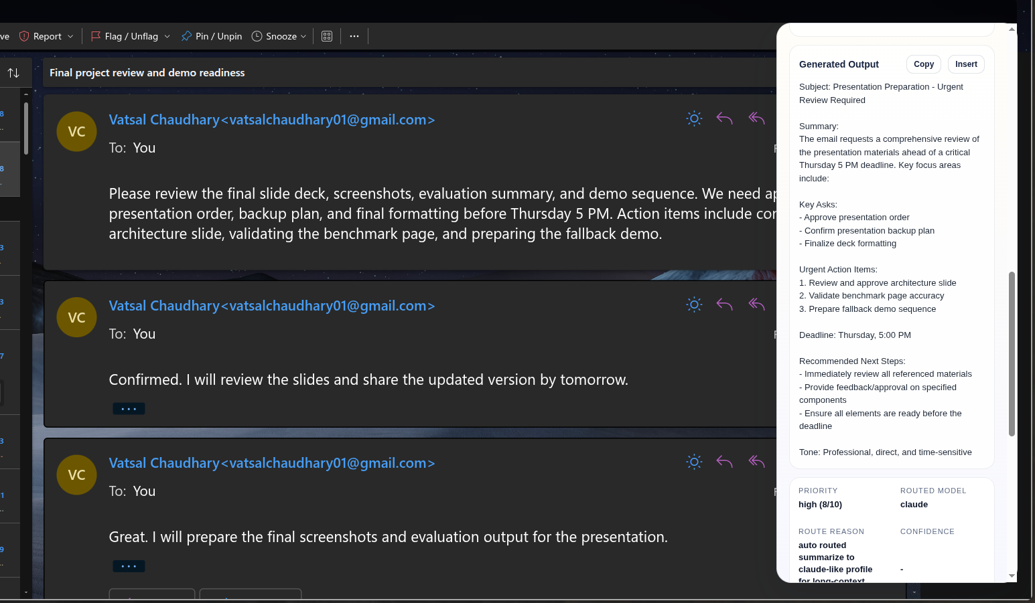

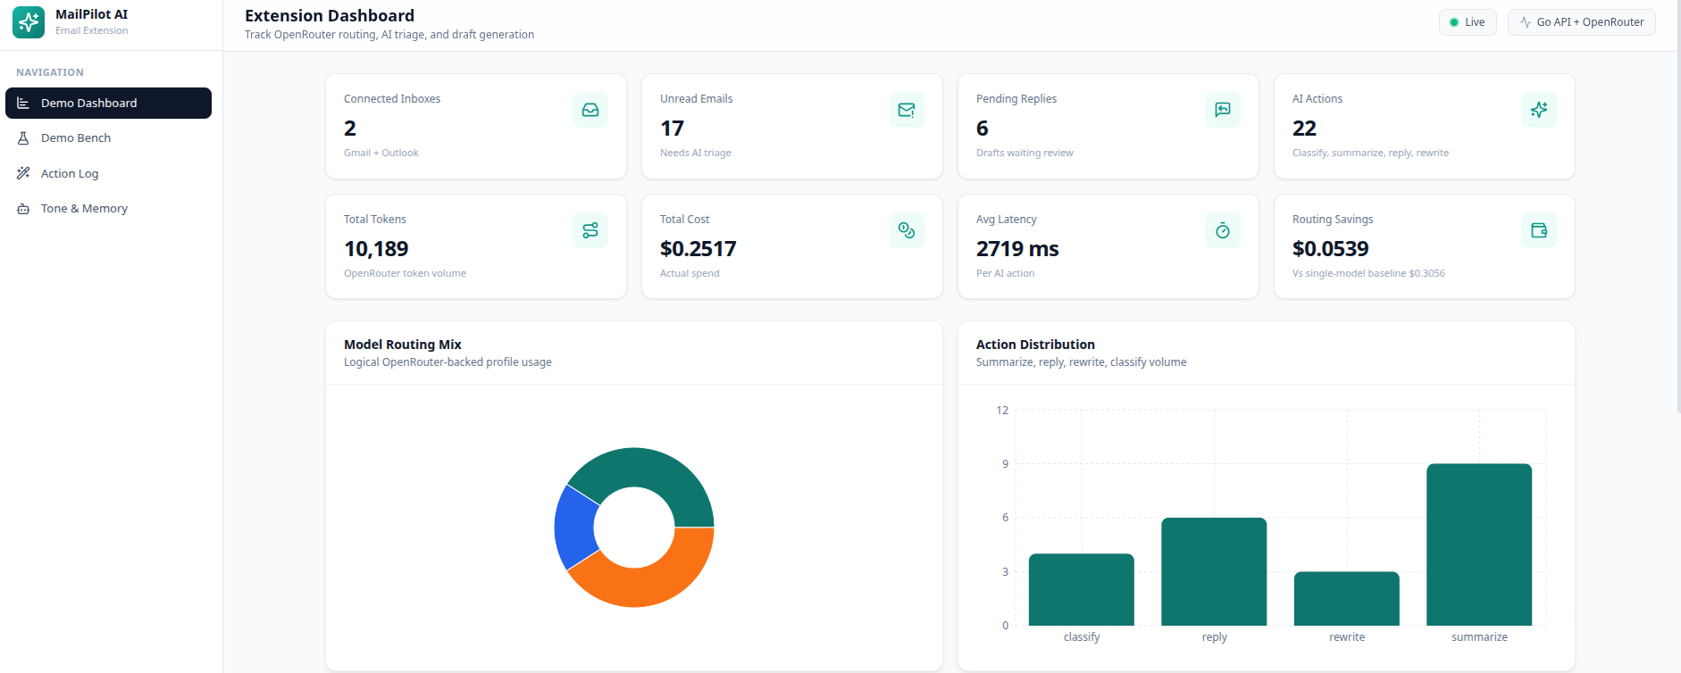

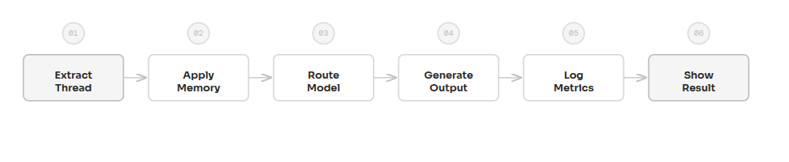

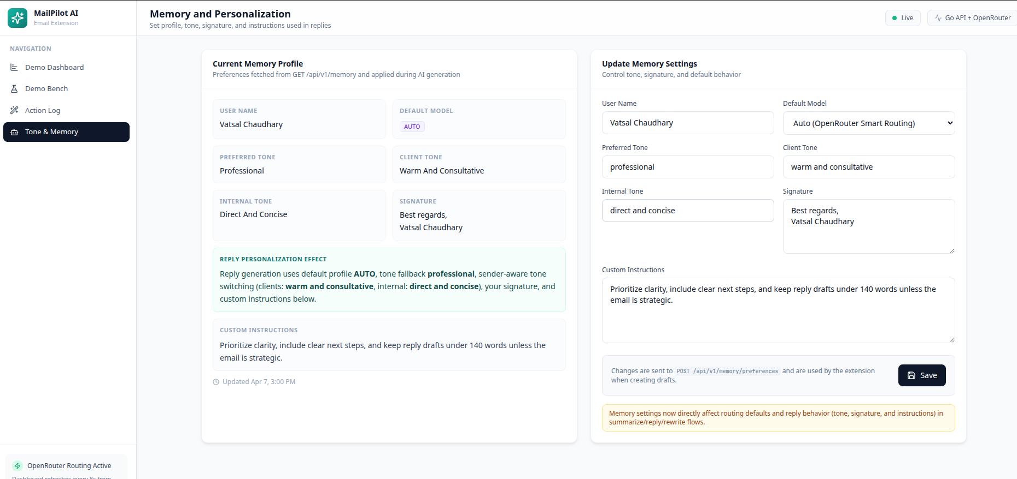

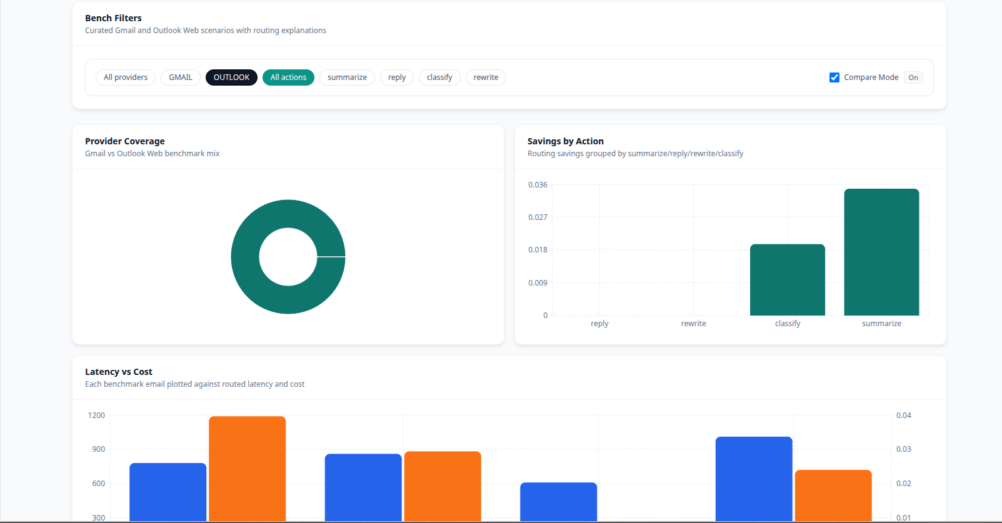

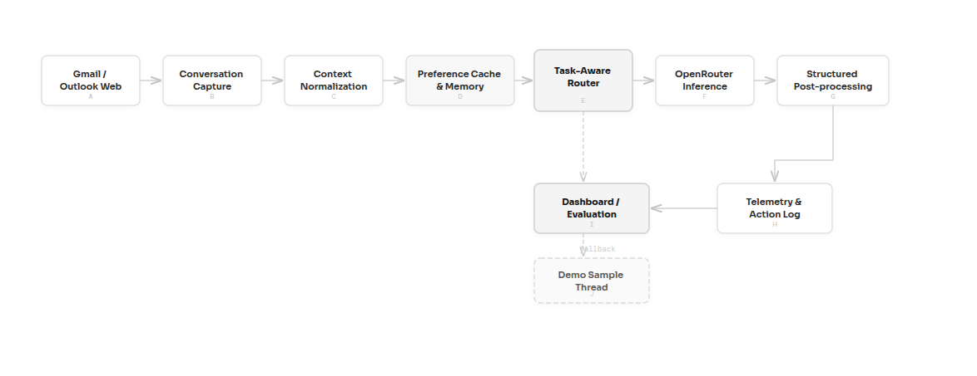



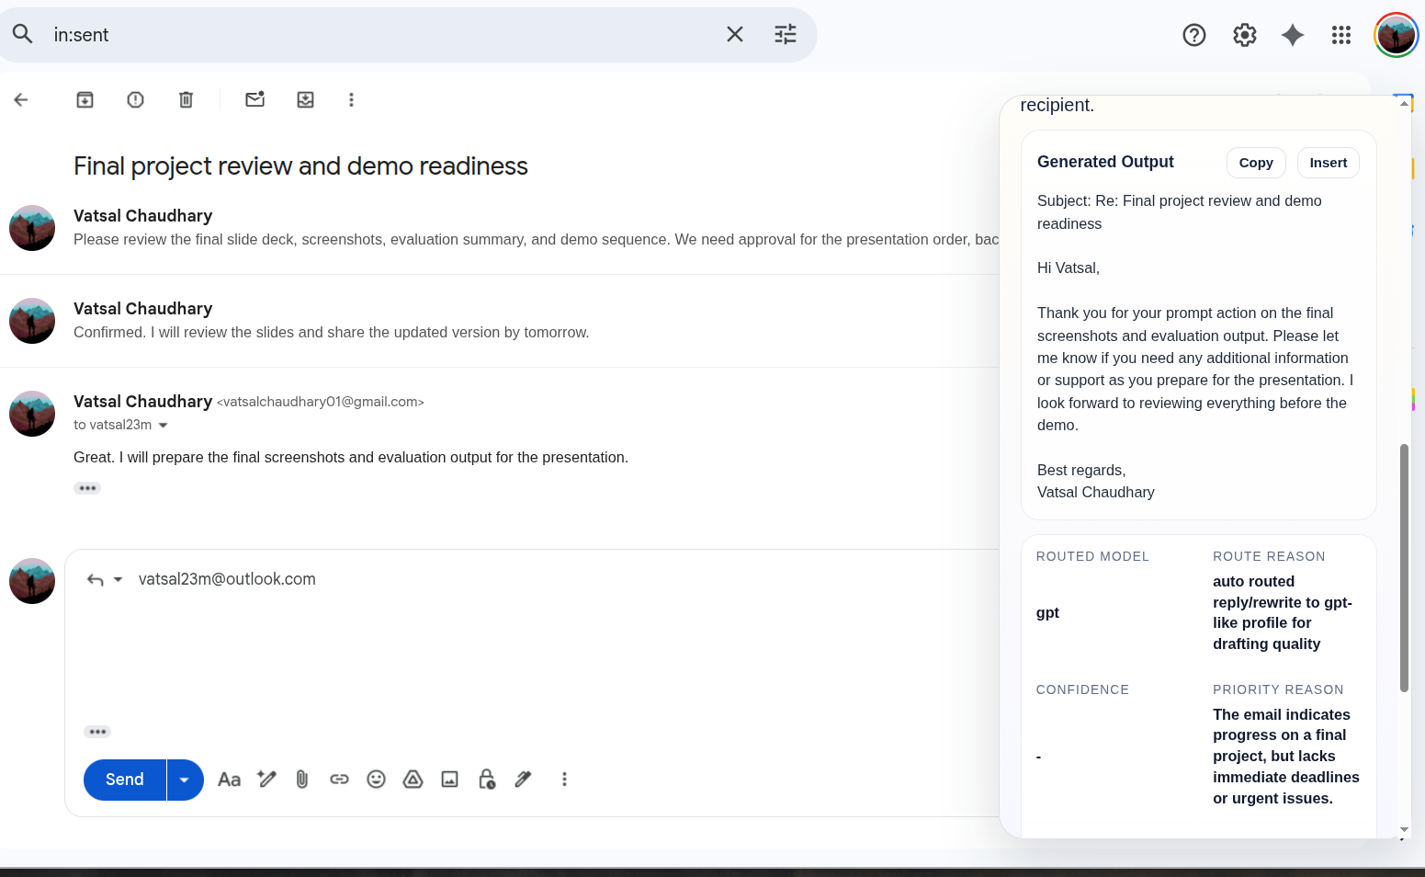

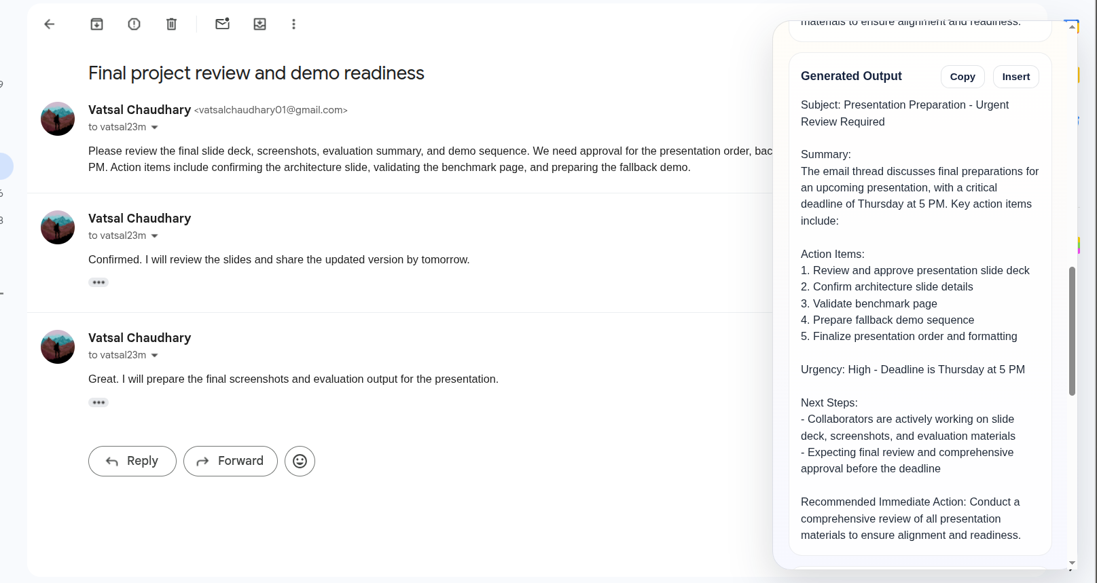

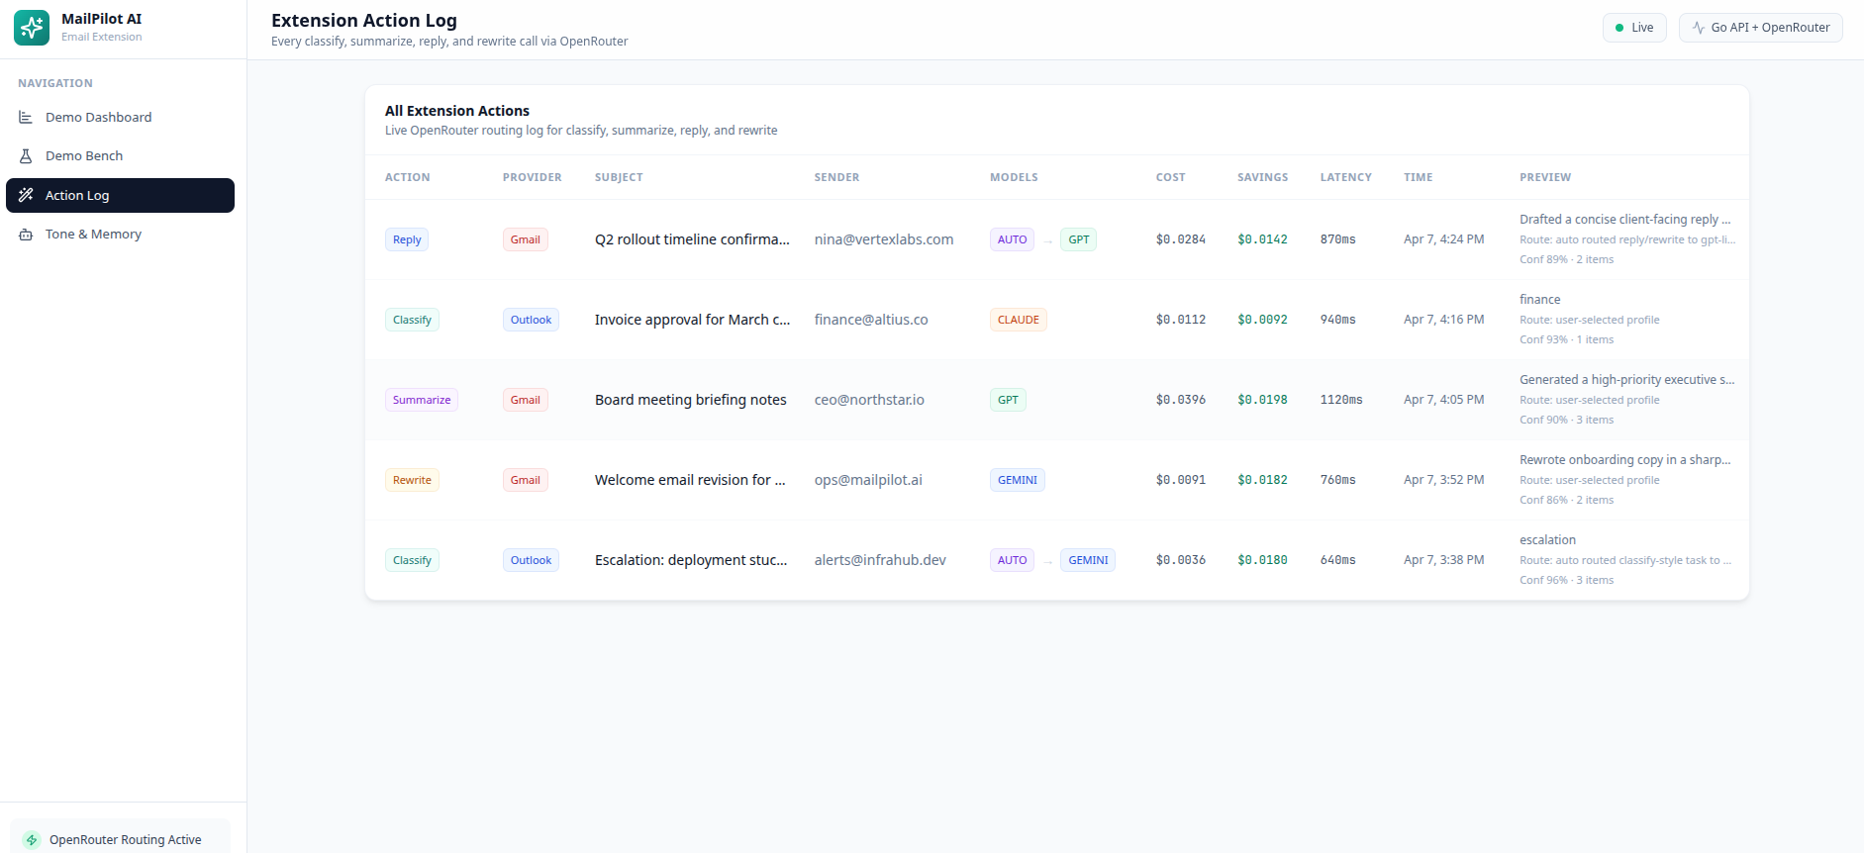

Page 1 (continued)

Page 11 (continued)

Page 21 (continued)

Page 31 (continued)

Page 41 (continued)

Page 51 (continued)

