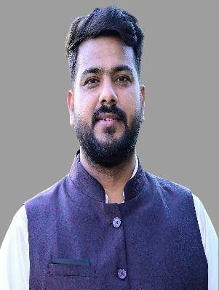
LinkedIn Profile
9646672638
Shreyansh.sharma011@gmail.com
Noida
SHREYANSH SHARMA
Services Engineer, GE Vernova T&D India Ltd

About Me

Proactive Technical Specialist with leadership abilities, strategic planning expertise, and problem-solving acumen. Experienced in SCADA/EMS and I am focused on bringing together technologies and expertise to help solve the toughest power system challenges, accelerating the global transition to a more resilient and reliable grid.

Work Experience & Internships

Services Engineer-GE Vernova T&D India Ltd June 2023- Present
- Currently working on Implementation of Unified Load Dispatch and Communication Phase-III SCADA/Upgradation (PGCIL).
- Led end-to-end integrated system testing for the ULDC-NR customer, successfully demonstrated platform scalability by executing performance validation under 300% load expansion beyond current production sizing.
- Designed and executed high-load simulation scenarios to validate system stability, throughput, and responsiveness under normal and peak operational conditions.
- Successfully implemented the Ethiopian Electric Power National Load Dispatch Centre (EEPNLDC) Project. My core responsibilities included configuring the SCADA, FEP, Historian, and EMS software, ensuring seamless design, supply, installation, and testing processes.
- Familiar with power system analysis applications including power flow, state estimation, and contingency analysis.
- Perform all technical aspects of customer-integrated projects, including detailed design, engineering implementation, FAT/ SITE testing.
- Knowledge of various communication protocols like IEC 101/104, IEC61850, ICCP, OPC, MODBUS -Serial & TCP/IP, DNP3
- Created detailed test plans, specifying testing procedures, equipment settings, and acceptance criteria, and collaborated with the team to execute tests effectively.
- Basic use of JIRA framework to implement agile methodology for continuous product enhancements and developments. This involved working closely with the development team to drive product improvements and address customer and product variances efficiently.
GET (Sale & Marketing Team)- Ambit Switchgear Pvt Ltd. April 2023- June 2023

- Sales and marketing-Switchgear (LT/HT Panels).
- Analyzing market potential & competition status and thereby implementing appropriate marketing strategies.
System Engineer Trainee-Infosys Jan 2021 to April 2021
- Training in JAVA and its application.
- SQL

Internship

Integrated EV Charger Jan 2020 to April 2020
- Designed and built an electric vehicle charger utilizing a 12 V battery as a power source.
- Implemented dual charging capability with the ability to charge from the grid or a solar panel environment.
- Controlled the charging process using an Arduino UNO microcontroller for efficient and reliable operation.

Education

Thapar Institute of Engineering and Technology, Punjab
BE, Electrical Engineering: - CGPA-7.85, 2016-2020 ST Paul Sec School, Samastipur, Bihar Percentage: -89.8% (PCM-90.3%), 2013-2015

B.D. Public School, Patna, Bihar
Percentage: - 95%, 2010-2012

Certifications
- Fundamentals of JAVA and data structure - Coding Ninja.
- Jira for Beginners- Detailed Course to Get started in Jira – Udemy

Skills & Interests
TECHINCAL | SOFT SKILLS
- MS-Office (Excel, PowerPoint, and Word) | - Teamwork
- SCADA/EMS (Basics of PF, CA, SE) | - Research and Strategy
- PROFICY HISTORIAN | - Time Management
- EFEP-Extensible Frontend Processor | - Problem Solving
- SQL/SSRS(Reporting)/Python (Basic) | - Communication
- JIRA | - Multitasking
- Protocols (IEC101/104/61850/MODBUS/OPC/DNP3) | - Customer Service and Relations
- Circuit Analysis/Power System/ | - Leadership

Interests
- Analyzing and Predicting box office collection of Bollywood Movies.
- Teaching.

